**MODULE 3:Core Values of NSTP**

**Filipino Characteristics and Filipino Citizenship Values**

**Specific Learning Outcomes:**

**At the end of the lesson, you shall be able to:**

1. Identify the good citizen values as the basis for NSTP core values
2. Produce an infographic showing the manifestation of the Filipino values

_______________________________________________________________________________



**Uncover**

**Let’s Get Started!**

In this unit, you will be dealing with the good Filipino values which is also one of the strong foundations of NSTP. To begin, do the activity that follows.

**Activity 1.**

## Complete the sentence. Write not less than five descriptions.



***You know you’re a Filipino when…………………***

_________________________

_________________________

_________________________

_________________________

_________________________

**Brainstorming**

**The Core Values of NSTP**

**Values are caught not taught** as the saying goes, it means you learn values or behaviors from the people who practice them, especially at home, which is considered your first school. You “catch” such values by seeing them lived. On the other hand, if you see someone consistently living out what they believe, you might “catch” it. If their modeling of those values is powerful enough, their values can be caught.

Values come from the Latin word “**valere**”. Value has been defined as any object, activity, or frame of mind that a person considers to be very important to his or her life. Unlike attitudes, values come in, as a conscious list of priorities. All of our values taken together are called value system.

A corporate culture, is a system of values shared in any given place or organization. Values education is founded on a sound philosophy of the human person with all its philosophical ramifications and implications. The system and overarching value that characterizes education is HUMAN DIGNITY.



**The Meaning of Man as a Person**

The term “**person**” can be exclusively attached to a human being since notall people are considered human beings and vice versa. To speak of man as abeing with others is to speak of man as a person. Ample consideration has beenrendered in an inquiry on personalism.

**Personalism** is a study of man as a person -- unique, a who, a subject, and a self... never alone in his existence.

**Personhood (pagkatao)** - individual unique personhood, inasmuch as theindividual is the person, and the person in the individual. Being with others is very important as the saying “No man is an island” goes; no man lives alone.People need people.

**LOVE OF GOD, OF ONESELE, OF NEIGHBOR, AND OF COUNTRY**has a biblical basis in *Matthew 22*

**greatest commandment**

*(37)love the Lord, your god with all your heart with all your soul, and with yourentire mind*

**2nd most important commandment**

*(39)Love your neighbor as you love yourself*

Selfhood is to conceive it as apersonal role that one plays in the general drama in life Individual differences,responsibilities, decisions, relationships, and involvements are to be lived and work to be performed.

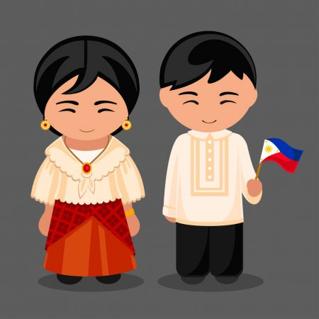

**Where Values Come From**

Values come from early childhood (values of our parents, the environment, the school, the church, and the government.)

**Core and Related Values**

Conceived and enunciated, the eight (8) core and related values thateverybodynot only the youth-should have and nurture.

1. Physical (health-physical fitness, cleanliness, harmony with materialuniverse, art and beauty)
2. Intellectual (truth knowledge, creative and critical thinking)
3. Moral (love-integrity, honesty, self-worth, self esteem, personaldiscipline)
4. Spiritual (spirituality-faith in God)
5. Social, Family, Society (social responsibility-mutual love, respect,fidelity, responsible parenthood, concern for others/common good,freedom/equality, social justice/respect; human rights- peace/ activenonviolence, popular participation)
6. Economic (economic efficiency-thriftiness, conservation of resources,work ethics, self-reliance, productivity, scientific and technologicalknowledge)
7. Political (nationalism-common identity, national unity, esteem,commitment, civic consciousness/pride, bayanihan/ solidarity, loyaltyto country)

“The reinvigoration of the national spirit must take place in the grass roots,in every city, tow, and barrio in the Philippines, and it must start among our own people to be a worthy citizen of the world one must first prove himselfto be a good Filipino. Life takes new meaning when we give ourselves to others.”

**Instill**

**Good Citizen Values**

**What is a good Filipino citizen?**

A **good Filipino citizen** is one who plays an **active and intelligent role** as amember of the community. He is one who fulfils his duties and obligations tothe government and society. i1e possesses the traits of respectfulness, courtesy, and consideration for parents and elders and for others. He observes punctuality,promptness, and good moral conduct. (Coloma, & Herrera, n.d.)

How can you become good citizens?

You can become good citizens by living in accordance with the good citizenship values derived from the preamble of the 1987 constitution: We the sovereign Filipino people, imploring the aid of Almighty God in order to build a just humane society and establish a Government that shall embody our ideals and aspirations, promote the common good, conserve and

develop our patrimony, and secure to ourselves and our posterity the blessings of independence and democracy under the rule of law and a regime of truth, justice freedom, love, equality, and peace, do ordain and promulgate this constitution.

The Filipino values presented in the preamble have been simplified and categorized into the following:

**I. MAKA - DIYOS (Pagkamaka-Diyos)** In whatever religion you belong or in whatever way you call your God (Yahweh, Jehovah, Christ, Allah, and the like), what is important is your faith in the Almighty God and follow all his commandments to the fullest of your ability, like our Filipino saints San Lorenzo Ruiz and Pedro Calungsod, who offered their lives for the love of God.



**A. Faith in the Almighty God imploring the aid of the Almighty God** This is the basic value: to put God in the center of your lives and communicate with Him by means of prayers. You should look to Him as your Ultimate Source, One with infinite powers to help you in your work, to enable you to meet your needs, and to get you out of trouble and crisis. With this experience, you become fully aware of the things you can accomplish when you live a life of faith.

**B. Respect for life** The most precious gift that you have received from God is “lite”; therefore, you need to treasure it, keep away from destroying yourself, do not take prohibited drugs, do not get drunk with liquors nor indulge in any other vices that might warm or destroy your life.

**C. Order** The value of order is to have priorities, “first things first”. It is Simply doing the right thing right at the right time and right place without any doubt. Order entails the discipline of your mind, emotion, and action. You need these for a peaceful, successful, and productive life.

**D. Work** "GIVE FISH TO A MAN, AND HE WILL HAVE FOODFOR A DAY; TEACH HIM HOW TO FISH, AND HE SHALL HAVE FOOD TO EAT THROUGHOUT HIS LIFETIME"

(Chinese proverb) Work is a gift, and it has become a part of your nature and destiny. God has given you talents to use wisely in your work, and in return, you are expected to settle for nothing less than excellent results.: Hard work, quality work, and honest work are what make a citizen a good, productive, and self-reliant member of the society.

**E. Concern for the family and future generations**

Be kind and generous starting with your family. This value emphasizes that your family is a gift from God and that utmost attention must be focused on the family, a sanctuary of life and a core unit of society. You draw inspiration and strength from your family, so you are expected to do your responsibilities as a member of the family to keep it intact and strong against the forces that tend to destroy its values and sense ofunity.

**II. MAKA - TAO (Pagkamaka-tao)**  Bob Ong says that love means so much to us, and simply, love is the answer to our many questions during these trying times. It is by love that we care, respect, accept, forgive, and trust. But why is it that our nation has never moved forward if we all have LOVE within us?

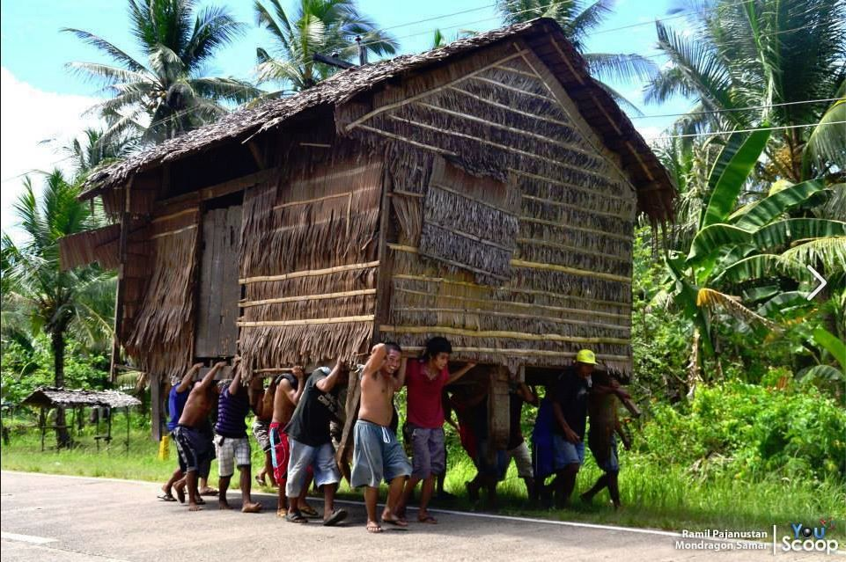

**A. Love** - Love conquers all as the saying goes; it is a four-letter word that entails sacrifice, responsibility, and service. Love binds us together as a nation as our heroes died for our freedom. Love is the key to our national progress. Let love be in the beginning, the

middle, and the end of our history as a nation.

**B. Freedom**, independence, and democracy-your freedom ends when others freedom begins. You should practice freedom with a clear understanding of its limits, with a sense of discipline and

chastity, which will lead you to love your fellowmen, understand their plight, and do what is good and right while avoiding what is wrong and evil.

**C. Peace** - Peace is a God-given gift that you must nurture by prayer and practice. This can be attained and sustained when you develop a deep sense commitment of your faith in God, concern and respect for your fellowmen, loyalty to your country, and care for your environment.

**D. Truth** Francis Bacon said: It is not what we eat but what we digest that makes us strong; not what we gain but what we save that makes us rich; not what we read but what we remember that makes us learned; and not what we profess but what we practice that gives us integrity.. Integrity is telling oneself the truth.

MarkTwain said, "When you tell the truth you don't have to remember anything"

**E. Justice**-You value justice by means of promoting ethical equality that enhance the essence of fairness and social justice. It also means the promotion of a healthy and humane society, respect for the poor and the unfortunate ones, correct use of power, moving carefully away from graft, corruption, and any other wrongdoings.

**III. MAKA - BAYAN (Pagkamaka-bansa)**

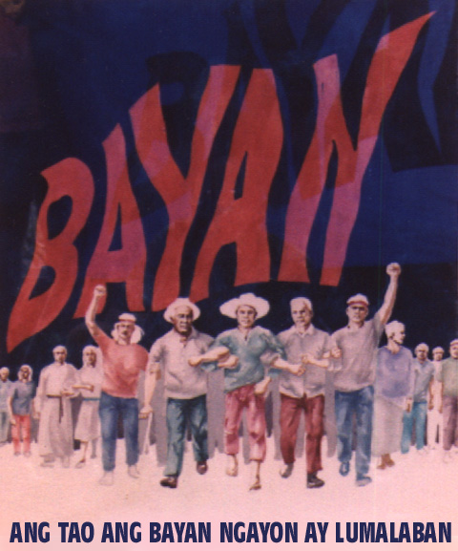

**A. Unity** - "United we stand; divided we fall" is a saying that binds people or nation to be united as one, especially in times of trials and aspiration. Like a broomstick, if just a piece of it is used you cannot sweep the mess easily, but when you bind the pieces together you can sweep and clean the entire surroundings. Unity was also the key when our heroes united against the colonizers just to get our freedom and secure the country's independence.

**B. Equality-** Mahatma Gandhi said: "There will never be real equality so long as one feels inferior or superior to another." This value means treating one another with equality and utmost dignity, respect for fellow human beings regardless of religion or cultural orientation, sex, social status, race, and so on. All men are created equal, and they have every right to be treated fairly in the interest of love and justice.

**C. Respect for law and government rule of law -** When you respect the law, you also respect the government. It shows patriotism and love of country. You can criticize the government against bad leaders, but you better keep mum if you cannot offer any alternatives or solutions to the problems

**D. Patriotism**, **conserve and develop our patrimony –**Patriotism is every person's sense of duty and responsibility to contribute to the development of our country, protecting our integrity, and upholding the rights and dignity of our people. Being proud of our personal and national identity and being **responsible voters** are some of the concrete examples of how we cultivate the value of patriotism.

**E. Common good**- To promote the common good is an obligation of every member of society to help one another in attaining social justice and welfare of the future generation. It is to share what you have with the other members of society who need your help most so that their human dignity will be upheld. In doing this, you should be sincere and willing to be counted in the work of promoting the common good since the government needs all citizens to join in this mission.

**IV. MAKA - KALIKASAN (Pagkamaka-kalikasan)**

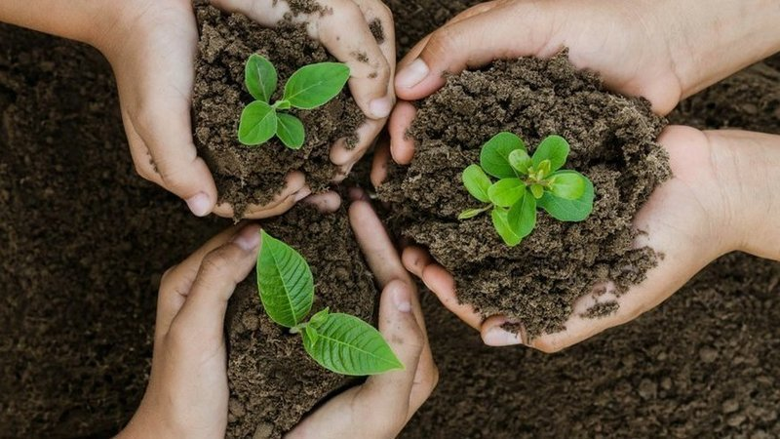

Concern for the environment is to prepare our future generation to have clean air to breathe, clean water to drink, clean river to swim, clean ocean to experience adventures, and a healthy life that is worth living. Nature is God's grace to you, so you should take care of all his creations, using all environment resources properly and prudently, and you should develop a sense of urgency in the way you treat your environment to bring back all the praises and glory to God. Participate and get involved in government efforts to protect the environment by launching an efficient and sustainable “clean-and-green” program nationwide.

**Apply**

**Activity 2. Creating infographics**

Instructions:

1. Create an infographic of examples that show the Filipino vales
2. Use 8.5 x 11 or 8.5x13 paper size
3. Avoid using too much disturbing graphics
4. You may use any applications or website to create your infographic.

**Nutshell**

**Complete the table. Submit your output in LMS.**

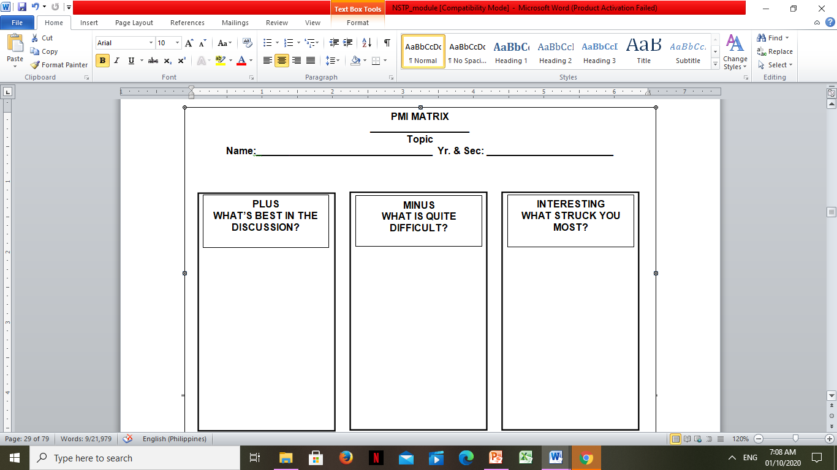

**PMI MATRIX**

**__________________**

**Topic**

**Name:________________________________ Yr. & Sec: _______________________**

**PLUS**

**WHAT’S BEST IN THE DISCUSSION?**

**MINUS**

**WHAT IS QUITE DIFFICULT?**

**INTERESTING**

**WHAT STRUCK YOU MOST?**

**PMI MATRIX**

**__________________**

**Topic**

**Name:________________________________ Yr. & Sec: _______________________**

**PLUS**

**WHAT’S BEST IN THE DISCUSSION?**

**MINUS**

**WHAT IS QUITE DIFFICULT?**

**INTERESTING**

**WHAT STRUCK YOU MOST?**

**PMI MATRIX**

**__________________**

**Topic**

**Name:________________________________ Yr. & Sec: _______________________**

**PLUS**

**WHAT’S BEST IN THE DISCUSSION?**

**MINUS**

**WHAT IS QUITE DIFFICULT?**

**INTERESTING**

**WHAT STRUCK YOU MOST?**