**TEST CASES**

We have written test cases to verify the working of our Multithreaded Web Server. These test cases are available in a python script **test.py**. To run the test cases, refer to the below snapshot

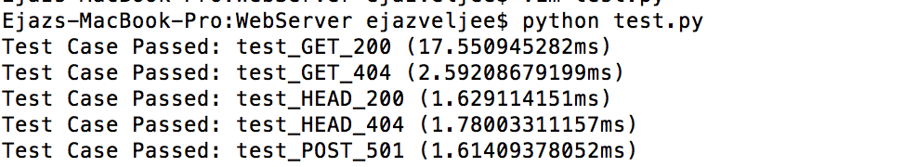

**OUTPUT SNAPSHOTS**

We have used the POSTMAN HTTP client tool to send http requests to the server

* Successful GET Request:

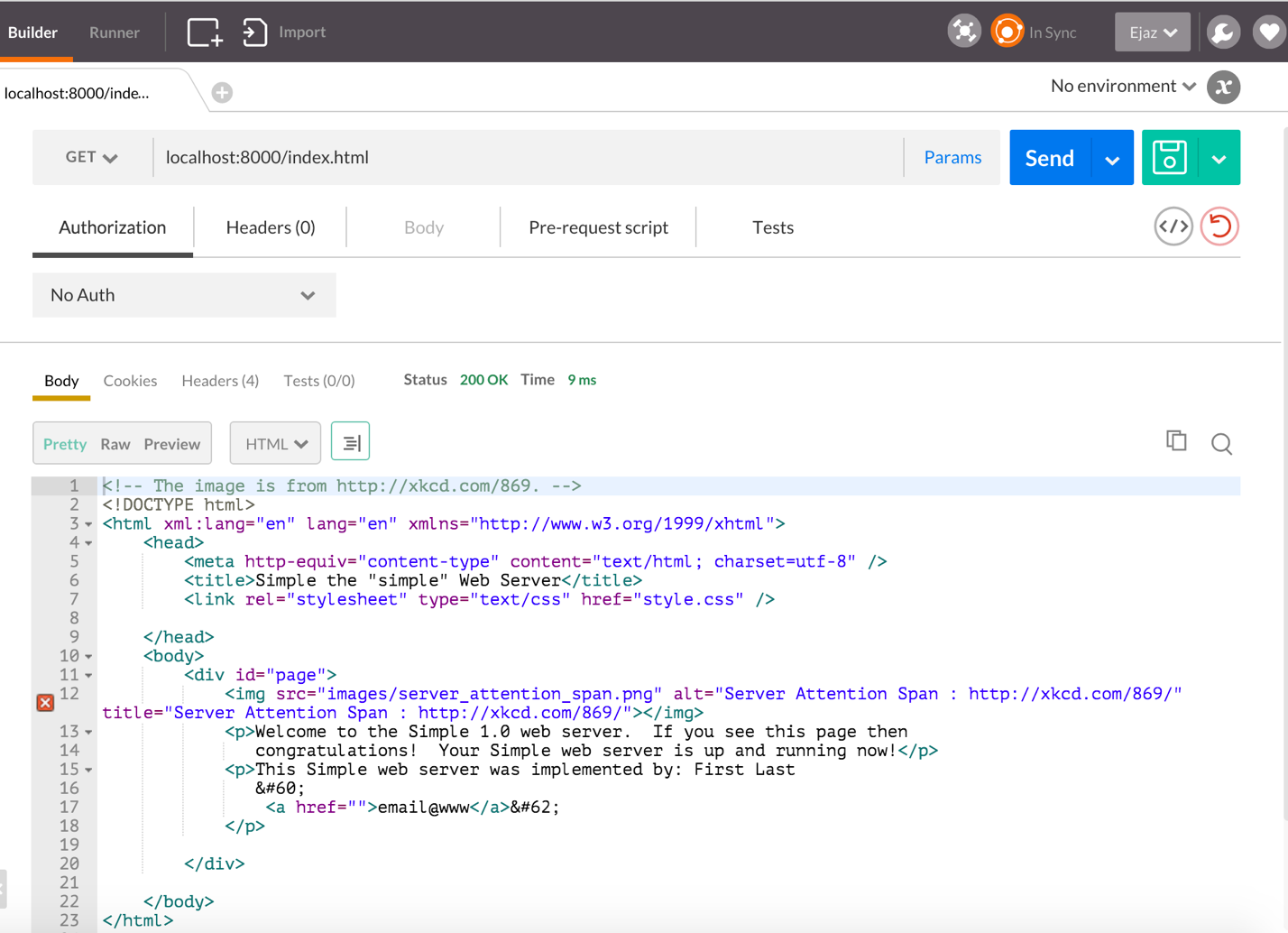

* Successful HEAD Request:

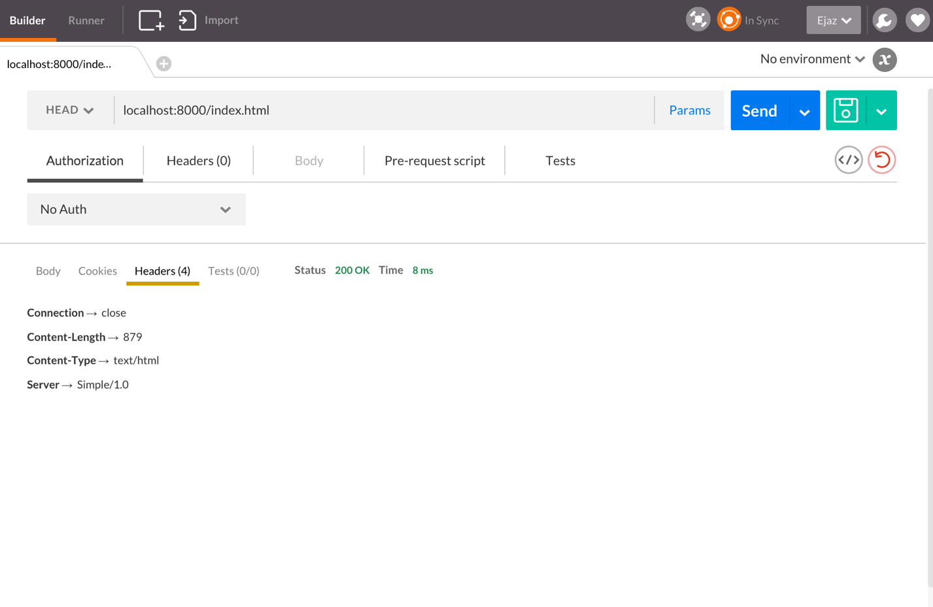

* Unsupported POST Request:

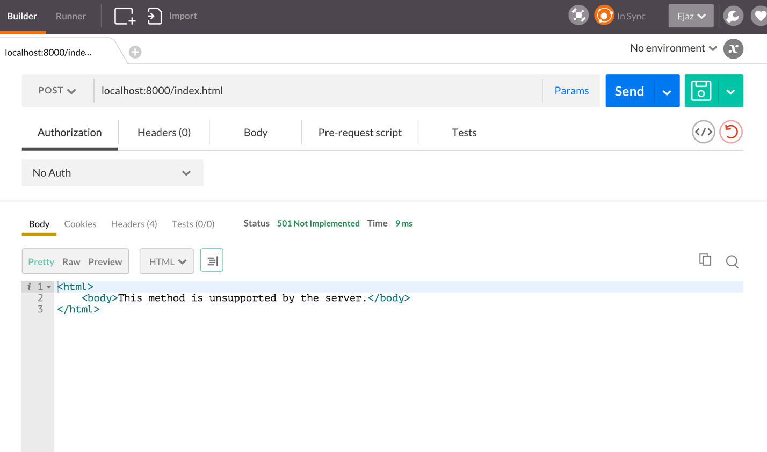

**START THE SERVER**

* Our server has been implemented in java. It’s an eclipse project and it can be directly imported into eclipse.
* In eclipse run the **Simple.java** file present in the package *cmu.webser.socket*
* Pass the port number as a command line argument. If the path to the www/ folder is not provide, the server chooses a default path. Hence, this parameter is not compulsory.

**PROJECT TEAM MEMBERS**

* EJAZ VELJEE
* APURV BHARGAVA