Project:
Fire and smoke detection system
Github repository link:

Code:
import cv2
import numpy as np
from google.colab import files, patches

def choose_image():
uploaded = files.upload()
if not uploaded:
print("No file uploaded.")
return None
for filename in uploaded.keys():
return filename
return None

def detect_fire_and_smoke(image_path):
image = cv2.imread(image_path)
if image is None:
print("Could not open image.")
return

output = image.copy()
h, w = image.shape[:2]
total_pixels = h * w

hsv = cv2.cvtColor(image, cv2.COLOR_BGR2HSV)
gray = cv2.cvtColor(image, cv2.COLOR_BGR2GRAY)
b, g, r = cv2.split(image)

kernel = np.ones((5, 5), np.uint8)

---------------- FIRE DETECTION ----------------
lower_fire1 = np.array([0, 80, 120])
upper_fire1 = np.array([25, 255, 255])

lower_fire2 = np.array([160, 80, 120])
upper_fire2 = np.array([179, 255, 255])

fire_mask1 = cv2.inRange(hsv, lower_fire1, upper_fire1)
fire_mask2 = cv2.inRange(hsv, lower_fire2, upper_fire2)
fire_mask_hsv = cv2.bitwise_or(fire_mask1, fire_mask2)

fire_rgb = ((r > 150) & (r > g) & (g > b)).astype(np.uint8) * 255
fire_mask = cv2.bitwise_or(fire_mask_hsv, fire_rgb)

fire_mask = cv2.morphologyEx(fire_mask, cv2.MORPH_OPEN, kernel)
fire_mask = cv2.morphologyEx(fire_mask, cv2.MORPH_DILATE, kernel)

fire_detected = False
fire_boxes = []
fire_pixels = 0

contours, _ = cv2.findContours(fire_mask, cv2.RETR_EXTERNAL, cv2.CHAIN_APPROX_SIMPLE)
for cnt in contours:
area = cv2.contourArea(cnt)
if area < 100:
continue

x, y, ww, hh = cv2.boundingRect(cnt)

if ww * hh > total_pixels * 0.5:
continue

fire_pixels += area
fire_boxes.append((x, y, ww, hh))
fire_detected = True

fire_ratio = fire_pixels / total_pixels

if fire_ratio < 0.001:
fire_detected = False
fire_boxes = []

---------------- SMOKE DETECTION ----------------
# Light/gray smoke
light_smoke_lower = np.array([0, 0, 60])
light_smoke_upper = np.array([180, 90, 230])
light_smoke_mask = cv2.inRange(hsv, light_smoke_lower, light_smoke_upper)

# Dark/black smoke
# low brightness + not colorful
dark_smoke = ((gray > 25) & (gray < 140) & (hsv[:, :, 1] < 120)).astype(np.uint8) * 255

# Combine both
smoke_mask = cv2.bitwise_or(light_smoke_mask, dark_smoke)

# Remove very bright clean white objects
bright_white = ((gray > 235) & (hsv[:, :, 1] < 25)).astype(np.uint8) * 255
smoke_mask = cv2.bitwise_and(smoke_mask, cv2.bitwise_not(bright_white))

# Remove blue sky-like regions
lower_sky = np.array([90, 20, 80])
upper_sky = np.array([140, 255, 255])
sky_mask = cv2.inRange(hsv, lower_sky, upper_sky)
smoke_mask = cv2.bitwise_and(smoke_mask, cv2.bitwise_not(sky_mask))

# Edge map for filtering solid objects
blurred = cv2.GaussianBlur(gray, (7, 7), 0)
edges = cv2.Canny(blurred, 50, 150)

# Make smoke regions smoother
smoke_mask = cv2.morphologyEx(smoke_mask, cv2.MORPH_OPEN, kernel)
smoke_mask = cv2.morphologyEx(smoke_mask, cv2.MORPH_CLOSE, kernel)
smoke_mask = cv2.dilate(smoke_mask, kernel, iterations=1)

smoke_detected = False
smoke_boxes = []
smoke_pixels = 0

contours, _ = cv2.findContours(smoke_mask, cv2.RETR_EXTERNAL, cv2.CHAIN_APPROX_SIMPLE)

for cnt in contours:
area = cv2.contourArea(cnt)
if area < 1000:
continue

x, y, ww, hh = cv2.boundingRect(cnt)

# Ignore very bottom flat regions like roads
if y > int(h * 0.82):
continue

aspect_ratio = ww / float(hh + 1)
rect_area = ww * hh
fill_ratio = area / float(rect_area + 1)

# Roads / flat objects
if aspect_ratio > 5.0 and hh < 80:
continue

# Solid rectangles like doors/walls/windows
if fill_ratio > 0.85 and aspect_ratio < 2.5:
continue

# Smoke is usually soft, not very edge-dense
roi_edges = edges[y:y+hh, x:x+ww]
roi_edge_ratio = cv2.countNonZero(roi_edges) / float(rect_area + 1)

if roi_edge_ratio > 0.22:
continue

# Smoke usually spreads vertically or has enough area
if hh < 50 and area < 2500:
continue

smoke_pixels += area
smoke_boxes.append((x, y, ww, hh))
smoke_detected = True

smoke_ratio = smoke_pixels / total_pixels

if smoke_ratio < 0.01:
smoke_detected = False
smoke_boxes = []

# ---------------- FINAL RESULT ----------------
result_text = []

if fire_detected:
result_text.append("Fire Detected")
for (x, y, ww, hh) in fire_boxes:
cv2.rectangle(output, (x, y), (x + ww, y + hh), (0, 0, 255), 2)

if smoke_detected:
result_text.append("Smoke Detected")
for (x, y, ww, hh) in smoke_boxes:
cv2.rectangle(output, (x, y), (x + ww, y + hh), (255, 0, 0), 2)

if not result_text:
result_text.append("No Fire or Smoke Detected")

text = ", ".join(result_text)

print("Selected Image:", image_path)
print("Result:", text)

cv2.putText(output, text, (20, 35),
cv2.FONT_HERSHEY_SIMPLEX, 1, (0, 255, 0), 2)

print("\nOriginal Image")
patches.cv2_imshow(image)

print("\nDetection Output")
patches.cv2_imshow(output)

if __name__ == "__main__":
image_path = choose_image()

if image_path:
detect_fire_and_smoke(image_path)
else:
print("No image selected.")
Output:
Sample 1
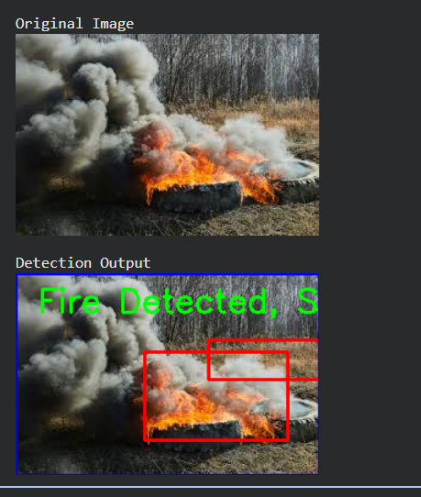

Sample 2
