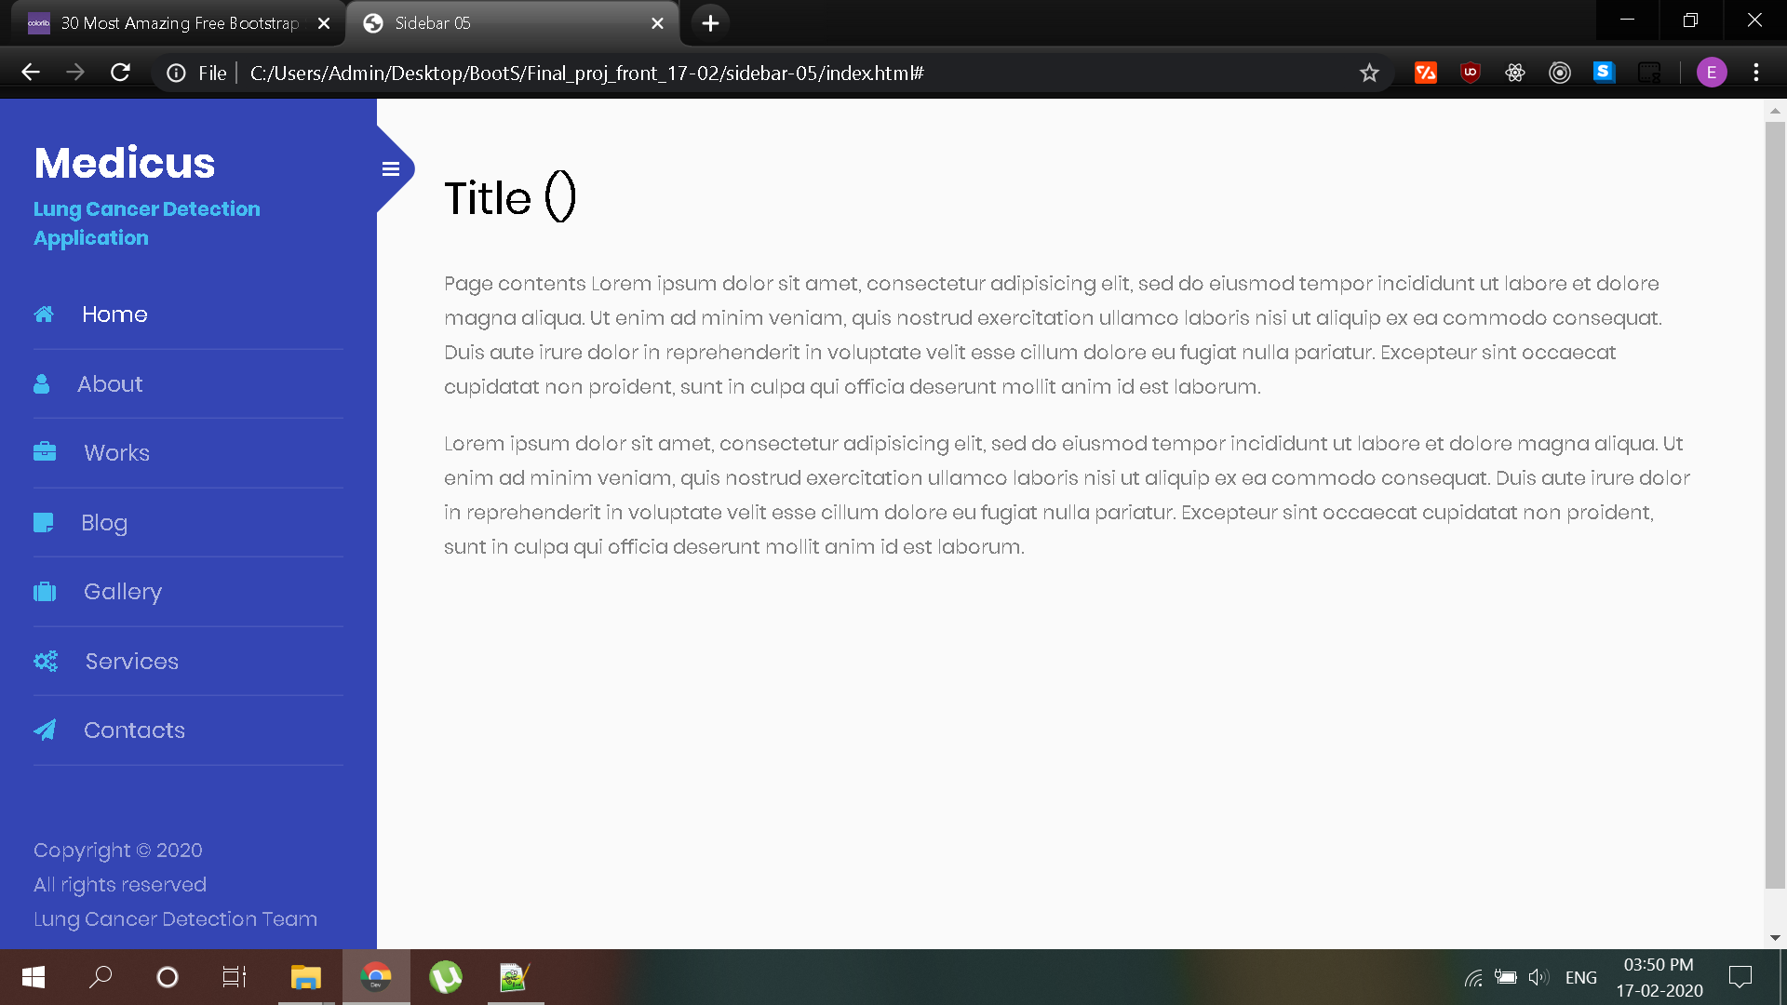

Logos-

1.Home-Home

2.Application-Services

3.Additional Info-Notes

4.About us-About

5.Contact us-cont

<https://bootsnipp.com/snippets/j6PRq>