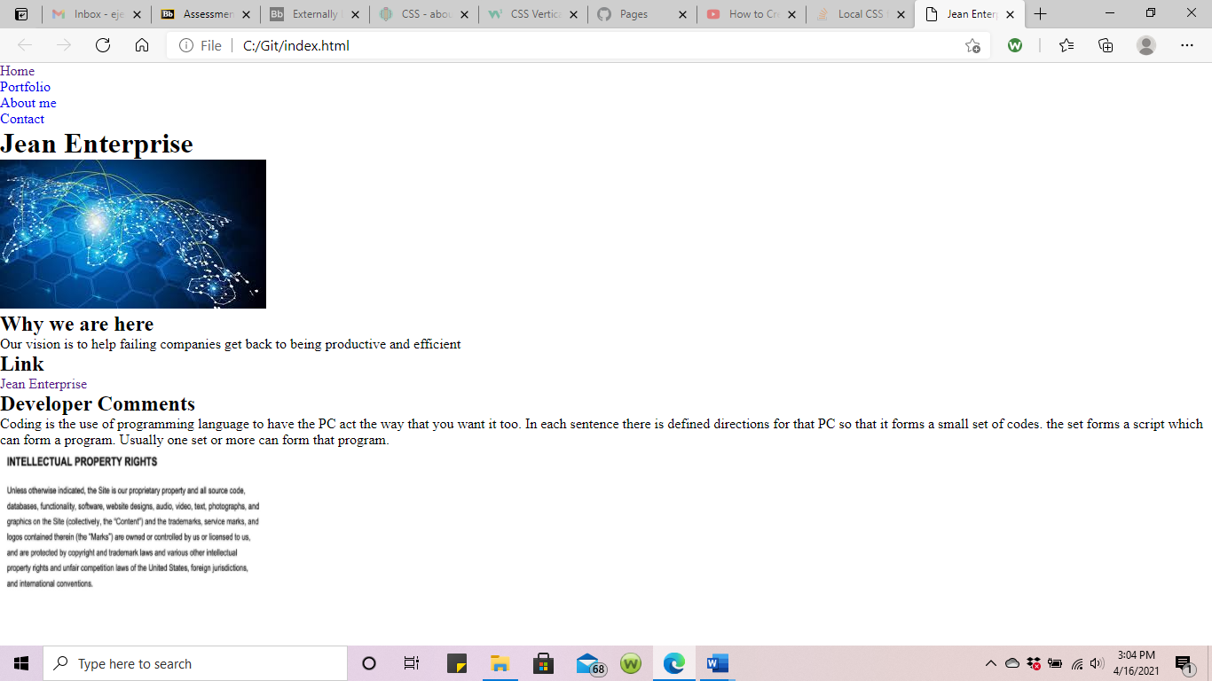

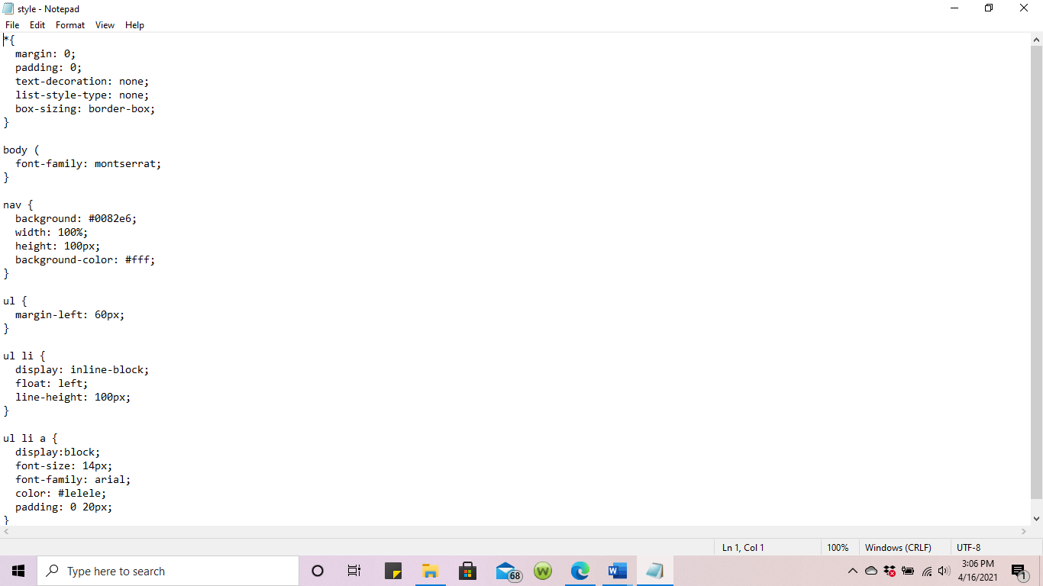

Microsoft 10 Edge browser was used

This browser was used to view the above snapshot. “[Jean Enterprise](file:///C:\Users\ejb97\OneDrive\Desktop\HTML\template.html)”

