Windows Edge template

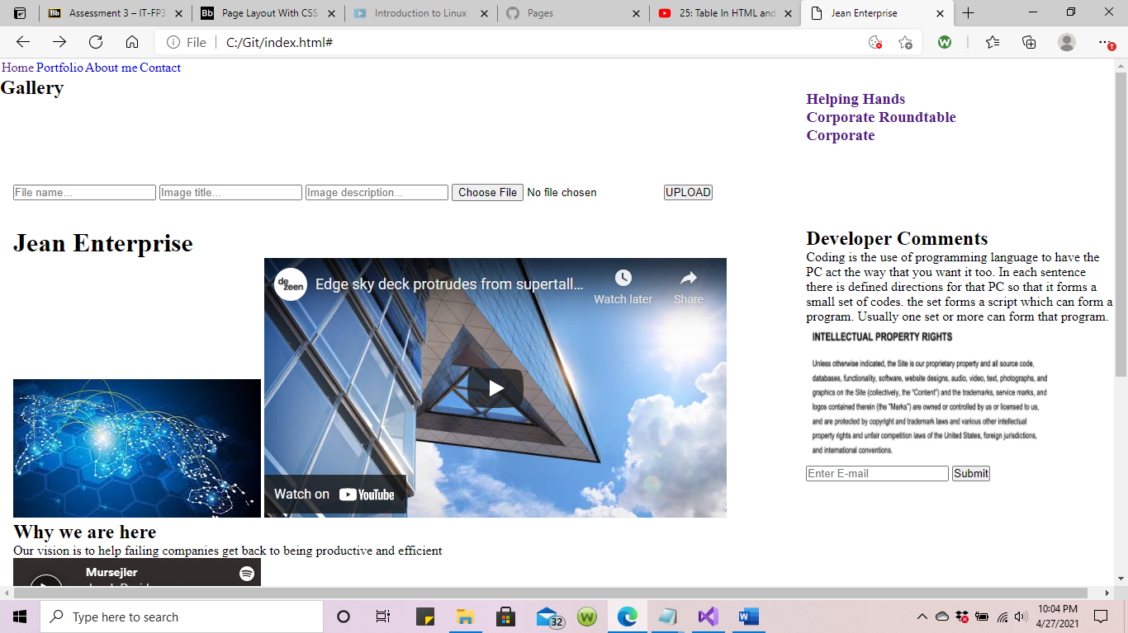

* The code that was used to present the image above was basic CSS grid. Though the colors did not appear like I intended, the coding was still completed in the manner that it is supposed to be in.

HTML template

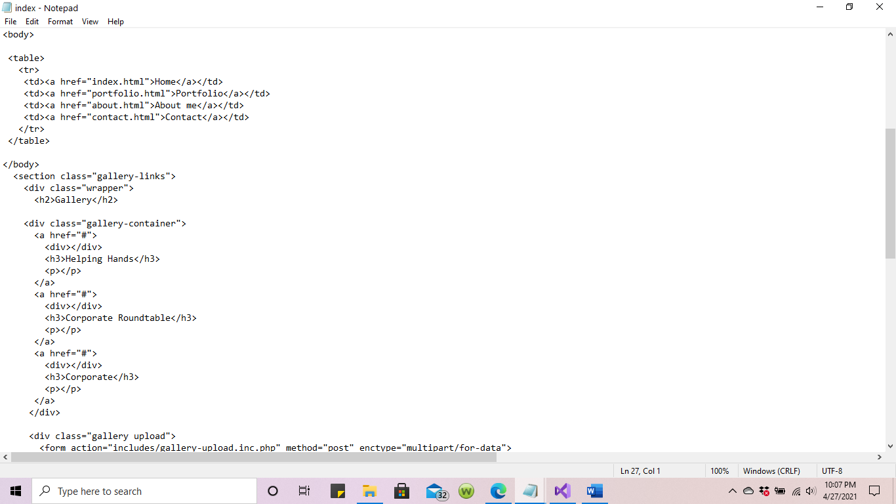

CSS template

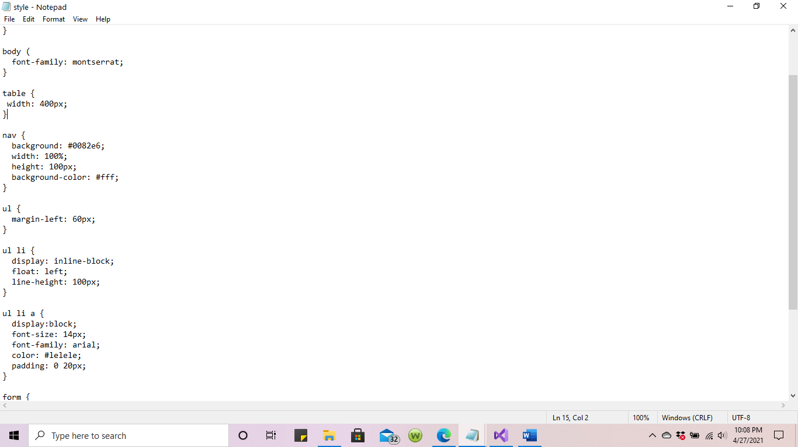

Microsoft 10 Edge browser was used

This browser was used to view the above snapshot. “[Jean Enterprise](file:///C:\Users\ejb97\OneDrive\Desktop\HTML\template.html)”

