CERTIFICATE OF APPROVAL

In Partial Fulfillment of the Requirements
for the Degree of

MASTER IN ARTIFICIAL INTELLIGENCE AND DATA ANALYTICS

This Capstone Project Entitled
MARKET SEGMENTATION FOR PHILIPPINE AIRLINES THROUGH MACHINE LEARNING

Has been prepared and submitted by:

YAMZON, MARTIN ALOYSIUS R. (1st author)
BINADAY, EDYLL JOSHUA B. (2nd author)
VERSOZA, ARIEN JADD. (3rd author)
LIM, JEREMY JAY V. (4th author)

and has been accepted following a successful Defense before a duly Constituted Panel whose signatures appear below

Jose Miguel Bautista
First Faculty Adviser Date

Rebecca R. Ricalde
Second Faculty Adviser Date

Name and Signature Date
Panelist Nathaniel Ryan Vasay
Panelist Date

Kristine Ann Carandang
Panelist Date

Imee Lanie Uy
Panelist Date

CERTIFICATION

We, MARTIN ALOYSIUS R. YAMZON, EDYLL JOSHUA BINADAY, ARIEN JADD VERSOZA, and JEREMY JAY V. LIM, hereby certify that unless expressly acknowledged in the Capstone, the text, analysis, recommendations and, in general, the substance of my Capstone Project are my personal and individual work.

The data therein are real and not fabricated. Where I used the help of others in the gathering of data, the supervision of data gathering, including the formulation of questionnaires, and the interpretation of data, including the interpretation of responses to questionnaires, are my own personal and individual work.

Capstone Project Title:

Market Segmentation for Philippine Airlines Through Machine Learning

YAMZON, MARTIN ALOYSIUS R. ___________
Date

BINADAY, EDYLL JOSHUA. ______________
Date

VERSOZA, ARIEN JADD. _______________
Date

LIM, JEREMY JAY V. _______________
Date

© 2026
Asian Institute of Management
ALL RIGHTS RESERVED

Copyright © Asian Institute of Management, Makati City, Philippines, https://aim.edu/.
For inquiries, please contact the AIM Knowledge Resource Center at krc@aim.edu.

The Asian Institute of Management is not liable for any infringing, copied, or plagiarized materials present in the capstones submitted by its students. Responsibility for ensuring compliance with copyright laws and academic integrity standards rests solely with the student.



MARKET SEGMENTATION FOR PHILIPPINE AIRLINES THROUGH MACHINE LEARNING
Martin Yamzon
Jeremy Jay Lim
Arien Jadd Versoza
Edyll Joshua Binaday

A Capstone Project submitted to
the Aboitiz School of Innovation, Technology, and Entrepreneurship
in Partial Fulfillment of the Requirements for
the Degree of Master of
Science in Data Analytics and Artificial Intelligence

Under the supervision of:
Jose Miguel Bautista, PhD
Rebecca R. Ricalde, Clinical Professor
ASIAN INSTITUTE OF MANAGEMENT
December 2026

TABLE OF CONTENTS
TABLE OF CONTENTS i
LIST OF TABLES iii
LIST OF FIGURES iv
ABSTRACT v
CHAPTER 1: INTRODUCTION AND CONTEXT 1
1.1. Background of the Study 1
1.2. Problem Statement 2
1.3. Objectives of the Project 3
1.3.1. Machine Learning Model Development 4
1.3.2. Executive Dashboard 4
1.3.3. Technical Document 4
1.4. Significance of the Study 4
1.4.1. Practical and Commercial Value for Philippine Airlines 4
1.4.2. Strategic Impact on the Philippine Aviation Sector 5
1.4.3. Contribution to Applied Data Science and Aviation Research 5
1.4.4. Consumer Insight and Privacy Compliant Personalization 6
1.5. Scope and Limitations 6
1.5.1. Dataset Scope and Scale 6
1.5.2. Technical and Analytical Boundaries 6
1.5.3. Privacy and Data Governance Protocols 7
1.5.4. Proprietary Ownership and Confidentiality 7
CHAPTER 2: REVIEW OF RELATED LITERATURE 7
2.1. Theoretical Framework for Customer Segmentation & Unsupervised Learning 7
2.1.1. Traditional Aviation Segmentation & Loyalty Frameworks 7
2.1.2. Business Models in Aviation and FFP Valuations 8
2.1.3. Behavioral & LRFMC Feature Engineering Models 8
2.1.4. Principles of Unsupervised Learning 10
2.2. Methodological Review of Clustering Algorithms 11
2.2.1.Partitioning & Centroid-Based Algorithms (K-Means & MiniBatchKMeans) 11
2.2.2. Density-Based Clustering (HDBSCAN) 11
2.2.3. Probabilistic & Latent Variable Models (GMM & Latent Class Analysis) 12
2.2.4. Rule Waterfalls & Negative Learning Architectures 13
2.2.5. Mathematical Evaluation Metrics 15
2.3. Recent Studies in Aviation Marketing Strategy 18
2.3.1. Competitive Airline Dynamics in Southeast Asia 18
2.3.2. Add-on Revenue Optimization & Personalization 18
2.3.3. Key Aviation Passenger Segments 19
2.4. Synthesis and Research Gap 21
2.4.1. Synthesis of Literature 21
2.4.2. Identification of the Research Gap 21
2.4.3. Contribution of This Study 22
CHAPTER 3: METHODOLOGY 23
3.1. Analytical Framework and Data Architecture 23
3.2. Data Collection and Passenger Data Sources 24
3.3. Data Preprocessing and Exploratory Data Analysis 28
3.3.1. Dataset Overview and Quality Assessment 28
3.3.2. Data Preprocessing and Grain Definition 29
3.3.3. Exploratory Data Analysis (EDA) 29
3.4. Clustering Model Development and Parameter Tuning 37
3.5. Model Evaluation and Performance Metrics 37
CHAPTER 4: RESULTS, ANALYSIS, AND DISCUSSION 41
4.1. Clustering Results 41
4.1.1 Central Finding: Clusters Follow a Continuum 41
4.1.2 Algorithm Sensitivity 43
4.1.3 Resulting Methodology: Clustering then Refinement 45
4.2. Analysis and Interpretation of Segments 46
4.2.1 Resulting Methodology - Clustering then Refinement 46
4.2.2 Construct Validity 47
4.2.2 Criterion Validity 49
4.2.3 Temporal Stability 49
4.2.4 Level 2 Segmentation (Subsegments) 50
4.3. Commercial Value and Business Case 51
4.3.1 Cost of Inaction: Doing Nothing v.s. Doing Something 52
4.3.2 Build vs. Buy Analysis on Comparable Solutions 54
4.3.3 Operational Efficiency and Labor Reallocation 56
4.3.4 Activating Traveler DNA 61
CHAPTER 5: FINDINGS, RECOMMENDATIONS AND CONCLUSIONS 63
5.1. Technical and Strategic Business Findings 63
5.1.1 Summary of Technical and Strategic Findings (TSF) 63
5.1.2 Summary of Strategic and Business Findings (SBF) 66
5.2. Data Enrichment Strategy 67
5.2.1. Ingestion of High-Priority Operational and Commercial Features 68
5.2.2. Derived Behavioral Feature Engineering 69
5.2.3. Independent Ground-Truth Data Set 70
5.2.4. Prioritized Data Enrichment Implementation Roadmap 70
5.3. Dashboard Management Strategy 72
5.3.1. Overview and Enterprise Architecture 72
5.3.2. Governance and Operating Model 72
5.3.3. Semantic Layer Design 75
5.3.4. Data Pipeline and Lakehouse Architecture 75
5.3.5. Continuous Improvement and AI-Assisted Insighting 76
5.3.6. Phased Implementation Roadmap 77
5.4 Machine Learning Model Pilot Deployment Strategy 79
5.5. Operational and Strategic Recommendations 83
5.5.1. Strategic Framework: The Three Horizon Value Realization Model 83
5.5.2. Horizon 1: Obtaining Quick Wins (0 to 6 Months) 84
5.5.3. Horizon 2: Scale and Operationalize Machine Learning (6 to 18 Months) 85
5.5.4. Horizon 3: Augmenting Existing Systems for Hyper-Personalization (18 to 36 Months) 86
5.6. Final Project Conclusions 87
REFERENCES 89
APPENDIX 1: Man - hours FTE Calculation & Survey 91
Appendix 2: PowerBI Dashboard Phases 92

LIST OF TABLES
Table 2.1: Key Aviation Passenger Segments and Commercial Priority………………………19
Table 3.1: List of Features …………………………………………………………………………………….25
Table 3.2: Exploratory Passenger Segment Booking Share and Revenue Contribution 31
Table 3.3: Target Metrics………………………………………………………………………………………38
Table 4.1: Detection Threshold Summary ………………………………………………………………44
Table 4.2: Level 1 Rule Waterfall …………………………………………………………………………..45
Table 4.3: Level 1 Rule Waterfall …………………………………………………………………………..46
Table 4.4: Base Case Model Parameters …………………………………………………………………52
Table 4.5: Benchmarking Summary of MAIDA Model vs Comparable Solutions ……….54
Table 4.6: Assumptions in FTE Calculation ……………………………………………………………57
Table 4.7: Computation for Annual Hours Saved ……………………………………………………58
Table 5.1: Prioritized Data Enrichment Roadmap …………………………………………………..70
Table 5.2: Governance Roles and Responsibilities Matrix ……………………………………….73
Table 5.3: Dashboard Implementation Roadmap …………………………………………………..77
Table 5.4: ML Pilot Team Governance and Operating Roles Matrix …………………………80
Table 5.5: High Level Machine Learning Deployment & Operationalization Roadmap 82

LIST OF FIGURES
Figure 2.1: The LRFMC Feature Engineering Framework for Aviation Passenger Segmentation ………………………………………………………………………………………………………..9
Figure 2.2: Executive Dashboard Illustration Showing Sales Revenue per Market Segment ……………………………………………………………………………………………………………..10
Figure 2.3: Comparative Analysis of Density Based Clustering: DBSCAN Fixed Radius vs. HDBSCAN Hierarchical Tree Dynamics …………………………………………………………….12
Figure 2.4: The Latent Class Analysis (LCA) Framework: Mapping Observed Behaviors to Discrete Latent Personas …………………………………………………………………………………..13
Figure 2.5: The Hybrid Classification Architecture: Negative Learning Impossibility Filters and Priority Rule Waterfalls ……………………………………………………………………….14
Figure 2.6: Conceptual Framework of Negative Learning: Using Impossibility Filters to Refine Segmentation …………………………………………………………………………………………….15
Figure 2.7: Visual Interpretation of the Silhouette Score ………………………………………….16
Figure 2.8: Comparative Visual Framework for Clustering Validation: The Davies Bouldin Index vs. The Calinski Harabasz Index ………………………………………………………17
Figure 2.9: Visualization of the Commercial Asymmetric Cost Penalty Matrix: Quantifying Financial Risk in Segment Misclassification …………………………………………18
Figure 3.1: Data Architecture ……………………………………………………………………………….23
Figure 3.2: Analytical Framework …………………………………………………………………………24
Figure 3.3: Segment Booking Volume Share versus Net Revenue Share and Average Revenue per Booking …………………………………………………………………………………………..33
Figure 3.4: Route Region Volume Distribution Stacked by Passenger Segment Composition ……………………………………………………………………………………………………….34
Figure 3.5: Volume Distribution Across Farebrands ……………………………………………….35
Figure 3.6: Volume Distribution Across Channels ………………………………………………….35
Figure 3.7: Booking Lead Time and Fare Brand Behavior ……………………………………….36
Figure 4.1: Evidence 2 Separation Ceiling ……………………………………………………………..41
Figure 4.2: Evidence 3 Algorithm Disagreement ……………………………………………………42
Figure 4.3: Sensitivity Matrix ………………………………………………………………………………43
Figure 4.4: Algorithm Sensitivity to Synthetic Customer Groups …………………………….44
Figure 4.5: Construct Validation ………………………………………………………………………….48
Figure 4.6: Level 2 Segmentation of Balikbayan/VFR …………………………………………….51
Figure 4.7: Net Cash Flow of Doing Nothing vs Doing Something ………………………….53
Figure 4.8: Man Hours Calculation Requirements ……………………………………………….57
Figure 4.9: Hours Freed per Department ……………………………………………….……………60
Figure 4.10: Traveler DNA Top-Level Process ………………………………………………………61

ABSTRACT
Philippine Airlines (PAL), the flag carrier of the Philippines, transports an estimated sixteen million passengers annually across an archipelago of more than 7,600 islands. Facing aggressive capacity expansion and promos from low-cost carriers and a highly diverse base, the airline must protect its margins by inferring passenger purchase intent from transactional data rather than from demographic information. PAL currently segments passengers, post booking, using subject matter expert inference, which limits the airline's ability to offer more personalized offers on its customer touchpoints. This study developed and evaluated a machine learning segmentation model using 38.1 million flight coupon records spanning May 2024 to May 2027, representing 22.9 million ticketed bookings and 13.4 million unique customers. Benchmarking across multiple clustering paradigms showed that passenger booking behavior forms a continuous behavioral spectrum, rather than naturally distinct groups. This prompted a hybrid architecture that combines a deterministic rule waterfall with Latent Class Analysis to partition the behavioral feature space into commercially actionable personas. The resulting segments were integrated into an interactive Power BI dashboard for commercial reporting. Findings indicate that an in-house segmentation model could generate an estimated $2.7 million in annual margin returns, avoid $272 thousand in recurring SaaS licensing fees, and save approximately 4,600 annual labor hours, supporting behavior-based segmentation as a viable, lower-cost alternative to third-party CRM platforms for full-service carriers.

CHAPTER 1: INTRODUCTION AND CONTEXT

1.1. Background of the Study
Commercial aviation operates across a diverse spectrum of business models, ranging from Full Service Network Carriers (FSNCs) to Low Cost Carriers (LCCs) and Ultra Low Cost Carriers (ULCCs). In mature global markets, leading legacy network carriers such as: United Airlines, Delta Air Lines, American Airlines, and Qantas have built sophisticated passenger data ecosystems where loyalty schemes function as major revenue generators. As demonstrated by De Boer and Gudmundsson (2017), the stand-alone financial valuations of frequent flyer programs in major network carriers frequently rival or even exceed the enterprise valuations of their underlying flight operations, driven by lucrative credit card partnerships, direct marketing channels, and customer lifetime tracking. In sharp contrast, ultra low cost carriers such as Ryanair operate without elaborate loyalty schemes, relying instead on high aircraft utilization (load factors), unbundled point to point pricing, and extreme operating cost efficiency to generate commercial margins (de Wit & Zuidberg, 2012) .

As the Philippines' only full-service network carrier, Philippine Airlines (PAL) balances commercial profitability with its initiative to support national connectivity, economic integration, and labor mobility across the country’s 7,600 islands. The airline transports approximately 16 million passengers annually across an exceptionally diverse customer base (Marasigan, 2026) . This passenger spectrum encompasses Overseas Filipino Workers (OFWs) traveling on long haul corridors to the Middle East and Europe, Balikbayan migrants visiting family and friends (VFR) from North America, corporate executives commuting between regional commercial centers, and domestic leisure travelers exploring island destinations.

Unlike North American mega carriers, PAL does not operate a multi-billion-dollar stand-alone loyalty financing entity, nor does its Mabuhay Miles program possess continuous Customer Relationship Management (CRM) tracking across the vast majority of non-loyalty passengers. Despite subscribing to Amadeus’ customer profiling system “Traveler DNA”, PAL still lacks in delivering hyper-personalized services, similar to what is observed from other FSC’s like Singapore Airlines (Wirtz & Johnston, 2003) .
Simultaneously, PAL cannot replicate the ultra-lean operating model of pure budget carriers such as Cebu Pacific and AirAsia, which compete aggressively on price across high density domestic and regional corridors (Hanaoka et al., 2014) . To defend its market share, protect premium cabin yields, and improve passenger revenue per available seat kilometer (PRASK), PAL cannot rely on aggressive price competition. Instead, the flag carrier must extract deep, actionable intelligence from its extensive transactional booking silos. By leveraging travel patterns and behavioral intent derived from anonymized ticket sales data, PAL can effectively tailor its service offerings to individual customer needs.

1.2. Problem Statement

There is an opportunity for Philippine Airlines to optimize its customer segmentation models, using machine learning, to further personalize its service and maximize opportunities within each segment.

Philippine Airlines currently faces a critical structural deficiency in its customer segmentation capabilities. The airline relies on a legacy, intuition based tagging system that assigns passenger categories such as business, leisure, or migrant traveler manually after booking based on static fare basis codes and point of sale geographic indicators (Teichert et al., 2008; Wei et al., 2010) . This static framework is incapable of capturing dynamic traveler behavior and underlying purchase intent. On high volume international corridors such as Manila to Dubai or Manila to Los Angeles, a passenger purchasing a discounted economy ticket may represent an OFW deploying for employment, a corporate traveler operating under a restrictive travel policy, or a leisure traveler visiting relatives. Under the existing framework, these distinct travelers are grouped identically, obscuring substantial differences in booking lead times, price elasticity, willingness to pay for baggage, and return travel probability.

This lack of behavioral visibility creates severe commercial vulnerabilities in an increasingly contested aviation market. Regional and domestic LCC’s have expanded aggressively across PAL’s core route network, capturing price sensitive traffic through unbundled low fares (Hanaoka et al., 2014) . Lacking granular behavioral insights, PAL frequently defaults to broad, reactive fare discounting to protect seat load factors. This reactive discounting erodes operating margins, cannibalizes premium revenue, and fails to leverage the airline’s established brand equity.

Furthermore, while PAL maintains massive historical repositories of ticketed origin destination transactions, forward booking data, and channel logs, this data remains underutilized due to the absence of automated behavioral modeling pipelines. Conventional analytical models also fail to differentiate commercial customer value when allocating promotional inventory. Without an automated behavioral machine learning model, PAL cannot dynamically allocate inventory to price-sensitive travelers while safeguarding high-yield corporate and transpacific bookings .

1.3. Objectives of the Project
The objective of this strategic consulting project is to design, evaluate, and deploy a machine learning segmentation architecture that models the continuous behavioral spectrum of Philippine Airlines' passenger base into commercially actionable personas and latent subsegments.

To accomplish this objective, the project establishes three core deliverables:

1.3.1. Machine Learning Model Development
The first objective is to build and calibrate a hybrid machine learning model, tailored to high volume aviation transactional data.The model is designed to process anonymous ticketed origin destination data, ensuring robust alignment with domain expertise and commercial operational logic.

1.3.2. Executive Dashboard
The second objective is to implement a baseline, interactive Power BI executive reporting environment. This dashboard simplifies the complex machine learning outputs for commercial stakeholders, allowing intuitive filtering across origin destination pairs, travel months, cabin classes, and distribution channels to facilitate data driven decision making.

1.3.3. Technical Document
The third objective is to provide a technical document detailing how Philippine Airlines will be able to update, monitor and maintain the model and ensure that the quality of insights do not degrade on the executive dashboards. This document will also provide strategies to deploy the dashboard for production and deploy the ML itself once it is ready for production.

1.4. Significance of the Study

1.4.1. Practical and Commercial Value for Philippine Airlines
This study establishes a proof of concept that transitions Philippine Airlines from reactive, intuition-based tagging of customer segments to a data-driven, behavioral segmentation. By modeling passenger price sensitivity, booking lead times, and travel structures, the framework enables the commercial team to improve revenue per available seat-kilometer (RASK) by initiating hyper personalized offers, like attaching dynamic baggage and seat selection bundles during digital checkout, and through any other deliverable service through Traveler DNA.
The commercial viability of this approach is demonstrated through actionable revenue enablement initiatives designed to unlock value across key domestic and international corridors. Additionally, the solution operates on static data warehouse extracts and lightweight Parquet files within Power BI, requiring no recurring third-party software licensing fees, costly cloud infrastructure, or external tracking tools.
Developing in-house commercial tools, rather than buying or leasing from third party SaaS providers will reduce costs for the airline. Given the cost structure of airlines, and the variable environment PAL exists now in for commercial jet fuel cost, this study will help PAL reduce overhead costs by relying less on subscription costs.

1.4.2. Strategic Impact on the Philippine Aviation Sector
As the national flag carrier, PAL’s implementation of behavioral machine learning provides an operational benchmark for aviation in Southeast Asia. The study demonstrates how full service carriers in developing, archipelagic markets can successfully defend premium market share against low cost carriers without engaging in aggressive price competitions, while fulfilling national connectivity obligations for diverse demographic groups including overseas contract workers and regional commuters.

1.4.3. Contribution to Applied Data Science and Aviation Research
This research contributes directly to the literature on applied machine learning in revenue management. By demonstrating that large scale airline booking data forms a continuous behavioral spectrum rather than discrete density clusters, the study illustrates the empirical limitations of purely unsupervised clustering algorithms (such as K-Means and HDBSCAN) on categorical-heavy aviation datasets. It validates a hybrid semi-supervised framework that combines domain driven deterministic logic, negative learning constraints, and latent variable modeling, offering a reproducible methodology for high dimensional industry research.

1.4.4. Consumer Insight and Privacy Compliant Personalization
By demonstrating that a passenger can confidently be inferred based on anonymous flight booking metadata (such as purchase lead times, fare brands, and routing combinations), the project establishes that effective personalization can be achieved without relying on intrusive tracking or personal identifiable information (PII). This ensures strict compliance with enterprise data governance and international privacy standards while enabling richer, more tailored travel experiences for passengers.

1.5. Scope and Limitations
The operational boundaries and limitations of this Strategic Consulting Project are defined in accordance with the project Terms of Reference (TOR), the Business Requirements Document (BRD), and the structural characteristics of the enterprise dataset:

1.5.1. Dataset Scope and Scale
The empirical analysis is conducted on an extract of ticketed origin destination coupon records provided by Philippine Airlines, comprising 38.1 million flight legs with departure dates spanning May 2024 to May 2027. When aggregated to the ticketed booking level, the dataset contains 22.9 million distinct bookings representing 13.4 million unique customer profiles. The scope encompasses the airline’s complete online domestic and international commercial scheduled passenger network.

1.5.2. Technical and Analytical Boundaries
The technical deliverable consists of a baseline hybrid semi-supervised machine learning model that segments passenger bookings on an origin destination and travel month level. The model is integrated with an executive reporting dashboard developed in Microsoft Power BI and supported by a technical maintenance guide outlining data pipeline schemas, model retraining protocols, and scaling procedures. The project does not include real-time production API deployment into airline Global Distribution Systems (GDS) or direct transactional booking systems.

1.5.3. Privacy and Data Governance Protocols
In strict adherence to the terms related to data security and conflict of interest in the TOR and BRD, the dataset is completely anonymized. All personal identifiable information (PII), including passenger names, contact numbers, email addresses, passport details, and payment card data, were excluded prior to analysis. The modeling framework relies exclusively on non-sensitive behavioral attributes such as booking dates, fare classes, route geometries, and channel types.

1.5.4. Proprietary Ownership and Confidentiality
All methodologies, software scripts, analytical models, executive dashboards, and strategic recommendations developed during this capstone project are the exclusive intellectual property of Philippine Airlines. In compliance with the Non-Disclosure Agreement (NDA) and institutional guidelines of the Asian Institute of Management, project outputs are strictly confidential and restricted from external publication or commercial distribution.

CHAPTER 2: REVIEW OF RELATED LITERATURE

2.1. Theoretical Framework for Customer Segmentation & Unsupervised Learning

2.1.1. Traditional Aviation Segmentation & Loyalty Frameworks
Customer segmentation in the airline industry has historically relied on static, demographic, and fare class classifications (Teichert et al., 2008; Wei et al., 2010). Full Service Carriers (FSCs) have traditionally grouped passengers using broad categories such as "business," "leisure," or "discount economy," mapped primarily from booking fare basis codes and point of sale geographic locations.

2.1.2. Business Models in Aviation and FFP Valuations
The global aviation industry is generally divided into Full-Service Network Carriers (FSNCs) and Low-Cost Carriers (LCCs). FSNCs like Philippine Airlines (PAL) offer a comprehensive service product, including multi-cabin configurations, hub-and-spoke connectivity, and integrated loyalty schemes. In contrast, LCCs such as Ryanair or Cebu Pacific focus on unbundled point-to-point pricing and extreme operating efficiency. For FSNCs, Frequent Flyer Programs (FFPs) have evolved from simple marketing tools into sophisticated data ecosystems and major revenue generators. Literature suggests that the standalone valuations of loyalty programs in major network carriers frequently exceed the enterprise value of their underlying flight operations, driven by lucrative co-branded credit card partnerships and high-margin customer lifetime tracking (De Boer & Gudmundsson, 2017).
PAL faces a classic dilemma: defending its premium, full-service position against low-cost competitors without resorting to aggressive price competition. The path forward is via behavior-based segmentation where the passenger intent is analyzed through anonymized flight booking data, PAL can move beyond static fare categories, optimizing yields through targeted, personalized offers rather than broad-based discounting.

Similarly, frequent flyer loyalty programs, such as Philippine Airlines' Mabuhay Miles, utilize rigid and tier based structures (e.g., Classic, Elite, Premier Elite, and Million Miler) where member status progression is evaluated strictly on accumulated flight distance or points earned. These traditional tagging rules fail to capture dynamic behavioral nuances across large passenger bases. An economy ticket purchased on an international sales channel may be used by various passenger types, such as Overseas Filipino Workers (OFWs) returning to employment, cost-conscious corporate travelers, or leisure travelers visiting relatives. Legacy rule-based systems group these travelers identically, disregarding critical differences in booking lead time, price elasticity, and add-on service preferences (McInnes et al., 2017; Wei et al., 2010).

2.1.3. Behavioral & LRFMC Feature Engineering Models
To overcome the limitations of static demographics, modern passenger analytics incorporate behavioral feature engineering models. While classical marketing relies on Recency, Frequency, and Monetary (RFM) attributes, aviation research adapts this into the LRFMC framework: Length (L): Duration of the customer relationship or length of stay at the destination. Recency (R): Days elapsed since the passenger's last flown booking. Frequency (F): Total flight segments completed within a defined time window. Monetary (M): Total net revenue or average fare contribution. Cabin or Discount (C): Weighted cabin class hierarchy and farebrand discount level. By incorporating behavioral metrics such as advance booking lead time (calculated as flight date minus PNR creation date), add-on service purchase ratios, and itinerary travel structures, carriers gain significantly greater discriminative power when mapping passenger intent (Campello et al., 2015; McInnes et al., 2017).

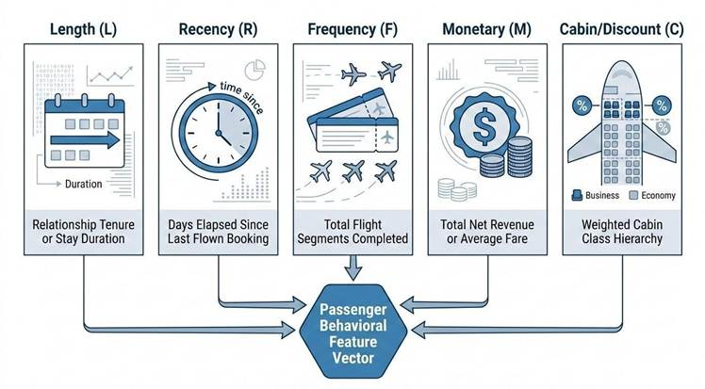

Figure 2.1: The LRFMC Feature Engineering Framework for Aviation Passenger Segmentation.

2.1.4. Principles of Unsupervised Learning
Unsupervised machine learning is commonly used to discover potential groupings within high-dimensional, unlabeled datasets. However, critical differences exist between datasets containing discrete, partitionable clusters and those exhibiting a continuous behavioral spectrum. If the dataset forms a continuum, the traditional partition distance metrics often result in a curve that lacks a sharp 'elbow' or clear inflection point. In such instances, low separation scores (e.g., silhouette scores below 0.381) indicate a lack of naturally isolated densities. Consequently, a hybrid approach—such as a business-rule waterfall supported by Latent Class Analysis (LCA)—is necessary to impose actionable commercial structure on these smooth behavioral distributions (Campello et al., 2015; McInnes et al., 2017).
In evaluating data visualization tools, Jha et al. (2020) highlight that organizations frequently experience operational inefficiencies when relying on static spreadsheets or disconnected tools. Their qualitative findings show that transitioning to interactive Business Intelligence (BI) platforms, such as Microsoft Power BI, significantly accelerates analytics capability by establishing ‘single source of truth' across international business units. For high-volume aviation datasets, disaggregating customer-level segment labels back to individual flight coupons and serving them via star-schema Parquet exports in Power BI aligns directly with Jha et al.’s framework for organizational technology adoption.
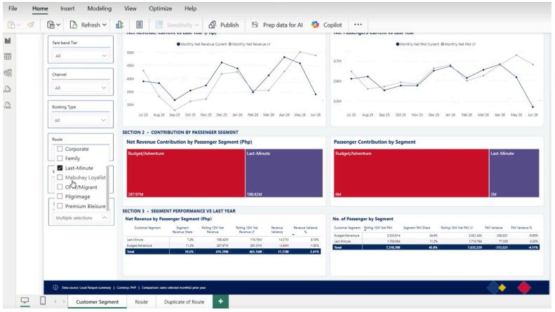

Figure 2.2: Executive Dashboard Illustration Showing Sales Revenue per Market Segment.

2.2. Methodological Review of Clustering Algorithms

2.2.1.Partitioning & Centroid-Based Algorithms (K-Means & MiniBatchKMeans)
Partitioning algorithms, such as K Means, divide a dataset of N records into k distinct, non overlapping clusters by minimizing the Within Cluster Sum of Squares (WCSS):

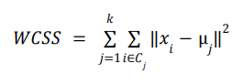

Centroid-based algorithms like K-Means offer high computational efficiency O(N), making them well-suited for multi-million-row transactional extracts. However, these methods operate under strict mathematical assumptions of isotropic, spherical cluster geometries of equal size. They are highly sensitive to initial centroid placement and the presence of extreme outliers. Furthermore, K-Means forces every record into a cluster membership, which often pollutes the resulting groups by pulling borderline records from a behavioral continuum into artificial centroids, thereby reducing the commercial precision of the resulting personas.

2.2.2. Density-Based Clustering (HDBSCAN)
Density-based algorithms group data points that reside in closely packed feature regions, identifying low density boundary points as noise. HDBSCAN (Hierarchical Density Based Spatial Clustering of Applications with Noise) extends traditional DBSCAN by converting fixed radius distance thresholds into a dynamic hierarchical tree (Campello et al., 2015; McInnes et al., 2017).

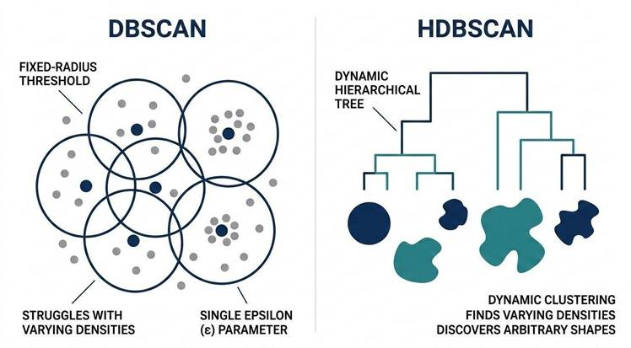

Figure 2.3: Comparative Analysis of Density Based Clustering: DBSCAN Fixed Radius vs. HDBSCAN Hierarchical Tree Dynamics.

2.2.3. Probabilistic & Latent Variable Models (GMM & Latent Class Analysis)
Rather than forcing hard boundaries, probabilistic methods model observed transactions as mixture distributions. Gaussian Mixture Models (GMM) assign soft probability vectors to capture overlapping traveler behaviors, while Latent Class Analysis (LCA) evaluates class-conditional probabilities on categorical features to separate large parent segments into discrete subtypes (Campello et al., 2015; McInnes et al., 2017).

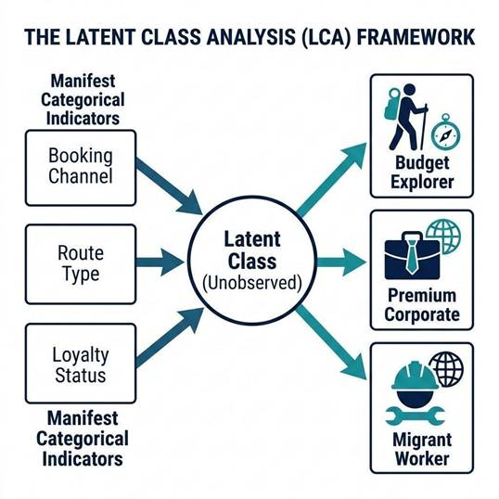

Figure 2.4: The Latent Class Analysis (LCA) Framework: Mapping Observed Behaviors to Discrete Latent Personas.

2.2.4. Rule Waterfalls & Negative Learning Architectures
In real world enterprise deployments, purely unsupervised models often fail to align with commercial logic. A priority rule waterfall applies a deterministic sequence of business logic rules where the highest priority commercial rule assigns the segment label. For instance, if a passenger books in a Business cabin, the system immediately assigns the "Corporate" label, effectively bypassing lower-priority price-based or volume-based rules that might otherwise apply.To strengthen rule waterfalls, Negative Learning (Impossibility Rules) is applied prior to classification. Impossibility rules run across the dataset to rule out invalid

candidate segments (e.g., "Booked more than 60 days in advance in Economy without loyalty status cannot be Corporate"), thereby shrinking the decision space before final assignment (Campello et al., 2015; McInnes et al., 2017; Wei et al., 2010).

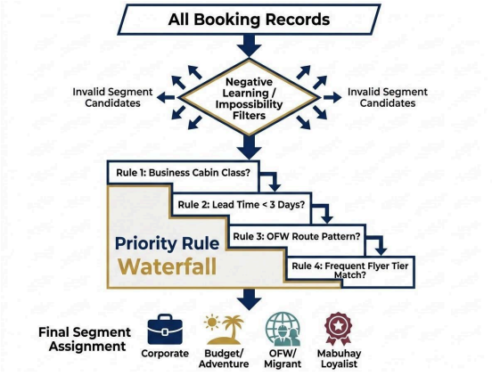
Figure 2.5: The Hybrid Classification Architecture: Negative Learning Impossibility Filters and Priority Rule Waterfalls.

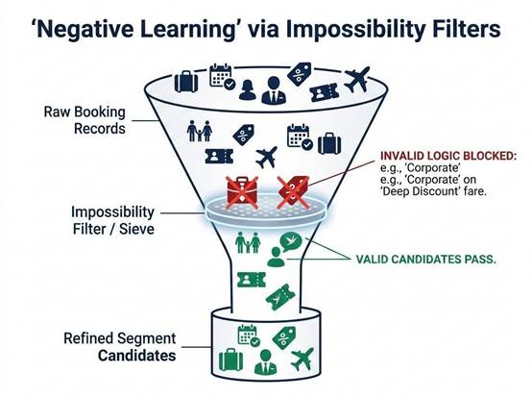

Figure 2.6: Conceptual Framework of Negative Learning: Using Impossibility Filters to Refine Segmentation.

2.2.5. Mathematical Evaluation Metrics
The following quantitative metrics were used to evaluate the performance of the clustering algorithms and validate the integrity of the resulting behavioral segments.
Silhouette Score : Measures cluster cohesion versus separation. This was used because it provides a quantitative assessment of how tightly points are matched to their assigned cluster relative to neighboring clusters. Its relevance is critical to this study: low silhouette scores empirically validate that the booking data lacks naturally isolated densities and instead forms a continuous behavioral spectrum. As a result, this metric justifies the need of our hybrid semi-supervised framework, proving that purely unsupervised clustering algorithms are insufficient for defining actionable commercial boundaries in this dataset.

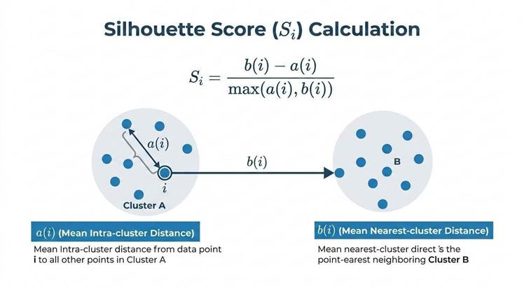
Figure 2.7: Figure 2.7: Visual interpretation of the Silhouette Score (ranging from -1 to +1), illustrating the relationship between mean intra-cluster distance (a) and nearest cluster separation (b)

Davies Bouldin Index (DB) & Calinski Harabasz Index (CH): DB evaluates the ratio of within cluster scatter to between cluster separation (lower is better), while CH measures the ratio of between cluster dispersion to within cluster dispersion (higher is better).

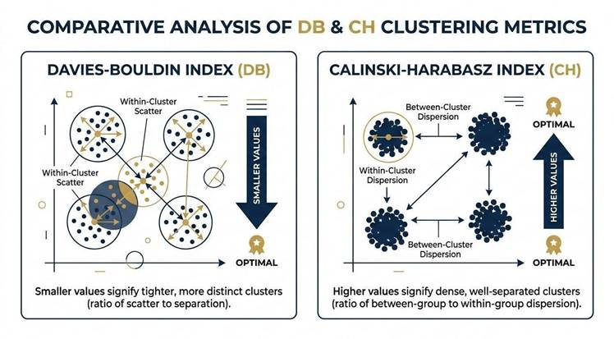
Figure 2.8: Comparative Visual Framework for Clustering Validation: The Davies Bouldin Index (Lower is Better) vs. The Calinski Harabasz Index (Higher is Better).
Standard evaluation metrics treat all classification errors equally. However, in airline operations, misclassifying a high-yield Corporate traveler as a Budget Leisure passenger causes the carrier to needlessly offer promotional fares to a premium customer, resulting in severe revenue dilution. Conversely, the opposite mistake—such as providing a Budget Leisure traveler with Corporate perks—incurs only the minimal cost of an unearned benefit. To reflect these financial trade-offs, the evaluation framework applies an asymmetric cost penalty function, co-designed with Philippine Airlines revenue management experts:
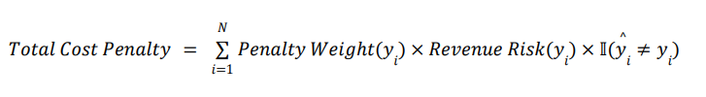
To illustrate further, refer to Figure 2.9 where the evaluation framework incorporates an asymmetric cost penalty matrix co-designed with Philippine Airlines revenue management experts.

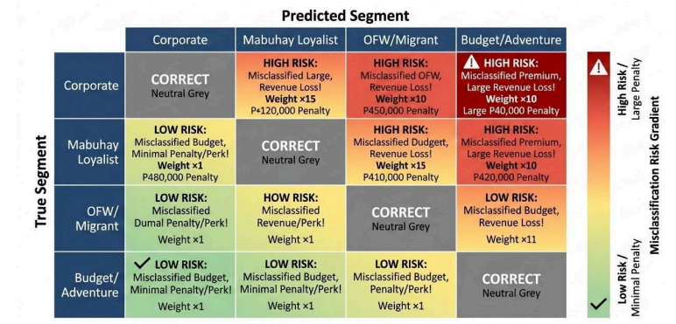
Figure 2.9: Visualization of the Commercial Asymmetric Cost Penalty Matrix: Quantifying Financial Risk in Segment Misclassification.

2.3. Recent Studies in Aviation Marketing Strategy

2.3.1. Competitive Airline Dynamics in Southeast Asia
The Southeast Asian aviation landscape is characterized by intense competition between Full Service Carriers (FSCs) and Low Cost Carriers (LCCs like Cebu Pacific and AirAsia). LCCs aggressively target the price sensitive domestic and regional routes through low-base fares and unbundled services. To maintain market share and brand equity, FSCs like Philippine Airlines must leverage data-driven segmentation to personalize service offerings, optimize inventory allocation, and protect premium passenger yields (McInnes et al., 2017; Wei et al., 2010).

2.3.2. Add-on Revenue Optimization & Personalization
Aviation marketing research emphasizes that add-on services, such as prebooked baggage, seat selection, lounge access, inflight Wi-Fi, and priority check in,drive significant airline profit margins. Granular passenger segmentation enables dynamic upselling by matching add-on service bundles to specific traveler intent (e.g., offering extra baggage allowances to migrant workers or lounge access to premium bleisure travelers)

2.3.3. Key Aviation Passenger Segments
Literature identifies several core market personas that govern airline commercial operations. Table 2.1 outlines the consolidated passenger personas derived from aviation literature, mapped alongside domain-specific operational definitions and the corresponding commercial priority weights established for Philippine network operations

Table 2.1: Key Aviation Passenger Segments and Commercial Priority

Segment | Primary Behavioral Attributes | Commercial Priority
Corporate | Short lead times (≤3 days), business cabin, GDS channels, weekday flights, high yield | Highest (×10 Penalty Weight)
Mabuhay Loyalist | High flight frequency, active Mabuhay Miles tier, award redemptions, high CLV | Very High (×8 Penalty Weight)
OFW /  Migrant | Long haul Middle East corridors, sea crew/agency channels, high baggage needs, TTA point of sale | High (×5 Penalty Weight)
Premium Bleisure | Business/Premium Economy cabin, ASEAN routes, weekend travel, high | Moderate (×4 Penalty Weight)

 | ancillary spend
Pilgrimage | Group travel bookings, Middle East/Gulf destinations, seasonal peak travel | Moderate (×3 Penalty Weight)
Balikbayan  / VFR | Visiting Friends & Relatives, long haul foreign origin to domestic beyonds, group travel | Low (×2 Penalty Weight)
Family | Multi-passenger group bookings (is_group = True), holiday seasons, Economy cabin | Low (×2 Penalty Weight)
Digital Nomad | Solo travelers, ASEAN/regional corridors, direct Web/App booking, long lead times | Low (×2 Penalty Weight)
Last MinuteLast Minute | 0–3 day advance booking horizon, Economy Flex fares, urgent travel intent | Baseline (×1 Penalty Weight)
Budget / Adventure | Deep-discount farebrands (Saver/Supersaver), third-party OTAs, highly price-sensitive | Baseline (×1 Penalty Weight)

2.4. Synthesis and Research Gap

2.4.1. Synthesis of Literature
The literature establishes that transitioning from static, rule based demographic tagging to advanced machine learning segmentation allows airlines to optimize pricing, personalize marketing, and increase Customer Lifetime Value (CLV) (McInnes et al., 2017; Wei et al., 2010). However, successful enterprise implementation requires balancing statistical algorithm performance with domain driven commercial interpretability (Campello et al., 2015; McInnes et al., 2017).

2.4.2. Identification of the Research Gap
Despite extensive global research in aviation machine learning, three critical gaps remain in existing literature:

1. Lack of research tailored to the Philippine Aviation Context: Existing airline clustering studies focus heavily on Western or European network carriers. These models fail to represent the unique socioeconomic factors of the Philippine market specifically the massive volume of Overseas Filipino Workers (OFWs) operating on contract driven deployment corridors and the seasonal surges of Balikbayan travelers during Christmas and Easter holidays (Campello et al., 2015; McInnes et al., 2017; Wei et al., 2010).
2. Assumption of Discrete Density Clusters vs. Real Data Continuum: Academic literature often assumes that passenger datasets naturally contain discrete, spherical clusters easily separable by algorithms like K Means or HDBSCAN. In practice, real world multimillion row booking extracts form a continuous behavioral spectrum without clear natural gaps. This is evidenced by monotonic Bayesian Information Criterion (BIC) curves without sharp elbows and maximum silhouette separation scores below 0.381, justifying the use of hybrid rule waterfalls to define actionable business boundaries where natural ones are absent.
3. Absence of Penalty Weighted Evaluation in Airline Clustering: Standard clustering literature evaluates models using unweighted accuracy or silhouette scores. There is a lack of empirical frameworks that incorporate asymmetric cost penalty matrices to explicitly measure financial risk (pesos at risk) when misclassifying high stakes passenger segments (Campello et al., 2015; McInnes et al., 2017).
In addition, a critical gap in extant aviation literature is the heavy focus on algorithmic performance metrics (e.g., Silhouette scores or Davies Bouldin indices) without addressing how non technical stakeholders interact with model outputs. As Jha et al. (2020) demonstrated, intra organizational power dynamics and functional divides often stall analytics implementation unless model outputs are presented through intuitive executive dashboards. This study addresses this gap by presenting an end to end pipeline that connects deterministic rule waterfalls and Latent Class Analysis (LCA) directly to an executive Power BI dashboard tailored for Philippine Airlines' commercial teams.

2.4.3. Contribution of This Study
This capstone project bridges these research gaps by designing and deploying a localized, hybrid segmentation framework specifically tailored to Philippine Airlines (McInnes et al., 2017; Wei et al., 2010). By combining a deterministic priority rule waterfall, negative learning impossibility filters, Latent Class Analysis (LCA) subsegment refinement, and asymmetric cost penalty matrix validation across a 38.1 million coupon extract, this study provides a defensible, production ready methodology for aviation market segmentation (Campello et al., 2015; McInnes et al., 2017). By moving beyond academic mathematical validation toward the operationalization of model outputs into decision-support tools, this study addresses the critical disconnect between model metrics and commercial delivery, providing a defensible, production-ready methodology for aviation market segmentation.

CHAPTER 3: METHODOLOGY

3.1. Analytical Framework and Data Architecture

The architectural design of this segmentation project goes beyond standard supervised or unsupervised frameworks. To resolve the data imbalance which is inherent in commercial aviation records, a hybrid pipeline was implemented that applies a robust semisupervised framework. (see Figure 3.1)

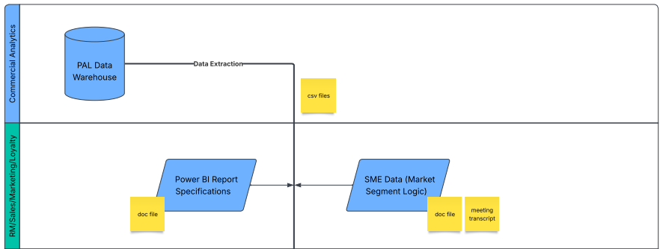
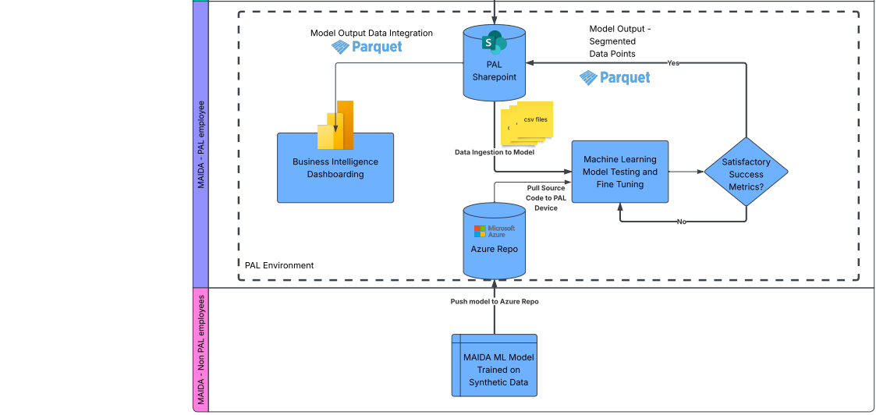
Figure 3.1: Data Architecture

The data architecture initiates with data extraction from PAL’s Enterprise Data Warehouse (EDW) and SharePoint into CSV and Parquet files. From a dedicated PAL machine, the pipeline cleans and flags important fields within the ticket origin destination dataset, grouping the data into distinct ticketed bookings and rolling them up to the booking level (see Figure 3.2 for the detailed analytical framework). Using deterministic business rules guided by subject matter expert (SME) qualitative constraints, an algorithm is made to tag incoming passenger data in a rule waterfall before machine learning is applied to flesh out hidden segments within large groups. The methodology uses latent class analysis (LCA) to extract boundaries and create subsegments based on statistical traits. Finally, the model output ungroups the data back to the coupon level, generating a consolidated Parquet file that feeds directly into a static Power BI environment for commercial dashboarding.

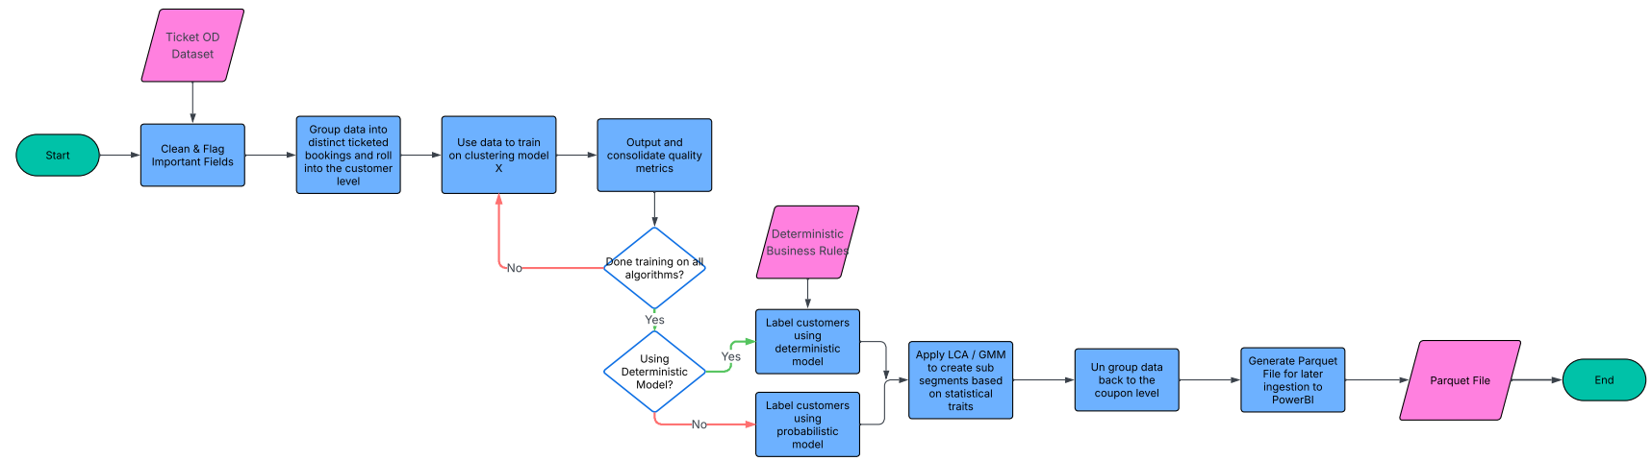
Figure 3.2: Analytical Framework

3.2. Data Collection and Passenger Data Sources

The primary data source for this model is Philippine Airlines' (PAL) ticketed origin destination (O&D) data set, which encompasses 38.1 million flight legs with departure dates spanning from May 2024 to May 2027. Within the architecture, this raw data is aggregated into 22.9 million distinct bookings; the primary unit of analysis represents a single purchase decision which corresponds to 13.4 million distinct customers.
The data is completely stripped of personally identifiable information and lacks direct CRM integrations. However, a unique customer key enables the tracking of repeat behavior, tenure, and loyalty over continuous spans of up to 3.2 years. Key behavioral attributes captured include booking lead times, routing combinations, and a clean farebrand value ladder that standardizes every booking class from Economy Supersaver up to Business Flex.

Table 3.1: List of Features

Column Name | Description
[DateOfIssuance] | The date the ticket was issued
[POO] | The airport point of origin of a ticketed itinerary
[CountryCodeOfIssue] | The country code where the ticket was issued
[CouponNumber] | The coupon number of a ticket
[CurrentCouponStatus] | Tags tickets whether F (flown) or (O) open
[BookingClass] | The booking class used when the ticket was flown
[SoldBookingClass] | The booking class used when the ticket was issued
[SoldOperatingCabinClass] | The cabin class used when the ticket was issued
[TripOD] | The directional origin-destination pair that includes both OAL-operated and PR-operated sectors
[OnlineOD] | The directional origin-destination pair that includes only PR-operated sectors
[Sector] | The directional flight pair of a route
[DepartureDate] | The departure date of a ticket
[DaysBeforeMonthEnd] | The number of days prior to the end of the travel month
[OperatingCarrierCode] | The operating carrier of a ticket's flight
[OperatingFlightNumber] | The operating flight number of a ticket's flight
[DepartureDateTime] | The departure date and time of a ticket
[ArrivalDateTime] | The arrival date and time of a ticket
[OperatingCabinClass] | The cabin class used when the ticket was flown
[TripOD_DepartureDate] | The departure date pairs for a Trip OD Path
[TripOD_Path] | The sectors a passenger used for a Trip OD
[TripOD_Coupons] | The coupon number pairs for a Trip OD Path
[TripOD_FlightSequence] | The operating flight number pairs for a Trip OD Path
[TripOD_CouponStatus] | The coupon status pairs for a Trip OD Path
[TripOD_OperatingCabinClass] | The flown cabin class pairs for a Trip OD Path
[TripOD_BookingClass] | The flown booking class pairs for a Trip OD Path
[OnlineOD_DepartureDate] | The departure date pairs for a Online OD Path
[OnlineOD_Path] | The sectors a passenger used for a Online OD
[OnlineOD_Coupons] | The coupon number pairs for a Online OD Path
[OnlineOD_FlightSequence] | The operating flight number pairs for a Online OD Path
[OnlineOD_CouponStatus] | The coupon status pairs for a Online OD Path
[OnlineOD_OperatingCabinClass] | The flown cabin class pairs for a Online OD Path
[OnlineOD_BookingClass] | The flown booking class pairs for a Online OD Path
[is_nonstop] | Nonstop indicator
[PaxCount] | The sectoral passenger count of a ticket (1 sector = 1 pax count)
[NetRevenue] | Total revenues based on base fare and YQ surcharge of a ticket
[NetFare] | Total base fare of a ticket
[Booking Type] | Group/Individual booking indicator of a PNR
[Age] | Computed as the date of birth of a passenger over the ticket issuance date
[Unique Identifier] | Unique customer identifier
[Channel] | The sales channel where the ticket was issued
[PurchaseLeadTime] | Number of days before passenger's trip (Flight Date - DateofIssuance)
[Farebrand] | Unique farebrands with different ancillaries and benefits

3.3. Data Preprocessing and Exploratory Data Analysis

3.3.1. Dataset Overview and Quality Assessment
The primary dataset consists of 38,116,260 raw flight coupons issued for travel between May 2024 and May 2027. These records represent 13,447,672 distinct customers (identified via a hashed UniqueID) and translate to 22,924,577 unique bookings. Overall data quality is remarkably high, with near zero null values across core operational fields. Cleaning procedures were minimal; exactly one row was removed due to a corrupted SoldOperatingCabinClass value, and a streaming approximate distinct check confirmed zero exact duplicates on the natural coupon key, resulting in a final processed dataset of 38,116,259 rows.
Importantly, demographic and explicit loyalty signals were found to be too sparse to serve as the foundation for segmentation. Age data is missing for 57% of the records, and award tickets (Mabuhay Miles) account for only 0.024% of the total coupons. Consequently, the segmentation methodology necessarily relies on behavioral features such as booking lead time, route geography, fare tier, channel selection, and party size, rather than demographic profiles.
A defining constraint during the exploratory phase was the requirement for anonymous segmentation. Operating without personally identifiable information (PII) such as passenger names or loyalty IDs linked directly to the demographic data, the analysis was compelled to derive trip purpose and commercial value strictly from the behavioral and transactional signals embedded within the booking itself. This required the EDA to transition from looking for known identifiers to mapping empirical travel patterns, treating the data not as a roster of known individuals, but as a continuous spectrum of behavioral signatures.

3.3.2. Data Preprocessing and Grain Definition
To ensure the integrity of the behavioral clustering, specific operational populations that distort typical customer patterns were isolated and flagged. Preprocessing steps included:
- Exclusion of Non Revenue Passengers: Staff and complimentary tickets, representing 0.082% of coupons (12,306 all non revenue customers), were flagged and entirely excluded from feature engineering.
- Handling of Refunds and Reissues: Negative revenue rows (refunds), accounting for 0.101% of the data, were flagged and excluded from revenue summations. Instances of negative lead times resulting from ticket reissues (0.005%) were clamped and flagged.
- Establishing the Booking Grain: The foundational grain for analysis was defined as (customer_id, issue_date). This assumption cleanly reconstructs journey types, capturing 42.7% as round-trips and yielding an average of 1.66 coupons per booking.

3.3.3. Exploratory Data Analysis (EDA)
The exploratory data analysis reveals three clear patterns across Philippine Airlines' passenger records. First, most customers fly only occasionally: the median customer has just two coupons, and 95% have fewer than eight. Second, network traffic is heavily domestic, with local routes making up 57.7% of all bookings. Third, the customer base buys mostly economy tickets, with 95.2% of flight coupons in Economy and 88.1% in the three lowest economy fare tiers. A central takeaway from the exploratory analysis is that booking volume and revenue move in opposite directions across customer groups.
Prior confirmation with PAL SME’s, the research began with ten target segments based on aviation literature and PAL SME requirements: Corporate, Mabuhay Loyalist, OFW/Migrant, Balikbayan/VFR, Family, Pilgrimage, Premium Bleisure, Budget/Adventure, Last-Minute, and Digital Nomad. In the model pipeline, these segments are defined through a mix of expert rules, data patterns, and hybrid logic:
1. Mabuhay Loyalist (SME Rule): Defined by airline experts to track frequent flyer members. Because the dataset lacks loyalty tier columns, this rule relies strictly on award redemption tickets (is_award = True), identifying explicit award travel (0.03% of bookings).
2. Corporate (Hybrid Rule): Captures high-yield business travelers using corporate agency channels (TMC/GDS) or business fares booked within 7 days of departure.
3. Pilgrimage (SME Rule): Identifies religious travel to Saudi Arabia based on destination airport codes for Jeddah (JED) and Medina (MED).
4. OFW / Migrant (SME Rule): Identifies overseas contract workers using the Sea Crew agency channel or foreign-issued, one-way international economy tickets in fare tiers 1 through 4.
5. Balikbayan / VFR (SME Rule): Identifies overseas Filipinos visiting home using foreign-issued, round-trip international economy tickets in fare tiers 1 through 4.
6. Premium Bleisure (Hybrid Rule): Captures high-value leisure and business passengers flying international routes in Business Class or Premium Economy.
7. Family (SME Rule): Identifies leisure groups using group booking flags (is_group = True) or multi-passenger booking records.
8. Last-Minute (Data Rule): Identifies urgent, individual bookings made 3 days or fewer before departure across non-corporate channels.
9. Budget / Adventure (Data Rule): The baseline domestic rule, capturing all remaining domestic economy bookings not matched by earlier rules.
10. Digital Nomad (SME Hypothesis): Conceived as solo remote workers staying 31 or more nights. Without a specific remote-work indicator, this segment could not be isolated in the deterministic rules; in practice, 66.3% of long-stay round trips fall into Balikbayan/VFR and 10.7% into Unassigned.
11. Unassigned (Data Residue): A distinct 9.60% group of bookings (2.19 million bookings) that did not match any of the ten rule criteria. It consists mostly of Philippine-issued, outbound international economy travel and is kept separate for future commercial policy definition.
A set of 10 SME designed constraints were constructed with analysts from PAL, as a pre-requisite to the first model run. Table 3.2 describes the classification origin whether it was purely an SME rule, hard data rule or hybrid of the two. Penalty weights were also assigned based on SME priority of the identified segments. The rule waterfall was constructed and used to further visualize, after tagging the entire data set, whether the constraints made were logically sound for the PAL SME’s. Given that these are the parameters for the rule waterfall in the initial run, it was decided that these are not necessarily final and are subject to change during the model training and testing phase.
Table 3.2: Exploratory Passenger Segment Booking Share and Revenue Contribution Summary

Segment Name | Classification Origin | Booking Share (%) | Net Revenue Share (%) | Average Revenue ($) | Penalty Weight
Budget / Adventure | Data Rule | 39.40% | 10.75% | $74 | x1
OFW / Migrant | SME Rule | 17.10% | 19.68% | $312 | x5
Last-Minute | Data Rule | 12.90% | 6.52% | $137 | x1
Balikbayan / VFR | SME Rule | 12.70% | 28.95% | $618 | x2
Unassigned | Data Residue | 9.60% | 12.75% | $360 | --
Corporate | Hybrid Rule | 4.40% | 8.00% | $493 | x10
Premium Bleisure | Hybrid Rule | 2.10% | 11.65% | $1,504 | x4
Family | SME Rule | 1.60% | 1.39% | $235 | x2
Pilgrimage | SME Rule | 0.20% | 0.30% | $404 | x3
Mabuhay Loyalist | SME Rule | 0.03% | 0.01% | $113 | x8
Digital Nomad | SME Hypothesis | -- | -- | -- | x2
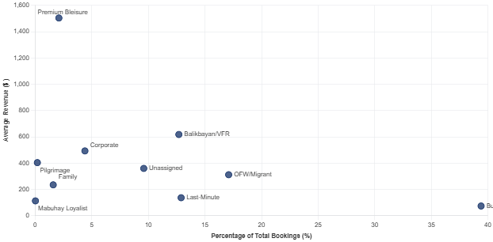
Figure 3.3: Segment Booking Volume Share versus Net Revenue Share using hypothesized segments

As shown in Figure 3.3 and Table 3.2, high volume does not equal high revenue in the PAL network. Budget/Adventure accounts for 39.40% of all bookings (9.04 million bookings) but generates only 10.75% of total net revenue, bringing in an average of $74 per booking. On the other hand, long haul travelers drive most of the airline's earnings. Balikbayan/VFR generates the largest share of network revenue at 28.95% on 12.70% of bookings (2.91 million bookings), averaging $618 per booking. OFW/Migrant follows with 19.68% of net revenue from 17.10% of bookings (3.92 million bookings), averaging $312 per booking.
The strongest revenue per passenger comes from Premium Bleisure. Although it represents only 2.10% of bookings (481,666 bookings), it contributes 11.65% of net revenue, earning $1,504 per booking,roughly twenty times the revenue of a Budget/Adventure booking. Corporate travelers generate 8.00% of revenue from 4.40% of bookings ($493 average), while Last-Minute individual bookings account for 12.90% of volume and 6.52% of revenue ($137 average). An unassigned segment of 9.60% of bookings accounts for 12.75% of revenue ($360 average), representing Philippine issued outbound international economy passengers not covered by specific rules. Smaller segments like Family group travel (1.60% volume, 1.39% revenue, $235 average), Pilgrimage travel (0.20% volume, 0.30% revenue, $404 average), and Mabuhay Loyalist award redemptions (0.03% volume, 0.01% revenue, $113 average) complete the passenger base.

To understand how these commercial personas distribute geographically across the network, booking volume was evaluated across major route regions using a stacked compositional structure.
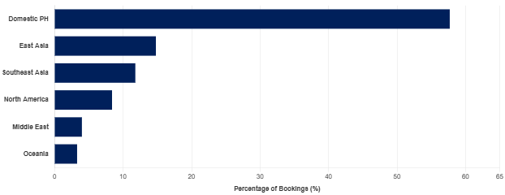
Figure 3.4: Route Region Volume Distribution Stacked by Passenger Segment Composition
Figure 3.4 shows the passenger segment mix within each route region as a 100% stacked bar chart. Domestic Philippine routes make up 57.7% of all bookings, consisting mainly of Budget/Adventure and Last-Minute travelers. Transpacific North America routes account for 8.4% of bookings and are dominated by high yield Balikbayan/VFR and Premium Bleisure passengers. Middle East routes (4.0% of bookings) are shaped by OFW/Migrant workers and seasonal Pilgrimage flights to Jeddah and Medina. Regional corridors in East Asia (14.8%) and Southeast Asia (11.8%) show a mix of Corporate, Premium Bleisure, Unassigned outbound travelers, and budget leisure passengers. Oceania routes (3.3%) capture holiday traffic between Australia/New Zealand and the Philippines. Notably, 38.4% of all coupons were issued outside the Philippines, highlighting the importance of overseas points of sale for labor routes.
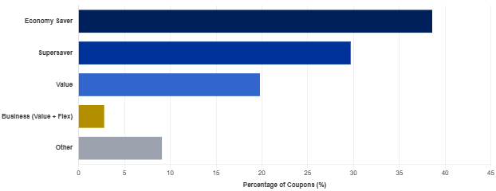
Figure 3.5: Volume Distribution Across Farebrands
Cabin and fare distributions confirm that PAL operates primarily as an economy carrier. As shown in Figure 3.5, 95.2% of flight coupons are in Economy (Y). Within Economy, bookings are clustered in three entry level brands: Economy Saver (38.6%), Supersaver (29.7%), and Value (19.8%). Business Class (2.9%) and Premium Economy (2.8%) together make up less than 6% of the network. Because most travelers buy similar low cost economy fares, fare tier alone cannot distinguish different types of travelers.
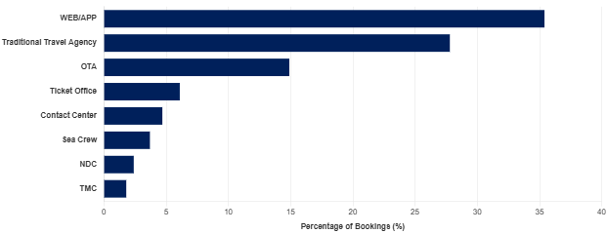
Figure 3.6: Volume Distribution Across Channels

Ticketing channels help separate passenger groups and identify commercial buyer types. Direct web and mobile bookings lead with 35.4%, followed by Traditional Travel Agencies at 27.8% and Online Travel Agencies at 14.9%. Ticket Offices account for 6.1%, Contact Centers for 4.7%, and corporate travel channels (TMC and NDC) for 4.2%. The data also isolates a specialized Sea Crew agency channel representing 3.7% of coupons (1.41 million coupons). This maritime workforce, alongside ticket consolidators, creates a heavy tail of about 5,000 customers holding over 100 coupons each, reflecting corporate purchasing rather than regular passenger habits.
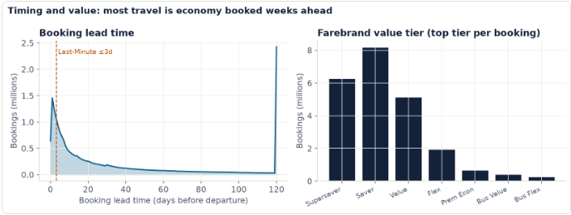
Figure 3.7: Booking Lead Time and Fare Brand Behavior
As illustrated in Figure 3.7, booking lead times and fare brand selections show smooth, continuous distributions rather than isolated clusters. The median lead time is 25 days (mean of 53.2 days), with 13.3% of passengers booking within 3 days of departure.
While these smooth visual curves hint at a behavioral continuum, exploratory charts alone do not prove the absence of natural clusters. The mathematical validation for a continuous behavioral spectrum comes from the unsupervised clustering benchmarks in Sections 3.5 and 4.1. Across ten clustering algorithms, the highest Gower Silhouette score reached only 0.381,well below the 0.50 threshold for distinct clusters(Kaufman & Rousseeuw, 1990) , the Davies Bouldin index remained at 0.961, and Density Based Clustering Validation (DBCV) collapsed on categorical features (Gower, 1971) . Furthermore, Bayesian Information Criterion (BIC) curves fell steadily without an elbow, and pairwise agreement between different algorithm families averaged just 0.41 ARI at k = 10. These cluster statistics confirm that passenger behavior forms a smooth continuum, justifying the use of a deterministic rule waterfall backed by machine learning monitoring.

3.4. Clustering Model Development and Parameter Tuning

Because standard clustering algorithms result in qualitative rules with less precision, the primary segment labeller in the pipeline relies on a transparent, prioritized rule waterfall. This deterministic model maps bookings into one of 10 commercially meaningful segments (e.g., Corporate, OFW/Migrant, Budget/Adventure) or an explicit 'Unassigned' bucket for records representing a genuine, overarching travel pattern. The rules are anchored by Subject Matter Expert (SME) constraints, utilizing both hard statements of impossibility and soft probabilistic tendencies.
Machine learning plays a vital supporting role through Latent Class Analysis (LCA) (Linzer & Lewis, 2011) . LCA functions as the refinement layer, stepping in to evaluate oversized segments and extract actionable subtypes based on latent statistical traits. For example, the massive Budget/Adventure segment is mathematically divided into four subsegments, such as advance purchase round trips and bargain one way supersavers, adding profound operational color beneath the headline segments.

3.5. Model Evaluation and Performance Metrics

Model validation in this pipeline is strictly segregated into three distinct metric groups, to ensure commercial viability and guard against model drift.
- Algorithm Selection: Evaluates which algorithm produces the optimal clusters during the model design phase. Because density based clustering actively misleads standard metrics, the study utilizes Density Based Clustering Validation (DBCV) alongside Silhouette, Davies Bouldin, Calinski Harabasz, and Noise percentage to dictate algorithmic superiority. Other probabilistic metrics are also indicated in Table 3.3.
Table 3.3: Target Metrics Used in this Study
Metric | Definition | Target
Silhouette Score | A higher score indicates that data points are tightly matched to their own cluster and poorly matched to others.  range: [-1, 1 ] | > 0.50 (Ideal)  > 0.25 (Acceptable for weak structure)  (Kaufman & Rousseeuw, 1990)
Davies Bouldin Index | Measures compactness of clusters where centroids are used as reference points. A lower score means clusters are more defined  range: [ 0, infinity ] | < 0.50 (Strong)  < 1.00 (Acceptable)  (Davies & Bouldin, 1979)
Calinski Harabasz Index | Ratio between cluster separation divided by compactness. A higher score means clusters are distinct  range: [ 0, infinity ] | no universally acceptable cut-off value in statistical literature. It is a metric used purely for direct model comparison  (Calinski & Harabasz, 1974)
Noise (%) | Tracks % of points the model could not place into a cluster.  range: [0,1] | < 10.0%  (McInnes et al., 2017)
Bayesian Information Criterion (BIC) | Penalized log likelihood used to compare candidate class solutions, where lower is better | No fixed cut off, this is used to detect the “elbow”  (Nylund & Asparouhov, 2007)
Adjusted Rand Index (ARI) | Cluster stability or agreement across resamples and/or refreshes | > 0.25 (minimum acceptable), > 0.50 (ideal)  (Hubert & Arabie, 1985)
Smallest Class Proportion | Size of the smallest latent sub class as a percentage of the total | ≥ 1–5% of sample  (Weller et al., 2020)
Silhouette Score (on posterior probability vectors) | Same concept as the DBCV metric, but computed on class membership probability space. | > 0.50 (ideal), > 0.25 (acceptable)  (Rousseeuw, 1987; Kaufman & Rousseeuw, 1990)

- Label Validation: Validates the final business labels during every training iteration. The methodology strictly tracks Per Segment Recall (with a threshold of ≥ 91% for Corporate/OFW priority) and Weighted Cost/Record using an asymmetric penalty matrix to measure direct business impact.
- Production Monitoring: Tracks spatial and behavioral shifts in the real world (Siddiqi, 2006). During every monthly refresh, the study tracks the Population Stability Index (PSI) to trigger a retrain if it exceeds 0.25, and the Adjusted Rand Index (ARI) to investigate cross refresh stability if it drops below 0.75 (Hubert & Arabie, 1985) .
This rigorous, multi-tiered evaluation ensures that segments remain stable over time and that the commercial realities of Philippine Airlines are mathematically safeguarded.

CHAPTER 4: RESULTS, ANALYSIS, AND DISCUSSION

4.1. Clustering Results
Our study's most empirical result is that PAL booking base does not contain natural, well-separated clusters at the top level. Rather than attributing this to methodological failure, we confirmed this lack of structure across six independent algorithmic families and validated it with a planted-segment power analysis.

4.1.1 Central Finding: Clusters Follow a Continuum
The data is found to be one massive, overlapping continuum of passenger behaviors rather than distinct, separate buckets. Different types of clustering models were also used. All are pointing to the continuum conclusion and the evidence is summarized on below items:
Evidence 1: Model Selection
LCA on a 60,000 booking sample resulted in a BIC that continuously fell. Ideally, it will flatten and create an elbow but in our case, it is still falling at k=9. Our model just kept slicing the data infinitely.
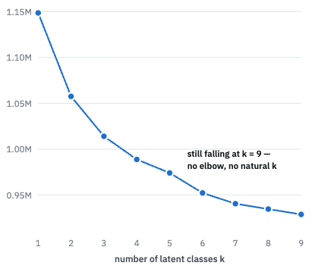
Figure 4.1: Evidence 2 Separation Ceiling
In order to rule out the wrong algorithm for this data shape, we have also tried different types of clustering models. We ran the data through ten different clustering algorithms and measure Gower’s Silhouette. The absolute highest score a model could get was 0.381 (at $k=3$). By standard statistical rules, a score of 0.381 means the structure is weak but real.

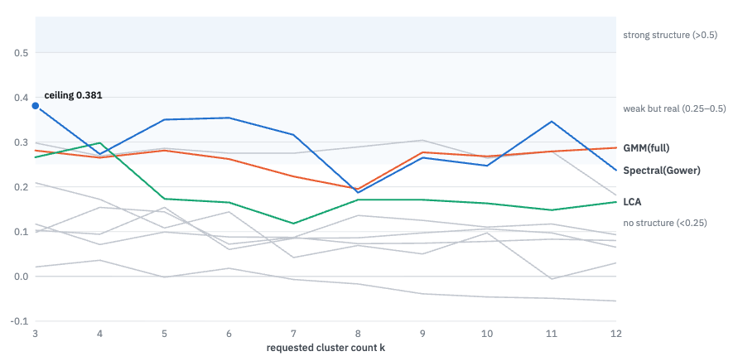
Figure 4.2: Evidence 3 Algorithm Disagreement
We have this initial hypothesis that if we are trying to recover the same latent partitions, somehow, the algorithms would agree. At k=10, the media pairwise Adjusted Rand Index across methods is 0.41. Agreement is only high within algorithmic families, Gaussian mixtures at 0.85 and the Euclidean-centroid trio ranges from 0.68-0.79.
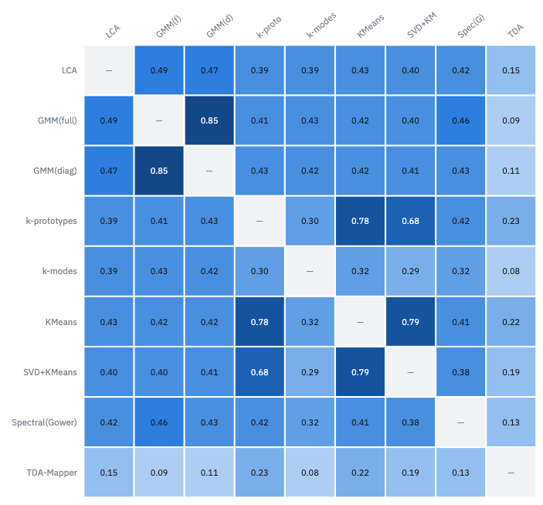
Figure 4.3: Sensitivity Matrix

4.1.2 Algorithm Sensitivity
To test the algorithms' sensitivity, we took perfectly formed, mathematically distinct synthetic segments (fake customer groups) and hid them inside the real, messy PAL booking data. We varied these fake groups by two metrics:
- Size (Prevalence): Ranging from 0.5% - 10% of all bookings
- Distinctness (Mixing Weight $w$): How obviously different the group was from the rest of the data.
We then ran the algorithms on this mixed dataset (at $k=11$). By intuition, we theorized that a fake segment can only be "detected" if the majority of the algorithms can find it. If only one algorithm out of twelve combinations stumbled upon it by chance, we will ignore it. This prevents us from falsely claiming their tools are highly sensitive based on luck. Results are summarized from the table below:
Table 4.1. Detection Threshold Summary
Planted Size | Majority Detection Floor
< 1% | Never detected
2% | Detected from ≈ 0.0.494
5% | Detected from ≈ 0.219
10% | Detected from ≈ 0.130

The null can therefore be stated in bounded and falsifiable form: no segment exists in these features at or above 2% of bookings with distinctness at or above ≈ 0.494. When a planted segment is smaller than 1% of bookings, this could exist undetected.
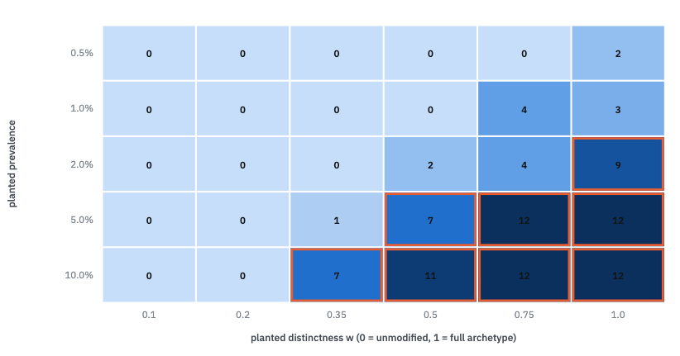
Figure 4.4 Algorithm Sensitivity to Synthetic Customer Groups

4.1.3 Resulting Methodology: Clustering then Refinement

With our analysis pointing out that the data is a continuum and the business requirement of PAL is to have actionable customer groups, we implemented a hybrid solution. Instead of relying on clustering models to define the top-level segments, we have used a deterministic rule waterfall. This system categorizes 22.9 million bookings into 11 concrete business segments, plus one "Unassigned" group. The clustering models were kept only for diagnostic checking and deeper sub-segmentation.

The rules categorizing the customers were not guessed by an algorithm and were co-designed directly by the MAIDA team and PAL revenue managers using 39 specific rules and 57 constraints with multiple iterations and reverts.

Table 4.2. Level 1 Rule Waterfall
Segment | Condition
Mabuhay Loyalist | Award redemption (is_award)
Corporate | Corporate channel (TMC / corporate web portal), or a business-cabin leg booked ≤ 7 days out
Corporate | Round trip with a same-/next-day turnaround (stay ≤ 1 night) on a Flex-or-above fare
Corporate | Round trip booked ≤ 3 days out, stay ≤ 3 nights, with a premium-cabin leg
MICE | Group booking, round trip, booked ≥ 45 days out, 3–7-night stay, no business-cabin leg
Pilgrimage | Destination in the pilgrimage-hub list
OFW/Migrant | Sea-crew booking channel
International Student | International round trip with a 90–150-night stay
OFW/Migrant | Foreign-issued international economy (fare tier ≤ 4), one-way
Balikbayan/VFR | Foreign-issued international economy (fare tier ≤ 4), round trip — excluding premium stays of ≤ 3 nights
Ultra Wealthy Leisure | Premium-cabin round trip booked ≥ 30 days out with a stay of ≥ 7 nights
Premium Bleisure | Any premium-cabin leg on an international itinerary
Outbound International Leisure | Philippine-issued international travel with no premium-cabin leg
Leisure | Domestic travel with no premium-cabin leg
Unassigned | If all rules fail

It was decided that strict business rules must be hard-coded into the pipeline so the analytical code and the business logic cannot drift apart. Features like "Last-Minute" and "Value Band" were removed as mutually exclusive segments and converted into overlapping flags. Because priority rules previously hid overlapping data, making "Last-Minute" a universal flag exposed 50% more short-lead bookings.
The latest version of the business rules added four newly defined segments (Outbound International Leisure and MICE) and deleted three that were either unmeasurable (Digital Nomad) or poorly defined (Family). The single largest improvement was a 74% reduction in the "Unassigned" category and this unassigned volume fell from 9.58% to 2.47% by accurately identifying that 75% of those previously unclassified bookings were actually Filipino-issued international economy travel.

4.2. Analysis and Interpretation of Segments

4.2.1 Resulting Methodology - Clustering then Refinement

Table 4.3. Level 1 Rule Waterfall
Segment | Bookings | Bookings Share | Mean Revenue Per Booking | Share of Revenue
Leisure | 11,595,711 | 50.61% | $80 | 14.95%
OFW/Migrant | 3,907,805 | 17.06% | $312 | 19.64%
Balikbayan/VFR | 2,871,255 | 12.53% | $615 | 28.41%
Outbound International Leisure | 2,182,074 | 9.52% | $398 | 13.98%
Corporate | 1,168,451 | 5.10% | $460 | 8.65%
Unassigned | 566,126 | 2.47% | $177 | 1.61%
Premium Bleisure | 343,309 | 1.50% | $1,188 | 6.57%
Ultra Wealthy Leisure | 157,490 | 0.69% | $1,968 | 4.99%
Pilgrimage | 43,616 | 0.19% | $404 | 0.28%
International Student | 42,153 | 0.18% | $1,159 | 0.79%
MICE | 27,007 | 0.12% | $269 | 0.12%
Mabuhay Loyalist | 6,453 | 0.03% | $113 | 0.01%

Rather than a mysterious group of unknown customers, the "Unassigned" segment is a highly specific mathematical leftover created by the rule waterfall's design. Because standard domestic flights are automatically routed to the Leisure segment, domestic flights can only land in Unassigned if they include a premium cabin. The group is almost entirely (94.5%) domestic premium-cabin travel, with a small sliver of foreign-issued international economy.

It is also a known limitation that PAL has still incomplete data for a loyalty field (Mabuhay) and as such, the MAIDA team can only use a derived feature of awards redemption as a proxy for loyalty. Consequently, this segment makes up a microscopic 0.03% of total bookings and consists entirely of award bookings, making this more of a data availability issue rather than an accurate picture of frequent flyers.

4.2.2 Construct Validity

To prove that the segments are different, the MAIDA team looked at data fields the rules didn't use to create the segments (like passenger age or departure month). If two segments truly represent different types of travelers, their behavior on these unseen data points should look different. We have found out that some unseen/ unused fields were secretly leaking information. For example, age is recorded on 88% of international bookings but less than 1% of domestic ones (a data limitation issue from PAL). As a result, when we used "age" to test if a domestic segment was different from an international one, the model somehow learns and “cheats”, resulting in testing geography again. As a mitigation, we have carefully withheld any anchor that leaked information about the specific boundary being tested, ensuring the test was genuinely independent.
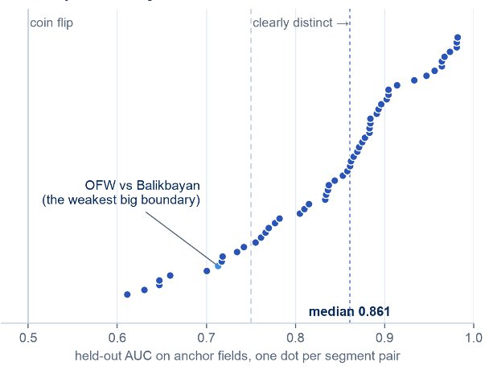
Figure 4.5. Construct Validation
Using the adaptive measure, the results strongly supported the business rules. All 55 possible pairs of segments (e.g., Corporate vs. Leisure, Leisure vs. MICE) were at least weakly distinguishable from each other (scoring an AUC of 0.60). In addition, 44 of the pairs were clearly distinct with AUC $>0.75$ and there are no pairs that are indistinguishable.
For the purposes of transparency, the MAIDA team is highly transparent about their weakest boundary, which separates Overseas Filipino Workers (OFWs/Migrants) from "Balikbayans" (Visiting Friends and Relatives). These two massive groups (representing 30% of all bookings, or $6.8$ million flights) are separated in the rules by only one factor: one-way vs. round-trip tickets. We tried to improve the separation on multiple iteration attempts, the new rules only moved 1.4% of the bookings and didn't improve the mathematical distinguishability. Even though the mathematical boundary is weak, we kept the two segments separate because the airline requires entirely opposite commercial strategies for an OFW versus a Balikbayan traveler. We flagged this as the taxonomy's "most improvable boundary," heavily implying the airline needs better data to tell these two groups apart.
Furthermore, while investigating the OFW/Balikbayan issue, we found a strange anomaly. Travelers flying between Manila and the Gulf have a massive spike in trips lasting exactly one month (28-32 nights). This is the only travel corridor where a one-month trip is more common than a two-week trip. The PAL SMEs believe this is due to "employer-mandated leave", the MAIDA team asserted a warning that a simple airline pricing rule like a "maximum one-month stay" condition on cheap economy fares would perfectly mimic this exact pattern. They are waiting for fare data to prove if this is real human behavior or just an artifact of the airline's own pricing rules.
Two limits on interpretation are maintained all throughout. Distinguishability shows the groups differ but it cannot show that the group labelled Corporate is what the airline's commercial team means by Corporate. The labels are behaviourally validated but not externally confirmed and the adjudication against ~1,000 SME-labelled bookings remains the outstanding strongest test. A weak boundary is evidence about that boundary, not authority to merge segments: an unsupported split is reported to the airline as a proposal with evidence attached.

4.2.2 Criterion Validity

Another validation attempt is to test if knowing a customer's segment alone could predict outcomes that the rules never actually looked at, specifically the question “will the customer actually complete their travel and will they rebook within 180 days?”.
We compared the predictive power of just the single segment label against a complex model using 11 different data features. The single label retained 24% of the complex model's power for predicting travel completion, and 54% of its power for predicting rebooking.
It doesn't create new and better data fit for prediction but it can condense it down into a single, highly communicable label (like "Corporate" or "Leisure") that is useful for business targeting.

4.2.3 Temporal Stability
Lastly for validation, we want to check if the model will be stable after a year. We split the extract into two adjacent twelve-month issuance windows (9,770,643 vs. 10,076,646 bookings, both placed strictly inside the region where no lead time up to the 365-day clip is censored, with outcome fields near the extract boundary excluded from every comparison). Below are the findings:
- The overall mix of customers in each segment barely changed. The total difference between the two years was only 1.71% across the entire dataset. The single biggest shift was in the OFW/Migrant segment, which moved by only 1.39%
- While the segments were stable, the amount of money those segments brought in shifted more noticeably. For example, the Balikbayan/VFR segment kept the exact same share of total bookings, but their share of total revenue dropped from roughly 29% to 26%. We emphasized to PAL that both numbers must always be reported together because revenue is what the commercial team prioritizes than volume.
- 8 of 12 segments which accounts for 98.1% of all bookings showed almost zero change in their behavioral profiles over time. The four segments that did change (Premium Bleisure, Pilgrimage, MICE, Mabuhay Loyalist) make up only 1.9% of total bookings. Because these groups are so small, few bookings can severely throw off their averages. Thus, the MAIDA team flagged these four small segments as "unresolved" and recommended PAL to re-profile them before using them in marketing campaigns.
- The overall customer base did change slightly over the two years, which the researchers proved by training a model to guess which year a booking happened in. However, the segmentation rules absorbed this change smoothly. The biggest change in the data was the introduction of a brand new booking channel (NDC), which went from 0 bookings in year one to over 366,000 bookings in year two. We highlighted this to show that their monitoring systems must be able to tell the difference between "customers changing their behavior" and "the airline launching a new product."

4.2.4 Level 2 Segmentation (Subsegments)

Level 2 segmentation is where the MAIDA team applied machine learning. We applied Latent Class Analysis to the five largest segments (the MAIDA team and PAL deemed important): Leisure, OFW/Migrant, Balikbayan/VFR, Outbound International Leisure, and Corporate. Together, these make up 94.8% of all bookings. For each of these five parents, the model generated exactly four sub-types yielding 20 sub-segments total.
The class-count search ran over k = 2–4 and BIC preferred the maximum in every parent. These sub-segments are just artificial slices of a continuous spectrum, capped at four because that is manageable and actionable for PAL. The true finding wasn't the number of groups, but the shared rules. Even though the model analyzed each of the five parent segments completely independently, it split them all using the exact same three variables - (1) trip direction, booking timing, and fare tier. An example of a sub segment is as below, splitting Balikbayan/VFR segment into 4 sub segments.

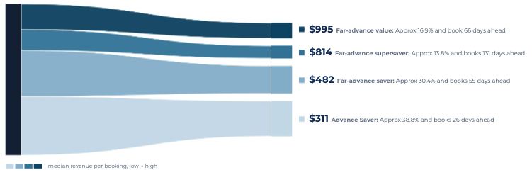
Figure 4.6. Level 2 Segmentation of Balikbayan/ VFR

The main business reason to build these sub segments is to discover massive differences in how much money people spend within a single segment.
- High Variance (Needs Targeting): The "Balikbayan/VFR" segment contains travelers spending vastly different amounts. Simply based on how early they book, their median revenue swings wildly from $322 to $962. The "Corporate" sub-segments also show a massive spread from $113 to $643 based on direction and fare.
- Low Variance: Conversely, sub segments inside the "OFW/Migrant" and "Outbound International Leisure" segments spend roughly the exact same amount. This is a highly valuable "negative result" because it tells the airline not to waste time or money trying to build complex sub-segment pricing strategies for these specific groups.

4.3. Commercial Value and Business Case
These technical findings are only justified if commercial value can be extracted from the various departments in PAL, acting with guidance from business insights. This section will discuss the rationale of the cost of inaction and benefit of running the model in production. Cost benefit analysis is also applied to identify the cost of building your own in house segmentation solution vs buying or leasing from software as a service (SaaS) providers. Operational efficiency is also analyzed among the current processes within PAL’s commercial group; and finally maximizing their in-house customer profiling system, “Traveler DNA”.

4.3.1 Cost of Inaction: Doing Nothing v.s. Doing Something
To evaluate the economic viability of implementing the proprietary segmentation model versus maintaining the status quo (the "do nothing" scenario), the team conducted a study that relies strictly on a bottom-up breakeven analysis. The justification anchors entirely on the measured revenue dilution exposure inherent in the "do nothing" state, weighed against the fixed cost of the in-house build.

Table 4.4. Base Case Model Parameters
Parameter | Value | Justification/ Reasoning
Passengers per year | 16.3 million | PAL Data
Average revenue per passenger | $120 | Cebu Pacific ≈ $74, PAL ≈ $199  (FY2024)
Ancillary share of revenue | 15% | Global average 14.9% (IdeaWorks, 2025)
Lever 1: Ancillary Uplift | 2% of ancillary revenue (Conservative) | +6% seat revenue/pax (airBaltic, 2023)
Lever 2: Retention Uplift | 0.10% of passenger revenue | +5% retention translates to approx. +25–95% profit (Reichheld & Schefter, 2000; Gallo, 2014)
Lever 3: Marketing Efficiency | 10% of 0.8% of revenue budget (Conservative) | 40% cost per booking (Supermetrics, 2022)
Contribution Margin (Incremental Revenue) | 30% | Conservative ancillary-weighted assumption
Realization Factor | 70% | Factoring in execution risk
Implementation cost, year 1 (all-in, including the cloud, compute, and manpower cost) | $77,904 | PAL actual budget; +5%/yr
Discount rate | 10% | Substitute Airline WACC

Under the parameters on the table above, implementation is cash-positive even within its first year with year 1 ramped benefit of approximately $540k, exceeding year one costs. Cumulative net cash flow reaches approximately US$10.25 million by year five, and the five-year net present value of implementing is +US$7.3 million. The inaction state forgoes approximately US$10.7 million in nominal margin over the same horizon, or US$7.6 million in present value. At steady state, the annual benefit is approximately 28 times the annual cost. These can be seen on the figure below:
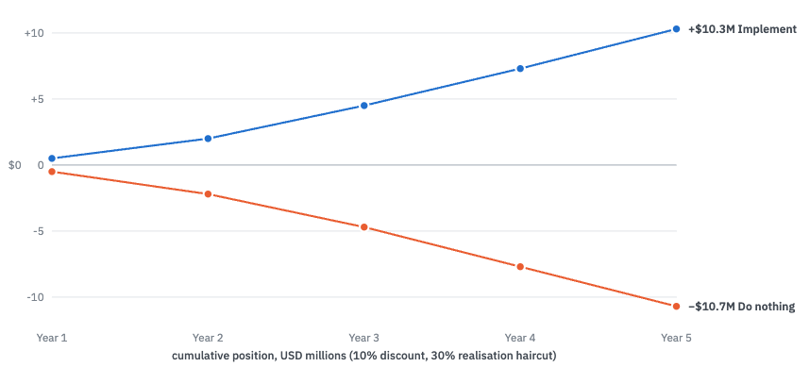
Figure 4.7: Net Cash Flow of Doing Nothing vs Doing Something
The model above however has limitations:
- The benefit evidence consists largely of vendor and airline case studies subject to selection and publication bias; the 70% realization factor, the conservative selection of value of the MAIDA team, and fractional lever sizes mitigate but cannot eliminate this.
- The cost basis is the airline's own budget figure rather than an independent estimate, and it is well below market benchmarks for equivalent capability.
- The modeled levers materialize only if segments are wired into campaign, pricing, digital, and loyalty systems, and attribution requires the control-group discipline described in the implementation plan. If PAL did nothing actionable using the output of the MAIDA model, benefit realization will be zero.
- As mentioned above, figures came from airline case studies only and might not capture nuances of the PH market. Revenue per passenger and marketing intensity should be reconsidered before generalization. This analysis is done by our team for decision support and not audited financial forecasting.

4.3.2 Build vs. Buy Analysis on Comparable Solutions
The team also evaluated the financial and operational viability of deploying our proprietary, in-house customer segmentation architecture versus procuring a commercial Customer Data Platform (CDP) or personalization engine. Based on cost benchmarking, current data constraints, and the necessity of strict governance, the recommendation is to maintain the in-house build until robust customer identity data becomes available.
Table 4.5. Benchmarking Summary of MAIDA Model vs Comparable Solutions
 | MAIDA-Built Model | Salesforce Data Cloud | Adobe Real-Time CDP | Sitecore (Boxever) | Amadeus (Nevio) | Hightouch / Uniphore | Twilio Segment
Architectural Approach | Open-Source Modern Data Stack | Suite-Embedded CRM/CDP | Suite-Embedded Ecosystem | Decisioning & Personalization | Native PSS Extension | Composable / Warehouse-Native | Composable Data Infrastructure
Key Capabilities | Bespoke aviation algorithms, completely custom ML feature store | Zero-copy architecture, native Agentforce AI integration | Sub-200ms decisioning, patented data usage label governance | Sub-second real-time inference, proven airline conversion ROI | Direct Altéa/Navitaire integration, dynamic ancillary pricing | Zero-copy querying, LLM prompt-based segmentation | API-first routing, vast integration connector ecosystem
Primary Cost Drivers | Engineering labor salaries, raw cloud compute, compliance audits | Seat licenses, Flex Credits, mandatory Suite dependencies | Platform fees, heavy reliance on Adobe Experience Cloud | Traffic volume, monthly visitor allocations, overages | PSS contract renegotiations, transaction volume fees | Usage-based on data warehouse compute and activation volume | Monthly Tracked Users (MTUs), aggregate API call volume
Data Sovereignty & Vendor Lock-In | Zero lock-in; complete data and architectural sovereignty | High lock-in; highly dependent on Salesforce ecosystem | High lock-in; requires deep Adobe integration | Medium lock-in; opaque proprietary modeling | Very High lock-in; permanently tethered to PSS roadmap | Low lock-in; data stays in your cloud warehouse | Low lock-in; acts primarily as a routing layer
Estimated 1-Year Cost | ~$77,904 | $360,000 - $750,000+ | $400,000 - $800,000+ | $250,000 - $600,000+ | Custom / Transactional | $150,000 - $350,000+ | $150,000 - $400,000+

The cost comparison reveals a massive asymmetry between building and buying. The in-house model is highly cost-effective and mathematically proves its own baseline value. Enterprise CDPs price at an order of magnitude above our actual budget before integration costs are factored in. Almost all comparable solutions rely on rules-based application on just a more, friendly UI. To justify this premium, a vendor must deliver net-new analytical capabilities that are not available with our segmentation model.
In addition, commercial solutions rely entirely on rich, identified data (e.g., logged-in app behavior, loyalty IDs). It is a known limitation acknowledged by PAL that their current operating environment is limited to a very skeletal Passenger Name Record (PNR) data. These comparable solutions would hit the exact same "identity ceiling" as our in-house build and procuring a vendor solution now means paying immediate, day-one licensing fees for advanced capabilities that our underlying data architecture cannot yet support.
Lastly, the ongoing trend and regulations require an explainable AI component (xAI). Our proprietary rule waterfall ensures that all segment boundaries are fully reviewable, version-controlled, and asserted directly in the code. It allows us to directly input and monitor Subject Matter Expert (SME) constraints. Commercial solutions operate as opaque black boxes behind APIs. This lack of transparency introduces unacceptable operational risk when attempting to audit segment boundaries or adjust business logic.
The MAIDA team then recommends the Procurement strategy on comparable solutions should be re-evaluated strictly when the "identity ceiling" is lifted - Specifically, upon the integration of robust loyalty and frequent-flyer data. Until then, the in-house taxonomy as our auditable system of record plus the sub segment segmentation is proposed.

4.3.3 Operational Efficiency and Labor Reallocation
Given PAL’s current operational environment, where jet fuel costs have been the highest compared to recent years and profitability is at risk during the first half of 2026, it is a priority to use existing resources efficiently to maximize margins. Since PAL does not have an existing data science or machine learning operations team, augmenting man hours from existing departments will guarantee the smooth operations of this semi-supervised ML model.
Figure X illustrates the data requirements to be gathered from PAL SME’s to arrive at the Full Time Equivalent (FTE) calculation, which represents the number of employees that can be freed up from manual work, in PAL, once the model is deployed. The team interviewed PAL SME’s across the 6 departments: Revenue Management, Sales, Marketing, Loyalty, Customer Experience and Commercial Analytics to assess the manual tasks done today which will be replaced or made more efficient given the segmentation model. Each task is evaluated based on its frequency per year, number of people per cycle, current working hours and estimated working hours after implementation.

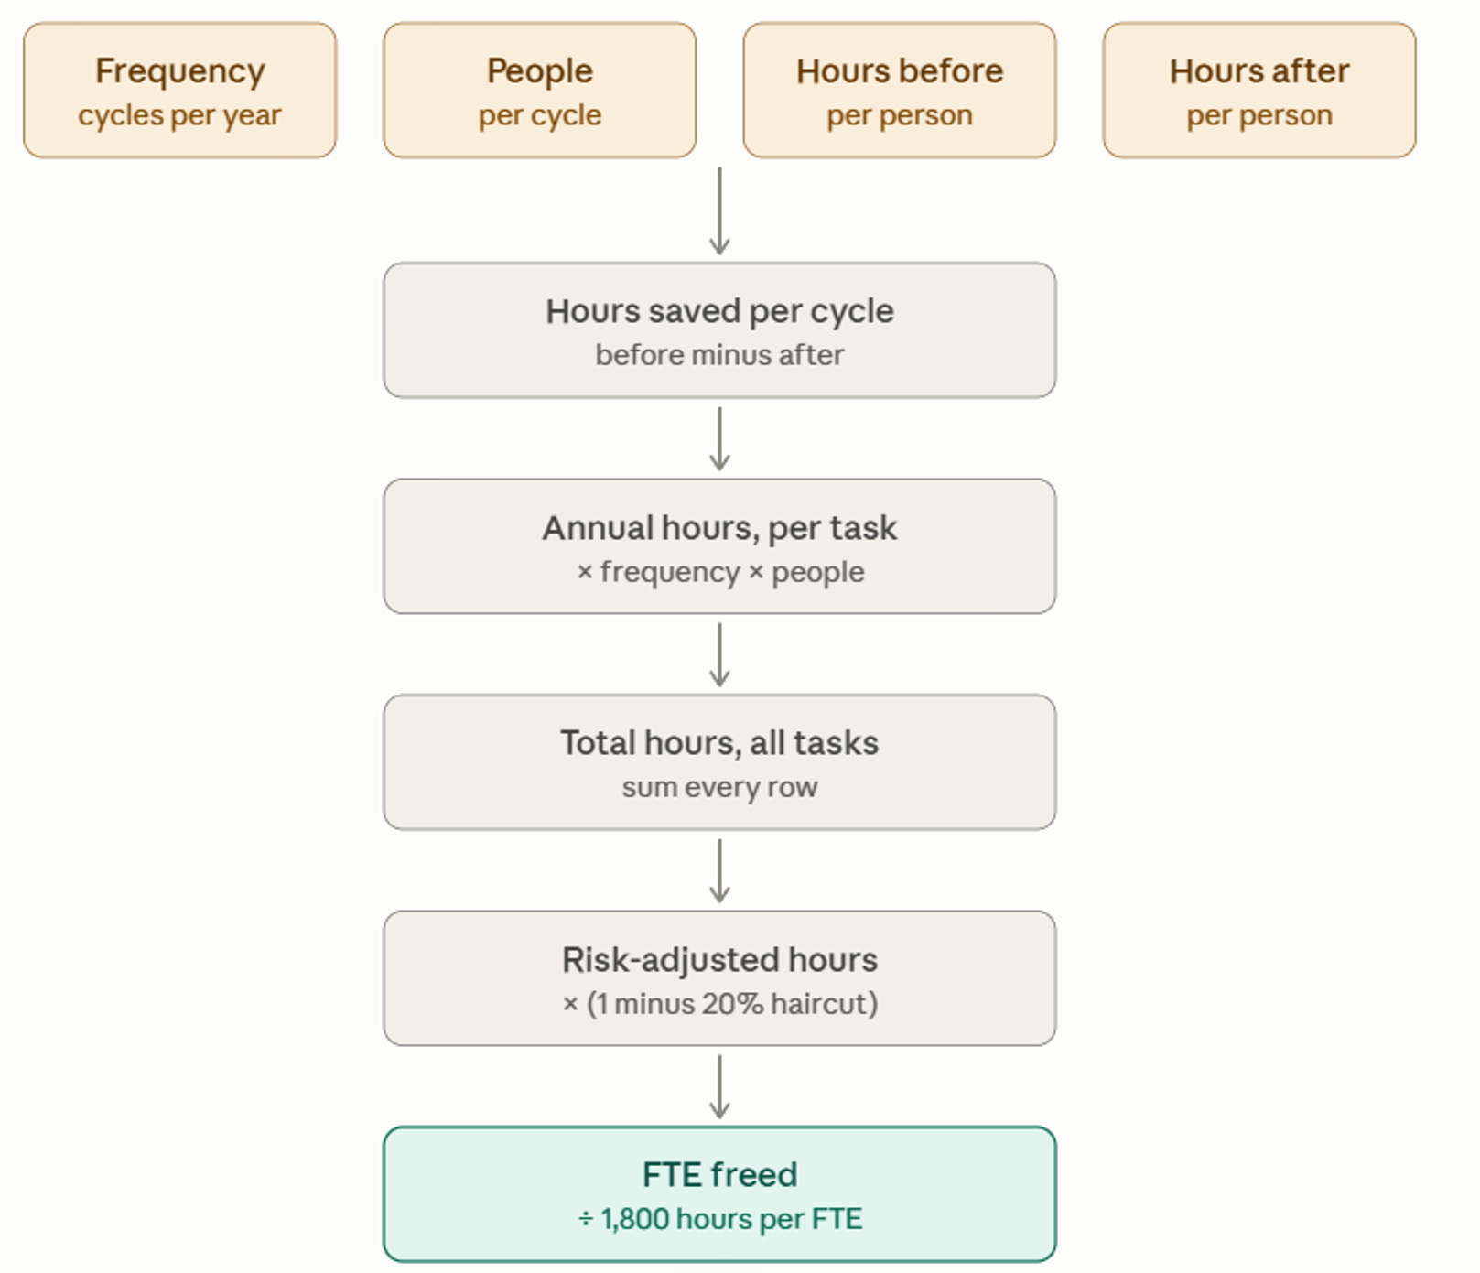
Figure 4.8. Man hours Calculation Requirements

Table 4.6: Assumptions in FTE Calculation
Assumption | Value | Remarks
Working days per year | 247 days | PH gross days = 261; regular holidays 10-12; special non working 5-7;
Productive hours per FTE annually | 1548.8 hours | 247 days * 8 hours * 80% utilization
Average annual salary | PhP 540,000 | Human Capital Reference of PAL
Employer loading | 35% | % uplift from 13th month, government benefits, overhead
PhP per USD | 61.77 PhP / USD | BSP reference rate during evaluation
Haircut on reported hours | 20% | SME’s overestimate time spent on tasks

Table X includes the assumed figures used in the calculations of FTE, generally conservative values were used. The various tasks gathered during SME interviews, their durations and frequency, are included the following in Table X
Table 4.7: Computation for Annual Hours Saved
# | Task name | Team | Dashboard view it is replaced by | Frequency  (cycles per year) | People  (per cycle) | Hours BEFORE | Hours AFTER | Hours saved | ANNUAL HOURS SAVED
 | text | pick one | text | 52 = weekly  12 = monthly | whole number | hours (0.25 = 15 min) | hours (0.25 = 15 min) | G minus H | I x E x F
1 | Weekly route + segment performance pack | Revenue Management | 01 Route Revenue & PAX Performance | 52 | 3 | 2.5 | 0.25 | 2.25 | 351.0
2 | Post Departure Review : Interacting with sales/marketing in a meeting then building a deck | Revenue Management | Route revenue and segment performance | 52 | 12 | 3 | 1 | 2.00 | 1,248.0
3 | WTP Strategy Review: Studying which markets to drop/increase price through  inference of market segments | Revenue Management | Forward booking segment review | 52 | 12 | 3 | 0.5 | 2.50 | 1,560.0
4 | Manually building comparison decks or reviews for  which segments are up or down during bi weekly reviews | Sales | Persona Card | 24 | 19 | 3 | 1 | 2.00 | 912.0
5 | Conducting research/designing farebasis code bundles for specific  corporate channels | Marketing | Persona Card | 12 | 21 | 2.5 | 1 | 1.50 | 378.0
6 | Filling in Traveler DNA (manual market segmentation tool from amadeus) | Commercial Analytics | Persona Card | 4 | 2 | 1 | 0 | 1.00 | 8.0
7 | Manually reviewing where to prioritize CX investments  in lounges, baggage handling, by destination | Customer Experience | Forward booking segment review | 12 | 7 | 7 | 3 | 4.00 | 336.0
8 | Manual review of promotions to send to inactive  users in mabuhay miles | Loyalty | Data extract | 24 | 9 | 8 | 3.5 | 4.50 | 972.0

Given the assumptions, and listed tasks, which were evaluated conservatively according to the SME’s, 5,665 hours can be saved annually. Adjusting using a 20% haircut, the risk adjusted hours per year saved stands at 4,612 hours, equivalent to $35,143 per year at 2.98 FTE.
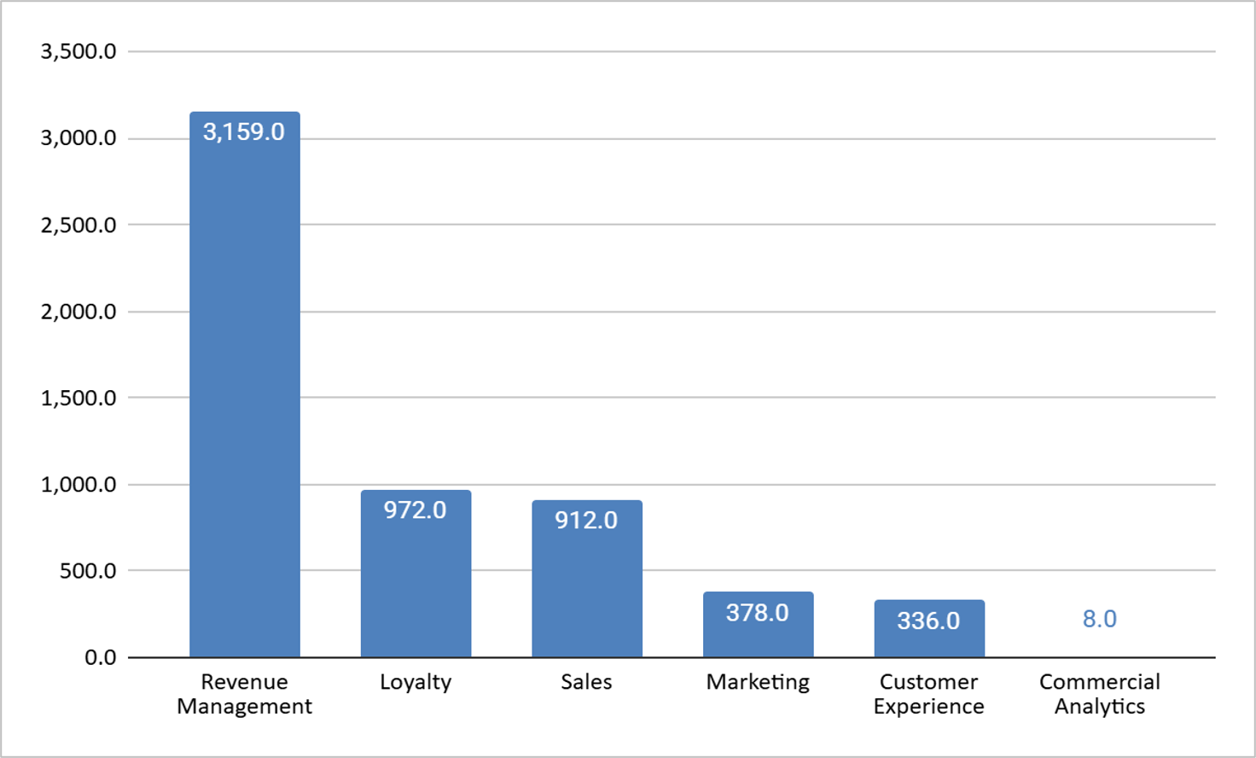
Figure 4.9. Hours Freed per Department

The distribution of freed work hours highlights revenue management as one of the departments fatigued with manual work related to market segmentation and its review, at 3,159 man hours annually. It stands to reason that if the model is run in production and is of sound output, it will return 4,612 analyst hours a year across the 6 commercial teams, freeing up 3 FTE’s.

4.3.4 Activating Traveler DNA
Philippine Airlines has been subscribed to Amadeus’ customer profiling platform, traveler DNA, since 2024, but has remained largely underutilized. Its personalization filters are built solely and managed by a single SME, so any segment based targeting PAL executes today depends on the manual input of one person, rather than a systematic and empirical wide rule. Figure X illustrates the top-level process flow from PAL’s passenger service system (PSS) until the delivery of personalized services and campaign activation.

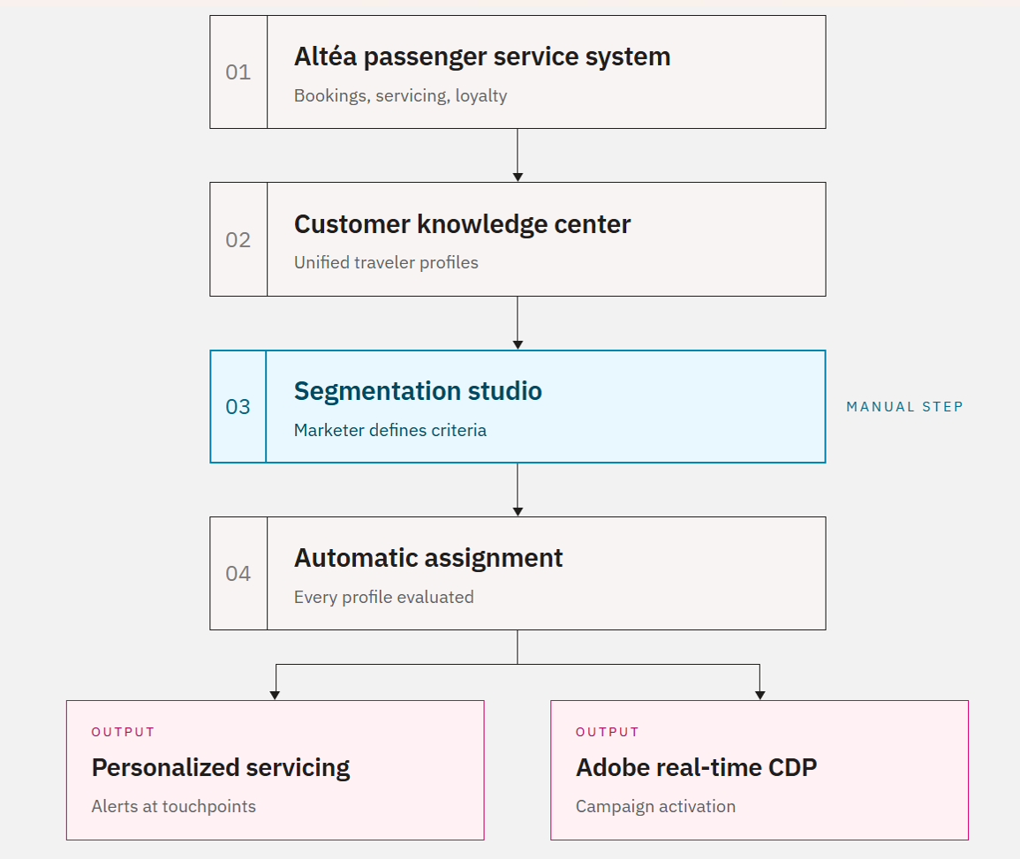
Figure 4.10. Traveler DNA Top-Level Process

In Traveler DNA, Segmentation studio is used to filter behaviors like, destination, ancillary purchases and length of stay, to filter among existing passenger historical profiles from the customer knowledge center. Once filtered, these customers that appear are tagged to behave accordingly, so once a passenger re-appears in a future booking, certain personalized offers can be sent to up-sell ancillary packages or premium cabins for an upgrade.
The issue with this manual filtering is that the input of one SME does not encapsulate or consider all possible behaviors in the 45+ feature space that exists within PAL’s EDW. Once the semi-supervise model is used in production, the output files can be used as an input into the Amadeus system, tagging the customer knowledge data base with relevant market segments per customer, allowing PAL an empirical process to tag customers and deliver personalized services and targeted emails through Adobe’s real time campaign manager. Traveler DNA is not a rival customer segmenting model, but rather PAL’s already live platform to deliver personalized products.

CHAPTER 5: FINDINGS, RECOMMENDATIONS AND CONCLUSIONS

5.1. Technical and Strategic Business Findings

5.1.1 Summary of Technical and Strategic Findings (TSF)

TSF #1 PAL Booking PNR data is a behavioral continuum, and the null is bounded
No natural, well-separated clusters exist at the top level. This is supported when BIC fall monotonically from a single component with no elbow anywhere. The team tried ten methods across six algorithmic families and it resulted in a Gower Silhouette of 0.381 maximum.
Furthermore, the algorithmic methods disagree with one another about where the boundaries are (median cross-method ARI 0.41), and every internal validity index computable on the data (namely Silhouette, Davies–Bouldin, Calinski–Harabasz — agrees that nothing settles.
A planted-segment power analysis shows the pipeline reliably recovers a synthetic segment of ≥2% prevalence at distinctness ≈0.494. It is an acknowledged limitation that anything below ~1% of bookings (~229,000) could hide undetected. The methods disagree with one another about where the boundaries are (median cross-method ARI 0.41), and every internal validity index computable on the data — silhouette, Davies–Bouldin, Calinski–Harabasz — agrees that nothing settles

TSF #2 A MAIDA-PAL co-designed rule waterfall arrived to eleven named segments plus a 2.47% residual

Unsupervised agreement with the taxonomy peaks only at the trivial geography cut (ARI 0.537 at k = 2), this is where the domestic/international bit was rediscovered. Past that is moderate at best (0.389), which is the expected shape on a continuum.

TSF#3 Segments are distinguishable on evidence the rules never saw
All 55 pairs are at least weakly distinguishable and 44 are clearly distinct (median AUC 0.861) against passing negative controls. The labels are behaviorally validated and not externally confirmed. It is an action point from PAL to provide the MAIDA team labeled samples so they can verify the model and score the taxonomy against it.

TSF #4 The taxonomy's weakest boundary did not improve (MAIDA Team reported it as a result)

OFW/Migrant (overseas workers) and Balikbayan/VFR (Filipinos abroad flying home to visit family) together have 6.8M bookings (30% of the whole base). In the rule waterfall they're almost identical. Both are foreign-issued, international, economy, fare tier ≤ 4, the only rule separating them is one boolean, if it is a one-way trip. Roundtrip = Balikbayan, else OFW. This distinction hanging on one field is inherently fragile: an OFW who books a return for contract leave, or a balikbayan on a one-way, gets the wrong label with nothing else to catch it. The validation numbers confirm this fragility with pair scores AUC 0.548, a little better than a coin flip.

What would actually separate these groups is identity — an OFW on a contract cycle and a balikbayan visiting family have different loyalty profiles. That's frequent-flyer data, PAL doesn’t have (or did not provide to MAIDA Team). PAL agreed on Aug. 18 2026 to supply frequent-flyer, tour-code, and upgrade indicators and those fields sit on the critical path of exactly this boundary. As of writing (Aug. 23, 2026), this is still not provided.

TSF #5 The segmentation is a lossy but faithful compression, by design

The label alone carries a real outcome signal (AUC ≈0.60 on two stable outcomes) but adds ≤0.0024 on top of its input features (which is essentially nothing). So, the team positions its value for coordination and not for prediction.

TSF #6 Taxonomy is stable across 12-month step

Segment shares move 1.71 pp in total variation on full-population counts. revenue mix moves 3.36 pp, led by a 2.7 pp Balikbayan/VFR revenue share decline. Whether a year-old model transfers and its impact to PAL is still unconfirmed and unresolved. Thus, the MAIDA team recommends monitoring drift yearly and evaluate its implications.

TSF #7 Level 2 shares the same grammar and continuum

Inside each of the five largest segments (94.8% of bookings), LCA was fitted separately and each fit saw only that one segment's bookings. Two things to hold apart:

- 4 Sub segments is a cap: BIC ran to the top of its allowed range (k = 2–4) in every parent, identical to ceiling behaviour as the top level. The data never says it is the right k but it was decided by the MAIDA team that it is the business-actionable granularity that was imposed.
- Shared grammar: Five independent fits were done with each blind to the other four segments. All split along the same three axes: trip direction, booking timing, and fare tier.

TSF #8 The taxonomy exposes behavioral regularities that survive adversarial checks

87.8% of customers never leave their segment across their observed history, so the label is a stable personal attribute rather than a per-trip attribute.
- Repeat behaviour span 3 times (12.2% Pilgrimage to 36.4% Corporate — floors, because the data is right-censored).
- OFW/Migrant and Balikbayan/VFR peak in opposite months (August against December), so the same corridors can be revenue-managed to two calendars.
- Manila–Gulf traffic runs on a one-month stay clock no other corridor has (month-to-fortnight ratio 2.25 against ≤0.60 everywhere else). This behavior is reported as a pattern by the MAIDA team to PAL until its fare-rule confound is settled.

5.1.2 Summary of Strategic and Business Findings (SBF)

SBF #1 The binding constraint is data and not modelling

The loyalty segment is unmeasurable at 0.03% with only award redemptions the only visible signal. Churn is also not computable, 73.9% of customers are observed once in a right-censored window, so a new customer and a lost one are indistinguishable and no churn score can be computed. The extract also carries no ancillary revenue, and age is captured on under 1% of domestic bookings. These are all published limitations of the model until the data is given to the MAIDA team.

SBF #2 Volume and value are almost near inverses

To illustrate, Leisure accounts for 50.6% of bookings and 15.0% of revenue while Balikbayan/VFR supplies 12.5% of bookings and 28.4% of revenue. Any strategy metric denominated in passengers systematically overweights the low-yield base, and segment-denominated reporting is the correction.

SBF #3 Uniform treatment misprices a measured $645.8M

If a price or promotion aims at a route × cabin × fare-brand cell, or at a whole parent segment, everyone inside gets the same treatment. But the sub segments show large value spreads inside single parents. Sub-types priced at ≥1.25× their parent's mean are 4 of the 20 sub segments, equivalent to 2.13M bookings (22.9% of parent bookings) carrying $645.8M (29.7% of parent revenue). A parent-uniform discount reaches all of them, and every discount dollar landing on a customer already paying well above the mean is margin given away by this shotgun labeling. If PAL tightens the threshold to 1.5× and the core exposure will be lesser ($358M).

SBF#4 — Department readiness is derived from the evidence and not asserted

- Sales and CX — These departments should go first. Prioritization just reallocates effort already being spent, so the measured fact is the deliverable. Agency dependence spans 6.6× (11.8% Corporate to 78.2% Pilgrimage), the sea-crew channel is $136.6M flowing to effectively one segment, digital revenue share spans 19× (2.6% to 48.8%).
- Revenue Management— The next should be RMs. The $645.8M spread is measured, but the payoff depends on a recovery rate nobody has measured yet.
- Marketing — This will be a testing site. Its assumption (response rate) is the one that's testable inside a single campaign cycle. One instrumented campaign replaces the free parameter with a measurement. Its own case is stated as a breakeven.
- Loyalty — Since churn isn't computable yet, any loyalty action today would run on an invented number.

5.2. Data Enrichment Strategy

5.2.1. Ingestion of High-Priority Operational and Commercial Features
The initial feature set was strictly constrained by privacy and data availability covenants. To significantly improve model discriminative power, the central data warehouse should ingest five high-priority operational attributes:
1. Detailed Fare Basis Codes:
In the baseline model, booking classes were aggregated into a 7-tier fare brand value ladder. While effective as a general hierarchy, it obscures critical booking conditions. Ingesting raw alphanumeric fare basis codes enables the model to explicitly identify fare restrictions, corporate negotiated ticket codes, promotional flash-sale indicators, and government/seaman contract tags. This directly resolves the contestation between price-inelastic corporate travelers and last-minute budget flyers who purchase comparable economy booking classes.
2. Comprehensive Mabuhay Miles Loyalty Tiers:
The baseline model was limited to observing explicit award ticket redemptions (is_award = True), artificially constraining the Mabuhay Loyalist segment to 0.03% of volume. Ingesting active frequent flyer tier levels (Classic, Elite, Premier Elite, and Million Miler) will expand loyalty visibility across the entire booking base, allowing the model to capture revenue contributions and booking frequency from high-tier members traveling on commercial revenue tickets.
3. Corporate Client Account and Contract Identifiers:
The Corporate segment currently suffers from high rule contestation, with only 6.4% of corporate assignments being uncontested and 25.6% matching three or more rules. Ingesting corporate contract codes, Tour Code / Corporate Discount IDs, and Travel Management Company (TMC) client profile flags will provide deterministic ground truth for contracted business travel, eliminating false-positive leakage into leisure categories.
4. Add-on services Product and Baggage:
Pre-purchased add-on services behaviors provide powerful signals of passenger intent. Incorporating check-in baggage piece counts, pre-paid excess baggage weights, advance seat selection categories (extra legroom, forward zone), inflight meal orders, and travel insurance indicators will sharply differentiate labor-migrant travelers (who exhibit high baggage intensity) and premium bleisure travelers from basic budget backpackers.
5. Customer Demographics and Passenger Type Codes:
While adhering strictly to enterprise data governance, ingesting standardized passenger type codes (such as Adult, Child, Infant, Seaman, Senior Citizen, and Student) and validating age distributions (currently 57% null) will provide vital demographic grounding without exposing sensitive personal identifiers.

5.2.2. Derived Behavioral Feature Engineering

In addition to raw operational fields, the feature store can be enriched by deriving advanced behavioral metrics from existing transactional records:
1. Length of Stay (LOS) on Round-Trip Itineraries: An empirical audit demonstrated that stay length can be reliably computed for 98.8% of round-trip bookings (9.67 million bookings) by calculating the elapsed days between outbound arrival and inbound departure. Integrating stay duration enables the model to cleanly isolate short-duration corporate business trips (1 to 3 days), standard holiday vacations (4 to 14 days), and extended diaspora/migrant visits (30+ days).
2. Cabin Movement and Willingness-to-Pay: Evaluating differentials between sold cabin class (SoldOperatingCabinClass) and flown cabin class (OperatingCabinClass) identified approximately 369,000 upgrade events across the network. Deriving an upgrade propensity index and bid-for-upgrade transaction flag captures latent willingness to pay among economy passengers, providing a clear statistical bridge between Budget/Adventure and Premium Bleisure subsegments.
3. Booking Pace and Rebooking Velocity: Incorporating passenger-level historical rebooking velocity (such as 90-day and 180-day repeat booking frequency) and booking lead time deviation relative to route-level seasonal averages will enhance the model's ability to separate habitual commuters from one-off holiday travelers.

5.2.3. Independent Ground-Truth Data Set

A critical limitation identified in the baseline development log was circular validation,evaluating rule-based classifications against proxy labels generated by the rules themselves. To establish objective accuracy:
1. Gold Standard SME-Labeled Dataset: Philippine Airlines should curate a verified ground-truth dataset of approximately 1,000 ticketed bookings independently annotated by commercial subject matter experts from Revenue Management, Sales, and Marketing. Annotations must employ a multi-rater protocol with at least two independent reviewers per booking to measure inter-annotator reliability.
2. Sampling on Contested Boundaries: Rather than random sampling, annotation efforts should be concentrated on highly contested decision boundaries identified by rule confidence telemetry. Specifically, sampling will target: Corporate vs. Last-Minute vs. Budget/Adventure conflicts on short-lead economy bookings; OFW/Migrant vs. Balikbayan/VFR boundaries on long-haul transpacific and Middle East corridors; High-revenue outbound international bookings currently falling into the 9.60% Unassigned segment.

5.2.4. Prioritized Data Enrichment Implementation Roadmap

The data enrichment strategy is structured into three prioritized operational phases to guide engineering and analytics teams:
Table 5.1: Prioritized Data Enrichment Roadmap
Phase | Priority Level | Target Feature Ingestion & Enrichment Tasks | Primary Data Source / System | Expected Impact on Quality Metrics
Phase 1: Immediate Wins | High | Ingest Fare Basis Codes; derive Length of Stay (98.8% coverage) and Cabin Movement (Upgrades); curate 1,000 SME gold-standard sample | Amadeus Altea PSS / Ticketing Data Mart | Drives LCA Silhouette Score across the > 0.25 threshold; eliminates circular validation
Phase 2: Core Expansion | High | Ingest Mabuhay Miles loyalty tiers (Classic to Million Miler); integrate Corporate Account / TMC IDs; separate Last-Minute as overlay flag | Loyalty Database / Sales CRM / GDS Feeds | Sharpens Corporate and Loyalist separation; increases ARI toward > 0.80 ideal
Phase 3: Advanced Telemetry | Medium | Ingest Add-on services & Baggage piece/weight records; resolve 9.6% Unassigned segment; implement SegmentConfidence scoring | Add-on services Merchandising system / DCS Baggage Logs | Reduces Unassigned noise to < 5%; enables automated production drift telemetry

5.3. Dashboard Management Strategy

5.3.1. Overview and Enterprise Architecture

To transition the research outputs into daily operational use, an enterprise analytics suite comprising six specialized Microsoft Power BI dashboards was developed in Power BI Project (PBIP) format. The suite is designed to address two complementary commercial horizons: three realized performance dashboards evaluating route, segment, and comparative market metrics over the trailing twelve months, and three forward looking dashboards projecting booking curves, pace, and pickup from the current travel month through the next twelve months.
Grounded in the organizational strategy domain of the IIBA Guide to Business Data Analytics (2020), this management strategy operationalizes four essential data strategy planning pillars: data governance, data architecture, data security, and metadata management. The foundational design principle governing the suite is architectural decoupling. By isolating machine learning segment classifications behind a standardized, conformed semantic layer, model retraining, scoring refreshes, and the future integration of Level 2 subsegments can be executed as seamless backend data refreshes without requiring structural redesigns of visual reports.

5.3.2. Governance and Operating Model

Sustainable commercial adoption requires managing the analytics suite as an active enterprise product rather than a static reporting artifact. In alignment with IIBA organizational governance principles, Philippine Airlines should implement a hybrid hub-and-spoke Center of Excellence (CoE) operating model. Under this structure, a central analytics team maintains platform governance, semantic data models, and DAX calculation standards, while cross functional business spokes across Revenue Management, Sales, Marketing, and Loyalty drive commercial interpretation and decision making.
Table 5.2: Governance Roles and Responsibilities Matrix
Governance Role | Minimum Operational Accountability | Recommended PAL Department
Executive Sponsor | Approves production rollout, resource allocation, and cross functional adoption mandates | Commercial Analytics
Dashboard Product Owner | Manages the analytics roadmap, release priorities, and business user acceptance | Commercial Analytics
Business Data Owners | Validates and approves business definitions for revenue, passenger counts, routes, and lead times | Commercial Analytics
Model Owner / Data Science Lead | Governs segmentation methodologies, scoring pipelines, drift monitoring, and retraining protocols | Data Science Team (temporarily Commercial Analytics)
Data Engineering Owner | Oversees data ingestion, lakehouse transformations, lineage, quality gates, and snapshot retention | Data Analytics Team
Power BI / Semantic Model Owner | Manages semantic models, DAX measure libraries, PBIP version control, and performance optimization | Commercial Analytics
Platform Administrator | Configures tenant settings, capacity allocation, deployment pipelines, and gateway connectivity | Commercial Analytics
Information Security and Privacy | Enforces role based access control, data classification labels, and privacy governance | Information Security Department (ISD)
Business Super Users | Conducts user acceptance testing, coaches departmental users, and submits enhancement requests | Commercial Group (Revenue Management, Sales, Marketing)

Version control and change management are enforced by maintaining the PBIP repository within Azure DevOps or GitHub, utilizing branch protection and formal pull request reviews. In addition, an enterprise data dictionary must be maintained to document every calculated DAX measure, dimension field, and segment classification rule.

5.3.3. Semantic Layer Design
To achieve seamless modularity between machine learning pipelines and visual dashboards, the semantic data layer is engineered with specific structural safeguards:
- Dedicated Segment Dimension: Segmentation outputs are mapped to a dedicated dimension table with stable surrogate keys. Visual charts and DAX measures reference segment labels solely through these keys, ensuring that updating model predictions or adjusting threshold boundaries does not disrupt frontend visuals.
- Pre-structured Level 2 Hierarchy: A two level hierarchical dimension (Segment Level 1 to Level 2) is established in the semantic schema prior to production rollout. While Level 2 remains unpopulated during initial launch, frontend matrix and treemap visuals inherit automatic drill down capability the moment unsupervised subsegmentation models (LCA or GMM) are certified.
- Unassigned segment: Unassigned bookings (representing 9.60% of volume) are explicitly modeled as a first class dimension member. This ensures strict referential integrity across the star schema, prevents row drops during table joins, and enables revenue managers to directly track the revenue impact of unclassified traffic.
- Conformed Filter Dimensions: All add-on services slicers,including Fare Brand, Fare Brand Tier, Sales Channel, Booking Type, Route Region, and Point of Sale Geography,are built as conformed dimension tables, ensuring consistent cross filtering across all six dashboards.
- Consolidated DAX Measure Library: Analytical calculations are standardized into a centralized measure library. Time intelligence calculations utilize standard functions (such as SAMEPERIODLASTYEAR and DATEADD), while dynamic user toggles (such as switching visual axes between Net Revenue and Passenger Volume) are implemented using Power BI Field Parameters rather than duplicating visual objects.

5.3.4. Data Pipeline and Lakehouse Architecture

The structural split between realized historical performance and forward looking booking trends requires a two cadence ingestion and refresh architecture, deployed within Microsoft Fabric:
Unified OneLake and Direct Lake Architecture: Raw transaction extracts are ingested into OneLake and curated into a star schema inside a Fabric Lakehouse using Data Factory pipelines. The Power BI semantic model connects via Direct Lake mode, enabling subsecond query performance across millions of historical records without the refresh latency of traditional import modes.
Dual Cadence:
- Monthly Realized Cadence: The historical reporting dashboards refresh once monthly following official accounting and revenue month close.
- Daily Forward Snapshot Cadence: The forward looking dashboards refresh daily, capturing an immutable daily booking snapshot. Persisting historical daily snapshots is essential to calculate booking pace, forward pickup curves, and lead time velocity relative to prior year benchmarks.
Pipeline Automation and Quality Gates: Machine learning scoring jobs are scheduled within Azure Machine Learning or Fabric Notebooks, writing predicted segment labels to the curated lakehouse layer prior to dataset refreshes. Automated data quality gates validate row counts, null thresholds, and unassigned volume ratios, triggering automated notifications in Microsoft Teams or email in the event of pipeline anomalies.

5.3.5. Continuous Improvement and AI-Assisted Insighting
In accordance with the iterative analytics lifecycle defined by the IIBA (2020), dashboard operations follow a structured continuous improvement protocol:
Review Cadences and Drift Monitoring: A quarterly governance review evaluates semantic definitions, DAX performance, and report utilization. Concurrently, data science teams track the Population Stability Index (PSI) and Adjusted Rand Index (ARI) to detect feature drift and trigger model recalibration when thresholds exceed 0.25.
Exploration of Microsoft Fabric Copilot and AI Agents: Once certified semantic models are established, PAL can pilot AI assisted analytics capabilities:
- Copilot in Power BI: Empowers commercial analysts to query certified datasets using conversational natural language (e.g., querying which passenger segments are lagging prior year booking pace on specific transpacific corridors).
- Fabric Data Agents: Enables autonomous multi step investigative queries across curated lakehouse tables.
- Smart Narratives: Automatically generates dynamic executive summaries beneath key visual cards, accelerating data storytelling across commercial business units.

5.3.6. Phased Implementation Roadmap

Operationalizing the dashboard management strategy is executed across five distinct phases structured around the model acceptance:
Table 5.3: Dashboard Implementation Roadmap
Phase | Milestone Focus | Key Operational Activities | Primary Responsible Unit | Prerequisite
Phase 0: Foundation | Governance & Semantic Readiness | Establish hub-and-spoke RACI; configure Git PBIP repository; provision Dev/Test/Prod workspaces; deploy decoupled semantic schema; run dashboards in provisional mode | Commercial Analytics | Pre-deployment baseline
Phase 1: Model Acceptance | Segmentation Certification | Validate machine learning performance metrics against acceptance thresholds; swap provisional labels for certified model output; certify enterprise dataset | Data Science Team | Formal Model Acceptance
Phase 2: Pipeline Productionization | Dual-Cadence Data Pipeline | Deploy Fabric Lakehouse and Direct Lake semantic model; build persisted daily snapshot fact table; schedule automated scoring and refresh orchestration | Data Engineering & Analytics | Phase 1 Completion
Phase 3: Production Rollout | Controlled Go-Live | Publish dashboards to Power BI production service; configure role-based access control and sensitivity labels; conduct business user training and data storytelling sessions | Commercial Analytics | Phase 2 Validation
Phase 4: Continuous Improvement | Operational Iteration & AI Pilot | Conduct quarterly semantic and drift audits; roll in Level 2 subsegment hierarchies; initiate Microsoft Fabric Copilot and AI agent proof of concept | Commercial Analytics & Data Science | Stable Production Baseline

5.4 Machine Learning Model Pilot Deployment Strategy
The approach that is recommended for deployment aims at putting the approved segmentation model into operation by means of a controlled pilot carried out within PAL's current Microsoft environment. The pilot should be directed at verifying the end-to-end operating model, covering the entire process from data ingestion and batch scoring through to dashboard usage, and it should not involve the introduction of a more extensive MLOps platform until such time as there is a actual need to do so. Those model-specific points which are still subject to final acceptance, such as the model metrics and the monitoring requirements, must be confirmed at the time of handover and then taken on by the following development team.
5.4.1 Recommendation 1: Establish ML Pilot Team
Form a cross-functional pilot team with clear responsibility in the areas of business, data, technology, security, and reporting. The aim is to make sure that the model is not viewed as a standalone output of data science but rather as an operational process with clearly defined accountability from the stage of acceptance until go-live.

Role | Function | PAL Recommended Department
Pilot Sponsor | Provide executive sponsorship, confirm business priority, and resolve major issues that require management direction. | Executive Sponsor / Commercial Leadership
ML Product Owner | Own the business requirements, confirm the intended use of the segmentation output, and approve material changes affecting the pilot. | Revenue Management & Commercial
Project Manager | Manage the implementation plan, dependencies, risks, stakeholder coordination, acceptance activities, and go-live readiness. | PMO / Commercial Analytics
Data Engineer | Develop and maintain the ingestion and data pipeline required to prepare model inputs and publish the approved segment output. | Data Analytics / Data Engineering
Data Scientist / ML Engineer | Complete model handover, package the scoring process, define approved model metrics, and support monitoring, retraining, and technical validation. | Data Science Team (Temp: Commercial Analytics)
Platform / Cloud Engineer | Provision and configure the Microsoft cloud environment, container runtime, access requirements, and supporting infrastructure. | ISD / IT Infrastructure
Power BI / BI Owner | Integrate the approved segment output into the semantic model and six pilot dashboards, including refresh and report validation. | Commercial Analytics
Information Security and Privacy | Review the proposed data handling, access, security, and privacy controls before production use. | ISD / Data Privacy
5.4.2 Recommendation 2: Proposed Architecture

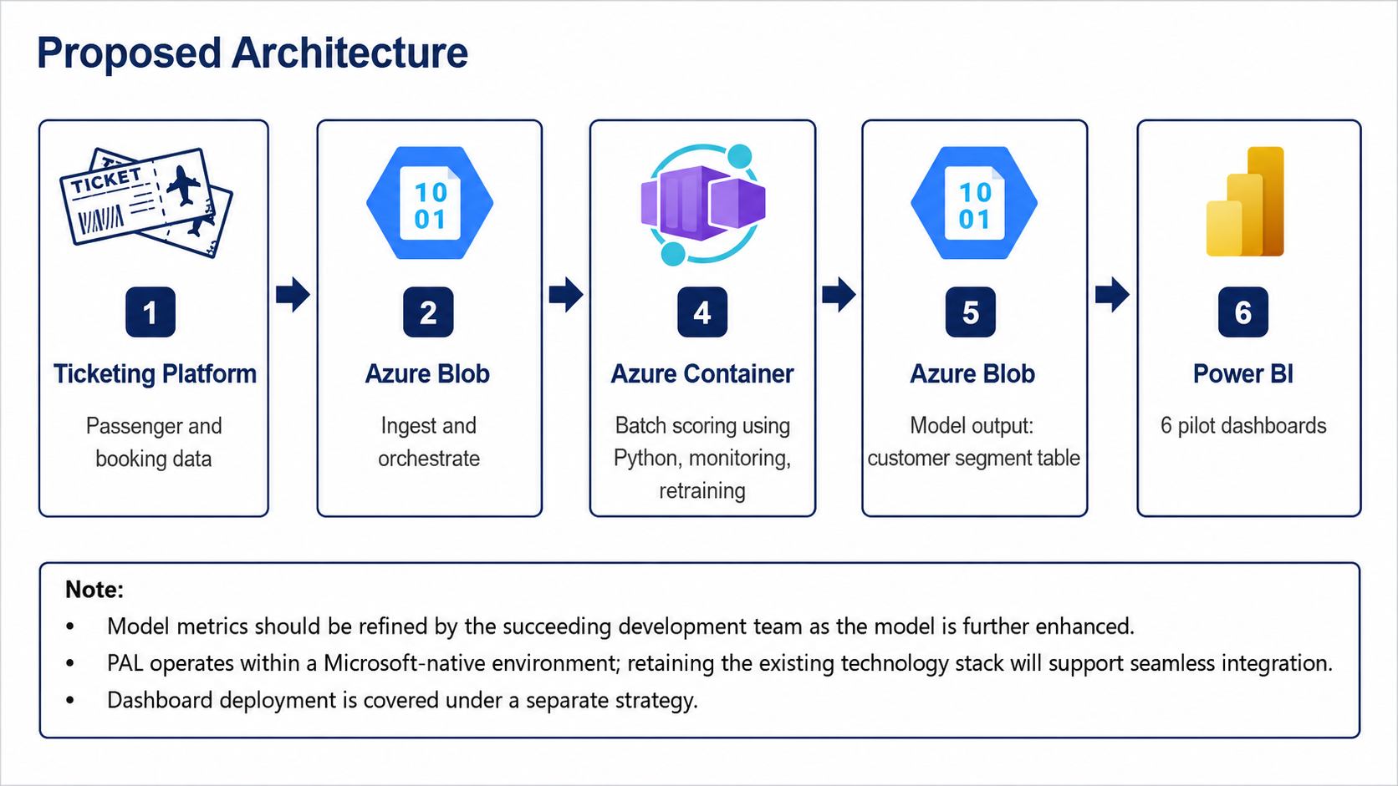
Proposed Architecture

For the pilot use a lightweight architecture that is native to Microsoft. Each component should carry out only the function necessary to verify the deployment approach and ensure a controlled route from the source data to the approved Power BI output.
- Ticketing Platform
Provides the passenger and booking data needed for customer segmentation and model scoring.
- Azure Blob – Input Landing Zone
Take the necessary model input files and place them in a controlled location before carrying out batch processing.
- Azure Container
The Python-based batch scoring process and the model-related operating tasks which have been approved for the pilot are carried out, including the monitoring and retraining activities where they are required.
- Azure Blob – Model Output
The output table for the customer segment, which is produced by the model, is stored and a controlled handoff point is provided for use in downstream reporting.
- Power BI
Take in the output from the approved segment using the reporting model and then display the results on the six pilot dashboards.
5.4.3 Roadmap
The implementation must proceed in accordance with a staged sequence so that the building of the environment and the process of putting it into operation do not take place before the model has been accepted. The times given below are only indicative and might be carried out in parallel where the dependencies have already been resolved.
Activity | Estimated Duration | PAL Recommended Department
Confirm Model Acceptance & Handover | 5–10 days | Revenue Management & Commercial; Commercial Analytics / Data Science; PMO
Provision Microsoft Environment | 5–10 days | ISD / IT Infrastructure; ISD / Data Privacy
Build Data Pipeline | 10–15 days | Data Analytics / Data Engineering; ISD / IT Infrastructure
Operationalize the Model | 10–15 days | Data Science Team (Temp: Commercial Analytics); ISD / IT Infrastructure
Validate & Go-Live | 5–10 days | Revenue Management & Commercial; Commercial Analytics; PMO
The total duration is about 35 to 60 days.

5.5. Operational and Strategic Recommendations

5.5.1. Strategic Framework: The Three Horizon Value Realization Model
Given the volatile environment PAL is operating in, wherein market share is constantly a battle among competing LCC’s, it is recommended to maximize commercial returns immediately levering insights from segmented markets, to push for more personalized strategies; as soon as the model and dashboard is put in production. It is recommended that the airline adopt an agile Three Horizon Value Realization Model. This framework balances immediate, low risk commercial quick wins in the near term and the capability to build across revenue management, sales, marketing, loyalty, and customer experience in the long term.
Grounded in the organizational strategy domain of the IIBA Guide to Business Data Analytics (2020) and global airline commercial best practices, the implementation roadmap is organized across three sequential time horizons:
1. Horizon 1: Quick wins (0 to 6 Months): Model refinement through data enrichment strategies, establishing data governance across the commercial group and user acceptance training (UAT) to prepare relevant departments for deployment.
2. Horizon 2: Scaling machine learning operations (6 to 18 Months): Building the data science and ML operations team to ensure pipeline continuity, leveraging Microsoft’s Azure ML to build and operate the automated pipeline and to initiate more personalized offers with Traveler DNA in all customer touchpoints.
3. Horizon 3: Augmenting existing technology (18 to 36 Months): Augment market segment model outputs with Amadeus & RM Systems, Salesforce and deploy hyper-personalization at scale.

5.5.2. Horizon 1: Obtaining Quick Wins (0 to 6 Months)
The objective of horizon 1 is to establish data credibility, proper governance across the commercial group and begin deployment of the model and dashboards, to gain immediate and quick returns.

Key Operational Initiatives:
1. Data Enrichment Strategy:
As stated in section 5.2, data enrichment will involve data analytics teams to audit, clean, and centralize historical ticketed coupon transactions, fare brand hierarchies, sales channel logs, and basic ancillary records into a centralized Fabric Lakehouse ready for model ingestion. Anomalies, including ticket reissues resulting in negative lead times, refund accounting discrepancies, and currency conversions across foreign points of sale, etc, are adjusted.
2. Data Governance: Assigning Stewardship & Ownership
Initial data stewards must be appointed across ISD and Commercial Analytics to formalize standard metric definitions for the features used for data ingestion, establishing a single source of truth across commercial leadership. It must be clear throughout all commercial leads who owns the dashboard, where the data is stored and who will manage initial extraction, re-training, monitoring and the connection to the BI dashboard.

3. UAT & Deployment:
User acceptance training will be led by Commercial Analytics and select super-users across the commercial group, to inform, support and gather inputs from analysts once they are given access. Once all critical issues are resolved, if any, Commercial Analytics fully deploys the initial six dashboard Power BI suite. Even prior to full machine learning certification, this minimum viable product provides immediate visibility into commercial anomalies and revenue leaks across the network.

5.5.3. Horizon 2: Scale and Operationalize Machine Learning (6 to 18 Months)

Horizon 2 focuses on scaling the machine learning operations, automating batch scoring, training and model monitoring. This begins with building a dedicated data science and ML Operations team using the augmented man hours freed from section 4.3.3.. Finally, more personalized offers should be delivered across all customer touch points, fully leveraging Traveler DNA.

Key Operational Initiatives:
- Building the Data Science and ML Operations team: After PAL ensures that model deployment has made several manual tasks across teams efficient, it should source man-power it can develop to train and monitor the machine learning model. Up-skilling is an option to provide for such employees in the long-term, the best option will always be to hire trained professionals. If there is limited budget available, then augmenting staff will be the best option in the meantime who are freed from other operations. If needed, after dashboard deployment, another survey should be conducted to ensure the working hours have been minimized on manual tasks and the FTE calculation is at least the estimated 3.

2. Model Pipeline Automation through Azure ML: Upon formal handover from the development team, Data Science and MLOps teams register the certified model artifact in Azure Machine Learning. Automated Fabric Data Factory pipelines orchestrate scheduled feature generation, quality gate validation, and batch inference. Note that this step will require the review of enterprise plans as the free tier of Azure ML will not be sustainable in the long term. Key milestones from section 5.4 in ML deployment strategies must be established before moving onto more hyper-personalization efforts.

3. Commercial Enablement, Training, for Personalization:
Commercial Analytics conducts structured training bootcamps and data storytelling sessions for route analysts, pricing specialists, sales managers and other relevant SME’s. Weekly route performance reviews are formally restructured around passenger segment behavioral metrics rather than broad reviews. The target commercial value is accelerated revenue uplift through increased add-on services attach rates, expanded corporate contract penetration, captured return migrant journeys, and enhanced commercial decision speed.

5.5.4. Horizon 3: Augmenting Existing Systems for Hyper-Personalization (18 to 36 Months)

Horizon 3 is a state, when customer segmentation evolves from visual reporting into an automated, intelligent commercial process that dynamically optimizes revenue, pricing, loyalty, and customer experience in real time. This is done by augmenting the model pipeline to also serve existing systems. Systems in revenue management like PROS’ RM management tool, or Sales’ Salesforce.
Key Operational Initiatives:
1. System Augmentation and Real-Time Hyperpersonalization:
Moving beyond passive dashboard recommendations to a closed loop automated process. Machine learning segmentation outputs are integrated directly into digital booking systems, revenue management systems, and customer touchpoints via secure APIs:
- Dynamic Checkout Merchandising: The airline's website and mobile application query real time inference APIs during the booking flow to dynamically adjust add-on services pricing, recommended baggage bundles, and seat selection options based on the passenger's inferred trip purpose and willingness to pay.
- Real-Time Revenue Management Inventory Control: Segment level price elasticity and forward booking pace feed directly into automated revenue management algorithms, dynamically tuning bid prices and fare availability by cabin class to prevent premature discount dilution.
- Customer Experience and Journey Assurance: Inferred traveler personas are integrated into airport departure control and cabin crew service interfaces. High value business and premium bleisure passengers receive automated priority service assurance, lounge access invitations, and proactive flight disruption handling, while families receive coordinated group seating arrangements.

5.6. Final Project Conclusions
This project set out to segment Philippine Airlines' passenger base using machine learning, and the first finding was that the data would not cooperate with that framing. Across ten methods and six algorithmic families, no natural top-level clusters emerged. BIC fell monotonically with no elbow, the maximum Gower Silhouette reached 0.381, and the methods disagreed with one another about where boundaries sit. PAL's booking data is a behavioral continuum, not a set of naturally isolated groups.
Rather than force boundaries onto a smooth distribution, the design was inverted. A co-designed deterministic rule waterfall became the primary labeller, and machine learning acted as the refinement layer. This produced eleven named segments with a 2.47% residual, down from 9.58% in the prior iteration, with Latent Class Analysis splitting the five largest parents into twenty sub-segments. The segmentation holds up against checks: 44 of 55 segment pairs are clearly distinct, 87.8% of customers never change segment, and segment shares move only 1.71 percentage points across a twelve-month period.
The commercial case does not depend on the model being perfect. It depends on PAL currently treating unlike customers alike. Volume and value run in opposite directions across the network. Beneath the parent segments, four of the twenty sub-types are priced at or above 1.25× their parent's mean, representing 2.13 million bookings and $645.8 million in revenue that a parent uniform discount reaches. Against that, the build is inexpensive. At $77,904 in year 1, implementation is cash positive within the first year, delivers a 5-year NPV of +7.3 million, and returns roughly 4,612 analyst hours annually, enough to staff a small team needed to run it.
The limiting factor is data, not modelling. Loyalty is unmeasurable at 0.03% visibility, churn cannot be computed on a right-censored window where 73.9% of customers appear once, and ancillary revenue is absent entirely. PAL agreed to supply frequent-flyer, tour-code, and upgrade indicators, which sit directly on the critical path of the weakest boundary in the study. This shapes the sequencing: Sales and Customer Experience move first because prioritization reallocates effort already being spent, Revenue Management follows where the spread is measured but the recovery rate is not, Marketing serves as the test site, and Loyalty waits until churn becomes computable.
What this project delivers is working segmentation, twenty sub-segments beneath it, six dashboards, a deployment architecture on PAL's existing stack, and a path to activate Traveler DNA, a platform the airline has paid for since 2024 but has not maximized. What it does not deliver is a finished system. It carries a stated blind spot below 1% prevalence, one fragile boundary awaiting data, and no value at all if the segments stay in a dashboard and never reach pricing, campaign, and digital systems. PAL cannot out-discount Cebu Pacific or AirAsia and does not need to. It needs to stop pricing a $995 far-advance Balikbayan and a $311 advance saver as the same passenger. That distinction is now measurable, auditable, and cheap to maintain.

REFERENCES
Calinski, T., & Harabasz, J. (1974). A dendrite method for cluster analysis. Communications in Statistics, 3(1), 1–27. https://doi.org/10.1080/03610927408827101
Campello, R. J. G. B., Moulavi, D., & Sander, J. (2013). Density-based clustering based on hierarchical density estimates. In Advances in Knowledge Discovery and Data Mining (pp. 160–172). Springer. https://doi.org/10.1007/978-3-642-37456-2_14
Campello, R. J. G. B., Moulavi, D., Zimek, A., & Sander, J. (2015). Hierarchical density estimates for data clustering, visualization, and outlier detection. ACM Transactions on Knowledge Discovery from Data (TKDD), 10(1), 1–51. https://doi.org/10.1145/2733381
Celeux, G., & Soromenho, G. (1996). An entropy criterion for assessing the number of clusters in a mixture model. Journal of Classification, 13(2), 195–212. https://doi.org/10.1007/BF01246098
Davies, D. L., & Bouldin, D. W. (1979). A cluster separation measure. IEEE Transactions on Pattern Analysis and Machine Intelligence, PAMI-1(2), 224–227. https://doi.org/10.1109/TPAMI.1979.4766909
De Boer, E. R., & Gudmundsson, S. V. (2017). 30 years of frequent flyer programmes: What have we learned and how did we get here? Journal of Air Transport Management, 64, 467–478. https://doi.org/10.1016/j.jairtraman.2017.04.004
de Wit, J. G., & Zuidberg, J. (2012). The growth limits of the low cost carrier model. Journal of Air Transport Management, 21, 17–23. https://doi.org/10.1016/j.jairtraman.2011.12.013
Gower, J. C. (1971). A general coefficient of similarity and some of its properties. Biometrics, 27(4), 857–871. https://doi.org/10.2307/2528823
Hanaoka, S., Takebayashi, M., Ishikura, T., & Saraswati, B. (2014). Low-cost carriers versus full service carriers in ASEAN: The impact of liberalization policy on competition. Journal of Air Transport Management, 40, 96–105. https://doi.org/10.1016/j.jairtraman.2014.06.008
Hubert, L., & Arabie, P. (1985). Comparing partitions. Journal of Classification, 2(1), 193–218. https://doi.org/10.1007/BF01908075
International Institute of Business Analysis. (2020). A guide to business data analytics.
Jha, A. K., Agi, M. A. N., & Ngai, E. W. T. (2020). A note on big data analytics capability development in supply chain. Decision Support Systems, 138, 113382. https://doi.org/10.1016/j.dss.2020.113382
Kass, R. E., & Raftery, A. E. (1995). Bayes factors. Journal of the American Statistical Association, 90(430), 773–795. https://doi.org/10.1080/01621459.1995.10476572
Kaufman, L., & Rousseeuw, P. J. (1990). Finding groups in data: An introduction to cluster analysis. John Wiley & Sons.
Linzer, D. A., & Lewis, J. B. (2011). poLCA: An R package for polytomous variable latent class analysis. Journal of Statistical Software, 42(10), 1–29. https://doi.org/10.18637/jss.v042.i10
Marasigan, L. S. (2026, February 23). Air passenger traffic hit record levels last year. BusinessMirror. https://businessmirror.com.ph/2026/02/23/air-passenger-traffic-hit-record-levels-last-year/
McInnes, L., Healy, J., & Astels, S. (2017). hdbscan: Hierarchical density based clustering. Journal of Open Source Software, 2(11), 205. https://doi.org/10.21105/joss.00205
Nylund, K. L., Asparouhov, T., & Muthén, B. O. (2007). Deciding on the number of classes in latent class analysis and growth mixture modeling: A Monte Carlo simulation study. Structural Equation Modeling, 14(4), 535–569. https://doi.org/10.1080/10705510701575396
Rousseeuw, P. J. (1987). Silhouettes: A graphical aid to the interpretation and validation of cluster analysis. Journal of Computational and Applied Mathematics, 20, 53–65. https://doi.org/10.1016/0377-0427(87)90125-7
Schwarz, G. (1978). Estimating the dimension of a model. Annals of Statistics, 6(2), 461–464. https://doi.org/10.1214/aos/1176344136
Siddiqi, N. (2006). Credit risk scorecards: Developing and implementing intelligent credit scoring. John Wiley & Sons.
Teichert, T., Shehu, E., & von Wartburg, I. (2008). Customer segmentation revisited: The case of the airline industry. Transportation Research Part A: Policy and Practice, 42(1), 227–242. https://doi.org/10.1016/j.tra.2007.08.003
Wei, J. T., Lin, S. Y., & Wu, H. H. (2010). A review of the application of RFM and LRFMP models in customer segmentation. Expert Systems with Applications, 37(5), 4199–4206. https://doi.org/10.1016/j.eswa.2009.11.082
Weller, B. E., Bowen, N. K., & Faubert, S. J. (2020). Latent class analysis: A guide to best practice. Journal of Black Psychology, 46(4), 287–311. https://doi.org/10.1177/0095798420930932
Wirtz, J., & Johnston, R. (2003). Singapore Airlines: What it takes to sustain service excellence – a senior management perspective. Managing Service Quality: An International Journal, 13(1), 10–19. https://doi.org/10.1108/09604520310456672

APPENDIX 1: Man - hours FTE Calculation & Survey
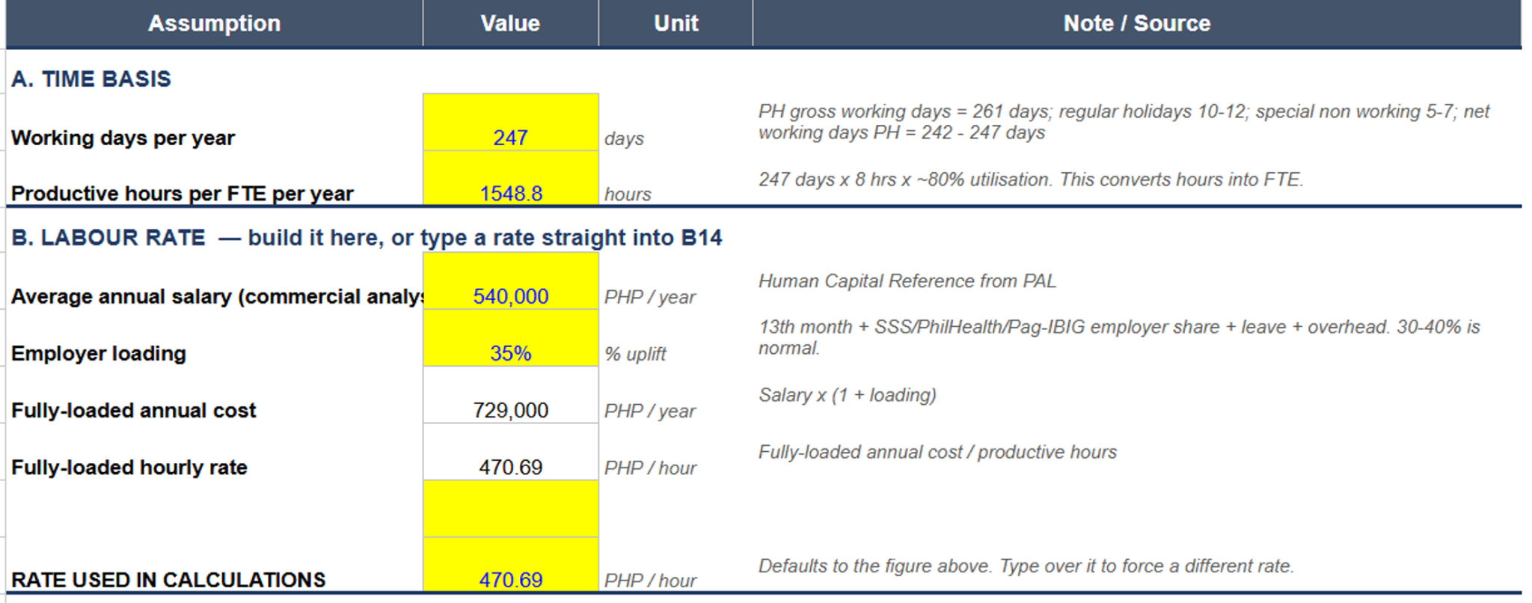
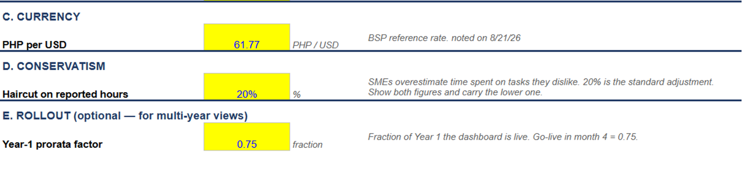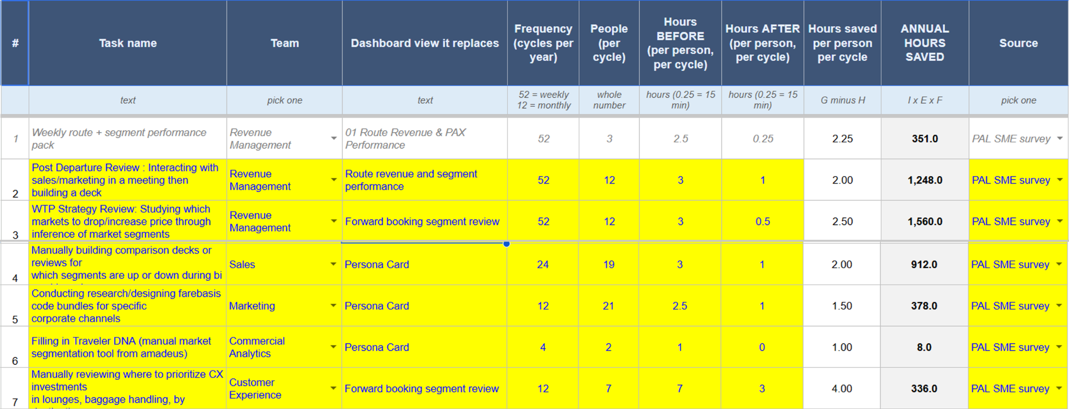

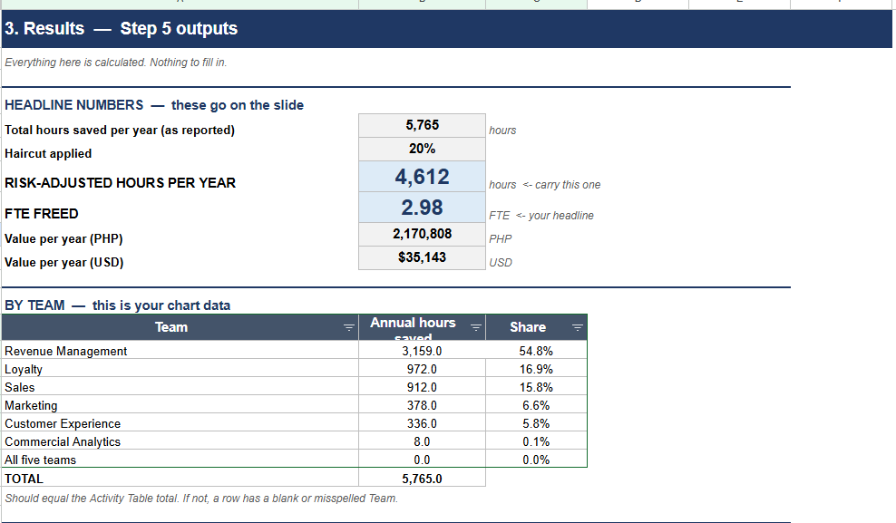

Appendix 2: PowerBI Dashboard Phases

