Operability Take Home Exercise

Erich EJ Best – 201-218-9860  
[ej.best@outlook.com](mailto:ej.best@outlook.com)

Here is what is completed

* Setup a Vagrant configuration for deployment of Virtual Machine
* The Virtual Machine will have a Jenkins Server for Continuous Integration
* Vagrant will call an Ansible Playbook and will tailor the Jenkins Server

How this was tested

* Tested with Kali Linux 2023.1 with privileged account
* Tested on Windows 11 with privileged account (inconsistent results)

Following software is required

1. Hashicorp Vagrant
2. Oracle Virtual Box
3. Red Hat Ansible

Unzip vagrant-virtualbox-ansible-jenkins.zip

Files included

* 1. Vagrantfile
  2. playbook.yml
  3. readme.docx

Setup with the following steps

cd vagrant-virtualbox-ansible-jenkins

Startup Vagrant

vagrant up

Connect to the Virtual Machine

vagrant ssh

Get privileges

sudo su -

List this file with the password

cat /var/lib/jenkins/secrets/initialAdminPassword

You can see the password and use copy/paste the password for the next step

In a browser see Jenkins

Navigate to <http://localhost:8080> and Jenkins should be starting up

The initial Jenkins Screen will be waiting for this password.

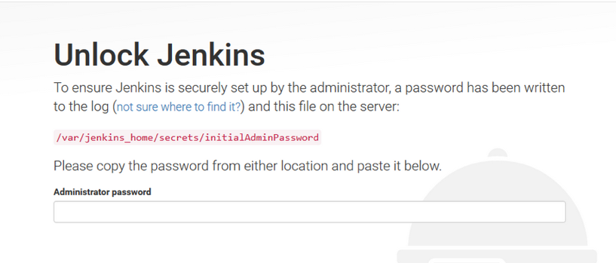

If the password is accepted; you will get prompted to start entering users

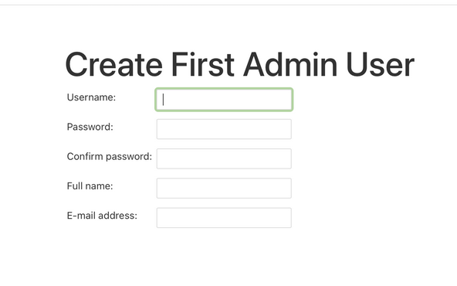

You can begin using Jenkins

The command vagrant suspend and vagrant halt will stop vagrant from running the Virtual Server. During a “suspend” or “halt” the host computer can shutdown. With a suspend “there is extra disk space to save the ram contents”. A suggested rule or habit is “vagrant halt when you want to power off your machine, use vagrant suspend when you want to hibernate your machine.” Such details can by confirmed by this site independent of the vendor and the product:

<https://stackoverflow.com/questions/42549087/in-vagrant-which-is-better-out-of-halt-and-suspend>

If the system is shutdown or rebooted; upon startup

cd vagrant-virtualbox-ansible-jenkins

vagrant up

Jenkins should be available in a browser at <http://localhost:8080>

Other Command for resetting and starting over

* vagrant destroy -g -f ; -g graceful and -f is force for no prompting
* this command will destroy any setups of the Jenkins Server

To Prepare for Production

* + Define expanded requirements
  + Create an account with specific required privileges
  + Investigate insecure messages and lock down