A Comparative Network and Sentiment Analysis of Rhythm Game Communities on YouTube
By: UG Group 59

Authors:
Ethan Bito (s4102812)
Roopkotha Chakrabarti (s4054393)

Contents
I. Introduction 2
II. Research Question 3
a. Aim 3
III. Dataset Overview 4
IV. Success Criteria 4
V. Data Collection 5
VI. Data Preprocessing 5
VII. Sentiment Analysis Method 6
VIII. Network Construction and Metrics 6
a. Nodes and Edges 7
b. Density and Connected Components 7
c. Community Detection and Modularity 7
d. Centrality 7
IX. Result 7
a. Final Dataset Overview 7
b. Sentiment Distribution 8
c. Sentiment Model Agreement 10
d. Network Structure Comparison 11
e. Centrality and Sentiment 12
f. Community and Cluster Findings 13
g. Summary of Main Findings 14
X. Discussion 15
a. Sentiment Differences Between the Communities 15
b. Network Structure and Cluster Formation 16
c. Central Users and Sentiment 16
d. Evidence of Self-Reinforcing Interaction Clusters 17
e. Why the Two Communities Differ 17
f. Connection to the Research Question 18
XI. Limitations 18
XII. Conclusion 19
XIII. References 20

Introduction
Online fandom communities are an important part of social media culture, especially for games that rely on music, characters, events and ongoing fan participation. Rhythm games such as Project SEKAI: Colorful Stage! and BanG Dream! Girls Band Party! have active YouTube communities where users comment on videos, discuss songs and characters, react to updates and interact with other fans. These interactions can reveal how different fandoms organise themselves around shared interests whether the discussion patterns differ between similar communities on the same platform.
YouTube, as a platform, is useful for this analysis because it combines textual comments with interaction structures such as comment replies. This makes it possible to study both the emotional tone of discussion through sentiment analysis and the structure of user interaction through network analysis. Since both Project SEKAI and BanG Dream are rhythm game communities with similar music-centred fandom cultures, comparing them allows the project to focus on the differences in community behaviour rather than the differences between unrelated topics.
This report investigates how interaction networks and sentiment patterns differ between the Project SEKAI and BanG Dream YouTube communities. The analysis uses YouTube comment data collected from 30 videos for each game. Sentiment analysis was used to compare the emotional tone of comments, while network analysis was used to examine reply structures, user centrality, community clustering and modularity. Two sentiment approaches, VADER and RoBERTa, were included to compare whether the overall sentiment trends remained consistent across both a rule-based model and a contextual transformer-based model. Together, these methods help identify whether the two rhythm game fandoms show different forms of interaction and whether their communities appear clustered or self-reinforcing.

Research Question
The research question for this project is:
How do interaction network structures and sentiment patterns differ between Project SEKAI and BanG Dream rhythm game communities on YouTube?

Aim
The aim of this project is to compare two major rhythm game fandoms on YouTube using both text-based and network-based analysis. Specifically, the project examines:
- Whether the two fandoms differ in overall sentiment
- Whether VADER and RoBERTa identify similar or different sentiment pattenrs
- Whether their reply networks differ in size, density, clustering and modularity
- Whether highly central users show different sentiment patterns from peripheral users
- Whether detected network communities suggest clustered or self-reinforcing interaction patterns.
This question is suitable for social media and network analysis because YouTube comments provide both textual content and relational interaction data. The text allows sentiment analysis to be performed, while comment replies allow a user interaction network to be constructed. By comparing two similar rhythm game fandoms on the same platform, the project can focus on how community behaviour differs between fandoms while keeping the platform consistent.

Dataset Overview
The dataset contains YouTube comments collected from videos related to two rhythm game communities: Project SEKAI and BanG Dream. For each game, 30 YouTube videos were used. The final cleaned dataset contains a similar number of comments for both communities, making the comparison reasonably balanced.
Game | Raw Comments/Replies | Removed Empty Text | Removed Duplicates | Final Comments | Top-Level Comments | Replies | Unique Users | Final Reply Edges | Videos
Project SEKAI | 13253 | 1 | 49 | 13203 | 8617 | 4586 | 9537 | 3372 | 30
BanG Dream | 12977 | 8 | 21 | 12948 | 9621 | 3327 | 8290 | 2582 | 30

The Project SEKAI dataset contains slightly more comments, replies, unique users and reply edges than BanG Dream dataset. This suggests that the Project SEKAI videos in the sample generated more direct user interaction, while the BanG Dream dataset had a higher proportion of top-level comments compared with replies.
The data supports both required parts of the assignment. The comment text supports the sentiment and textual analysis, while the reply relationships between users support the network construction and analysis. The cleaned comments were used for sentiment analysis, and the reply edges were used to build separate interaction networks for each game.

Success Criteria
The analysis is considered successful if it can produce meaningful evidence for comparing the two rhythm game communities. The main success criteria are:
- Constructing a comparable YouTube reply networks for Project SEKAI and BanG Dream.
- Calculating and comparing network measures such as nodes, edges, density, connected components, communities and modularity.
- Performing sentiment analysis on comments from both communities using VADER and RoBERTa.
- Comparing sentiment patterns between the two fandoms.
- Comparing agreement and differences between the two sentiment models.
- Examining whether central users differ from peripheral users in sentiment.
- Interpreting whether the results suggest clustered or self-reinforcing interaction patterns.
The project does not aim to prove the existence of echo chambers in a strict casual sense. Rather, it investigates whether the YouTube reply networks will show any evidence of clustered interaction patterns and whether those clusters relate to the differences in sentiments across the two fandoms.

Data Collection
Data collection for this project utilised YouTube Data API v3, providing access to publicly available video metadata, comment threads, and user interaction data. These communities were selected as both are music-centred rhythm games with actvive YouTube fandom discussion, making them suitable for comparing sentiment and user interaction patterns.
Multiple serach queries were use for each game to capture a broade range of content. Project SEKAI queries included terms such as “Project Sekai update”, “Project Sekai tier list”, and “Project Sekai community”. BanG Dream queries included “Bandori”, “Bandori gameplay”, and “Girls Band Party”. This helped collected gameplay, update opinion, and community-related videos.
The YouTube search endpoint was used to retrieve candidate videos, with duplicate videos removed across queries. Up to 30 videos per game were retained. Fro each video, metadata including title, publication date, view count, like count, and comment count were collected.
Top-level comments were collected using the <commentThreads> endpoint, with up to 500 top-level comments per video. Videos with fewer than 100 totla comments or replies were excluded. Replies were also collected using the <comments> endpoint, with 20 replies per thread, allownig user reply reltationships to be used for network construction.
For each comment and reply, the dataset stored both text fields for sentiment analysisi and relational fields for network analysis, including <authorChannelId>, <commentId>, <parentCommentIDd>, and <commentID> *FIX ALL THESE FIELDS*
The final output was stored as structured JSON files containing video metadata and nested comment/reply data for each game.

Data Preprocessing
The raw YouTube API output was stored as nested JSON files containing video-level metadata and comment/reply records. To prepare for the data analysis, the JSON structure was first flattened into tabular format, with video metadata merged into each comment row. This produced a structured dataset where each row represented a single top-level comment or reply.
Comment text was then cleaned to improve consistency for sentiment analysis. HTML entities were decoded, URLSs were removed, and excessive whitespace was normalised. Comments with empty text after cleaning were excluded from the dataset. Duplicate records were also removed based on game label, comment identifier, and cleaned text.
To prepare the network analysis dataset, reply comments were converted into directed user-to-user edges using YouTube channel IDs. In this network, the source node represented the replying user and the target node represented the author of the parent comment. Repeated reply interactions between the same pair of users were aggregated into weighted edges, allow the final network to capture both interaction structure and reply frequency.
The preprocessing stage produced two main outputs including a cleaned comment dataset for sentiment analysis, and ana edge list dataset for network analysis.

Sentiment Analysis Method
Sentiment analysis was performed using VADER (Valence Aware Dictionary and sEntiment Reasoner), a rule-based sentiment anaylsis tool designed for short social media text. VADER was selected because it performs well on informal online language and can account for features such as punctuation, emphasis, slang, and sentiment-bearing words comonly found in YouTube comments.
For each cleaned comment, VADER generated four sentiment scores including positive, neutral, negative, and an overall compound score ranging from –1 to 1. The compound score was used as the main sentiment measure and converted into sentiment categories using standard VADER threshold.
- Positive: compound score >= 0.05
- Negative: compound score <= -0.05
- Neutral: compound score between –0.05 and 0.05
Sentiment labels were assigned to all comments in both fandom datasets, allowing overall sentiment distributions to be compared between Project SEKAI and BanG Dream, as well as within individual communities and user groups.

Network Construction and Metrics

Nodes and Edges
A directed reply network was constructed for each game community. Each node represents a unique YouTube user identified by “authorChannelId”, anc each directed edge represents one user replying to another user. Edges were weighted by the amount of repeated replies between the same pair of users.

Density and Connected Components
To compare the overall structure of the two networks, graph-level metrics were calculated includes nodes, edges, density, connected components, largeset connected component, average degree, clustering coefficient, and reciprocity. These metrics were used to assess how connected, fragmented, and interactive each fandom network was.

Community Detection and Modularity
For community detection, the directed reply networks were converted into undirected weighted graphs. The greed modularity community detection algorithm was then applied to identify groups of users who interacted more frequently with each other than with the rest of the network. Modularity was used to measure how strongly separated these communities were.

Centrality
Node-level centrality measures were calculated to identify influential users in each network. Weighted degree measures overall interaction volume, PageRank measured importance based on network position, and betweenness centrality identified users who acted as bridges between parts of the network. These measures were later used to compare sentiment patterns between highly central and peripheral users.

Result
This section will present the main findings from the sentiment and network analyses. The results compare the Project SEKAI and BanG Dream YouTube communities in terms of dataset size, sentiment distribution, reply network structure, centrality-based sentiment patterns and community clustering.

Final Dataset Overview
The final cleared dataset contained a similar number of comments for both rhythm game communities. Project SEKAI had 13203 comments after preprocessing, while BanG Dream has 12948 comments. Both communities were collected from 30 YouTube videos, making the dataset reasonably balanced for comparison.
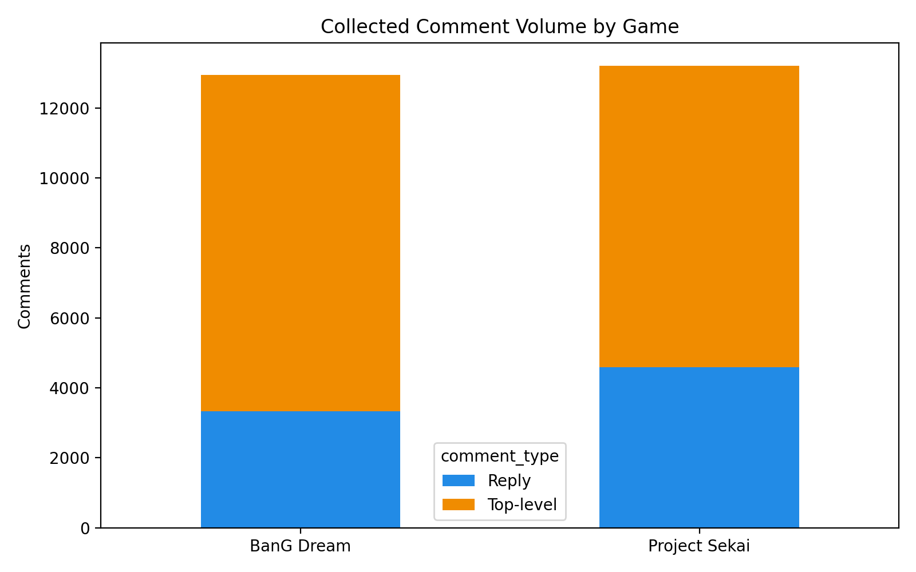
Project SEKAI had more unique users, replies and final reply edges than BanG Dream. This suggests that the Project SEKAI sample generated more direct reply-based interaction, while BanG Dream had a larger proportion of top-level comments. BanG Dream had 9621 top-level comments compared to their 3327 replies, while Project SEKAI shared 8617 top-level comments with 4586 replies.
This difference is important to note, as the network analysis is based on reply interactions. Thereby, Project SEKAI having more replies would mean its network has more direct user-to-user interaction available for analysis.

Sentiment Distribution
The sentiment distribution shows clear differences between the two rhythm game communities. Since both VADER and RoBERTa were used, the analysis compares whether the same broad trends appear across both models.
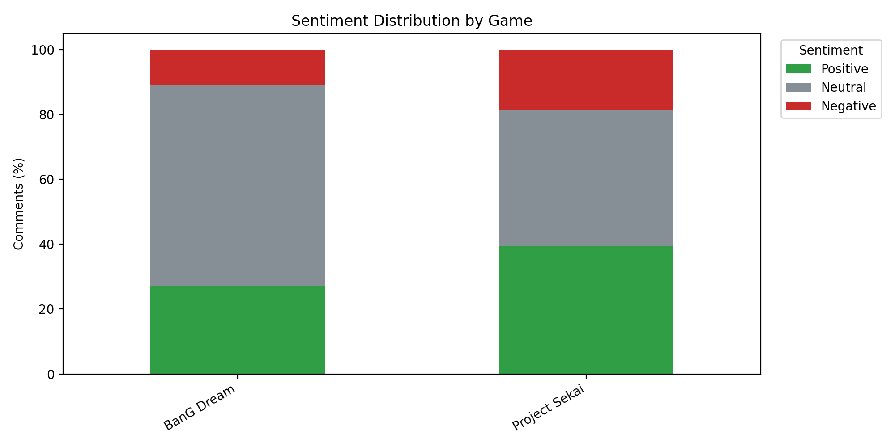
Using VADER, Project SEKAI had a higher percentage of both positive and negative comment sentiments. Positive comments made up 39.50% of their respective dataset, compared to the 27.23% of the same for BanG Dream. Negative comments were also more common within Project SEKAI, making up 18.61% of comments compared with 10.84% within BanG Dream.
However, BanG Dream had a much higher neutral percentage, with 61.92% of its comments being identified and classified as neutral. In comparison, for Project SEKAI, only 41.89% of the comments were neutral.
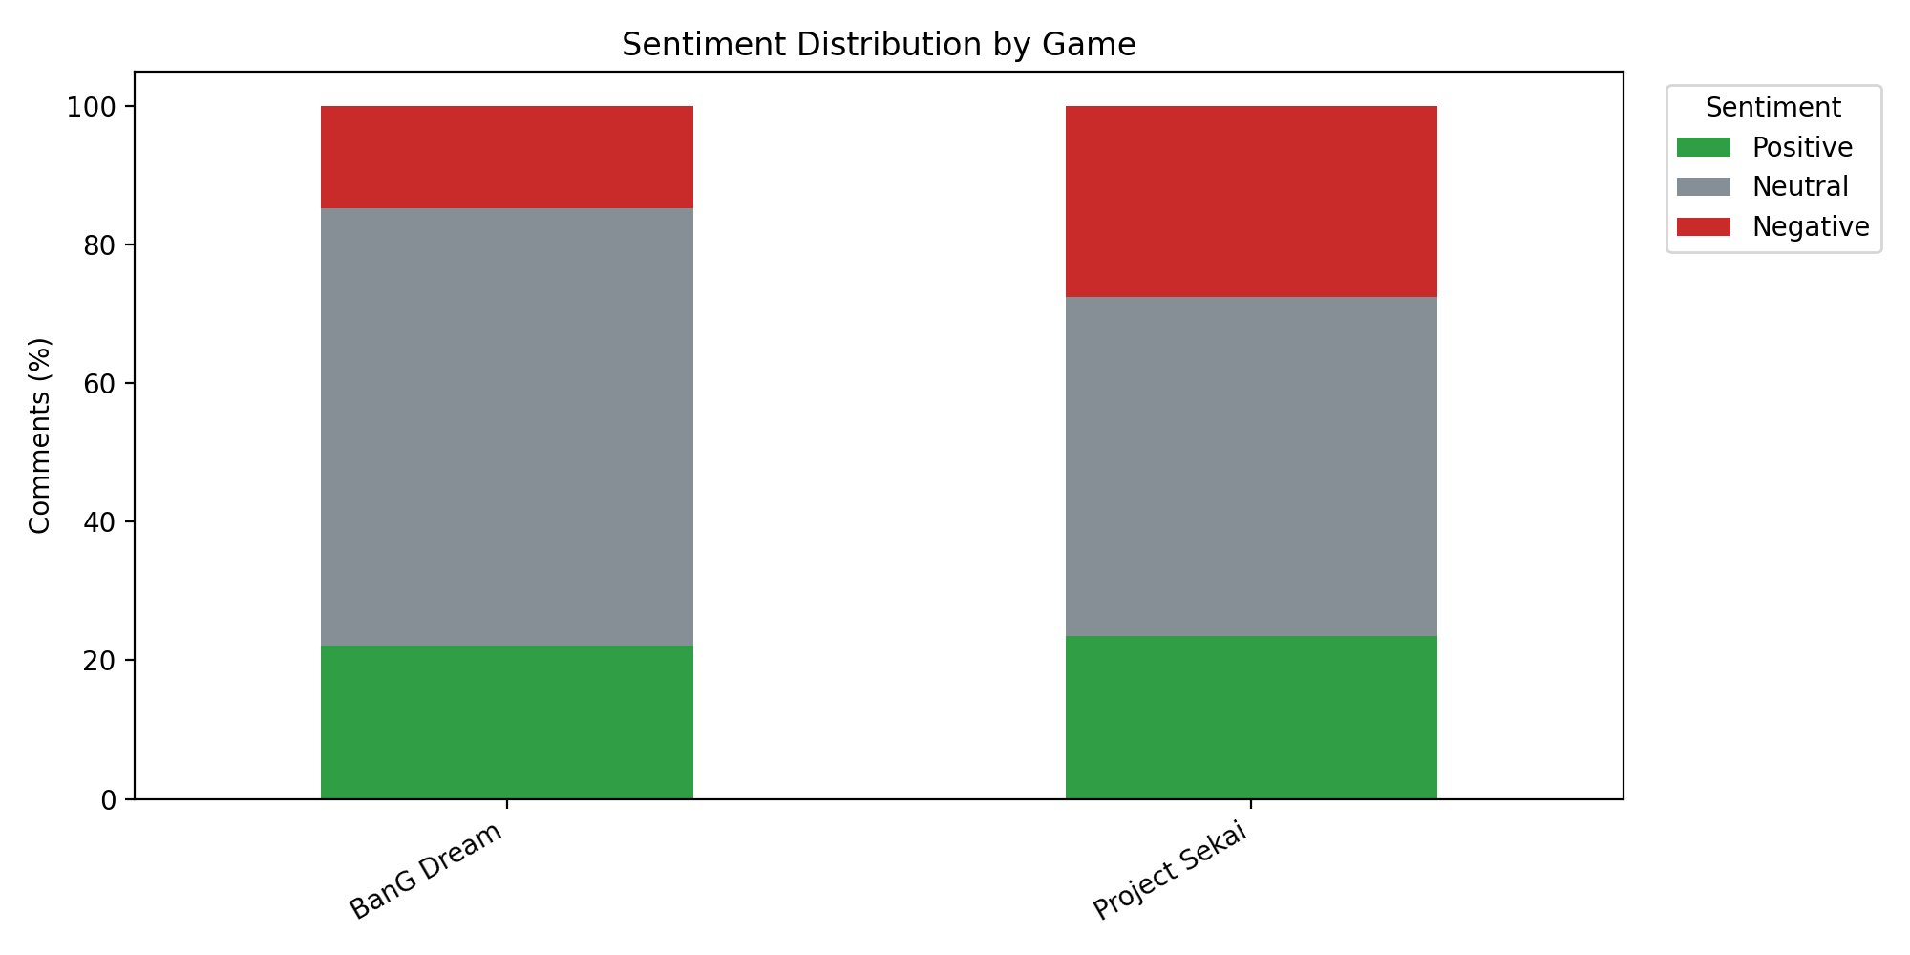
The RoBERTa results showed a similar overall pattern in terms of BanG Dream being more neutral, but it classified sentiment more cautiously for Project SEKAI. Under RoBERTa, Project SEKAI had 23.55% positive comments, 48.85% neutral comments and 27.60% negative comments. BanG Dream had 22.15% positive comments, 63.10% neutral comments and 14.75% negative comments.
Overall, both models suggest that BanG Dream comments were more neutral than Project SEKAI comments. However, the models differed in how they classified Project SEKAI sentiment. VADER classified Project SEKAI as more positive overall, while RoBERTa identified a higher proportion of negative comments. This suggests that Project SEKAI comments may be more emotionally complex or harder to classify, possibly due to fandom-specific language, sarcasm, humour or stronger emotional reactions.
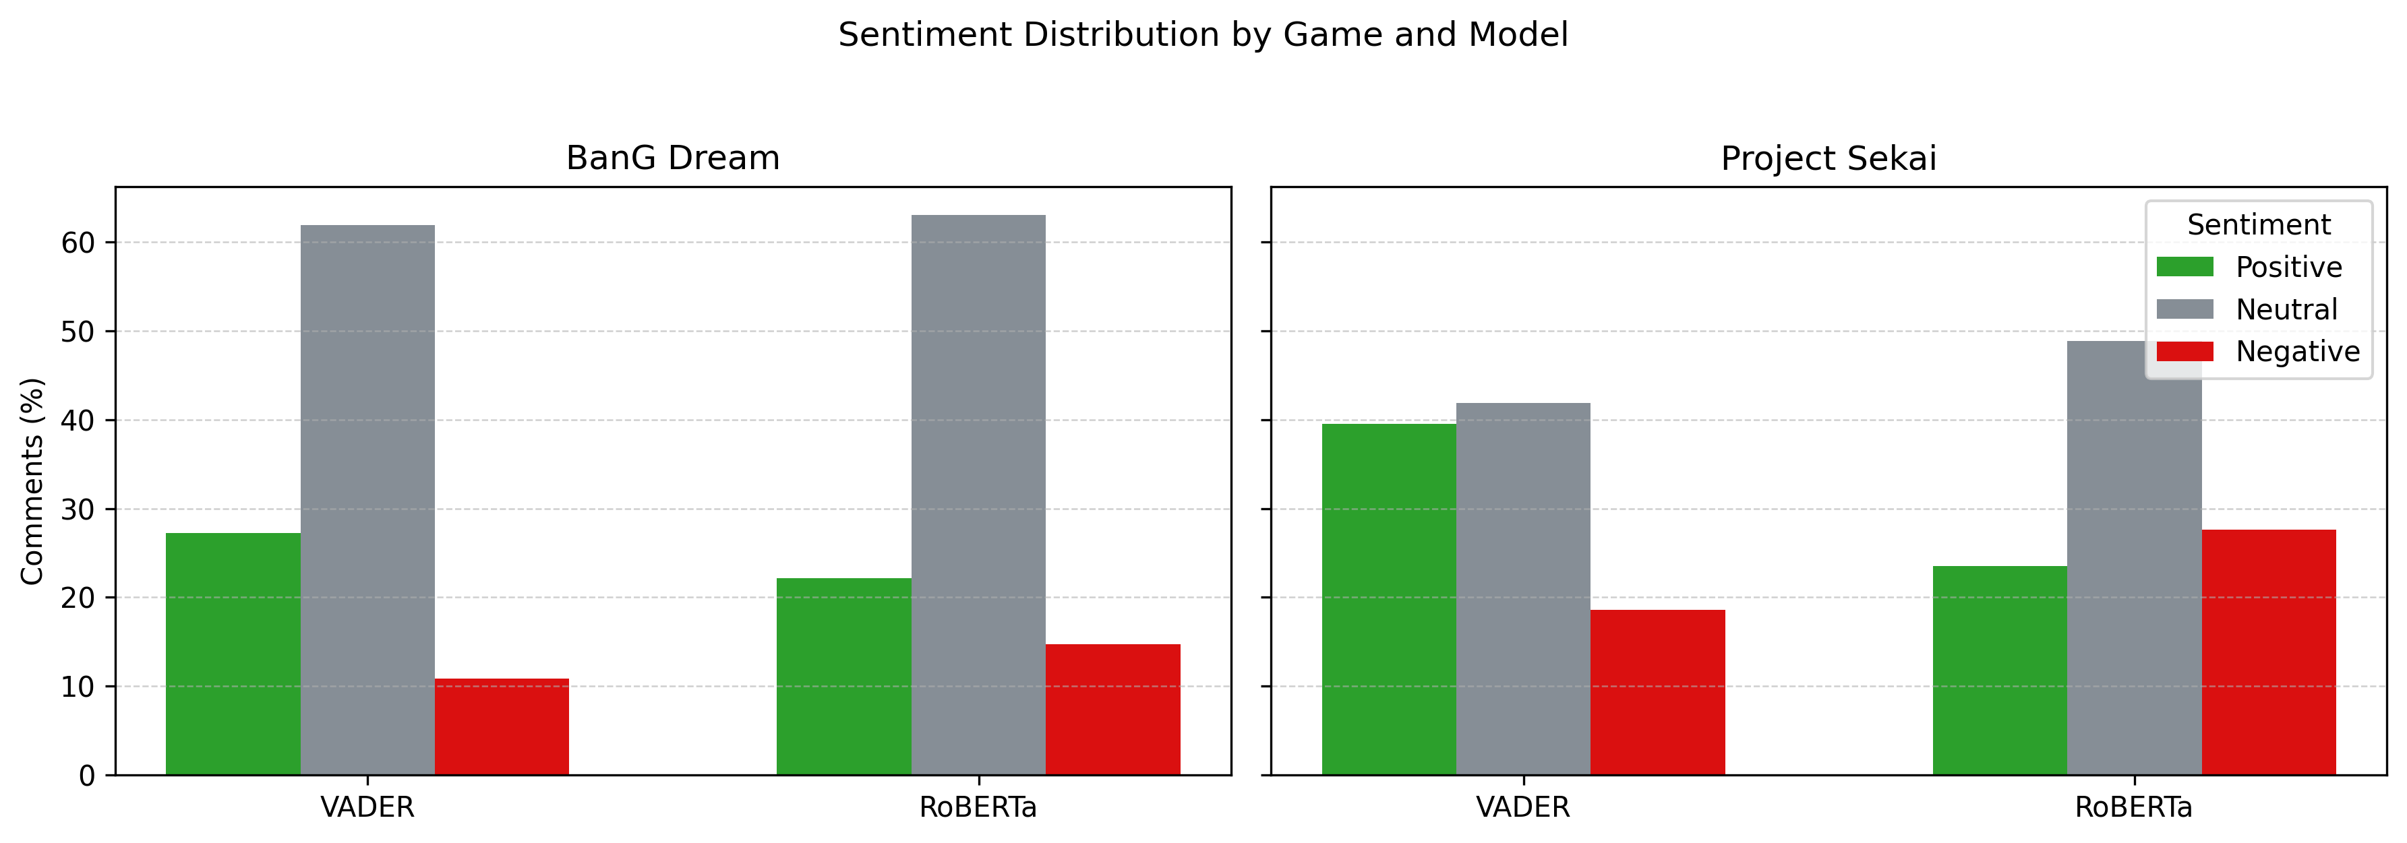
This finding is important to the research question because it shows that two similar rhythm game fandoms can still have noticeable differences in emotional patterns on the same platform. BanG Dream appears more neutral across both sentiment models, while Project SEKAI appears more emotionally polarised.

Sentiment Model Agreement
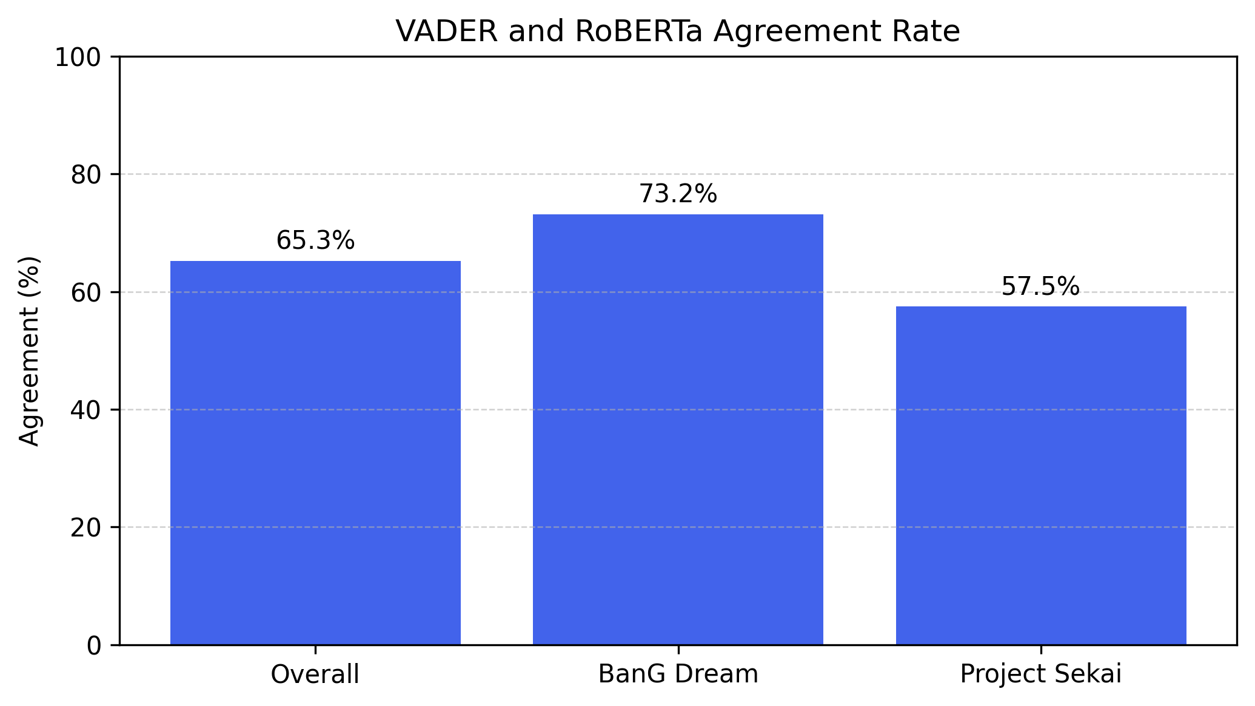
The VADER and RoBERTa results were also compared to examine whether both models classified comments in similar ways. Overall, the two models agreed on 65.26% of comments. However, the agreement rate differed between the two games. BanG Dream had a higher agreement rate of 73.18%, while Project SEKAI had a lower agreement rate of 57.49%.
This suggests that BanG Dream comments were easier for both models to classify consistently, likely because many comments were neutral or less emotionally intense. In contrast, the lower agreement rate for Project SEKAI suggests that its comments may contain more ambiguous, emotional, sarcastic, or fandom-specific language. This supports the earlier finding that Project SEKAI discussion appears more emotionally complex or polarised than BanG Dream discussion.

Network Structure Comparison
The reply networks for both communities were sparse and highly modular. This means that users did not interact evenly across the whole network. Rather, the interaction was divided into many separate groups or components.
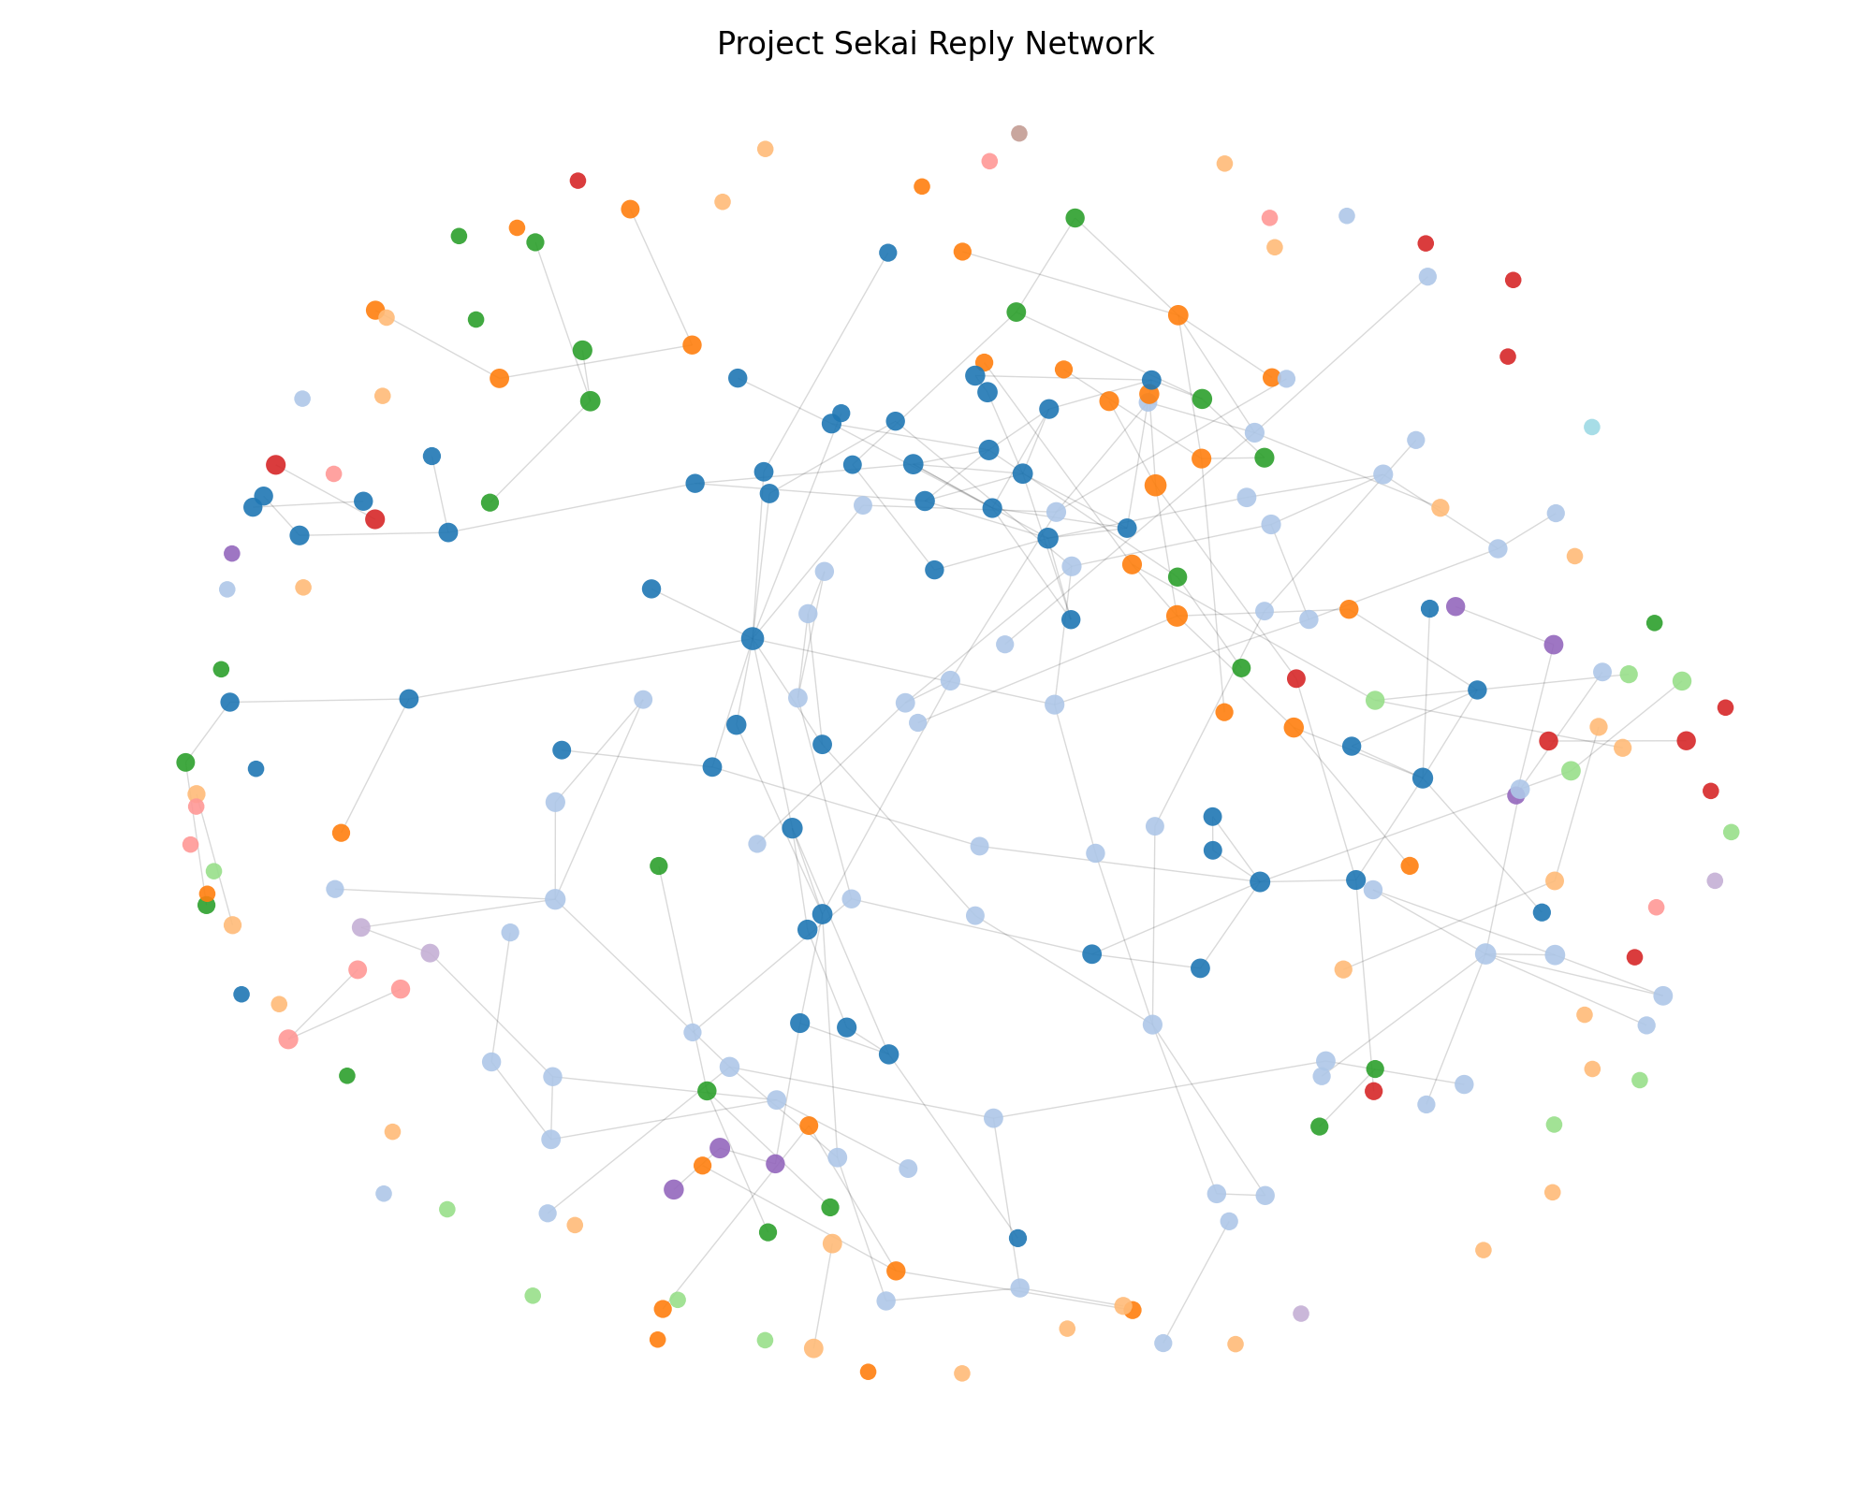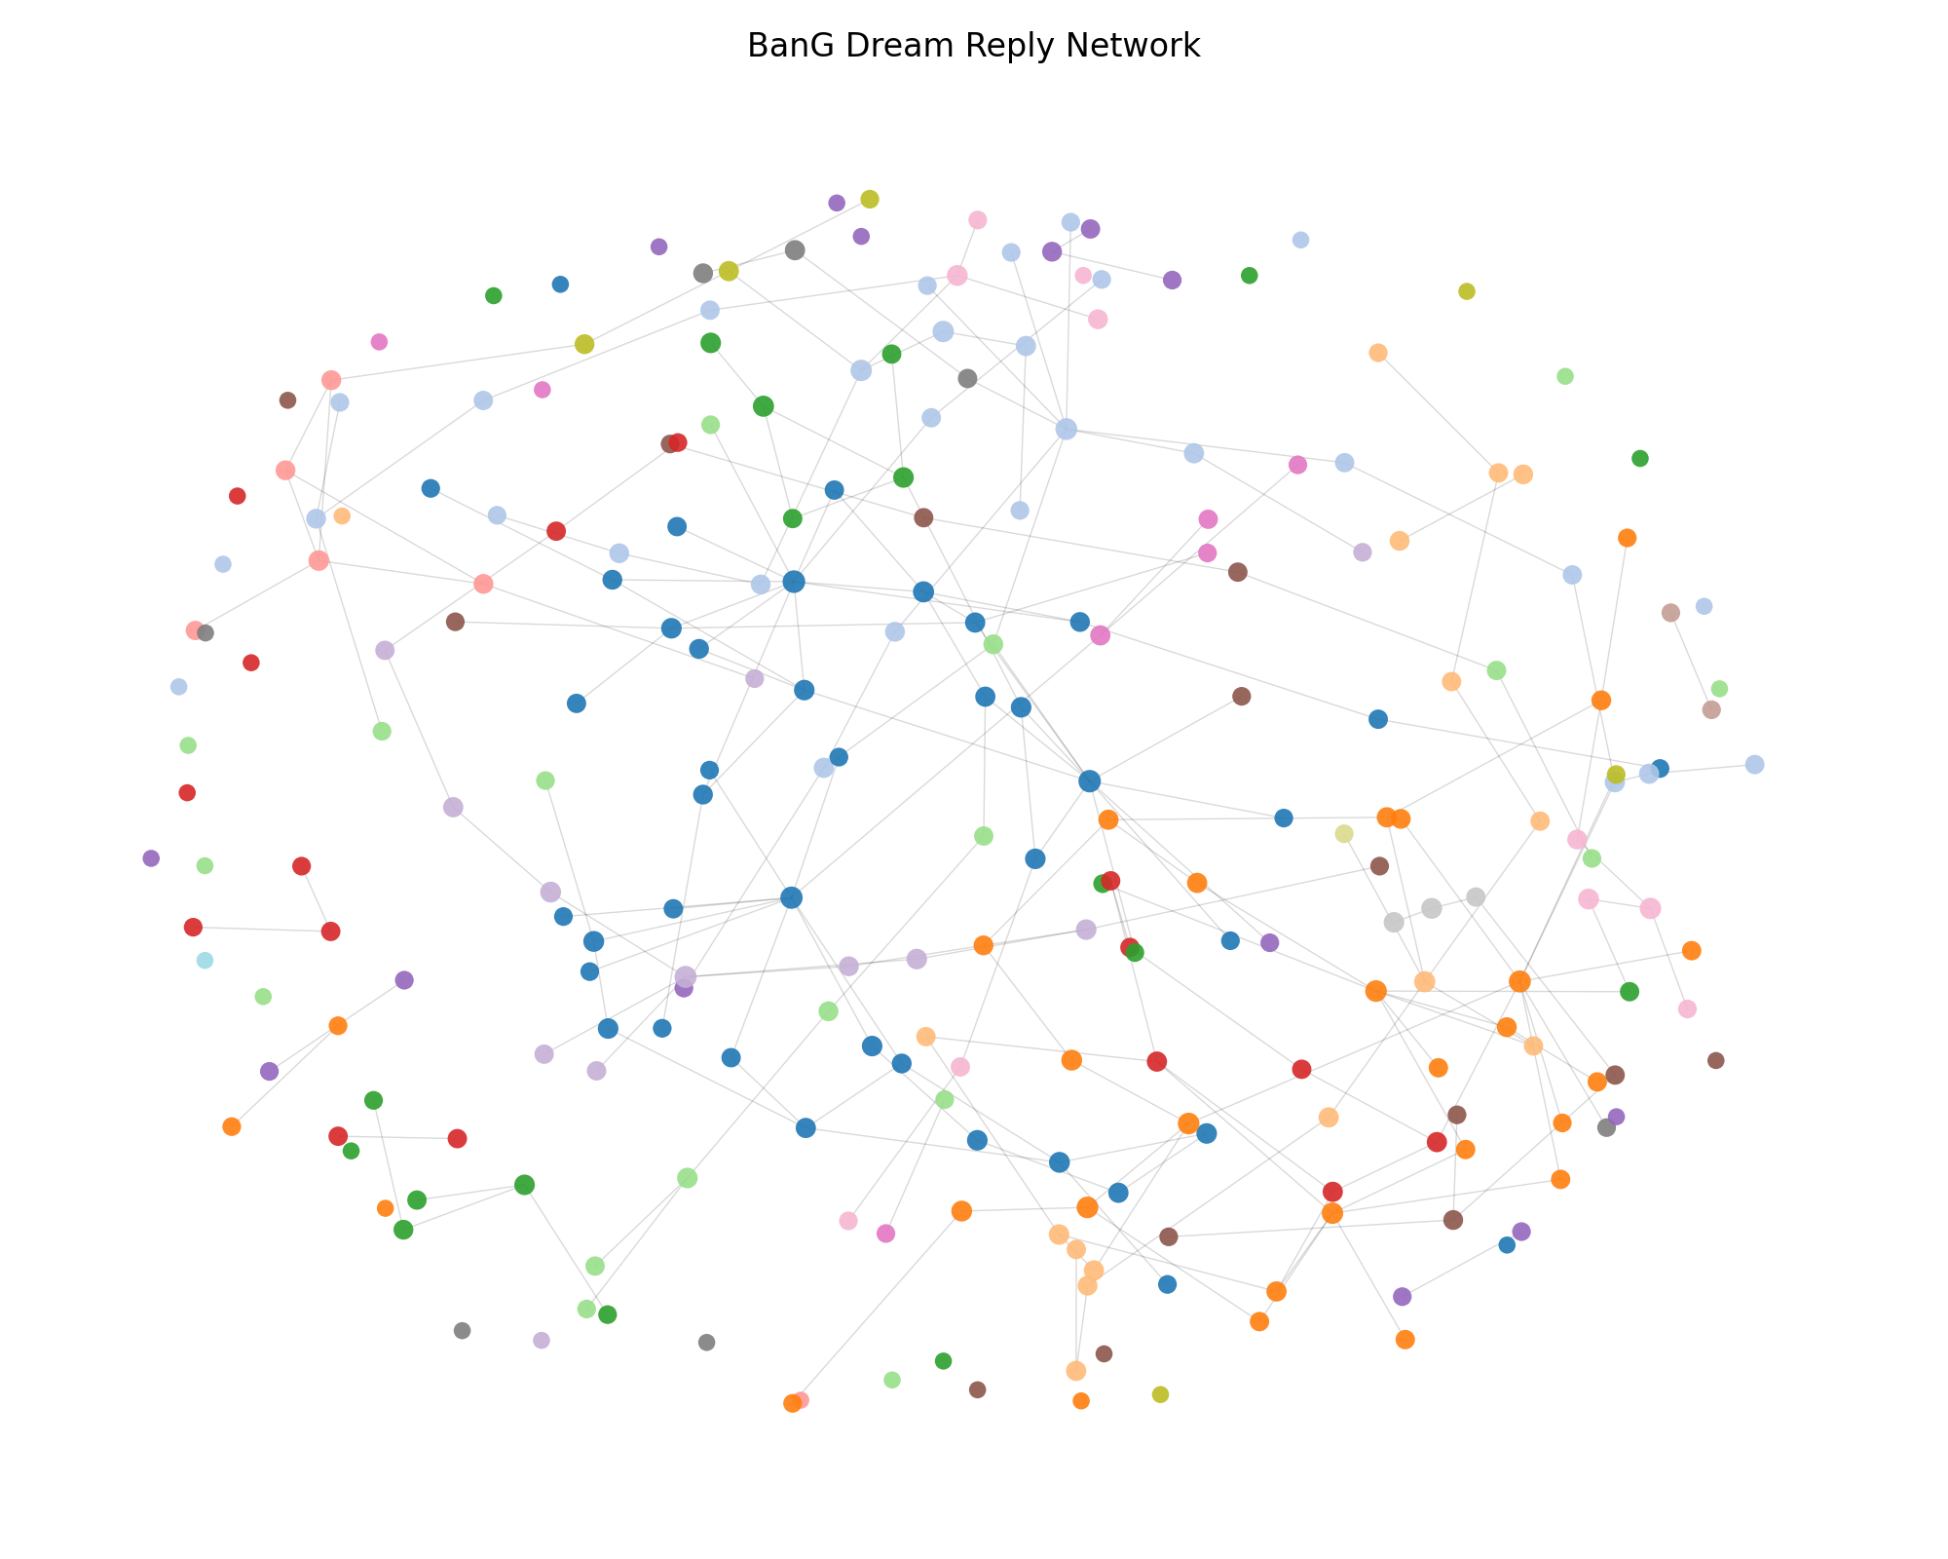
Project SEKAI had a larger reply network overall, with 3504 nodes and 3372 edges. While, BanG Dream had 2651 and 2582 respectively. This matches the dataset overview, where Project SEKAI had more replies and reply edges.
Both networks had extremely low density. Project SEKAI’s density was 0.000275, while BanG Dream’s density was 0.000368. This shows that only a very small fraction of possible user-to-user connections occurred within the networks. This is expected in YouTube comment networks since many users comment once or only reply to a small number of people.
Both networks were also fragmented into many components. Project SEKAI had 369 connected components, while BanG Dream had 274. This would mean, neither fandom formed one fully unified interaction network. Rather, users were distributed across many smaller reply groups. However, both networks also had a large main component: Project SEKAI’s largest component contained 2364 users, while BanG Dream’s largest component contain 1933 users.
The community detection results show the strong clustering within both fandoms. Project SEKAI had 407 detected communities and a modularity score of 0.941378. While BanG Dream had 305 detected communities and a modularity score of 0.920611. These modularity scores are very high, suggesting that both networks are strongly divided into clusters.
Though, Project SEKAI’s modularity score was slightly higher than BanG Dream’s, which suggests that Project SEKAI’s reply network may be more strongly separated into distinct interaction clusters. However, both scores are high enough to show that clustering is a major feature found in both communities.

Centrality and Sentiment
The analysis also compared sentiment patterns between high centrality users and peripheral users. High centrality users are more structurally important in the reply network, while peripheral users are less connected.
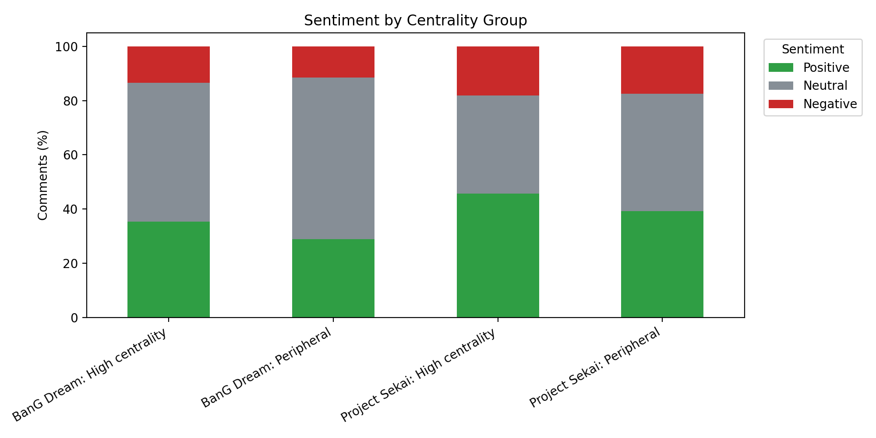
In both communities, high centrality users had a higher percentage of positive comments than peripheral users. For Project SEKAI, 45.64% of high centrality user comments were positive, compared with 39.25% for peripheral users. For BanG Dream, 35.36% of high centrality user comments were positive, compared with 28.97% for peripheral users.
This suggests that more connected users in both fandoms may contribute more emotionally engaged or supportive comments. In contrast, high centrality users also had slightly higher negative percentages than their peripheral counterparts in both datasets. This suggests that central users may be more emotionally expressive overall, rather than only more positive.
Project SEKAI’s high centrality users were especially positive compared with BanG Dream’s high centrality users. Though, Project SEKAI also had a higher negative percentage. This supports earlier sentiment findings that Project SEKAI discussion appears more polarised as compared to BanG Dream’s neutral discussion.
This result is useful because it connects network position with sentiment. It shows that the sentiment is not only different between games but also differs depending on user’s role in the interaction network.

Community and Cluster Findings
Community detection found many clusters in both reply networks. Project SEKAI had 407 detected communities, while BanG Dream had 305. The high modularity scores suggests that these clusters are not random but meaningful structural divisions in the network.
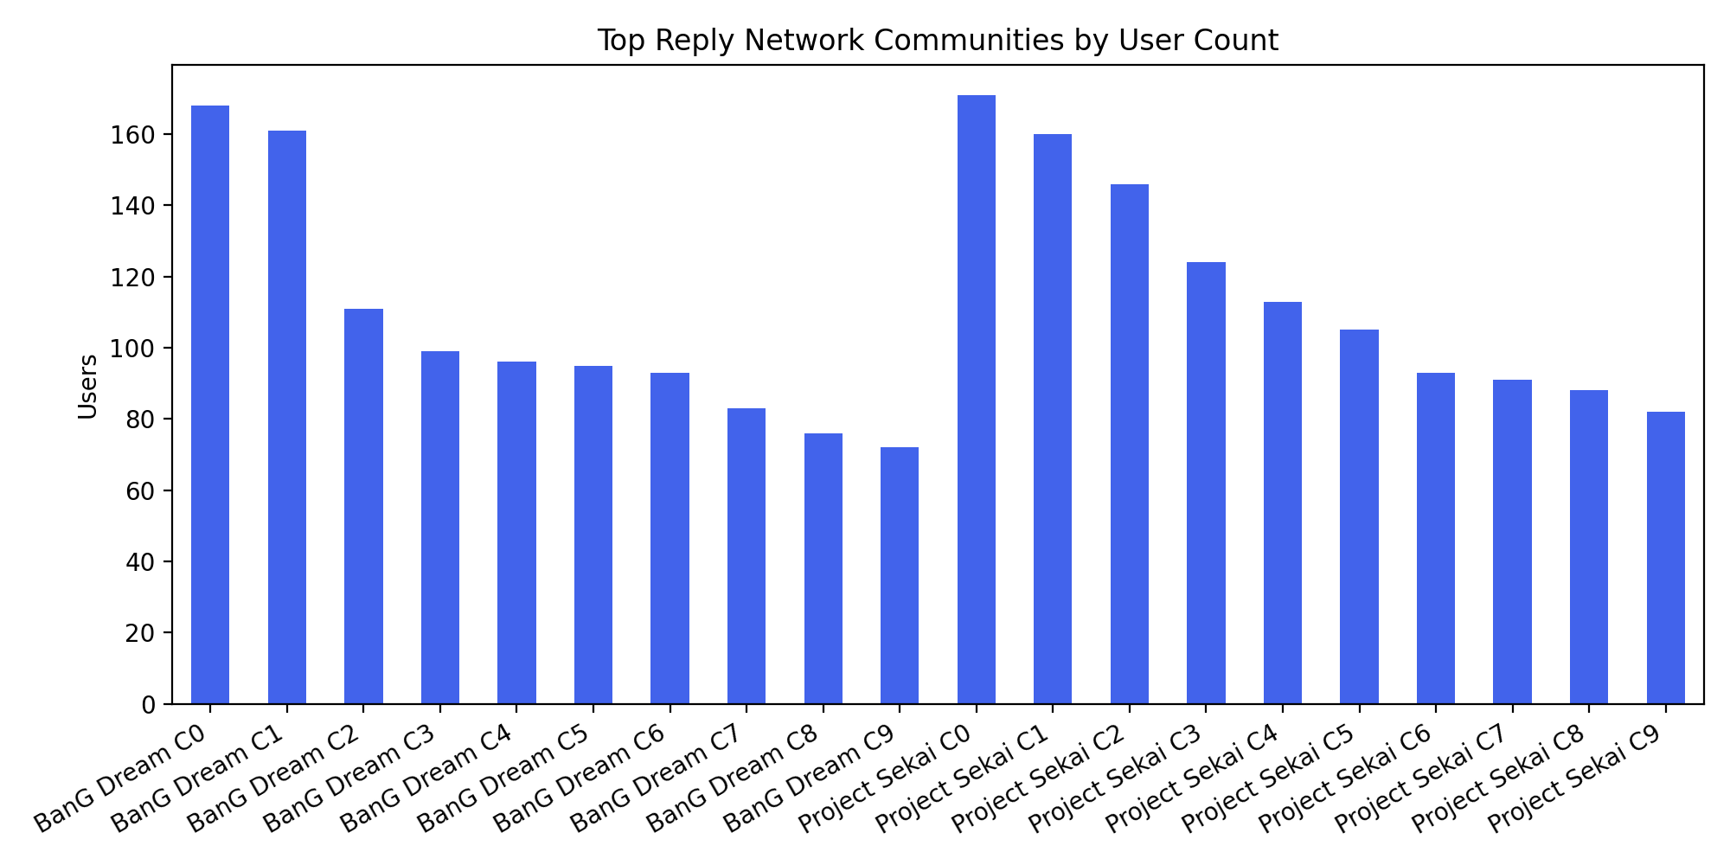
The largest BanG Dream communities ranged from 168 users to 72 users in the top ten communities. While for the largest Project SEKAI communities, they were generally larger, matching its larger reply network overall. Many smaller communities in both networks contained only a few users, which suggests that a large part of the YouTube reply interaction happens within small, isolated conversations.
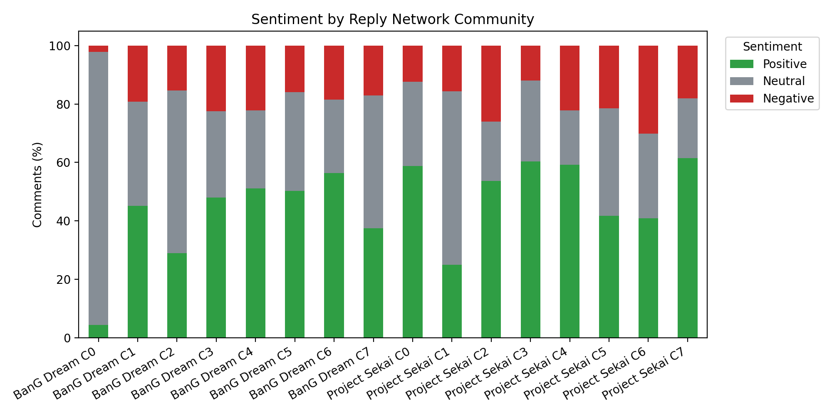
The community sentiment analysis showed that different clusters had different emotional patterns. For example, some BanG Dream communities were overwhelmingly neutral, while others had more positive or negative sentiment. In the community summary, one BanG Dream community had 93.55% neutral comments, while another had 56.31% positive comments. This shows that even within the same fandom, different interaction clusters can have different emotional tones.
This supports the idea that the YouTube rhythm game fandoms are not emotionally uniform. Instead, users appear to form smaller discussion clusters that may differ in both topic and sentiment. However, these clusters should not automatically be described as echo chambers. The analysis shows clustered interaction, but it does not prove that users are avoiding opposing views or reinforcing beliefs over time.
A more careful interpretation could be that both fandoms show evidence of self-contained interaction clusters. These clusters may become self-reinforcing if users mostly interact within the same group or around the same topic. Additionally, the use of longitudinal analysis would be needed to prove echo chamber behaviour more strongly.

Summary of Main Findings
The main findings from the results are:
- Both datasets are reasonably balanced, with 30 videos for each game with around 13000 comments per community.
- Project SEKAI had more unique users, replies and reply edges, thereby suggesting a more direct reply-based interaction in the sample.
- VADER classified Project SEKAI as having both higher positive and negative sentiment than BanG Dream.
- RoBERTa also showed Project SEKAI as less neutral and more negative than BanG Dream.
- BanG Dream was more neutral overall across both sentiment models.
- VADER and RoBERTa agreed more often on BanG Dream comments than on the same for Project SEKAI, suggesting Project SEKAI comments may be more emotionally complex or harder to classify.
- Both reply networks were sparse, fragmented and highly modular.
- Project SEKAI had a slightly larger and more modular network than BanG Dream.
- High centrality users were more positive than peripheral users in both communities under the VADER-based analysis.
- Different network communities showed different sentiment patterns, suggesting that the emotional tone varies across the different interaction clusters.
Overall, the results show that Project SEKAI and BanG Dream communities differ in both sentiment and network structure, even though they belong to the same broader rhythm game fandom category.

Discussion
Reiterating the research question:
How do interaction network structures and sentiment patterns differ between Project SEKAI and BanG Dream rhythm game communities on YouTube?
The results show that both communities form sparse and highly clustered YouTube reply networks. But they differ noticeable in their emotional tone and interaction scale. Although both communities belong to the same broader rhythm game category, the Project SEKAI dataset showed more reply-based interaction and more emotionally polarised sentiment, while the BanG Dream dataset showed a more neutral overall sentiment pattern.

Sentiment Differences Between the Communities
The sentiment results suggest that Project SEKAI discussion is more emotionally expressive and complex than BanG Dream discussion. Under VADER, Project SEKAI had both a higher positive and higher negative comment percentage, which means the community was not simply more positive or more negative, but more polarised overall.
The RoBERTa results supported the idea that Project SEKAI differs emotionally from BanG Dream, but in a more cautious way. RoBERTa classified fewer Project SEKAI comments as positive and more as negative compared with VADER. This difference suggests that the emotional tone of Project SEKAI comments may be more difficult to classify, especially if comments include sarcasm, memes, exaggeration, fandom-specific language or emotionally intense phrasing.
BanG Dream, in contrast, had a much higher neutral percentage across both sentiment models. This suggests that BanG Dream comments in the dataset were likely more descriptive, short, informational or less emotionally intense. This does not mean that the BanG Dream fandom is less engaged, but it may indicate that the sampled videos produced fewer strongly emotional reactions in the comments.
The model agreement results also support this interpretation. VADER and RoBERTa agreed more often on BanG Dream comments than on Project SEKAI comments. This suggests that BanG Dream comments were more straightforward for automated sentiment models to classify, while Project SEKAI comments were more ambiguous or emotionally varied.
This difference matters because it shows that two similar rhythm game fandoms can have different emotional cultures on the same platform. Even when the platform and broad genre are held constant, fandom-specific dynamics still appear to shape sentiment patterns.

Network Structure and Cluster Formation
Both communities formed sparse reply networks with very low density. This means users were not broadly connected to many others across the whole comment space. Instead, most users interacted with only a small number of others. This is typical of YouTube comment sections because many users post a single top-level comment or reply only once.
Both networks also showed very high modularity. Project SEKAI had a modularity score of 0.941378, while BanG Dream had a modularity score of 0.920611. These values suggest that both communities were strongly divided into clusters. In other words, users tended to interact within smaller groups rather than forming one evenly connected discussion network.
Project SEKAI’s network was larger and slightly more modular than BanG Dream’s. It had more nodes, edges, connected components, and detected communities. This suggests that Project SEKAI had more direct reply-based interaction but that this interaction was also divided into many separate clusters.
This supports the idea that rhythm game fandoms on YouTube can form self-contained interaction clusters. However, it is important not to overstate this as definite evidence of echo chambers. The analysis shows that clusters exist, but it does not prove that users are only exposed to similar opinions or that they avoid disagreement. Therefore, the findings are better described as evidence of clustered interaction patterns rather than full echo chambers.

Central Users and Sentiment
The centrality analysis showed that high-centrality users were more positive than peripheral users in both communities. This would suggest that the users who are more connected in the reply network may contribute more positive or emotionally engaged comments.
For Project SEKAI, high-centrality users had 45.64% positive comments, compared to the 39.25% among peripheral users. For BanG Dream, the high centrality users had 35.26% positive comments compared with the 28.97% among peripheral users. This patter suggests that central users may play a role in shaping the emotional tone of the discussions in the communities.
However, high-centrality users also had slightly higher negative percentages in both communities. This means that central users may simply be more expressive overall rather than purely more positive. They may be more likely to participate in debates, respond to others, defend opinions, or react strongly to content.
This is important because it connects the sentiment and network findings. The results suggest that sentiment is not evenly distributed across all users. Instead, a user’s network position may relate to the type or intensity of sentiment they express.

Evidence of Self-Reinforcing Interaction Clusters
The high modularity scores and large number of detected communities suggest that both fandoms contain many interaction clusters. These clusters may be self-reinforcing if users mainly interact with others within the same cluster or around the same video topic.
In the context of YouTube, this clustering may happen because discussions are organised around specific videos. Users who comment on or reply within the same video may form temporary clusters around that content. If a video attracts users with similar opinions, humour, preferences or emotional reactions, the comment section may become a small self-reinforcing space.
However, the evidence is stronger for interaction clustering than for full echo chambers. Echo chambers usually imply repeated exposure to similar viewpoints and limited exposure to opposing views over time. This project uses a static dataset of comments and replies, so it cannot fully prove long-term reinforcement or isolation.
Therefore, the most accurate conclusion is that both Project SEKAI and BanG Dream YouTube communities show signs of clustered interaction structures, but further research would be needed to determine whether these clusters behave as true echo chambers.

Why the Two Communities Differ
The differences between the two communities may have been caused by several factors.
Firstly, the selected videos were not perfectly matched in content type. Project SEKAI had a variety of videos including more opinion-based, update based and discussion style videos, while BanG Dream videos included more official music, anime, live performances and gameplay related videos. Opinion based videos may naturally invite a more emotional or polarised comment section rather than official music or episode content.
Secondly, the two fandoms may have different audience cultures. Project SEKAI has a large and highly active online fandom, especially around characters, units, events and songs. This may encourage more debate and emotionally expressive commenting. BanG Dream, while also has a strong fandom, the sampled videos utilised may have attracted more general appreciation or neutral reactions instead.
Lastly, YouTube itself shapes interaction patterns. Unlike a discussion forum like Reddit, where long threaded responses are central to the platform, YouTube comment sections are primarily attached to the videos. This means that interaction clusters may form around specific video content rather than around stable community groups. As a result, clustering in this project may reflect video centred engagement, as much as fandom division.

Connection to the Research Question
Overall, the results show that Project SEKAI and BanG Dream YouTube communities differ in both sentiment patterns and interaction network structures.
Project SEKAI had a larger reply network, more direct reply interactions, more detected communities and a slightly higher modularity score. It also had a more polarised sentiment distribution, with both more positive and more negative comments than BanG Dream. This suggests that the Project SEKAI community in the dataset was more active in reply-based interaction and more emotionally expressive.
BanG Dream had a smaller reply network and a more neutral sentiment distribution. Its network was still highly modular, showing strong clustering, but its comments were less emotionally polarised overall.
Therefore, the findings suggest that both rhythm game communities form clustered interaction networks on YouTube, but the nature of those clusters and the sentiment patterns within them differ. Project SEKAI appears more emotionally intense and structurally fragmented, while BanG Dream appears more neutral but still clustered.

Limitations
This study has several limitations. Firstly, sentiment analysis was performed user VADER, which is suitable for short social media text, but still has limitations. YouTube fandom comments often include sarcasm, humour, emojis, slang, and game-specific references. These features may cause some comments to be misclassified as positive, neutral, or negative. Future work could address this by comparing VADER with a contextual transformer-based model such as RoBERTa, which may better capture meaning in sarcastic or context-dependent comments.
The network analysis is based only on YouTube reply interactions. This means that the network captures users replying to each other in comment threads, but it does not capture wider social relationships such as subscriptions, friendships, likes, views, or interactions on other platforms. As a results, the network should be interpreted as a reply network rather than a complete fandom social network. Future work could extend the analysis to platforms such as Reddit, X/Twitter, or Discord to capture broader fandom interactions.
Moreover, YouTube comment networks are often shallow and one-directional. Many users leave only one comment or reply once, which can produce sparse networks with low density and low reciprocity. Therefore, the detected communities show clusters of reply interaction, but they do not prove that users are isolated to strict echo chambers.
Finally, the comparison only focuses only on two rhythm game communities on one platform. The findings show differences between the sampled Project SEKAI and BanG Dream YouTube communities, but they should not be generalised to all rhythm game communities or to the same fandoms on other platforms. To improve reliability within this scope, both datasets were collected sing similar search strategies, the same collection limits, and the same preprocessing and analysis pipelines.

Conclusion
This project compared the YouTube communities of two major rhythm games, Project SEKAI: Colorful Stage! And BanG Dream! Girls Band Party!, using sentiment analysis and network analysis. The research question asked how interaction network structures and sentiment patterns differ between the two rhythm game communities on YouTube.
The results show that both communities form sparse, highly clustered reply networks. Both networks had very low density and high modularity, suggesting that user interaction is divided into many smaller clusters rather than one fully connected discussion space. This indicates that clustered interaction is a common feature of both rhythm game communities on YouTube.
However, the two communities differed in both scale and sentiment. Project SEKAI had more unique users, replies, reply edges and detected communities. The sentiment results also showed that Project SEKAI was more emotionally polarised than BanG Dream. VADER classified Project SEKAI as having both more positive and more negative comments, while RoBERTa classified it as less neutral and more negative than BanG Dream. BanG Dream had a higher proportion of neutral comments across both sentiment models, suggesting that its sampled YouTube discussion was less emotionally intense overall.
The centrality analysis also showed that high-centrality users were more positive than peripheral users in both communities. This suggests that more connected users may contribute more emotionally engaged or supportive comments. However, central users also showed slightly higher negative sentiment, meaning they may be more expressive overall rather than simply more positive.
Overall, the findings suggest that Project SEKAI and BanG Dream YouTube communities both form clustered interaction networks, but they differ in emotional tone and interaction intensity. Project SEKAI appears more active and emotionally polarised, while BanG Dream appears more neutral but still structurally clustered. The inclusion of both VADER and RoBERTa shows that the exact sentiment distribution depends on the model used, but both models support the broader conclusion that the two communities differ in emotional tone. These findings support the idea that even similar rhythm game fandoms on the same platform can develop different social and emotional patterns.
The project itself does not prove the existence of full echo chambers, but it does show evidence of self-contained interaction clusters. Future work could improve this analysis by using more closely matched video types, collecting data over time, comparing other relevant and active platforms, or analysing the topics discussed within each detected network community.

References

