|  |  |
| --- | --- |
| CS372-400 | Edmund Dea |
| 9/21/2019 | ID# 933280343 |

**Lab 1: Wireshark**

1. List 3 different protocols that appear in the protocol column in the unfiltered packet-listing window in step 7 above.

HTTP, DNS, TCP

1. How long did it take from when the HTTP GET message was sent until the HTTP OK reply was received? (By default, the value of the Time column in the packet listing window is the amount of time, in seconds, since Wireshark tracing began. To display the Time field in time-of-day format, select the Wireshark View pull down menu, then select Time Display Format, then select Time-of-day.)

22:00:14.318313 – 22:00:14.216926 = 0.101386 sec

It took 0.101386 sec from when the HTTP GET message was sent until the HTTP OK reply was received.

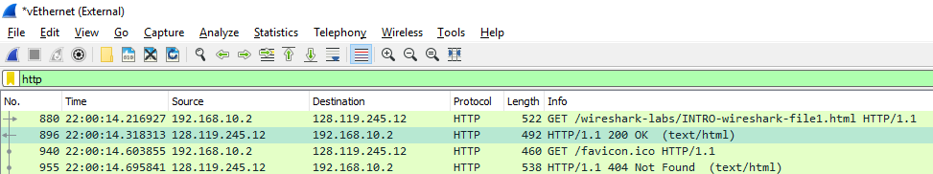

1. What is the Internet address of the gaia.cs.umass.edu (also known as wwwnet.cs.umass.edu)? What is the Internet address of your computer?

The internet address of gaia.cs.umass.edu is 128.119.245.12, which is the destination IP address.

The internet address of my computer is 192.168.10.2, which is the source IP address.

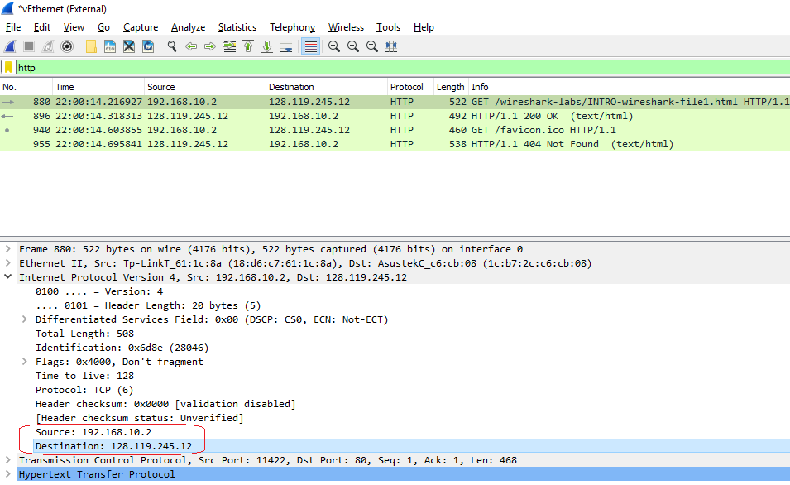

1. Screenshot the two HTTP messages (GET and OK) referred to in question 2 above. Make sure to include all pertinent information in the screenshot (Time field, Internet addresses, etc). Paste these screenshots into your lab report.

