**Creating a Scatterplot in RStudio for Beginners (All Downloads Included)**

This tutorial is designed for beginners with little to no experience with RStudio and the ggplot2 package. These instructions are best accessed online, as there are many live links to access for ease of use. All you need to follow this tutorial is a computer processing system compatible with R and RStudio and enough storage on your device to complete these downloads.

**5 Major Steps:**

1. Download r
2. Download rstudio
3. Access data and set up package
4. Build code
5. Customize your plot
6. **Download R**

To use RStudio, you must first download the software “R” on your device. You can think of R as a base software, and RStudio as the user interface. Your device must be run by Windows, macOS, or Linux to continue. If you already have R downloaded, check that you have the most recent version (as of 2/8/23 the most recent version is 4.2.2). If you do not have the most recent version, you can redownload R by continuing to follow these instructions. If you try to use an old version, the rest of these instructions may or may not be applicable to you depending on version differences.

* 1. Start by clicking this link: <https://cran.r-project.org/mirrors.html>.
  2. You will be prompted to choose a mirror. Choose the mirror in the location closest to the location that you plan to use RStudio the most. For Iowa State Students, scroll down to the Iowa State Mirror, or click this link <https://mirror.las.iastate.edu/CRAN/>.
  3. In the top box labeled “Download and Install R,” click on the download link compatible with your device.

* 1. Next, click on the link labeled “install R for the first time.”

* 1. Then, click the top link labeled “Download R…”. A download will pop up. Continue to follow the prompted instructions.

* 1. For further information, questions, or troubleshooting regarding your R download, refer to the R FAQ page at this link: <https://mirror.las.iastate.edu/CRAN/doc/FAQ/R-FAQ.html>.

1. **Download RStudio**

This step will be downloading RStudio. RStudio requires R to run, so make sure you have completed all of Step 1.

* 1. Here are some quick links for Windows and Mac RStudio downloads: Click the appropriate link if you have a Windows 10/11 or macOS 11+ operating system.
* Windows 10/11: <https://download1.rstudio.org/electron/windows/RStudio-2022.12.0-353.exe>
* macOS 11+: <https://download1.rstudio.org/electron/macos/RStudio-2022.12.0-353.dmg>
  1. For other processing systems, follow this link: <https://posit.co/download/rstudio-desktop/>
  2. Scroll down to the “All Installers and Tarballs” section. Click on the download link listed next to your computer’s operating system. Other operating systems supported include *Ubuntu 18+/Debian 10+, Ubuntu 22, Fedora 19/Red Hat 7, OpenSUSE 15,* and *Fedora 34/Red Hat 8*.

* 1. After clicking the necessary link for your operating system, follow the pop up guides to complete your download.

1. **Prepare for Plot**
   1. First open RStudio on your device by double clicking the icon, or searching for the application wherever you chose to store it on your device. The application icon looks like this:

* 1. Start by creating an RScript by clicking on File then R Script. This will create a savable document to store your code.

* 1. Click on the lower blue save icon to save your new script. The system will prompt you to choose a name for your file and place to store it. Choose a location where you can easily find your file.

* 1. Install the ggplot2 package by copying and pasting the code below into your saved R Script. While your cursor is clicked into the same line as your code, hold the “control” key then simultaneously click the “enter” key on your keyboard to send your code to run.

install.packages("ggplot2")

1. **Create a Basic Scatterplot**
   1. This step is where you can read in your own data, but for demonstration purposes, we will use a dataset named *iris* that is already accessible. Importing your own data only adds a small step. Follow this link for a simple guide to this step: <https://journeytodatascientist.blog/2019/07/21/read-data-from-excel-text-csv-files-rstudio/#:~:text=To%20read%20in%20a%20csv%20file%2C%20you%20use,df_csv%20%3D%20read.csv%20%28%E2%80%9Cfilename.csv%E2%80%9D%2C%20header%20%3D%20TRUE%2C%20sep%3D%E2%80%9D%2C%E2%80%9D%29>
   2. Use the library function so that RStudio will access the ggplot2 package that you just downloaded. Copy and paste the code below, then send it to the console to run (reference 3.4).

library("ggplot2")

* 1. Enter the code for the scatterplot. Copy, paste, then run the code below. Make sure you are on the “Plot” tab in the right corner to see your scatterplot appear.

ggplot(iris, aes(x=Sepal.Length, y=Sepal.Width)) + geom_point()

* 1. To access or save your plot, right click on the plot and select “Copy Image” or “Save Image As”.

1. **Customize Your Plot**

You are done creating your basic plot, but plots used in professional settings need to be elevated. This final step is crucial if you plan to present your graphics. Copy, paste, and run the lines of code that you would like to add to your plot. Note, the “+” sign needs to go at the end of the line above it.

* 1. Add a title

+ ggtitle("Iris Sepal Length and Width")

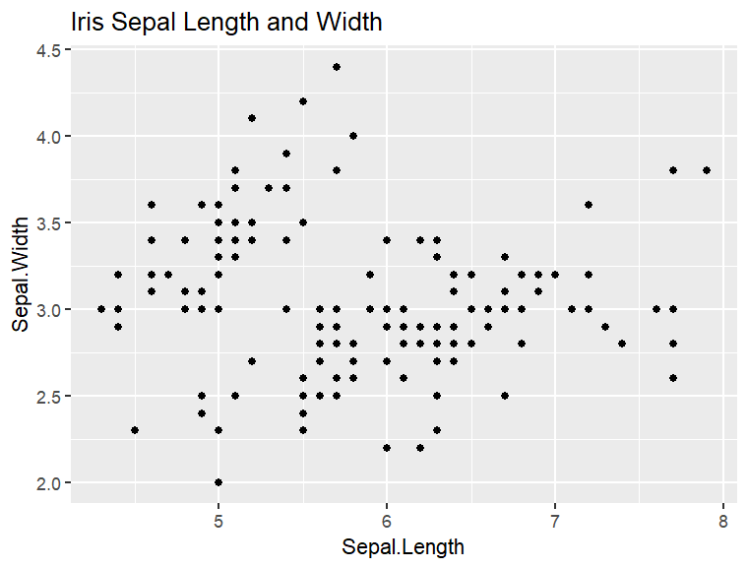

ggplot(iris, aes(x=Sepal.Length, y=Sepal.Width)) +

geom_point() +

ggtitle("Iris Sepal Length and Width")

* 1. Change axis title
  2. Add color