NOVEL INFRARED SENSORS AND APPLICATIONS

Elijah R. Jensen M.S.

Proposal Supplemental Information

Many physical quantities and phenomenon can be studied using optical methods. The use of EM waves can be the best way of studying physical phenomenon in general. For many applications visible light is a sufficient illumination, however for many systems light outside of the visible range must be employed.
This thesis outlines techniques and technologies for sensing and detecting phenomenon using light in the IR spectrum. Current sensor technology is employed to make various measurements including: seismic activity sensing, health monitoring, materials defects and astronomy. Measurements are made using a novel 32 bit data acquisition system (DAQ) that was designed to support this work, as well as custom designed circuits for integrating current optical sensing devices. Novel designs for inexpensive room temperature IR sensors using nanoscale graphene antenna arrays are also designed and tested with the same 32 bit DAQ system. These devices are analyzed, compared and ranked for usefulness in particular applications.
INTRODUCTION

Most of what we understand of the world around us is based on what we can see. What humans can see however is a very small part of the electromagnetic spectrum. Our eyes only function in a small part of the spectrum from ~400nm to ~700nm. Figure 1.1 shows a map of the EM spectrum. The region just to the right of the visible region in this figure is the infrared region (IR). Infrared literally means "below red" the name comes from the Latin infra meaning below. In frequency terms the IR region extends from 300GHz to 430THz (1mm to 700nm wavelength). With regard to human recorded history, IR radiation is a relatively new discovery; William Herschel noticed its effect on a thermometer in the year 1800. Making further experiments on what Herschel called the ‘calorific rays’ that existed beyond the red part of the spectrum, he found that they were reflected, refracted, absorbed and transmitted just like visible light. It would take Maxwell's theories to solidify “calorific rays” as just another part of the same electromagnetic spectrum.

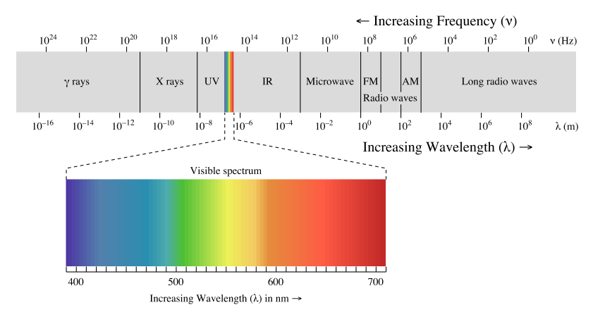
The first infrared detectors were based on the Seebeck effect. In this scheme the infrared light thermally heats a detector made of dissimilar metals. The voltage produced is linearly proportional to the temperature of the junction, and thus proportional to the infrared wave power transferred. Many Far Infrared detectors are still made using this method. This method of thermal conversion is used in microbolometer arrays. An advantage to microbolometer arrays is that the distribution of detectivity vs. wavelength is a constant. That is to say microbolometers have a large bandwidth. There is a disadvantage however due to the fact that the thermal conversion is slow compared to other methods of conversion. The substrate must heat up to provide a signal voltage and therefore the sampling time is on the order of seconds to minutes. It was not until 1957 when W.D. Lawson, et. al. discovered HgCdTe ternary alloy as infrared detector material. The first solid state arrays for imaging were produced in 1961. Since that time much progress has been made in making CCD and CMOS detectors a viable option for IR detection. Photon capture methods still have some disadvantages however. Because of thermal noise it is impossible to achieve a high signal to noise ratio in a photon capture based IR detector without cooling the device. Most mid-IR range devices need to be cooled to at least 77K to operate effectively. Far IR range devices need further cooling, in many cases even down to 4K. Different methods of cooling these devices will be discussed further on in this thesis.

