CPRE 575 Project Proposal – Virtual Backdrop

# Sales Pitch:

Virtual Backdrop eliminates the need to spend hours at the Driver License Station waiting for other people to take photos. It does this by creating professional grade driver's license photos using a picture from a cell phone. Costs will be reduced, the speed will be increased and your photo will look better. Virtual Backdrop will let you take advantage of this by taking your photo, removing the background and allowing you to choose your favorite photo before you even step into the Drivers License Station. We also are aiming to ensure that hair is included inside the picture as many currently used algorithms get confused.

Virtual Backdrop will specifically be used to separate the background from pictures/videos. This will allow it to be used in other applications besides giving a backdrop for Driver's license photos. However, the primary purpose of this application is to allow users to use their own photos as their driver's license photo.

# Target Audience:

We are targeting drivers between the ages of 16 and 30 who routinely download applications and would like to spend less time at the Drivers License Station. Furthermore these users must be aiming to get a driver's license within the state of Iowa. We are specifically targeting users with Android based smart phones and anyone who currently uses a kiosk to replace their driver's license photo. At the current time, kiosks need to have a standing our mounted backdrop behind the photos and Virtual Backdrop could help eliminate this.

# Need for Application:

Virtual Backdrop is needed to enhance the experience of getting a Drivers license for residents of the State of Iowa. This application can further be used to create a database for facial recognition. The pictures we create will meet the standards for a driver's license and in doing so, will meet the standards for facial recognition.

Specifically, with the introduction of new technologies that require a photo with a high enough quality to be included in biometric databases used for facial recognition, photos will need to remove artifacts from their backgrounds to create consistent images of faces. Previously, colored backdrops were used to ensure noise was reduced from the photos. But this places significant limitations on the photos that can be used in the databases and the process to take said photos (i.e. cellphone cameras cannot be used). Ideally, software could be created to identify faces, remove backgrounds and produce a uniform virtual backdrop for the photo regardless of the composition of the original photo. One specific hurdle to overcome is that current algorithms can sometimes get confused with a person's hair and fill in the hair with the backdrop color instead of leaving the alone.

# Previous Approaches

# Previous Experience

Our team is comprised of three people: Edward Jezisek, Nichole Dugan and Brian Schulte. Edward Jezisek has experience with Mobile experience and a strong interest in

Nichole Dugan is a C# developer working for the state of Iowa in the Department of Transportation. She has been working with driver’s license issuance since 2007 and has helped with the facial recognition program in the state of Iowa. She has also worked with vendors for the state of Iowa implementing self-service kiosks for the state, and recently has worked with a vendor to interface with the state of Iowa’s system of record for the mobile driver’s license project.

# Approach

Our proposed approach to this project is two-pronged. First, we want to research current algorithms being used as well as if said current algorithms could be modified to accomplish the goal. Secondly, we want to design a high-level process that is streamlined, scale-able and secure for users to import pictures taken with many types of cameras in many environments, manipulate them easily (like clicking a button rather than manually altering) and save a picture that meets the necessary specifications into the database.

# Overall Requirements

The AAMVA (American Association of Motor Vehicle Administrators) is the governing body regulating driver’s license documents. According to AAMVA standards, the background for driver’s license photos is stated as:

Background. A uniform light blue color or white background shall be used to provide a contrast to the face and hair. Note: Preference is for uniform light blue color, such as Pantone 277 (though the specific Pantone color is not a requirement – a uniform light blue color or white background is a requirement).[1]

An example photo from a driver’s license is shown in the below image.



A typical driver’s license station with the photo backdrop is shown in the below image.

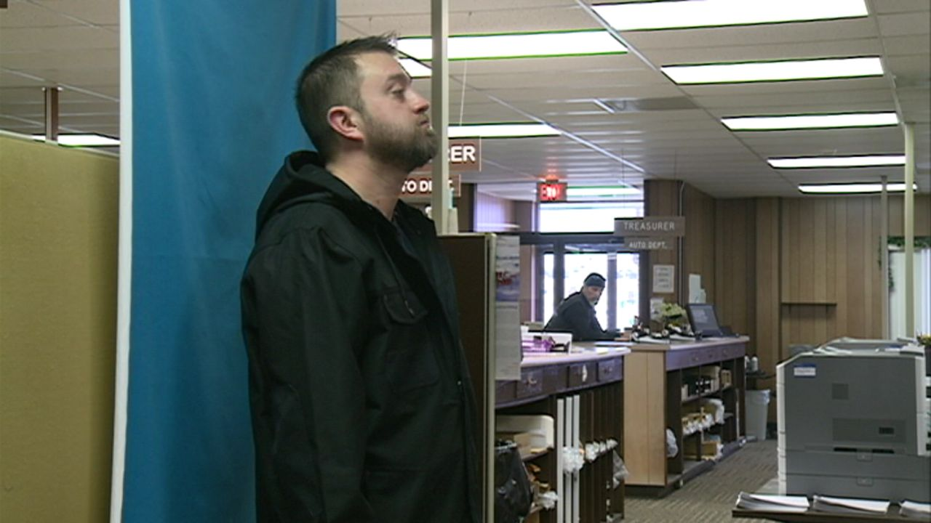

When kiosks were introduced as a solution for citizens of the state of Iowa to be able to renew or replace their driver’s licenses without visiting a driver’s license station, certain limitations were required because of the backdrop functionality. The kiosk needs to have a standing or mounted backdrop behind the photo area to allow for the photo to have the required blue backdrop. A video showing the kiosks is located at this URL: <http://www.kcci.com/news/new-kiosks-let-you-renew-your-iowa-drivers-license/33374300>

In addition to the kiosks, the state of Iowa has recently introduced a pilot program to allow for mobile driver’s licenses. One of the suggested features has been allowing the user to take a photo from their device and use that as their driver’s license photo.

# Hardware Requirements

For this project a camera will be needed. This camera will need to take pictures of approximately 72dpi. These pictures will be approximately 4MB in size. For our project to be successful; we need to be able to process all of the drivers in Iowa in a one month time period. As there are 2.3 million drivers we need to be able to process 8 Terabytes worth of pictures in a one month time period. In addition, if this is to scale to multiple states; we need to make sure that our solution is distributive and able to scale/be run on multiple machines. Our initial product will run on the Ubuntu O/S, but future releases will need to use Redhat to ensure scalability.

Our application will be created using C++ and the gcc (Ubuntu 4.8.4-2ubuntu1~14.04) 4.8.4 compiler , the OpenCV 3.1.0 library and Boost. This will allow us to use the library based functions inside of OpenCV and develop intermediary tests for our application using the Boost::Test framework. Finally, we will provide several videos/pictures that can be used in our application to ensure that the provided photos meet necessary standards. Some of the processing will need to be done on the device as to prevent the server from receiving and processing too much of the required load.

This will require us to include parts of our code in Android. The specific version of Android that we will use is: ____

1. AAMVA 2013 CDS (Card Design Standards) http://www.aamva.org/WorkArea/DownloadAsset.aspx?id=4435