Fall 2020 Quiz: Legal Authorities

Reminder: We have significantly edited many of these authorities, including the case names and citations. Accordingly, do not use or cite these authorities for any other purpose besides this assessment.

Authorities 1 and 2 appear in a print source, the spine of which is shown below right. It is dated 2019, states that it contains North Carolina’s official statutory compilation, and is published by LexisNexis:

Authority 1
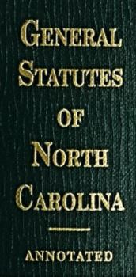
Chapter 107. Landlord and Tenant
Article 2a. Ejectment of Residential Tenants
Section 107-19.6. Manner of ejectment of residential tenants
It is the public policy of the State of North Carolina, in order to maintain the public peace, that a residential tenant shall be evicted, dispossessed or otherwise removed from his dwelling unit only in accordance with the procedure prescribed in Article 3 of this Chapter.

Authority 2

Chapter 107. Landlord and Tenant
Article 3. Summary Ejectment
Section 107-20. Tenant holding over may be dispossessed in certain cases

(a) Any tenant or lessee of any house or land who holds over and continues in the possession of the premises, or any part thereof, without the permission of the landlord, and after the landlord has demanded that the tenant or lessee leave the premises, may be removed from such premises in the manner hereinafter prescribed in any of the following cases:

- When a tenant in possession of real estate holds over after his term has expired.

- When the tenant or lessee, or other person under him, has done or omitted any act by which, according to the stipulations of the lease, his estate has ceased.
Authority 3 appears in Volume 20, dated 2020, of Strong’s North Carolina Index 4th, shown below right, and states in part the following on page 40:

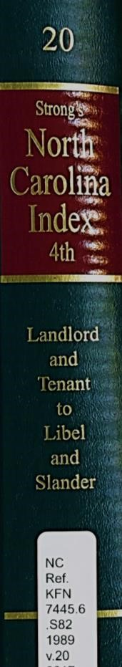
Sally J.T. Necheles, J.D., LL.M
IV. In General; Summary Ejectment
B. In General
2. Grounds for Summary Ejectment

Statutes:
Any tenant or lessee of any house or land who holds over and continues in the possession of the premises after his or her term has expired, without the permission of the landlord, and after the landlord has demanded that the tenant or lessee leave, may be removed from the premises in the manner prescribed.
Cases:
The summary ejectment remedy is restricted to those cases or grounds expressly covered by the statute.

The summary ejectment remedy is restricted to situations where the relationship of landlord and tenant exists, and if the record lacks evidence to support a finding of a landlord-tenant relationship, the court must dismiss the plaintiff's summary ejectment proceeding.

Authority 4 appears in the two reporters shown below right, starting at page 264 of the official state reporter and page 383 of the unofficial regional reporter.
Authority 4 states in part:
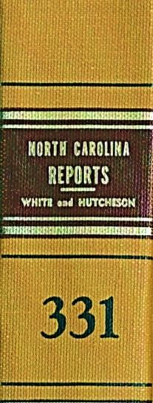

Supreme Court of North Carolina.
THE COMMUNITY HOUSING GROUP OF
NORTH CAROLINA and Darius Stanfield.
v.
Bryan T. HENRY.
No. 372A91.
June 20, 1996.
- 264 … ** 383 It is apparent from an inspection of the record that the court lacked jurisdiction.
The jurisdiction of a court in summary ejectment
proceedings is purely statutory. The remedy of summary
ejectment is restricted to those cases expressly provided by
the summary ejectment statute. Both the basis and the scope of the proceeding are limited by the statute.
- 265 Here, the proceeding should have been dismissed for lack of jurisdiction as the plaintiff did not allege that defendant committed any action set out in the statute.
** 384 This decision renders unnecessary any discussion of defendant’s other alleged exceptions.

The decision of the district court is thus reversed and remanded.

Authority 5 appears in the two reporters shown below right. It starts at page 319 of volume 109 of the official state reporter and at page 111 of volume 420 of the unofficial regional reporter. Authority 5 states in part:
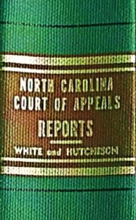


Court of Appeals of North Carolina.
Robert L. JONES, Plaintiff,
v.
Eileen SWAIN, Defendant.
No. 0321SC986.
August 12, 2004.

- 319 … ** 111 The question before us is whether the district court had authority to enter summary judgment for plaintiff on his complaint for summary eviction of defendant.

The summary ejectment statute only applies if the tenant entered into possession under some contract * 320 or lease, either actual or implied, with the supposed landlord.

** 112 In his affidavit in support of his motion for summary judgment, the plaintiff, Robert L. Jones, stated only that (1) Eileen Swain has resided at 1705 Oberlin Road since approximately August 1986 and has not paid rent, (2) no rent has been requested from her, and (3) Ms. Swain “is residing in the premises under no lease.”

- 321 Jones has thus provided absolutely no evidence that he is a “landlord,” that defendant is a “tenant,” or that there was ever any contract or lease, actual or implied, between him and Ms. Swain. ** 113 Accordingly, the statute providing for summary ejectment has no application here, and the district court had no authority to enter summary judgment summarily ejecting defendant.

Reversed and remanded.

Authority 6 appears in the two reporters shown below right, starting at page 167 of

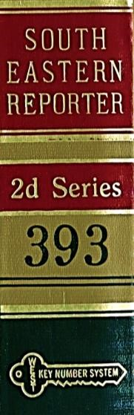
the official state reporter and at page 18 of the unofficial regional reporter. Authority 6 states in part:

Court of Appeals of North Carolina.
Anthony T. RAMIREZ, d/b/a Hickory Homes,
Plaintiff,
v.
Margaret LEE and Willie P. JONES, Defendants.
No. 0021SC986.
February 17, 2001.

… * 171 … ** 22 Defendants are a married couple who, for two years, lived in a single-family residence owned by Plaintiff. For each of those two years, Defendants and Plaintiff * 172 entered into a written agreement providing that Defendant Jones would maintain the property and three other properties owned by Plaintiff. In exchange, Defendants would be allowed
to live in the residence.

Near the end of the second year-long term, Plaintiff told Defendants that he would henceforth instead employ a management company to maintain his properties. ** 23 He asked Defendants to sign a normal lease, but they refused, and when their term ended, they also refused to vacate the residence. Plaintiff filed a summary ejectment action.

At the trial court, Defendants moved * 173 to dismiss the case, arguing that summary ejectment was not appropriate because they did not have a landlord-tenant relationship with Plaintiff. The trial court denied the motion and ultimately ordered that Defendants be removed. Defendants now appeal.

North Carolina’s statutory summary ejectment remedy is restricted to situations where a landlordtenant relationship exists. If the record lacks evidence to support a finding of a landlord-tenant relationship, the court must dismiss the case.

- 174 … ** 24 Here, Defendants argue that, because they were not paying monetary rent to Plaintiff, they had an employer-employee relationship, not a landlord-tenant relationship.

We disagree. The agreement provided that Defendants would be allowed to occupy the residence in exchange for something. That something was labor instead of money. That exchange sufficed to make the relationship between Plaintiff and Defendants a landlord-tenant relationship. AFFIRMED.
Authority 7 appears in volume 959 of West’s North Eastern Reporter, Second Series, starting at page 943 of that volume. Authority 7 states in part:

Supreme Court of Illinois.
MANAGEMENT PARTNERSHIP CO., INC., et al.
v.
Sarvadaman BANKER and Eileen BANKER
No. 09 494
August 5, 2011

- 943 The sole issue on appeal is whether the Forcible Entry and Detainer Act applies to cooperatives. We hold that it does.
Defendants are members of the Rocky Ledge Cooperative (Cooperative). Pursuant to the terms of an Occupancy Agreement, defendants occupied an apartment in the Cooperative’s building. * 944 The Occupancy Agreement obligates defendants to pay “monthly carrying charges” representing their proportionate share of the Cooperative’s operating expenses.
Plaintiff, for the Cooperative, filed a forcible entry and detainer action against defendants, seeking unpaid monthly carrying charges. Defendants argued that the Act does not apply to cooperatives. The court disagreed and entered judgment in favor of the Cooperative. This appeal followed.
- 945 The occupancy agreement gives a member of a cooperative the right to occupy a particular dwelling unit, and generally contains many of the provisions found in long-term residential leases. Thus, we agree with plaintiff that, in the usual situation, the relationship between a cooperative and its members is, in part, that of landlord and tenant. Accordingly, the Act applies to the Cooperative.

While we recognize that defendants also have an ownership interest in the Cooperative by virtue of their shares in the corporate entity, * 946 we nonetheless see no reason to treat the occupancy agreement differently than other leases for purposes of the Act.
Affirmed.

