**Write-up:**

We investigated airline departures from the U.S. by U.S. citizens to various regions across 1996-2017. We got this data from the National Trade and Tourism ITA research office (<https://travel.trade.gov/research/monthly/departures/index.html>). We also obtained travel spending information from their surveys at (<https://travel.trade.gov/outreachpages/outbound.general_information.outbound_overview.asp>), specifically the Monthly spending xlsx file. We obtained economic indicator data from two sources. First, we obtained U.S. seasonally-adjusted unemployment rate data from the Bureau of Labor Statistics using their data tool ([https://beta.bls.gov/dataQuery/find?fq=survey:[ln]&s=popularity:D](https://beta.bls.gov/dataQuery/find?fq=survey:%5bln%5d&s=popularity:D)). We obtained data for median income of U.S. Households from the Economic data archived by the Federal Reserve Bank of St. Louis (<https://fred.stlouisfed.org/series/MEHOINUSA672N>), who obtained it from the U.S. Census Bureau.

**Below, we highlight the questions we asked of the data with relevant charts attached. For more information, please see the data analysis Jupyter notebook.**

1. How has travel numbers changed over time? (Regional distribution changed over months or years?)

Travel has nearly doubled since 1996, however some regions have shown more of a change than others. The Middle East and Central America have shown a highly upward trend over time, while South America and Oceania have lagged behind other areas in growth.

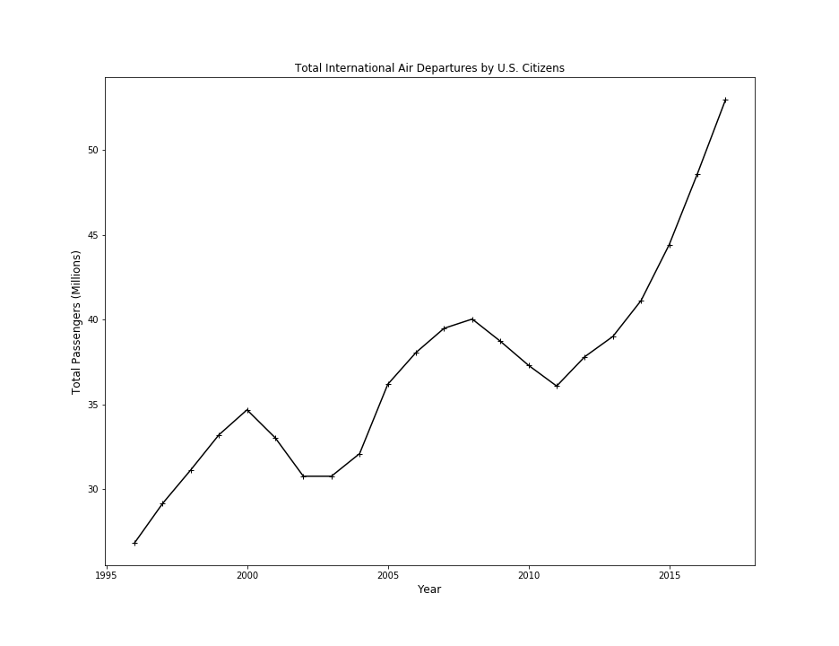

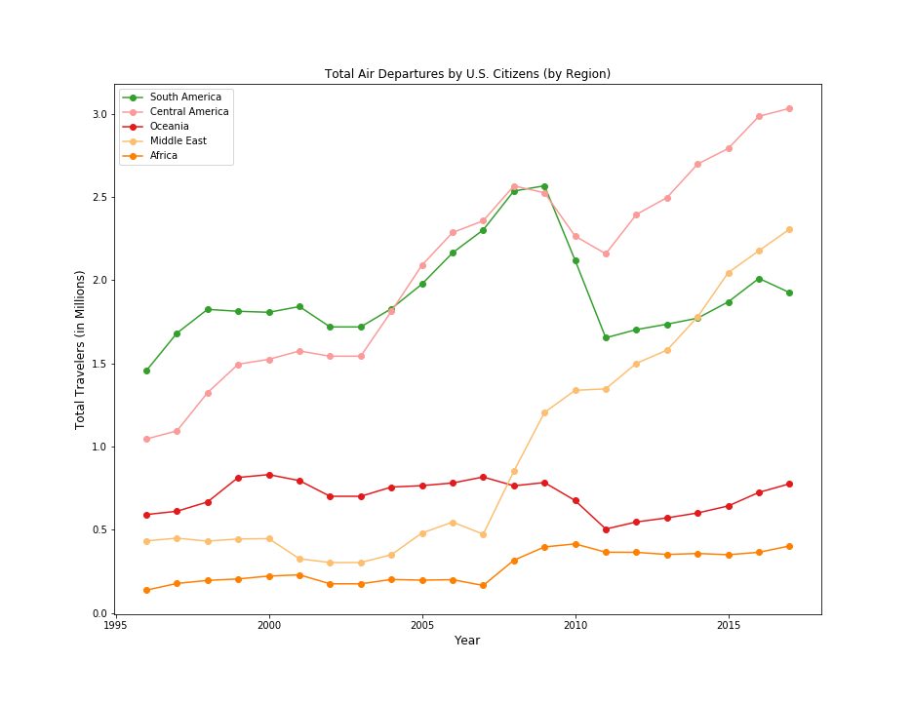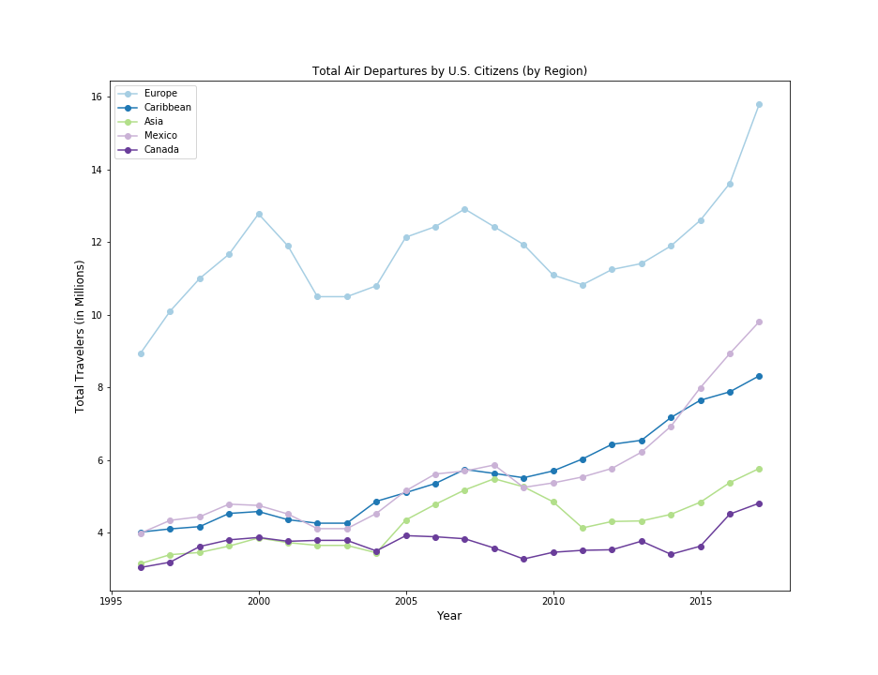

**2. What may make people travel during certain periods of time?**

Travel patterns reveal themselves in monthly charts. There are spikes for travel in March potentially due to carnival/spring break. The summer months are the busiest, likely due to the pleasant weather and kids being out of school. September shows a downwards trend for the carribean and mexican regions, perhaps owing to the hurricane season. December has a noticeable spike as well, most likely because of the holidays and time from work.

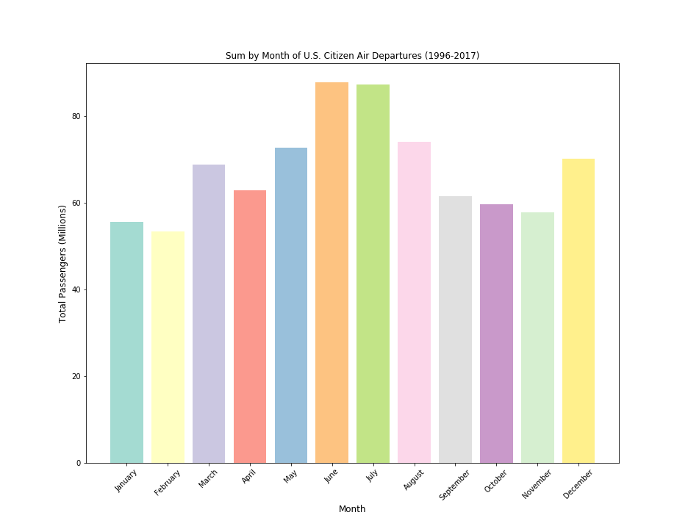

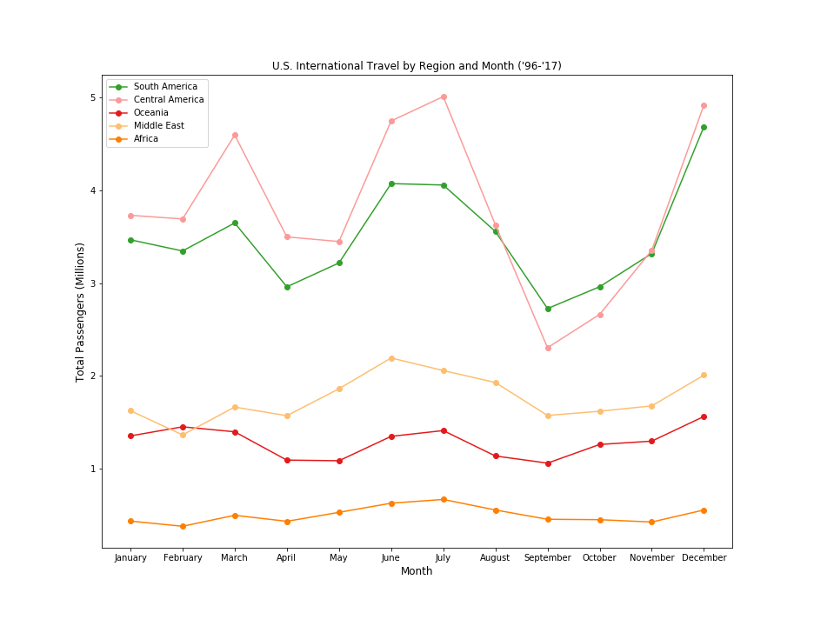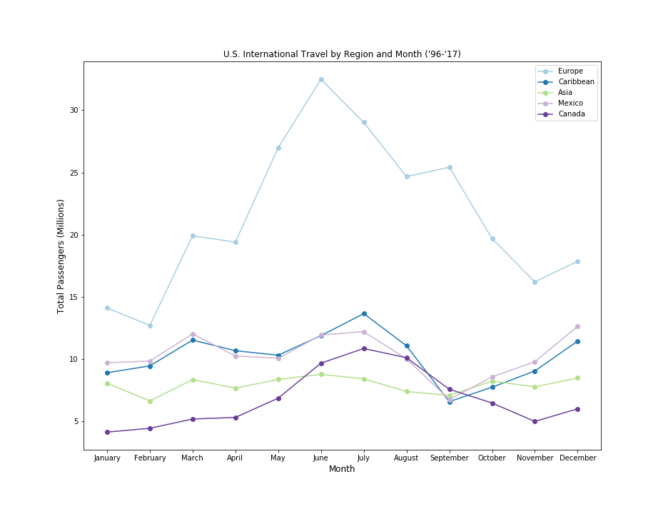

**3. What's the most popular travel destination and the least favorable destination according to the travel trends in the past 20 years?**

Europe is by far the most popular travel destination. Mexico and the Carribean alternate between second and third place fairly often. The least traveled to region appears to be Africa.

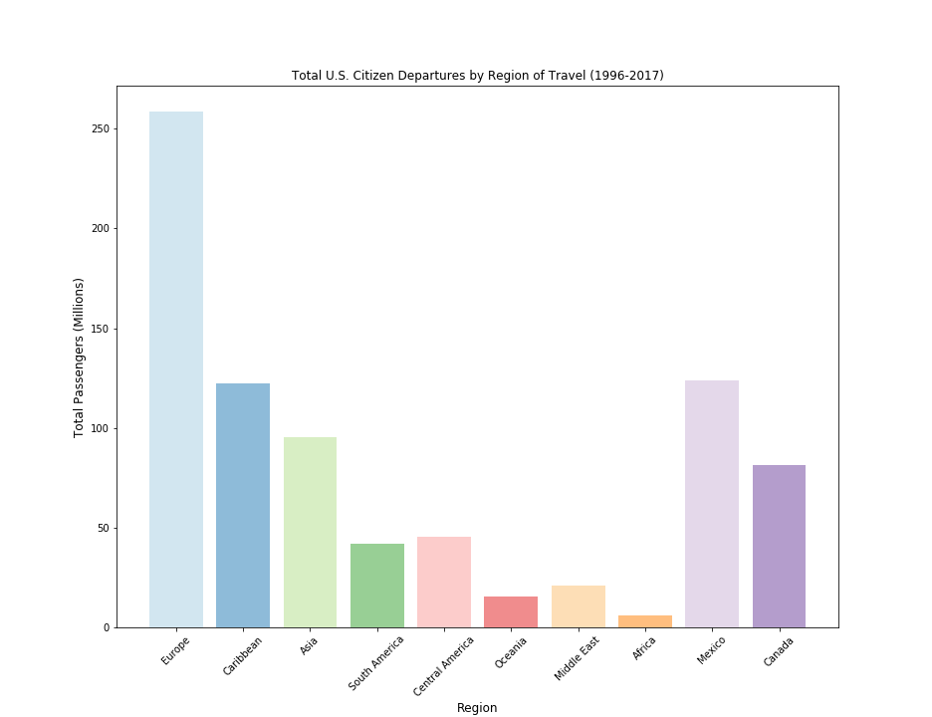

**4. How the change of economy affect people's purchasing power on traveling overseas?**

**The amount of outbound visitors appears to be inversely linked to the unemployment rate.** Travel spending has made an upward trajectory overall, suffering only slight setbacks after 9/11 and the recession in 2008.

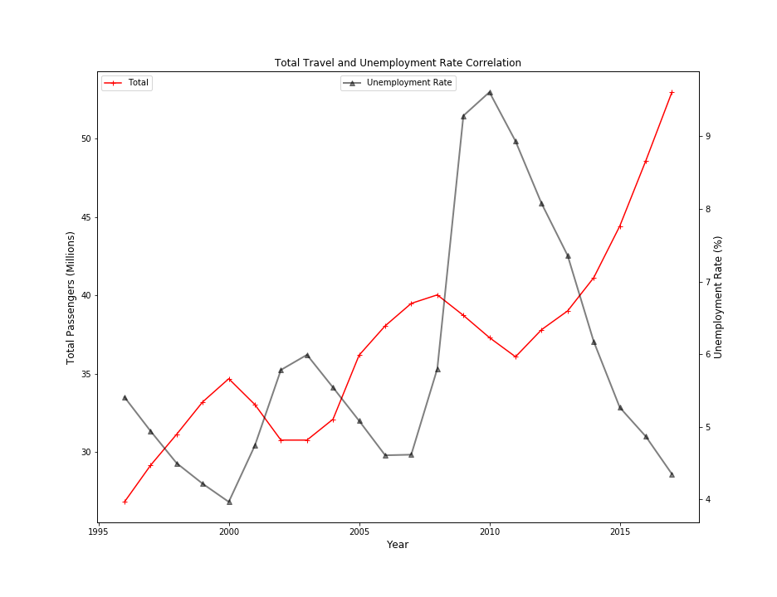

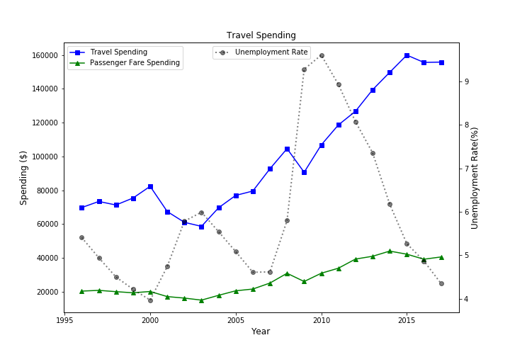

**5. The change on travel numbers during a major historical event/natual disarster/ political crisis.**

It is difficult to describe the impact of a major historical event on the data that we have. We can not conclusively say that events such as 9/11 have impacted the travel data, while at the same time discounting the recession around that time and its impact on travel tourism and the economy.

