

Injection Moulding 4.0

### Authors

student – s231473

October 21, 2023

Table of Contents

Authors 1

Preface 3

Introduction 3

Answer to Question no. 1 3

Solution 3

7

Discussion 8

Conclusion 9

Answer to Question Nr. 2 11

Solution 11

Discussion 12

Conclusion 12

Answer to Question no. 3 12

Answer to Question no. 4 13

Answer to Question no. 5 14

Answer to Question no. 6 14

Answer to Question no. 7 16

Summary 18

List of References 18

Appendix 1 19

# Preface

The objective of this report is to conduct an analysis and evaluation of two materials that are commonly used in injection molding: ABS SINKRAL F332 and SAN KOSTIL B266. The aim of this study is to comprehend the varying impact of different factors and responses based on simulations and analysis. Injection molding, known for its versatility and efficiency, has become an essential process in manufacturing various products. However, the quality and effectiveness of the product majorly depend on the properties of the materials used.

# Introduction

The process of injection molding is crucial for manufacturing components that we use in our daily

lives, ranging from consumer goods to electronics. It is not only about the shape of the material but also about the material's characteristics and the factors that affect its quality and efficiency. This report aims to conduct a comparative study of two plastic materials in the Moldex3D database: ABS SINKRAL F332 and SAN KOSTIL B266.

The project's objective is to comprehend how the materials behave under specific injection molding conditions. The project will compare their behavior for pvT and Viscosity plots. Additionally, a DOE analysis will be conducted using the software JMP, targeting the key factors such as molding- and melting temperatures, injection speed, packing pressure, and packing time.

Moreover, simulations will be carried out using Moldex3D with the provided 3D CAD model during the course to obtain the response values necessary to complete the Fit Model in the DOE analysis.

# Answer to Question no. 1

## Solution

**Structure of ABS SINKRAL F332:**

ABS SINKRAL F332 is a thermoplastic polymer composed of three main monomers:

1. **Acrylonitrile (A):** Provides rigidity and resistance to chemicals.

2. **Butadiene (B):** Imparts resilience and impact resistance.

3. **Styrene (S):** Contributes to ease of processing and surface hardness.

The polymerization of these monomers results in an amorphous structure, which means the molecular chains are not arranged in a regular, crystalline pattern. This amorphous nature gives ABS SINKRAL F332 its exceptional properties, including impact resistance, toughness, and good processability (Versalis S.p.A, 2022).

**Applications of ABS SINKRAL F332:**

ABS SINKRAL F332 is a versatile material used in various industries for a wide range of applications, including:

• **Automotive:** Commonly used for interior components such as dashboards, instrument panels, door handles, and trim parts due to its excellent impact resistance and durability.

• **Consumer Goods:** Found in everyday consumer products like toys, luggage, and small appliances, ABS SINKRAL F332 is suitable for these applications due to its impact resistance.

• **Electronics:** Used in the electronics industry for casings, connectors, and housing of devices due to their electrical insulating properties and ease of molding.

• **Construction:** ABS SINKRAL F332 is employed in construction materials like pipes and fittings as it offers a good balance of strength, toughness, and chemical resistance.

The material’s versatility, coupled with its unique combination of properties, makes ABS SINKRAL F332 a popular choice for various product categories in different industries (Versalis S.p.A, 2022).

**Structure of SAN KOSTIL B266:**

SAN KOSTIL B266 is a thermoplastic polymer that belongs to the class of styrene-acrylonitrile (SAN) copolymers. This material is created by combining two main monomers:

**1. Styrene (S):** Styrene contributes to the material’s transparency, surface hardness, and processability.

**2. Acrylonitrile (AN):** Acrylonitrile enhances the material’s chemical resistance and strength.

The resulting structure of SAN KOSTIL B266 is highly transparent and amorphous, which means its molecular chains lack a regular, crystalline pattern. This amorphous structure gives the material its exceptional optical clarity (Britannica, 2023).

**Applications of SAN KOSTIL B266:**

SAN KOSTIL B266 is commonly used in applications where transparency and optical clarity are of paramount importance, including:

• **Food Packaging:** SAN KOSTIL B266 is employed in the production of transparent food containers, bottles, and packaging material. Its optical clarity allows consumers to view the contents.

• **Medical Devices:** In the medical industry, SAN KOSTIL B266 is used for the manufacturing of transparent medical devices, including syringes, vials, and diagnostic equipment, where the visibility of contents is crucial.

• **Consumer Electronics:** Used in the production of cases, covers and screens for electronic devices such as mobile phones, tablets, and laptops, SAN KOSTIL B266 complements the aesthetic appeal of these products due to its transparency.

• **Optical Components:** SAN KOSTIL B266 can be found in optical lenses, light guides, and other optical components where clarity and light transmission are essential.

**Analysis of Viscosity**

Viscosity plays a critical role in injection molding, influencing flow behavior and mold filling. Lower viscosity means easier flow, while higher viscosity suggests more flow resistance. To determine which material has the highest viscosity, we can compare their viscosity using Figure 1 and Figure 2 presented below.

ABS SINKRAL F332 Viscosity Plot: Figure 1 illustrates that the viscosity of ABS SINKRAL F332 declines with increasing temperature, a typical behavior for thermoplastic materials. The graph shows a linear decrease with temperature, indicating that ABS SINKRAL F332 has higher viscosity at lower temperatures and gradually becomes less viscous as the temperature increases.

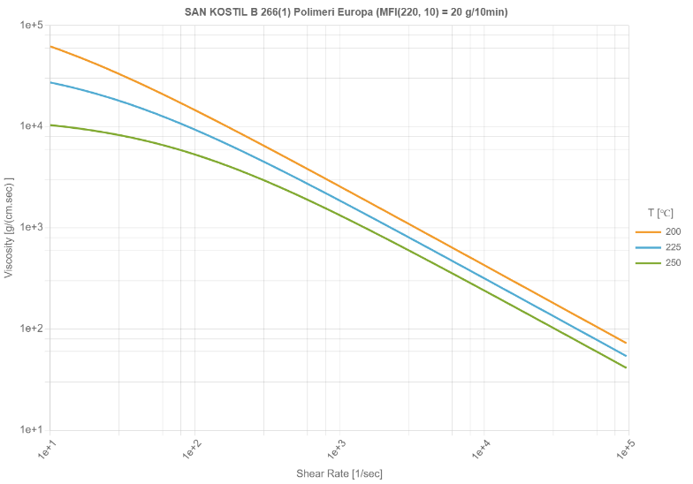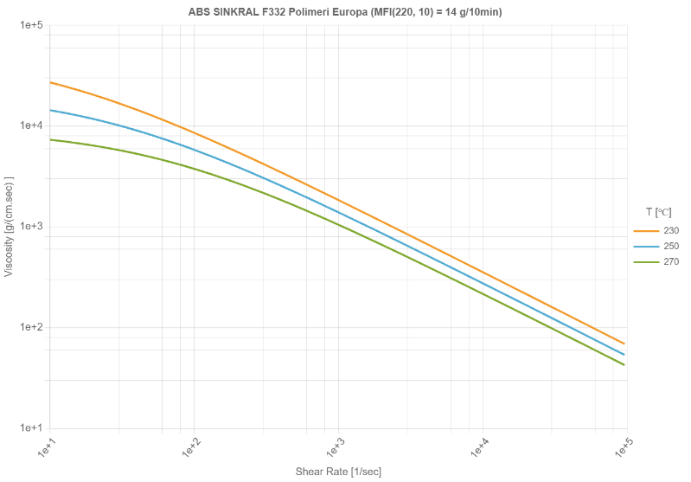SAN KOSTIL B266 Viscosity Plot: Similarly, Figure 2 for SAN KOSTIL B266 also reveals a linear decrease in viscosity as the temperature increases.

Figure 2 : SAN KOSTIL B 266 Viscosity

Figure : ABS SINKRAL F332 Viscosity

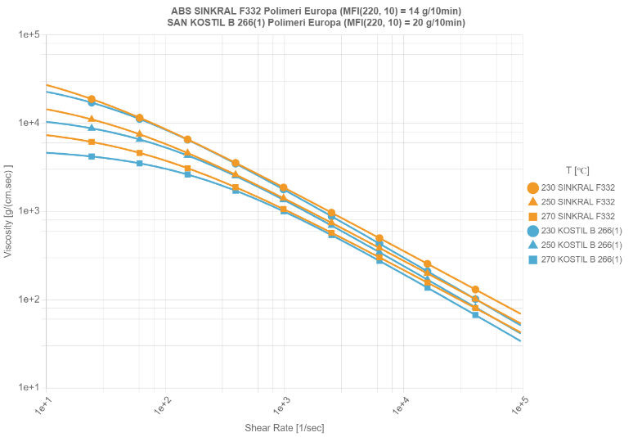**Viscosity Differences**

Figure 3: Comparing the materials.

After conducting a comparison, it was noted that ABS SINKRAL F332 exhibits a higher viscosity than SAN KOSTIL B266. The accompanying Figure 3 demonstrates this comparison, with ABS SINKRAL F332 represented by the orange line and SAN KOSTIL B266 by the blue line.

**Volumetric Shrinkage Analysis (pvT Analysis)**

Volumetric shrinkage is the change in volume of a material as it cools after injection into a mold. By comparing the pvT charts of ABS SINKRAL F332 and SAN KOSTIL B266, we can gain insights into their volumetric shrinkage behaviors.

**ABS SINKRAL F332 pvT:** The pvT chart for ABS SINKRAL F332 illustrates how pressure and temperature affect volume. Specifically, the chart in Figure 4 shows that volume expands as temperature increases and shrinks as pressure rises.

**SAN KOSTIL B266 pvT:** The pvT chart for SAN KOSTIL B 266 illustrates how the material behaves when subjected to changes in temperature and pressure. According to Figure 4, the chart for SAN KOSTIL B 266 indicates that the material experiences minimal volumetric expansion as temperatures increases.

Additionally, Figure 4 also highlights that ABS SINKRAL F332 has a higher degree of shrinkage compared to SAN KOSTIL B 266.

Figure 4 - pvT plot for materials

# 

## Discussion

**Viscosity Analysis**

Based on a comparative analysis of ABS SINKRAL F332 and SAN KOSTIL B266, it can be observed that their viscosities are quite similar, as can be seen in Figures 1, 2 and 3.

ABS SINKRAL F332 is made up of acrylonitrile, butadiene, and styrene, and displays typical thermoplastic behavior, where its viscosity decreases linearly with an increase in temperature. At lower temperatures, ABS SINKRAL F332 has a higher viscosity that gradually decreases as the temperature rises. This indicates that the material has varying flow properties in response to temperature fluctuations during the molding process.

On the other hand, SAN KOSTIL B266, a styrene-acrylonitrile copolymer, also demonstrates a similar linear decrease in viscosity with an increase in temperature. However, the analysis reveals that SAN KOSTIL B266 consistently maintains lower viscosity levels across the entire temperature range in comparison to ABS SINKRAL F332.

The orange line, representing ABS SINKRAL F332, consistently maintains higher viscosity levels compared to the blue line, representing SAN KOSTIL B266. This difference suggests that ABS SINKRAL F332 generally presents more resistance to flow at all temperatures, which can have implications for mold filling, flow behavior and overall processing conditions.

**Volumetric Shrinkage Analysis (pvT Analysis):**

The pvT charts offer valuable insights into how materials behave during the cooling phase after injection molding. ABS SINKRAL F332 expands as the temperature rises and contracts as pressure increases. SAN KOSTIL B266, on the other hand, shows less expansion with temperature changes, suggesting a more stable response to varying temperature conditions.

Comparing the orange line representing ABS SINKRAL F332 and the blue line for SAN KOSTIL B266, ABS SINKRAL F332 undergoes a more significant change in volume with temperature fluctuations. This behavior implies that ABS SINKRAL F332 may experience more dimensional variations during the cooling phase after molding compared to SAN KOSTIL B266. This could potentially affect the final part dimensions and tolerances.

**Overall Comparison**

Based on the viscosity and pvT analyses, it can be concluded that ABS SINKRAL F332 exhibits higher viscosity levels and more pronounced volumetric changes when compared to SAN KOSTIL B266. These properties can have a significant impact on the flow behavior, mold filling, and dimensional stability of the materials during the injection molding process. Therefore, it is important to understand these differences to select the appropriate material for a specific application based on the desired properties and processing requirements.

## Conclusion

An in-depth analysis of ABS SINKRAL F332 and SAN KOSTIL B266 has been conducted to understand their structural composition, applications, and behavior during the injection molding process. The study includes a detailed examination of their viscosity and volumetric shrinkage, providing valuable insights into the unique characteristics of these thermoplastic materials.

**Material Composition and Applications**

Acrylonitrile, butadiene, and styrene make up the composition of ABS SINKRAL F332. This material is known for its remarkable impact resistance, toughness, and ease of processing, which makes it a preferred choice across various industries, including automotive, consumer goods, electronics, and construction.

On the other hand, SAN KOSTIL B266 is a copolymer of styrene and acrylonitrile, which is highly recognized for its optical clarity. It is commonly used in applications where transparency is crucial, such as food packaging, medical devices, consumer electronics, and optical components.

**Viscosity Analysis**

The examination of viscosity-temperature trends helps distinguish the flow behaviors of ABS SINKRAL F332 and SAN KOSTIL B266. ABS SINKRAL F332 consistently exhibits higher viscosity levels at different temperatures in comparison to SAN KOSTIL B266. This higher viscosity of ABS SINKRAL F332 implies greater resistance to flow, which may have an effect on the mold filling process during injection molding.

**Volumetric Shrinkage Analysis**

According to the pvT charts, there are noticeable differences in the way ABS SINKRAL F332 and SAN KOSTIL B266 behave volumetrically during the cooling phase. ABS SINKRAL is more sensitive to temperature fluctuations, which could lead to significant dimensional changes and make it difficult to maintain part tolerances.

**Overall Assessment**

After analyzing ABS SINKRAL F332 and SAN KOSTIL B266, they behave differently during injection molding processes. When choosing materials for these processes, it is important to consider the unique characteristics of each material. ABS SINKRAL F332 has a higher viscosity and more significant volumetric changes, which makes it more challenging to control the flow and maintain dimensional stability compared to SAN KOSTIL B266, which has a lower viscosity and more stable volumetric behavior.

It is crucial to understand the behaviors, trends, and responses of these materials to make informed decisions when selecting the most appropriate material for molding applications. With this knowledge, manufacturers can optimize their production processes and ensure the quality and integrity of the final molded products.

# Answer to Question Nr. 2

## A screenshot of a computer Description automatically generatedSolution

To determine the appropriate highs and lows for melt and mold temperatures for ABS SINKRAL F332 and SAN KOSTIL B266, when the values for injection speed, packing pressure and packing time are given, we referred to the recommendation table provided by Moldex3D. Figure 5 on the right displays the recommended minimum and maximum temperatures for both melt and mold temperatures. Below are two tables based on the given values (black color) and the set values (red color) for both materials.

Figure 5 - Content Table of the Materials

|  |  |
| --- | --- |
| **ABS SINKRAL F332** | |
| *Low melt temperature = $T_{low},_{ABS}$* | $$230°$$ |
| *High melt temperature = $T_{high},_{ABS}$* | $$270°$$ |
| *Low mold temperature = $T_{low},_{ABS}$* | $$40°$$ |
| *High mold temperature = $T_{high},_{ABS}$* | $$80°$$ |
| *Low injection speed = $T_{low},_{ABS}$* | $$60 mm/s$$ |
| *High injection speed = $T_{high},_{ABS}$* | $$80 mm/s$$ |
| *Low packing pressure = $T_{low},_{ABS}$* | $$100 bar$$ |
| *High packing pressure = $T_{high},_{ABS}$* | $$200 bar$$ |
| *Low packing time = $T_{low},_{ABS}$* | $$2 s$$ |
| *High packing time =* |  |

|  |  |
| --- | --- |
| **SAN KOSTIL B266** | |
| *Low melt temperature = $T_{low},_{SAN}$* | $$200°$$ |
| *High melt temperature = $T_{high},_{SAN}$* | $$250°$$ |
| *Low mold temperature = $T_{low},_{SAN}$* | $$40°$$ |
| *High mold temperature = $T_{high},_{SAN}$* | $$80°$$ |
| *Low injection speed = $T_{low},_{SAN}$* | $$60 mm/s$$ |
| *High injection speed = $T_{high},_{SAN}$* | $$80 mm/s$$ |
| *Low packing pressure = $T_{low},_{SAN}$* | $$100 bar$$ |
| *High packing pressure = $T_{high},_{SAN}$* | $$200 bar$$ |
| *Low packing time = $T_{low},_{SAN}$* | $$2 s$$ |
| *High packing time = $T_{high},_{SAN}$* | $$16 s$$ |

## Discussion

The temperature ranges for ABS SINKRAL F332 and SAN KOSTIL B266 were selected based on Moldex3D's recommendations. These ranges were chosen to align with the suggested minimum and maximum temperatures, ensuring proper flow, solidification, and material integrity during the injection molding process.

## Conclusion

To ensure the best possible conditions for ABS SINKRAL F332 and SAN KOSTIL B266, we have adhered to Moldex3D's recommended temperature ranges for both the melt and mold stages. By following these temperature guidelines, we aim to optimize the flow of the material, cooling rates, and the overall quality of the final molded products.

# Answer to Question no. 3

To comprehensively understand how different processing parameters affect injection molding outcomes, we conducted a full factorial Design of Experiments (DOE) with predetermined values for injection speed, packing pressure, and packing time, as well as carefully calibrated melt and mold temperature levels.

We used Moldex3D simulation to obtain precise response metrics such as mass (in grams), maximum injection pressure, cavity injection time, and warpage along the X, Y, and Z axes. These simulated responses were crucial in our analysis and were inputted into the statistical analysis software JMP Pro 16 for rigorous examination.

The selection and setting of factors within the DOE were done methodically, taking into account the prescribed values as well as those established through critical evaluation of the materials and process parameters. After curating these factors, we compiled the data into a comprehensive table, capturing the outcomes from the Moldex3D simulations.

With the tabulated data at hand, we employed the Fit Model feature of JMP Pro 16 to conduct an in-depth analysis of the factorial design. This analysis aimed to reveal the main effects and interactions of the variables under consideration, thereby shedding light on the intricacies of the injection molding process and informing future optimization efforts.

# Answer to Question no. 4

The research employed Moldex3D simulation software to simulate an injection molding process.

To start, a 3D CAD model was imported into the Moldex3D environment, and model attributes were defined. The model was a cold runner system with two parts, a common configuration in injection molding practices.

After importing the model, the mesh was established to accurately represent the model geometry. This involved creating and refining the mesh, a fundamental step in the simulation process. Predefined variables were used to guide mesh generation.

With the mesh in place, materials were assigned for the simulation runs, and process parameters were input. Material properties and specific processing conditions were carefully selected and integrated to ensure the fidelity of the simulation.

Once the materials and parameters were configured, the simulation progressed to the analysis phase. The simulation encompassed the essential stages of the injection molding process, including filling, packing, cooling, and warpage analysis. Each stage was rigorously simulated to provide insights into the behavior of the molding process under the set conditions.

The simulation aimed to yield a granular understanding of the injection molding process. It helped to assess material behavior, process stability, and the potential for quality deviations in the molded parts.

# Answer to Question no. 5

Please see the attached files.

# Answer to Question no. 6

**DOE Analysis**

As shown in Figure 5 below, the main effect summary table from a Design of Experiments (DOE) analysis in JMP, a statistical software package, lists the main effects and interactions between different factors, along with their associated LogWorth and P-Values. The source column lists the factors and interactions being evaluated in the DOE. For example, “Melt Temperature” is a factor, and “Melt Temperature*Injection Speed” is an interaction term between melt temperature and injection speed.

The LogWorth is a transformation of the p-value, used to rank the effects on a consistent scale where higher values represent more statistically significant effects. It helps to identify the most important effects in the presence of multiple testing. The larger the LogWorth, the stronger the evidence against the null hypothesis.

The P-Value indicates the probability of observing the given result, or one more extreme, if the null hypothesis were true.

**San Kostil B 266 - Analysing Figure 5**

The analysis reveals that the most crucial factors are "Packing Time" and "Packing Pressure". "Packing Time" has the highest LogWorth and a p-value of 0.00000, making it the most significant factor. The second most significant factor is "Packing Pressure" which has a high LogWorth and a p-value of 0.00006. Lastly, "Injection Speed" has a significant p-value of 0.00007.

Packing time is the duration for which the packing pressure is applied. It helps maintain the dimensional accuracy of the part by ensuring that the material remains compacted as it solidifies. If the packing time is too short, the resulting part may not be fully densified. Conversely, if the packing time is too long, it can waste cycle time and potentially degrade the material.

Packing pressure is used to pressurize the molten plastic into the mold as it solidifies. Without adequate pressure, the material may shrink away from the mold walls as it cools, leading to defects.

The injection speed is a crucial factor that affects the filling of the mold. A faster injection speed can help fill the mold before the material starts to cool, but it can also cause higher internal stresses and defects, such as jetting or burning. On the other hand, a slower speed can result in a more uniform part but may also lead to incomplete filling or longer cycle times.

In the conducted tests, several factors displayed non-significant results with interaction p-values greater than 0.05, which are typically not considered statistically significant. Figure 5 highlights the factors "Packing Time" and "Packing Pressure", indicating that these factors did not have a significant impact on the tested process.

Figure 5 - DOE Anlysis of SAN KOSTIL B 266

**ABS SINKRAL B 266 – Analyzing Figure 6**

The most important main effects that we can analyze are related to “Packing Time". This factor has the highest LogWorth and a p-value of 0.00000, which makes it the most critical factor. The second most significant factor is "Packing Pressure", with a high LogWorth and a p-value of 0.00000.

Figure 6 - Main Effect of ABS SINKRAL F 332 DOE

The significance and non-significance of the factors observed here are very similar to those in Figure 5, where SAN KOSTIL B 266 was analyzed. The non-significant factors are the same as those in Figure 5.

# Answer to Question no. 7

**SAN KOSTIL B 266 – Interactions analysis**

In the main effect plot, the aim is to identify which combinations of factors have the most significant synergistic effects on the outcome. Figure 5, which illuminates these relationships, shows that the "Injection Speed*Packing Time" interaction has the most pronounced effect and considerable influence on the process.

The "Packing Pressure*Packing Time" interaction comes second, with a noteworthy LogWorth coupled with a minimal p-value signaling a potent interaction effect. This suggests that the interplay between these factors is critical in shaping the final product characteristics.

On the other hand, interactions such as "Mold Temperature*Injection Speed" and "Injection Speed*Packing Pressure" present less significance. They have lower LogWorth values and higher p-values, indicating that their influence on the process outcome is less pronounced. This differential significance can be attributed to the complexities of how different process parameters interact with each other. Some interactions have a more direct and strong influence on the material's behavior in the mold, which reflects the nuanced nature of the injection molding process.

The hierarchy in interaction significance often stems from the physical and thermal dynamics of the injection molding process. Factors such as injection speed and packing time directly affect how the material fills the mold and solidifies, which are primary drivers of part quality. Conversely, mold temperature and injection speed might not have as clear a synergistic effect because their relationship to the final part quality can be more indirect, or their optimal ranges are broader and hence less sensitive to interaction effects.

**ABS SINKRAL F 332 – Interactions analysis**

**Significant Interactions:**

The interaction between Packing Pressure and Packing Time is highly significant. It is evident from the LogWorth value of 5.949 and a p-value of 0.00000 that this relationship has a strong influence on the duration of packing time. This is especially important in the context of thermoplastic polymers like ABS, where it affects the material's behavior during processing and ultimately determines the quality and properties of the final product.

Another crucial interaction is between Injection Speed and Packing Pressure, with a LogWorth of 1.921 and a p-value of 0.01199. This interaction indicates that injection speed affects the material's behavior differently depending on the packing pressure applied. Hence, adjusting these parameters simultaneously is crucial for optimizing the injection molding process to achieve the desired product characteristics.

In contrast, the interaction between Melt Temperature and Injection Speed has a lower significance with a LogWorth of 0.319 and a p-value of 0.47952. This suggests that changes in melt temperature do not significantly affect how injection speed affects the process outcomes.

Similarly, the interaction between Melt Temperature and Packing Pressure has a low significance with a LogWorth of 0.451 and a p-value of 0.35440. This implies that the sensitivity of the material's response to packing pressure is not substantially influenced by variations in melt temperature within the tested range.

# Summary

This report analyzes and evaluates the performance of two materials in injection molding: ABS SINKRAL F 332 and SAN KOSTIL B 266. The study aims to understand and compare the behavior of these materials under specific molding conditions, focusing on pivotal aspects such as pvT relationships, viscosity behaviors, and their interactions with various molding parameters. A Design of Experiments (DOE) analysis utilizing JMP software will be used to identify the most significant variables affecting the quality of the molded materials. Additionally, simulations will be conducted employing Moldex3D alongside a supplied 3D CAD model. The goal is to generate a deeper understanding of the materials' behaviors, enabling a data-driven approach to optimizing injection molding processes.

# List of References

AdrecoPlastics. (2022). ABS plastic properties. AdrecoPlastics. [https://adrecoplastics.co.uk/abs-plastic-properties/](https://adrecoplastics.co.uk/abs-plastic-properties/?fbclid=IwAR3y3lsYtrizl7crmbaKLbztJMPYtyi7wzKBT5GneWSmuF5ww1GMvLEoRjQ) (Downloaded: 04.11.2023)

Britannica. (2023). Styrene-acrylonitrile copolymer. Britannica. [https://www.britannica.com/science/styrene-acrylonitrile-copolymer](https://l.facebook.com/l.php?u=https%3A%2F%2Fwww.britannica.com%2Fscience%2Fstyrene-acrylonitrile-copolymer%3Ffbclid%3DIwAR3WP5vISx0WKJ_eez86x5yA9OpqZa4X7RfWo0xP9iM6wgloaHfw6xbBgA0&h=AT0r34YIRGMfSh0pNY4tEk_xbszv0sJGFlJmKQhyN3oSFsrHsDB4hlrC-Pi-1kUHo9jH9UlLKWbxpX9qnRNYe6PhA8dnQLty1AwRyO22zbmPoM5wFaROxP0E9pqlhimr1Gd6yA) (Downloaded: 04.11.2023)

Versalis S.p.A. (2022). Technical data sheet – Kostil® B 266. Versalis. [https://versalis.eni.com/assets/documents/versalis/en/portfolio/polimeri-e-intermedi/stirenici/schede-tecniche/san/TDS%20B266.pdf](https://versalis.eni.com/assets/documents/versalis/en/portfolio/polimeri-e-intermedi/stirenici/schede-tecniche/san/TDS%20B266.pdf?fbclid=IwAR3WP5vISx0WKJ_eez86x5yA9OpqZa4X7RfWo0xP9iM6wgloaHfw6xbBgA0) (Downloaded: 03.11.2023)

Versalis S.p.A. (2022). Technical data sheet – Sinkral® F 332. Versalis. [https://versalis.eni.com/assets/documents/versalis/en/portfolio/polimeri-e-intermedi/stirenici/schede-tecniche/abs/TDS%20F332.pdf](https://versalis.eni.com/assets/documents/versalis/en/portfolio/polimeri-e-intermedi/stirenici/schede-tecniche/abs/TDS%20F332.pdf?fbclid=IwAR2Cj8nNROt-apjbbwob_HjzY90vxdxhJikcb-a84cIAaxIdry4tg2ERUCg) (Downloaded: 03.11.2023)

Moldex 3D (2023). Simulation Software. <https://www.moldex3d.com/> (Downloaded: 25.10.2023)

# Appendix 1