

Exercise of AM Digital Shadow/Twin

### Authors

student – s231473

November 23, 2023

Table of Contents

Authors 1

Preface 3

Introduction 3

# Preface

The objective of this report is to manage the diverse and complex data in modern digital manufacturing. We will explore it by combining different types of data, such as measurements from microscopy images, sensor readings, and X-ray CT analysis, to pinpoint potential risk areas in operational processes. The focus of the report is to establish a correlation between various process parameters – both controlled and uncontrolled – and the resulting properties of manufactured parts, such as roughness and hardness. This creation is the creation of a digital shadow/twin of the powder bed fusion metal additive manufacturing process, utilizing a combination of experimental data from multiple sources. This will provide practical insights into the complexities and methodologies involved in digital twin creation within additive manufacturing, (“Exercise of AM Digital Shadow/Twin”, 23 November 2023).

# Introduction

# Step 1: Filling in the table on the sheet “Result of DoE.”

In the section of step 1, we are going to fill in the table on the sheet for the “Result of DoE”, based on the file “DoE and results”. This part it is 5 sub-parts: filling the “Real GFS”, “Real O”, and “Real O STD” columns, filling the Porosity column, filling the Hardness column, filling the Converted GFS column, and a discussion with the group about which of the scaling approach is more suitable.

## Graph Analysis and Calculations

The “DoE and results” xl-spreadsheet contained 14 components with recorded sensor data with variables like layer data, oxygen value, and measured gas flow. It also contained an unfilled DoE and a porosity sample, (“Exercise of AM Digital Shadow/Twin”, 23 November 2023).

Firstly, we selected the gas flow column of the file that was imported and used the graph builder feature in JMP to plot a 2D line graph to observe the trend of Sample 1 of the gas flow speed. The graph had multiple sudden rises/drops in the sensor reading and some were bigger than others, but it corresponded to the process being interrupted (either because the process ended or because the production of support structures had started), (“Exercise of AM Digital Shadow/Twin”, 23 November 2023).

Figure 1: 2D plot of the gas flow speed included rises and drops.

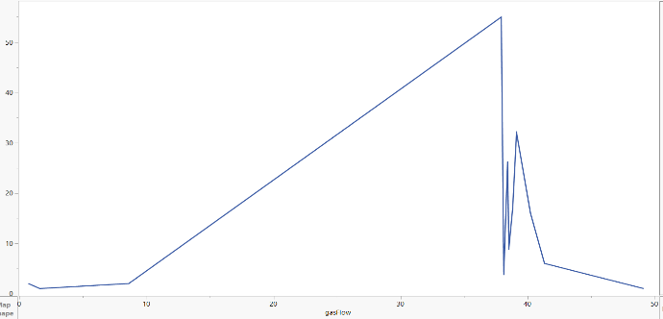Analyzing Sample 1, the graph shows a very clear trend in the gas flow speed with a significant rise/drop toward the end of the process. To evaluate what is the appropriate way to calculate the mean and standard deviation for the observed data it is important to first determine the range of data points before the sudden rise/drop, which represents the stable operation of the process. Secondly, based on Figure 1 to the right, the data shows a relatively stable trend before the sudden rise/drop, which suggests that the process was operating in a consistent manner during the period. As mentioned earlier, the rise/drop is likely an outlier or a result of a different process condition, such as the end of the process or the start of support structure production, and that data should not be included in the calculation of the mean for the normal operation conditions. So, based on the trend of the graph the appropriate way to calculate the mean of the gas flow speed is to use the arithmetic mean, and that is because the arithmetic mean is straightforward to calculate. Also, the two other mean calculations geometric mean are more appropriate for data that are log-normally distributed, and the root mean square (RMS) is useful for variables where the magnitude is important regardless of the direction, that’s why the arithmetic mean is more appropriate.

# References

[1] “Exercise of AM Digital Shadow/Twin”, 23 November 2023. [Exercise of AM Digital Shadow/Twin]