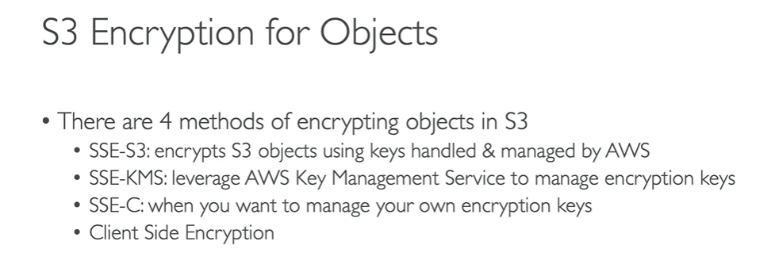

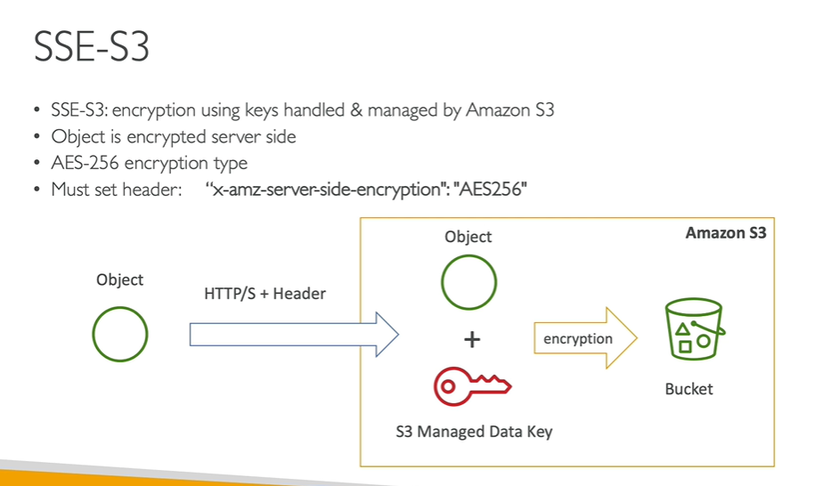

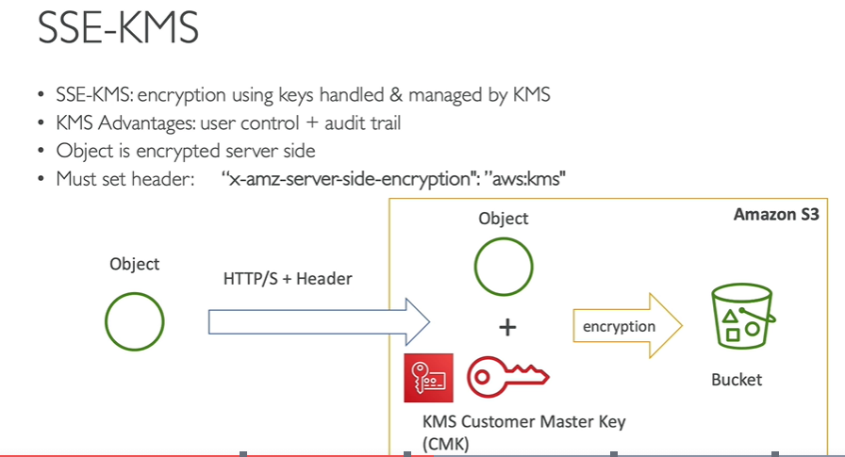

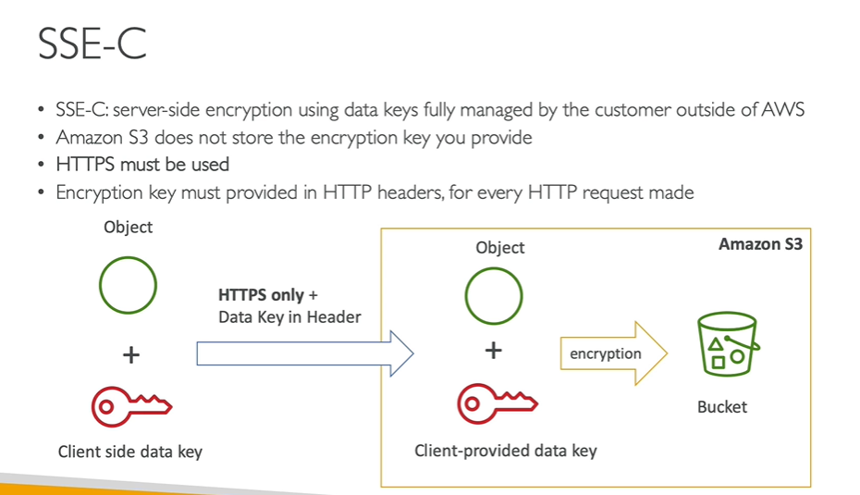

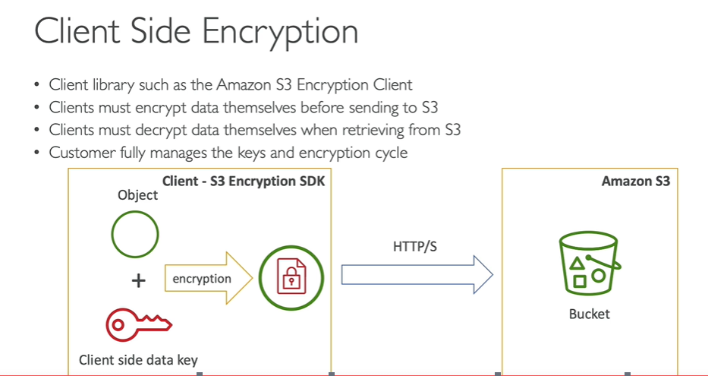

Default encryption will be in disable mode

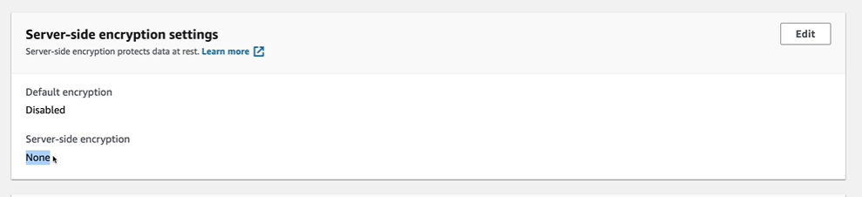

Upload the object into the bucket by enabling server side encryption with SSE-S3 type

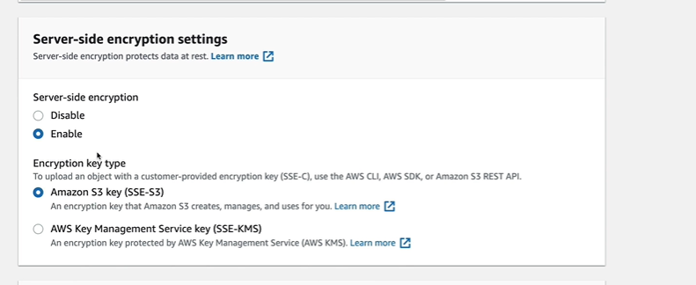

Upload the object into the bucket by enabling server side encryption with SSE-KMS type

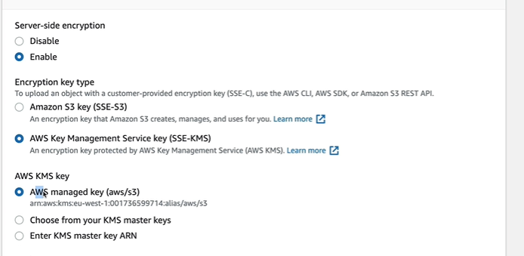

Objects can be uploaded separately into the bucket by enabling encryption, but on the bucket level encryption will be in disabled mode.

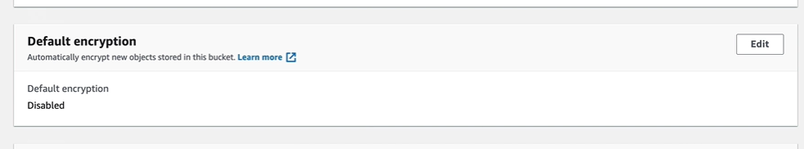

To update on bucket level , click on edit and enable encryption, going forward object level encryption enable is not needed, by default all the objects of the bucket will be in encrypted mode.

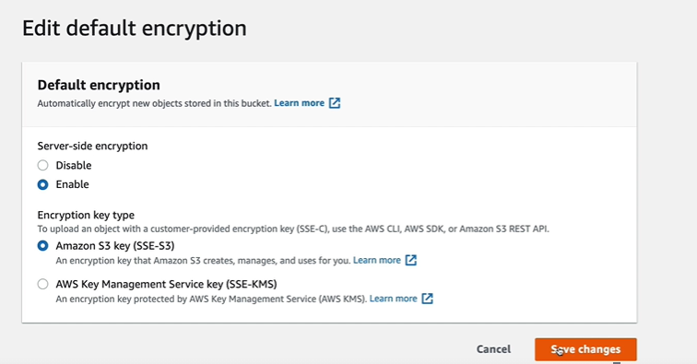

We can verify the Default encryption is showing as Enabled

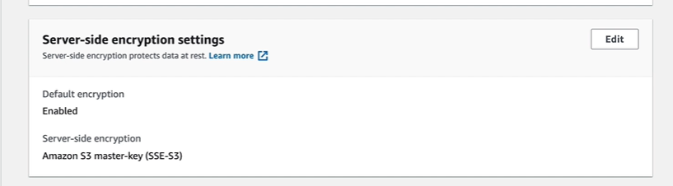

Policies:

Use case: Restrict uploading of objects into bucket if objects are not encrypted:

Go to policy generator, choose s3 policies

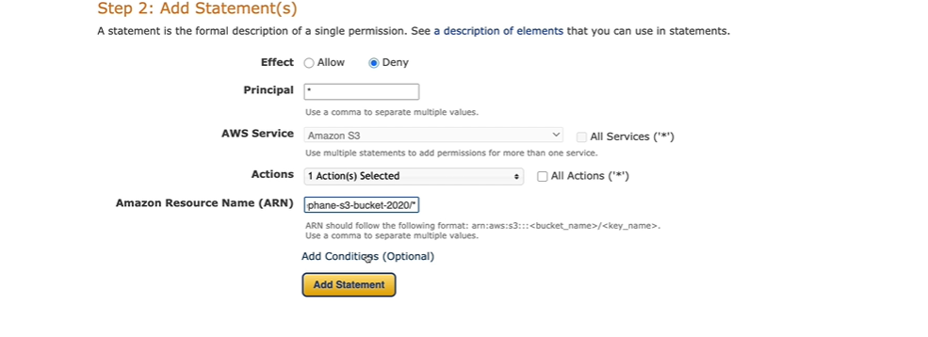

Create two conditions

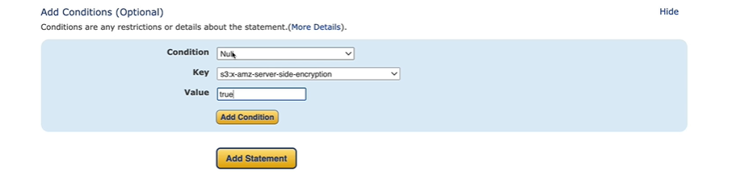

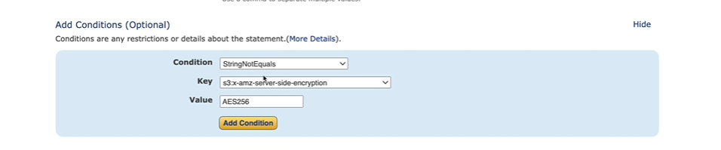

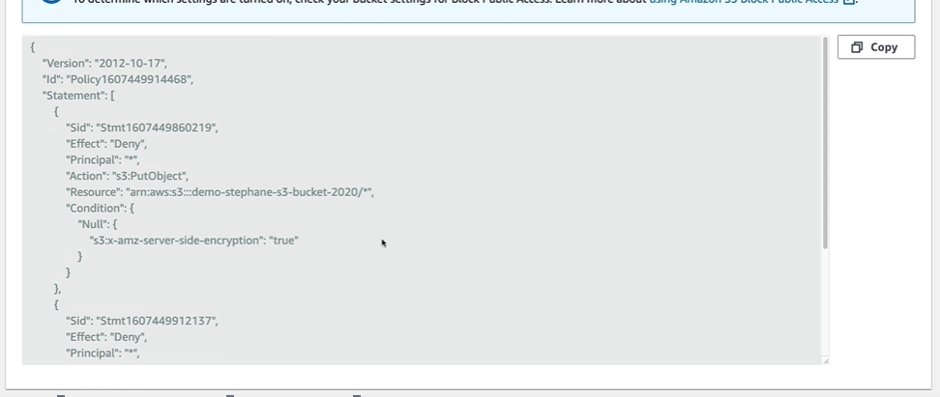

Generate the policy and add the policy.

Try to upload the object without encryption , it will fail

