CIS171: Java

Week 2 - Error Lab Questions

In case you need the code for the HelloPrinter program again, here it is.

public class HelloPrinter
{
public static void main(String[] args)
{
System.out.println("Hello, World");
}
}

It’s ok to make errors. In fact, the more errors you make, the quicker you will become an expert Java programmer. Each error can teach you an important lesson. So … let’s make a few errors by experimenting with the HelloPrinter program.

- Try deleting the only semicolon. What happens when you compile (be specific if you get an error message)? Go ahead and ‘Proceed’ even if Eclipse tries to stop you when you save.
Exception in thread "main" java.lang.Error: Unresolved compilation problem:
Syntax error, insert ";" to complete BlockStatements

at HelloPrinter.main(HelloPrinter.java:7)
- Fix the error. Try deleting the left brace under the main method and compiling your program. What happens?
Exception in thread "main" java.lang.Error: Unresolved compilation problem:
Syntax error on token ")", { expected after this token

at HelloPrinter.main(HelloPrinter.java:3)
- Fix the error. Delete the first left brace in the program. What happens when you compile?
Exception in thread "main" java.lang.Error: Unresolved compilation problem:

at HelloPrinter.main(HelloPrinter.java:3)
- Fix the program. Change main to Main. Does the program compile? Does the program run? What is the problem?
Error: Main method not found in class HelloPrinter, please define the main method as:
public static void main(String[] args)
or a JavaFX application class must extend javafx.application.Application
- Fix the program. Next, change the program so that it has a run-time error. What is the run-time error that you created?
Program says “Helo, World!”
- What is the difference between compile-time error and a run-time error?
Compile errors are errors within the program that keep the program from compling correctly. Run time errors are thing such as spelling mistakes in the value that your trying to show.
Eclipse will often give you a line number on a compile-time error. They appear to the left of the code.
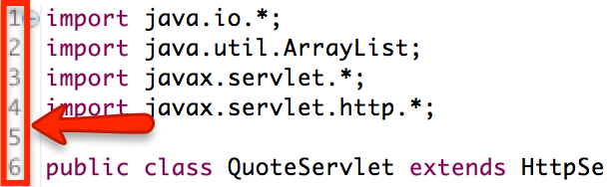

If you do not see line numbers, you need to enable them.
Windows | Mac
Window → Preferences → General → Editors → Text editors and place a checkmark next to “Show line numbers” | Eclipse → Preferences → General → Editors → Text editors and place a checkmark next to “Show line numbers”

With compile time errors, the line where the error occurs will display in the error message in the Console.
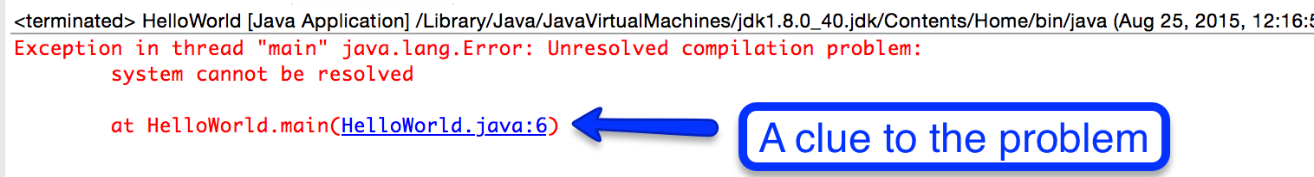

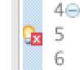
You will also see this icon next to the line number when you try to save the java file. It can also be a strong hint that something’s wrong.


Finally, if you see a red x next to the file name, it can also be a hint that there’s an error. You’ll also see that same icon throughout the whole project in the project explorer.
- What are two methods you can use in Eclipse to identify and troubleshoot compile time errors?
Red x’s next to the line of the error or red x’s next to the file name.
- How can you identify and troubleshoot run-time errors?

Look for red x’s or read error message and find the line it’s on.

