Introduction:

For now, this is a non-profit project by the students of Software Engineering 2 of University of San Carlos. It is a web based application for creating, joining, and viewing events that are available anywhere in the Philippines. It serves as a good medium for people with busy schedule but want to join events that cater their interests. It is also a system that can help organizers to manage and promote their events.

System Requirements:

Below is the list of software tools and their corresponding version, accompanied by the usage for the deployment process.

|  |  |  |
| --- | --- | --- |
| **Software Tool** | **Version** | **Usage** |
| CodeIgniter | 3.1.6 or higher | This provides the framework of the system using Php. |
| FileZilla | 3.28.0 or higher | Uploading the website to the chosen domain. |
| Chrome | 61.0.3163.100 or higher | This is a browser which enables the programmer to verify and validate if the changes made to the system were applied. |
| Sublime Text | 3 | The environment to be used in tweaking the Source code for deployment using Codeigniter as framework |

Note: All the tools mentioned above can be used in Windows, Linux, and MAC OS. There are no Hardware requirements since the System will be deployed to the cloud via web host.

**A Developers guide to Software Deployment for the Event System using FileZilla**

This documents contains: Meaning of the software, Source package, Notes for installation, management files. All of the mentioned below are the things the developers must know in order to understand and to deploy the said website to the internet.

**What is FileZilla?**

**FileZilla** is a [free software](https://en.wikipedia.org/wiki/Free_software), [cross-platform](https://en.wikipedia.org/wiki/Cross-platform) [FTP](https://en.wikipedia.org/wiki/FTP) application, consisting of FileZilla Client and FileZilla Server. Client binaries are available for [Windows](https://en.wikipedia.org/wiki/Microsoft_Windows), [Linux](https://en.wikipedia.org/wiki/Linux), and [macOS](https://en.wikipedia.org/wiki/MacOS" \o "MacOS), server binaries are available for Windows only. The client supports [FTP](https://en.wikipedia.org/wiki/File_Transfer_Protocol), [SFTP](https://en.wikipedia.org/wiki/SSH_file_transfer_protocol) and [FTPS](https://en.wikipedia.org/wiki/FTPS) (FTP over [SSL/TLS](https://en.wikipedia.org/wiki/Transport_Layer_Security)).

In this part of our FileZilla tutorial we will show you how to install the FTP client on the three most popular operating systems: Windows, Linux and Mac OS. Before proceeding with the FileZilla installation we should download the corresponding package from the suggested

website: <https://filezilla-project.org/download.php?type=client>

But any other sources may just be fine.

**Installation notes for Windows**

**Part 1:**

The FileZilla installation on the Windows OS is quite simple. Log in your Windows software with an administrator account. After the download of the correct package (the .exe extension package is recommended) click on it.

The License Agreement screen will appear.

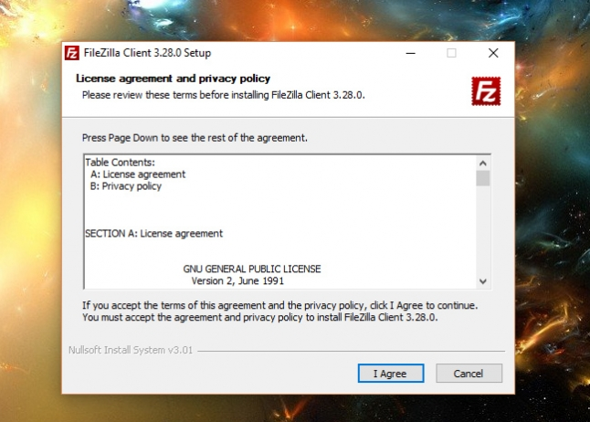

**Part 2:**

Press the **I Agree** button. On the next screen you should decide whether every user of the OS can work with the FTP client or it is allowed only for the admin account.

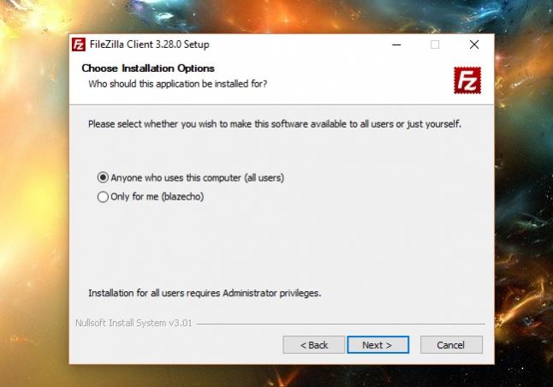

**Part 3:**

Click on the **Next** button to proceed. Select the components which you want to install. When ready - click on the **Next** button.

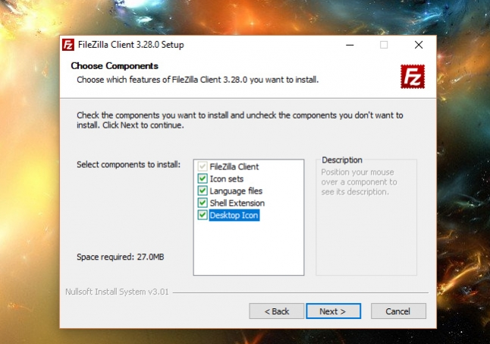

**Part 4:**

The next window allows you to set the destination folder for the FileZilla installation. Choose the desired folder and press the **Next**button.

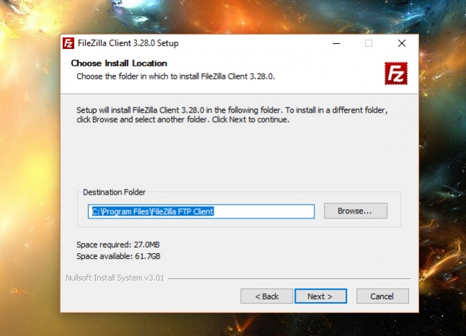

**Part 5:**

After that you should choose the Start Menu folder and click on the **Install** button.

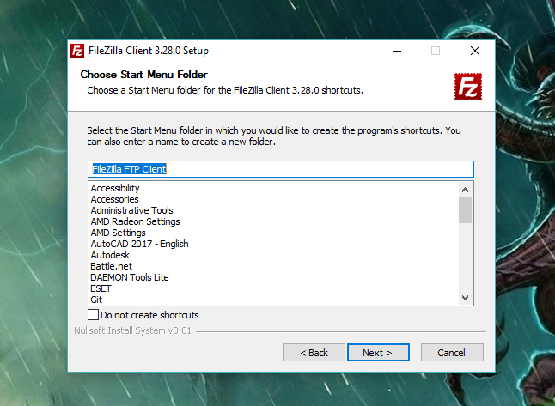

**Part 6:**

The installation should be completed in a few minutes. You can leave the Start FileZilla now check box checked and click on the **Finish** button. This will start your FileZilla FTP client.

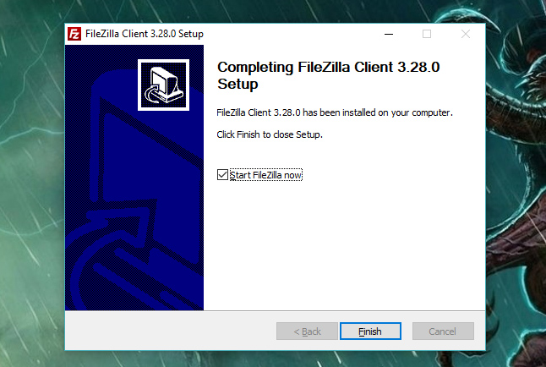

**Installation notes for Linux**

In this section we will inform you how to install FileZilla on the most popular Linux distributions - Ubuntu and Fedora.

Both the distributions allow the FileZilla software to be installed through their package managers.

In Ubuntu open a terminal window, log as the root user and execute the following command: ***Apt-get install filezilla***

You will be prompted whether you want to continue with the installation. Type "Y" and click on the Enter key of your keyboard.

The installation will be completed.

You can find the software in your Applications->Internet menu.

The installation on a computer with a Fedora distribution is almost the same.

First you need to setup the [RMP fusion repository](http://rpmfusion.org/) in order to install the software.

Then execute the following command as the root user in the terminal window:***Yum –y install filezilla***

**Installation notes for Mac OS**

Basically the installation of the FileZilla software on a Mac OS can be completed in several steps. First you need to download the installation package of **FileZilla** from the [official website of the application](http://filezilla-project.org/download.php?type=client).

When you open the above URL, click the file designated for the processor in your computer.

In case the installation does not start automatically, locate the FileZilla_[version number]_tar.bz2 file on your computer and double-click on it. Following the installation instructions, you will be asked to agree to FileZilla's general public license, then choose options and a location for your FileZilla files. When you have completed the last step, click the "**Install**" button to install FileZilla on your computer. When installation is complete, click the "**Close**" button.

**Deployment and Management of Files**

**UI of FileZilla**

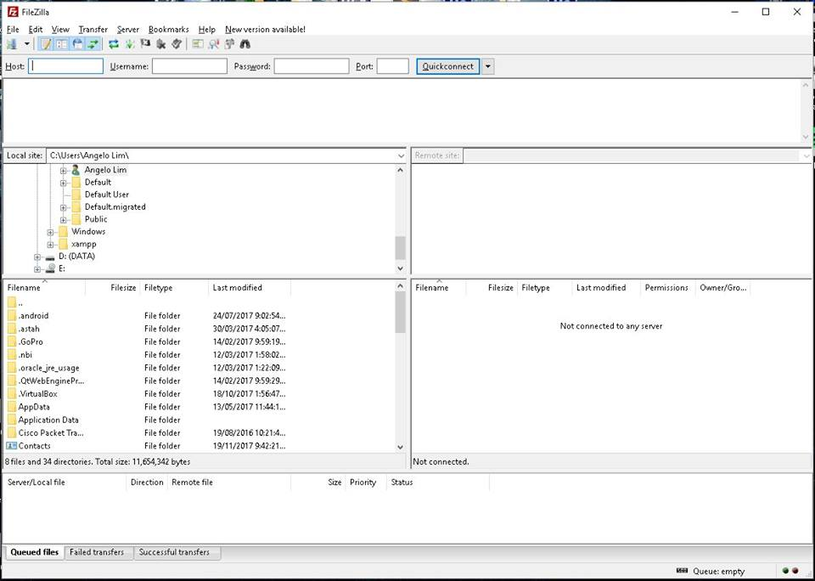

**Step 1:**

**Establish FTP connection**

1. Click on ‘File’, then ‘Site Manager’

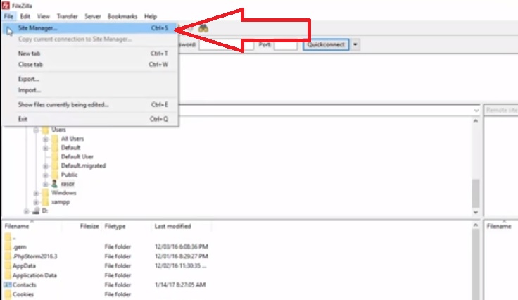

1. A pop-up will appear which will be the setup of the Site Manager. Click on ‘New Site’ button.

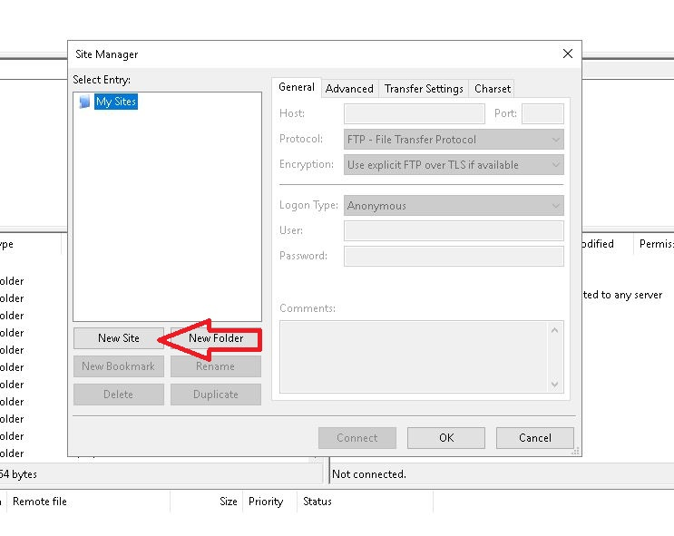

1. Then enter the name for the website

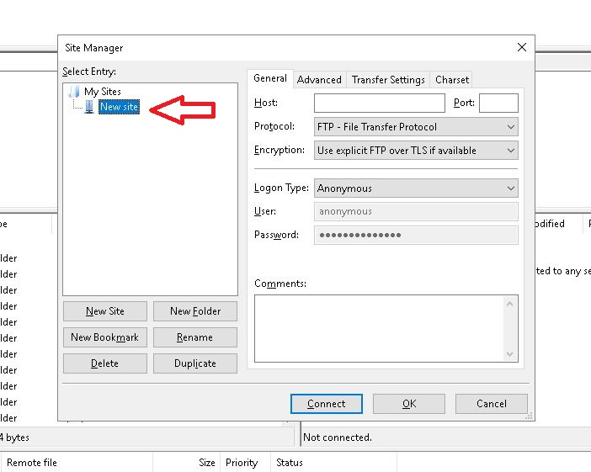

1. Do the following:
   1. **Hostname** - enter your domain name or the name of the hosting server where your account resides
   2. **Username** - enter the FTP username (you can use your cPanel username or the one of a new FTP account)
   3. **Password** - enter the corresponding FTP password
   4. Click ‘Connect’

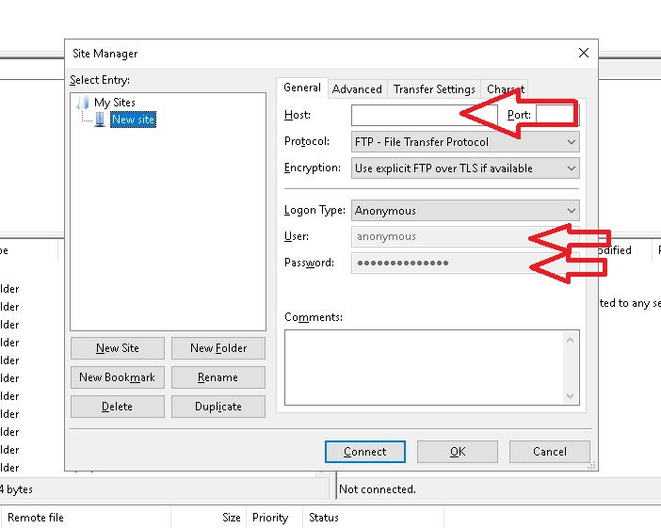

**Step 2:**

**Management of files**

Once it is successfully connected to the server, there will be two areas of the user interface of FileZilla

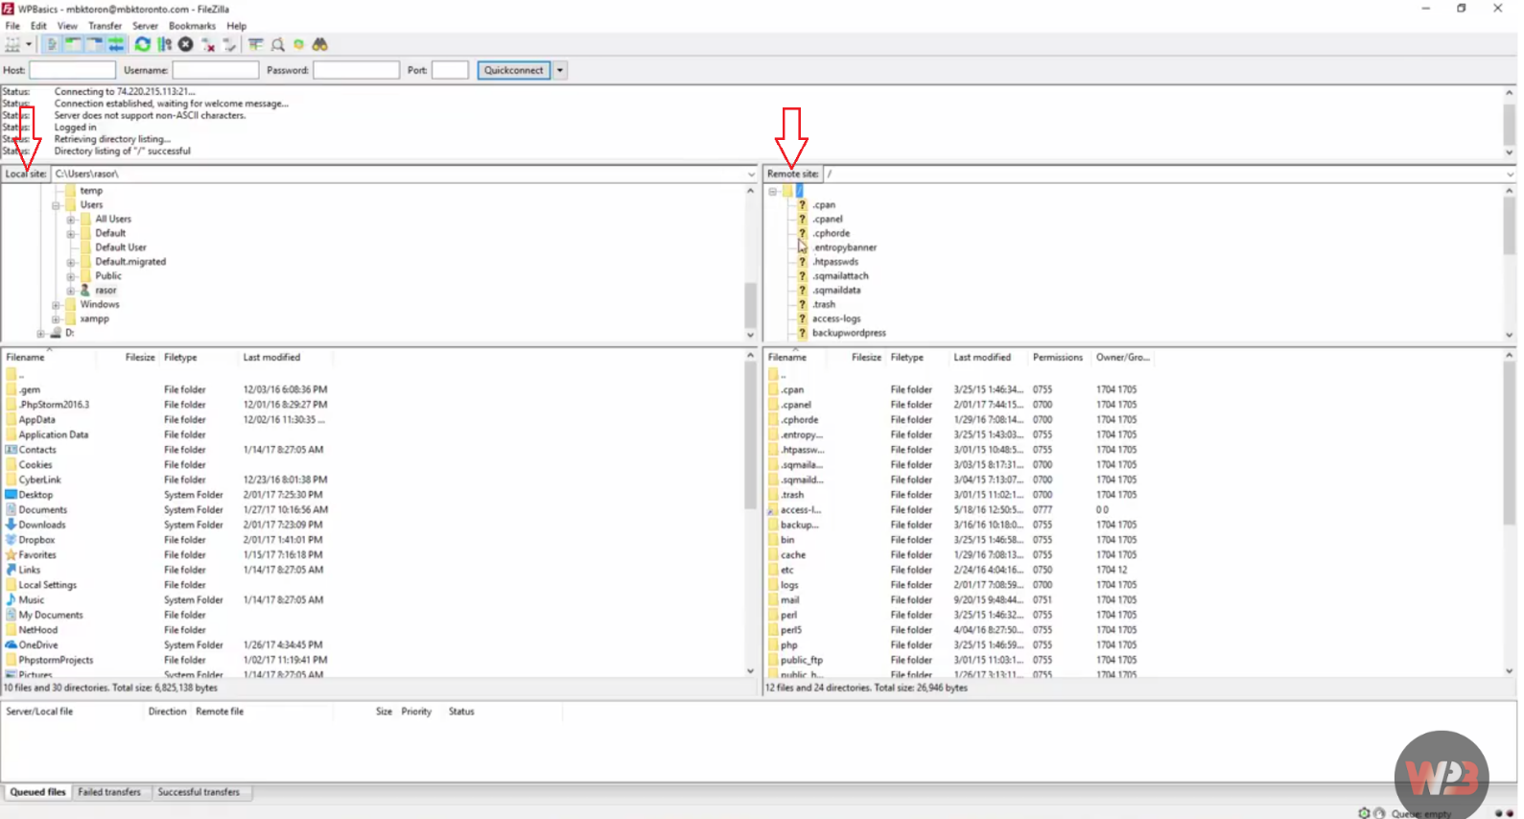

**Left side (Local Site):** Local Files (on your PC/Laptop)

**Right side (Remote Site):** Server Files

Drag the website directory files from the **Local Site** to the new web directory on the **Remote Site**.

Then, open a browser and test the website if it is live and running.