Mark McDonough

Elijah Banks

Geoffery Greiner

Adam Deisz

CSC4500 Project documentation

**Overview:**

This project is designed for an office or general store that holds and uses or sells office supplies. It is not a direct store where the general public can buy supplies from. It is meant to streamline the process of an office or store to re-stock their inventory of specific office supplies. They will be able to place orders for supplies with specific provides, view their orders, view their coworker contact information, view the costs of the suppliers, and add, change, and sort all of these resources through the admin page.

**Tools used:**

* My SQL
* Ruby on Rails
* Bootstrap

**GITHUB LINK:**

<https://github.com/ejoebanks/office>

**Database E/R MODEL:**

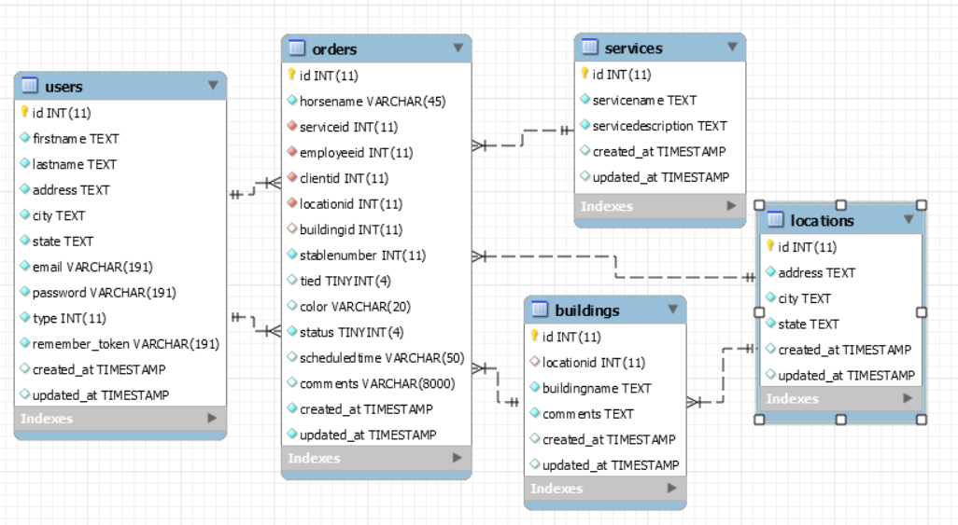

**pages:**

Inventory:

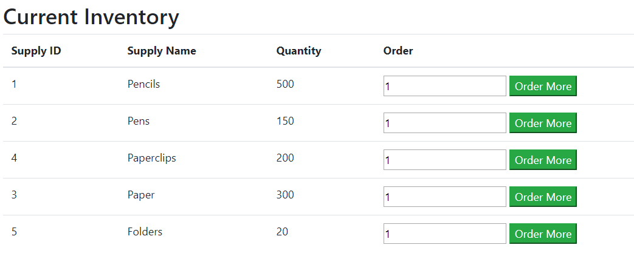

Inventory Functionality:

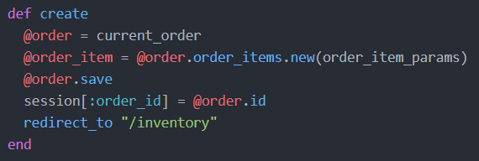

Inventory Cart:

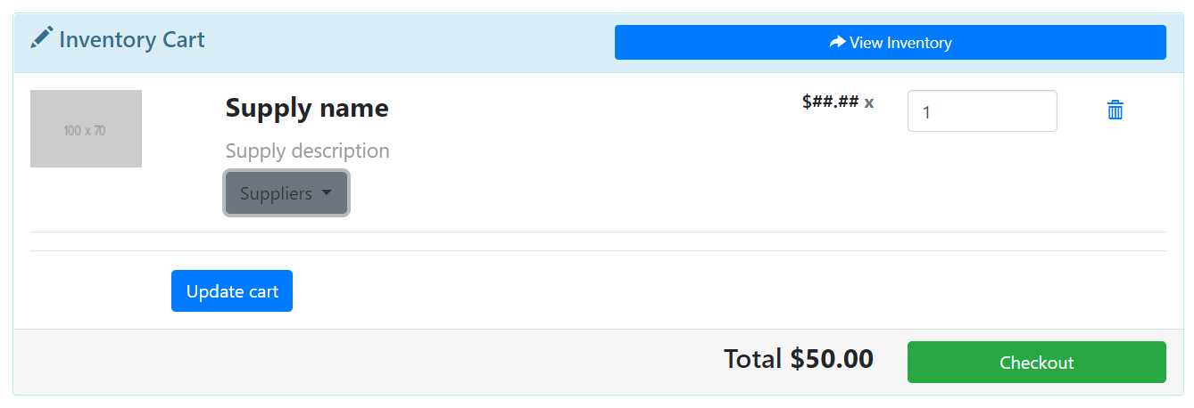

Normal User Inventory View:

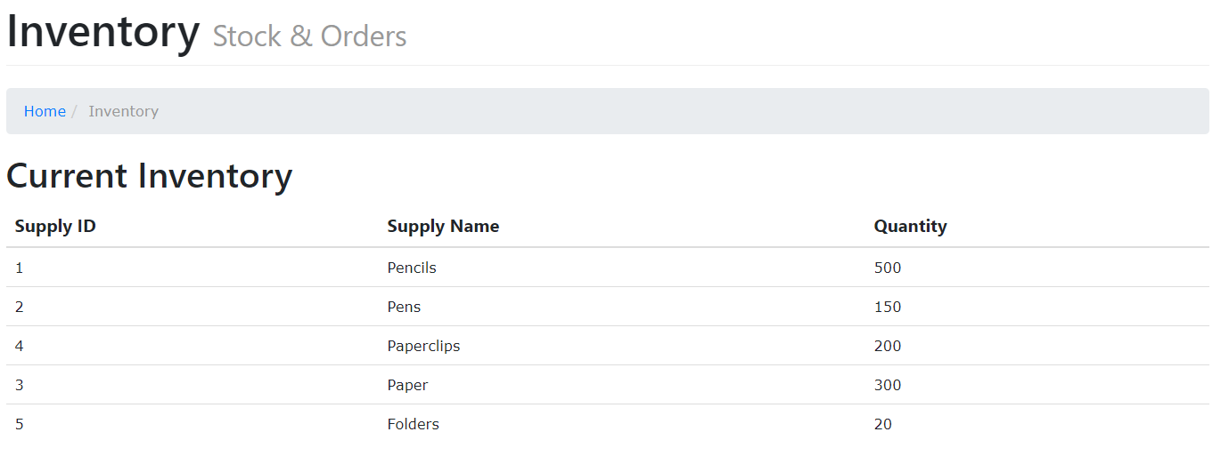

Employees:

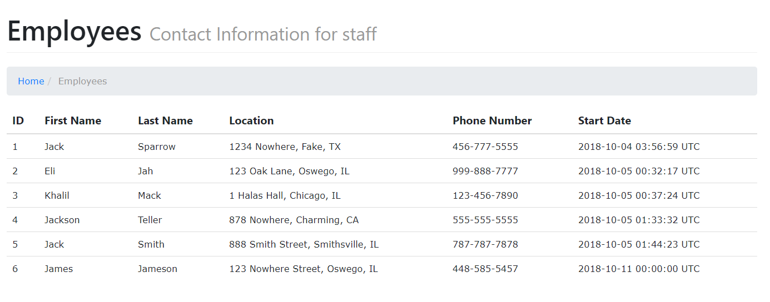

Cart:

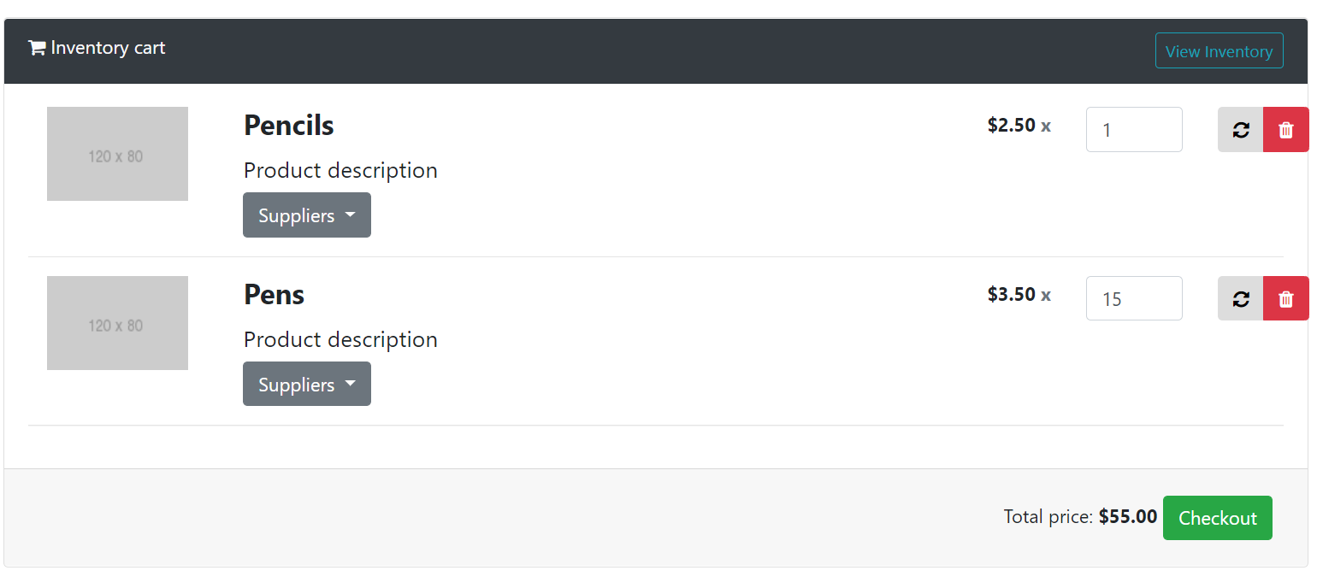

Cart Functionality:

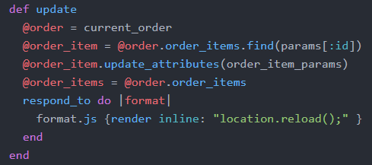

Admin Page:

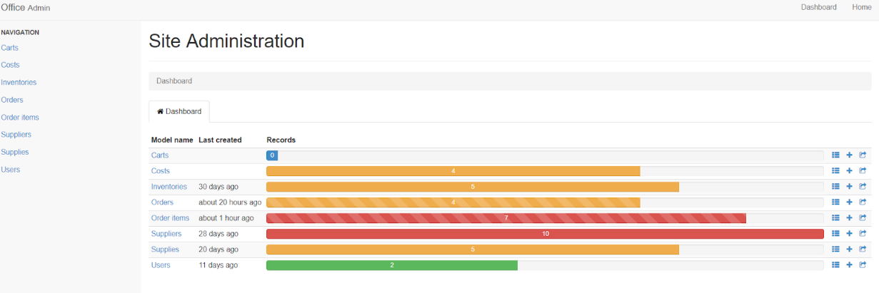

Query Page:

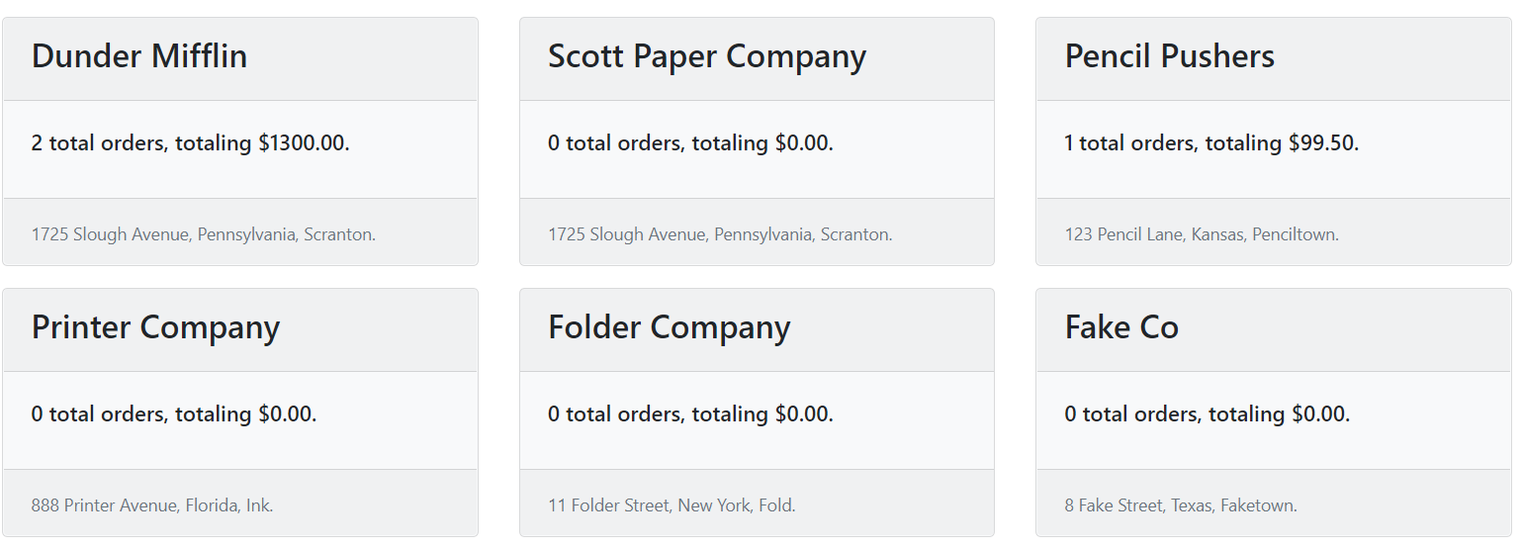

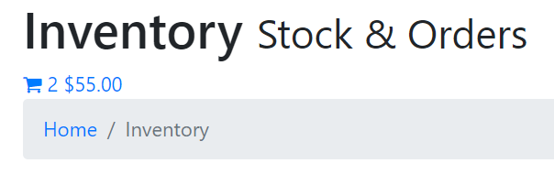  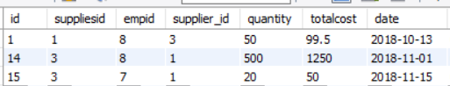

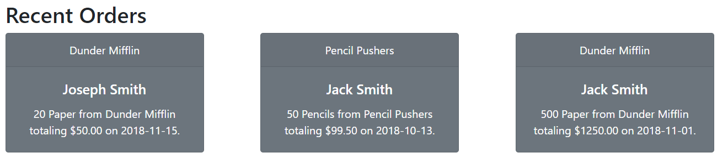

Order Functionality:

https://lh5.googleusercontent.com/DMZ3M6tWG9U5nqy5kgWYjBDd7zOstT8j-0Uyl2LVX5kKmVEpo8thg0Muia6558o1Pi44P9POJf0-BDVPADxo5sQ7jj2EM9fhZRZkI0TEo6xzh6du5qVF15LOZsnBEft7mbjh754td6Q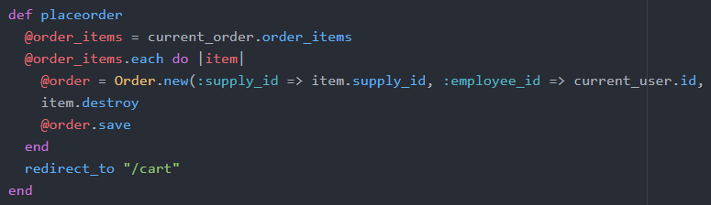

**TRIGGERS:**

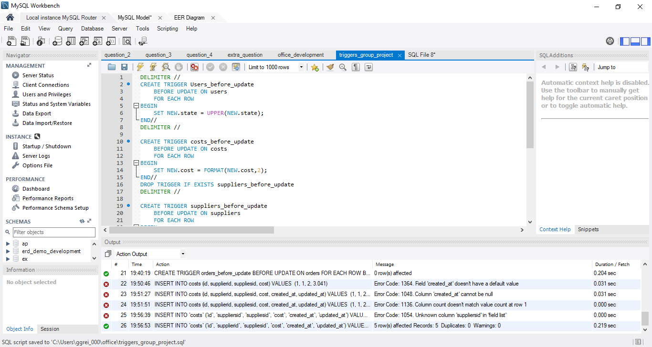

Triggers correct mixed-case state names in the users and suppliers database and format float variables to 2 decimal places for cost in the costs table and total cost in the orders table.

**EVENTS:**

Event to update inventory every 12 hours:

