1. Probabilistic Inference
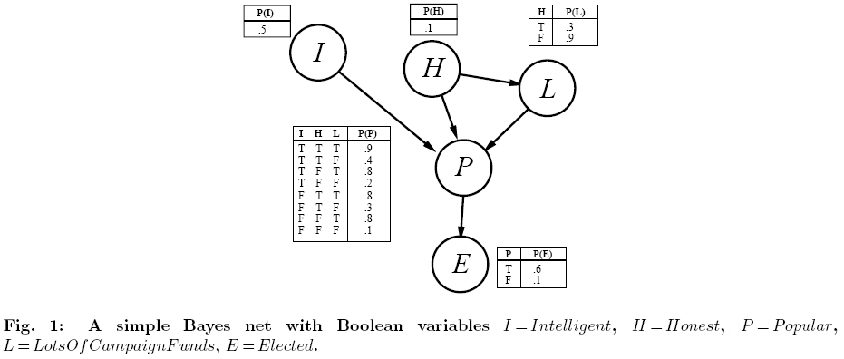
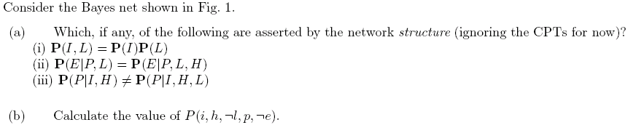

Solution:
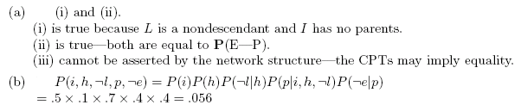
2. Learning
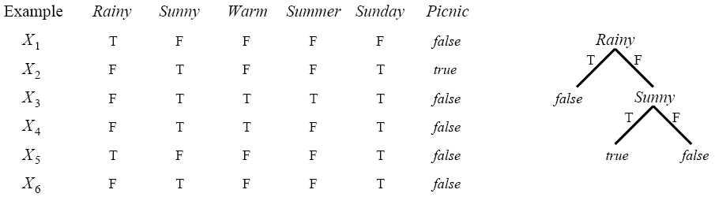

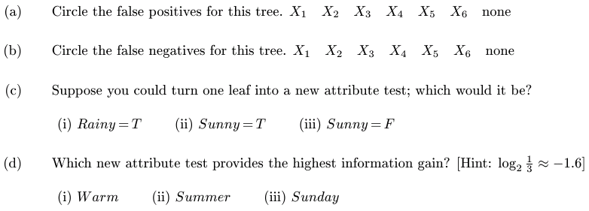

Solution:
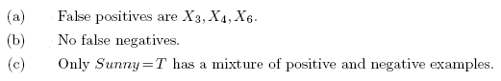
(d)
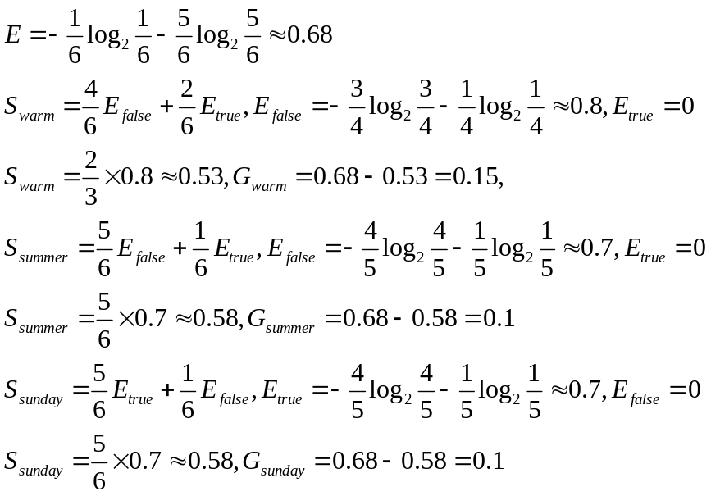
Conclusion: The attribute ‘warm’ provides the highest information gain.

3. Clustering
Given a set of data: {2.4，8，30，50，3.7，4.2，44，12，19.5}, use k-means clustering algorithm to divide these data into three clusters. (The first three data are taken as the initial cluster means)

Solution:
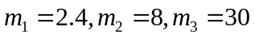(1)
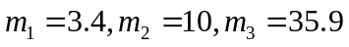(2)

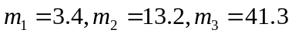(3)

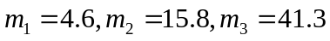(4)

