1. Search
For 8-puzzle problem, the initial state S0 and the goal state Sg are shown in the following Figures:

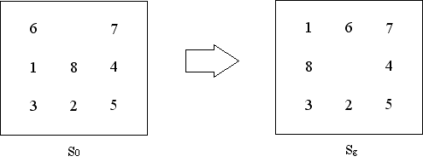
Use A* algorithm to solve this problem. Label the value of h(n) and f (n) for each node.
Solution: The heuristic function is the number of misplaced tiles

6 7
1 8 4
3 2 5
h=3
f=3

6 7
1 8 4
3 2 5
6 7
1 8 4
3 2 5
6 8 7
1 4
3 2 5

h=4
f=5
h=2
f=3
h=3
f=4

1 6 7
8 4
3 2 5
h=1
f=3

1 6 7
8 4
3 2 5
h=0
f=3
1 6 7
3 8 4
2 5
h=2
f=5

2. Game
A game tree is given as follows. We perform 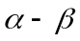 searching in this tree, where the left nodes are generated firstly. Please label the pruning process, including values and  values, as well as the pruned leaves.
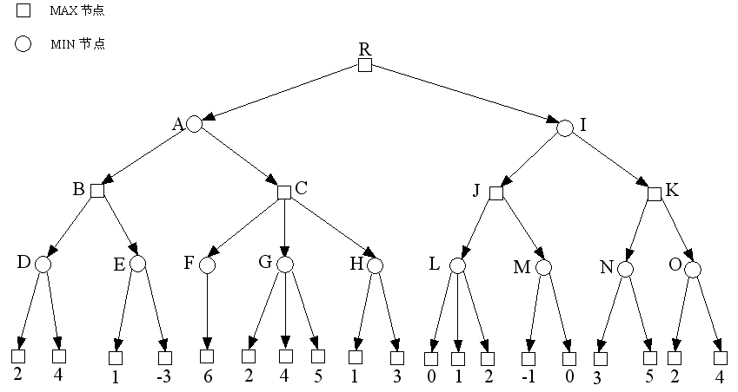

Solution:
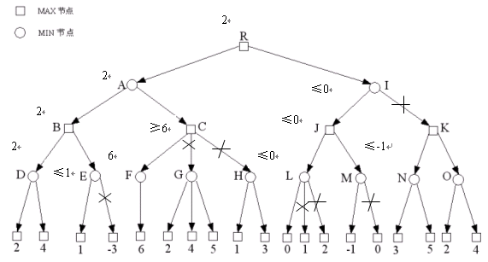
3. Represent the following sentences using first-order logic:
（l）Someone like plum blossom, someone like chrysanthemum, someone like both plum blossom and chrysanthemum.
Solution:
HUMAN(X)：X is a human；LIKE(X, Y)：X like Y

（2）He play basketball every afternoon.
Solution:
AFTERNOON(X)：X is afternoon；PLAY(X, Y)：X play Y

（3）The new computer performs with high speed and contains large memory.
Solution:
NEW(X)：X is new；COMPUTER(X)：X is a computer；FAST(X)：X performs with high speed；LARGEMEMO(X)：X contains large memory

（4）It is not true that all students in the department of computer science like programming.
Solution:
COMPUDEPT(X)：X is in the department of computer science；STUDENT(X)：X i s a student；LIKE(X, Y)：X like Y

（5）All person who like programming like computers.
Solution:
HUMAN(X)：X is a human；LIKE(X,Y)：X like Y

4. Logic Inference
Zhang was stolen. Five detectives were assigned to investigate this case. When they discussed the case, the detective A said: “Either Zhao or Qian must be the thief.”; the detective B said: “Either Qian or Sun must be the thief.”; the detective C said: “Either Sun or Li must be the thief.”; the detective D said: “Either Zhao or Sun must not be the thief.”; the detective E said: “Either Qian or Li must not be the thief.”. Suppose the words of five detectives are true. Please prove Zhao is not the thief using the resolution inference rule.

Solution：
（1）Use the first-order logic to represent the sentences above:
P(x) : x is a thief
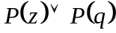，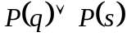，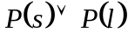，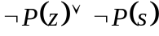，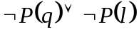

（2）Negate the conclusion
P(z)

（3）Resolution process:
resolved with ，get 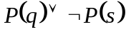；
resolved with ，get P(q)
P(q) resolved with ，get 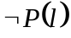
resolved with ，get P(s)
P(s) resolved with ，get 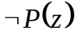\
resolved with P(z)，get NIL，prove that Zhao is not the thief

