**Curriculum design and implementation of distributed database  
  
Samsung's mobile phone sales system**

**Distributed Database Design and Implementation  
  
  
  
  
  
  
  
  
School: School of Computer Science:**

**Course Name: Distributed Databases**

**Project members**

**HAQ IJAZ UL – GROUP LEADER (ID:2820150066)**

**JAlIL FURQAN (ID:2820150079)**

**RON WONG SEE (ID:2820150151)**

 

**Table of Contents**  
  
**Chapter I Samsung phone store sales system**  
1.1 Background 1  
1.2 Feasibility Analysis 1  
1.3 System objectives and advanced place 2  
1.4 Team members and task assignment 3  
**Chapter II demand analysis** 5  
2.1 User Needs Summary 5  
2.2 Business Requirements Analysis 5  
2.3 Functional Analysis 6  
**Chapter III System Design** 8  
3.1 System Development Environment 8  
3.2 System operating environment 8  
**Chapter 9 Distributed Database Analysis and Design**  
4.1 Database Concepts Design 9  
4.2 Logical Database Design Fragmentation and location assignment 14 4.3Data table design 14  
4.4 site database distribution information 14  
**Chapter V distributed system based MYSQL detailed design** 16  
5.1 Design a login window 16  
5.2 The total design management interface manager after landing 17  
5.3 Design stores long after landing management interface 19  
5.4 Design staff management interface after landing 25  
**The sixth chapter summarizes** 26  
**Acknowledgements** 27  
  
 

**Chapter I Samsung phone store sales system**  
**1.1 Background**

With the wide spread of development of science and technology as well as mobile phones, mobile phones have become a necessity of daily life, except for some remote place, almost everyone have a mobile phone. At the same time many mobile phone brands have been launched after one and another, Such as Nokia, Samsung and other brands once dominated China market. However, in recent years, Samsung's smart phones to the Chinese mobile phone market has brought new. Samsung phone is increasingly common in China, consumer demand for the Samsung phone is also growing, therefore, sales of Samsung's phone sales and marketing is also increasing.  
With the development of Samsung's mobile phone sales store growth, especially the expansion of the chain, so that they have dispersed and relatively centralized management features of the region, often have both local control and decentralized management of the store, but also to have the entire organization The global control and a high level of co-management.  
Therefore, these stores and centers are connected via a network, based on the design and development of a distributed database system Samsung phone chain store sales is imperative.

**1.2 Feasibility Analysis**

**(1)Economic feasibility**  
Use Samsung's mobile phone chain store sales system for Samsung mobile phone chain information management will directly increase the efficiency of company management. Submit remotely over the network summary information for each store to headquarters, saving a lot of time and money. On the other hand, with the information management statistics lot of data, save a lot of manpower and financial resources, and provides better decision support.

**(2) Technical feasibility**  
Network application infrastructure improvement, due to the development of information technology, the rapid development of China's computer networks, has built a Chinese public multimedia communication network, China Net, China Education and Research Network and other components of the main Chinese Internet, network applications into the enterprise and general family, which provides the infrastructure for the development of the supermarket chain network office. Network security technology applications, including encryption algorithms, CA digital certificates, digital signatures, etc., to provide security guarantees for the application of the network office system, which implements the network transmission of data security, integrity and so on.  
Finally, there is the popularity of network technology and control, such as networking, network security, network database technology, so that we have the ability to develop their own management systems to achieve.  
Therefore, the company building technology bottlenecks (network application infrastructure, network security, the development of technology) cross-regional management systems have been effectively resolved, the company is technically feasible to build NMS.

**(3) Operational feasibility**  
Samsung mobile phone chain store sales since the operating system is based on client C / S end of the page operation, simple, users do not need to learn, are generally able to know how to operate easily. The administrator need not have the expertise needed only some of the data input as well as the usual routine maintenance is enough.

**1.3 System objectives and advanced place**

**(1) System Target**  
Samsung mobile phone chain to improve efficiency and reduce costs; optimize the Samsung phone chain management, streamline workflow, save resources, improve work efficiency, great to meet customer needs; to analyze various aspects of control, to achieve a unified scheduling.  
Samsung mobile phone chain to meet basic management functions, information systems play flexibility, reduce the burden on business management and operations staff, and improve work efficiency.  
The system has more comprehensive management capabilities, stores the data in the operation of process management and analysis, enterprise management personnel to facilitate business decision-making. Fully embodies the modern enterprise management theory advocated by the work efficiency, relaxed environment atmosphere.

**1-Advanced place**

**(2) System**  
1- various branches of the most complete in situ processing Computer

2- Around by the data communication network links.  
 3-overcome the weaknesses of a centralized database.  
 4-improve the reliability of the system, one branch of the system fails, the other branches can continue to work.  
 5-location of each database is transparent, easy system expansion.  
 6-Affairs to coordinate the activities of the whole system, a high performance transaction management cost.

**1.4 team members and task assignments**  
Tasking member name  
1) assignments, organizational scheduling  
2) survey, a clear demand for supermarket chains and business processes  
3) System Design  
4) Coding System Implementation  
5) Reporting PPT production, project report final results  
6) The final layout design documentation, review

The work was divided as follow among the all the group members.

Haq Ijaz Ul Work:

1) survey, a clear demand for supermarket chains and business processes  
2) is based on a distributed MySQL database implementation  
3) Coding System Implementation  
4) The final layout design documentation, review

Jalil Furqan

1) the establishment of an entity - relationship model, drawing E-R diagram  
2) outline design database distribution and fragmentation, relevant illustrations drawing set  
3) System Joint Test

Ron Wong See

Design 1) the core database tables  
2) the establishment of system communication model, the associated drawing legend  
3) outline design database distribution and fragmentation, the relevant legends draw  
4) Joint Test System  
  
  
  
  
  
  
**Chapter II demand analysis**

**2.1 User Needs Summary**  
The following are obtained by the investigation needs Samsung phone stores main information data analysis results:  
(1) Samsung phone chain usually consists of a central (headquarters), multiple remote chain stores (stores) composition, and each chain are located in different regions.  
(2) They are not among the various chain stores Samsung phone data transmission, only between the branches and the head office only need to exchange data, this data exchange is carried out via a LAN.  
(3) The total head office can be summarized for each branch manager of sales information aggregated stores employee information, and a summary of basic information for each branch.  
(4) Each remote site (each branch and headquarters), respectively, a database system, each form an independent subsystem can perform independent business processes in this sector respectively.  
(5) various branches of the local staff of the manager and staff information, local sales information, information on local suppliers, local purchasing information, local product information, management information and stores the local aftermarket information. Therefore, branch chief and staff only for local centralized database management, do not exchange data between the various branches.  
(6) Staff Information whole Samsung phone chain management and maintenance by the head office, each branch employee can only query the information in this sector.

**2.2 Business requirements analysis**  
Samsung mobile phone chain through business, managing business processes investigation, give the following business needs.  
① achieve for users who have different administrative rights Log database operations.  
② Total administrator only sales, staff, the branch management situation.  
③ Administrator of employee information, vendor information, purchase information, sales information, product information, sale information, store information management.  
④ Staff of customer information, sales information, product information, sale information and warehouse information management.  
In addition, the performance of the system are mainly the following aspects of the demand.  
System in the design process should be fully taken into account scalability requires that the user interface is elegant, easy to use.

**2.3 Functional Analysis**

According to the system of business surveys and user needs analysis, combined with computer information management features, design the system to achieve the following functions.  
**(1) To achieve for the user to have different administrative rights Log database operations.**  
Each user login database, you need to enter a user name and password dialog box and manually select the user type: Total manager, branch chief, general staff, before you can log into the database.  
**(2) The Chief Administrator rights management**  
Total administrator only for sales, staff, the branch situation management, information collection purposes.

**Implemented features include:**  
For sales inquiries and preview;  
Staff situation on the query and preview;  
For stores to conduct inquiries and preview.

**(3) The Administrator rights management**  
Administrator of employee information, vendor information, purchase information, sales information, product information, sale information, store information management.

Implemented features include:  
*Vendor information, purchase information, sales information, product information, sale information, store information for preview and inquiries;*According to the chain area of ​​supplier information, purchase information, sales information, product information, sale information, store information inquiries;  
Vendor information, purchase information, sales information, product information, sale information to add and delete;  
Vendor information, purchase information, sales information, product information, sale information, store information is updated.

**(4) General staff rights management**

The general staff of customer information, sales information, product information, sale information and warehouse information management. Implemented features include:  
*Customer information, sales information, product information, sale information and warehouse information query and preview;*Customer information, sales information, sale information and to add and update.  
  
  
  
  
**Chapter III System Design**

**3.1 System Development Environment**  
This system is under the Chinese version of the Windows 7 operating system environment, using Eclipse developed using Java language. During development, the use of OLE technology and JDBC technology, SWT technology. Background database system design uses Microsoft's MySQL database system via JDBC database development technology, direct manipulation of the database files. SWT is used to interface design.  
**3.2 System operating environment**  
B the software has been packaged as an exe application, so the system can in Win98, Win2000, WinXP Windows 7 Windows 8,   
  
  
**Chapter IV distributed database analysis and design**

**4.1 Database Concepts Design**  
Analysis of Samsung's mobile phone chain management processes, data entities system includes branch entity, the entity staff, suppliers entity, commodity entity, customer entity, warehouses entities.  
The system of E-R diagram shown in Figure 4-1.

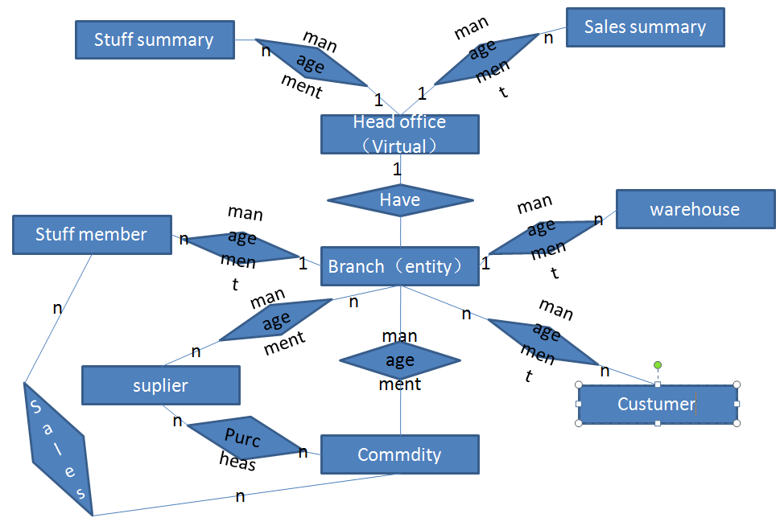  
 Figure 4-1 Samsung mobile phone chain store sales system E-R diagram

**4.2 logical database design**

Merchandise table, customer list, vendor table, table sales, after-sales table, branch table, staff table, table purchase, warehouse table information.  
Product table:  
   
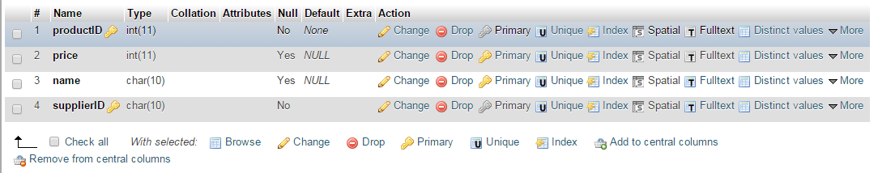

Figure 4-2 Product table

**Customer table:**

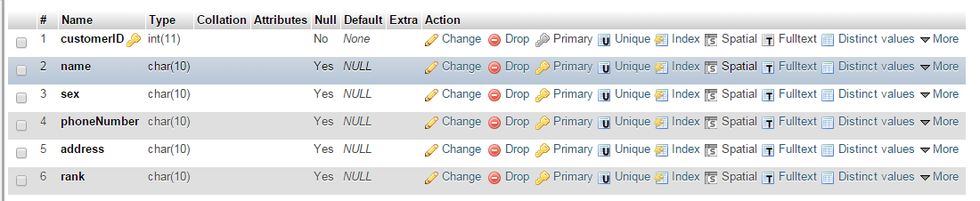

Figure 4-3 Customer table

**Suppliers table:**

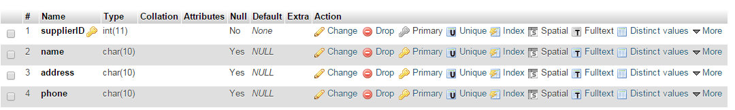

Figure 4-4 Supplier Table

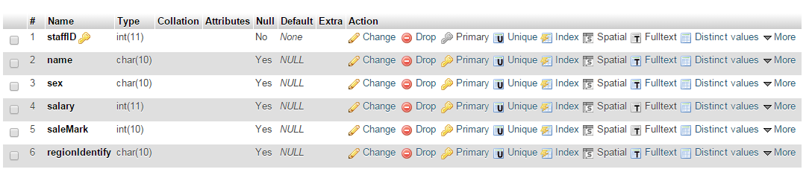

Staff Table Figure 4-5

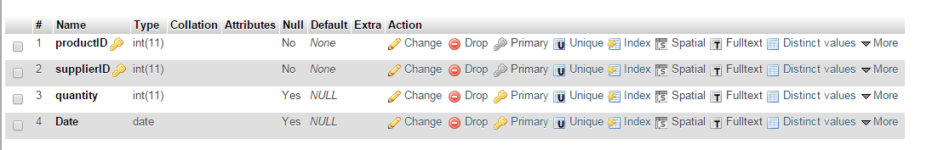

Stock Table Figure 4-6

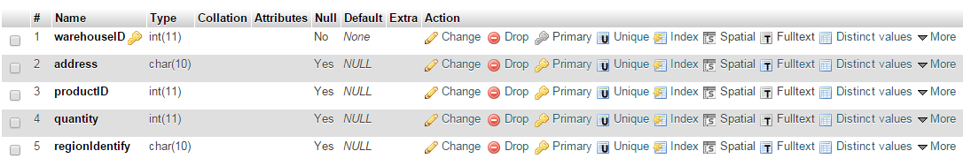  
Warehouse Table Figure 4-7

Thus, according to the staff table and warehouse table area (Area Branch mark) horizontal slices are obtained.  
**(2)** The Data recorded for each branch stores table information for each branch in order to facilitate inquiries, and generally only query without modification, so each site is equipped with a copy of the table.  
**(3)** As a result of the rest of the table is often used to store this information, so these tables are copied, and the copy number is the number of branches in order to achieve redundant storage.

**4.4 site database distribution information**  
Our database distributed on two computers, each computer on behalf of a region, such head office (virtual) can easily transparent access to the database.

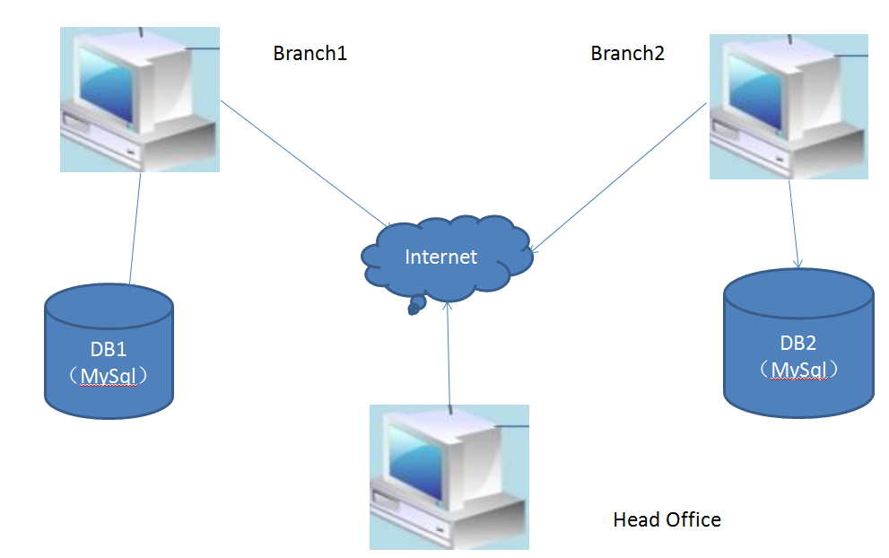  
   
Figure 4-11 sites distributed representation  
  
  
**Chapter V distributed system based MYSQL detailed design**

**5.1 Design a login window**  
The main achievement of login_to_sql.java, the main function of this code is to achieve a variety of roles landing.

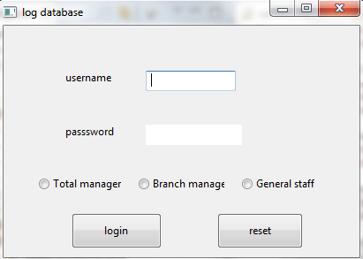

The program starts, the first pop-up "sign-on database" dialog box, enter the correct user name, password, and select the correct user can enter the system.

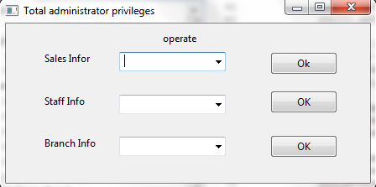  
   
Figure 5-1 "Log Database" dialog  
If the login user is always administrator, will enter as shown in "general administrator privileges" window interface shown in 3-2.

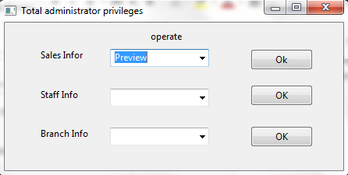  
   
Figure 5-2 "general administrator privileges" window

**5.2 The total design management interface manager after landing**  
The main achievement of displayAllSale.java, displayAllWorker.java, searchAllSale.java, searchAllWorker.java, search_subshop.java.  
Enter "general administrator privileges" window, administrators can always sell information, employee information, store information, preview and query. As shown in Figure 5-3,5-4,5-5,5-6. Wherein Figure 5-4,5-6 total sales administrator for information preview and query results.

 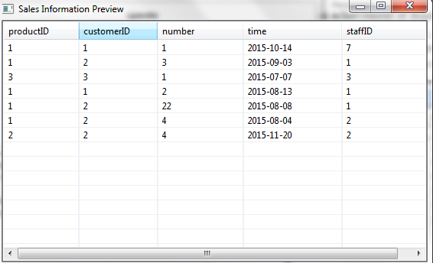  
Figure 5-3 Total sales information administrators preview  
   
Figure 5-4 Total administrator preview the results of the sales information  
 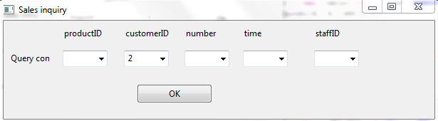  
Figure 5-5 Total sales administrator for information query  
 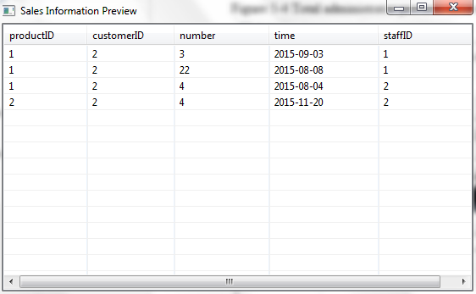  
Figure 5-6 Total administrator for the results of the sales information  
  
**5.3 Design stores long after landing management interface**  
The main achievement of delete_productor.java, delete_worker.java, insert_income.java, insert_productor.java, insert_worker.java, search_income.java, search_productor.java, search_subshop.java, search_worker.java, update_productor.java, update_worker.java.  
If the login user to store long, then enter the "Administrator Privileges" window interface shown in Figure 5-7.

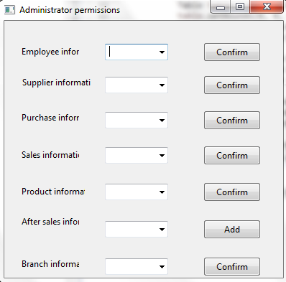  
   
Figure 5-7 "Administrator Privileges" window  
Enter the "Administrator Privileges" window, the administrator can employee information, vendor information, purchase information, sales information, product information, sale information, preview and store information based on branch location queries. As shown in Figure 5-8,5-9,5-10. Wherein Figure 5-10 shows employee information Haidian District administrators were results of the query.

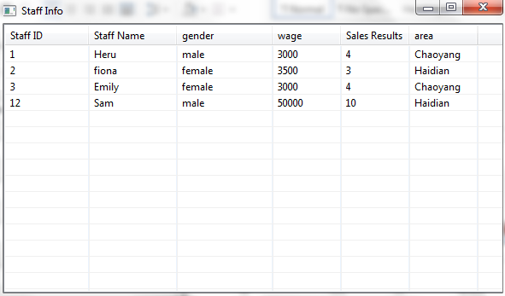  
   
Figure 5-8 Administrator of Staff Information preview

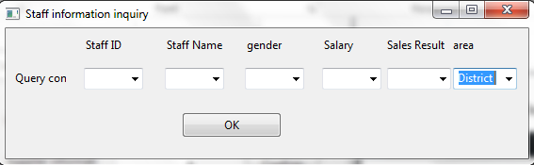  
   
Figure 5-9 Administrator of Haidian District employee information query

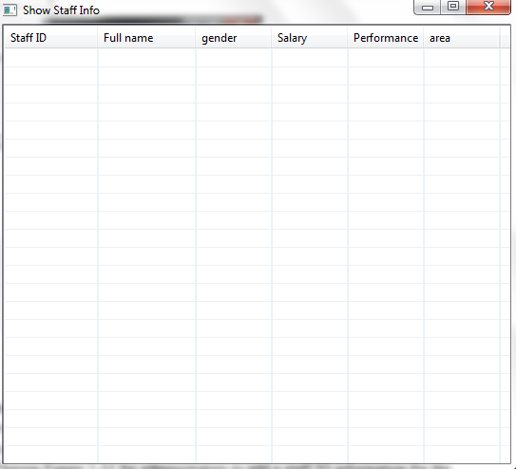  
   
Figure 5-10

Administrator query result to Haidian District employee information, but we do not have data in the database that is why it is empty.  
In addition to the above preview and query capabilities, administrators can vendor information, purchase information, sales information, product information, sale information to add and delete, as shown 5-11,5-12. Wherein Figure 5-11 for administrators to add a staff ID information for the operating staff 4, Figure 5-12 for deletion staff ID information for the operating staff 4.  
   
 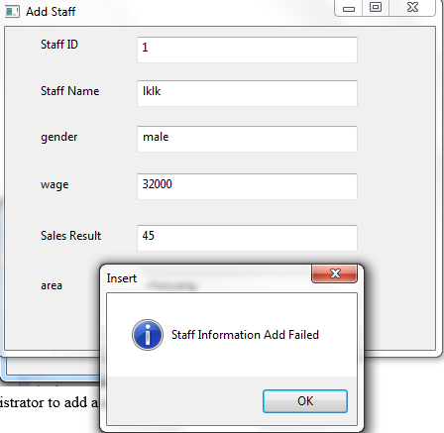

Figure 5-11 administrator to add a staff ID information for staff 4

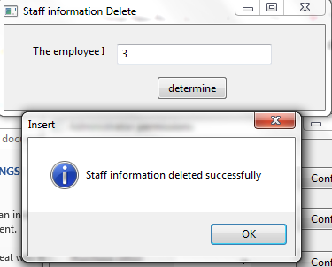  
   
Figure 5-12 Administrator delete the employee ID information for staff 4  
In addition, administrators can also vendor information, purchase information, sales information, product information, sale information, store information is updated, as shown in Figure 3-13 employee ID as information officers 4 update.  
   
Figure 5-13 employee ID as information officers 4 Updated  
If the login user is the general staff, then enter the "Staff Permissions" window interface shown in Figure 3-14.

 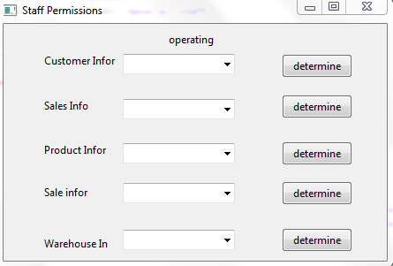  
Figure 5-14 "Staff Permissions" window interface  
  
**5.4 Design staff management interface after landing**  
The main achievement of delete_custormer.java, delete_goods.java, delete_sale.java, delete_storehouse.java, insert_custormer.java, insert_goods.java, insert_sale.java, insert-servicing.java, search_customer.java, search_goods.java, search_sale.java, search_serving .java, search_storehouse.java, update_customer.java, update_goods.java, update_storehouse.java.  
The general staff can customer information, sales information, product information, sale information and warehouse query and preview information, customer information, sales information, sale information and to add and update. Since the same as the corresponding operations are the administrator of the general staff, and are not discussed here.  
  
  
**Chapter VI Summary**  
After a month of effort, finally we completed the contents of this subject. During this time, our team to consolidate and deepen the knowledge learned in the understanding of distributed databases, but also to learn new knowledge java programming language for the next job and learning to lay a more solid foundation.

  In general, the subject of the ideal to achieve the desired purpose, but there are some deficiencies, like in some places there are defects in the software, a lot of which some features not yet implemented, considering the emergency situation is relatively limited understanding of new learning content is still relatively superficial. These require an open mind in the future we will continue to learn and study hard.  
  
  
**Acknowledgements:**  
Suddenly, a term also so later! Our team also successfully completed the course design of distributed databases. In the meantime, thank every member of our team, thanks to our rich heritage of cooperation and mutual understanding.