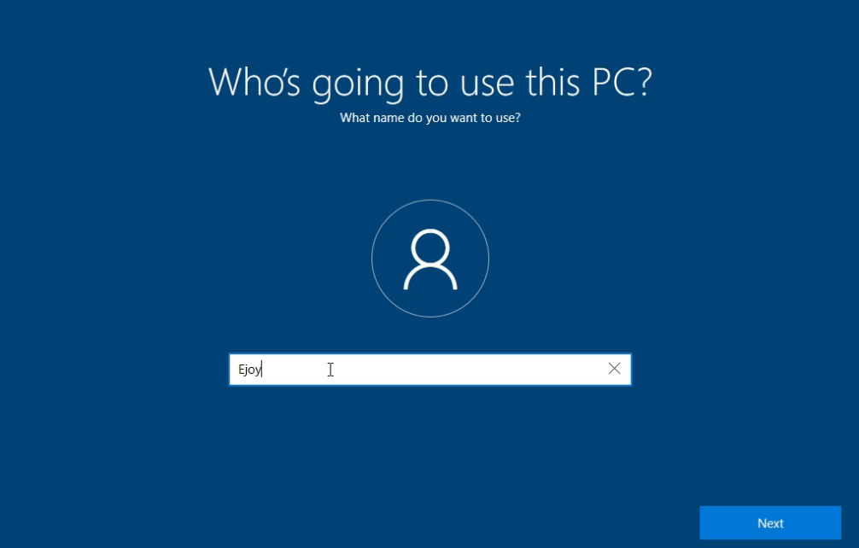**Note:** Did not take some screenshots during installation.  
Network adapter in VMware was **disconnected first** to make the installation easier.  
Selected **Offline Account** and **Limited Experience**, then created a **system partition**.

Chose **Custom Installation** → **Created a partition** → clicked **Next**.

Installation took several minutes to complete.

After installation, created a **local account** with a username and password.

Once setup finished, logged in successfully to the Windows 10 desktop.

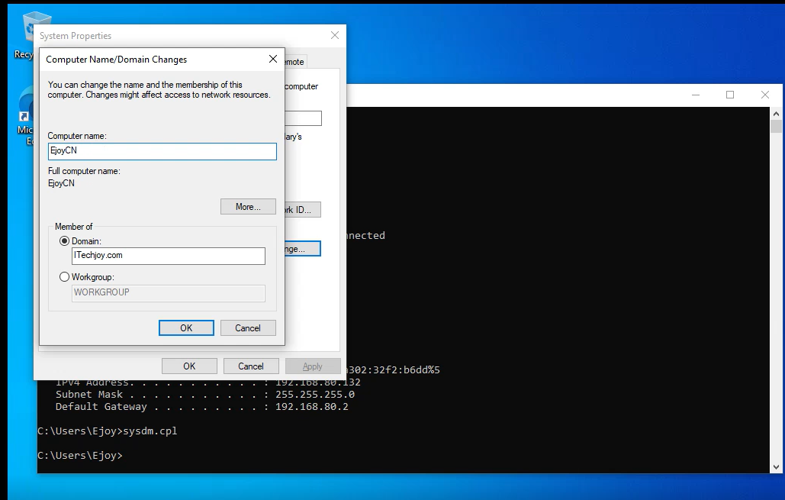

Using **Command Prompt**, ran ipconfig and ncpa.cpl to access Ethernet settings and manually set the **IP address**, **gateway**, and **DNS** to match the domain controller network.

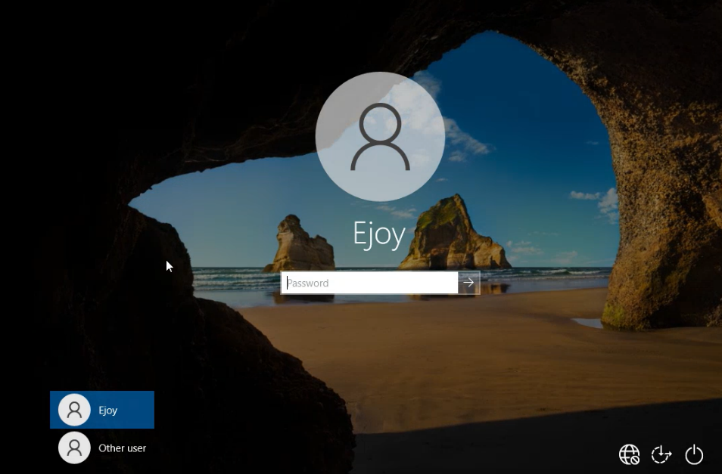Next, opened **System Properties** using sysdm.cpl, clicked **Change**, and joined the domain **ITechjoy.com** using the administrator credentials.

After restarting, the login screen displayed the domain sign-in option, confirming successful **domain join and authentication** with the server.