**AIM:** perform the extraction transformation and loading (ETL) process to construct the database in the SqlServer/PowerBI **.**

# ETL Process in Power BI

* 1. **Remove other columns to only display columns of interest**

In this step you remove all columns except ProductID, ProductName, UnitsInStock, and QuantityPerUnit

Power BI Desktop includes Query Editor, which is where you shape and transform your data

connections. Query Editor opens automatically when you select Edit from Navigator. You can also open the Query Editor by selecting Edit Queries from the Home ribbon in Power BI Desktop. The following steps are performed in Query Editor.

* + 1. In Query Editor, select the ProductID, ProductName, QuantityPerUnit, and UnitsInStock columns (use Ctrl+Click to select more than one column, or Shift+Click to select columns that are beside each other).
    2. Select Remove Columns > Remove Other Columns from the ribbon, or right-click on a column header and click Remove Other Columns.

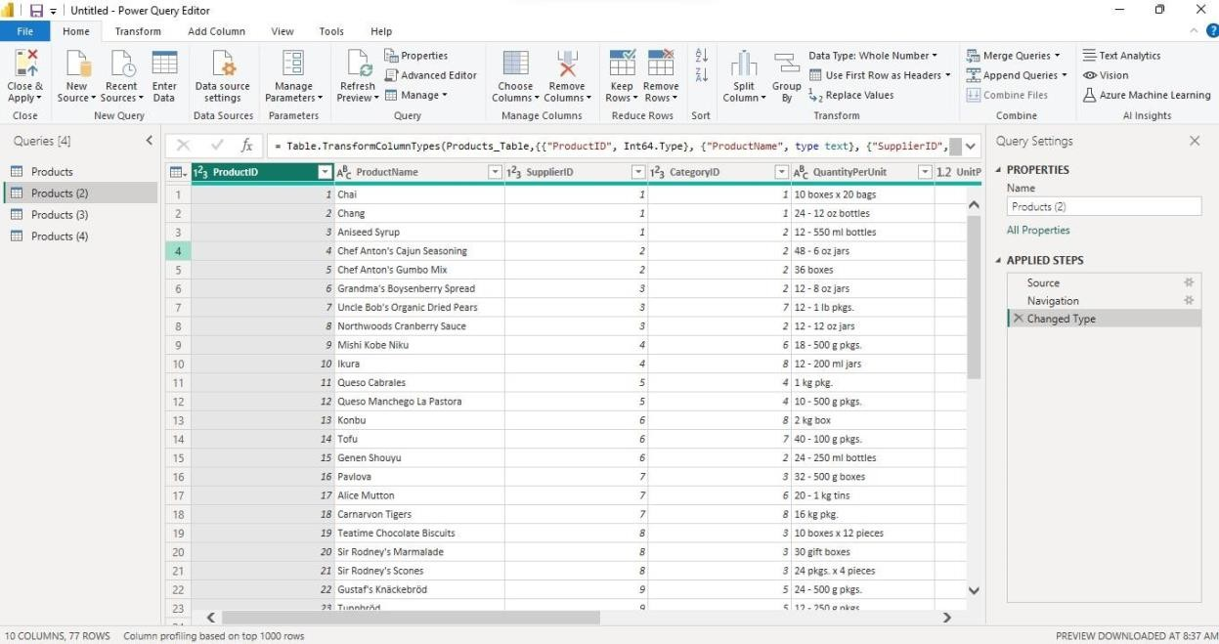

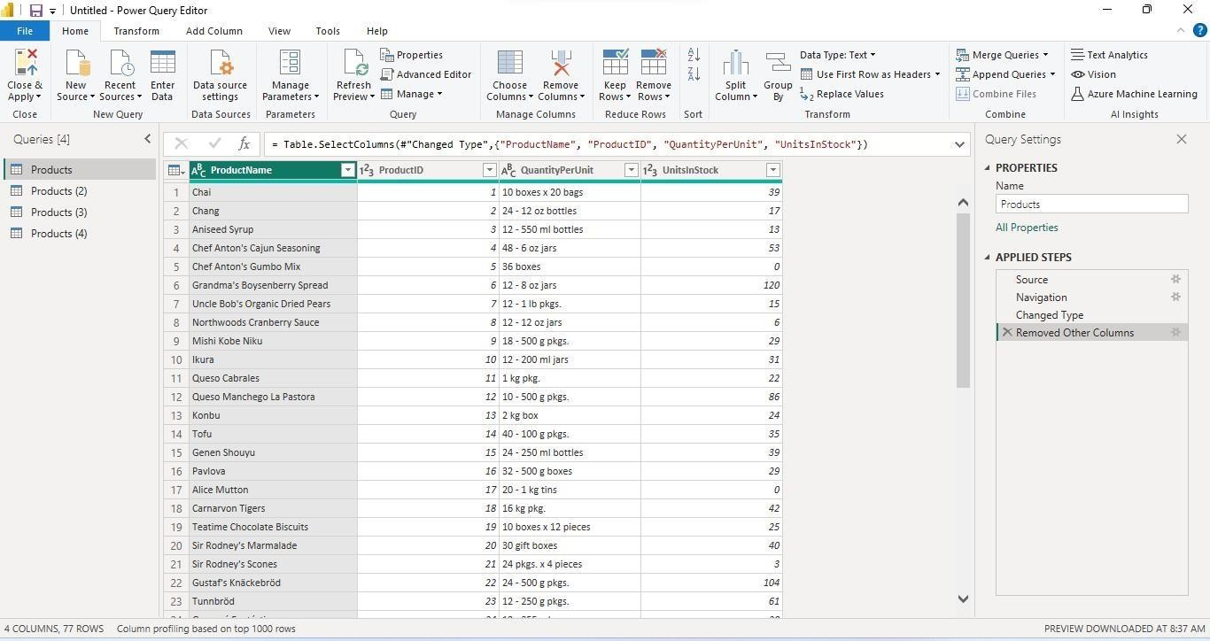

## 2. Change the data type of the UnitsInStock column

When Query Editor connects to data, it reviews each field and to determine the best data type. For the Excel workbook, products in stock will always be a whole number, so in this step you confirm the

UnitsInStock column’s datatype is Whole Number.

1. Select the UnitsInStock column.
2. Select the Data Type drop-down button in the Home ribbon.
3. If not already a Whole Number, select Whole Number for data type from the drop down (the Data Type: button also displays the data type for the current selection)

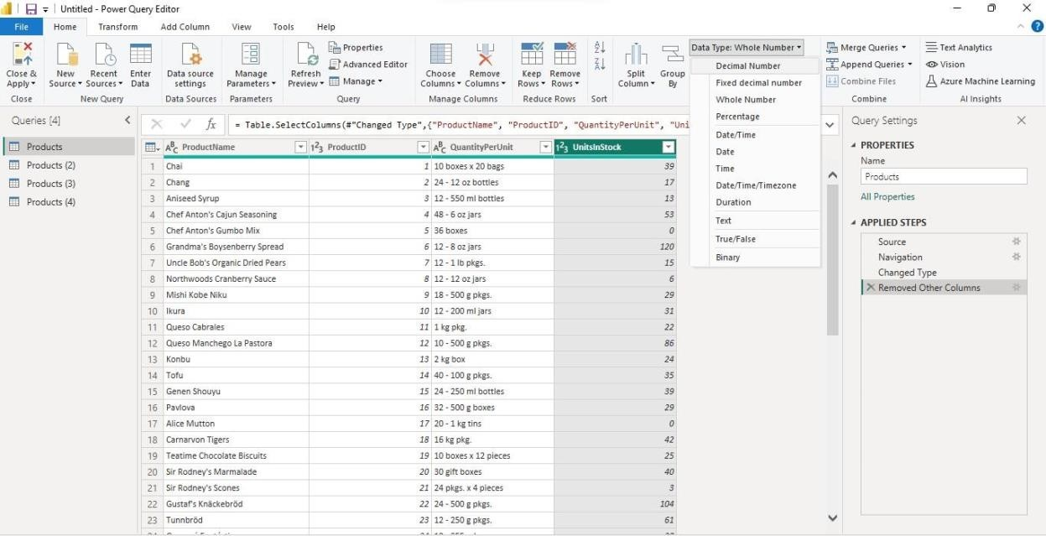

## Expand the Order_Details table

The Orders table contains a reference to a Details table, which contains the individual products that were included in each Order. When you connect to data sources with multiples tables (such as a relational database) you can use these references to build up your query.

In this step, you expand the Order_Details table that is related to the Orders table, to combine the ProductID, UnitPrice, and Quantity columns from Order_Details into the Orders table. This is a

representation of the data in these tables:

The Expand operation combines columns from a related table into a subject table. When the query runs, rows from the related table (Order_Details) are combined into rows from the subject table (Orders).

After you expand the Order_Details table, three new columns and additional rows are added to the Orders table, one for each row in the nested or related table.

1. In the Query View, scroll to the Order_Details column.
2. In the Order_Details column, select the expand icon ( ).
3. In the Expand drop-down:
   1. Select (Select All Columns) to clear all columns.
   2. Select ProductID, UnitPrice, and Quantity.
   3. 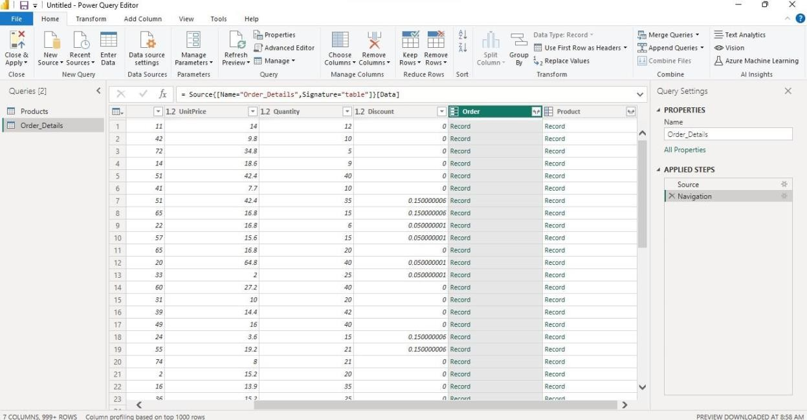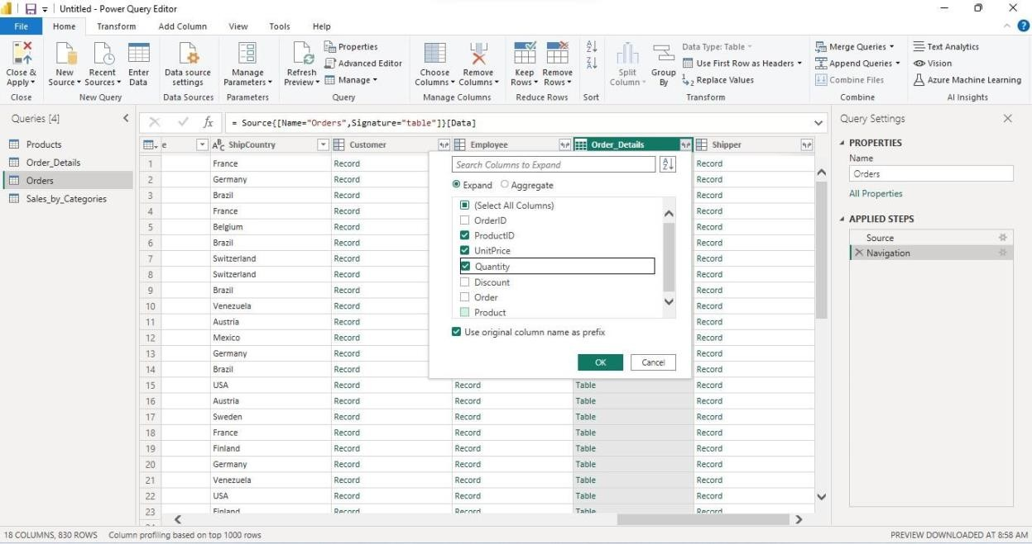click

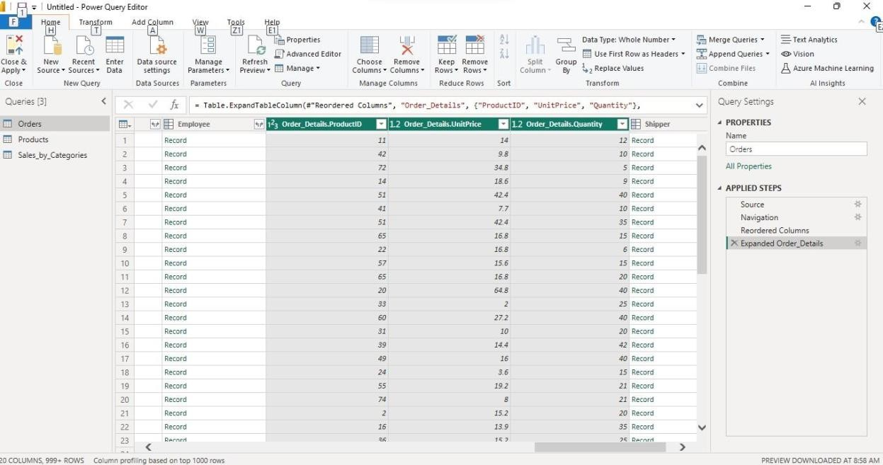

## Calculate the line total for each Order_Details row

Power BI Desktop lets you to create calculations based on the columns you are importing, so you can

enrich the data that you connect to. In this step, you create a Custom Column to calculate the line total for each Order_Details row. Calculate the line total for each Order_Details row:

* + - 1. In the Add Column ribbon tab, click Add Custom Column.

## Combine the Products and Total Sales queries

Power BI Desktop does not require you to combine queries to report on them. Instead, you can create Relationships between datasets. These relationships can be created on any column that is common to your datasets we have Orders and Products data that share a common 'ProductID' field, so we need to ensure there's a relationship between them in the model we're using with Power BI Desktop. Simply specify in Power BI Desktop that the columns from each table are related (i.e. columns that have the same values). Power BI Desktop works out the direction and cardinality of the relationship for you. In some cases, it will even detect the relationships automatically.

In this task, you confirm that a relationship is established in Power BI Desktop between the Products and Total Sales queries

Step 1: Confirm the relationship between Products and Total Sales

* + - 1. First, we need to load the model that we created in Query Editor into Power BI Desktop. From the Home ribbon of Query Editor, select Close & Load.

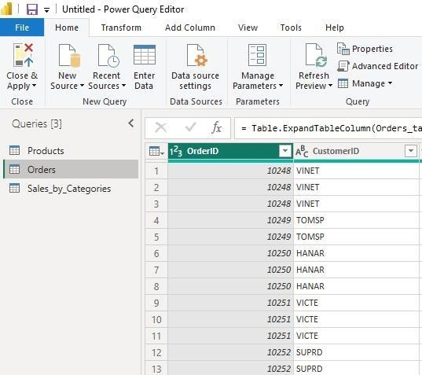

* + - 1. 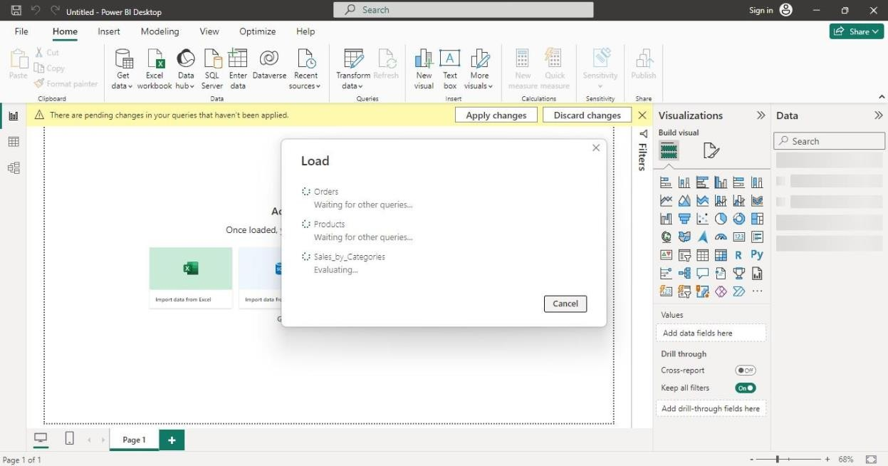Power BI Desktop loads the data from the three queries.
      2. Once the data is loaded, select the Manage Relationships button Home ribbon.
      3. Select the New… button
      4. When we attempt to create the relationship, we see that one already exists! As shown in the Create Relationship dialog (by the shaded columns), the ProductsID fields in each query already have an established relationship.

1. Select Cancel, and then select Relationship view in Power BI Desktop.
2. We see the following, which visualizes the relationship between the queries.

