MAKERERE UNIVERSITY
IST2106 Technopreneurship and Digital Marketing
Solution Validation and Business Model Evidence Portfolio
JengaConnect · Evening A Group 6 · Phase 2 (Week 2) · 1 November 2026
Group member | Registration number
LUYOBYA VICENT | 25/U/03863/EVE
YIGA AKRAM | 23/U/18680/PS
KWAGALA ELVIS | 25/U/0365
MUGANWA EDRINE | 25/U/03890/EVE
MUJUNI NASEEM | 25/U/03899/EVE

Contents
1. Customer persona
2. Customer journey
3. Full Business Model Canvas
4. Prototype wireframes and service flow
5. Prototype-testing guide, consent script and feedback form
6. Anonymised feedback records (P01 to P05)
7. Prototype change log
8. Critical assumption and validation log
9. Photo and video evidence register
10. Fieldwork log and individual contribution log
11. Recorded group discussion plan
Evidence status: blank or [pending] fields must be filled from real fieldwork. No interviews, feedback, photographs, videos or figures have been invented. As at this version: 0 of at least 5 prototype feedback sessions are recorded.
AI disclosure: an AI assistant helped draft the layout and wording of these documents. Fieldwork, feedback and every figure must come from the team's own work and be verified before submission.
1 Customer persona
Provisional persona for the primary customer. Basis codes: P1 Phase 1 brief, P2 Phase 2 preparation notes, A assumption to test. Update after fieldwork.
Trait | Provisional persona: self-builder | Basis
Profile | Adult artisan or household builder building or extending in stages, buying small quantities near Kampala or Wakiso. | P1 (artisan / household builder); staged building is A
Goal | Find the right quantity of usable material nearby, in a condition they can inspect, at a total collection cost that is worth the trip. | P2 hypothesis
Motivation | Keep a build moving and control cost. | A
Frustrations | Uncertain availability, unsuitable quantities, quality doubts and transport cost. | P2 hypothesis
Behaviour today | Asks personal contacts, visits hardware shops, looks at general classified listings. | P1 alternatives list
Context | A small shortfall appears mid-build and work waits until it is solved. Uses a mobile phone for search. | A

Users, customers, buyers and beneficiaries
Role | Who | Note
User and buyer | Self-builders, artisans, small contractors | Primary segment (P1)
Seller and proposed payer | Site managers, contractors, hardware sellers with surplus | Payer is untested (A3)
Beneficiaries | Neighbouring builders and community through reuse | Benefit claimed only, not measured

Needs, pains and gains (hypotheses)
Needs | Pains | Expected gains
Right quantity; inspectable condition; affordable total collection cost | Uncertain availability; unsuitable quantities; quality concerns; transport cost | A relevant local offer; clear collection arrangements

Evidence supporting these: Phase 1 problem definition only. Participant evidence: [pending].
2 Customer journey
Current journey of the persona (hypothesis, to be confirmed by interviews).
Stage | Current experience | Pain / touchpoint | Opportunity for JengaConnect
1 Recognise need | Finds a shortfall or leftover gap during building. | Unsure whether usable leftovers exist nearby. | Browse by material, quantity and area.
2 Search | Asks contacts, calls or visits hardware shops, scans classifieds. | Scattered sources; time and travel before knowing availability. | One material-specific listing view.
3 Evaluate | Compares price, distance and condition by phone or photo. | Condition and quantity unclear; seller authority unknown. | Photos, condition, unit and quantity on every listing.
4 Select / use | Agrees price, inspects and arranges transport. | Transport cost and a wasted trip if stock differs. | Questions, inspection arrangement and collection window.
5 After use | Uses the material; keeps or disposes of leftovers. | No simple route to report a problem or list leftovers. | Completion status and a simple complaints route.

Touchpoints to observe in fieldwork
- Phone calls and messages to contacts and shops
- Visits to hardware shops
- General classified listings
- Transport arrangement and inspection visit
3 Business Model Canvas
Key Partnerships  Hardware shops  site managers  Delivery providers. | Key Activities  Maintain listings  recruit sellers and buyers  moderation  customer support | Value Propositions  Buyers: find small quantities of usable material nearby with condition and quantity visible before travelling or delivery.  Sellers: a way to sell surplus material rather than incurring storage or transport costs. | Customer Relationships  Listing support for sellers  listing status updates on a material.  A complaints route and moderation of reports. | Customer Segments  Buyers: self-builders, artisans and small contractors.  Sellers: site managers, contractors and hardware sellers with usable, non-hazardous surplus.
 | Key Resources  Listing platform and hosting  material information(proof of ownership and sales agreements)  support and moderation staff  operating funds. |  | Channels  Mobile website  direct outreach to site managers.  shareable listing links.
Cost Structure  Hosting, mobile data, support and management, outreach and verification, tax and legal compliances |  |  | Revenue Streams  A seller listing fee.

Justification and status of each block
Block | Why this choice | Status
Customer Segments | Two sided because a listing needs both a seller and a nearby buyer. Scope taken from Phase 1. | Hypothesis
Value Propositions | Matches the Phase 1 problem statement and the Week 2 persona pains. | Hypothesis
Channels | Basic smartphone browsers are assumed; reach is built through construction contacts. | Assumption
Customer Relationships | Trust and condition are the main risks named in Phase 1. | Assumption
Revenue Streams | Sellers hold the surplus to clear; buyers are small and likely price sensitive (assumption). No figures claimed. | To test (A3)
Key Resources | Needed to keep listings accurate and safe. | Assumption
Key Activities | Follows the four prototype screens. | Assumption
Key Partnerships | Supply and collection help. Payments and escrow are outside the first concept. | Hypothesis
Cost Structure | No cost figures are stated until sourced. | Week 3

Completing all nine blocks does not validate the model. Cost and revenue figures are not stated because none has been sourced.
4 Prototype wireframes and service flow
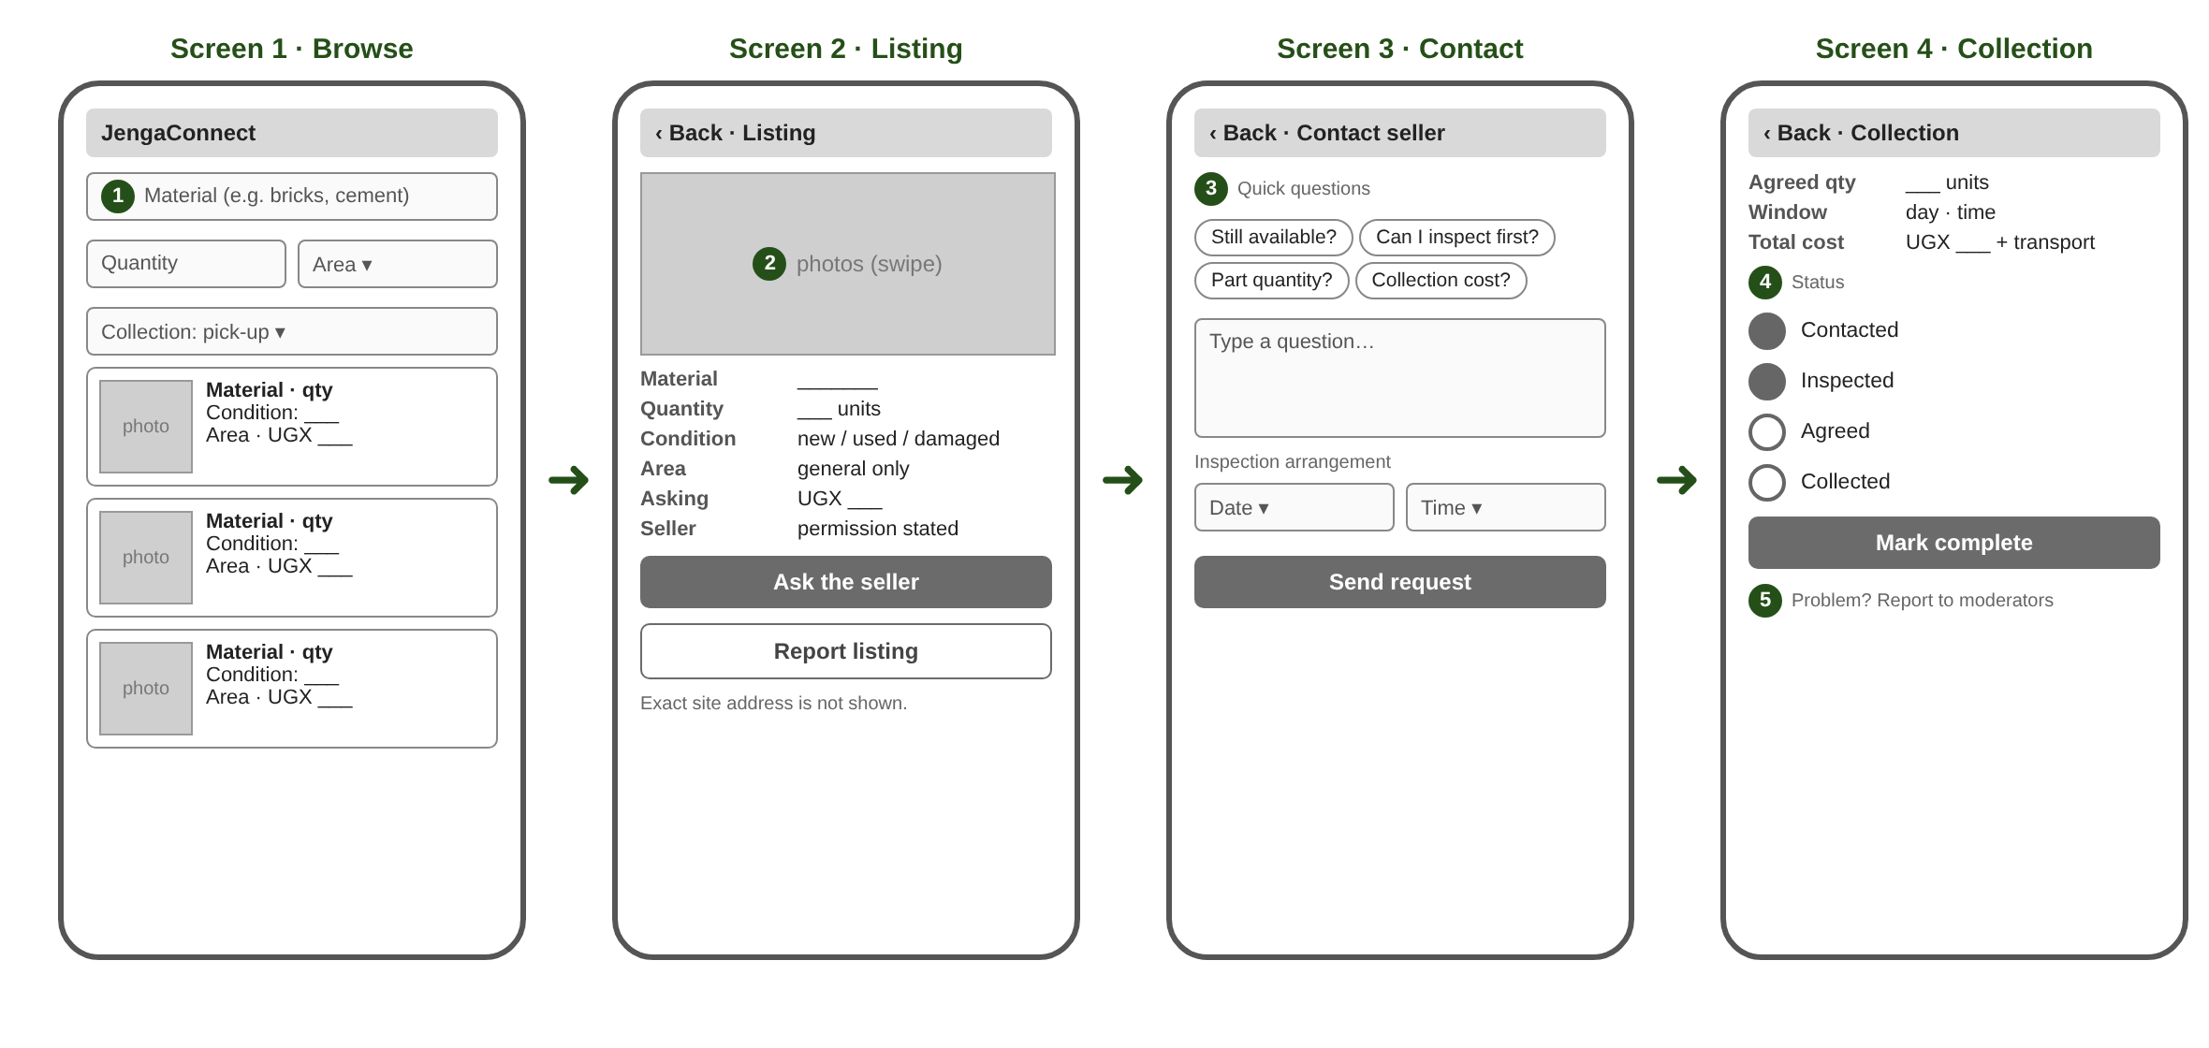
Labelled features
1. Material search and filters: Browse by material, quantity, broad area and collection option.
2. Structured listing: Photos, condition, unit, quantity and asking price; exact site address hidden.
3. Seller contact and inspection: Pre-set questions and an inspection arrangement.
4. Collection coordination: Agreed quantity, collection window and completion status.
5. Moderation and reporting: Listing checks, seller permission and a report button.
Intended user flow and decision points
Buyer opens Browse and filters by material, quantity and area → opens a Listing → decision: is the condition and quantity acceptable? If no, return to Browse; if yes → Contact the seller and propose an inspection → decision: does inspection confirm the listing? If no, report or return to Browse; if yes → agree quantity, collection window and total cost → Collection screen → mark complete.
Seller side: create a listing (material, photos, condition, unit, quantity, asking price, general area) → moderation check → published → respond to questions → confirm collection.
View-only prototype link: [add Figma or Canva link]. A functioning application is not required.
5 Prototype-testing guide and consent
Consent script (read aloud)
"We are Makerere University students testing an idea for a building-materials listing service. Taking part is voluntary and you may stop at any time. We will not record your name unless you wish, and we will record audio, photos or video only with your permission. Your answers will be anonymised in our report. Do you agree to take part? May we take notes? May we photograph or record (optional)?"
Tasks to show on the prototype
- Find a suitable quantity of a material you recently needed.
- Say what you think each screen lets you do.
- Ask the seller a question and arrange an inspection.
- Tell us what information is missing.
Interview questions
1. Does this solution address the problem you described?
2. Which features would be most useful to you, and why?
3. What is unclear, difficult or unnecessary?
4. How would you expect this solution to work?
5. What concerns would prevent you from using it?
6. How does it compare with the alternatives you use now?
7. What would prevent you from contacting the seller?
8. How would you check quality and arrange collection?
9. Who should pay a fee, and in what form? (tests A3; do not suggest a number)
Do not pressure participants to be positive. Record negative responses as carefully as positive ones.
6 Anonymised feedback records (at least five participants)
Complete from real sessions only. Use codes, not names.
Record P01
Date | Role (buyer / seller / other) | Consent: notes / photo / recording

Question | Response (anonymised)
Does this solution address the problem you described?
Which features would be most useful to you, and why?
What is unclear, difficult or unnecessary?
How would you expect this solution to work?
What concerns would prevent you from using it?
How does it compare with the alternatives you use now?

Record P02
Date | Role (buyer / seller / other) | Consent: notes / photo / recording

Question | Response (anonymised)
Does this solution address the problem you described?
Which features would be most useful to you, and why?
What is unclear, difficult or unnecessary?
How would you expect this solution to work?
What concerns would prevent you from using it?
How does it compare with the alternatives you use now?

Record P03
Date | Role (buyer / seller / other) | Consent: notes / photo / recording

Question | Response (anonymised)
Does this solution address the problem you described?
Which features would be most useful to you, and why?
What is unclear, difficult or unnecessary?
How would you expect this solution to work?
What concerns would prevent you from using it?
How does it compare with the alternatives you use now?

Record P04
Date | Role (buyer / seller / other) | Consent: notes / photo / recording

Question | Response (anonymised)
Does this solution address the problem you described?
Which features would be most useful to you, and why?
What is unclear, difficult or unnecessary?
How would you expect this solution to work?
What concerns would prevent you from using it?
How does it compare with the alternatives you use now?

Record P05
Date | Role (buyer / seller / other) | Consent: notes / photo / recording

Question | Response (anonymised)
Does this solution address the problem you described?
Which features would be most useful to you, and why?
What is unclear, difficult or unnecessary?
How would you expect this solution to work?
What concerns would prevent you from using it?
How does it compare with the alternatives you use now?

7 Prototype change log
Participant code | Observed difficulty or request | Change made | Reason | Screenshot / version

Attach before and after screenshots for every change.
8 Critical assumption and validation log
ID | Team belief | Why it matters | Evidence so far | Test | If wrong | Result
A1 | Enough suitable surplus exists within a practical collection area. | Without supply there are no listings and no matches. | None yet. Phase 1 desk comparison only; 0 participants. | Ask sellers about one recent surplus event: what, how much, what happened to it. Count real examples. | Narrow materials or area, or recruit hardware shops as a steadier supply source.
A2 | Buyers accept the total cost and effort after inspection and transport. | Buyers decide on total cost, not asking price alone. | None yet. Alternatives and costs not yet rated by participants. | Compare each buyer's last purchase with a worked listing example including collection cost. | Add shared collection or delivery partners, or target larger quantities.
A3 | A clearly identified payer will pay a fee that supports operating costs. | No payer means no revenue model. | None yet. Payer and price unknown. | Ask sellers and buyers which side would pay, in what form (flat fee or share of price), and at what level. | Test the other payer, a different fee form, or a partner-funded model.

Cycle: ASSUME → TEST → LEARN → REFINE.
9 Photo and video evidence register
Ref | Type | Description | Consent obtained (Y/N) | Link or file
V04 | Video | Group presentation and prototype pitch (unlisted YouTube) |  | [pending]
V05 | Video | Prototype validation fieldwork (with consent) (unlisted YouTube) |  | [pending]
V06 | Video | Recorded group discussion, 20 to 35 minutes (unlisted YouTube) |  | [pending]

Keep identifiable fieldwork records out of public videos. An unlisted link is not secure storage.
10 Fieldwork and individual contribution log
Date | Participant code | Team members present | Activity | Evidence ref

Member | Reg. no. | Role (Week 1) | Week 2 activities | Contribution | Evidence | In recorded discussion
LUYOBYA VICENT | 25/U/03863/EVE | [confirm]
YIGA AKRAM | 23/U/18680/PS | [confirm]
KWAGALA ELVIS | 25/U/0365 | [confirm]
MUGANWA EDRINE | 25/U/03890/EVE | [confirm]
MUJUNI NASEEM | 25/U/03899/EVE | [confirm]

11 Recorded group discussion plan (20 to 35 minutes)
# | Topic | Minutes | Lead speaker
1 | What did the team learn from Week 1? | 2
2 | How did findings shape persona and value proposition? | 3
3 | Why this technology solution? | 3
4 | What does the prototype demonstrate? (pitch) | 4
5 | What feedback did customers give? | 4
6 | What changes were made after validation? | 3
7 | How will the venture create, deliver and capture value? | 3
8 | The three biggest assumptions | 3
9 | What must be addressed in Week 3? | 2

Planned total: 27 minutes. All five members must speak. Upload as an unlisted YouTube video and add the link to the Word report and slides.

