MAKERERE UNIVERSITY
IST2106 Technopreneurship and Digital Marketing
Venture Planning and Commercialization Evidence Portfolio
JengaConnect | Evening A Group 6 | Week 3 (Module 3)
Group member | Registration number
LUYOBYA VICENT | 25/U/03863/EVE
YIGA AKRAM | 23/U/18680/PS
KWAGALA ELVIS | 25/U/0365
MUGANWA EDRINE | 25/U/03890/EVE
MUJUNI NASEEM | 25/U/03899/EVE

Contents
1. Integration of Weeks 1 and 2, and changes made
2. Operating model diagram and description
3. Detailed resource requirements
4. Basic financial estimates and calculations
5. Evidence supporting cost assumptions
6. Proposed financing options and justification
7. Intellectual property assessment
8. Legal and ethical readiness checklist
9. Commercialization pathway
10. Proposed 90-day implementation roadmap
11. Venture risk assessment matrix
12. Records of stakeholder consultations
13. Updated assumption and decision logs
14. Video evidence register
Evidence status. This is a proposed venture plan, not an operating business. Figures marked Q are quoted public fees, L are listed prices and E are team estimates without a quotation. Revenue figures are projections, not income. No supplier quotation, partnership or stakeholder meeting has been invented.
AI disclosure: an AI assistant helped research and draft the layout and wording of this portfolio. The team must verify every figure, source and statement and be able to defend them.
1 Integration of Weeks 1 and 2, and changes made
The venture remains consistent with the problem, the customer evidence, the prototype, the value proposition, the Business Model Canvas and the feedback gathered earlier. Five customer interviews were held on 1 November 2026 and recorded in the feedback form: https://forms.gle/veDxmqMqBfvS9Rgb6. Participants declined recording, so the form is the evidence.
Finding (5 interviews, 1 Nov 2026) | Count | Effect on the venture
Said the idea solves a problem they have | 5 of 5 | Concept retained
Raised ownership or stolen goods | 4 of 5 | Ownership or permission declaration added. Proof kept private
Sellers who need someone else's permission | 3 of 4 sellers | Permission tick. Start with owner-sellers and shops
Named the seller as payer | 4 of 5 | Seller remains the proposed payer
Would pay only after a sale. Would stop if charged first | 3 of 5 / 2 of 5 | Fee changed from a listing fee to a commission after a completed exchange
Would buy reused material | 4 yes, 1 maybe | Reuse assumption supported in this small sample

Business Model Canvas: updated version
Block | Updated proposal | Change since Week 2
Customer Segments | Buyers: self-builders, artisans, small contractors. Sellers: site managers, contractors, hardware sellers with usable, non-hazardous surplus. Kampala and Wakiso. | None
Value Propositions | Buyers: small quantities nearby, condition and ownership visible before travelling. Sellers: a route to move surplus before storage or transport cost outweighs its value. | Ownership or permission shown on listings
Channels | Mobile website (no install), shop and site contacts, shareable listing links, WhatsApp and phone for contact. | No SMS service in the pilot
Customer Relationships | Listing support, status updates, report button, moderation. | Moderator checks proof
Revenue Streams | 5% seller commission with a UGX 3,000 minimum, charged only after both sides confirm a completed exchange. Later, tested after the pilot: shop subscriptions, featured listings and transport referrals. | Minimum fee added. Other income proposed
Key Resources | Platform on free tiers, listing and ownership records (private), founders' time, pilot funds of UGX 936,556 from the founders. | Funds quantified
Key Activities | Moderate listings, recruit sellers, support inspection and collection, invoice commission. | Invoicing added
Key Partnerships | Hardware shops, site managers, pickup or boda owners and mobile money providers. None engaged yet. | Mobile money added
Cost Structure | One-off UGX 467,956 and monthly UGX 156,200 (section 4). | Costs quantified

Completing the canvas does not validate it. Every block is still tested through the pilot.
2 Operating model diagram and description
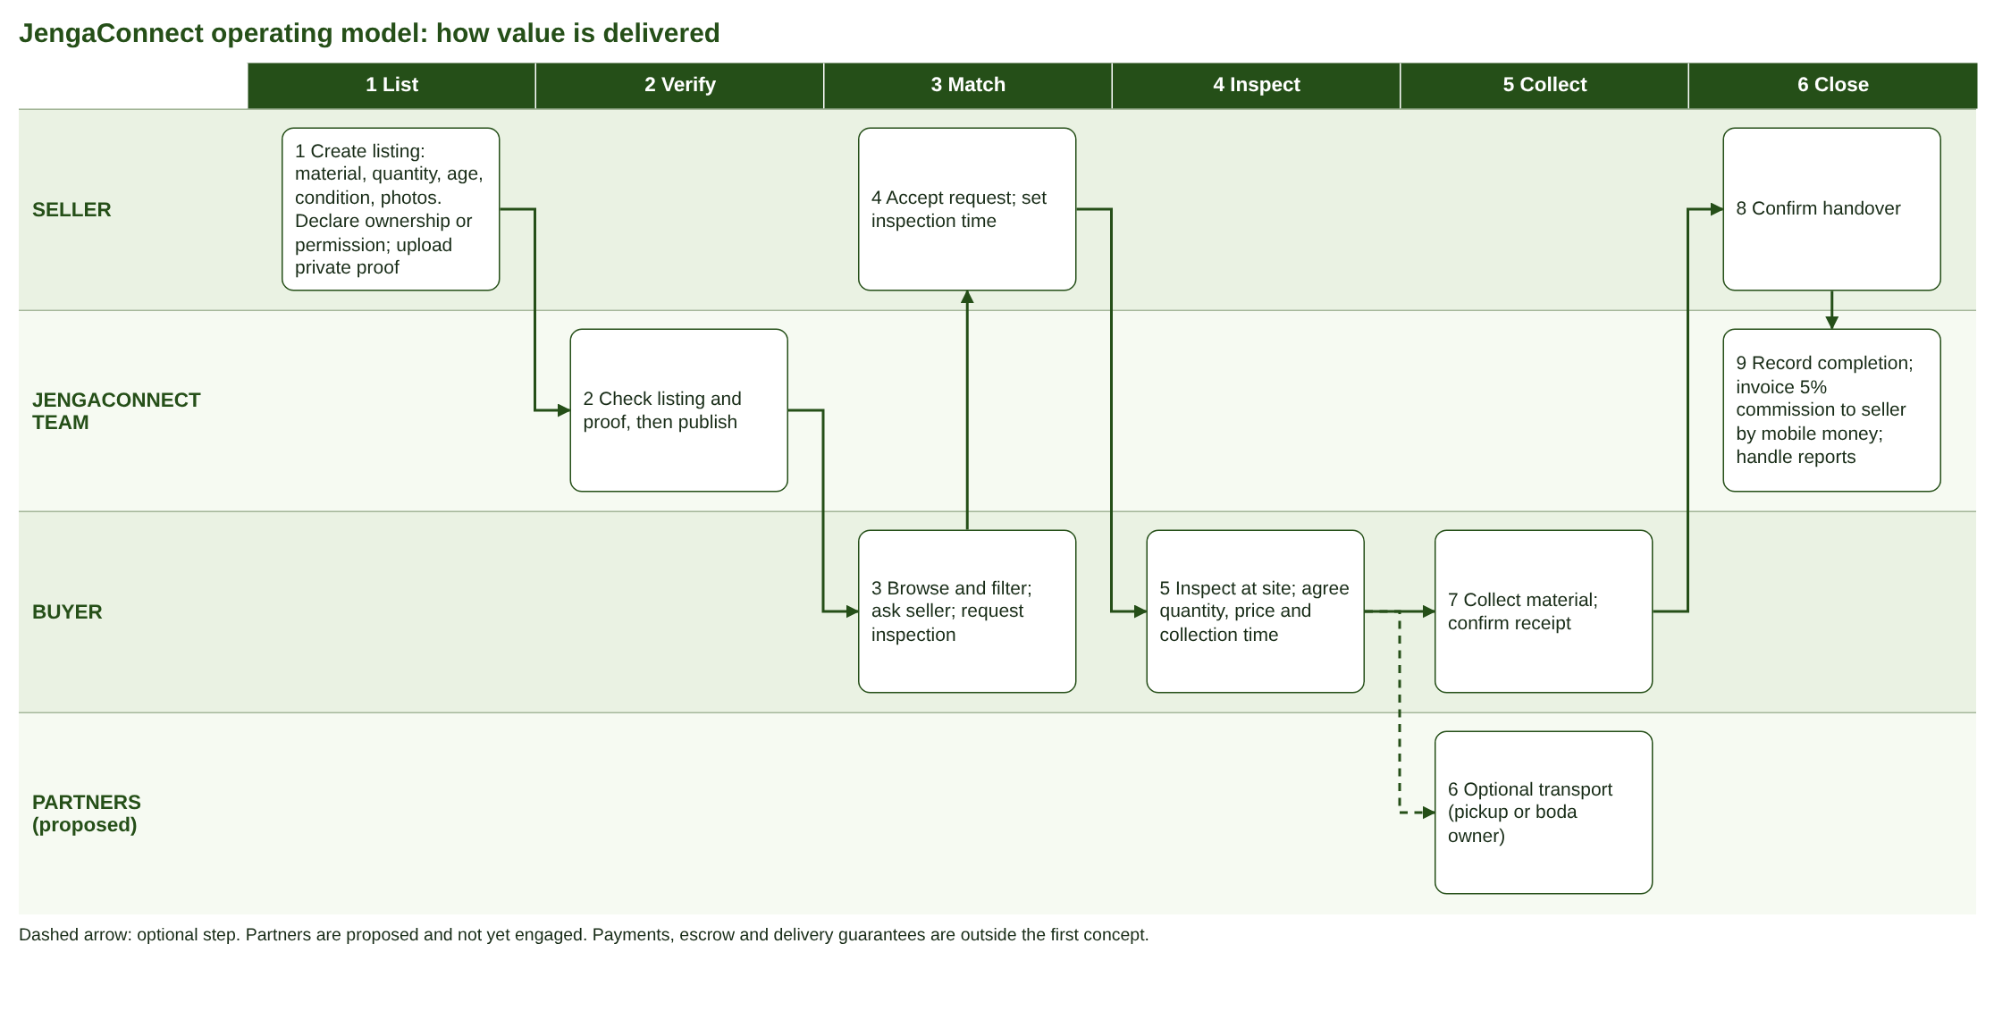
Question | Answer
Core product or service | A moderated mobile-web marketplace for surplus building materials, with inspection and completion tracking
How customers access it | • Phone browser, no install  • links shared by shops and site contacts  • support by phone and WhatsApp
Main activities and workflows | List, verify and publish, match, inspect, collect, confirm, invoice commission (diagram above)
Roles needed | Venture Lead, Customer and Market Research, Product and Technology, Business Model and Finance, Marketing and Brand, Data, Ethics and Commercialization. Moderation is shared by the founders in the pilot.
Technology and infrastructure | Free-tier hosting, database and photo storage, .com domain, HTTPS. Mobile money account for commission.
External suppliers, partners, providers | Proposed: hardware shops and site managers, pickup or boda owners, MTN and Airtel mobile money. None engaged yet.
Customer support and delivery | Report button, moderator review within 24 hours (target), phone and WhatsApp help. Delivery is not provided by JengaConnect

3 Detailed resource requirements
Category | Pilot (days 1 to 90) | Later growth | Cost line (section 4)
Human resources and skills | 5 founders (unpaid): web development, moderation, outreach, finance tracking, data protection | Paid moderators, outreach officer, developer | None in the pilot (founders unpaid)
Technology, software, digital infrastructure | Free-tier hosting, database and photo storage, .com domain, HTTPS, open-source web framework | Paid hosting, mobile money API, analytics, SMS only if needed | Free tiers 0 (team decision), domain 67,956 (Namecheap, 2026)
Equipment and physical facilities | Members' own phones and laptops. No office | Shared office, test phones | None in the pilot
Data and information | Listings, user contacts, ownership proofs (private), reports, PDPO-registered | Price index and demand data | PDPO registration 100,000 (E)
Operational resources | Moderation checklist, listing guide, templates for terms and privacy notice, field visits | Support desk, dispute procedure | Outreach and promotion 90,000 a month (E), legal review and materials 200,000 (E)
Strategic partnerships | 10 shops or sites, 1 or 2 transport owners, mobile money account | Shop chains, builders' associations | None yet
Financial resources | UGX 936,556 from the five founders | Investment if the gates are passed, early commission revenue | Total 936,556

4 Basic financial estimates and calculations
Currency UGX. Exchange rate assumed UGX 4,200 per USD, which may fluctuate (a 10% change is tested below). The editable workbook JengaConnect_Week3_Financial_Worksheet.xlsx holds the same numbers with formulas.
Estimated startup costs (one-off, pilot)
Item | UGX | Basis | Source
Domain, .com first year, (15.98 + 0.20 ICANN) USD x 4,200 | 67,956 | Listed price x assumed rate | Namecheap (2026)
PDPO registration as data controller | 100,000 | Estimate: fee not confirmed | Eagle Online (2026)
Local trading licence | 100,000 | Estimate: fee not confirmed | E
Legal review of terms of use and privacy notice (templates otherwise) | 150,000 | Estimate | E
Launch materials: digital posters and a small flyer run for hardware shops | 50,000 | Estimate | E
TOTAL one-off | 467,956
Deferred until after the pilot: name reservation 35,000, incorporation 105,000, trademark 150,000, annual return 55,000 | 345,000 (not in budget) | Quoted fees | URSB (2026a, 2026b)

Estimated monthly operating costs (lean pilot)
Item | UGX | Basis | Source
Mobile data for outreach (2 x 20 GB MTN bundle at UGX 26,000) | 52,000 | Listed price | Pulse Uganda (2026)
Field outreach: founder visits, campus and WhatsApp groups | 60,000 | Estimate | E
Pilot promotion | 30,000 | Estimate | E
Hosting, database and photo storage | 0 | Free tiers | Team decision
Moderation by founders | 0 | Unpaid | Team decision
Subtotal | 142,000
Contingency 10% | 14,200 | Assumption
TOTAL MONTHLY | 156,200

Revenue calculation and expected income
Estimated monthly income = completed exchanges x fee per exchange, where the fee is the larger of 5% of the exchange value and UGX 3,000. A UGX 30,000 bag earns 1,500 at 5% (3,000 with the minimum) and a UGX 150,000 exchange earns 7,500. Values are assumptions, with cement at UGX 28,000 to 34,000 a bag (Smeaton Constructions, 2026). Scenarios are not promised income.
Expected monthly income (UGX), assumption x price | Cautious | Base | Strong
Commission: 15, 30 or 50 exchanges at fee 3,000, 5,000 or 7,500 | 45,000 | 150,000 | 375,000
Subscriptions: 0, 5 or 10 shops at 20,000 | 0 | 100,000 | 200,000
Featured listings: 0, 10 or 30 at 5,000 | 0 | 50,000 | 150,000
Transport referrals: 0, 20 or 60 jobs at 2,000 (proposal, no partner) | 0 | 40,000 | 120,000
Verified-seller checks: 0, 5 or 15 at 10,000 | 0 | 50,000 | 150,000
Total expected monthly income | 45,000 | 390,000 | 995,000
Total over 90 days at that monthly rate | 135,000 | 1,170,000 | 2,985,000
Against lean monthly cost 156,200 | -111,200 | +233,800 | +838,800
Against sustainable monthly cost 607,200 | -562,200 | -217,200 | +387,800

Pilot funding need and sustainability
Item | UGX
One-off startup cost | 467,956
Working capital: 3 months x 156,200 | 468,600
Total pilot funding need | 936,556
Founders' ceiling | 1,500,000
Headroom under the ceiling | 563,444
Share per founder (5 founders) | 187,311

Why 5% alone does not sustain the venture. A UGX 30,000 cement bag earns UGX 1,500 at 5% and a UGX 150,000 exchange earns UGX 7,500.
• The lean monthly cost of UGX 156,200 needs 105 bag-sized exchanges (156,200 / 1,500) or 21 exchanges of UGX 150,000 (156,200 / 7,500).
• Sustainable operation costs UGX 607,200 a month: mobile data 52,000, a paid moderator 250,000, field costs 150,000, marketing 100,000 and 10% contingency. At 5% only this needs 405 bag-sized exchanges (607,200 / 1,500) or 81 larger ones (607,200 / 7,500).
• With the UGX 3,000 minimum fee on a bag, the same costs need 53 and 203 exchanges.
So 5% carries a founder-run pilot but not paid staff or growth. Other income is proposed for after the pilot: the minimum fee, shop and contractor subscriptions, featured listings, referral fees from transport providers (proposal only, no partner claimed) and an optional verified-seller or inspection fee. In the pilot, 50 exchanges at the base fee of UGX 5,000 would earn about UGX 250,000 in commission.
A 10% lower or higher exchange rate gives a pilot need of UGX 929,760 or 943,352, because only the domain is priced in USD.
Decision: no SMS service in the pilot, because a registered SMS sender ID is reported at about UGX 250,000 a month (Telerivet, n.d.), more than the whole lean monthly cost. Contact is by phone and WhatsApp links.
5 Evidence supporting cost assumptions
Public sources used for quoted fees and listed prices. The citations in brackets next to each figure, and this reference list, carry the evidence. No supplier quotation has been requested or invented. Items marked E are estimates to be replaced with a real quotation.
Source | Used for | Source and date
URSB (2026a) | Name reservation 35,000, incorporation 105,000, annual return 55,000 (all after the pilot) | Uganda Registration Services Bureau (2026) Business Name, Company and Document Registration fees. https://ursb.go.ug/business-company-and-document-registration-fees/ (accessed 3 Nov 2026).
URSB (2026b) | Trademark application 50,000, registration 100,000 (after the pilot) | Uganda Registration Services Bureau (2026) Intellectual Property Fees. https://ursb.go.ug/intellectual-property-fees/ (accessed 3 Nov 2026).
Eagle Online (2026) | • PDPO registration duty  • criminal conviction July 2025  • fee not stated | Eagle Online (2026) 'Over 500,000 Ugandan firms collect personal data without registration: PDPO', 19 August. https://eagle.co.ug/2026/08/19/over-500000-ugandan-firms-collect-personal-data-without-registration-pdpo/
Telerivet (n.d.) | DPPA fines up to 2% of turnover, SMS sender ID about UGX 250,000 a month | Telerivet (n.d.) Sending SMS in Uganda: UCC registration, the DPPA, and what changed in 2025. https://www.telerivet.com/blog/uganda-sms-compliance-ucc-dppa (accessed 3 Nov 2026).
Namecheap (2026) | .com registration USD 15.98 a year from 1 November 2026, excluding the ICANN fee | Namecheap (2026) .com price change, November 1, 2026. https://www.namecheap.com/support/knowledgebase/article.aspx/10840/2201/com-price-change-november-1-2026/
Pulse Uganda (2026) | MTN 20 GB monthly bundle UGX 26,000 | Pulse Uganda (2026) 'MTN Uganda introduces new monthly data bundle', 19 August. https://www.pulse.ug/story/mtn-uganda-new-monthly-data-bundles-2026081912451933692
Smeaton Constructions (2026) | Cement UGX 28,000 to 34,000 per 50 kg bag, 2026 indicative | Smeaton Constructions (2026) Latest Building Materials Prices in Uganda 2026, 13 September. https://smeatonconstructions.com/building-materials-prices-uganda-2026/
UICT (2026) | Student innovation funding up to UGX 30 million | Uganda Institute of Information and Communications Technology (2026) 'UICT student innovations secure up to UGX 30 million at Innovation Bootcamp 2026', 1 June. https://uict.ac.ug/uict-student-innovations-secure-up-to-ugx-30-million-at-innovation-bootcamp-2026/
Daily Monitor (n.d.) | Makerere Shs 1.5 billion for student innovations | Daily Monitor (n.d.) 'Makerere to inject Shs1.5b in students' innovations'. https://monitor.co.ug/uganda/news/national/makerere-to-inject-shs1-5b-in-students-innovations-3982990

Estimates (E) without a source: PDPO registration 100,000, trading licence 100,000, legal review 150,000, launch materials 50,000, outreach 60,000 and promotion 30,000. In the sustainable case only: moderator 250,000, field costs 150,000 and marketing 100,000. Next step: ask one lawyer and one printer for written quotations.
6 Proposed financing options and justification
Option | Assessment for JengaConnect now | Decision
Founder savings or contributions | Funds the whole pilot: UGX 936,556, about UGX 187,311 each, under the UGX 1.5 million ceiling | Selected
Family and friends | Possible back-up. Informal terms can strain relationships | Back-up
Grants and innovation competitions | A later option. Student innovations won up to UGX 30 million in 2026 (UICT, 2026) and Makerere funds student innovations (Daily Monitor, n.d.). Competitive and slow. | After the pilot
Business loan | Repayment would start before revenue exists | Not now
Angel investors | Sought only after the pilot passes its 90-day gates. Dilution. | After the pilot
Venture capital | Needs proven growth | Later
Crowdfunding | Needs an audience and a working product | Later
Revenue from early customers | Commission and other income cover the lean monthly cost at about 21 to 105 exchanges, and paid operation needs more | After the pilot

Amount: UGX 936,556 from the five founders (about UGX 187,311 each), under the UGX 1.5 million ceiling. Purpose: domain, PDPO registration, trading licence, one legal review and launch materials (467,956) and three pilot months (468,600). Investment is sought only if the pilot passes its 90-day gates: exchanges, measured average value, deals taken offline and repeat use. Major risk: founders cannot contribute, so costs are kept minimal and hosting uses free tiers.
7 Intellectual property assessment
Type | What it protects in JengaConnect | Relevance | Action
Copyright | Code, interface designs, listing guide, documents | High. Arises automatically | • Written assignment from each member to the company  • check Makerere's policy on student work  • registration optional
Trademark | JengaConnect name and logo | High. Brand trust | File at URSB after the pilot: application UGX 50,000, registration UGX 100,000 after 60 days without opposition (URSB, 2026b). Search first.
Trade secrets | Moderation checklist, seller and price data | Medium | Access limits, confidentiality terms for moderators
Patents | None identified: a listing marketplace is not a new technical invention | Low | Not pursued
Licensing | Open-source components. Users' listing photos | Medium | Check each licence. Terms grant a licence to display photos
Ownership of materials | Photos, designs and text made by members or contractors | High | Contributor agreement. No unlicensed images

Most relevant: copyright (automatic) and trademark (brand). No registration is required during this assignment.
8 Legal and ethical readiness checklist
Status key: Not started / Planned / Done. All are Not started unless the team updates them. Laws below must be confirmed with a qualified lawyer.
Requirement | Relevance to JengaConnect | Action before launch | Responsible role | Status
Business registration and licensing (URSB, URA TIN, local licence) | Needed to invoice, hold a mobile money account and contract | Trading licence and PDPO registration now. Reserve name, incorporate and get a TIN after the pilot. | Venture Lead | Not started
Data Protection and Privacy Act 2019. PDPO registration | • Collects names, phones, locations, photos and ownership proofs  • a director was convicted in July 2025 for not registering  • fines reach 2% of turnover | • Register  • consent text  • privacy notice  • data minimisation  • hide exact address  • keep proofs private  • deletion on request | Data, Ethics and Commercialization Lead | Not started
Cybersecurity and information security (Computer Misuse Act. Electronic Transactions Act) | Fake listings, account takeover, breach would destroy trust | HTTPS, strong passwords, backups, access limits, incident checklist, accepted online terms | Product and Technology Lead | Not started
Consumer protection and fair practice | Buyers rely on descriptions and photos | • Mandatory fields  • 'no guarantee' notice  • removal of misleading listings | Data, Ethics and Commercialization Lead | Not started
Stolen goods and permission to sell | 4 of 5 raised ownership. 3 of 4 sellers need permission | Declaration, private proof, moderator check, report button, cooperate with police requests | Customer and Market Research Lead | Planned (prototype v2)
Safety | Hazardous items (asbestos sheets, treated timber, spoilt cement) | Banned-items list. Inspect in daylight at the site | Product and Technology Lead | Not started
Contracts and IP ownership | Members' code and designs. Moderators' confidentiality | Assignment and confidentiality agreements | Venture Lead | Not started
Accessibility and inclusion | Basic phones, low data, language | Light pages. English first, Luganda later | Marketing and Brand Lead | Not started
Responsible AI | No AI makes decisions in the first concept | If used, only to assist moderators with human review | Product and Technology Lead | Not applicable now
Misleading marketing and inaccurate information | Week 4 campaigns | Only claims the team can prove. State pilot status clearly | Marketing and Brand Lead | Not started

9 Commercialization pathway
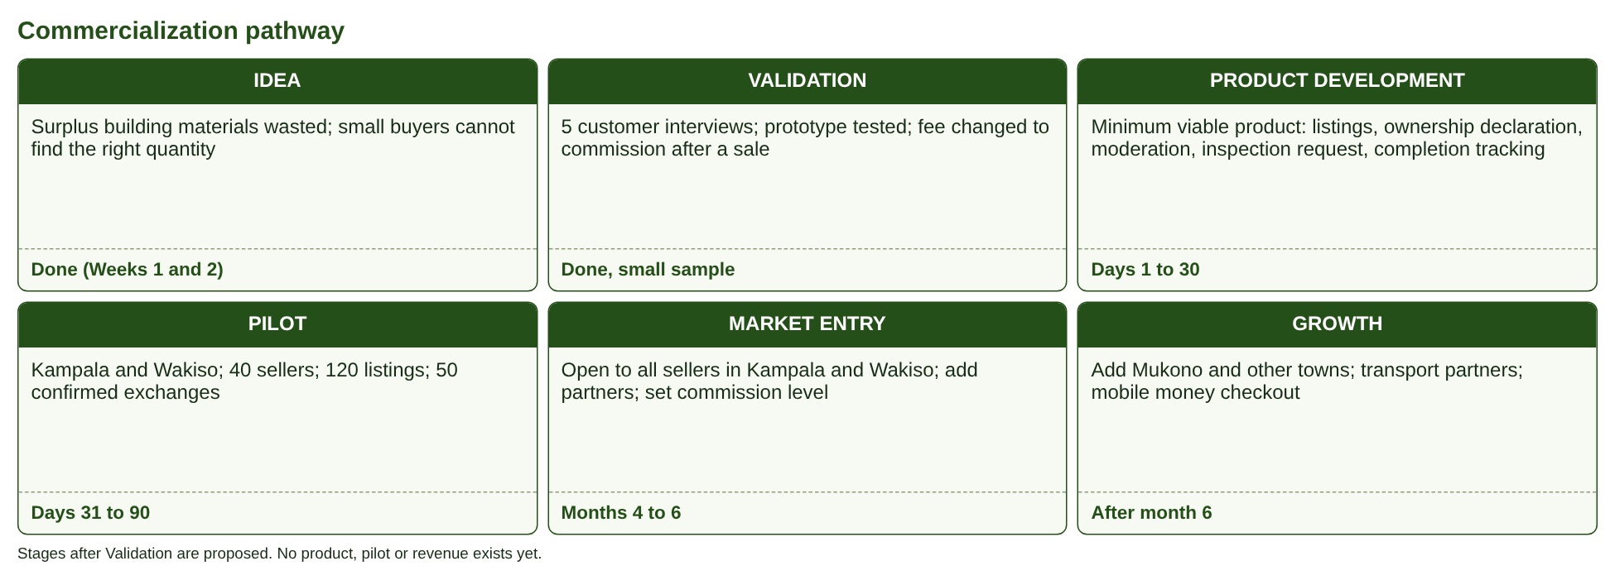
Item | Plan
Initial target market | Self-builders, artisans and small contractors (buyers) and site managers, contractors, hardware sellers (sellers) in Kampala and Wakiso
Minimum viable product | Listings with ownership declaration, moderator review, ask and inspection request, collection arrangement, completion confirmation and manual commission invoice
Pilot | 90 days, 40 sellers, 120 listings, 50 confirmed exchanges, weekly feedback. Success is measured against SMART objectives 1 and 2.
Pricing and revenue | 5% seller commission with a UGX 3,000 minimum, charged after completion and tested in the pilot. No fee for buyers. Higher-value materials such as iron sheets and timber first. Later: shop subscriptions, featured listings and referrals.
Distribution and delivery channels | • Mobile website  • shop and site contacts  • shareable listing links  • optional pickup or boda owners arranged by users
Strategic partnerships | Hardware shops, site managers, transport owners, mobile money providers (all proposed, none agreed)
Customer acquisition | • Visits to shops and sites  • referrals from first sellers  • WhatsApp groups of builders  • in Week 4 a digital plan
Milestones | Day 30 product live, day 90 pilot report and stop or go decision, months 4 to 6 market entry, after month 6 growth

10 Proposed 90-day implementation roadmap
Phase | Responsible role | Key activities | Expected output
Days 1 to 30: Set up | Venture Lead. Data, Ethics and Commercialization Lead | Register with PDPO and get the trading licence, privacy notice and terms of use. Incorporation and trademark wait until after the pilot. | Compliance documents and licence
 | Product and Technology Lead | Build the minimum viable product (listing, ownership declaration, moderation view, inspection request, completion confirmation) on free-tier hosting and database, and buy the domain | Working site on the live domain
 | Customer and Market Research Lead. Marketing and Brand Lead | Recruit first 10 sellers through hardware shops and site contacts. Draft a listing guide | 10 sellers. First 30 listings
 | Business Model and Finance Lead | Open a mobile money account for commission, track costs and agree the stop or go gates | Cost tracker and gates agreed
Days 31 to 60: Pilot | All roles | • Launch in Kampala and Wakiso  • grow to 25 sellers  • moderate every listing  • weekly check-ins | • 25 sellers  • 80 listings  • first 20 exchanges
Days 61 to 90: Evaluate | Venture Lead. Business Model and Finance Lead | Reach 40 sellers and 50 confirmed exchanges, review ratings, commission payment and complaints, and apply the stop or go gates: exchanges, average value, offline deals, repeat use | Pilot report and decision to stop, change or seek investment

This is a proposal for what the team would do if it proceeded after the capstone. It is not being implemented during the course.
11 Venture risk assessment matrix
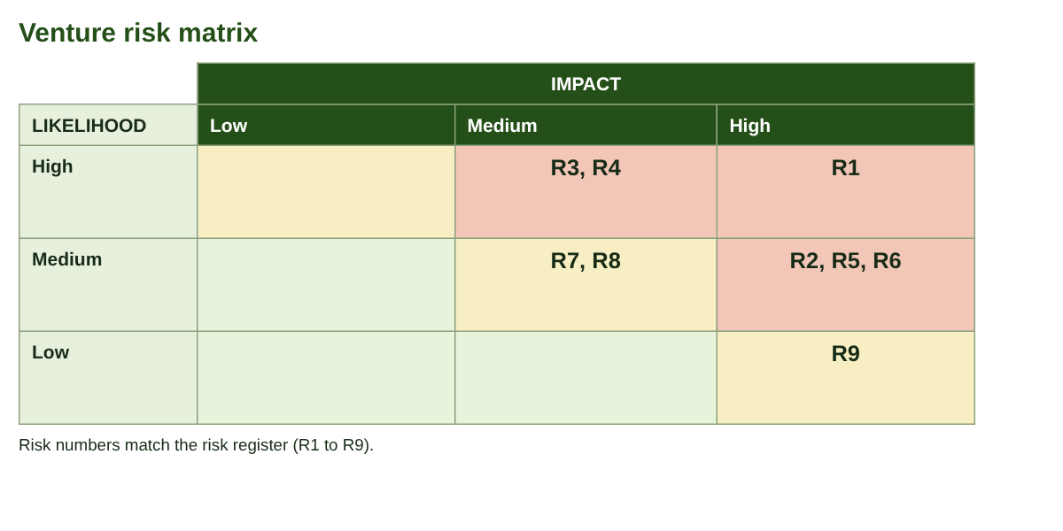
ID | Risk | Likelihood | Impact | Mitigation | Evidence
R1 | Stolen or misdescribed goods are listed, so buyers lose trust | High | High | Ownership or permission declaration, private proof, moderator check, report button, removal and cooperation with police requests | 4 of 5 respondents raised ownership or theft
R2 | Too few listings (low supply) so buyers leave | Medium | High | • Start with 10 hardware-shop and site contacts  • focus on cement, timber, bricks and iron sheets  • recruit weekly | 4 of 5 had real leftovers (Week 2)
R3 | Sellers lack permission from clients or employers | High | Medium | Permission tick, template permission message, start with owner-sellers and shops | 3 of 4 sellers need permission
R4 | Users agree deals offline and skip the commission | High | Medium | Low 5% rate with a UGX 3,000 minimum, charge only after confirmed completion, reputation badges and inspection scheduling as reasons to stay | 3 of 5 would pay only after a sale
R5 | Non-compliance with data protection law (PDPO registration, consent) | Medium | High | Register with PDPO, privacy notice, consent, minimum data, hidden exact address, proof kept private | Criminal conviction for non-registration, July 2025
R6 | Founders cannot fund the UGX 936,556 pilot, or free-tier limits are reached | Medium | High | Keep the pilot under the UGX 1.5 million ceiling, share UGX 187,311 each, check free-tier limits before launch and upgrade only at the limit | Estimate in the financial worksheet
R7 | Material quality dispute or injury at inspection (for example hardened cement) | Medium | Medium | Age and condition fields, prohibited items list, inspect in daylight at the site, no guarantee statement | P01's 30 kg cement hardened on site
R8 | Competition from Facebook groups and classifieds, or hardware shops cutting prices | Medium | Medium | Material-specific listings, verified sellers and completion tracking | Buyers use contacts and shops today
R9 | Website downtime or account breach | Low | High | Backups, HTTPS, strong passwords, minimum stored data, incident checklist | Free-tier limits and backups checked before launch

12 Records of stakeholder consultations
No supplier, partner or business-owner consultation has been held for Week 3. The only fieldwork is the five customer interviews from Week 2 (form: https://forms.gle/veDxmqMqBfvS9Rgb6). Costs rest on public sources and clearly labelled estimates. Direct engagement was not undertaken in the time available, and the plan does not claim any.
13 Updated assumption and decision logs
Assumption log (Week 2 assumptions updated. Week 3 assumptions added)
ID | Assumption | Evidence so far | Test | If wrong
A1 | Enough suitable surplus exists within a practical collection area | 4 of 5 described a real leftover (cement, timber, stones, iron bars, wire). N=5 | Count listings and sources in the pilot | Narrow materials or area. Recruit shops
A2 | Buyers accept total cost and effort after inspection and transport | 4 of 5 would buy reused material, 1 maybe. Total cost not yet rated | Show a worked example with collection cost | Add transport partners. Target larger quantities
A3 | A clearly identified payer will pay a fee that supports operating costs | Seller named by 4 of 5. 3 would pay only after a sale | Ask pilot sellers to pay after a sale | Test the other payer or partner funding
A4 | Sellers will accept a 5% commission (minimum UGX 3,000) after completion | Not tested. 3 of 5 interviewees would pay only after a sale | Ask first 10 sellers. Track payments | Lower rate or flat fee
A5 | Average exchange value (UGX 150,000 assumed) can be reached with higher-value materials | Price list only (Smeaton, 2026) | Measure agreed prices in the pilot | Recalculate break-even
A6 | Sellers can give proof of ownership or permission | 3 of 4 sellers need permission | Ask first 10 sellers | Start with owners and shops
A7 | The pilot can run on about UGX 936,556 from the founders, with free tiers for hosting, database and storage | Public sources and estimates | Get written quotations | Update the budget
A8 | Other income (subscriptions, featured listings, referrals) will add to commission as in the scenarios | Not tested: scenario assumptions only | Test after day 90 with the first sellers | Stop or change direction at the gates

Decision log
ID | Decision | Reason and evidence | Date
D1 | Fee changed to a 5% commission after a completed exchange | 3 of 5 would pay only after a sale. 2 would stop if charged first | 1 Nov 2026
D2 | Ownership or permission declaration and private proof added | 4 of 5 raised ownership or theft | 1 Nov 2026
D3 | No SMS service in the pilot | Sender ID about UGX 250,000 a month (Telerivet, n.d.) | Week 3
D4 | Founders fund the pilot. Investment is sought after the pilot. No loan. | Keeps the first concept free of debt and under the UGX 1.5 million ceiling | Week 3
D5 | Commission invoiced manually by mobile money. Payments and escrow out of scope | Keeps the first concept small | Week 3
D6 | Free tiers for hosting, database and storage, only the domain is bought | Cuts the pilot to UGX 936,556 | Week 3
D7 | Fee of 5% with a UGX 3,000 minimum, and other income only after the pilot | 5% alone earns UGX 1,500 on a bag and does not sustain paid staff | Week 3
D8 | Incorporation and trademark after the pilot | Saves UGX 345,000 until the idea shows traction | Week 3

14 Video evidence register
Ref | Description | Consent | Link
W3-V1 | Recorded group discussion, 10 to 15 minutes (unlisted YouTube) | All members agree | [add link]

