MAKERERE UNIVERSITY
IST2106 Technopreneurship and Digital Marketing
Solution Validation and Business Model Evidence Portfolio
JengaConnect · Evening A Group 6
Group member | Registration number
LUYOBYA VICENT | 25/U/03863/EVE
YIGA AKRAM | 23/U/18680/PS
KWAGALA ELVIS | 25/U/0365
MUGANWA EDRINE | 25/U/03890/EVE
MUJUNI NASEEM | 25/U/03899/EVE

Contents
1. Customer persona
2. Customer journey
3. Full Business Model Canvas
4. Prototype wireframes and service flow
5. Prototype-testing guide, consent script and feedback form
6. Anonymised feedback records (P01 to P05)
7. Prototype change log
8. Critical assumption and validation log
9. Photo and video evidence register
10. Fieldwork log and individual contribution log
11. Recorded group discussion plan

1 Customer persona
Provisional persona for the primary customer. Basis codes: P1 Phase 1 brief, P2 Phase 2 preparation notes, A assumption to test. Update after fieldwork.
Trait | Provisional persona: self-builder | Basis
Profile | Adult artisan or household builder building or extending in stages, buying small quantities near Kampala or Wakiso. | P1 (artisan / household builder); staged building is A
Goal | Find the right quantity of usable material nearby, in a condition they can inspect, at a total collection cost that is worth the trip. | P2 hypothesis
Motivation | Keep a build moving and control cost. | A
Frustrations | Uncertain availability, unsuitable quantities, quality doubts and transport cost. | P2 hypothesis
Behaviour today | Asks personal contacts, visits hardware shops, looks at general classified listings. | P1 alternatives list
Context | A small shortfall appears mid-build and work waits until it is solved. Uses a mobile phone for search. | A

Users, customers, buyers and beneficiaries
Role | Who | Note
User and buyer | Self-builders, artisans, small contractors | Primary segment (P1)
Seller and proposed payer | Site managers, contractors, hardware sellers with surplus | Payer is untested (A3)
Beneficiaries | Neighbouring builders and community through reuse | Benefit claimed only, not measured

Needs, pains and gains (hypotheses)
Needs | Pains | Expected gains
Right quantity; inspectable condition; affordable total collection cost | Uncertain availability; unsuitable quantities; quality concerns; transport cost | A relevant local offer; clear collection arrangements

Evidence supporting these: 3 prototype-feedback responses (P01 to P03, section 6).
2 Customer journey
Current journey of the persona (hypothesis, to be confirmed by interviews).
Stage | Current experience | Pain / touchpoint | Opportunity for JengaConnect
1 Recognise need | Finds a shortfall or leftover gap during building. | Unsure whether usable leftovers exist nearby. | Browse by material, quantity and area.
2 Search | Asks contacts, calls or visits hardware shops, scans classifieds. | Scattered sources; time and travel before knowing availability. | One material-specific listing view.
3 Evaluate | Compares price, distance and condition by phone or photo. | Condition and quantity unclear; seller authority unknown. | Photos, condition, unit and quantity on every listing.
4 Select / use | Agrees price, inspects and arranges transport. | Transport cost and a wasted trip if stock differs. | Questions, inspection arrangement and collection window.
5 After use | Uses the material; keeps or disposes of leftovers. | No simple route to report a problem or list leftovers. | Completion status and a simple complaints route.

Touchpoints to observe in fieldwork
- Phone calls and messages to contacts and shops
- Visits to hardware shops
- General classified listings
- Transport arrangement and inspection visit
3 Business Model Canvas
Key Partnerships  Hardware shops  site managers  Delivery providers. | Key Activities  Maintain listings  recruit sellers and buyers  moderation  customer support | Value Propositions  Buyers: find small quantities of usable material nearby with condition and quantity visible before travelling or delivery.  Sellers: a way to sell surplus material rather than incurring storage or transport costs. | Customer Relationships  Listing support for sellers  listing status updates on a material.  A complaints route and moderation of reports. | Customer Segments  Buyers: self-builders, artisans and small contractors.  Sellers: site managers, contractors and hardware sellers with usable, non-hazardous surplus.
 | Key Resources  Listing platform and hosting  material information(proof of ownership and sales agreements)  support and moderation staff  operating funds. |  | Channels  Mobile website  direct outreach to site managers.  shareable listing links.
Cost Structure  Hosting, mobile data, support and management, outreach and verification, tax and legal compliances |  |  | Revenue Streams  A seller listing fee or transaction commission.

Justification and status of each block
Block | Why this choice | Status
Customer Segments | Two sided because a listing needs both a seller and a nearby buyer. | Hypothesis
Value Propositions | Matches the Phase 1 problem statement and the Week 2 persona pains. | Hypothesis
Channels | Basic smartphone browsers are assumed; reach is built through construction contacts. | Assumption
Customer Relationships | Trust and condition are the main risks named | Assumption
Revenue Streams | Four of five respondents named the seller as payer; three would pay only after a sale. Commission level untested. No figures claimed. | Changed after feedback; level to test (A3)
Key Resources | Needed to keep listings accurate and safe. | Assumption
Key Activities | Follows the four prototype screens. | Assumption
Key Partnerships | Supply and collection help. Payments and escrow are outside the first concept. | Hypothesis
Cost Structure | No cost figures are stated until sourced. | Week 3

4 Prototype wireframes and service flow
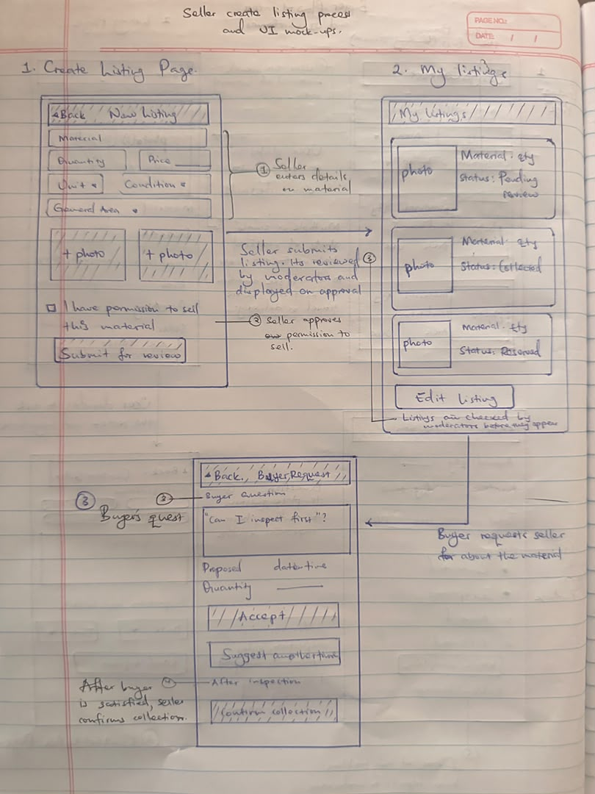
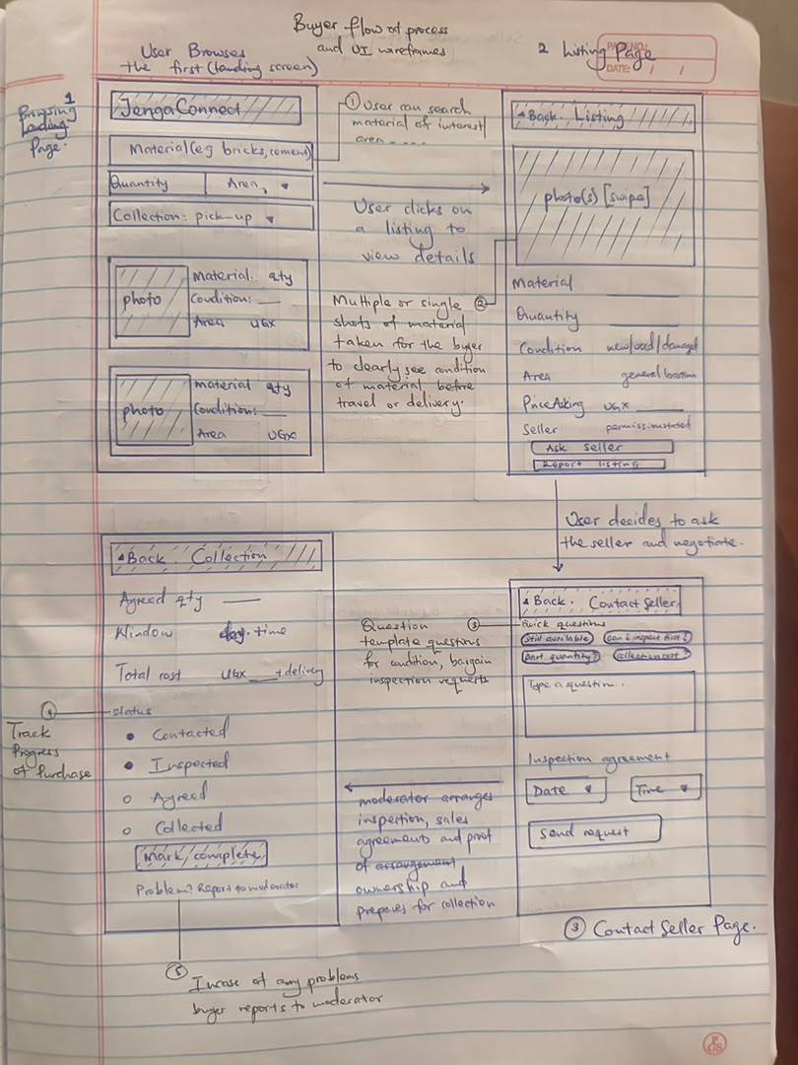

Labelled features
1. Material search and filters: Browse by material, quantity, broad area and collection option.
2. Structured listing: Photos, condition, unit, quantity and asking price; exact site address hidden.
3. Seller contact and inspection: Pre-set questions and an inspection arrangement.
4. Collection coordination: Agreed quantity, collection window and completion status.
5. Moderation and reporting: Listing checks, seller permission and a report button.
Intended user flow and decision points
Buyer opens Browse and filters by material, quantity and area → opens a Listing → decision: is the condition and quantity acceptable? If no, return to Browse; if yes → Contact the seller and propose an inspection → decision: does inspection confirm the listing? If no, report or return to Browse; if yes → agree quantity, collection window and total cost → Collection screen → mark complete.
Seller side: create a listing (material, photos, condition, unit, quantity, asking price, general area) → moderation check → published → respond to questions → confirm collection.
Prototype link: https://ejr-arch.github.io/jengaConnect (version 2, 1 Nov 2026).
5 Prototype-testing guide and consent
Consent script (read aloud)
"We are Makerere University students testing an idea for a building-materials listing service. Taking part is voluntary and you may stop at any time. We will not record your name unless you wish, and we will record audio, photos or video only with your permission. Your answers will be anonymised in our report. Do you agree to take part? May we take notes? May we photograph or record (optional)?"
Tasks to show on the prototype
- Find a suitable quantity of a material you recently needed.
- Say what you think each screen lets you do.
- Ask the seller a question and arrange an inspection.
- Tell us what information is missing.
Interview questions
1. Does this solution address the problem you described?
2. Which features would be most useful to you, and why?
3. What is unclear, difficult or unnecessary?
4. How would you expect this solution to work?
5. What concerns would prevent you from using it?
6. How does it compare with the alternatives you use now?
7. What would prevent you from contacting the seller?
8. How would you check quality and arrange collection?
9. Who should pay a fee, and in what form? (tests A3; do not suggest a number)

6 Anonymised feedback records (at least five participants)
Participants declined video or audio recording, so each record comes from the team's interview answers entered in the feedback response form: https://forms.gle/veDxmqMqBfvS9Rgb6. Use codes, not names.
Record P01
Date | Role (buyer / seller / other) | Consent: notes / photo / recording
1 Nov 2026 | Seller (artisan), also buys | Interview: consent confirmed, recorded in form

Question | Response (anonymised)
Does this solution address the problem you described? | Yes, fully. Ratings (1 to 5): easy to understand 4; listing shows what I need 4; would use instead of current way 4; trust inspection and collection 3.
Which features would be most useful to you, and why? | Browse by material, quantity and area; arranging an inspection; collection status updates; creating a listing for my leftovers.
What is unclear, difficult or unnecessary? | Not sure yet.
How would you expect this solution to work? | Upload my leftover material for someone to buy.
What concerns would prevent you from using it? | If I am buying, how sure I am that the goods are not stolen; also the location of the material.
How does it compare with the alternatives you use now? | It lets me get only the quantity I want (unlike some hardware shops) and see materials from places near me.

Record P02
Date | Role (buyer / seller / other) | Consent: notes / photo / recording
1 Nov 2026 | Buyer (self-builder) | Interview: consent confirmed, recorded in form

Question | Response (anonymised)
Does this solution address the problem you described? | Yes, fully. Ratings (1 to 5): 5, 5, 5, 5.
Which features would be most useful to you, and why? | Browse by material, quantity and area; photos and condition on every listing.
What is unclear, difficult or unnecessary? | Responses were slow.
How would you expect this solution to work? | Virtually contact the company for service provision.
What concerns would prevent you from using it? | No, I can't fail to use it.
How does it compare with the alternatives you use now? | I don't compare, because of its assured delivery.

Record P03
Date | Role (buyer / seller / other) | Consent: notes / photo / recording
1 Nov 2026 | Both buyer and seller (site manager) | Interview: consent confirmed, recorded in form

Question | Response (anonymised)
Does this solution address the problem you described? | Yes, fully. Ratings (1 to 5): 1, 5, 1, 5 (inconsistent; to clarify with the participant).
Which features would be most useful to you, and why? | All seven listed features, including replying to buyer requests.
What is unclear, difficult or unnecessary? | None.
How would you expect this solution to work? | Selling the construction leftovers.
What concerns would prevent you from using it? | None. (Elsewhere: ownership concerns and data privacy; heavy charges would make me stop using it.)
How does it compare with the alternatives you use now? | Convenient.

Record P04
Date | Role (buyer / seller / other) | Consent: notes / photo / recording
1 Nov 2026 | Both buyer and seller (self-builder) | Interview: consent confirmed, recorded in form

Question | Response (anonymised)
Does this solution address the problem you described? | Yes, fully. Ratings (1 to 5): 4, 4, 4, 3.
Which features would be most useful to you, and why? | All seven listed features, including creating a listing for my leftovers.
What is unclear, difficult or unnecessary? | No answer.
How would you expect this solution to work? | Lets me upload material for potential buyers, and also buy other second-hand material in the quantity I want.
What concerns would prevent you from using it? | No answer. (Elsewhere: would stop using it if made to pay before selling; wants proof the seller owns the goods.)
How does it compare with the alternatives you use now? | I can inspect nearby materials before buying and am sure the person selling is the owner.

Record P05
Date | Role (buyer / seller / other) | Consent: notes / photo / recording
1 Nov 2026 | Both buyer and seller (artisan, site manager) | Interview: consent confirmed, recorded in form

Question | Response (anonymised)
Does this solution address the problem you described? | Yes, fully. Ratings (1 to 5): 5, 5, 4, 5.
Which features would be most useful to you, and why? | All seven listed features, including replying to buyer requests.
What is unclear, difficult or unnecessary? | No answer.
How would you expect this solution to work? | Sell and buy second-hand building materials.
What concerns would prevent you from using it? | If I buy a material and later it is said to be stolen.
How does it compare with the alternatives you use now? | Easily find goods around me without having to travel or look around randomly.

7 Prototype change log
Participant code | Observed difficulty or request | Change made | Reason
P01, P03 | Fear of stolen goods; ownership concerns | Create listing: 'I own this material or have permission to sell it' tick plus optional proof upload; listing shows 'ownership / permission confirmed' | Trust in the seller is the main barrier for buyers
P01 | Leftover cement hardened while stored | Added 'Age: months in storage' to create listing and listing view | Condition depends on age for cement
P02 | Saw JengaConnect as a company that delivers | Browse note: 'Listings are posted by individual sellers. JengaConnect does not sell or deliver.' | Avoid a wrong expectation of delivery
P03 | Data privacy when listing | Note on create listing: 'Proof is kept private. Buyers only see confirmed.' | Reassure sellers about private documents
P01, P04, P05 | Would pay only after a sale; would stop if charged first | Revenue stream changed to a seller commission charged only after a completed exchange; no upfront listing fee | Avoids paying with no buyer; matches what sellers said they would accept
P04 | Wants a listing status when a request arrives | Planned for Week 3: Reserved status shown on the seller request screen | Stops a second buyer asking for an item already requested

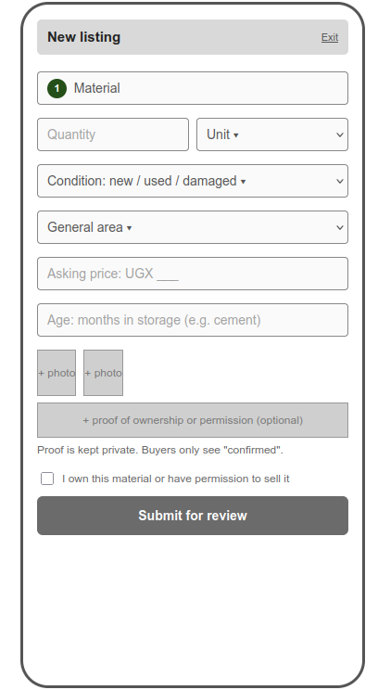
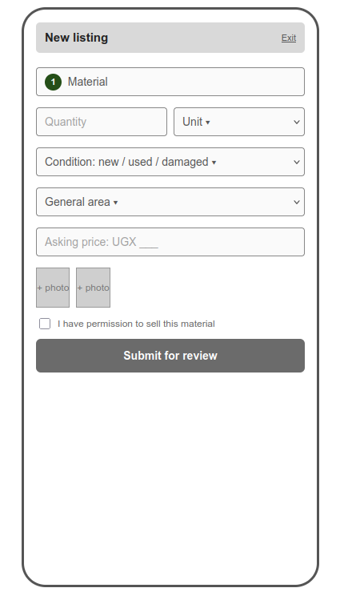
BEFORE AFTER
8 Critical assumption and validation log
ID | Team belief | Why it matters | Evidence so far | Test | Result
A1 | Enough suitable surplus exists within a practical collection area. | Without supply there are no listings and no matches. | 5 responses (1 Nov 2026): 4 described a real leftover (cement, timber, stones, iron bars, wire) kept at home, on site or in store. One respondent was a buyer only. | Ask sellers about one recent surplus event: what, how much, what happened to it. Count real examples. | Assumption confirmed true
A2 | Buyers accept the total cost and effort after inspection and transport. | Buyers decide on total cost, not asking price alone. | 5 buyers: 4 would buy reused material, 1 maybe. Price and condition decide (P04, P05). Transport: UGX 5,000, none, about 30,000 (25 km). Total cost not yet rated. | Compare each buyer's last purchase with a worked listing example including collection cost. | Not confirmed
A3 | A clearly identified payer will pay a fee that supports operating costs. | No payer means no revenue model. | Payer: seller 4, buyer 1. Three want to pay only after a sale (P01, P04, P05); P04 and P05 would stop if charged first; P03 says heavy charges would stop use. | Ask sellers and buyers which side would pay, in what form (flat fee or share of price), and at what level. | Seller pays – still confirming whether before or after a material is bought

Cycle: ASSUME → TEST → LEARN → REFINE.
9 Photo and video evidence register
Ref | Type | Description | Consent obtained (Y/N) | Link or file
V04 | Video | Group presentation and prototype pitch (unlisted YouTube) |  | https://drive.google.com/file/d/1CTWrszgR6Pe66uDFjBaxbb8G03cJURLg/view?usp=drivesdk
F01 | Form | Feedback response form (Google Form) filled by the team during interviews; participants declined recording | Y (confirmed in interview, recorded in form) | https://forms.gle/veDxmqMqBfvS9Rgb6

10 Fieldwork and individual contribution log
Date | Participant code | Team members present | Activity | Evidence ref
1 Nov 2026 | P01 | Elvis, Vicent, Naseem | Interview after the participant viewed the prototype; answers recorded in the feedback form | Form response, 12:59
1 Nov 2026 | P02 | Elvis, Vicent, Naseem | Interview after the participant viewed the prototype; answers recorded in the feedback form | Form response, 13:01
1 Nov 2026 | P03 | Elvis, Vicent, Naseem | Interview after the participant viewed the prototype; answers recorded in the feedback form | Form response, 13:18
1 Nov 2026 | P04 | Elvis, Vicent, Naseem | Interview after the participant viewed the prototype; answers recorded in the feedback form | Form response, 16:27
1 Nov 2026 | P05 | Elvis, Vicent, Naseem | Interview after the participant viewed the prototype; answers recorded in the feedback form | Form response, 16:46

Member | Reg. no. | Week 2 activities | Contribution
LUYOBYA VICENT | 25/U/03863/EVE | Ran prototype feedback fieldwork (P01 to P05) | Interviewed P02 and P03
YIGA AKRAM | 23/U/18680/PS
KWAGALA ELVIS | 25/U/0365 | Ran prototype feedback fieldwork (P01 to P05) | Interviewed P01,P04 and P05
MUGANWA EDRINE | 25/U/03890/EVE
MUJUNI NASEEM | 25/U/03899/EVE | Ran prototype feedback fieldwork (P01 to P05) | Recorded the responses in the forms

