LAB ACT 3 - CI/CD - Continuous Integration and Continuous Delivery or Continuous Deployment
Discussion questions:
- What happens when a developer pushes a new commit to the main branch?
Answer: When you push a new commit to the main branch, GitHub detects the push event and automatically triggers our CI/CD pipeline defined in .github/workflows/ci-cd.yml. GitHub spins up an Ubuntu virtual runner, clones our repository, sets up Node 22, verifies our DEMO_API_KEY secret, and runs our linting, automated unit tests, and build script. If everything passes, it moves to the next job where it logs into GHCR, builds the Docker container, and pushes the image to our container registry.
- What is the purpose of actions/checkout?
Answer: GitHub Actions runners start completely blank without any of our project files. The actions/checkout action clones our repository and its commit history onto the runner workspace so that subsequent steps like npm install, running tests, and building the Docker image actually have access to our code.
- What is the difference between a job and a step?
Answer: A job runs on its own separate virtual machine runner (like ubuntu-latest). Jobs run in parallel at the same time unless you tell one to wait using needs:. A step is an individual task or command run inside a job (like running npm test or logging into GHCR). Steps run one after another on the same machine and share the same files.
- What happens when one of the workflow steps fails?
Answer: If any step fails (like an automated test failing with an error), GitHub Actions stops running the rest of the steps in that job right away and marks the job with a red X. Any jobs that depend on it (like our docker publish job that has needs: ci) are automatically skipped so broken code never gets built or pushed to the registry.
- Why is automation important in modern software development?
Answer: Automation saves a lot of time and prevents human mistakes. Instead of manually testing, building, and deploying by hand every time code changes, the pipeline runs all checks automatically on every push. It catches bugs early before they reach users and makes sure everyone's code works together properly.

Laboratory Module
CI/CD Pipeline with GitHub Actions
- Activity: Develop and implement an automated CI/CD pipeline using GitHub Actions and Docker.
- Duration: 3 hours
- Group size: 1–3 students
- Platform: GitHub, GitHub Actions, Docker, and GitHub Container Registry (GHCR).
A. Laboratory objectives
At the end of this laboratory activity, students should be able to:
- Create and configure a GitHub repository for a software project.
- Implement a GitHub Actions workflow using YAML.
- Automate linting, testing, and application building.
- Create a Dockerfile for containerizing an application.
- Build and publish Docker images to GitHub Container Registry.
- Configure and access GitHub Secrets securely.
- Verify the successful execution of a CI/CD pipeline.

B. Required tools and software
Tool | Purpose | Access
Git | Version control | Download
GitHub account | Repository and automation | Open
Node.js | Application development | Download
Visual Studio Code | Code editor | Download
Docker Desktop | Build and run containers | Download
GitHub Actions | CI/CD automation | Integrated with GitHub
GHCR | Docker image registry | Open
Prerequisites:
- Basic knowledge of HTML, JavaScript, or another programming language.
- Familiarity with Git commands.
- A GitHub account.
- Basic understanding of Docker.
- Internet connection.
C. Laboratory scenario
You are part of a software development team assigned to develop a simple web application called Student Information System (SIS).
Your team must establish an automated CI/CD pipeline so that every code update is automatically checked for errors, tested, built, and prepared for deployment.
Your team must implement the following workflow:
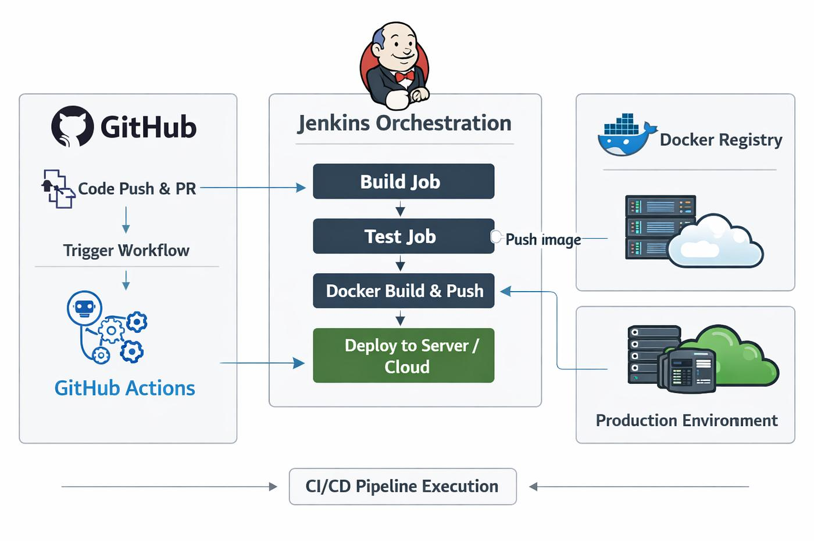
Figure 1. Example of CI/CD Pipeline Execution
Required pipeline:
- Developer pushes source code to GitHub.
- GitHub Actions triggers the workflow.
- The application undergoes lint checking.
- Automated tests are executed.
- The application is built.
- Docker creates a container image.
- The image is pushed to GHCR.
- Students verify that the image is available in the registry.
NOTE: Below is the example of Laboratory Procedures, apply your on-going project based on the Sample below

D. Step-by-step laboratory procedures
Activity 1. Create the project repository
Step 1. Create a GitHub repository.
Repository name:
student-information-system
Recommended settings:
- Repository visibility: Public (for easier classroom verification).
- Initialize with README: Yes.
- Default branch: main.

Step 2. Clone the repository.
Open your terminal:
git clone https://github.com/YOUR_USERNAME/student-information-system.git

cd student-information-system
Step 3. Create the project structure.
Organize your project as follows:
student-information-system/
│
├── .github/
│ └── workflows/
│ └── ci-cd.yml
│
├── src/
│ └── index.js
│
├── test/
│ └── app.test.js
│
├── Dockerfile
├── package.json
├── .gitignore
└── README.md
Activity 2. Develop the sample application
Step 1. Create package.json.
{
"name": "student-information-system",
"version": "1.0.0",
"description": "Sample SIS application for CI/CD",
"main": "src/index.js",
"scripts": {
"lint": "node --check src/index.js",
"test": "node --test",
"build": "mkdir -p dist && cp src/index.js dist/index.js",
"start": "node dist/index.js"
}
}
Step 2. Create src/index.js.
const http = require("node:http");

function getMessage() {
return "Student Information System is running!";
}

const server = http.createServer((req, res) => {
res.writeHead(200, {
"Content-Type": "text/plain"
});

res.end(getMessage());
});

if (require.main === module) {
server.listen(3000, "0.0.0.0", () => {
console.log("SIS running on port 3000");
});
}

module.exports = { getMessage };

Step 3. Create test/app.test.js.
const test = require("node:test");
const assert = require("node:assert");
const { getMessage } = require("../src/index");

test("SIS should return the correct message", () => {
assert.strictEqual(
getMessage(),
"Student Information System is running!"
);
});

Step 4. Test the application locally.
Install dependencies:
npm install
Run lint:
npm run lint

Run tests:
npm test
Build the application:
npm run build

Expected result:
All three commands should execute successfully.

Activity 3. Create the GitHub Actions CI/CD workflow
Step 1. Create the workflow file.
Navigate to:
.github/workflows/
Create:
ci-cd.yml
Step 2. Add the following workflow configuration.
name: SIS CI-CD Pipeline
on:
push:
branches:
- main
tags:
- "v*"

pull_request:
branches:
- main
workflow_dispatch:
jobs:

# JOB 1: LINT, TEST, AND BUILD
ci:
name: Code Quality and Testing
runs-on: ubuntu-latest

steps:
- name: Checkout Repository
uses: actions/checkout@v6

- name: Setup Node.js
uses: actions/setup-node@v6
with:
node-version: 22

- name: Install Dependencies
run: npm install

- name: Run Lint
run: npm run lint

- name: Run Automated Tests
run: npm test

- name: Build Application
run: npm run build

# JOB 2: BUILD AND PUSH DOCKER IMAGE
docker:
name: Docker Build and Publish
needs: ci
if: github.event_name != 'pull_request'
runs-on: ubuntu-latest

permissions:
contents: read
packages: write

steps:
- name: Checkout Repository
uses: actions/checkout@v6

- name: Login to GHCR
uses: docker/login-action@v3
with:
registry: ghcr.io
username: ${{ github.actor }}
password: ${{ secrets.GITHUB_TOKEN }}

- name: Generate Docker Metadata
id: meta
uses: docker/metadata-action@v6
with:
images: ghcr.io/${{ github.repository }}

- name: Build and Push Docker Image
uses: docker/build-push-action@v6
with:
context: .
push: true
tags: ${{ steps.meta.outputs.tags }}
labels: ${{ steps.meta.outputs.labels }}
Explanation of the workflow

Configuration | Purpose
name | Names the workflow.
on | Specifies workflow triggers.
push | Executes when changes are pushed.
pull_request | Executes when a pull request is opened or updated.
workflow_dispatch | Enables manual execution.
jobs | Defines automated jobs.
runs-on | Selects the execution environment.
steps | Defines individual tasks.
needs: ci | Requires the CI job to succeed first.
permissions | Defines token access rights.
if | Controls whether a job executes.
uses | Executes a reusable GitHub Action.
run | Executes a shell command.
Important implementation details:
- The Docker publishing job only executes after the CI job succeeds.
- Pull requests run the CI checks but do not publish images.
- The GITHUB_TOKEN is automatically provided by GitHub Actions; no manually generated personal access token is needed for this GHCR example.
- packages: write grants the Docker job permission to publish container images.
- Publishing should be performed only by trusted workflows.
Activity 4. Create a Dockerfile
Step 1. Create a file named Dockerfile.
Add:
FROM node:22-alpine

WORKDIR /app

COPY package*.json ./

COPY src ./src

COPY dist ./dist

EXPOSE 3000

CMD ["npm", "start"]
Explanation:
Instruction | Description
FROM | Defines the base image.
WORKDIR | Sets the working directory.
COPY | Copies project files into the image.
EXPOSE | Documents the application's container port.
CMD | Defines the default container command.
Step 2. Create .gitignore.
node_modules/
dist/
.env
*.log
Step 3. Test Docker locally.
First, build the application:
npm run build
Build the Docker image:
docker build -t sis-app:latest .
Run the container:
docker run -d \
--name sis-container \
-p 3000:3000 \
sis-app:latest
Open your browser:
http://localhost:3000
Expected output:
Student Information System is running!
To stop the container:
docker stop sis-container
docker rm sis-container
Activity 5. Configure GitHub Secrets
For this laboratory, GHCR uses the built-in GITHUB_TOKEN, so students do not need to create a Docker Hub password or personal access token.
However, each group must demonstrate how to configure a separate repository secret.
Step 1. Navigate to repository settings.
Go to:
Settings
→ Secrets and variables
→ Actions
→ New repository secret
Step 2. Create a demonstration secret.
Name:
DEMO_API_KEY
Value:
classroom-demo-12345
Use only this dummy value, not an actual API credential.
Step 3. Access the secret in a workflow.
Add a step to the CI job:
- name: Verify Secret Configuration
env:
DEMO_API_KEY: ${{ secrets.DEMO_API_KEY }}
run: |
if [ -n "$DEMO_API_KEY" ]; then
echo "Secret successfully configured."
else
echo "Secret is missing."
exit 1
fi
The workflow verifies that the secret exists without displaying its actual value.
Step 4. Discuss the importance of secrets.
Answer:
- Why should API keys not be committed to GitHub?
Answer: You should never commit API keys because anyone who views the repository can see and steal them, especially on public repos where automated bots constantly scan for leaked credentials. If someone gets your API key, they can abuse your account, access private data, or run up huge bills on paid services.
- What happens if a password is exposed in a public repository?
Answer: If a password is leaked in a public repo, attackers can use it immediately to compromise systems, databases, or accounts. Even if you push a new commit deleting the password, it remains saved in Git's commit history where anyone can view it. The only real fix is to immediately revoke and change the password.
- Why is using GitHub Secrets safer?
Answer: GitHub Secrets keeps your credentials encrypted so they never appear in your code or commits. They are only loaded into memory while the workflow runner is executing, and GitHub automatically hides and masks them with *** in the terminal logs so they cannot be seen by accident.
- What is the difference between a GitHub Secret and a regular environment variable?
Answer: A GitHub Secret is encrypted and meant for sensitive data like passwords and API tokens that should never be shown in logs or commit history. A regular environment variable is for normal, non-secret configurations like port numbers or application settings (like PORT=3000) where it does not matter if people can see the value.
Activity 6. Push the project to GitHub
Execute the following commands:
git add .

git commit -m "Implement CI-CD pipeline"

git push origin main
Expected behavior:
- GitHub detects the new commit.
- GitHub Actions automatically starts the workflow.
- The CI job installs dependencies.
- The linting process executes.
- Automated tests run.
- The application is built.
- The Docker job starts after CI succeeds.
- Docker creates the image and pushes it to GHCR.
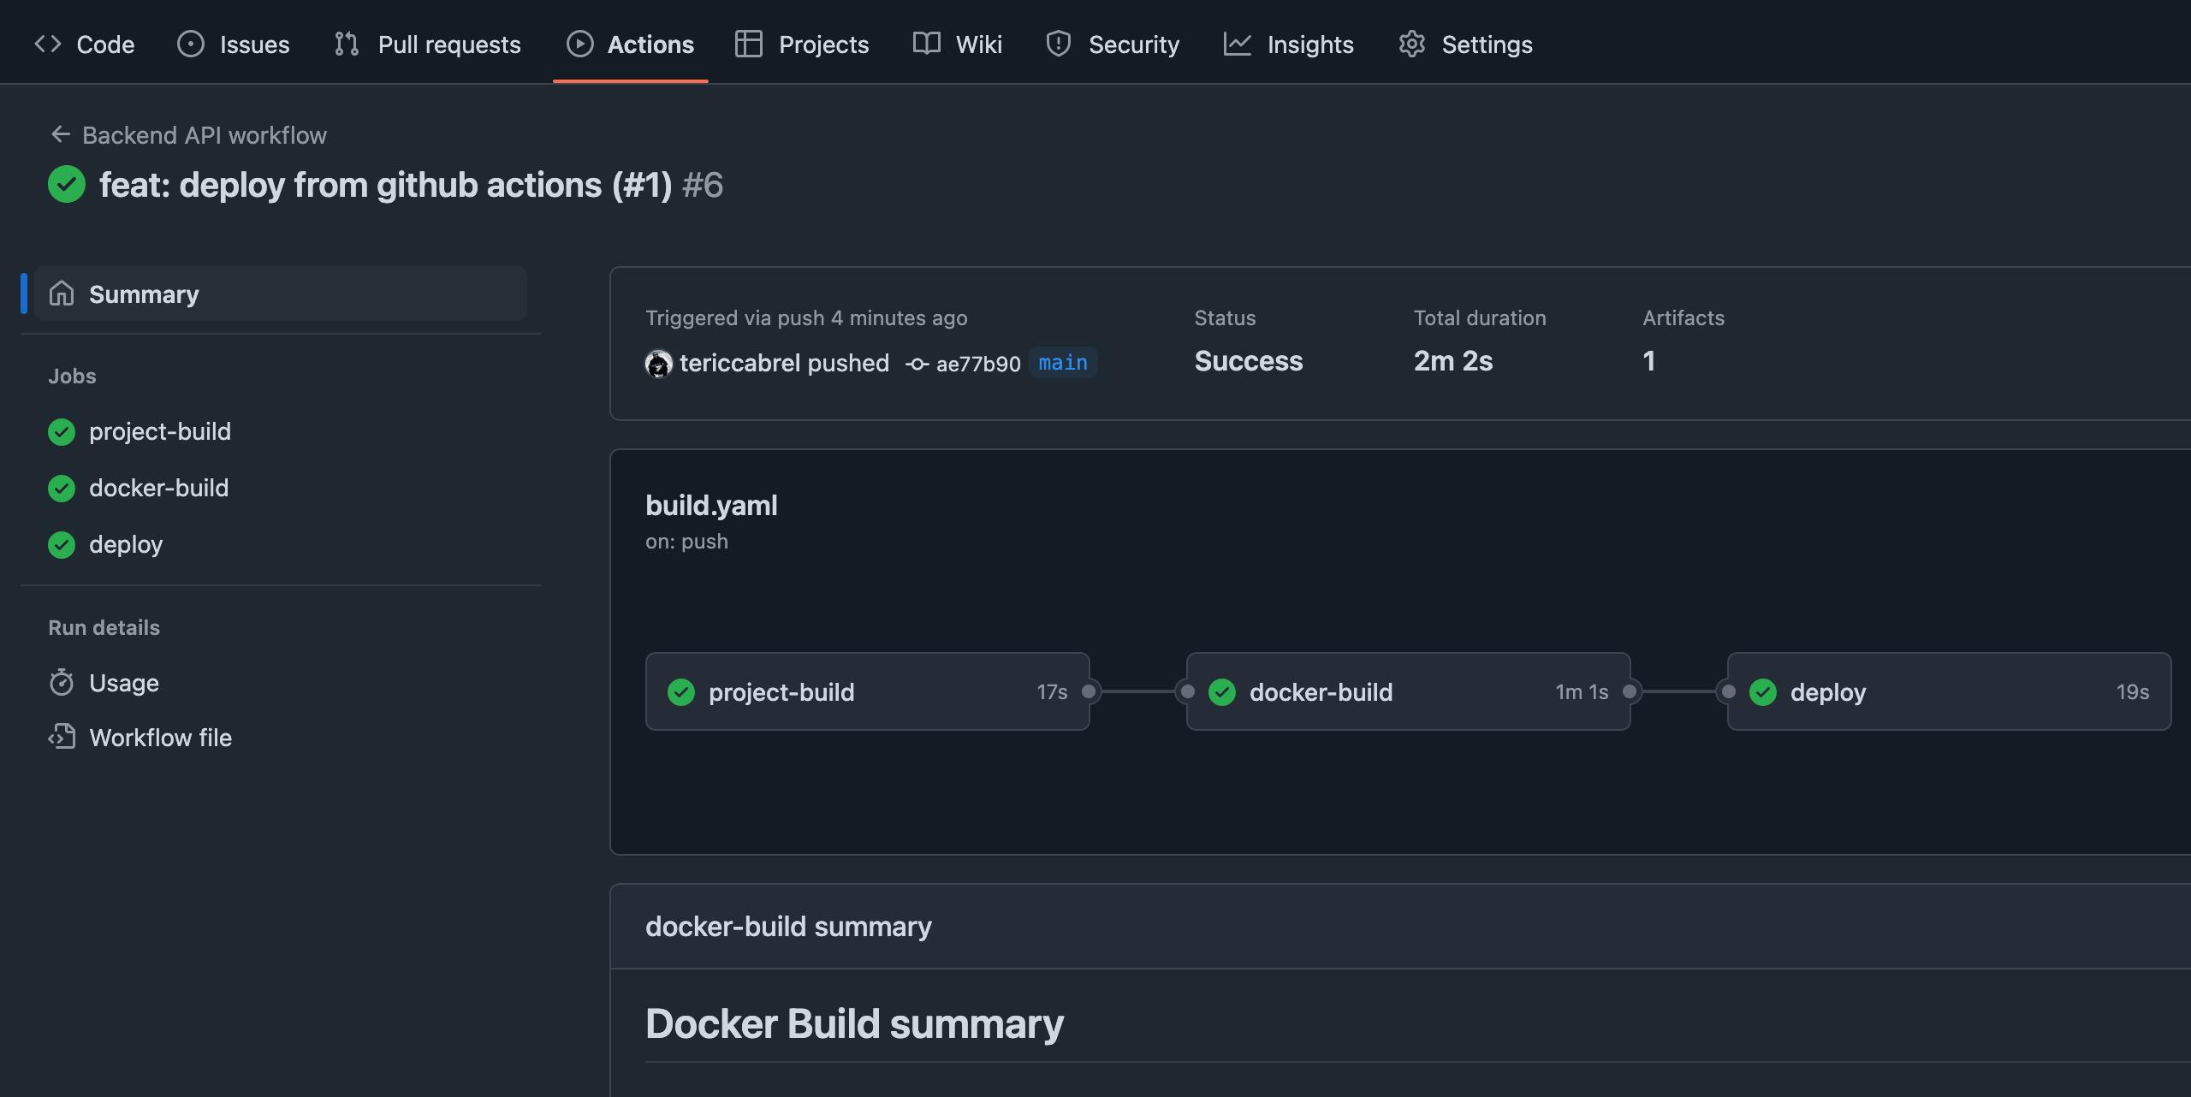
Activity 7. Verify the Docker image in GHCR
Step 1. Open the GitHub repository.
Navigate to the repository's Packages section or your GitHub profile's Packages page.
Step 2. Locate the published image.
Expected image format:
ghcr.io/YOUR_USERNAME/student-information-system

Step 3. Pull the image.
For a public image:
docker pull ghcr.io/YOUR_USERNAME/student-information-system:main
Use the actual tag displayed in the package if it differs.

Step 4. Run the published image.
docker run -d \
--name sis-published \
-p 3001:3000 \
ghcr.io/YOUR_USERNAME/student-information-system:main

Step 5. Verify the application.
Open:
http://localhost:3001
Expected output:
Student Information System is running!
Successful completion
The team has successfully implemented an automated CI/CD pipeline and published a Docker image to a container registry.

E. Additional Laboratory Challenges
After completing the main pipeline, each group must complete the following challenges.

Challenge 1: Test failure detection
- Modify the expected message in test/app.test.js.
- Push the changes to GitHub.
- Observe the GitHub Actions execution.
- Identify which stage failed.
- Restore the correct expected message.
- Push the corrected code.

Expected observation: The pipeline should fail during testing and prevent Docker publishing.

Challenge 2: Pull request automation
1. Create a new branch:
git checkout -b feature/student-profile
- Modify the application message.
- Commit the changes:

git add .
git commit -m "Update student profile feature"
git push origin feature/student-profile

- Open a pull request against main.
- Observe the automated CI execution.
- Review the results before merging.

Expected observation: CI runs on the pull request, but the Docker publishing job does not execute.

Challenge 3: Version tagging
Create a version tag:
git checkout main
git pull origin main
git tag v1.0.0
git push origin v1.0.0
Observe the workflow and examine the published image tags in GHCR.

Expected observation: The Docker metadata action generates an image tag corresponding to the release version.

Challenge 4: Docker image modification
Modify the application's output message to:
Welcome to the Student Information System - Version 2.0!
Run the pipeline again and verify that the updated Docker image is published.

F. Required submission and deliverables
Each group must submit the following:

No. | Deliverable | Description
1 | GitHub repository | Complete source code and project structure.
2 | GitHub Actions workflow | Functional ci-cd.yml file.
3 | Dockerfile | Valid Docker configuration.
4 | Automated tests | At least one successfully executed test.
5 | GHCR image | Published Docker image.
6 | README.md | Project description and setup instructions.
7 | Screenshots | Evidence of successful and failed pipeline executions.
8 | Laboratory report | Documentation of procedures and results.
9 | Individual reflection | Each member's contribution and learning experience.

G. Laboratory report format

The group must prepare a laboratory report containing:
- Title Page
  - Subject name
  - Laboratory Module 14
  - Activity title
  - Group members
  - Instructor
  - Date of submission
- Introduction
  - Explain CI/CD.
  - Discuss the importance of automation in software development.
- Objectives
  - State the objectives of the laboratory.
- Tools and Technologies
  - Git
  - GitHub
  - GitHub Actions
  - Docker
  - GitHub Container Registry
  - Node.js
- Procedures and Implementation
  - Explain each implementation step.
  - Include relevant source code and screenshots.
- Results and Discussion
  - Present successful pipeline executions.
  - Show failed test execution and recovery.
  - Demonstrate Docker image publication.
- Individual Contributions
  - Identify the assigned tasks of each member.
- Guide Questions
  - Answer all laboratory questions.
- Conclusion
  - Summarize the group's experience and learning outcomes.
- References
  - Include documentation and other technical references.
H. Guide questions
Each student must answer the following questions individually.
- What is CI/CD, and why is it important in modern software development?
Answer: CI/CD stands for Continuous Integration and Continuous Delivery / Deployment. It is a method where software updates are automatically checked, tested, built, and packaged every time a developer pushes code. It is important because it makes shipping software faster, prevents merge conflicts among team members, and catches bugs right away instead of waiting until the end of a project.
- Differentiate Continuous Integration, Continuous Delivery, and Continuous Deployment.
Answer: - Continuous Integration (CI): Developers push code frequently, and the system automatically checks for syntax errors and runs unit tests to make sure the code is not broken.
- Continuous Delivery (CD): Once the code passes CI, it is automatically built into a ready-to-deploy package (like a Docker image in GHCR), but putting it into live production still requires manual approval.
- Continuous Deployment (CD): Everything is 100% automated—if the code passes all tests and builds, it goes straight to the live production server without anyone having to click an approve button.
- What is the purpose of linting in a CI/CD pipeline?
Answer: Linting checks your code for syntax errors, typos, and formatting problems before you even try to run tests or build the app. In our lab, running node --check src/index.js quickly verifies that our JavaScript syntax is correct so we don't waste time running a pipeline on broken syntax.
- Why should automated tests execute before an application is deployed?
Answer: Automated tests need to run first to prove that the application actually works as intended and that new changes didn't break existing features. If you deploy without testing, broken code or bugs will go straight to the users and could crash the live website or service.
- What is the difference between a GitHub Actions workflow, job, and step?
Answer: A GitHub Secret is encrypted and meant for sensitive data like passwords and API tokens that should never be shown in logs or commit history. A regular environment variable is for normal, non-secret configurations like port numbers or application settings (like PORT=3000) where it does not matter if people can see the value.
- What is the purpose of the on keyword in a GitHub Actions YAML file?
Answer: The on keyword tells GitHub what events should trigger the workflow to run. In our lab, we used it to trigger the pipeline on pushes to main, whenever a version tag like v1.0.0 is created, when a pull request is opened, or when manually triggered via workflow_dispatch.
- Why is needs: ci used in the Docker publishing job?
Answer: By default, GitHub Actions runs jobs at the same time. Using needs: ci forces the docker job to wait until the ci job finishes successfully. This makes sure we only build and push a Docker image to GHCR if our code passes all tests and linting first.
- What is the purpose of a Dockerfile?
Answer: A Dockerfile is a set of instructions for building a Docker container image. It tells Docker what base OS and runtime to start with (node:22-alpine), what files to copy over from our project, what port to expose (3000), and what command to run when the container starts (npm start).
- Differentiate a Docker image and a Docker container.
Answer: - Docker Image: The read-only template or blueprint that contains the code, libraries, and settings needed to run the app. It doesn't do anything on its own until you run it.
- Docker Container: The live, running instance of an image. You can start, stop, and run multiple containers from the exact same image.
- What is the purpose of GitHub Container Registry?
Answer: GitHub Container Registry (GHCR) is GitHub's built-in place to store and share Docker images. It connects directly with our GitHub account and repository so we can push our built images directly from GitHub Actions without needing third-party services like Docker Hub.
- Why should API keys and passwords be stored in GitHub Secrets?
Answer: Secrets keep sensitive information safe. If you put passwords or API keys directly in your code, anyone who views the repository can see them. Storing them in GitHub Secrets keeps them encrypted, only exposes them to the runner when needed, and hides them with *** in the workflow logs.
- What happens when an automated test fails during pipeline execution?
Answer: When a test fails, the test runner exits with an error code. GitHub Actions stops the job right away, turns the workflow status red, and skips downstream jobs like Docker publishing. In our Challenge 1, we saw this happen: breaking the test stopped the pipeline and prevented any Docker image from being pushed.
- How does GitHub Actions improve collaboration among developers?
Answer: It gives the whole team automated feedback on every pull request. Team members don't have to manually clone and test a teammate's branch just to see if it works; GitHub Actions automatically runs the tests and checks. If it passes, reviewers know the branch is safe to merge into main.
- What are the possible risks of automatically deploying code without human approval?
Answer: - Automated tests might not catch every real-world bug or edge case, allowing bad code to reach users.
- A bad update could crash the live system or cause downtime before anyone notices.
- An untested third-party package or dependency update could introduce unexpected performance issues or security bugs.
- How would you improve the CI/CD pipeline implemented in this laboratory?
Answer: - Add automated security scanning (like using Trivy or npm audit) to check our Docker image and dependencies for known vulnerabilities.
- Add integration or end-to-end testing with tools like Playwright to test actual browser behavior.
- Use multi-stage Docker builds to keep the container image even smaller and lighter.
- Add an automated deployment step at the end that deploys the container to a cloud host (like Render or AWS) once pushed to GHCR.

I. Group assignments and collaboration
For a group of 3–5 students, assign responsibilities as follows:
Role | Responsibilities
Developer | Develops and maintains the application.
CI/CD Engineer | Creates and configures GitHub Actions workflows.
Docker Engineer | Develops Dockerfiles and manages image publication.
Tester / QA Engineer | Performs testing and verifies pipeline results.
Documentation Lead | Prepares the README, screenshots, and laboratory report.

For groups with fewer than three members, responsibilities may be combined.
All members must participate in code reviews, testing, and project discussions. Each member must also understand the overall pipeline, not only their assigned task.

