Dynamic Properties

Version | :
Classification | :

Document name: | 0000.doc
Document number:
Document type:

Authors
Name | Chapters, Sections | Initiale Date | Visa
Ueli Kurmann | creation | 4.6.2007

History
Version | Initials | Date | Description | Section
1.0 | UK | 4.6.2007 | Initial creation | all

Table of contents

1 Introduction 4
1.1 Purpose 4
1.2 Scope 4
2 Architecture 4
2.1 Property Types 4
2.1.1 Simple Type 5
2.1.2 Complex Type 5
2.1.3 List Type 5
2.1.4 Enumeration Type 5
2.2 Property Values 5
2.2.1 Simple Value 6
2.2.2 Complex Value 6
2.2.3 List Value 6
2.2.4 Enumeration Value 6
2.3 Multilingualism 6
2.4 Editor and Viewer 6
3 Persistence / Hibernate 7
4 pmMDA Integration 7
5 DataObject Editor 7
6 User Guide 7
6.1 PropertyInstanceManager 7
6.2 Create Property Types 8
6.3 Create and Use Properties 8
7 Package Overview 9
8 UML Diagram 10

Introduction

Purpose
Applications need to be extended dynamically with additional properties without the adaptation of the underlying data model. Dynamic Properties enables the definition of simple, complex and indexed properties. Furthermore it is integrated into pmMDA.

Scope
This document describes the architecture, design and the usage of the Dynamic Property framework.

Architecture
A property has a type and a value as shown in the class diagram below.

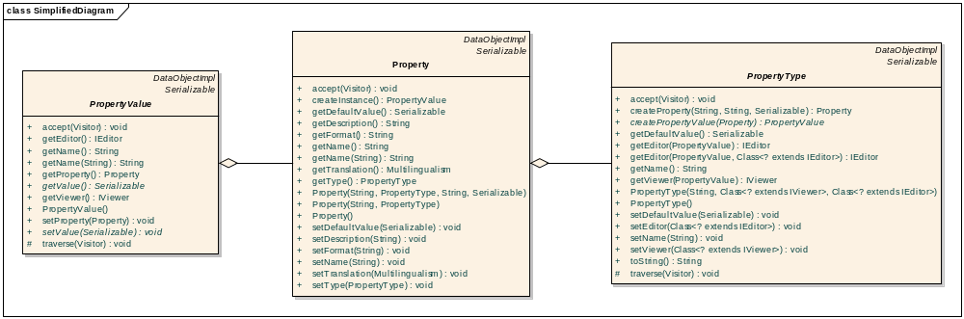

This model can be compared with the well known variable declaration. For example in Java the declaration of an integer value has the form int i = 0. The following sketch shows the mapping of this declaration to the data model.

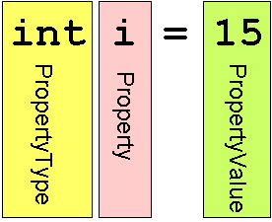

Property Types
We distinguish the following four property types as illustrated in the class diagram. The property type contains a method to instantiate corresponding properties of this type.

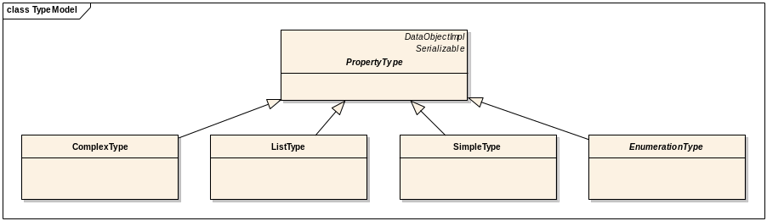

Simple Type
Simple types are the systems built in types as Boolean, Date, Double, Integer, String. They are mapped to the corresponding system type and are the base type system of the Dynamic Property framework. All simple types have to be serializable.

Complex Type
A complex type consists of arbitrary many properties. Complex types are analogue to classes and structs in programming languages. Inheritance is not supported.
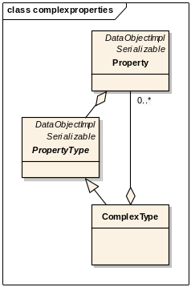
At a first glance it may be surprisingly that complex types containing properties and not types. But this is the mapping also used in programming languages like Java and it is evident that members of complex types have to be named which is not possible using types only.

List Type
The list type is a typed indexed property. The elements of the list can be of any type.

Enumeration Type
This type is used to map reference codes. Both, flat and hierarchical enumerations are supported.

Property Values
Accordingly to the four different types there are also four property value implementations.
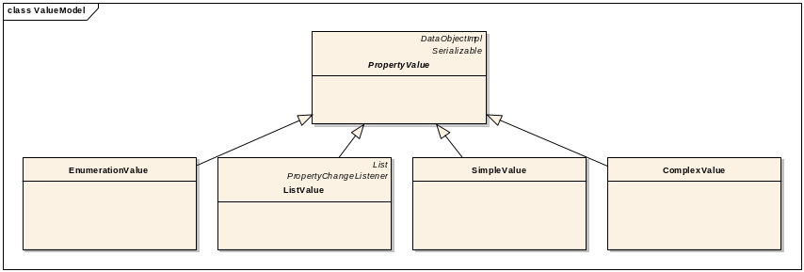
Property values should not be instantiated manually. Instances should be created on behalf of a property instance which contains a factory for this purpose. Furthermore property values may have default values which are defined by the property.

Simple Value
Simple types are serializable and therefore stored internally in a java.io.Serializable member variable.

Complex Value
Complex values are compounds of property values. Internally the values are stored in a map.

List Value
The list value has an anonymous property which handles the type of the list. The list values itself are stored in a collection of property values. The type list value implements the java.util.List interface to ensure standard access to particular elements.

Enumeration Value
The value of an enumeration is represented by an integer whereas each enumeration has a unique key.

Multilingualism
Property names and enumeration elements are language dependent. These values are translated with the multilingualism object. The name can be requested with the getter method and the corresponding language key. If the translation does not exist the default name is returned.

Editor and Viewer
To allow the visualization of property values an editor and viewer has to be assigned to property types. The editor is used to manipulate the value whereas the viewer provides a read-only presentation of the value. Special editors and viewers are provided for complex and list types. They recursively refer to other editors and viewers. Editors and Viewers have to implement the IEditor or IViewer interface and return a swing JComponent.

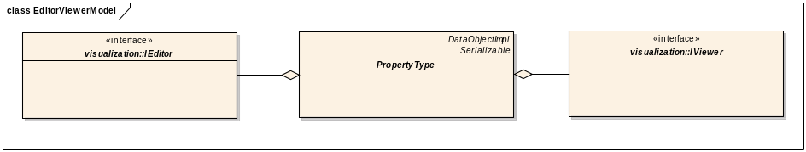

Persistence / Hibernate
All core classes can be persistent and implementing the DataObject interface. Therefore standard pmMDA persistence mechanism can be used. The Hibernate mapping file was created manually and is located in the source repository.

pmMDA Integration
The Dynamic Property Framework is integrated seamlessly into pmMDA. In the context of packages and classes the tagged value “extendable” can be set. The DOG generator creates a list of property values (propertyValues) for DataObjects which are “extendable”.

A singleton class manages the assignment of properties to DataObjects. For each dynamic property an instance of the corresponding property value is created. The properties are accessed with getter and setter methods which take the corresponding property name as parameter.

DataObject Editor
The DataObject Editor is a simple tool to manage the dynamic properties of DataObjects. It has basically two functions. On the one hand property types can be managed; on the other hand properties can be assigned to DataObjects. Types can be created, edited and deleted. Furthermore these types can be assigned to DataObjects. The editor has to be integrated manually into a pmMDA application.

User Guide
This section shows the usage of the Dynamic Property framework.

PropertyInstanceManager
The PropertyInstanceManager is a helper class which manages the available types and properties. Instantiated types and properties can be registered to be reused and the systems built in types are pre-registered. In the following sections the variable manager is a reference to PropertyInstanceManager.instance().

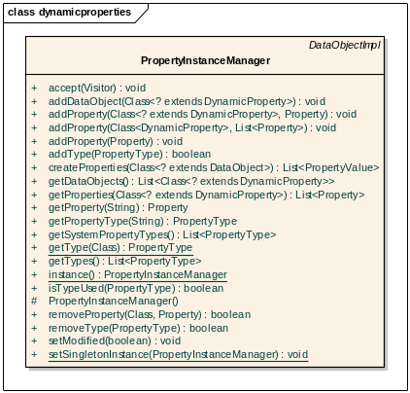

Create Property Types
The following code snippets illustrate instantiation of types.

/** Simple Type **/
SimpleType tInt = new SimpleType("int", Integer.class, StringViewer.class, IntegerEditor.class);

/** List Type **/
ListType tList = new ListType("intList", tInt, ListViewer.class, TableEditor.class);

/** Complex Type – name and birthday are properties registered in the property instance manager **/
ComplexType tPerson = new ComplexType("Person", ComplexViewer.class, ComplexEditor.class);
tPerson.addProperty(manager.getProperty("name"));
tPerson.addProperty(manager.getProperty("birthday"));

Create and Use Properties
The following code snippets illustrate the instantiation of simple properties.

/** Create Property **/
Property pName = new Property("name", PropertyInstanceManager.getType(String.class));

/** Create a Simple Property Value **/
SimpleValue pNameValue = (SimpleValue)pName.createInstance();

/** Set the Simple Property Value **/
pNameValue.setValue("Gosling");

/** Get the Simple Property Value **/
pNameValue.getValue();

The following code snippet shows the use of list properties.

/** Create Property **/
ListType intList = new ListType("intList", manager.getType(Integer.class));
Property numbersProperty = intList.createProperty("numbers", "", 0);

/** Create a List Property Value **/
ListValue numbers = (ListValue)numbersProperty.createInstance();

/** Add Elements to the List **/
numbers.add(1);
numbers.add(2);

/** Iterate over the Values **/
for(PropertyValue value:numbers){
System.out.println(value.getValue());
}

The following code snippet shows the use of complex properties.

/** Create Complex Type **/
ComplexType complexType = new ComplexType("contact");
complexType.addProperty(new Property("name", manager.getType(String.class)));
complexType.addProperty(new Property("birthdate", manager.getType(Date.class)));

/** Create Complex Property **/
Property contactProperty = complexType.createProperty("myContact", "", null);

/** Create a List Property Value **/
ComplexValue myContact = (ComplexValue)contactProperty.createInstance();

/** Set Elements **/
myContact.setValue("name", "Gosling");
myContact.setValue("birthdate", new Date("19/05/55"));

/** Get Values **/
myContact.getPropertyValue("name");
myContact.getPropertyValue("birthdate");

DataObject Editor
/** Shows the DataObject Editor **/
new DynamicPropertyView(manager);

/** afterwards the manager has to be made persistent **/

Package Overview
ch.bbv.dynamicproperties | Manager classes.
ch.bbv.dynamicproperties.core | The DataObjects of the framework.
ch.bbv.dynamicproperties.objecteditor | Implementation of the DataObject editor.
ch.bbv.dynamicproperties.visualization | Interfaces and implementation of editors and viewers.
ch.bbv.dynamicproperties.pmmda | Helper classes used by the pmMDA integration.

UML Diagram
