**IAM**

**Description** - Identity and access management (IAM) in enterprise IT is about defining and managing the roles and access privileges of individual network users and the circumstances in which users are granted (or denied) those privileges. Those users might be customers (customer identity management) or employees (employee identity management. The core objective of IAM systems is one digital identity per individual. Once that digital identity has been established, it must be maintained, modified and monitored throughout each user’s “access lifecycle.”

**Need of IAM** - Identity and access management is a critical part of any enterprise security plan, as it is inextricably linked to the security and productivity of organizations in today’s digitally enabled economy.

Compromised user credentials often serve as an entry point into an organization’s network and its information assets. Enterprises use identity management to safeguard their information assets against the rising threats of ransomware, criminal hacking, phishing and other malware attacks. Global ransomware damage costs alone are expected to exceed $5 billion this year, up 15 percent from 2016, Cybersecurity Ventures predicted.

In many organizations, users sometimes have more access privileges than necessary. A robust IAM system can add an important layer of protection by ensuring a consistent application of user access rules and policies across an organization.

Identity and access management systems can enhance business productivity. The systems’ central management capabilities can reduce the complexity and cost of safeguarding user credentials and access. At the same time, identity management systems enable workers to be more productive (while staying secure) in a variety of environments, whether they’re working from home, the office, or on the road.

**Three Typical Systems Used for Identity and Access Management**

There are many technologies to simplify password management and other aspects of IAM. A few common types of solutions that are used as part of an IAM program include:

• **Single Sign On (SSO):** An access and login system that allows users to authenticate themselves once and then grants them access to all the software, systems, and data they need without having to log into each of those areas individually.

• **Multi-Factor Authentication**: This system uses a combination of something the user knows (e.g. a password), something the user has (e.g. a security token), and something the user is (e.g. a fingerprint) to authenticate individuals and grant them access.

• **Privileged Access Management:** This system typically integrates with the employee database and pre-defined job roles to establish and provide the access employees need to perform their roles.

IAM technology can be provided on-premises, through a cloud-based model (i.e. identity-asa-service, or IDaaS), or via a hybrid cloud setup. Practical applications of IAM, and how it is implemented, differ from organization to organization, and will also be shaped by applicable regulatory and compliance initiatives.

**Policy Types**

The following policy types, listed in order of frequency, are available for use in AWS. For more details, see the sections below for each policy type.

• **Identity-based policies** – Attach managed and inline policies to IAM identities (users, groups to which users belong, or roles). Identity-based policies grant permissions to an identity.

• **Resource-based policies** – Attach inline policies to resources. The most common examples of resource-based policies are Amazon S3 bucket policies and IAM role trust policies. Resource-based policies grant permissions to the principal that is specified in the policy. Principals can be in the same account as the resource or in other accounts.

• **Permissions boundaries** – Use a managed policy as the permissions boundary for an IAM entity (user or role). That policy defines the maximum permissions that the identitybased policies can grant to an entity but does not grant permissions. Permissions boundaries do not define the maximum permissions that a resource-based policy can grant to an entity.

• **Organizations SCPs** – Use an AWS Organizations service control policy (SCP) to define the maximum permissions for account members of an organization or organizational unit (OU). SCPs limit permissions that identity-based policies or resource-based policies grant to entities (users or roles) within the account, but do not grant permissions.

• **Access control lists (ACLs)** – Use ACLs to control which principals in other accounts can access the resource to which the ACL is attached. ACLs are similar to resource-based policies, although they are the only policy type that does not use the JSON policy document structure. ACLs are cross-account permissions policies that grant permissions to the specified principal. ACLs cannot grant permissions to entities within the same account.

**• Session policies** – Pass advanced session policies when you use the AWS CLI or AWS API to assume a role or a federated user. Session policies limit the permissions that the role or user's identity-based policies grant to the session. Session policies limit permissions for a created session, but do not grant permissions. For more information, see Session Policies.

**Create IAM Users in AWS**

1. Log in to your AWS Account and go to Console

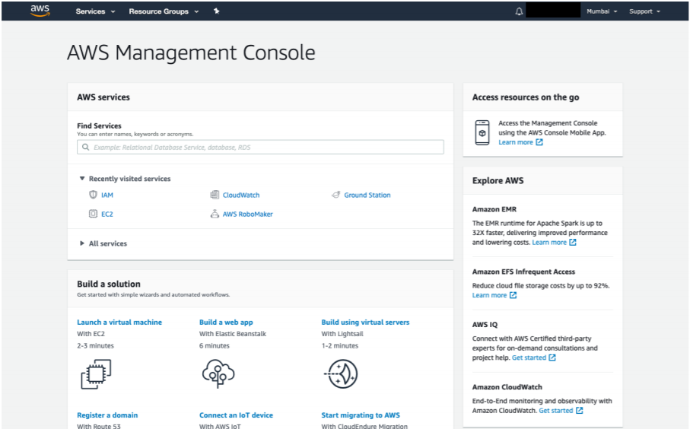

1. Search for IAM in services

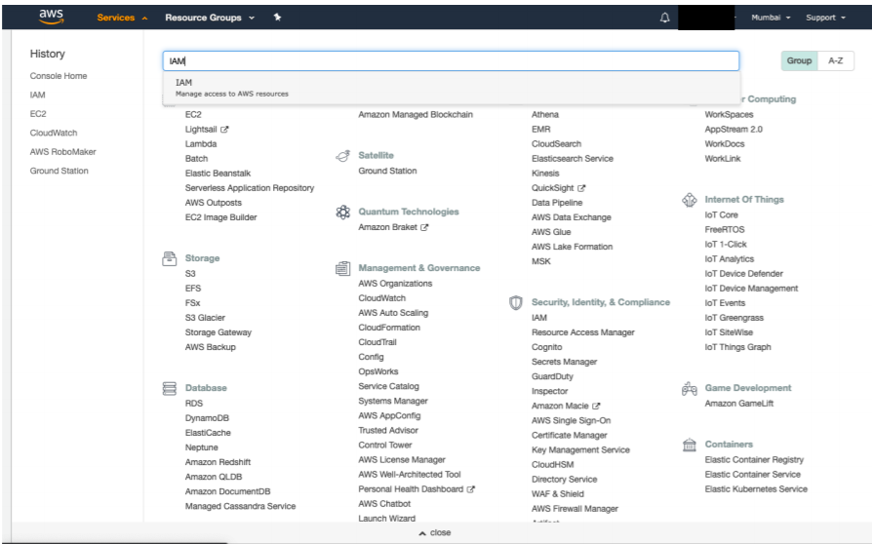

1. In the IAM menu select users

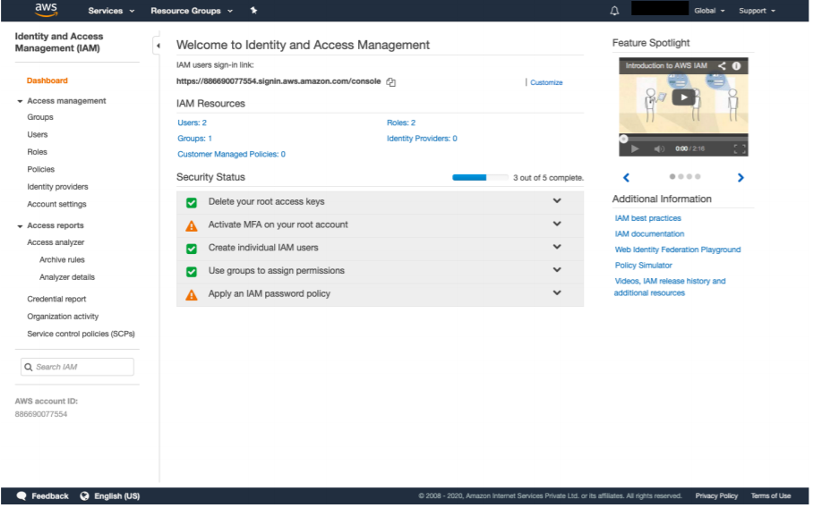

1. Select add new user and enter details

1. Add administrative policy to user one to avoid logging in to root account to perform further operations

1. Review and login using url provided and credentials mentioned above

**Create IAM Groups in AWS**

1. Select groups and add new group

1. Attach from the list of policies (in my case S3 access)

1. Review

1. To test the groups create a new user and add the user to this group

1. User cannot access any other service except S3

**Create IAM Groups in AWS**

1. Select roles and create new role (in our case for EC2 service)

1. Attach policies to role

1. Confirm and create role

1. Select instance settings and assign IAM role to EC2 instance

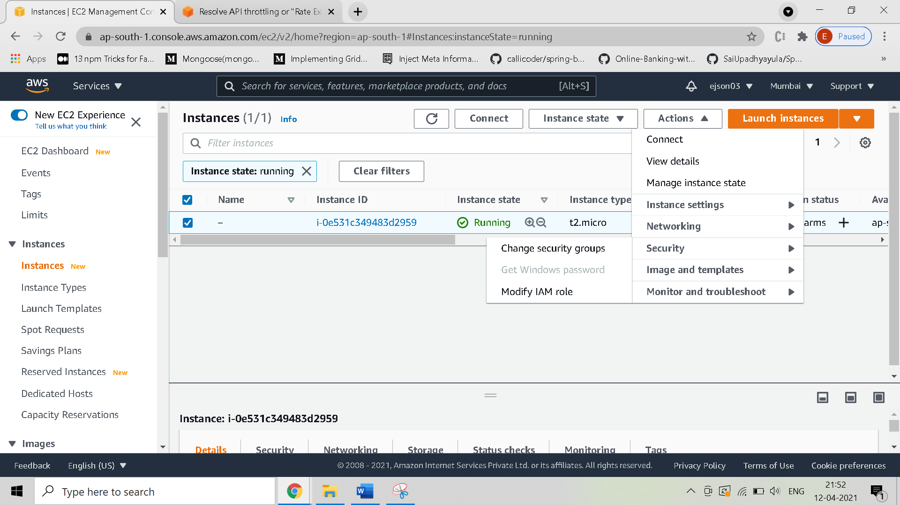

**Create IAM Policies in AWS**

1. Select custom policies and create new policy

1. Review

**IAM from AWS CLI**

**To create an IAM group and add a new IAM user to it**

1. Use the [create-group](https://docs.aws.amazon.com/cli/latest/reference/iam/create-group.html) command to create the group.

$ **aws iam create-group --group-name** *MyIamGroup*

{

"Group": {

"GroupName": "MyIamGroup",

"CreateDate": "2018-12-14T03:03:52.834Z",

"GroupId": "AGPAJNUJ2W4IJVEXAMPLE",

"Arn": "arn:aws:iam::123456789012:group/*MyIamGroup*",

"Path": "/"

}

}

1. Use the [create-user](https://docs.aws.amazon.com/cli/latest/reference/iam/create-user.html) command to create the user.

$ **aws iam create-user --user-name** *MyUser*

{

"User": {

"UserName": "*MyUser*",

"Path": "/",

"CreateDate": "2018-12-14T03:13:02.581Z",

"UserId": "AIDAJY2PE5XUZ4EXAMPLE",

"Arn": "arn:aws:iam::123456789012:user/*MyUser*"

}

}

1. Use the [add-user-to-group](https://docs.aws.amazon.com/cli/latest/reference/iam/add-user-to-group.html) command to add the user to the group.

$ **aws iam add-user-to-group --user-name** *MyUser* **--group-name** *MyIamGroup*

1. To verify that the MyIamGroup group contains the MyUser, use the [get-group](https://docs.aws.amazon.com/cli/latest/reference/iam/get-group.html) command.

$ **aws iam get-group --group-name** *MyIamGroup*

{

"Group": {

"GroupName": "*MyIamGroup*",

"CreateDate": "2018-12-14T03:03:52Z",

"GroupId": "AGPAJNUJ2W4IJVEXAMPLE",

"Arn": "arn:aws:iam::123456789012:group/*MyIamGroup*",

"Path": "/"

},

"Users": [

{

"UserName": "*MyUser*",

"Path": "/",

"CreateDate": "2018-12-14T03:13:02Z",

"UserId": "AIDAJY2PE5XUZ4EXAMPLE",

"Arn": "arn:aws:iam::123456789012:user/*MyUser*"

}

],

"IsTruncated": "false"

}

**To attach an IAM managed policy to an IAM user**

1. Determine the Amazon Resource Name (ARN) of the policy to attach. The following command uses list-policies to find the ARN of the policy with the name PowerUserAccess. It then stores that ARN in an environment variable.

$ **export** *POLICYARN***=$(aws iam list-policies --query 'Policies[?PolicyName==`PowerUserAccess`].{ARN:Arn}' --output text) ~**

$ **echo $***POLICYARN*

arn:aws:iam::aws:policy/PowerUserAccess

1. To attach the policy, use the [attach-user-policy](https://docs.aws.amazon.com/cli/latest/reference/iam/attach-user-policy.html) command, and reference the environment variable that holds the policy ARN.

$ **aws iam attach-user-policy --user-name** *MyUser* **--policy-arn $***POLICYARN*

1. Verify that the policy is attached to the user by running the [list-attached-user-policies](https://docs.aws.amazon.com/cli/latest/reference/iam/list-attached-user-policies.html) command.

$ **aws iam list-attached-user-policies --user-name** *MyUser*

{

"AttachedPolicies": [

{

"PolicyName": "PowerUserAccess",

"PolicyArn": "arn:aws:iam::aws:policy/PowerUserAccess"

}

]

}