NAME  Ian EJ E. Suacito |  | DATE  Feb. 4, 2017 | SCORE
SCHEDULE  Saturday (10-1) | SCORE |  | SCORE

LABORATORY EXERCISES
RECURSION

OBJECTIVES:
- Understand recursion and its parts
- Use recursion to solve programming problems

PROCEDURE:
- Encode the C++ program below.
- Save as rec1.cpp,and rec2.cpp, respectively.
- Compile and run the program by pressing Ctrl + F9.
- For each syntax or logical error encountered in the given program, do the following:
- Correct the error
- Recompile the program
- Repeat step 4 until no errors are encountered in the program.
- Illustrate the output of the modified program.

Program No. 1

#include <iostream>
Output:

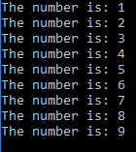

using namespace std;

void numberFunction(int i) {
cout << "The number is: " << i << endl;
i++;
if(i<10) {
numberFunction(i);
}
}

int main() {

int i = 1;
numberFunction(i);

return 0;
}

Program No. 2

#include <iostream>
using namespace std;

int factorial(int);

int main() {
int n;
cout<<"Enter a number to find factorial: ";
cin>>n;
cout<<"Factorial of "<<n<<" = "<<factorial(n);
return 0;
}
Output:

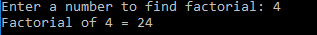

int factorial(int n) {
if (n>1) {
return n*factorial(n-1);
}
else {
return 1;
}
}

Supplementary Problem

- A recursive function that sums up the 10 integers in an array.

Program:
#include <iostream>
using namespace std;
int sum;

int func(int array[], int size) {

if (size == 0) {
return *array;
}
else {
return (*array + func(++array,size-1));
}
}

int main(void) {
int array[] = {6,9,12,7,10,1,4,8,2,11};
int answer;
answer = func(array,9);
cout << "sum is: " << answer << endl;

}

Output:
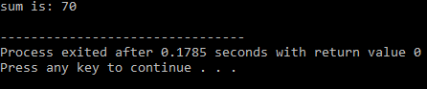

- A recursive function to produce the Fibonacci number for a given index in the series.
Use the function int fibonacci(int n)

Program:
#include <iostream>
using namespace std;

int fibonacci(int n) {
if (n==0) {
return 0;
}
if (n==1) {
return 1;
}
return fibonacci(n-1)+fibonacci(n-2);
}

int main() {
int number;
cout << "Enter a number: ";
cin >> number;
if (number < 0)
return 0;
else
cout << "Fibonacci is: " << fibonacci(number) <<endl;
return 0;
}

Output:
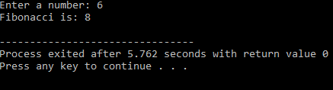

- A recursive function which raises its first parameter to the power of its second parameter.
Use the function int power(int number, int power)

Program:
#include <iostream>
using namespace std;

int pow(int number, int power) {
if (number == 0) {
return number*power;
}
if (power == 1) {
return number;
}
else
return number*pow(number,power-1);

}

int main() {
int a,b;
cout << "number: ";
cin >> a;
cout << "power: ";
cin >> b;
cout << "= " << pow(a,b) << endl;
return 0;
}

Output:
