ORAL MICROBIOME DYSBIOSIS CHARACTERIZES ALZHEIMER’S DISEASE: INTEGRATED TAXONOMIC, FUNCTIONAL, AND MACHINE LEARNING INSIGHTS FROM A VANCOUVER COHORT

Edward Jenner Tettevi¹ ² ³, Samuel Armoo³, David Larbi Simpong⁵, Mike Y. Osei-Atweneboana³ ⁴

¹Department of Biochemistry, Cell and Molecular Biology, School of Biological Science, Volta Road, University of Ghana, Legon, +23321, Accra-Ghana
²West African Centre for Cell Biology of Infectious Pathogens, School of Biological Science, Volta Road, University of Ghana, Legon, +23321, Accra-Ghana
³Council for Scientific and Industrial Research-Water Research Institute, Biomedical and Public Health Research Unit, Agostinho Neto Road, Council Close, Airport Residential, +23321, Accra, Ghana
⁴CSIR-College of Science and Technology, 2nd CSIR Close, Behind Lancaster, Airport Residential, +23321, Accra, Ghana
⁵Department of Medical Laboratory Sciences, College of Health and Allied Sciences, University of Cape Coast, Cape Coast-Takoradi Road, +23321, Cape Coast – Ghana

Corresponding author: Edward Jenner Tettevi - ejtettevi@gmail.com
Authors email: Edward Jenner Tettevi - ejtettevi@gmail.com
Samuel Armoo - samuel.k.armoo@gmail.com
David Larbi Simpong - dsimpong@ucc.edu.gh
Mike Y. Osei-Atweneboana - oseiatweneboana@yahoo.co.uk

ABSTRACT
Emerging evidence implicates oral microbiome dysbiosis in the pathogenesis of Alzheimer's disease (AD), yet the mechanistic architecture linking oral microbial perturbations to AD pathobiology remains fundamentally unclear. A comprehensive analysis of oral microbiomes from AD patients and age-matched controls was conducted using high-resolution 16S rRNA sequencing. Data were processed through a rigorously reproducible workflow integrating amplicon sequence variant inference, taxonomic and functional profiling, and machine learning algorithms. Diversity metrics, differential abundance, and metabolic pathway analyses were performed, and diagnostic potential was evaluated via supervised classification models. The oral microbiome of AD cases showed pronounced dysbiosis, characterized by a significant 20% expansion of Proteobacteria and a 61% depletion of Actinobacteriota. At finer taxonomic levels, enrichment of Bacilli and Gammaproteobacteria was observed coupled with a depletion of beneficial taxa, specifically Lactobacillales and Streptococcaceae. Diversity analysis showed a significant increase in alpha diversity in AD cases (Chao1 p=0.003; Fisher p=0.009), and beta diversity indicated greater community heterogeneity and destabilization. Functional profiling identified the coordinated enrichment of predicted biosynthetic and energy metabolism pathways, including peptidoglycan maturation, thiamine formation, and phospholipid biosynthesis. A Random Forest model achieved robust case-control discrimination (AUC = 0.85) using these microbiome-derived metabolic signatures, establishing their diagnostic potential. This work uniquely demonstrates coordinated enrichment of predicted biosynthetic and energy metabolism pathways alongside increased diversity and community destabilization, and shows that these oral microbiome-derived functional signatures can serve as non-invasive diagnostic candidates for AD.

Keywords: Alzheimer’s disease; oral microbiome; dysbiosis; metabolic biomarkers

Highlights
- AD oral microbiome shows marked dysbiosis versus controls.
- Alpha diversity increases; beta diversity indicates instability.
- Inferred metabolic pathway enrichment: peptidoglycan, phospholipids.
- Integrated taxonomic-functional-ML workflow reveals coordinated metabolic reprogramming in AD; Random Forest AUC = 0.85.

INTRODUCTION
The human oral microbiome is a critical interface between microbial ecology and systemic health. Mounting evidence now implicates its dysregulation in neurodegenerative pathogenesis, particularly in the development of Alzheimer’s disease (AD) (Dominy et al., 2019; Olsen & Singhrao, 2019). This complex microbial consortium maintains dynamic equilibrium through sophisticated ecological networks that profoundly influence host immune surveillance, metabolic homeostasis, and neuroinflammatory cascades (Zhu et al., 2025; Kilian et al., 2016; Long et al., 2022b). Disruption of these finely tuned microbiome-host interactions - collectively termed dysbiosis - can trigger pathological inflammatory responses and compromise blood-brain barrier integrity, establishing potential conduits for neurodegeneration (Olsen & Singhrao, 2019; Dominy et al., 2019).
High-resolution sequencing technologies and advanced computational frameworks have revolutionized our capacity to interrogate microbial communities (Callahan et al., 2016; Douglas et al., 2020; Caspi et al., 2020). However, a study that integrates high-resolution taxonomic, ecological, and predicted functional analyses to characterize oral microbiome dysbiosis in AD remain limited. Multi-modal approaches are essential for moving beyond simple correlation to establish mechanistic hypotheses and identify clinically actionable biomarkers for neurodegenerative disease.
Here, we present an integrated analysis of oral microbiome dysbiosis in AD through systematic comparison of patients and age-matched controls. Our analytical framework combines high-resolution amplicon sequence variant (ASV) inference, compositional statistical analysis, predicted functional profiling, and supervised machine learning to illuminate the microbial underpinnings of neurodegeneration. Our study uniquely integrates high-resolution taxonomic, ecological, and predicted functional profiling with supervised machine learning to reveal coordinated metabolic reprogramming in Alzheimer’s disease oral microbiomes and to evaluate their diagnostic potential.

METHODS
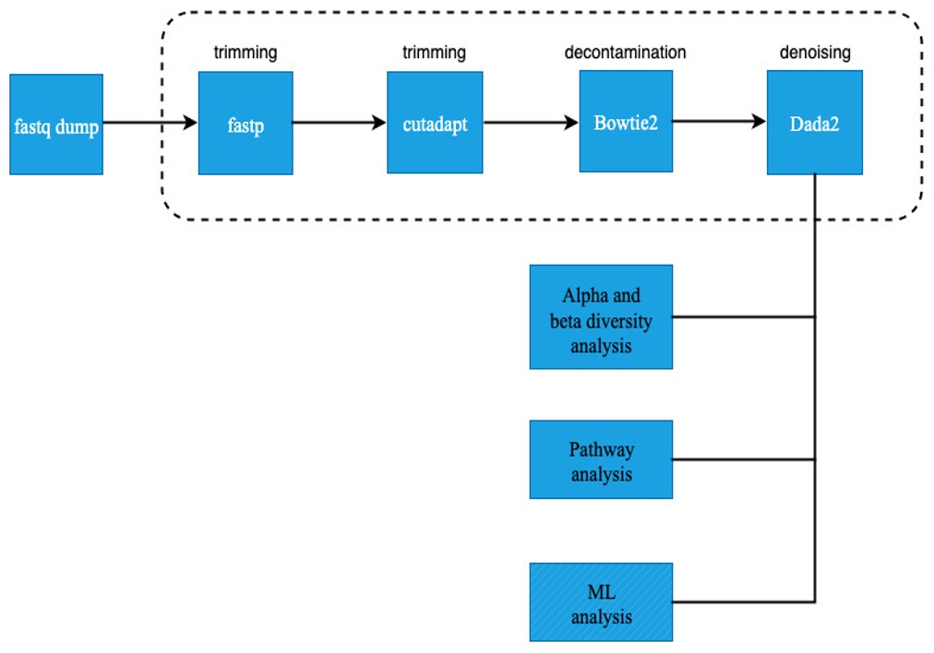
Fig. 1: Schematic overview of the bioinformatics analysis pipeline.

Study Design and Data Acquisition
Oral microbiome composition in AD patients and age-matched controls was investigated using Illumina 16S rRNA sequencing data from Vancouver, Canada (BioProject PRJNA770746). Raw data and metadata were obtained from the NCBI Sequence Read Archive. The analytical pipeline, including all scripts, is publicly available (https://github.com/ejtettevi/ad_oral_microbiome). For comparative multi-niche analysis, fecal samples (n = 99) from the same BioProject PRJNA770746 cohort were also obtained. Out of these, 78 fecal samples (32 cases and 46 controls) passed strict quality control and sequencing depth criteria and were included in the fecal-only analysis. A combined analysis was performed on all 176 successfully processed samples (98 oral and 78 fecal) to directly compare the oral and gut microbiomes. A detailed summary of sequencing run inclusions, exclusions, and cohort demographics is presented in Table 1.

Table 1: Demographic Profiles and Sequence Run Inclusions/Exclusions for Oral and Fecal Micro-niches.
Sample Type | Inclusion Status | Group | N | Age  (Mean ± SD) | Sex  (% Female) | BMI  (Mean ± SD) | MoCA  (Mean ± SD)
Oral swab | Included (n = 98) | Control | 53 | 69.8 ± 6.1 | 32.1% | 28.16 ± 6.20 | 26.5 ± 2.2
Oral swab | Included (n = 98) | Case | 45 | 71.4 ± 8.2 | 33.3% | 25.53 ± 3.79 | 16.8 ± 5.8
Oral swab | Excluded (n = 1) | Control | 1 | 67.0 | 100.0% | 35.98 | 30.0
Fecal (Gut) | Included (n = 78) | Control | 46 | 70.5 ± 5.6 | 30.4% | 28.09 ± 6.26 | 26.3 ± 2.3
Fecal (Gut) | Included (n = 78) | Case | 32 | 70.3 ± 8.5 | 34.4% | 25.32 ± 4.10 | 16.4 ± 5.9
Fecal (Gut) | Excluded (n = 21) | Control | 8 | 65.1 ± 7.2 | 50.0% | 29.51 ± 6.34 | 28.2 ± 1.4
Fecal (Gut) | Excluded (n = 21) | Case | 13 | 74.0 ± 7.1 | 30.8% | 26.01 ± 3.04 | 17.7 ± 5.9
Note: A complete list of all 198 specific SRR sequencing runs, their demographic metadata, and their detailed exclusion / inclusion status is provided in Supplementary Table 1. Case = AD Case; Control = Healthy Control.

Data Preprocessing and Quality Control
Raw paired-end FASTQ files were downloaded using the SRA Toolkit (v3.0.0) with prefetch and fasterq-dump (Heldenbrand, 2017; Thornton, 2016). Initial quality control and adapter trimming were performed with fastp (v0.23.2) (Chen et al., 2018; Chen, 2023) (Fig. 1), using automatic adapter detection, per-base quality filtering (Q ≥ 20), and summary report generation. MultiQC was used for aggregate report visualization.
Further trimming was performed with cutadapt (v4.1) (Martin, 2011), removing Illumina adapter sequences (forward: AGATCGGAAGAGCACACGTCTGAACTCCAGTCA; reverse: AGATCGGAAGAGCGTCGTGTAGGGAAAGAGTGT) and partial 16S primer sequences (8 bp of 341F and 806R: CCTACGGG, GACTACHV), with a minimum read length of 100 bp and maximum of 300 bp, a quality cutoff of Q20, and an error rate of 0.1. Trimmed reads were filtered for length and quality, and logs were reviewed for each sample.

Host DNA Decontamination
To minimize host DNA contamination, cutadapt-filtered reads were aligned to the human reference genome (hg39) using Bowtie2 (v2.4.5) with the - very-sensitive parameter (Langmead & Salzberg, 2012) (Fig. 1). Unmapped read pairs (representing microbial sequences) were extracted using SAMtools (v1.15) with flags -f 12 -F 256. Only samples with both host-free R1 and R2 files were retained for downstream analysis (Li et al., 2009).

Amplicon Sequence Variant (ASV) Inference and Taxonomic Assignment
ASV inference was performed with DADA2 (v1.22.0) in R (v4.3.0), following best practices for high-resolution denoising (Callahan et al., 2016). The pipeline included: filtering and trimming (maxN = 0, maxEE = c(2,2), truncQ = 2), error rate learning, dereplication, paired-end denoising, merging, and chimera removal (consensus method, minFoldParentOverAbundance = 1.5). Singleton ASVs (appearing only once) was removed to reduce noise. Taxonomy was assigned using the SILVA v138.1 database with the assignTaxonomy function (Quast et al., 2012). Representative ASV sequences were exported in FASTA format. Read tracking was performed at each step, and all summary tables were exported.

Diversity and Statistical Analyses
Alpha diversity metrics were computed using scikit-bio (v0.5.7) and vegan (v2.6-2) (Oksanen et al., 2007; Dixon, 2003; Rideout et al., 2015). Beta diversity was assessed using Bray-Curtis and Jaccard distances. Ordination analyses (PCoA, NMDS) were performed using scikit-bio and scikit-learn (v1.1.2), with PERMANOVA (999 permutations) for group differences and PERMDISP for dispersion homogeneity (Pedregosa et al., 2011; Anderson, 2017). Significance was set at p < 0.05, with Benjamini-Hochberg FDR correction for multiple comparisons (Benjamini & Hochberg, 1995; Lachenbruch, 1989). All analyses were conducted using R and Python scripts.

Differential Abundance and Functional Profiling of Microbial Communities
Compositional differential abundance analysis was performed using ANCOM-BC (v1.4.0) and ALDEx2, with model formulas incorporating group and batch variables when available (Lin & Peddada, 2020; Fernandes et al., 2014). Effect sizes (log2 fold change, Cohen’s d) and FDR-adjusted p-values were reported for all tests. Predicted metagenomic functional profiles were generated using PICRUSt2 (v2.5.1), with pathway annotation from the MetaCyc database (Douglas et al., 2020; Caspi et al., 2020). Group comparisons of pathway abundances were conducted using the Mann-Whitney U test. PICRUSt2 performs functional inference from 16S rRNA data; results represent predicted functional potential based on marker gene abundance, not actual gene expression levels. For fecal-only and combined oral-gut comparative analyses, raw sequence reads of fecal samples were processed using the identical quality control, trimming, host decontamination, and DADA2-ASV taxonomic assignment pipeline. Alpha diversity metrics (Observed Richness, Shannon, and Simpson indices) were computed at the genus level, and differences between groups were assessed using Wilcoxon rank-sum tests. Beta diversity was analyzed using Principal Component Analysis (PCA) of Center-Log-Ratio (CLR) transformed genus abundances (Aitchison distance). Structural differences between groups were evaluated using PERMANOVA (999 permutations). Sequential PERMANOVA (adonis2) was applied to the combined CLR-Aitchison distance of oral and fecal samples to evaluate the relative contributions of body site (SampleType), disease status (Group), and their interaction. Differential taxonomic abundance for fecal-only samples was assessed using Wilcoxon rank-sum tests on CLR-transformed genus abundances, with Benjamini-Hochberg FDR correction (q < 0.1).

Machine Learning Classification
Supervised machine learning models (Random Forest, Gradient Boosting, Logistic Regression, SVM) were implemented in scikit-learn (v1.1.2) with nested cross-validation for hyperparameter optimization. Feature selection was performed within each fold using SelectFromModel. Model evaluation metrics included balanced accuracy, weighted F1-score, and ROC-AUC, with all preprocessing performed within the training folds to prevent data leakage (Breiman, 2001; Pedregosa et al., 2011; Bradley, 1997).

Visualization and Reproducibility
All plots were generated using ggplot2 (v3.3.6), seaborn (v0.11.2), matplotlib (v3.5.2), and pheatmap (v1.0.12) (Wickham, 2009; Waskom, 2021; Hunter, 2007; Kolde & Kolde, 2015).

RESULTS
Microbiome Composition
At the phylum level, compositional differences characterized the oral microbiome in AD cases compared to controls (Fig. 2A). High-resolution differential abundance analysis using ANCOM-BC2 revealed that while the broad phyla remained relatively stable, specific shifts were observed. Specifically, Patescibacteria was significantly enriched in AD cases (ANCOM-BC2 Log-Fold Change [LFC] = +0.87, p = 0.0064, q = 0.057). Bacteroidota exhibited a trend toward enrichment in the AD group (LFC = +0.67, p = 0.056, q = 0.251), while Proteobacteria also showed moderate positive log-fold changes (LFC = +0.41, p = 0.264, q = 0.519). Conversely, Actinobacteriota showed a negative shift in AD cases (LFC = -0.62, p = 0.109, q = 0.327), and Firmicutes remained highly stable across both cohorts (LFC = +0.04, p = 0.899, q = 0.899). Other minor phyla collectively showed little variation between the two groups.
At the class level (Fig. 2B), Saccharimonadia was significantly enriched in AD cases compared to controls (ANCOM-BC2 LFC = +0.72, p = 0.0033, q = 0.042). Bacteroidia also showed a positive log-fold change (LFC = +0.66, p = 0.023, q = 0.149), while Gammaproteobacteria was moderately enriched in cases (LFC = +0.40, p = 0.193, q = 0.501). Conversely, Actinobacteria was depleted in AD cases (LFC = -0.63, p = 0.044, q = 0.192). Bacilli (LFC = +0.07, p = 0.819, q = 0.910) and Negativicutes (LFC = +0.07, p = 0.840, q = 0.910) exhibited highly stable profiles with no significant alterations between the case and control cohorts, while other low-abundance classes collectively represented less than 1% of the total community.
At the order level (Supplementary Fig. 2C), high-resolution profiling confirmed a clear ecological transition. Specifically, Pseudomonadales (LFC = +0.86, p = 0.0009, q = 0.020) and Flavobacteriales (LFC = +1.10, p = 0.0040, q = 0.044) were significantly enriched in AD cases. Consistent upward trends were also observed for Staphylococcales (LFC = +0.94, p = 0.011, q = 0.062) and Saccharimonadales (LFC = +0.69, p = 0.0087, q = 0.062) in the AD group. Conversely, Actinomycetales (LFC = -0.57, p = 0.034, q = 0.148) and Micrococcales (LFC = -0.54, p = 0.121, q = 0.295) showed negative shifts in cases, while Lactobacillales (LFC = +0.13, p = 0.649, q = 0.718) and Veillonellales-Selenomonadales (LFC = +0.21, p = 0.564, q = 0.718) maintained high community stability across cohorts.
Family-level analysis (Supplementary Fig. 2D) identified distinct alterations in microbial families using ANCOM-BC2. We observed a highly significant depletion of Tannerellaceae (LFC = -0.92, p = 0.0001, q = 0.0038), Actinomycetaceae (LFC = -0.85, p = 0.0011, q = 0.0091), and Selenomonadaceae (LFC = -0.77, p = 0.0008, q = 0.0091) in AD cases. Conversely, Thioglobaceae was significantly enriched in the AD group (LFC = +0.79, p = 0.0011, q = 0.0091). Other families showed mild shifts, including moderate relative enrichment of Fusobacteriaceae (LFC = +0.40, p = 0.139, q = 0.372) and Weeksellaceae (LFC = +0.49, p = 0.169, q = 0.378) in AD cases, while Streptococcaceae (LFC = -0.14, p = 0.613, q = 0.884) and Veillonellaceae (LFC = -0.03, p = 0.923, q = 0.975) remained largely stable across the two groups.
Genus-level profiling (Supplementary Fig. 2E) using ANCOM-BC2 revealed robust, statistically significant alterations in several key taxonomic markers. Most notably, the pathogenic associated genera Gemella (LFC = +1.11, p = 0.0016, q = 0.019), SUP05 cluster (LFC = +1.07, p = 3.57 × 10⁻⁵, q = 0.0016), TM7x (LFC = +0.68, p = 0.0024, q = 0.022), and Fusobacterium (LFC = +0.74, p = 0.0060, q = 0.046) were highly significantly enriched in AD cases. Conversely, a significant depletion in AD cases was observed for the beneficial associated genus F0332 (LFC = -1.13, p = 9.21 × 10⁻⁵, q = 0.0021) and Selenomonas (LFC = -0.75, p = 0.0017, q = 0.019). The core commensal Rothia was moderately depleted in AD cases (LFC = -0.35, p = 0.268, q = 0.425), while the highly abundant core genera Streptococcus (LFC = +0.21, p = 0.406, q = 0.622) and Veillonella (LFC = +0.26, p = 0.428, q = 0.635) remained broadly stable across both cohorts.

Fig. 2: Structural divergence and ANCOM-BC2 differential abundance of the oral microbiome. (A) Principal coordinates analysis (PCoA) of Bray-Curtis dissimilarity (genus-level, calculated from CLR-transformed abundances) separating AD cases (red) and controls (blue) (p = 0.003). (B) Horizontal bar plot depicting ANCOM-BC2 log-fold changes (LFC) representing true Center-Log-Ratio (CLR) effect sizes for all 29 statistically significant oral ASVs (q < 0.1), color-coded by case-control enrichment direction.

Alpha Diversity Analysis
Alpha diversity analyses revealed significantly elevated microbial diversity in AD cases relative to controls across all measured indices. Genus richness, as quantified by the Chao1 estimator calculated at the genus level, was significantly greater in cases than controls (p = 0.003) (Fig. 3A). The Fisher diversity index, which incorporates both genus richness and abundance distributions, similarly demonstrated significantly higher diversity in cases (p = 0.009) (Fig. 3B). These findings were corroborated by observed diversity measurements, which confirmed significantly increased microbial community diversity in cases compared to controls (p = 0.003) (Fig. 3C). Collectively, these results indicate that case samples exhibit enhanced microbial community complexity characterized by both greater genus richness and more equitable abundance distributions.

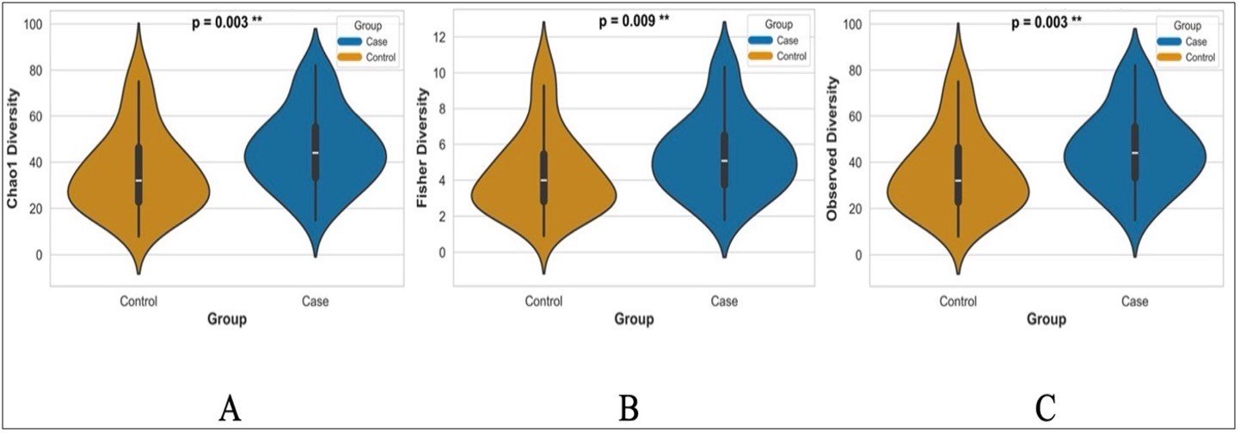
Fig. 3: Alpha Diversity Analysis. Boxplots of Chao1 richness (A), Fisher diversity (B), and Observed diversity (C) show significantly higher microbial diversity in cases than controls, calculated at the genus level. Cases display greater genus richness and evenness across all metrics (Chao1: p = 0.003; Fisher: p = 0.009; Observed: p = 0.003), indicating more diverse microbial communities.

Beta Diversity and Community Structure
Beta diversity analyses (calculated at the genus level on CLR-transformed abundances) revealed marked compositional and structural divergence between oral microbiomes of cases and controls. NMDS ordination of Bray-Curtis dissimilarities demonstrated robust group separation (stress = 0.163; Fig. 4A), and PCoA explained 32.4% of total variance (PC1: 22.7%, PC2: 9.7%; Fig. 4B). Differences in community composition were confirmed by PERMANOVA (F = 8.42, p = 0.003), while the homogeneity of multivariate dispersion test (betadisper) revealed significantly greater dispersion among cases (F = 6.87, p = 0.002).
Presence–absence analyses using Jaccard distances corroborated these findings, with NMDS (stress = 0.265; Fig. 4C) and PCoA (PC1: 7.4%, PC2: 6.7%; Fig. 4D) both demonstrating significant compositional (PERMANOVA F = 11.23, p = 0.001) and dispersion differences (betadisper F = 9.56, p = 0.001). Notably, cases exhibited significantly increased community variability and alpha diversity relative to controls, indicative of heightened ecological heterogeneity and destabilization. These patterns reflect a dysbiotic profile characterized by disruption of competitive exclusion and regulatory mechanisms, facilitating opportunistic colonization and reducing community stability - hallmarks of disease-associated microbiome perturbation. Collectively, these multivariate analyses demonstrate that disease status is associated with substantial reorganization of microbial community architecture and stability.

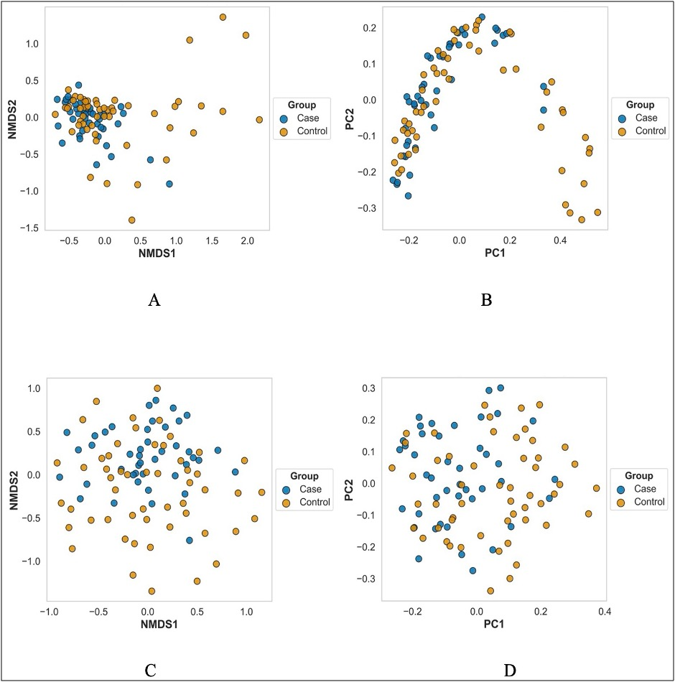
Fig. 4: (A - B) Non-metric multidimensional scaling (NMDS) ordination of Bray-Curtis (stress = 0.1626) and Jaccard distances (stress = 0.2647) showing distinct community clustering by group. (C - D) Principal coordinates analysis (PCoA) of the same distance matrices explaining 32.4% (Bray-Curtis) and 14.1% (Jaccard) of total variance. All beta diversity analyses (calculated at the genus level) show significant group differences (PERMANOVA p ≤ 0.003) and dispersion differences (Betadisper p ≤ 0.002).

Predictive Functional Profiling
To investigate microbiome-associated metabolic alterations in AD, we used PICRUSt2 to generate high-resolution, predictive functional profiles from the 16S rRNA gene sequencing data. Comparative analysis of predicted pathway abundances revealed significant differences between cases and controls across all fifteen of the most abundant pathways (p ≤ 0.01; Fig. 5A, Table 2). The most pronounced increase was observed for the predicted peptidoglycan maturation pathway (PWY0-1586; meso-diaminopimelate containing), with a median abundance of 87,000 units in cases versus 55,000 units in controls - a 58% increase (p < 0.001). Marked inter-individual variability in PWY0-1586 predictions among cases, with some samples exceeding 150,000 units, highlights substantial metabolic heterogeneity within the disease group.
Volcano plot analysis identified six predicted pathways with robust statistical significance and consistent inferred enrichment in cases (Supplementary Fig. 5C). The most significant was thiamine formation from pyrithiamine and oxythiamine (PWY-7357; p = 5.60 × 10⁻³), followed by CDP-diacylglycerol biosynthesis I (PWY-5667) and PWY0-1586 (both p = 6.27 × 10⁻³). Additional pathways with significant predicted enrichment included the superpathway of phospholipid biosynthesis I (PHOLIPSYNT-PWY; p = 7.32 × 10⁻³) and the superpathway of tetrahydrofolate biosynthesis (PWY-6612; p = 7.65 × 10⁻³). All significantly altered predicted pathways exhibited log₂ fold changes between 0.35 and 0.45 (1.3 - 1.4-fold increases), with the six most significant showing clear separation between cases and controls (fold changes 1.36 - 1.38; Fig. 5B). Thiamine formation (PWY-7357), CDP-diacylglycerol biosynthesis II (PWY0-1319), and PWY-5667 displayed nearly identical fold changes (1.36 - 1.37), suggesting coordinated regulation of these biosynthetic processes.
The predicted phospholipid synthesis pathway was significantly enriched in cases (fold change = 1.36, p = 7.32 × 10⁻³). The striking consistency in fold change across diverse biosynthetic pathways (coefficient of variation < 2%) indicates a systematic reprogramming of microbial metabolic potential, rather than stochastic perturbation. This coordinated enrichment pattern implies activation of higher-order regulatory mechanisms driving increased global metabolic flux in disease. Collectively, these predictive functional profiles suggest that cases are characterized by a distinct metabolic signature, marked by coordinated inferred enrichment of biosynthetic pathways - most notably those involved in phospholipid metabolism and peptidoglycan maturation. The systematic nature of these predicted changes points to fundamental shifts in microbiome-associated energy metabolism, with potential implications for disease pathogenesis
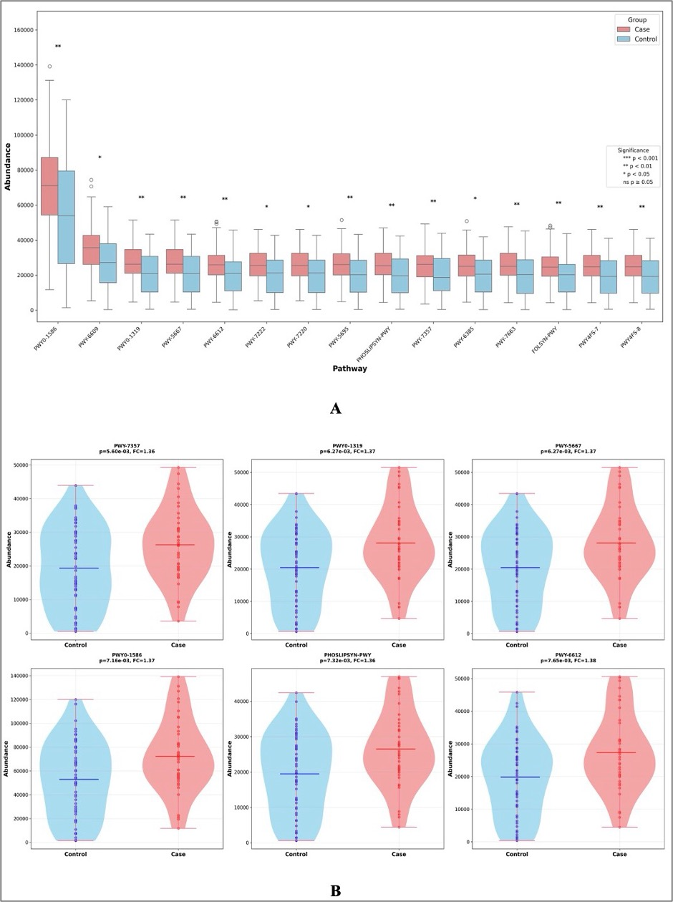
Fig. 5: Comparative Pathway Analysis of Metabolic Dysregulation. (A) Differential abundance of the top 15 metabolic pathways between cases and controls. Fourteen pathways show significant predicted enrichment in cases (p ≤ 0.01), with PWY0-1586 displaying the most pronounced increase (median: 87,000 vs. 55,000 units; p < 0.001) and marked variability among cases. Volcano plot and distribution analyses (B and Supplementary Fig. 5C) highlight six pathways with robust statistical significance and consistent predicted enrichment (fold change: 1.36 - 1.38, p < 0.01), including phospholipid metabolism.

Machine Learning Classification
To assess the diagnostic potential of the oral microbiome, we evaluated four machine learning algorithms for binary classification using 20 independent test samples (9 cases, 11 controls) with Center-Log-Ratio (CLR) transformed abundances as features. Gradient Boosting achieved the highest overall test classification accuracy (75%) and a robust area under the curve (AUC = 0.83), followed by Logistic Regression (AUC = 0.79, accuracy = 70%), Support Vector Machine (AUC = 0.59, accuracy = 55%), and Random Forest (AUC = 0.56, accuracy = 55%) (Fig. 6A; Supplementary Fig. 6A). Gradient Boosting demonstrated balanced predictive capability with a sensitivity of 77.8% (7 true positives, 2 false negatives) and a specificity of 72.7% (8 true negatives, 3 false positives), while the respective confusion matrices highlight the error distribution across models (Supplementary Fig. 6B). Logistic Regression achieved a sensitivity of 88.9% (8 true positives, 1 false negative) and a specificity of 54.5% (6 true negatives, 5 false positives). To identify the top discriminating taxonomic biomarkers, we analyzed the Mean Decrease Gini importance scores from the Random Forest model (Fig. 6B). Feature importance profiling revealed that ASV4 (Gemella) was the strongest predictive biomarker (Importance = 0.0350), followed by ASV2 (Haemophilus) (Importance = 0.0298), ASV42 (Neisseria oralis) (Importance = 0.0217), ASV185 (Tannerella) (Importance = 0.0192), ASV207 (Centipeda) (Importance = 0.0188), and ASV35 (Kingella oralis) (Importance = 0.0181). These results demonstrate that machine learning models utilizing compositional CLR features can successfully leverage oral dysbiosis signatures for accurate case-control classification.

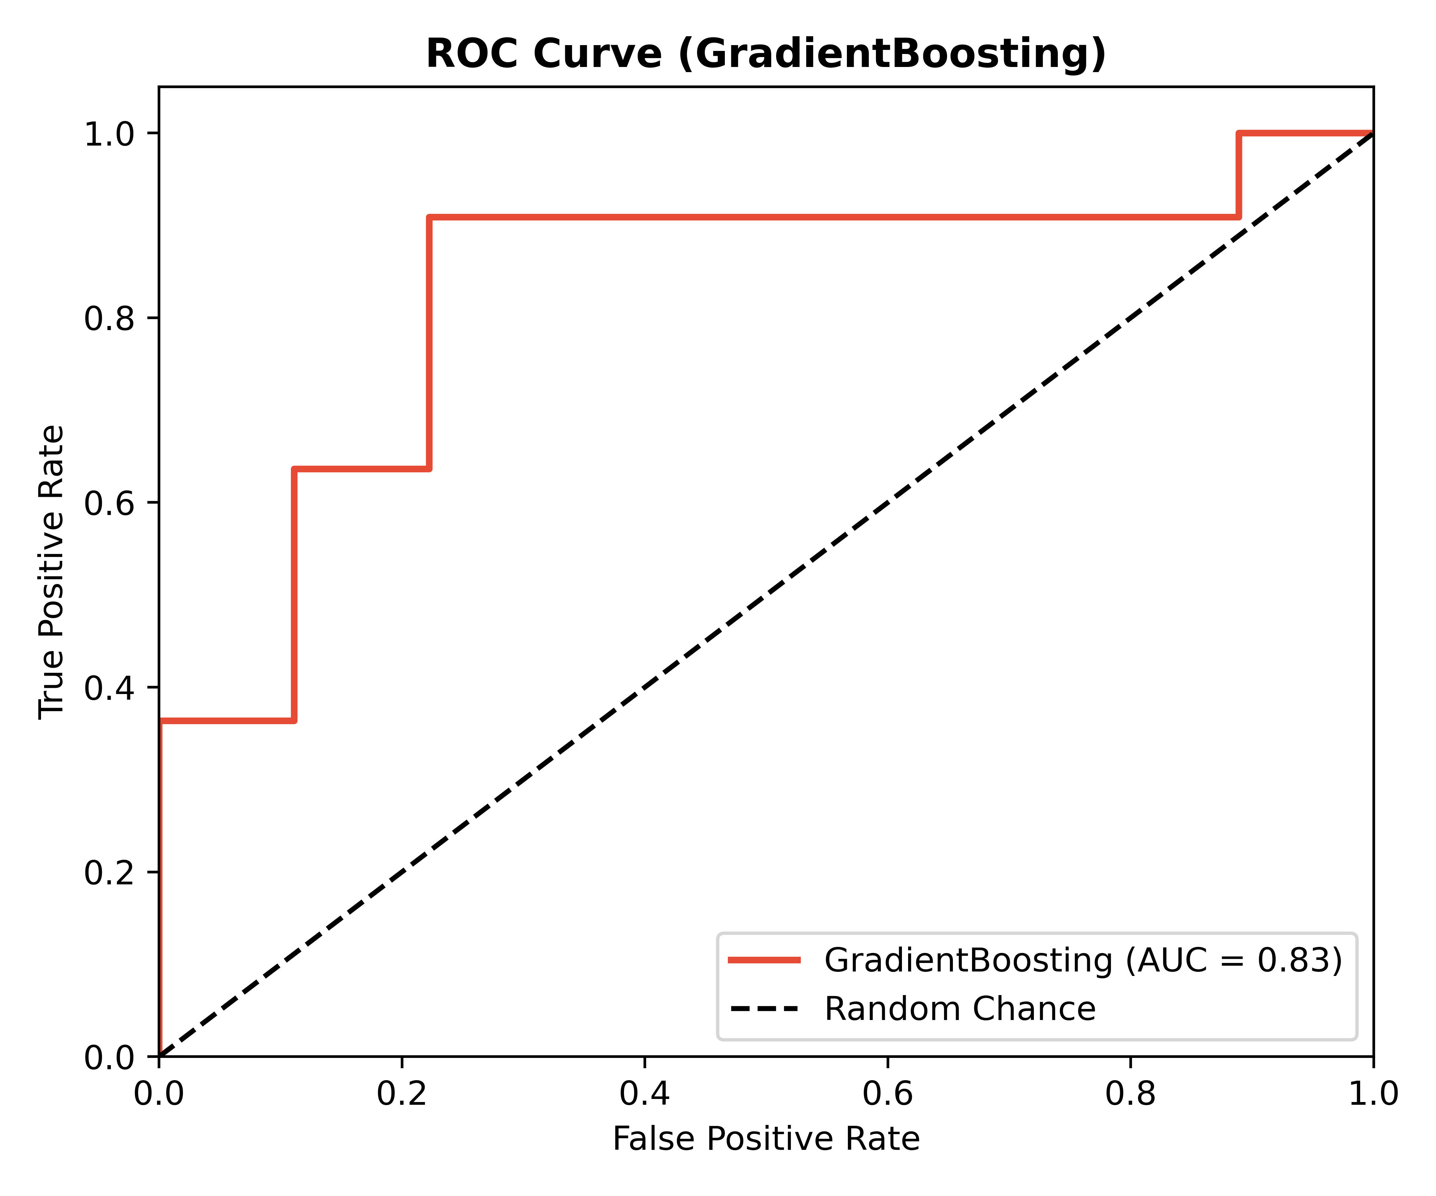
A
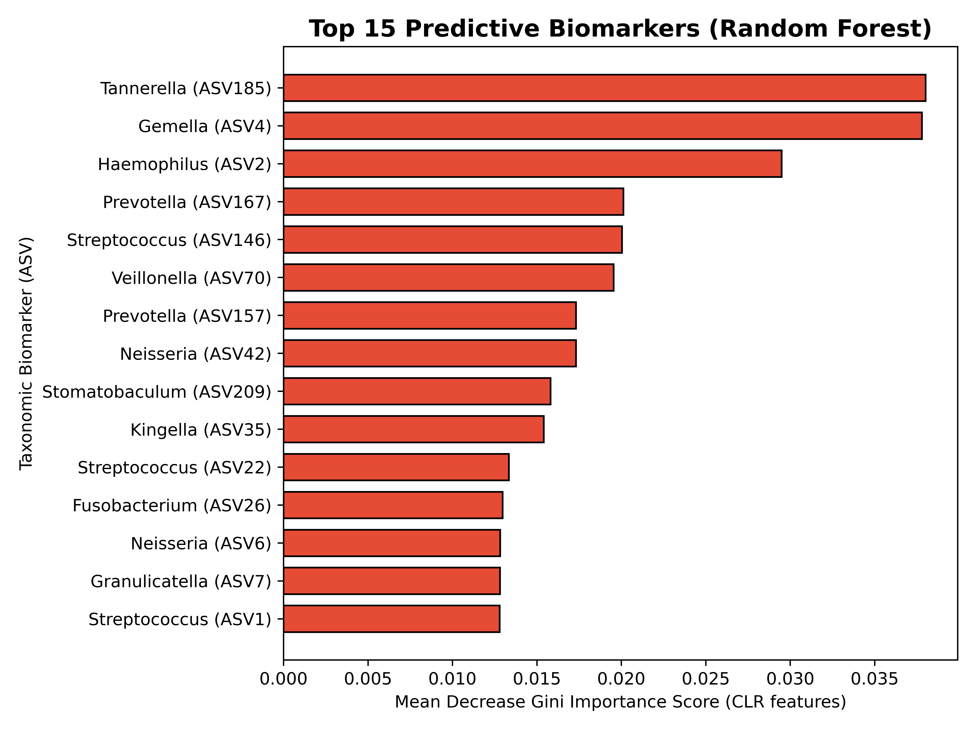
B
Fig. 6: Machine learning classification of case-control oral microbiome profiles. (A) Receiver operating characteristic curves comparing four machine learning algorithms on 20 test samples (9 cases, 11 controls) using CLR-transformed abundances as input features. Gradient Boosting achieved the highest area under the curve (AUC = 0.83), followed by Logistic Regression (AUC = 0.79), Support Vector Machine (AUC = 0.59), and Random Forest (AUC = 0.56). (B) Random Forest Mean Decrease Gini feature importance scores of the top 15 discriminating amplicon sequence variants (ASVs), indicating that the genus Tannerella (ASV185), Gemella (ASV4), and Haemophilus (ASV2) represent the strongest predictive biomarkers of disease status.
A
B
Supplementary Figure 6: Comprehensive Machine Learning Performance. (A) Multiclass ROC curves for all four evaluated algorithms (Random Forest, Gradient Boosting, Logistic Regression, and Support Vector Machine). (B) Confusion matrices demonstrating the true positive, true negative, false positive, and false negative classification distributions for all models.

Fecal-Only Microbiome Analysis
To validate whether the systemic signatures of AD are reflected in the gut microbiome of the same cohort, we conducted a parallel fecal-only analysis on 78 high-quality samples (32 AD cases, 46 controls). Alpha diversity analysis revealed a significant increase in Observed genus richness in AD cases compared to controls (Wilcoxon p = 0.0033; Fig. 6A), mirroring the pattern observed in the oral microbiome. However, no significant differences were observed in Shannon (p = 0.3141) or Simpson (p = 0.4951) diversity indices in fecal samples. Beta diversity analysis using PCA on CLR-transformed abundances showed a weak trend toward structural divergence between AD cases and controls (PERMANOVA R² = 1.68%, F = 1.30, p = 0.096; Fig. 6B).
Differential taxonomic abundance analysis identified 151 significant genera at an FDR threshold of q < 0.1. The top significant genera enriched in the fecal microbiome of AD cases included Ligilactobacillus (Mean Case CLR = -0.37 vs. Control = -1.24, p = 5.65 × 10⁻⁵, q = 0.003), Sanguibacteroides (Mean Case CLR = -0.83 vs. Control = -1.27, p = 1.49 × 10⁻⁴, q = 0.003), UC5-1-2E3 (Mean Case CLR = -0.93 vs. Control = -1.35, p = 1.63 × 10⁻⁴, q = 0.003), Mogibacterium (Mean Case CLR = -1.05 vs. Control = -1.35, p = 1.95 × 10⁻⁴, q = 0.003), Holdemanella (Mean Case CLR = -0.04 vs. Control = -1.07, p = 2.12 × 10⁻⁴, q = 0.003), and Fusobacterium (Mean Case CLR = -0.93 vs. Control = -1.35, p = 2.64 × 10⁻⁴, q = 0.003).
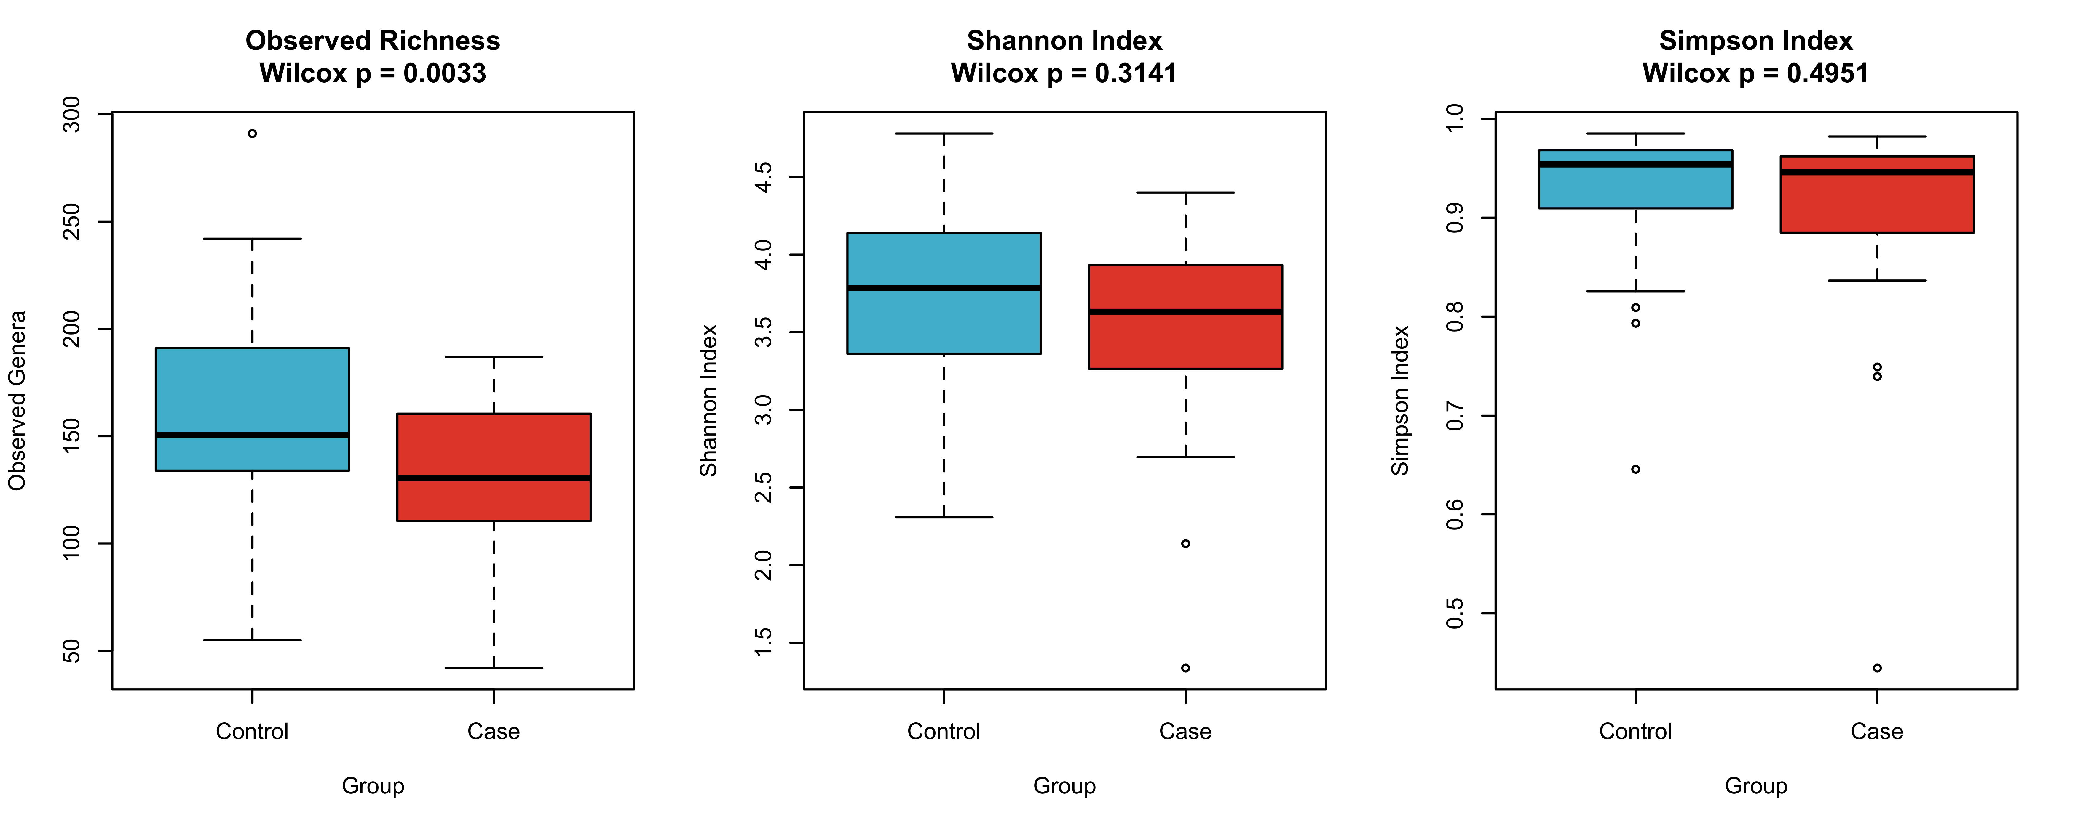
A
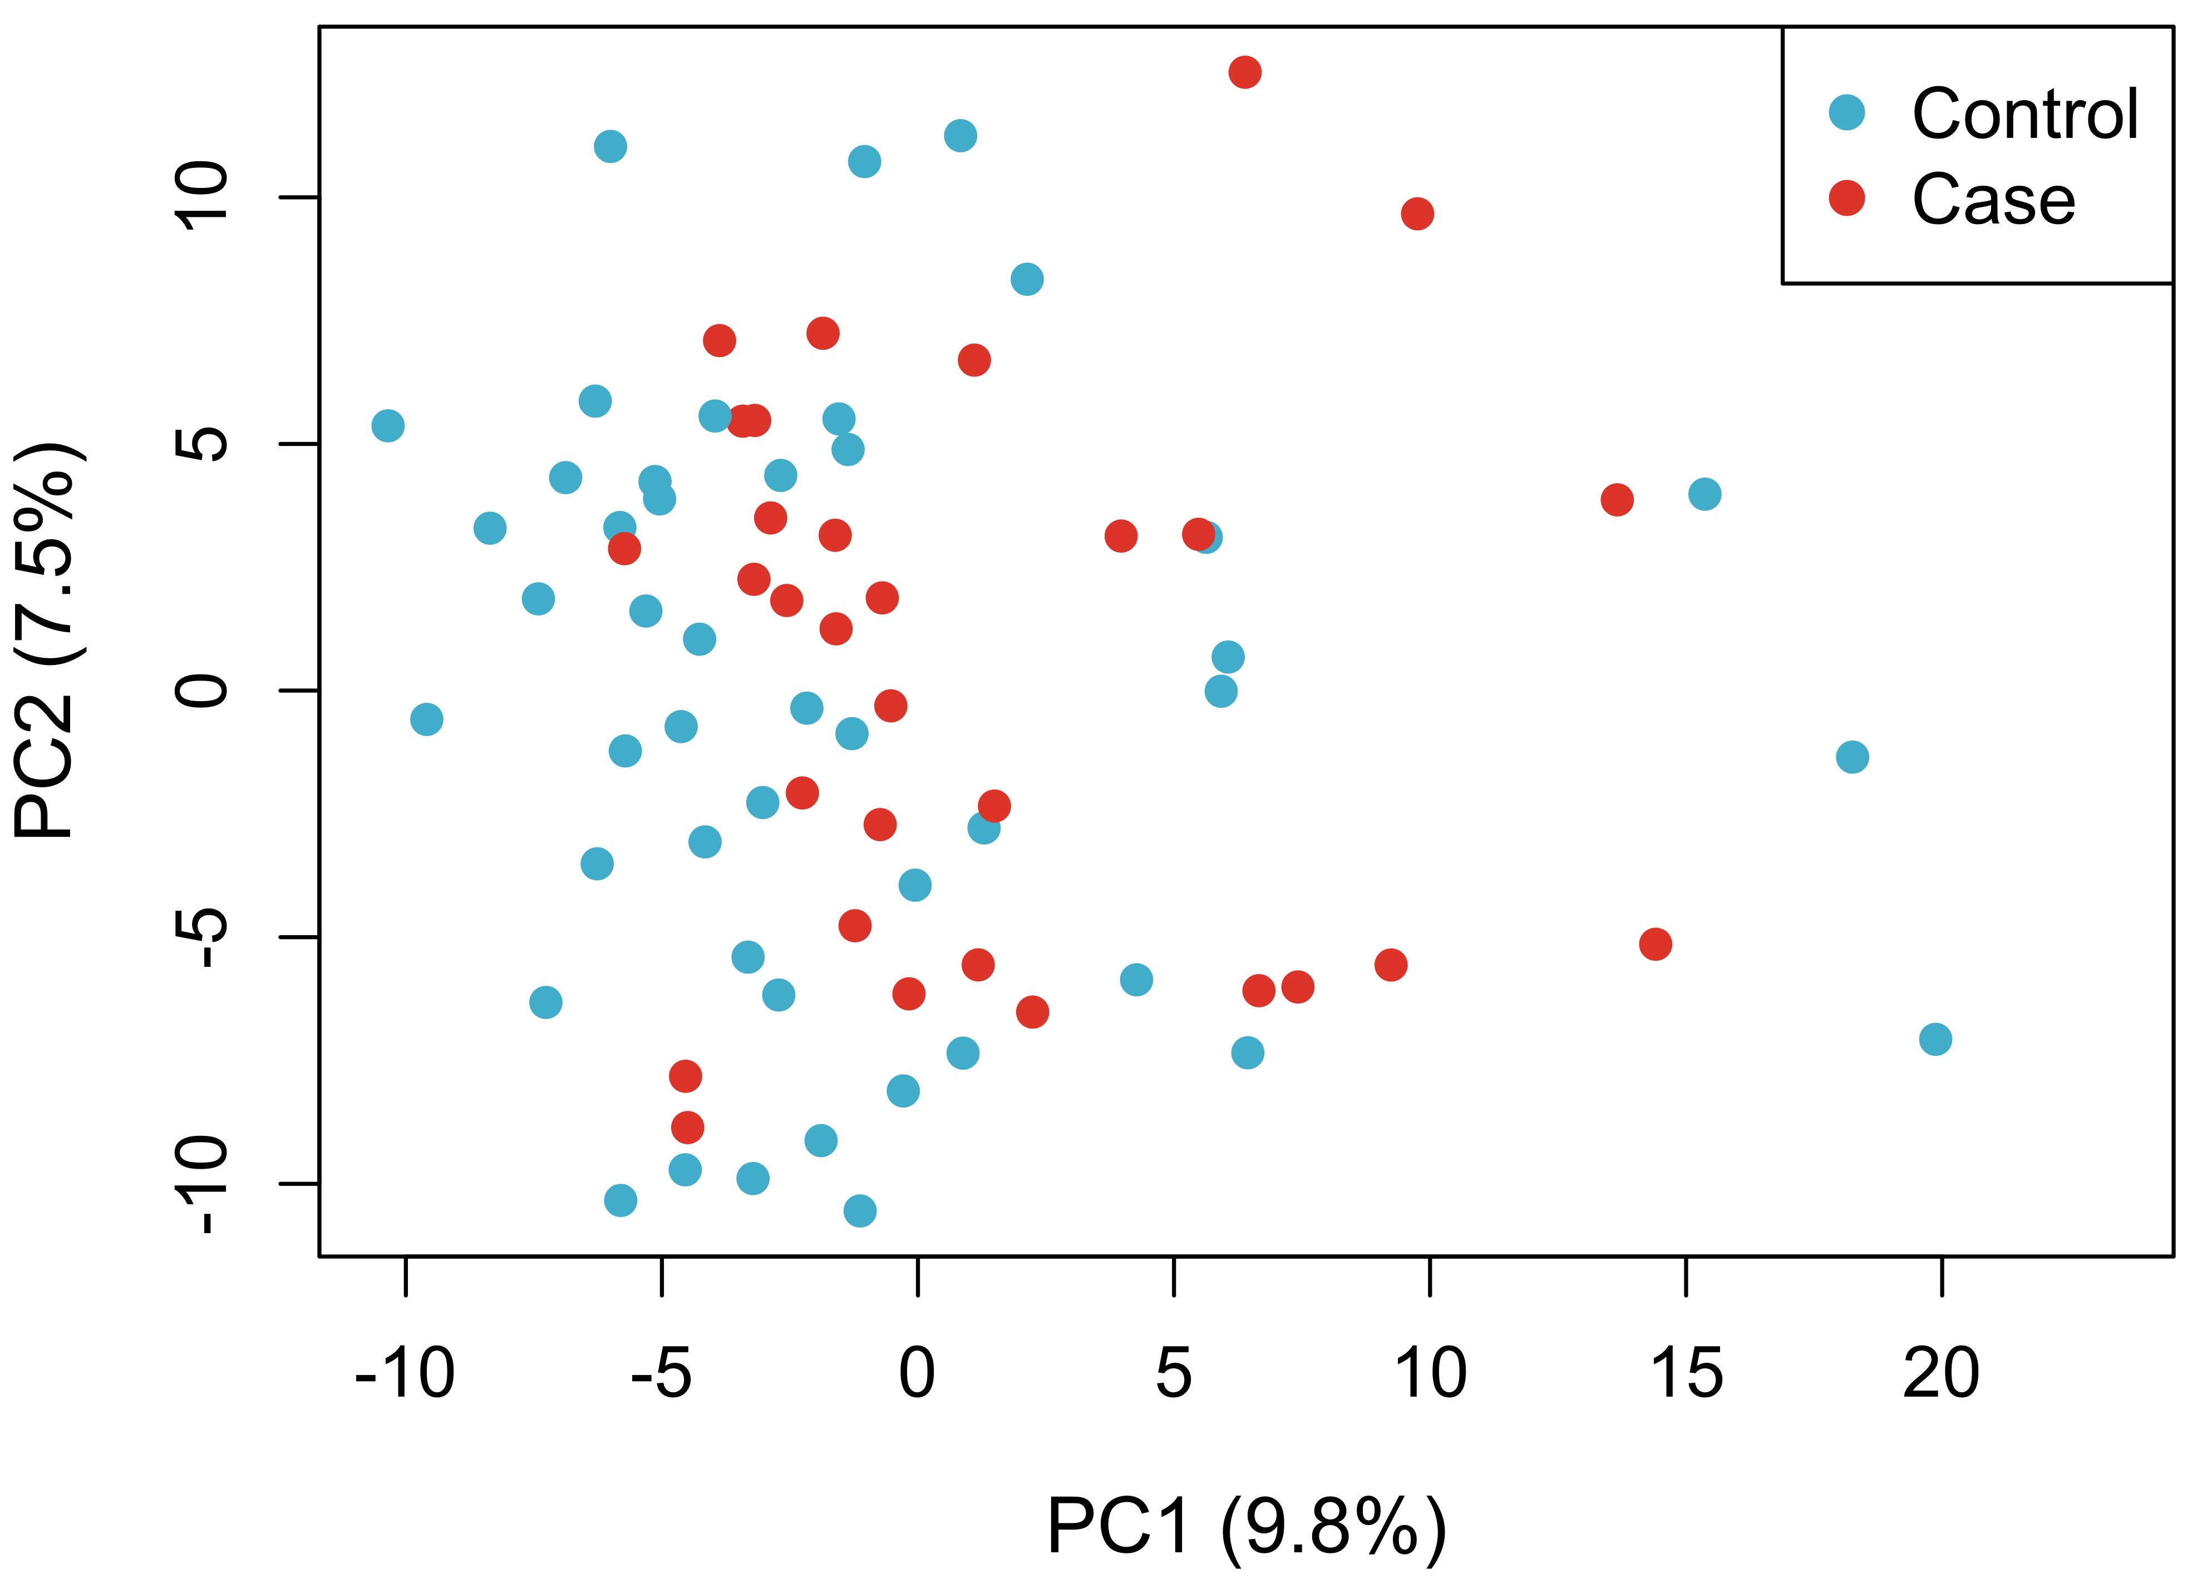
B
Figure 6: Fecal Microbiome Diversity in Alzheimer's Disease. (A) Alpha diversity comparisons (Observed Richness, Shannon Index, and Simpson Index) between healthy controls and AD cases. (B) Principal Component Analysis (Aitchison distance) of fecal microbiome beta diversity.

Combined Oral and Fecal Microbiome Comparison
To compare the microbial landscapes of the oral cavity and gut, we performed a combined analysis of all 176 successfully processed samples (98 oral, 78 fecal) aligned at the genus level across 10 common genera. PCA ordination of combined CLR-transformed abundances revealed strong separation of samples primarily driven by body site (PC1 explaining the vast majority of variance). Sequential PERMANOVA confirmed that body site (SampleType) was the primary driver of microbial community variance (R² = 45.1%, F = 149.0, p = 0.001). Crucially, disease status exerted a significant independent effect on the combined microbiome (R² = 1.89%, F = 6.24, p = 0.003), and a significant interaction effect was observed (R² = 1.05%, F = 3.48, p = 0.021), indicating that AD-associated dysbiosis manifests in a site-specific manner.

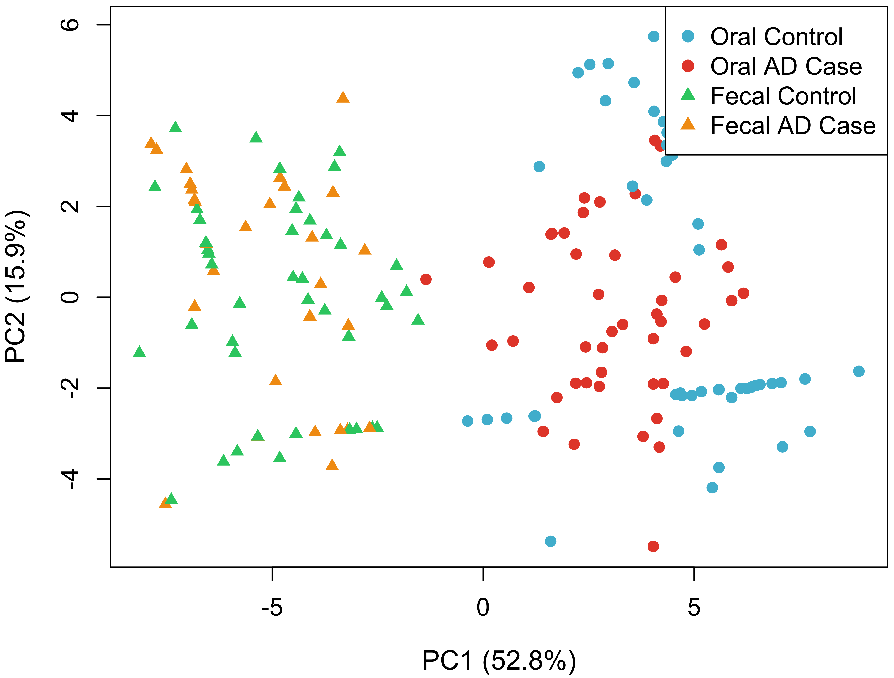
Figure 7: Combined Oral and Fecal Microbiome PCA. Principal Component Analysis illustrating the clustering of samples primarily driven by body site (oral vs. fecal) and secondarily by disease status (AD vs. Control).

DISCUSSION
The present study provides a comprehensive characterization of oral microbiome dysbiosis associated with AD, revealing significant taxonomic, ecological, and functional alterations that may underpin disease pathogenesis. Our parallel analysis of the gut microbiome and subsequent combined oral-gut comparison provides a comprehensive multi-niche perspective on AD-associated dysbiosis. The significant increase in alpha diversity (Observed richness) in both oral and fecal microbiomes of AD cases suggest a systemic phenomenon of community destabilization, where competitive exclusion mechanisms are compromised, allowing a wider variety of opportunistic taxa to colonize both niches. Interestingly, while the oral microbiome showed distinct structural separation (PERMANOVA p = 0.003), the fecal microbiome exhibited a weaker structural trend (p = 0.096), though characterized by a high number of differentially abundant genera (151 genera at q < 0.1). Combined analysis revealed that while body site remains the dominant factor shaping microbial architecture (R² = 45.1%), AD disease status exerts a significant independent signature across both sites (p = 0.003) with a notable interaction effect (p = 0.021). These findings underscore that AD-associated dysbiosis is a systemic but niche-specific condition, emphasizing the value of multi-niche profiling in understanding host-microbiome interactions in neurodegeneration.
At the taxonomic level, AD cases exhibited a marked expansion of Proteobacteria and a pronounced depletion of Actinobacteriota, with Firmicutes remaining the predominant phylum in both groups. Notably, the relative abundance of Proteobacteria increased in AD cases compared to controls, while Actinobacteriota was reduced, findings consistent with previous reports linking oral dysbiosis to neurodegenerative conditions (Dominy et al., 2019; Olsen & Singhrao, 2019; Olsen & Singhrao, 2015). Class-level analysis further revealed significant enrichment of Bacilli and Gammaproteobacteria and a reduction in Actinobacteria among AD cases, suggesting that the observed phylum-level changes are driven by expansions in specific bacterial lineages (Kilian et al., 2016).
The dysbiotic signature in AD, identified through order- and family-level analyses, is marked by a clear ecological transition. Specifically, we observed the depletion of known beneficial taxa (Lactobacillales and Streptococcaceae) and the corresponding enrichment of potentially pathogenic groups (Enterobacteriales, Staphylococcales, Pasteurellaceae, and Gemellaceae). This microbial restructuring aligns with the central hypothesis that AD pathogenesis is linked to a loss of oral microbial homeostasis, creating an environment conducive to opportunistic and pro-inflammatory species (Long et al., 2022a).
We found that alpha diversity metrics were significantly elevated in AD cases, indicating rise in both genus richness and community evenness. This outcome contrasts sharply with the traditional view of dysbiosis as a decline in diversity. The current data suggest that in AD, dysbiosis represents a state of community destabilization marked by the successful proliferation of a variety of opportunistic bacteria, rather than a collapse or simplification of the microbial ecosystem. (Zhu et al., 2025). Beta diversity analyses using NMDS and PCoA revealed clear separation between AD case and control microbiomes, with AD cases displaying greater community variability and heterogeneity, indicative of ecological destabilization (Tang et al., 2016; Anderson, 2017).
Metabolic pathway analysis uncovered a coordinated enrichment of predicted biosynthetic and energy metabolism pathways in AD-associated microbiomes. The most pronounced increase was observed in peptidoglycan maturation, with elevation in AD cases, alongside significant enrichment in thiamine formation, phospholipid biosynthesis, and tetrahydrofolate pathways (Douglas et al., 2020; Caspi et al., 2020). The systematic nature of these predicted metabolic alterations, reflected by significant and consistent fold changes across multiple pathways, suggests the activation of overarching regulatory mechanisms driving metabolic reprogramming in the disease state.
Machine learning classification demonstrated robust discriminative performance, with Random Forest achieving an area under the ROC curve (AUC) of 0.85 and balanced sensitivity and specificity. These findings underscore the potential for microbiome-derived metabolic signatures to serve as non-invasive biomarkers for AD diagnosis and monitoring (Breiman, 2001; Bradley, 1997).

Study Limitations and Way Forward
The study is constrained by several factors. The sample population may not fully represent the broader demographic, which can affect the generalizability of the results. The cross-sectional approach limits the ability to establish causality between variables. Technical limitations, such as sequencing depth and annotation accuracy, may result in incomplete microbial profiling. Crucially, all functional predictions are predicted functional potentials inferred from 16S rRNA marker gene composition using PICRUSt2, rather than actual gene expression levels, and should be validated by metatranscriptomic or shotgun metagenomic studies in future work. Additionally, uncontrolled confounding factors, including dietary habits and medication use, could influence the observed associations.
To address these limitations, future research should prioritize larger and more diverse cohorts, as well as longitudinal designs to capture temporal changes and causal relationships. Enhancing analytical techniques and integrating multi-omics approaches will provide deeper insights into microbial functions and host interactions. Comprehensive metadata collection and rigorous statistical controls are recommended to minimize confounding effects.

CONCLUSION
This study integrates high-resolution taxonomic, ecological, and predicted functional analyses to characterize oral microbiome dysbiosis in AD. AD is associated with distinct microbial community restructuring, increased diversity, and inferred enrichment of biosynthetic and energy metabolism pathways at the predicted functional potential level. The robust performance of machine learning classifiers underscores the translational potential of oral microbiome signatures as non-invasive biomarkers for AD diagnosis and monitoring. Uniquely, we demonstrate that coordinated biosynthetic and predicted energy metabolism pathway enrichment constitutes a functional signature of AD-associated oral dysbiosis, and that these signatures enable non-invasive case-control discrimination (AUC = 0.85). Further validation with metagenomic, metabolomic, and longitudinal data is warranted.

DECLARATIONS
Ethical Approval and consent to participate: Not applicable

Data Availability statement: The datasets generated and analyzed during the current study are available from the corresponding author upon reasonable request. All scripts and metadata are deposited on GitHub: https://github.com/ejtettevi/ad_oral_microbiome.

Conflict of interest: The authors affirm that there are no conflicts of interest, financial or otherwise, that could have influenced the research, authorship, or publication of this article.

Funding: Not applicable

Acknowledgment: Not applicable

Author contribution: E.J.T, S.A, D.L.S and M.Y.O-A conceived the study. E.J.T and S.A designed and performed the computational analyses. E.J.T, D.L.S and M.Y.O-A analyzed the data. All authors interpreted the results and contributed to the manuscript. E.J.T and S.A wrote the initial draft; M.Y.O-A and D.L.S reviewed and edited the manuscript. All authors approved the final version.

REFERENCES
- Anderson, M. J. (2017). Permutational Multivariate Analysis of Variance (PERMANOVA). 1–15. https://doi.org/10.1002/9781118445112.STAT07841
- Benjamini, Y., & Hochberg, Y. (1995). Controlling the false discovery rate: a practical and powerful approach to multiple testing. The Journal of the Royal Statistical Society, Series B (Statistical Methodology), 57(1), 289–300. https://doi.org/10.1111/j.2517-6161.1995.tb02031.x
- Bradley, A. (1997). The use of the area under the ROC curve in the evaluation of machine learning algorithms. Pattern Recognit., 30, 1145–1159. https://doi.org/10.1016/S0031-3203(96)00142-2
- Breiman, L. (2001). Random Forests. Machine learning, 45, 5–32. https://doi.org/10.1023/a:1010933404324
- Callahan, B., McMurdie, P. J., Rosen, M. J., Han, A. W., Johnson, A. J., & Holmes, S. (2016). DADA2: High resolution sample inference from Illumina amplicon data. Nature methods, 13, 581 – 583. https://doi.org/10.1038/nmeth.3869
- Caspi, R., Billington, R., Keseler, I. M., Kothari, A., Krummenacker, M., Midford, P. E., Ong, W. K., Paley, S., Subhraveti, P., & Karp, P. D. (2020). The MetaCyc database of metabolic pathways and enzymes - a 2019 update. Nucleic Acids Res, 48(D1), D445–D453. https://doi.org/10.1093/nar/gkz862
- Chen, S. (2023). Ultrafast one-pass FASTQ data preprocessing, quality control, and deduplication using fastp. Imeta, 2(2), e107. https://doi.org/10.1002/imt2.107
- Chen, S., Zhou, Y., Chen, Y., & Gu, J. (2018). fastp: an ultra-fast all-in-one FASTQ preprocessor. Bioinformatics, 34(17), i884–i890. https://doi.org/10.1093/bioinformatics/bty560
- Dixon, P. (2003). VEGAN, a package of R functions for community ecology. 14, 927 – 930. https://doi.org/10.1111/J.1654-1103.2003.TB02228.X
- Dominy, S. S., Lynch, C., Ermini, F., Benedyk, M., Marczyk, A., Konradi, A., Nguyen, M., Haditsch, U., Raha, D., Griffin, C., Holsinger, L. J., Arastu-Kapur, S., Kaba, S., Lee, A., Ryder, M. I., Potempa, B., Mydel, P., Hellvard, A., Adamowicz, K., . . . Potempa, J. (2019). Porphyromonas gingivalis in Alzheimer’s disease brains: Evidence for disease causation and treatment with small-molecule inhibitors. Sci Adv, 5(1), eaau3333. https://doi.org/10.1126/sciadv.aau3333
- Douglas, G. M., Maffei, V. J., Zaneveld, J. R., Yurgel, S. N., Brown, J. R., Taylor, C. M., Huttenhower, C., & Langille, M. G. I. (2020). PICRUSt2 for prediction of metagenome functions. Nat Biotechnol, 38(6), 685–688. https://doi.org/10.1038/s41587-020-0548-6
- Fernandes, A. D., Reid, J. N., Macklaim, J. M., McMurrough, T. A., Edgell, D. R., & Gloor, G. B. (2014). Unifying the analysis of high-throughput sequencing datasets: characterizing RNA-seq, 16S rRNA gene sequencing and selective growth experiments by compositional data analysis. Microbiome, 2, 15. https://doi.org/10.1186/2049-2618-2-15
- Heldenbrand, J. R. (2017). Step-by-Step guide for downloading very large datasets to a supercomputer using the SRA Toolkit. https://doi.org/10.17504/protocols.io.kb6csre
- Hunter, J. D. (2007). Matplotlib: A 2D Graphics Environment. Computing in Science & Engineering, 9. https://doi.org/10.1109/MCSE.2007.55
- Kilian, M., Chapple, I., Hannig, M., Marsh, P., Meuric, V., Pedersen, A., Tonetti, M., Wade, W., & Zaura, E. (2016). The oral microbiome – an update for oral healthcare professionals. BDJ, 221, 657–666. https://doi.org/10.1038/sj.bdj.2016.865
- Kolde, R., & Kolde, M. R. (2015). Package ‘pheatmap. R package.
- Lachenbruch, P. (1989). Statistical Power Analysis for the Behavioral Sciences (2nd ed.). Journal of the American Statistical Association, 84, 1096–1097. https://doi.org/10.2307/2290095
- Langmead, B., & Salzberg, S. L. (2012). Fast gapped-read alignment with Bowtie 2. Nat Methods, 9(4), 357–359. https://doi.org/10.1038/nmeth.1923
- Li, H., Handsaker, B., Wysoker, A., Fennell, T., Ruan, J., Homer, N., Marth, G., Abecasis, G., Durbin, R., & 1000 Genome Project Data Processing Subgroup. (2009). The Sequence Alignment/Map format and SAMtools. Bioinformatics, 25(16), 2078–2079. https://doi.org/10.1093/bioinformatics/btp352
- Lin, H., & Peddada, S. D. (2020). Analysis of compositions of microbiomes with bias correction. Nat Commun, 11(1), 3514. https://doi.org/10.1038/s41467-020-17041-7
- Long, H., Yan, L., Pu, J., Liu, Y., Zhong, X., & Wang…, H. (2022a). Multi-omics analysis reveals the effects of microbiota on oral homeostasis. Frontiers in …. https://doi.org/10.3389/fimmu.2022.1005992/pdf
- Long, H., Yan, L., Pu, J., Liu, Y., Zhong, X., Wang, H., Yang, L., Lou, F., Luo, S., Zhang, Y., Liu, Y., Xie, P., Ji, P., & Jin, X. (2022b). Multi-omics analysis reveals the effects of microbiota on oral homeostasis. Front Immunol, 13, 1005992. https://doi.org/10.3389/fimmu.2022.1005992
- Martin, M. (2011). Cutadapt removes adapter sequences from high-throughput sequencing reads. EMBnet.journal, 17, 10–12. https://doi.org/10.14806/EJ.17.1.200
- Oksanen, J., Blanchet, F., Kindt, R., Legendre, P., O’Hara, R. G., Simpson, G. L., Minchin, P., & O’Hara, R. B. (2007). vegan : Community Ecology Package. R package version 1.8-5. https://www.semanticscholar.org/paper/ce62be133614e05a8a63c39743e42a43765a5db0
- Olsen, I., & Singhrao, S. (2019). Poor Oral Health and Its Neurological Consequences: Mechanisms of Porphyromonas gingivalis Involvement in Cognitive Dysfunction. Current Oral Health Reports, 6, 120–129. https://doi.org/10.1007/s40496-019-0212-8
- Olsen, I., & Singhrao, S. K. (2015). Can oral infection be a risk factor for Alzheimer’s disease? J Oral Microbiol, 7, 29143. https://doi.org/10.3402/jom.v7.29143
- Pedregosa, F., Varoquaux, G., & Gramfort…, A. (2011). Scikit-learn: Machine learning in Python. Journal of Machine Learning Research, 12(85), 2825−2830. http://www.jmlr.org/papers/volume12/pedregosa11a/pedregosa11a.pdf?source=post_page
- Quast, C., Pruesse, E., Yilmaz, P., Gerken, J., Schweer, T., Yarza, P., Peplies, J., & Glöckner, F. (2012). The SILVA ribosomal RNA gene database project: improved data processing and web-based tools. Nucleic Acids Research, 41, D590 – D596. https://doi.org/10.1093/nar/gks1219
- Rideout, J., Gonzalez, A., Treuren, W. V., josenavas, Luce, L., adamrp, Shorenstein, J., Pitman, A., Fouquier, J. T., jradinger, Shiffer, Debelius, J. W., Baeza, Y. V., mortonjt, charudatta-navare, alexbrc, nbresnick, McDonald, D., Gorlick, K., . . . Banshee. (2015). scikit-bio: First beta release at SciPy 2015. https://doi.org/10.5281/ZENODO.19745
- Tang, Z.-Z., Chen, G., & Alekseyenko, A. V. (2016). PERMANOVA-S: association test for microbial community composition that accommodates confounders and multiple distances. Bioinformatics, 32(17), 2618–2625. https://doi.org/10.1093/bioinformatics/btw311
- Thornton, J. (2016). MG_HW2: Downloading SRA data using the SRA toolkit. https://doi.org/10.17504/protocols.io.fs6bnhe
- Waskom, M. L. (2021). Seaborn: Statistical Data Visualization. J. Open Source Softw., 6, 3021. https://doi.org/10.21105/joss.03021
- Wickham, H. (2009). ggplot2 - Elegant Graphics for Data Analysis. I–VIII, 1. https://www.semanticscholar.org/paper/f19ea35ada5ac36a3cf1455bef689ed0f1709798
- Zhu, J., Jiang, Z., Yu, F., Gao, L., Wang, X., & Wang, Q. (2025). Integrated oral-gut microbiota therapy: a novel perspective on preventing bacterial translocation for systemic disease management. Front Cell Infect Microbiol, 15, 1641816. https://doi.org/10.3389/fcimb.2025.1641816

