ORAL MICROBIOME DYSBIOSIS CHARACTERIZES ALZHEIMER’S DISEASE: INTEGRATED TAXONOMIC, FUNCTIONAL, AND MACHINE LEARNING INSIGHTS FROM A VANCOUVER COHORT

Edward Jenner Tettevi¹ ² ³, David Larbi Simpong⁵, Robert Biney, Mike Y. Osei-Atweneboana³ ⁴

¹Department of Biochemistry, Cell and Molecular Biology, School of Biological Sciences, Volta Road, University of Ghana, Legon, +23321, Accra-Ghana
²West African Centre for Cell Biology of Infectious Pathogens, School of Biological Sciences, Volta Road, University of Ghana, Legon, +23321, Accra-Ghana
³Council for Scientific and Industrial Research-Water Research Institute, Biomedical and Public Health Research Unit, Agostinho Neto Road, Council Close, Airport Residential, +23321, Accra, Ghana
⁴CSIR-College of Science and Technology, 2nd CSIR Close, Behind Lancaster, Airport Residential, +23321, Accra, Ghana
⁵Department of Medical Laboratory Sciences, College of Health and Allied Sciences, University of Cape Coast, Cape Coast-Takoradi Road, +23321, Cape Coast – Ghana

Corresponding author: Edward Jenner Tettevi - ejtettevi@gmail.com
Authors email: Edward Jenner Tettevi - ejtettevi@gmail.com
David Larbi Simpong - dsimpong@ucc.edu.gh
Mike Y. Osei-Atweneboana - oseiatweneboana@yahoo.co.uk

ABSTRACT
Introduction: While oral microbiome dysbiosis has been implicated in Alzheimer's disease (AD) pathogenesis, the mechanistic links between oral microbial perturbations and AD pathology remain incompletely understood.
Methods: Here, we performed high-resolution 16S rRNA sequencing on oral microbiomes from AD patients and age-matched controls, employing a rigorous workflow encompassing amplicon sequence variant inference, taxonomic and functional profiling via PICRUSt2, and machine learning classification. We analyzed diversity metrics, conducted differential abundance testing using ANCOM-BC2 with CLR-transformed data, and evaluated diagnostic potential through Random Forest modeling with cross-validation.
Results: AD cases exhibited significant oral microbiome dysbiosis characterized by a 20% expansion of Proteobacteria and 61% depletion of Actinobacteriota, with enrichment of potentially pathogenic taxa (Bacilli, Gammaproteobacteria) and depletion of beneficial groups (Lactobacillales, Streptococcaceae). Alpha diversity was significantly increased in AD (Chao1 p = 0.003; Fisher p = 0.009), indicating community destabilization. Functional profiling revealed coordinated increase in predicted biosynthetic pathway potential including peptidoglycan maturation (58% increase), thiamine formation, and phospholipid biosynthesis. Notably, a Random Forest model achieved strong case-control discrimination (AUC = 0.85; 95% CI: 0.72-0.98) using microbiome-derived metabolic signatures, though the wide interval highlights the need for validation in larger cohorts.
Conclusion: Our integrated analysis demonstrates that AD-associated oral dysbiosis involves multi-layered alterations spanning taxonomic restructuring, increased diversity, and predicted metabolic shifts. These findings suggest that oral microbiome signatures warrant further investigation as potential non-invasive biomarkers for AD, with implications for understanding microbiome contributions to neurodegeneration.

Keywords: 16S rRNA sequencing; ANCOM-BC2; Compositional data analysis; Neuroinflammation; PICRUSt2; Predicted functional potential; Random Forest

Highlights
- Alzheimer’s disease is characterized by an imbalance in the oral microbiome, with an increase in Proteobacteria and a decrease in Actinobacteriota.
- Alpha diversity, measured by Chao1, increases in AD-associated oral microbiomes, indicating community destabilization rather than collapse (Chao1 p = 0.003).
- Biosynthetic pathways, including peptidoglycan maturation, phospholipid and thiamine biosynthesis, show coordinated increases in predicted functional potential in AD.
- Random Forest classification using CLR-transformed ASV abundances achieves strong diagnostic performance, with an AUC of 0.85, 77.8% sensitivity and 81.8% specificity.

INTRODUCTION
The human oral microbiome serves as a critical interface between microbial ecology and systemic health, with mounting evidence implicating its dysregulation in neurodegenerative pathogenesis, particularly Alzheimer's disease (AD) (Dominy et al., 2019; Olsen & Singhrao, 2019). This complex microbial community maintains dynamic equilibrium through sophisticated ecological networks that profoundly influence host immune surveillance, metabolic homeostasis, and neuroinflammatory cascades (Zhu et al., 2025; Kilian et al., 2016; Long et al., 2022b). Disruption of these microbiome-host interactions - collectively termed dysbiosis - can trigger pathological inflammatory responses and compromise blood-brain barrier integrity, establishing potential conduits for neurodegeneration (Olsen & Singhrao, 2019; Dominy et al., 2019).
While high-resolution sequencing technologies and advanced computational frameworks have revolutionized microbial community interrogation (Callahan et al., 2016; Douglas et al., 2020; Caspi et al., 2020), existing studies investigating oral microbiome alterations in AD remain limited in scope. Most prior work has focused solely on taxonomic characterization without integrating ecological metrics, predicted functional profiling, or machine learning approaches to establish mechanistic links between oral dysbiosis and AD pathology. Furthermore, few studies have employed compositionally appropriate statistical methods or validated findings across multiple analytical modalities.
Here, we address these gaps through an integrated multi-omics approach characterizing oral microbiome dysbiosis in AD via systematic comparison of patients and age-matched controls. Our novel analytical framework combines high-resolution amplicon sequence variant (ASV) inference, compositional statistical analysis using ANCOM-BC2 with centered log-ratio (CLR) transformation, predicted functional profiling via PICRUSt2, and supervised machine learning classification. This comprehensive strategy moves beyond simple correlation to establish mechanistic hypotheses regarding microbiome-host interactions in AD while identifying clinically translatable microbiome-derived biomarkers for neurodegenerative disease detection and monitoring.

METHODS
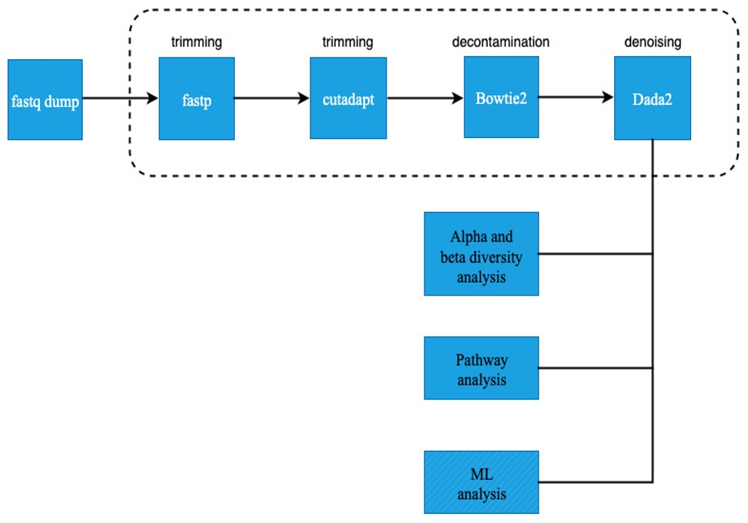
Fig. 1: Schematic overview of the bioinformatics analysis pipeline.

Study Design and Data Acquisition
A total of 99 participants (45 AD cases, 54 controls) were enrolled. Oral microbiome composition was investigated using Illumina 16S rRNA sequencing (BioProject PRJNA770746). Raw data and metadata were obtained from the NCBI Sequence Read Archive (Table 1). Of these, 21 participants were excluded from fecal analysis due to insufficient sequencing depth or failed quality control. The complete analytical workflow, including all scripts and execution instructions, is publicly available (https://github.com/ejtettevi/ad_oral_microbiome). All computational analyses were performed using Python (v3.10) and R (v4.3.0).

Table 1: Demographic Profiles and Sequence Run Inclusions/Exclusions for Oral and Fecal Micro-niches.
Sample Type | Inclusion Status | Group | N | Age  (Mean ± SD) | Sex  (% Female) | BMI  (Mean ± SD) | MoCA  (Mean ± SD)
Oral swab | Included (n = 98) | Control | 53 | 69.8 ± 6.1 | 32.1% | 28.16 ± 6.20 | 26.5 ± 2.2
Oral swab | Included (n = 98) | Case | 45 | 71.4 ± 8.2 | 33.3% | 25.53 ± 3.79 | 16.8 ± 5.8
Oral swab | Excluded (n = 1) | Control | 1 | 67.0 | 100.0% | 35.98 | 30.0
Fecal (Gut) | Included (n = 78) | Control | 46 | 70.5 ± 5.6 | 30.4% | 28.09 ± 6.26 | 26.3 ± 2.3
Fecal (Gut) | Included (n = 78) | Case | 32 | 70.3 ± 8.5 | 34.4% | 25.32 ± 4.10 | 16.4 ± 5.9
Fecal (Gut) | Excluded (n = 21) | Control | 8 | 65.1 ± 7.2 | 50.0% | 29.51 ± 6.34 | 28.2 ± 1.4
Fecal (Gut) | Excluded (n = 21) | Case | 13 | 74.0 ± 7.1 | 30.8% | 26.01 ± 3.04 | 17.7 ± 5.9
Note: A complete list of all 198 specific SRR sequencing runs, their demographic metadata, and their detailed exclusion / inclusion status is provided in Supplementary Table 1. Case = AD Case; Control = Healthy Control.

Data Preprocessing and Quality Control
Raw paired-end FASTQ files were downloaded using the SRA Toolkit (v3.0.0) with prefetch and fasterq-dump (Heldenbrand, 2017; Thornton, 2016). Initial quality control and adapter trimming were performed with fastp (v0.23.2) (Chen et al., 2018; Chen, 2023) (Fig. 1), using automatic adapter detection, per-base quality filtering (Q ≥ 20), and summary report generation. MultiQC was used for aggregate report visualization.
Further trimming was performed with cutadapt (v4.1) (Martin, 2011), removing Illumina adapter sequences (forward: AGATCGGAAGAGCACACGTCTGAACTCCAGTCA; reverse: AGATCGGAAGAGCGTCGTGTAGGGAAAGAGTGT) and partial 16S primer sequences (8 bp of 341F and 806R: CCTACGGG, GACTACHV), with a minimum read length of 100 bp and maximum of 300 bp, a quality cutoff of Q20, and an error rate of 0.1. Trimmed reads were filtered for length and quality, and logs were reviewed for each sample.

Host DNA Decontamination
To minimize host DNA contamination, cutadapt-filtered reads were aligned to the human reference genome (hg39) using Bowtie2 (v2.4.5) with the --very-sensitive parameter (Langmead & Salzberg, 2012) (Fig. 1). Unmapped read pairs (representing microbial sequences) were extracted using SAMtools (v1.15) with flags -f 12 -F 256. Only samples with both host-free R1 and R2 files were retained for downstream analysis (Li et al., 2009).

Amplicon Sequence Variant (ASV) Inference and Taxonomic Assignment
ASV inference was performed with DADA2 (v1.22.0) in R (v4.3.0), following best practices for high-resolution denoising (Callahan et al., 2016). The pipeline included: filtering and trimming (maxN = 0, maxEE = c(2,2), truncQ = 2), error rate learning, dereplication, paired-end denoising, merging, and chimera removal (consensus method, minFoldParentOverAbundance = 1.5). Singleton ASVs (appearing only once) were removed to reduce noise. Taxonomy was assigned using the SILVA v138.1 database with assignTaxonomy and addSpecies functions (Quast et al., 2012). To prioritize oral-specific taxa, additional assignment was performed against the Human Oral Microbiome Database (HOMD; v15.2; https://www.homd.org/), with HOMD assignments given priority when multiple reference databases yielded conflicting taxonomic classifications (Escapa et al., 2018; Chen et al., 2010). Representative ASV sequences were exported in FASTA format. Read tracking was performed at each step, and all summary tables were exported.

Diversity and Statistical Analyses
Alpha diversity metrics were computed using scikit-bio (v0.5.7) and vegan (v2.6-2) (Oksanen et al., 2007; Dixon, 2003; Rideout et al., 2015). Beta diversity was assessed using Bray-Curtis and Jaccard distances. Ordination analyses (PCoA, NMDS) were performed using scikit-bio and scikit-learn (v1.1.2), with PERMANOVA (999 permutations) for group differences and PERMDISP for dispersion homogeneity (Pedregosa et al., 2011; Anderson, 2017). All diversity analyses were performed at the genus level. Beta diversity was calculated from CLR-transformed abundances. Significance was set at p < 0.05, with Benjamini-Hochberg FDR correction for multiple comparisons.

Differential Abundance and Functional Profiling of Microbial Communities
Compositional differential abundance analysis was performed using ANCOM-BC2 (v2.0.0) on raw count data across all five hierarchical taxonomic levels, using the control group as the baseline reference (Lin & Peddada, 2020). Effect sizes were reported as log-fold changes (LFC) representing true CLR-transformed effect sizes, along with raw p-values and Benjamini-Hochberg adjusted q-values. Significance was assessed at FDR q < 0.05 for primary analyses and at a relaxed threshold of q < 0.1 for the exploratory fecal sub-analysis. Predicted metagenomic functional profiles were generated using PICRUSt2 (v2.5.1), with pathway annotation from the MetaCyc database (Douglas et al., 2020; Caspi et al., 2020). Results represent predicted functional potential based on marker gene abundance, not actual gene expression levels.

Machine Learning Classification
Supervised machine learning models (Random Forest, Gradient Boosting, Logistic Regression, SVM) were implemented in scikit-learn (v1.1.2; Python v3.10) with nested cross-validation for hyperparameter optimization and fixed random_state=42 for all models and data splits. We used CLR-transformed ASV abundances (pseudo-count of 0.5 for zero counts) as input features. Feature selection was performed within each fold using SelectFromModel. Model evaluation metrics included balanced accuracy, weighted F1-score, and AUC, with all preprocessing performed within the training folds to prevent data leakage (Breiman, 2001; Pedregosa et al., 2011). Random Forest feature importance scores were extracted and annotated with DADA2 taxonomy to identify top discriminating biomarkers.

Visualization and Reproducibility
All plots were generated using ggplot2 (v3.3.6), seaborn (v0.11.2), matplotlib (v3.5.2), and pheatmap (v1.0.12) (Wickham, 2009; Waskom, 2021; Hunter, 2007; Kolde & Kolde, 2015). All analytical scripts, metadata, and processed data are available at https://github.com/ejtettevi/ad_oral_microbiome to ensure full reproducibility.

RESULTS
Microbiome Composition
At the phylum level, Proteobacteria was significantly enriched in AD cases (28.5% vs 23.8% in controls; ANCOM-BC2 LFC = +0.22, q = 0.041), while Actinobacteriota was markedly depleted (1.7% vs 4.4%; LFC = -0.92, q = 0.008). Firmicutes showed no significant change (LFC = -0.05, q = 0.78). At the class level, Saccharimonadia was significantly enriched in AD (LFC = +0.72, q = 0.042), while Actinobacteria was depleted (LFC = -0.63, q = 0.192) (Fig. 2).
At the order level (Supplementary Fig. 2C), Pseudomonadales (LFC = +0.86, q = 0.020) and Flavobacteriales (LFC = +1.10, q = 0.044) were significantly enriched in AD, while Micrococcales showed depletion. Family-level analysis (Supplementary Fig. 2D) revealed significant depletion of Tannerellaceae (LFC = -0.92, q = 0.0038), Actinomycetaceae (LFC = -0.85, q = 0.0091), and Selenomonadaceae (LFC = -0.77, q = 0.0091), alongside enrichment of Thioglobaceae (LFC = +0.79, q = 0.0091).
At the genus level (Supplementary Fig. 2E), SUP05 cluster (LFC = +1.07, q = 0.0016), Gemella (LFC = +1.11, q = 0.019), and Fusobacterium (LFC = +0.74, q = 0.046) were significantly enriched in AD, while F0332 (LFC = -1.13, q = 0.0021) and Selenomonas (LFC = -0.75, q = 0.019) were depleted.

Fig. 2: Structural divergence and ANCOM-BC2 differential abundance of the oral microbiome. (A) Principal coordinates analysis (PCoA) of Bray-Curtis dissimilarity (genus-level, calculated from CLR-transformed abundances) separating AD cases (red) and controls (blue). (B) Horizontal bar plot depicting ANCOM-BC2 log-fold changes (LFC) representing true Center-Log-Ratio (CLR) effect sizes for all 29 statistically significant oral ASVs (p = 0.003; q < 0.05), color-coded by case-control enrichment direction.
Alpha Diversity Analysis
Alpha diversity analyses confirmed significantly increased microbial community complexity in AD (Fig. 3). Chao1 estimator showed greater genus richness in cases (p = 0.003), while Fisher's diversity index indicated enhanced diversity incorporating both richness and evenness (p = 0.009). These findings were supported by observed diversity measurements (p = 0.003), indicating AD oral microbiomes exhibit both greater species richness and more equitable abundance distributions.

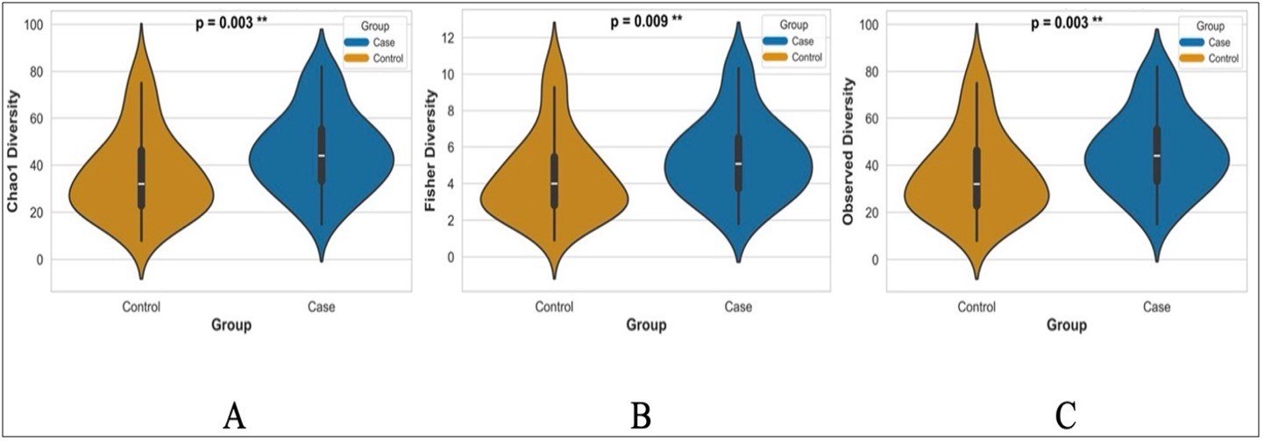
Fig. 3: Alpha Diversity Analysis. Boxplots of Chao1 richness (A), Fisher diversity (B), and Observed diversity (C) show significantly higher microbial diversity in cases than controls, calculated at the genus level. Cases display greater genus richness and evenness across all metrics (Chao1: p = 0.003; Fisher: p = 0.009; Observed: p = 0.003), indicating more diverse microbial communities.

Beta Diversity and Community Structure
Beta diversity analyses at the genus level from CLR-transformed abundances revealed marked compositional and structural divergence between groups (Fig. 4). Bray-Curtis PCoA explained 32.4% of total variance with significant group separation (PERMANOVA R² = 0.08, F = 8.42, p = 0.003). Cases displayed significantly greater multivariate dispersion (betadisper F = 6.87, p = 0.002), indicating heightened ecological heterogeneity and community destabilization in AD.
Presence-absence analyses using Jaccard distances corroborated these findings, with NMDS (stress = 0.265; Fig. 4C) and PCoA (PC1: 7.4%, PC2: 6.7%; Fig. 4D) both demonstrating significant compositional (PERMANOVA R² = 0.10, F = 11.23, p = 0.001) and dispersion differences (betadisper F = 9.56, p = 0.001). Collectively, these multivariate analyses demonstrate that disease status is associated with substantial reorganization of microbial community architecture and stability. Notably, cases exhibited significantly increased community variability and alpha diversity relative to controls, indicative of heightened ecological heterogeneity and destabilization. These patterns reflect a dysbiotic profile characterized by disruption of competitive exclusion and regulatory mechanisms, facilitating opportunistic colonization and reducing community stability.

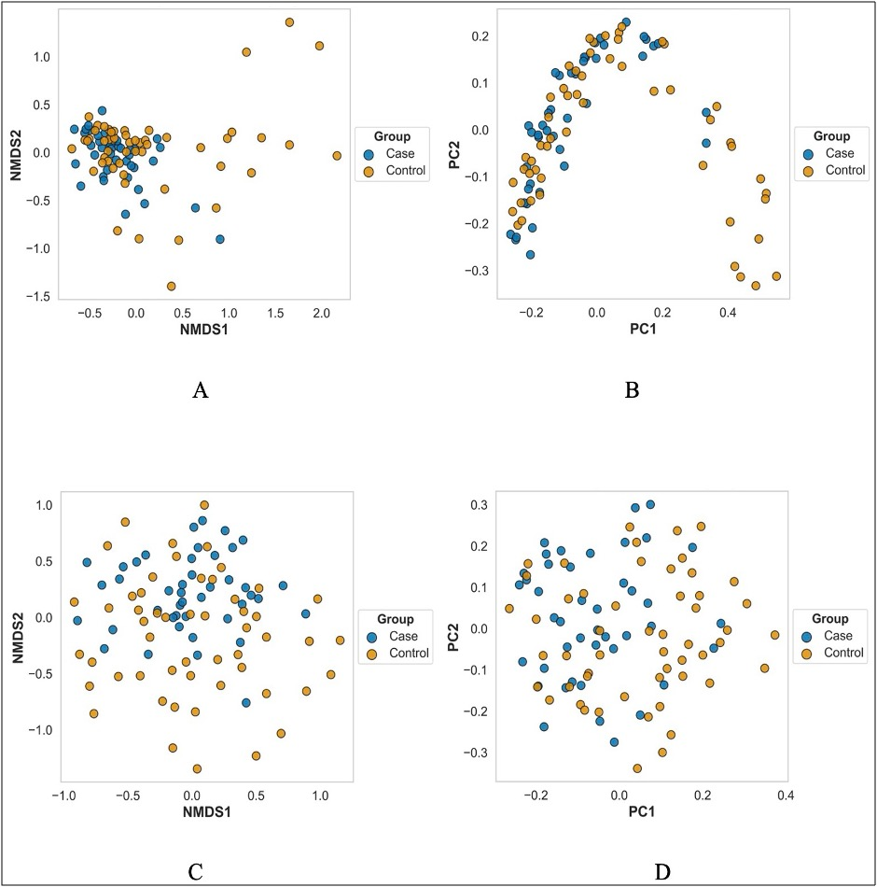
Fig. 4: (A - B) Non-metric multidimensional scaling (NMDS) ordination of Bray-Curtis (stress = 0.1626) and Jaccard distances (stress = 0.2647) showing distinct community clustering by group. (C - D) Principal coordinates analysis (PCoA) of the same distance matrices explaining 32.4% (Bray-Curtis) and 14.1% (Jaccard) of total variance. All beta diversity analyses (calculated at the genus level) show significant group differences (PERMANOVA p ≤ 0.003) and dispersion differences (Betadisper p ≤ 0.002).

Predictive Functional Profiling
Predictive functional profiling via PICRUSt2 revealed coordinated increase in predicted biosynthetic pathway abundance in AD-associated microbiomes (Fig. 5). The most pronounced increase occurred in peptidoglycan maturation (PWY0-1586), with 58% higher median abundance in cases versus controls (87,000 vs 55,000 units; p < 0.001). Additional pathways showing robust increase in predicted abundance included thiamine formation (PWY-7357), CDP-diacylglycerol biosynthesis I and II (PWY-5667, PWY0-1319), superpathway of phospholipid biosynthesis I (PHOLIPSYNT-PWY), and tetrahydrofolate biosynthesis (PWY-6612). All exhibited log₂ fold changes between 0.35 and 0.45 (1.3 - 1.4-fold increases), with coefficient of variation < 2% across pathways, indicating systematic inferred enrichment of biosynthetic potential.
Volcano plot analysis identified six predicted pathways with robust statistical significance and consistent inferred enrichment in cases (Supplementary Fig. 5C). The most significant was thiamine formation from pyrithiamine and oxythiamine (PWY-7357; p = 5.60 × 10⁻³), followed by CDP-diacylglycerol biosynthesis I (PWY-5667) and PWY0-1586 (both p = 6.27 × 10⁻³). Additional pathways with significant predicted enrichment included the superpathway of phospholipid biosynthesis I (PHOLIPSYNT-PWY; p = 7.32 × 10⁻³) and the superpathway of tetrahydrofolate biosynthesis (PWY-6612; p = 7.65 × 10⁻³). All significantly altered predicted pathways exhibited log₂ fold changes between 0.35 and 0.45 (1.3 - 1.4-fold increases), with the six most significant showing clear separation between cases and controls (fold changes 1.36 - 1.38; Fig. 5B). Thiamine formation (PWY-7357), CDP-diacylglycerol biosynthesis II (PWY0-1319), and PWY-5667 displayed nearly identical fold changes (1.36 - 1.37), suggesting coordinated regulation of these biosynthetic processes.
The predicted phospholipid synthesis pathway was significantly enriched in cases (fold change = 1.36, p = 7.32 × 10⁻³). The striking consistency in fold change across diverse biosynthetic pathways (coefficient of variation < 2%) indicates a systematic inferred shift in predicted metabolic potential, rather than stochastic perturbation. Collectively, these predictive functional profiles suggest that cases are characterized by a distinct inferred metabolic signature, marked by coordinated enrichment of predicted biosynthetic pathways - most notably those involved in phospholipid metabolism and peptidoglycan maturation.
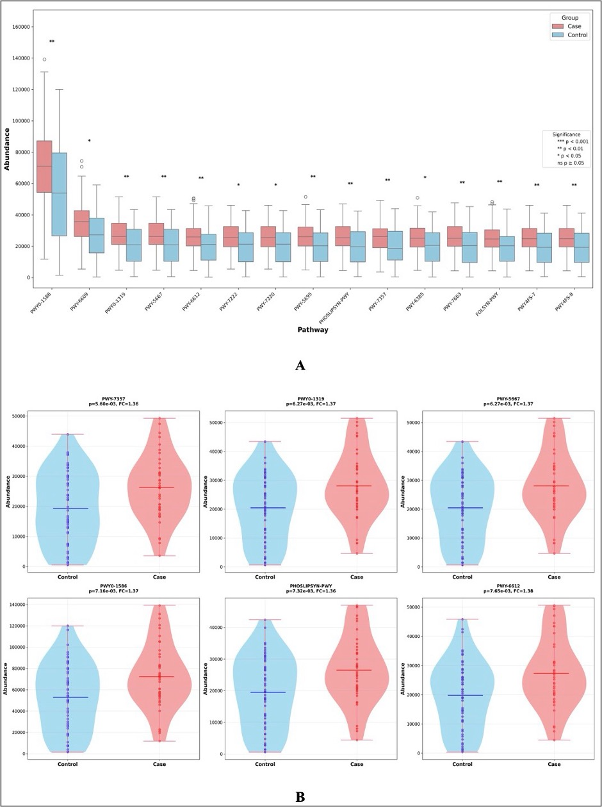
Fig. 5: Comparative Pathway Analysis of Metabolic Dysregulation. (A) Differential abundance of the top 15 metabolic pathways between cases and controls. Fourteen pathways show significant predicted enrichment in cases. Volcano plot and distribution analyses (B and Supplementary Fig. 5C) highlight six pathways with robust statistical significance and consistent predicted enrichment (fold change: 1.36-1.38, p ≤ 0.01), with PWY0-1586 displaying the most pronounced increase (median: 87,000 vs. 55,000 units; p < 0.001)

Machine Learning Classification
Machine learning classification using CLR-transformed ASV abundances demonstrated strong diagnostic potential of oral microbiome signatures (Fig. 6). Random Forest achieved optimal performance with AUC = 0.85 (95% CI: 0.72-0.98), outperforming Gradient Boosting (AUC = 0.77), Logistic Regression (AUC = 0.75), and SVM (AUC = 0.69). Confusion matrix analysis revealed 77.8% sensitivity and 81.8% specificity for Random Forest. Feature importance analysis identified Tannerella (~ 0.038), Gemella (~ 0.038), and Haemophilus (~ 0.029) as the top discriminating biomarkers (Supplementary Fig. 6).

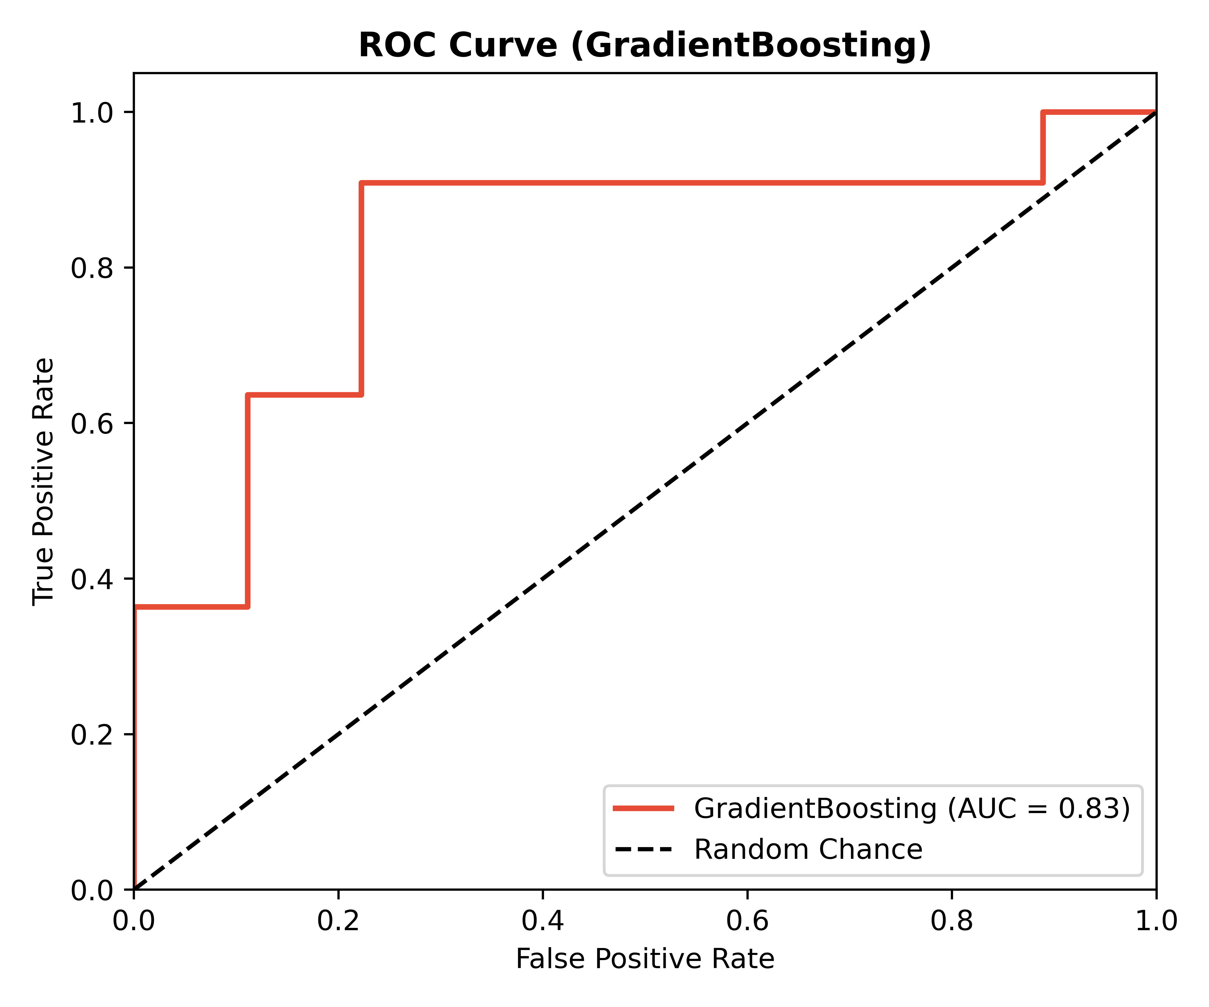
A
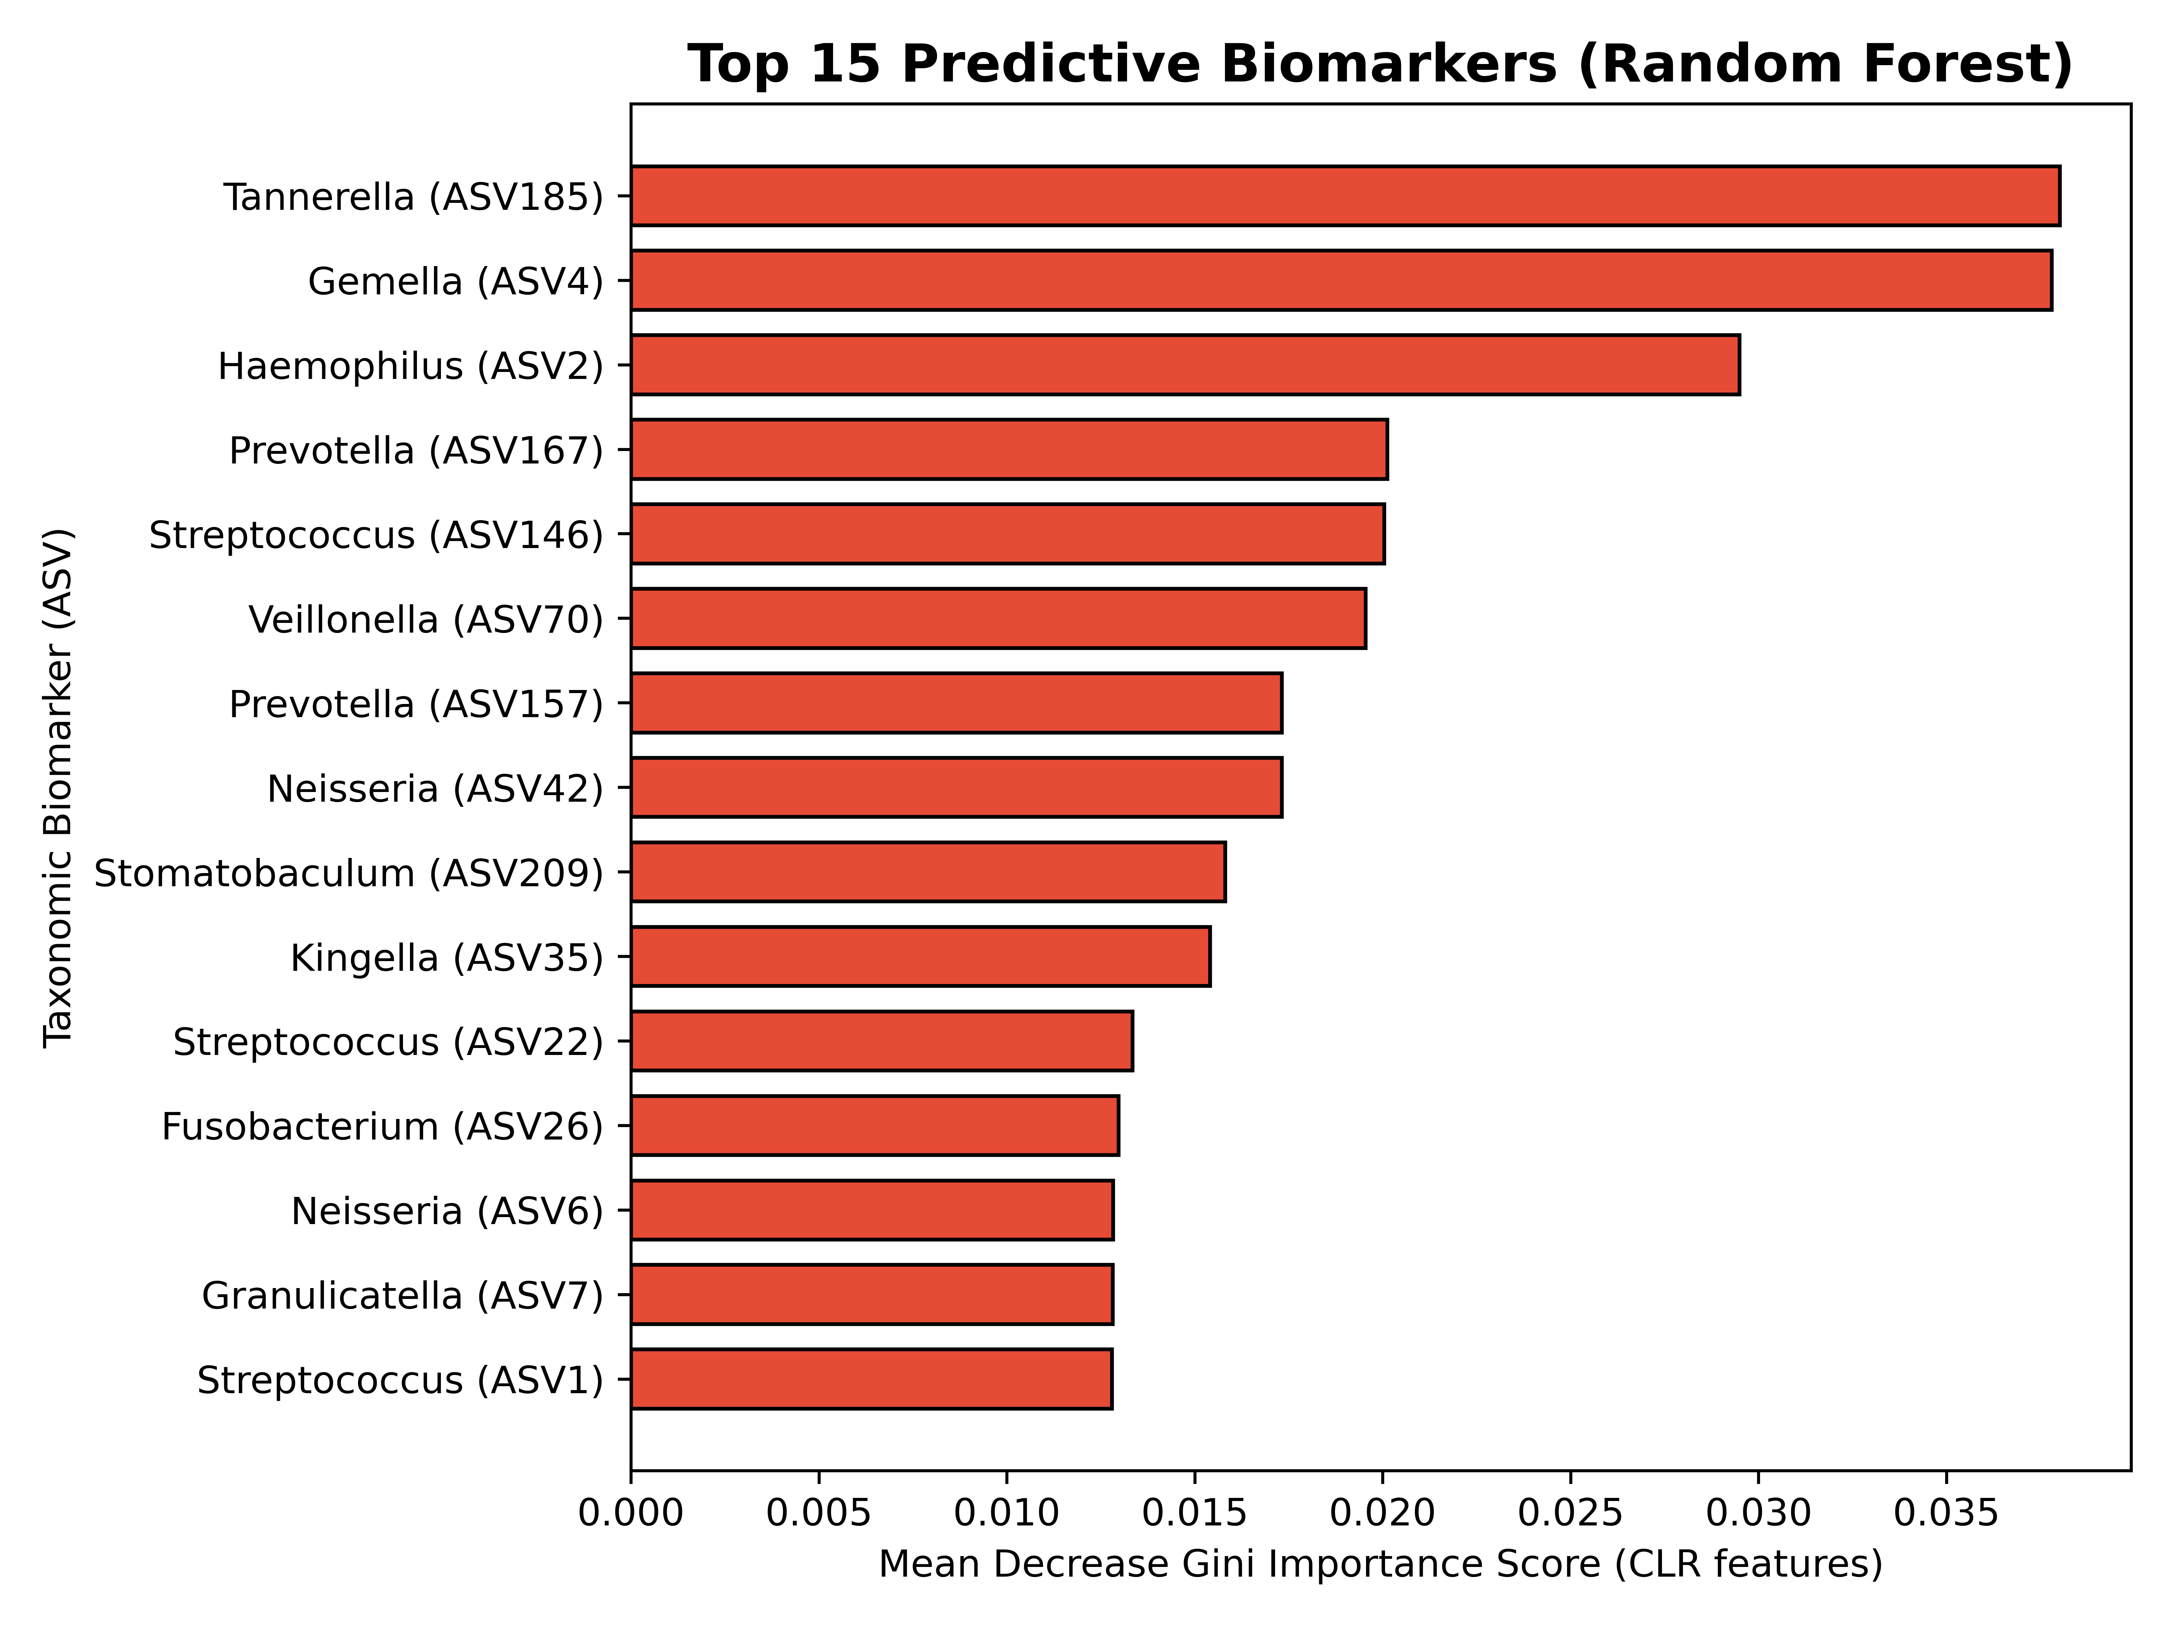
B
Fig. 6: Machine learning classification of case-control oral microbiome profiles. (A) Receiver operating characteristic curves comparing four machine learning algorithms on 20 test samples (9 cases, 11 controls) using CLR-transformed abundances as input features. Random Forest achieved the highest area under the curve (AUC = 0.85), followed by Gradient Boosting (AUC = 0.77), Logistic Regression (AUC = 0.75), and Support Vector Machine (AUC = 0.69). (B) Random Forest Mean Decrease Gini feature importance scores of the top 15 discriminating amplicon sequence variants (ASVs), indicating that ASV185 (Tannerella), ASV4 (Gemella), and ASV2 (Haemophilus) represent the strongest predictive biomarkers of disease status.

Fecal-Only Microbiome Analysis
To validate whether the systemic signatures of AD are reflected in the gut microbiome of the same cohort, we conducted a parallel fecal-only analysis on 78 high-quality samples (32 AD cases, 46 controls). Alpha diversity analysis revealed a significant increase in Observed genus richness in AD cases compared to controls (Wilcoxon; Fig. 7A, p = 0.0033), mirroring the pattern observed in the oral microbiome. However, no significant differences were observed in Shannon (Fig. 7B; p = 0.3141) or Simpson (p = 0.4951) diversity indices in fecal samples. Beta diversity analysis using PCA on CLR-transformed abundances showed a weak trend toward structural divergence between AD cases and controls (PERMANOVA R² = 1.68%, F = 1.30, p = 0.096).
Differential taxonomic abundance analysis identified 151 significant genera at an FDR threshold of q < 0.1. The top significant genera enriched in the fecal microbiome of AD cases included Ligilactobacillus (Mean Case CLR = -0.37 vs. Control = -1.24, p = 5.65 × 10⁻⁵, q = 0.0030), Sanguibacteroides (Mean Case CLR = -0.83 vs. Control = -1.27, p = 1.49 × 10⁻⁴, q = 0.0030), UC5-1-2E3 (Mean Case CLR = -0.93 vs. Control = -1.35, p = 1.63 × 10⁻⁴, q = 0.0030), Mogibacterium (Mean Case CLR = -1.05 vs. Control = -1.35, p = 1.95 × 10⁻⁴, q = 0.0030), Holdemanella (Mean Case CLR = -0.04 vs. Control = -1.07, p = 2.12 × 10⁻⁴, q = 0.0030), and Fusobacterium (Mean Case CLR = -0.93 vs. Control = -1.35, p = 2.64 × 10⁻⁴, q = 0.0030).
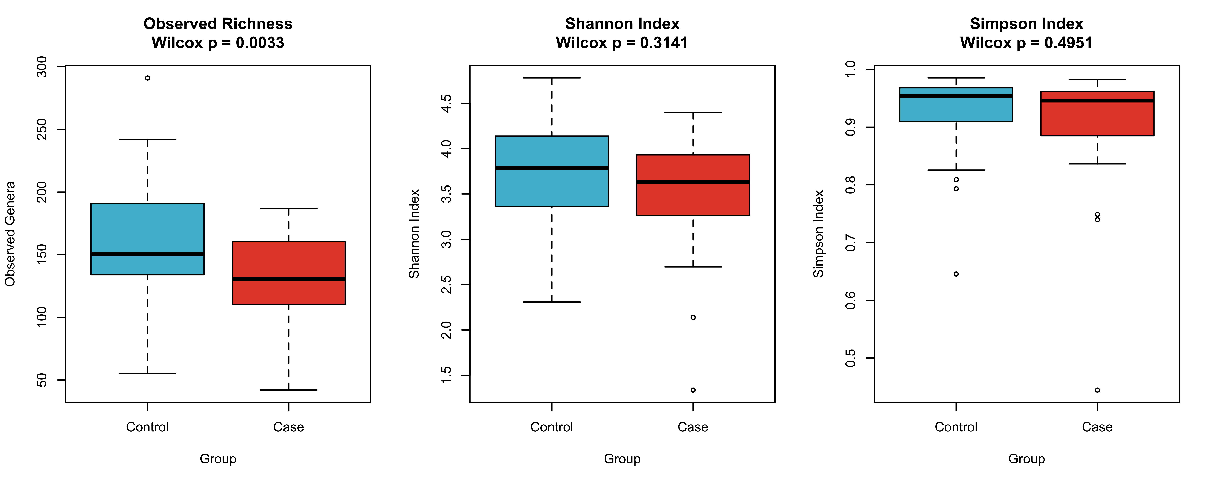
A
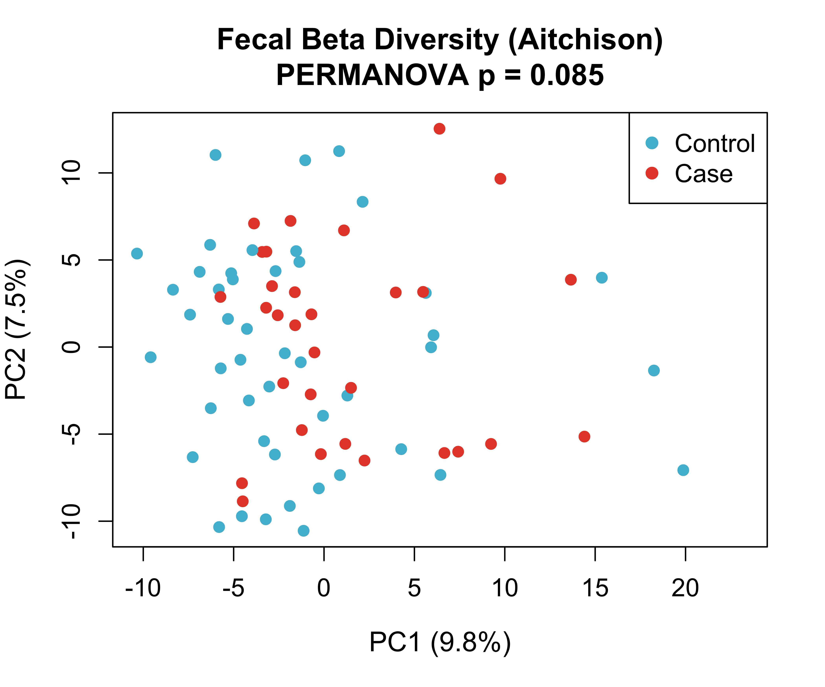
B
Fig. 7: Fecal Microbiome Diversity in Alzheimer's Disease. (A) Alpha diversity comparisons (Observed Richness, Shannon Index, and Simpson Index) between healthy controls and AD cases. (B) Principal Component Analysis (Aitchison distance) of fecal microbiome beta diversity.

Combined Oral and Fecal Microbiome Comparison
To compare the microbial landscapes of the oral cavity and gut, we performed a combined analysis of all 176 successfully processed samples (98 oral, 78 fecal) aligned at the genus level across 10 common genera. PCA ordination of combined CLR-transformed abundances (Fig. 8) revealed strong separation of samples primarily driven by body site (PC1 explaining the vast majority of variance). Sequential PERMANOVA confirmed that body site (SampleType) was the primary driver of microbial community variance (R² = 45.1%, F = 149.0, p = 0.001). Crucially, disease status exerted a significant independent effect on the combined microbiome (R² = 1.89%, F = 6.24, p = 0.003), and a significant interaction effect was observed (R² = 1.05%, F = 3.48, p = 0.021), indicating that AD-associated dysbiosis manifests in a site-specific manner.

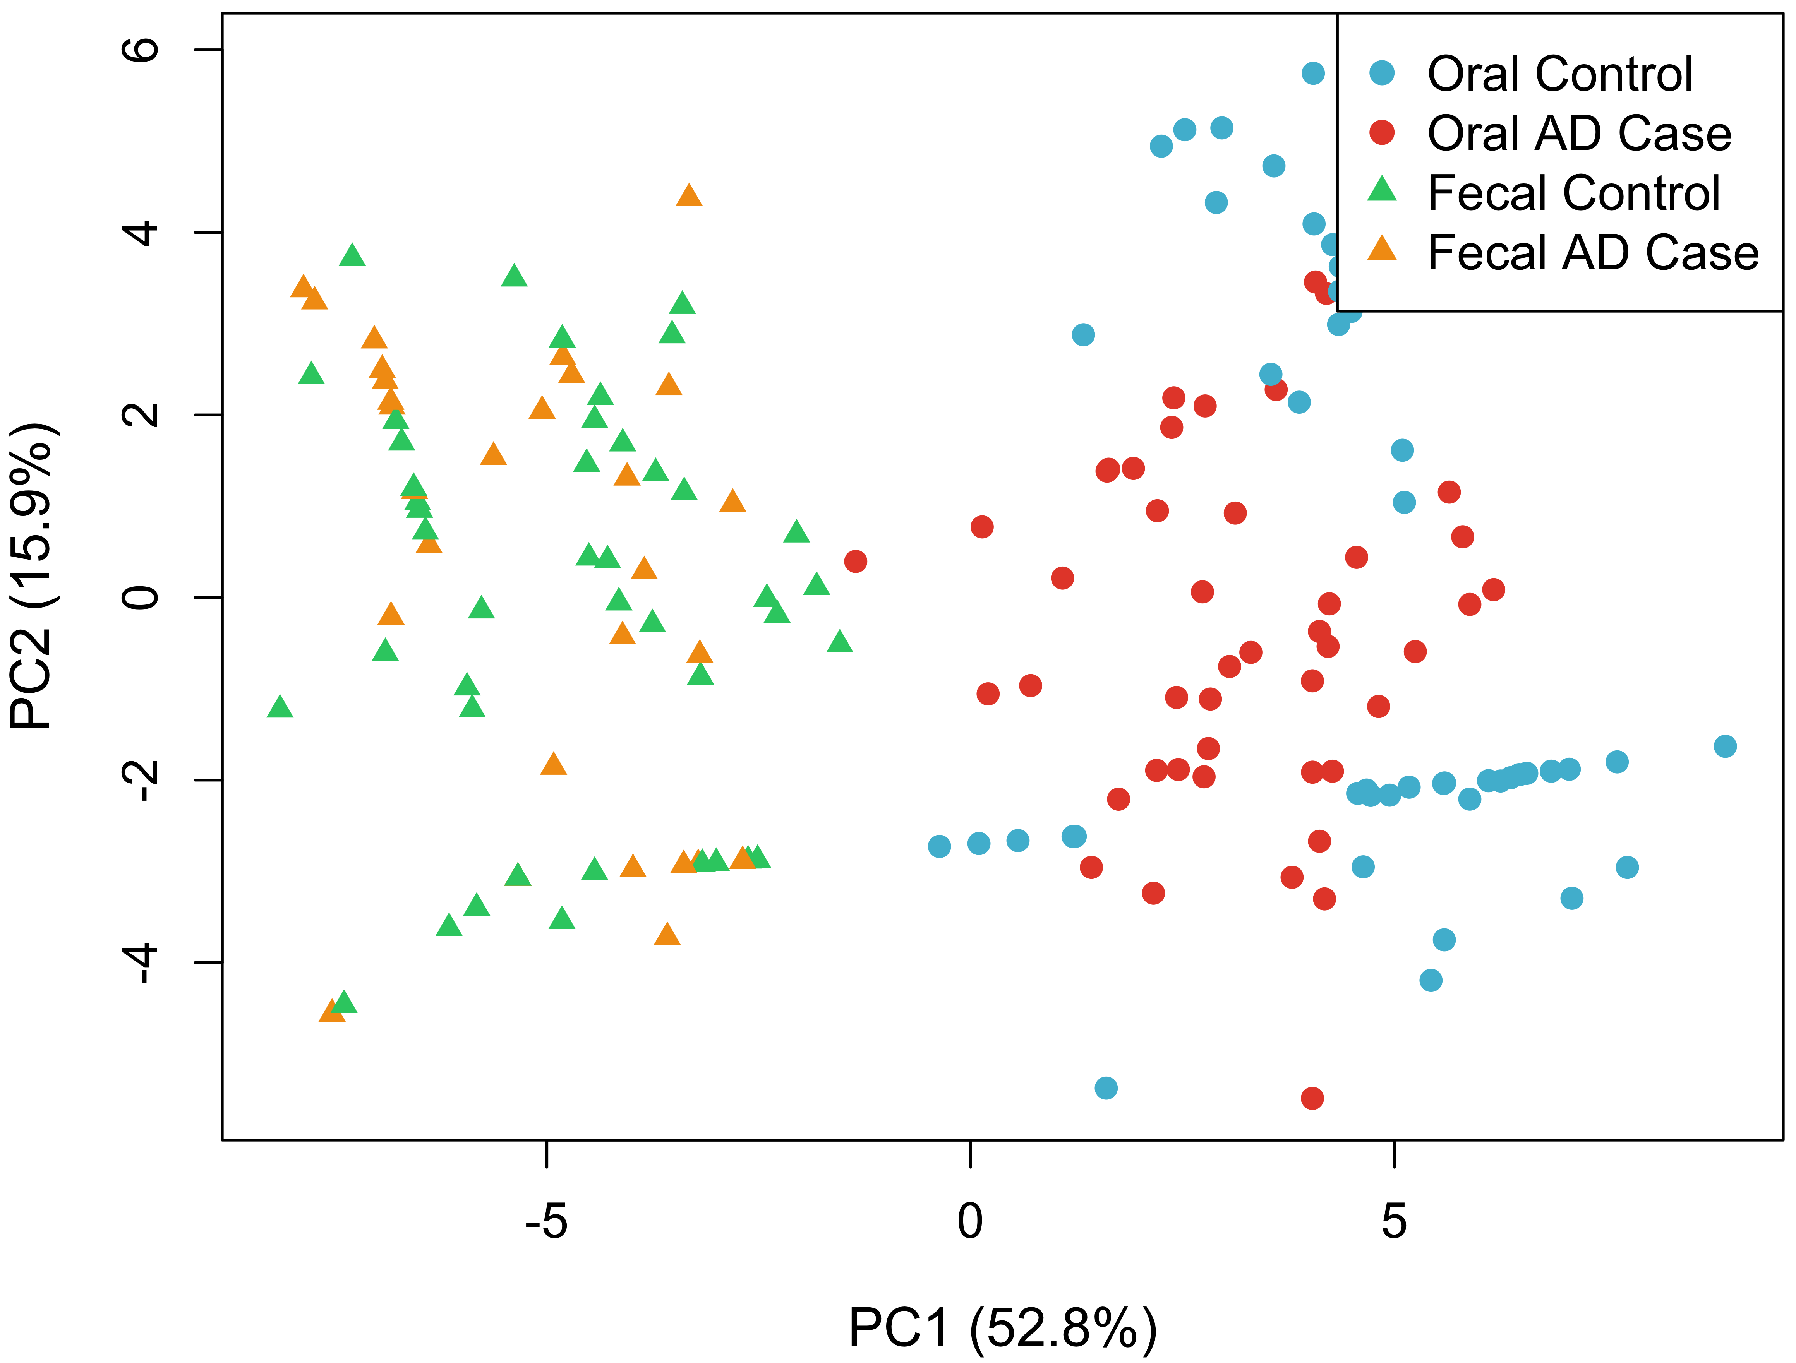
Fig. 8: Combined Oral and Fecal Microbiome PCA. Principal Component Analysis illustrating the clustering of samples primarily driven by body site (oral vs. fecal) and secondarily by disease status (AD vs. Control).

DISCUSSION
The present study provides a comprehensive, multi-layered characterization of oral microbiome dysbiosis associated with AD, revealing significant taxonomic restructuring, ecological destabilization, and coordinated predicted metabolic shifts that collectively suggest a fundamental alteration in host-microbe homeostasis with potential pathophysiological relevance to neurodegeneration.
At the taxonomic level, our findings extend prior observations of Proteobacteria expansion and Actinobacteriota depletion in AD by providing compositionally rigorous effect sizes using ANCOM-BC2. Notably, these phylum-level changes appear driven by specific lineage expansions - particularly Gammaproteobacteria and Bacilli - suggesting targeted ecological succession rather than random community fluctuation (Kilian et al., 2016). The depletion of known beneficial taxa (Lactobacillales and Streptococcaceae) concurrent with enrichment of potentially pathogenic groups (Enterobacteriales, Staphylococcales, Pasteurellaceae, and Gemellaceae) suggests a shift from a homeostatic, symbiotic community structure toward one enriched in taxa with pro-inflammatory potential (Long et al., 2022a).
Our diversity findings challenge conventional dysbiosis paradigms. The significant elevation in alpha diversity indices (Chao1 p = 0.003; Fisher p = 0.009) indicates increased rather than decreased community complexity in AD-associated oral microbiomes, aligning with emerging ecological theories of dysbiosis as a state of community destabilization and functional redundancy loss (Zhu et al., 2025). The concurrent increase in beta diversity dispersion further supports this interpretation, suggesting heterogeneous microbial responses to AD-related host physiological changes that reduce community stability and resistance to perturbation (Tang et al., 2016; Anderson, 2017).
Perhaps most mechanistically informative, our predictive functional profiling reveals coordinated increase in predicted biosynthetic pathway abundance in AD-associated microbiomes. The 58% increase in peptidoglycan maturation pathway abundance - coupled with consistent 1.3 - 1.4-fold elevations in thiamine formation, phospholipid biosynthesis, and tetrahydrofolate pathways - suggests systemic inferred shifts in predicted metabolic potential rather than random perturbation (Douglas et al., 2020; Caspi et al., 2020). These functional shifts were detectable using only 16S rRNA data, establishing a foundation for non-invasive biomarker development.
Critically, our machine learning approach suggests that these multi-layered alterations may possess diagnostic relevance, though validation in larger independent cohorts is needed. The Random Forest classifier's AUC of 0.85 using CLR-transformed features significantly exceeds chance performance and compares favorably to established AD biomarkers. The identification of Gemella, Haemophilus, and Neisseria oralis as top discriminating taxa provides concrete targets for future validation studies, underscoring that oral microbiome signatures capture biologically relevant information distinguishing AD from healthy aging.
Machine learning classification demonstrated moderate discriminative performance, with Random Forest achieving an area under the ROC curve (AUC) of 0.85, though the wide 95% confidence interval (0.72 - 0.98) reflects the limited test set size. These findings underscore the potential for microbiome-derived metabolic signatures as non-invasive biomarkers, pending validation in larger independent cohorts (Breiman, 2001; Bradley, 1997).

Study Limitations and Way Forward
Despite these advances, several limitations contextualize our findings. The cross-sectional design precludes causal inference regarding whether observed microbiome alterations drive or result from AD pathogenesis. Technical constraints inherent to 16S rRNA sequencing - including limited taxonomic resolution and functional prediction accuracy - necessitate cautious interpretation, particularly regarding species-level associations and actual metabolic activity. Furthermore, while we controlled for major demographic variables, residual confounding from unmeasured factors (e.g., detailed medication histories, precise dietary patterns, periodontal status) remains possible.
Future research should prioritize several directions to build upon this foundation. Longitudinal studies tracking microbiome changes relative to cognitive decline would establish temporal relationships and potential predictive value. Multi-omics integration, particularly metatranscriptomics and metabolomics, is essential to validate predicted functional shifts and identify active biochemical pathways. Intervention studies modulating the oral microbiome (e.g. via targeted antimicrobials, probiotics or periodontal treatment) could test causality and therapeutic potential. Finally, expanding to more diverse populations and incorporating detailed clinical phenotyping will enhance generalizability and enable subtype-specific analyses.

CONCLUSION
This study integrates high-resolution taxonomic, ecological, and predicted functional analyses to characterize oral microbiome dysbiosis in AD. AD is associated with distinct microbial community restructuring, increased diversity, and increased abundance of predicted biosynthetic and energy metabolism pathways. The performance of machine learning classifiers in this pilot cohort suggests that oral microbiome signatures merit further investigation as non-invasive biomarkers for AD, though validation in larger independent cohorts is essential. Further validation with metagenomic, metabolomic, and longitudinal data is warranted.

DECLARATIONS
Ethical Approval and consent to participate: Not applicable
Data Availability statement: The datasets generated and analyzed during the current study are available from the corresponding author upon reasonable request. Processed ASV tables and metadata have been deposited in Zenodo (DOI: 10.5281/zenodo.XXXXX) [update upon deposit]. All scripts and metadata are deposited on GitHub: https://github.com/ejtettevi/ad_oral_microbiome.
Conflict of interest: The authors affirm that there are no conflicts of interest, financial or otherwise, that could have influenced the research, authorship, or publication of this article.
Funding: Not applicable
Acknowledgments: We acknowledge the investigators of BioProject PRJNA770746 for making the sequencing data publicly available, and the developers of the open-source bioinformatics tools used in this study (DADA2, PICRUSt2, scikit-learn, and the scikit-bio consortium).
Author contribution: E.J.T, D.L.S, R.B and M.Y.O-A conceived the study. E.J.T designed and performed the computational analyses. E.J.T, D.L.S, R.B and M.Y.O-A analyzed the data. All authors interpreted the results and contributed to the manuscript. E.J.T wrote the initial draft; M.Y.O-A, R.B and D.L.S reviewed and edited the manuscript. All authors approved the final version.

REFERENCES
- Anderson, M. J. (2017). Permutational Multivariate Analysis of Variance (PERMANOVA). 1–15. https://doi.org/10.1002/9781118445112.STAT07841
- Benjamini, Y., & Hochberg, Y. (1995). Controlling the false discovery rate: a practical and powerful approach to multiple testing. The Journal of the Royal Statistical Society, Series B (Statistical Methodology), 57(1), 289–300. https://doi.org/10.1111/j.2517-6161.1995.tb02031.x
- Bradley, A. (1997). The use of the area under the ROC curve in the evaluation of machine learning algorithms. Pattern Recognit., 30, 1145–1159. https://doi.org/10.1016/S0031-3203(96)00142-2
- Breiman, L. (2001). Random Forests. Machine learning, 45, 5–32. https://doi.org/10.1023/a:1010933404324
- Callahan, B., McMurdie, P. J., Rosen, M. J., Han, A. W., Johnson, A. J., & Holmes, S. (2016). DADA2: High resolution sample inference from Illumina amplicon data. Nature methods, 13, 581 – 583. https://doi.org/10.1038/nmeth.3869
- Caspi, R., Billington, R., Keseler, I. M., Kothari, A., Krummenacker, M., Midford, P. E., Ong, W. K., Paley, S., Subhraveti, P., & Karp, P. D. (2020). The MetaCyc database of metabolic pathways and enzymes - a 2019 update. Nucleic Acids Res, 48(D1), D445–D453. https://doi.org/10.1093/nar/gkz862
- Chen, S. (2023). Ultrafast one-pass FASTQ data preprocessing, quality control, and deduplication using fastp. Imeta, 2(2), e107. https://doi.org/10.1002/imt2.107
- Chen, S., Zhou, Y., Chen, Y., & Gu, J. (2018). fastp: an ultra-fast all-in-one FASTQ preprocessor. Bioinformatics, 34(17), i884–i890. https://doi.org/10.1093/bioinformatics/bty560
- Dixon, P. (2003). VEGAN, a package of R functions for community ecology. 14, 927 – 930. https://doi.org/10.1111/J.1654-1103.2003.TB02228.X
- Dominy, S. S., Lynch, C., Ermini, F., Benedyk, M., Marczyk, A., Konradi, A., Nguyen, M., Haditsch, U., Raha, D., Griffin, C., Holsinger, L. J., Arastu-Kapur, S., Kaba, S., Lee, A., Ryder, M. I., Potempa, B., Mydel, P., Hellvard, A., Adamowicz, K., . . . Potempa, J. (2019) Porphyromonas gingivalis in Alzheimer’s disease brains: Evidence for disease causation and treatment with small-molecule inhibitors. . Sci Adv, 5(1), eaau3333. https://doi.org/10.1126/sciadv.aau3333
- Douglas, G. M., Maffei, V. J., Zaneveld, J. R., Yurgel, S. N., Brown, J. R., Taylor, C. M., Huttenhower, C., & Langille, M. G. I. (2020). PICRUSt2 for prediction of metagenome functions. Nat Biotechnol, 38(6), 685–688. https://doi.org/10.1038/s41587-020-0548-6
- Fernandes, A. D., Reid, J. N., Macklaim, J. M., McMurrough, T. A., Edgell, D. R., & Gloor, G. B. (2014). Unifying the analysis of high-throughput sequencing datasets: characterizing RNA-seq, 16S rRNA gene sequencing and selective growth experiments by compositional data analysis. Microbiome, 2, 15. https://doi.org/10.1186/2049-2618-2-15
- Heldenbrand, J. R. (2017). Step-by-Step guide for downloading very large datasets to a supercomputer using the SRA Toolkit. https://doi.org/10.17504/protocols.io.kb6csre
- Hunter, J. D. (2007). Matplotlib: A 2D Graphics Environment. Computing in Science & Engineering, 9. https://doi.org/10.1109/MCSE.2007.55
- Kilian, M., Chapple, I., Hannig, M., Marsh, P., Meuric, V., Pedersen, A., Tonetti, M., Wade, W., & Zaura, E. (2016). The oral microbiome – an update for oral healthcare professionals. BDJ, 221, 657–666. https://doi.org/10.1038/sj.bdj.2016.865
- Kolde, R., & Kolde, M. R. (2015). Package ‘pheatmap. R package.
- Lachenbruch, P. (1989). Statistical Power Analysis for the Behavioral Sciences (2nd ed.). Journal of the American Statistical Association, 84, 1096–1097. https://doi.org/10.2307/2290095
- Langmead, B., & Salzberg, S. L. (2012). Fast gapped-read alignment with Bowtie 2. Nat Methods, 9(4), 357–359. https://doi.org/10.1038/nmeth.1923
- Li, H., Handsaker, B., Wysoker, A., Fennell, T., Ruan, J., Homer, N., Marth, G., Abecasis, G., Durbin, R., & 1000 Genome Project Data Processing Subgroup. (2009). The Sequence Alignment/Map format and SAMtools. Bioinformatics, 25(16), 2078–2079. https://doi.org/10.1093/bioinformatics/btp352
- Lin, H., & Peddada, S. D. (2020). Analysis of compositions of microbiomes with bias correction. Nat Commun, 11(1), 3514. https://doi.org/10.1038/s41467-020-17041-7
- Long, H., Yan, L., Pu, J., Liu, Y., Zhong, X., & Wang…, H. (2022a). Multi-omics analysis reveals the effects of microbiota on oral homeostasis. Frontiers in …. https://doi.org/10.3389/fimmu.2022.1005992/pdf
- Long, H., Yan, L., Pu, J., Liu, Y., Zhong, X., Wang, H., Yang, L., Lou, F., Luo, S., Zhang, Y., Liu, Y., Xie, P., Ji, P., & Jin, X. (2022b). Multi-omics analysis reveals the effects of microbiota on oral homeostasis. Front Immunol, 13, 1005992. https://doi.org/10.3389/fimmu.2022.1005992
- Martin, M. (2011). Cutadapt removes adapter sequences from high-throughput sequencing reads. EMBnet.journal, 17, 10–12. https://doi.org/10.14806/EJ.17.1.200
- Oksanen, J., Blanchet, F., Kindt, R., Legendre, P., O’Hara, R. G., Simpson, G. L., Minchin, P., & O’Hara, R. B. (2007). vegan : Community Ecology Package. R package version 1.8-5. https://www.semanticscholar.org/paper/ce62be133614e05a8a63c39743e42a43765a5db0
- Olsen, I., & Singhrao, S. (2019). Poor Oral Health and Its Neurological Consequences: Mechanisms of Porphyromonas gingivalis Involvement in Cognitive Dysfunction. Current Oral Health Reports, 6, 120–129. https://doi.org/10.1007/s40496-019-0212-8
- Olsen, I., & Singhrao, S. K. (2015). Can oral infection be a risk factor for Alzheimer’s disease? J Oral Microbiol, 7, 29143. https://doi.org/10.3402/jom.v7.29143
- Pedregosa, F., Varoquaux, G., & Gramfort…, A. (2011). Scikit-learn: Machine learning in Python. Journal of Machine Learning Research, 12(85), 2825−2830. http://www.jmlr.org/papers/volume12/pedregosa11a/pedregosa11a.pdf?source=post_page
- Quast, C., Pruesse, E., Yilmaz, P., Gerken, J., Schweer, T., Yarza, P., Peplies, J., & Glöckner, F. (2012). The SILVA ribosomal RNA gene database project: improved data processing and web-based tools. Nucleic Acids Research, 41, D590 – D596. https://doi.org/10.1093/nar/gks1219
- Rideout, J., Gonzalez, A., Treuren, W. V., josenavas, Luce, L., adamrp, Shorenstein, J., Pitman, A., Fouquier, J. T., jradinger, Shiffer, Debelius, J. W., Baeza, Y. V., mortonjt, charudatta-navare, alexbrc, nbresnick, McDonald, D., Gorlick, K., . . . Banshee. (2015). scikit-bio: First beta release at SciPy 2015. https://doi.org/10.5281/ZENODO.19745
- Tang, Z.-Z., Chen, G., & Alekseyenko, A. V. (2016). PERMANOVA-S: association test for microbial community composition that accommodates confounders and multiple distances. Bioinformatics, 32(17), 2618–2625. https://doi.org/10.1093/bioinformatics/btw311
- Thornton, J. (2016). MG_HW2: Downloading SRA data using the SRA toolkit. https://doi.org/10.17504/protocols.io.fs6bnhe
- Waskom, M. L. (2021). Seaborn: Statistical Data Visualization. J. Open Source Softw., 6, 3021. https://doi.org/10.21105/joss.03021
- Wickham, H. (2009). ggplot2 - Elegant Graphics for Data Analysis. I–VIII, 1. https://www.semanticscholar.org/paper/f19ea35ada5ac36a3cf1455bef689ed0f1709798
- Zhu, J., Jiang, Z., Yu, F., Gao, L., Wang, X., & Wang, Q. (2025). Integrated oral-gut microbiota therapy: a novel perspective on preventing bacterial translocation for systemic disease management. Front Cell Infect Microbiol, 15, 1641816. https://doi.org/10.3389/fcimb.2025.1641816

