SUPPLEMENTARY

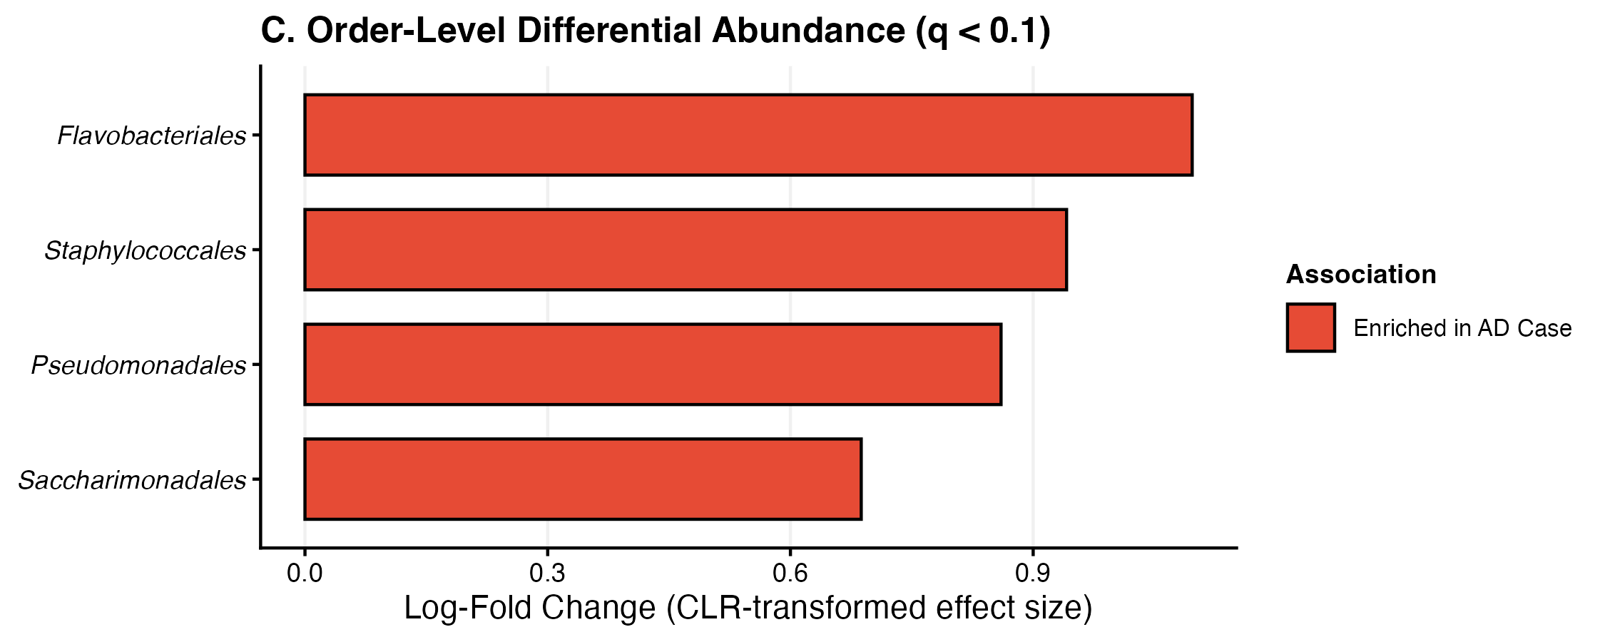
Supplementary Fig. 2C: Order-Level ANCOM-BC2 Differential Abundance. Horizontal bar plot depicting ANCOM-BC2 log-fold changes (LFC) representing CLR effect sizes for significantly differentiated orders between AD cases and controls (FDR q < 0.05). Positive LFC indicates enrichment in cases; negative LFC indicates depletion.

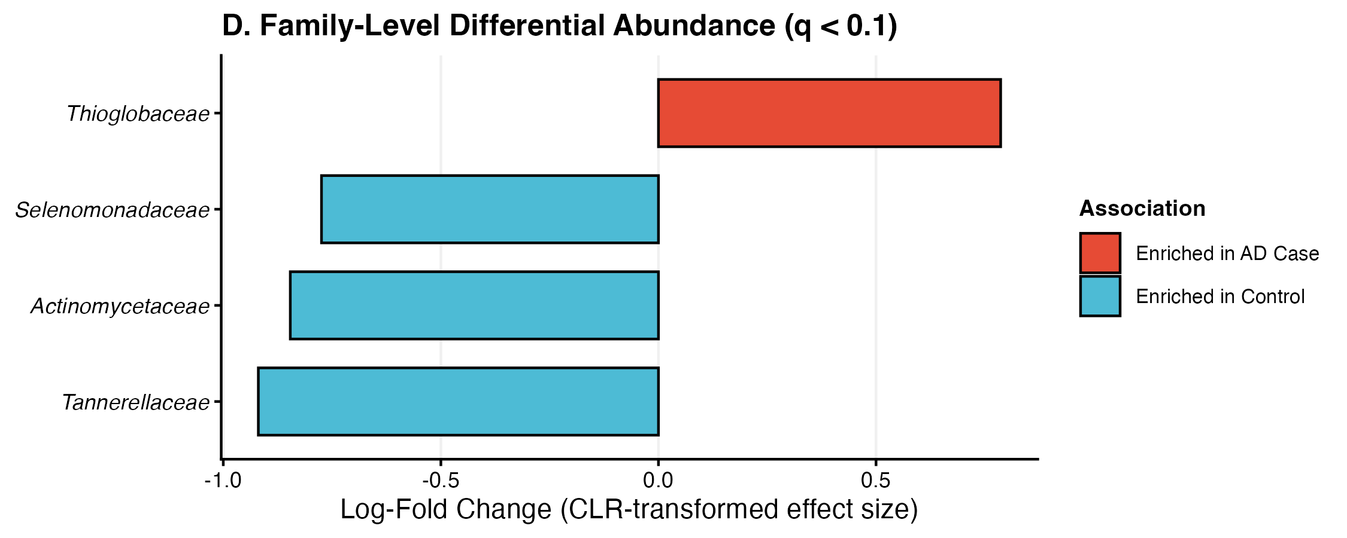
Supplementary Fig. 2D: Family-Level ANCOM-BC2 Differential Abundance. Horizontal bar plot depicting ANCOM-BC2 log-fold changes (LFC) representing CLR effect sizes for significantly differentiated families between AD cases and controls (FDR q < 0.05). Positive LFC indicates enrichment in cases; negative LFC indicates depletion.

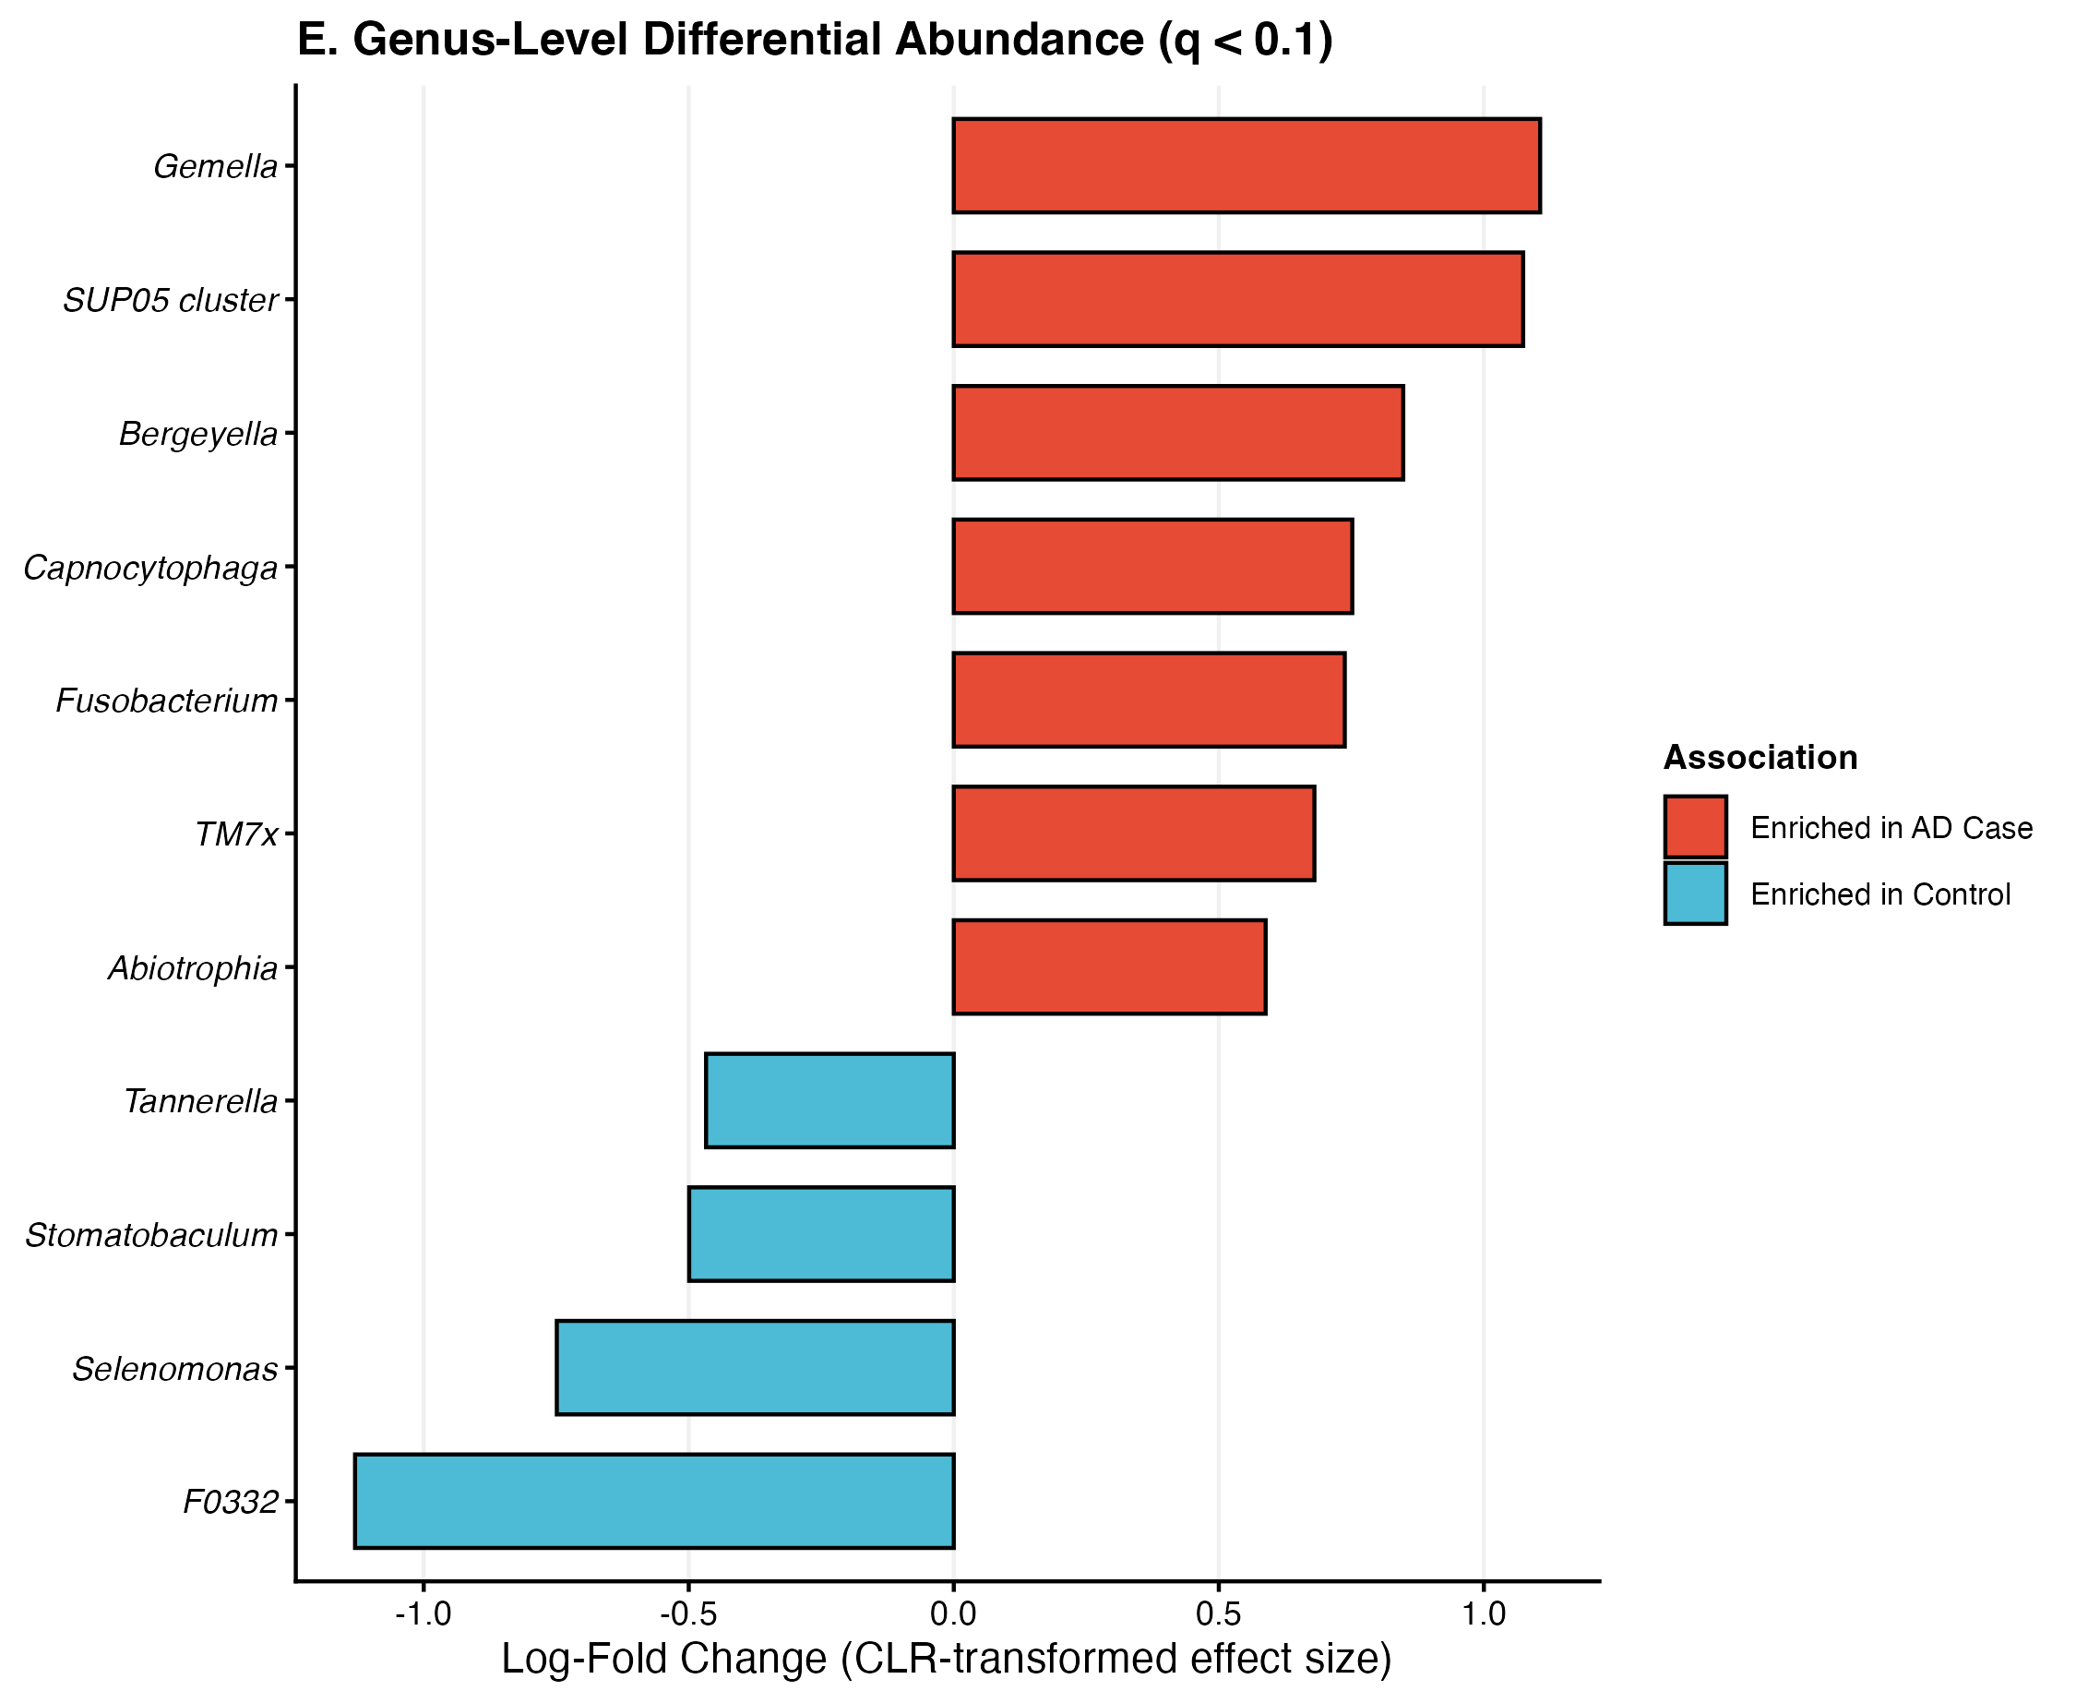
Supplementary Fig. 2E: Genus-Level ANCOM-BC2 Differential Abundance. Horizontal bar plot depicting ANCOM-BC2 log-fold changes (LFC) representing CLR effect sizes for significantly differentiated genera between AD cases and controls (FDR q < 0.05). Positive LFC indicates enrichment in cases; negative LFC indicates depletion.

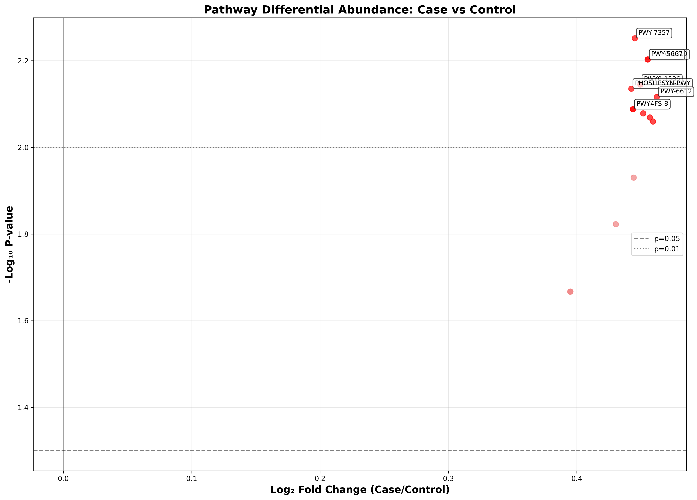
Supplementary Fig. 5C: Predicted Functional Pathway Volcano Plot. Volcano plot showing -log₁₀(p-value) versus log₂ fold change for predicted MetaCyc pathway abundances from PICRUSt2. Six pathways above the significance threshold exhibit robust inferred enrichment in AD cases (fold change: 1.36-1.38, p ≤ 0.01), including peptidoglycan maturation (PWY0-1586), thiamine formation (PWY-7357), and phospholipid biosynthesis pathways.

A
B
Supplementary Fig. 6: Comprehensive Machine Learning Performance. (A) Multiclass ROC curves for all four evaluated algorithms (Random Forest, Gradient Boosting, Logistic Regression, and Support Vector Machine). (B) Confusion matrices demonstrating the true positive, true negative, false positive, and false negative classification distributions for all models.

