README

I was able to get all of my real information into the database and the fake data as well. The mydatabase-small file is my old sql file from the previous project. It does not have the changes made to the new sql file but they work the same. The small database just has extra fields. As with the last project, I imported the database into mamp using the following command: mysql -u root -p < mydatabase.sql. This worked the same for me again but this time it took a lot longer. Below is pictures showing that I met the requirements that were asked for. These will be in the zip as well.

Picture 1: Overall view of my database

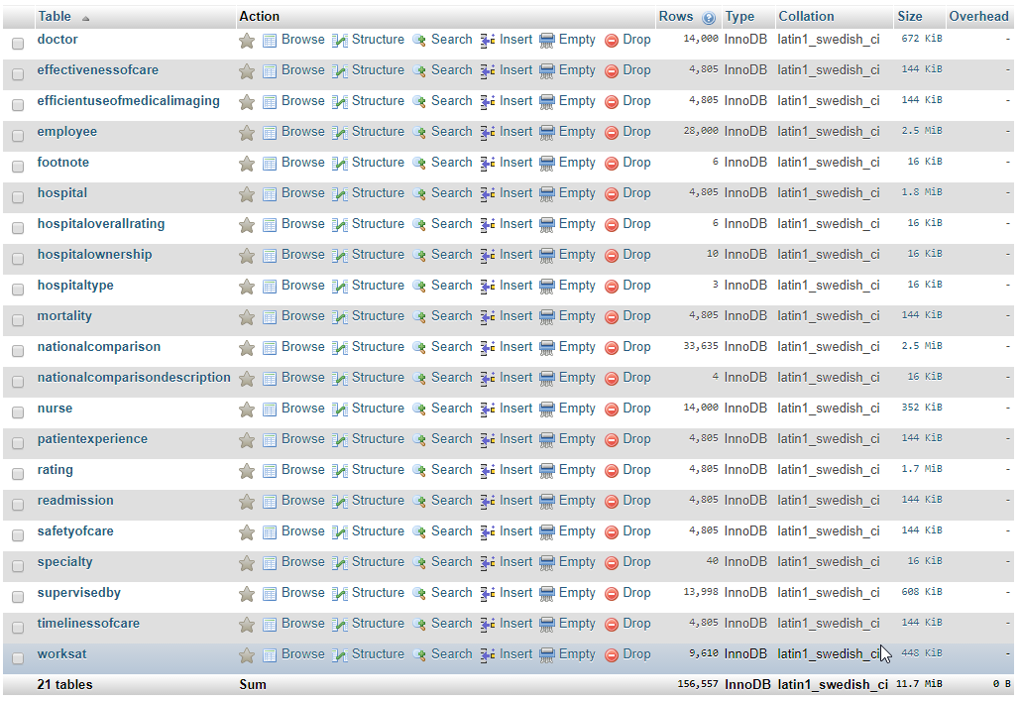

Picture 2: Doctor table

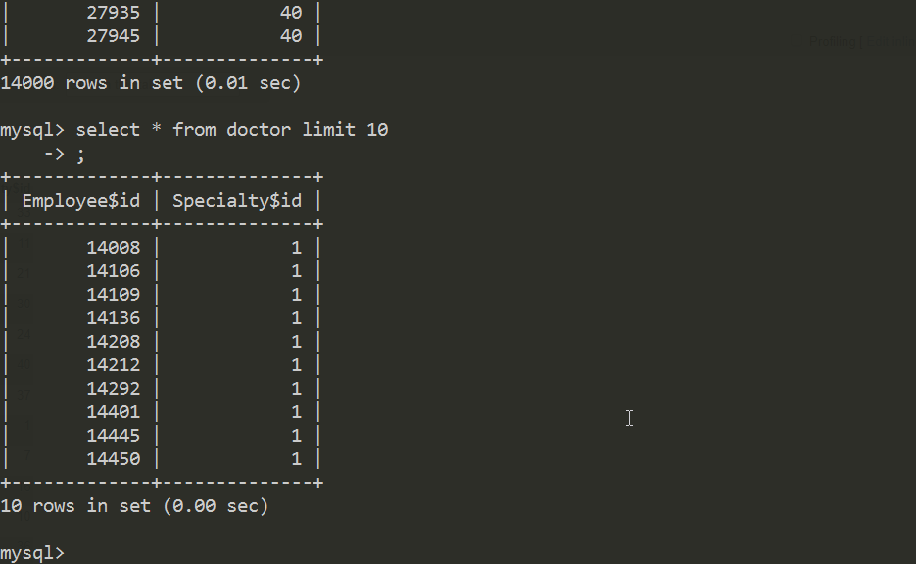

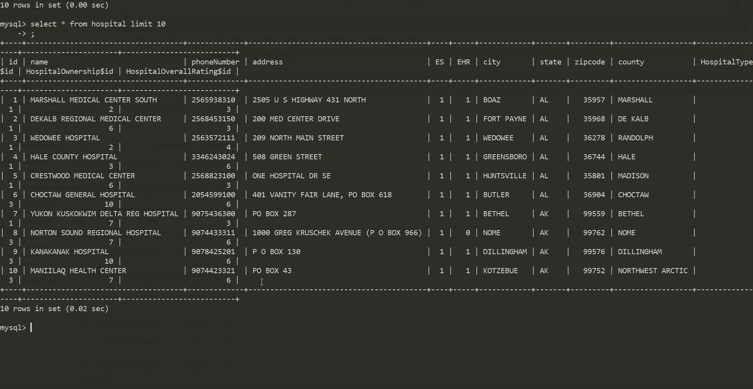Picture 3: Hospital Table

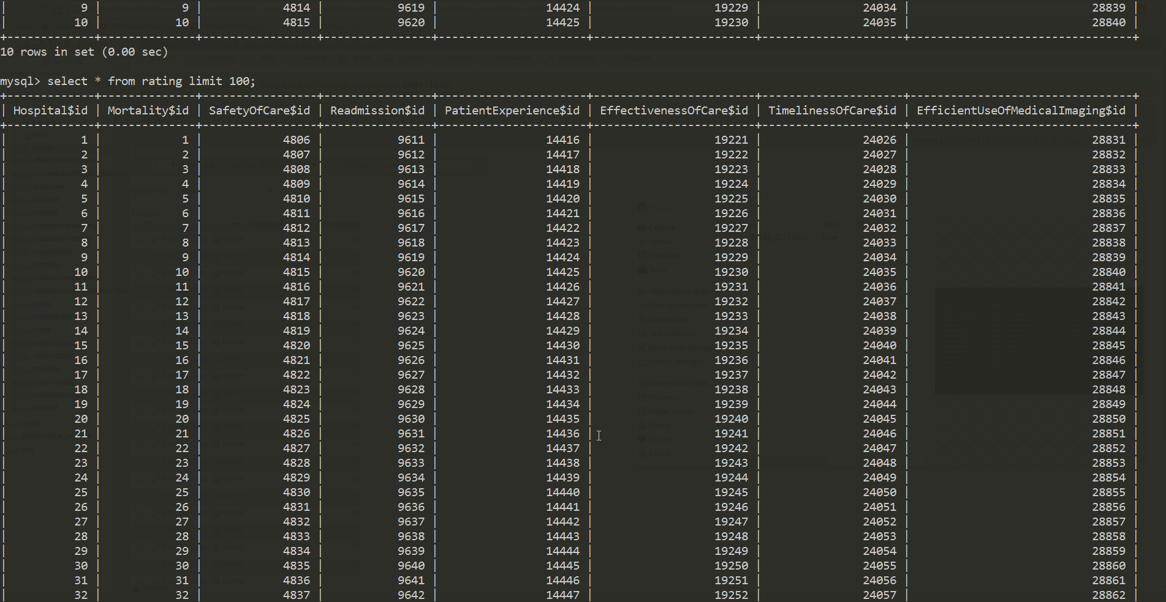Picture 4: Rating table

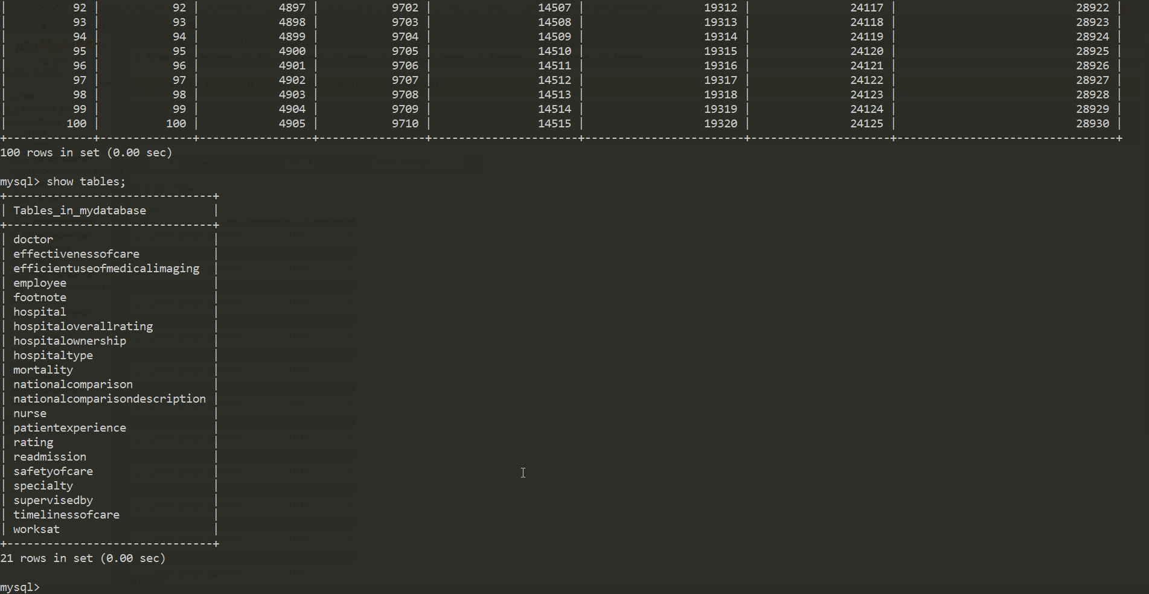Picture 5: All tables

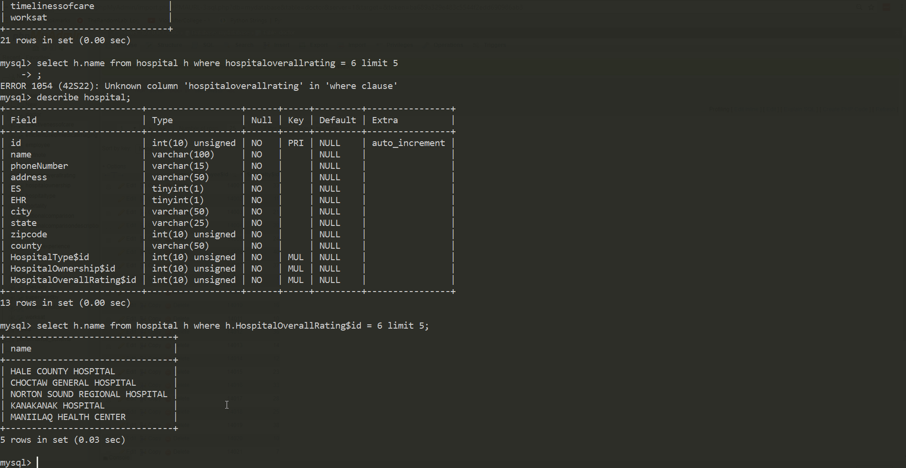Picture 6: Finding 5 hospitals where the hospitaloverallrating$id = 6

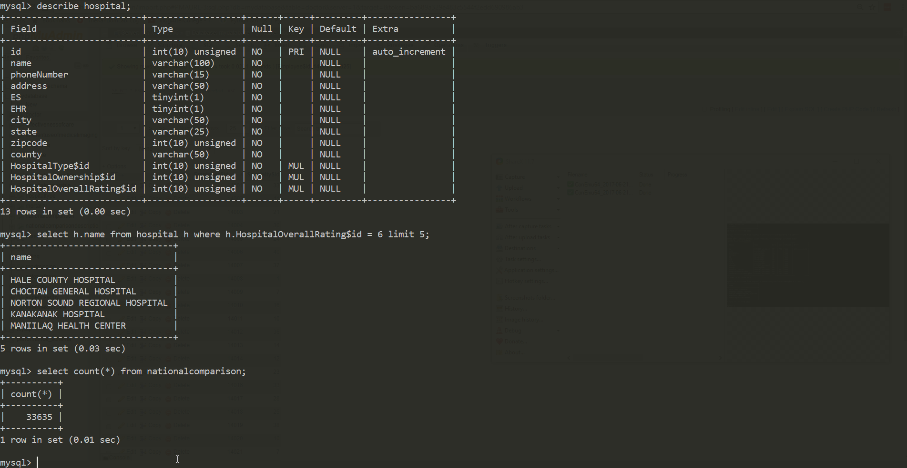Picture 7: Counting the number of tuples in the national comparison table