NFL Two-Point Conversion Analysis

Project Overview
This project analyzes over 1,700 NFL two-point conversion attempts across passing and rushing plays. The goal is to uncover insights into offensive play-calling tendencies, conversion success rates, player involvement, and positional performance to support data-driven decision-making and strategic game planning.

Dataset Summary
Dataset: twoPtPass.csv
- Rows: 1,217 - Columns: 9 - Key Features:
- Id (Pass, Play, Team, Player)
- Pass Position
- Sack, Completion, Null
- Conversion (Good/Fail)
Dataset: twoPtRush.csv
- Rows: 435 - Columns: 7 - Key Features:
- Id (Pass, Play, Team, Player)
- Rush Position
- Result (Good/Fail)
- Null
Dataset: twoPtRec.csv
- Rows: 1,153 - Columns: 8 - Key Features:
- Id (Pass, Play, Team, Player)
- Receiving Position
- Completion, Null
- Result (Good/Fail)

Exploratory Data Analysis using Python
We began with data preparation and cleaning in Python:
- Data Loading: Imported dataset using pandas.

- Initial Exploration: Used df.head() to check structure.

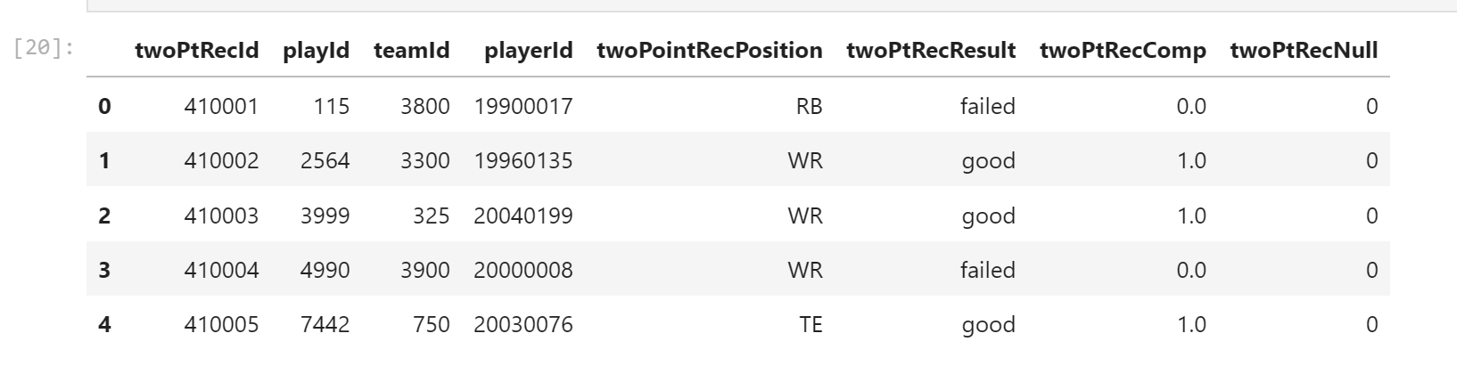

- Data Cleaning: Removed unnecessary columns, including null placeholder fields and redundant identifiers (teamId, playerId, and twoPtRecId), to prepare them for analysis.

- Dataset Integration: Merged passing and receiving datasets using the shared playId to accurately associate quarterbacks with their intended receivers for each two-point conversion attempt.
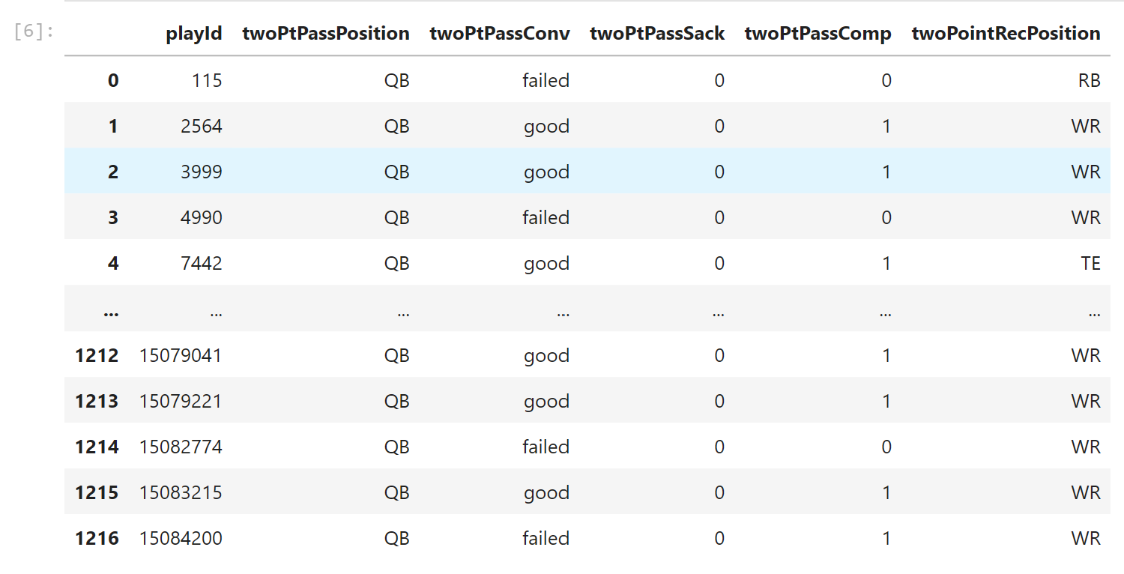
- Feature Engineering:

○ Created target_status column by analyzing twoPtPassSack and dftwoPtPassComp.

- Data Consistency Check: Verified if twoPtPassSack and twoPtPasscomp were redundant; dropped twoPtPassSack and twoPtPasscomp.

- Database Integration: Connected Python script to PostgreSQL and loaded the cleaned DataFrame into the database for SQL analysis.

Data Analysis using SQL
We performed structured analysis in PostgreSQL to answer key questions:
- 2-Point Attempts by Play Type – Compared the total number of two-point conversion attempts between passing and rushing plays.
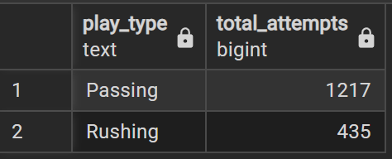

- Success Rate by Play Type – Analyzed and compared the conversion success rates of passing versus rushing two-point attempts.
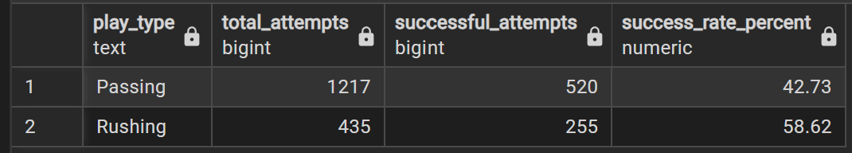

- Most Targeted Receivers – Identified the receivers who were targeted most frequently on two-point conversion pass attempts.

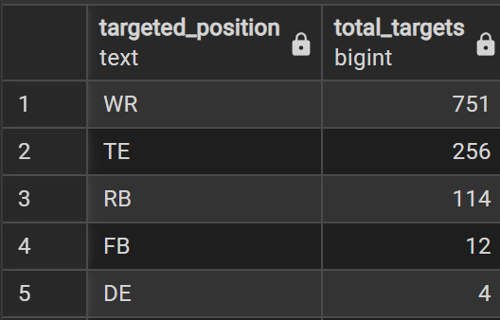
- Receiver Conversion Efficiency – Determined which receivers achieved the highest success rate on two-point conversion targets.
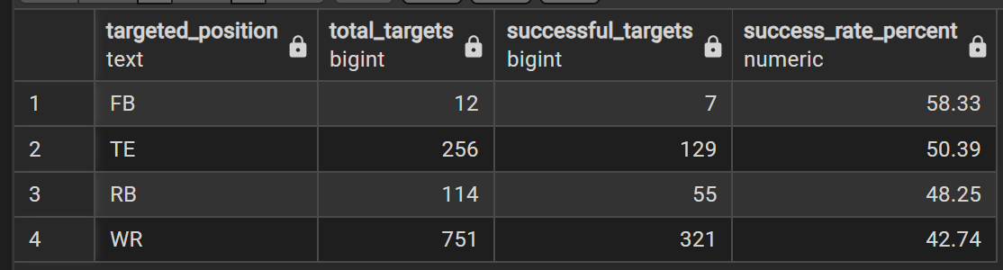

- Most Active Rushers – Determined which rushing success rates to identify the most effective two-point conversion rushers.
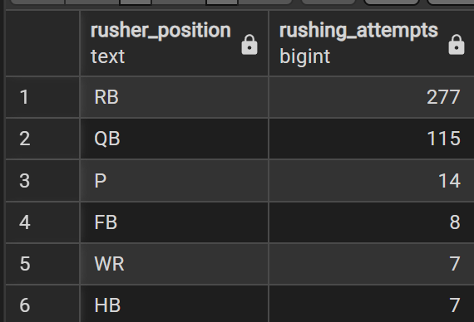

- Rusher Conversion Efficiency – Compared the rushing success rates to identify the most effective two-point conversion rushers.
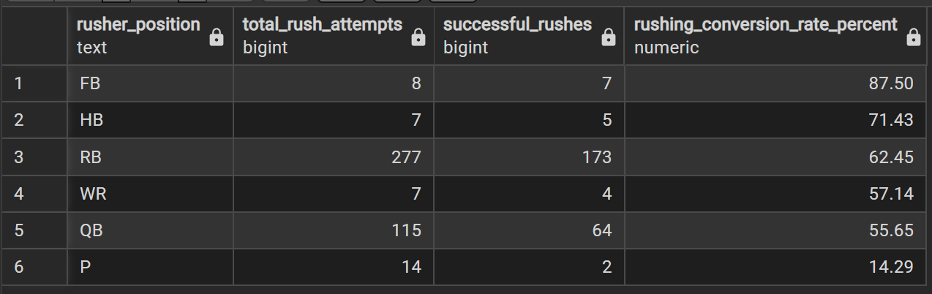

- Most Involved Players – Identified the players who participated in the greatest number of two-point conversion attempts across both passing and rushing plays.

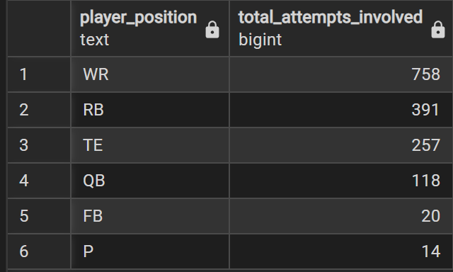

Dashboard in Power BI

Finally, we built a dashboard in Power BI to present insights visually.

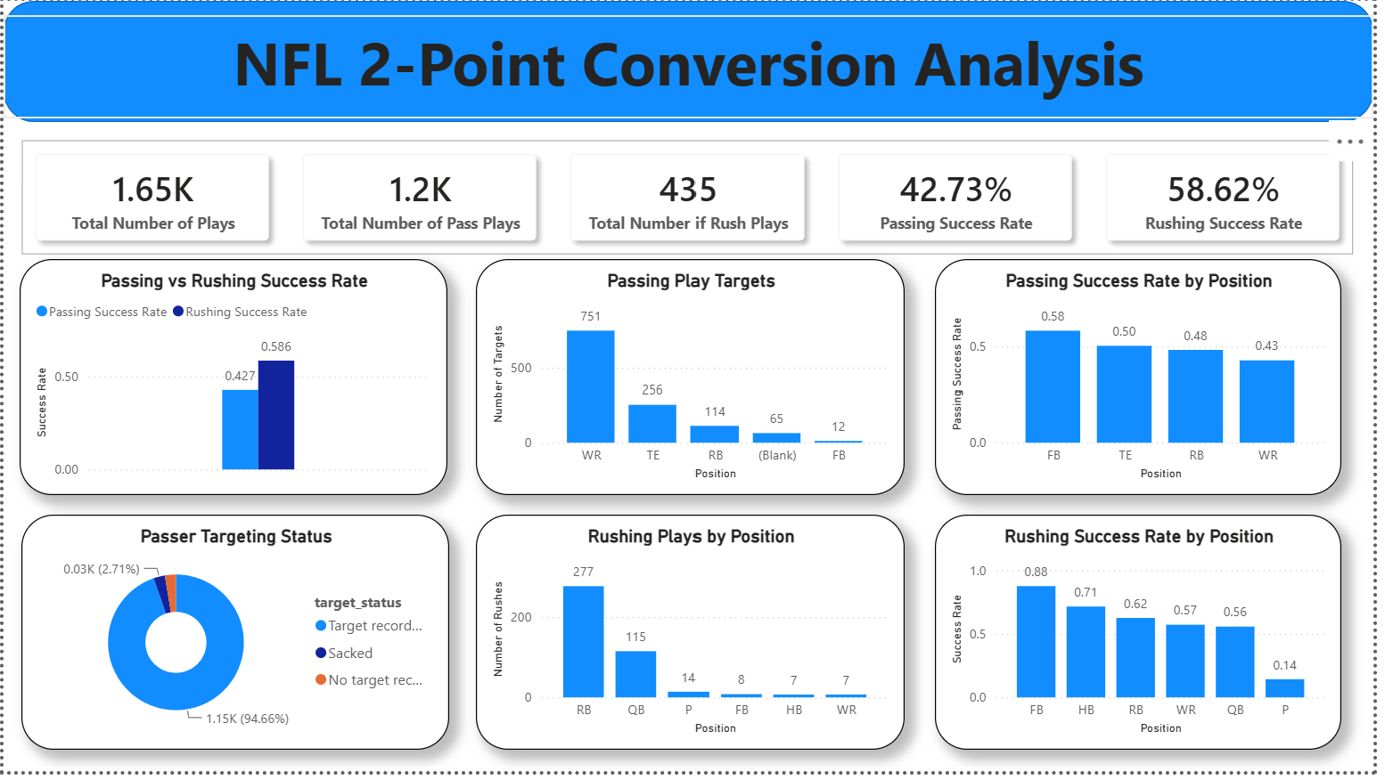

Recommendations

- Increase the Use of Rushing Plays – teams should consider favoring rushing attempts in high-leverage situations where maximizing the probability of conversion is the priority.

- Expand the Use of Tight Ends - Increasing the number of designed plays targeting tight ends could improve overall passing efficiency while reducing offensive predictability.

- Reduce Overreliance on Wide Receivers – Diversifying passing targets by utilizing tight ends and running backs may create a more balanced offense and make defenses less able to anticipate play calls.

- Evaluate Underperforming Passing Concepts - Review these lower-performing play designs and refine or replace them with more efficient alternatives.

