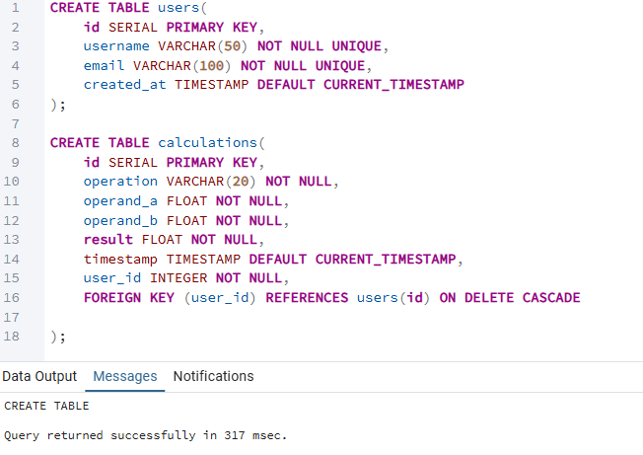
Query returned successfully: The successful creation of a table

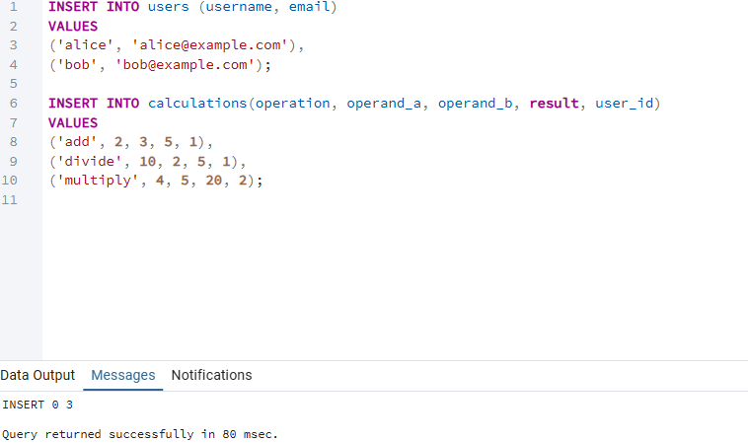
Query returned successfully: Added records to a table

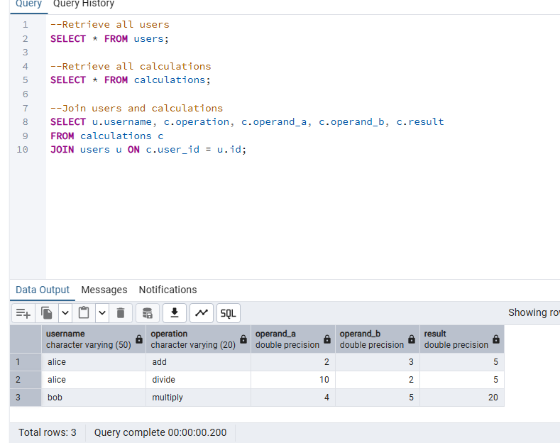
Query returned successfully: Retrieved data from tables and joined them

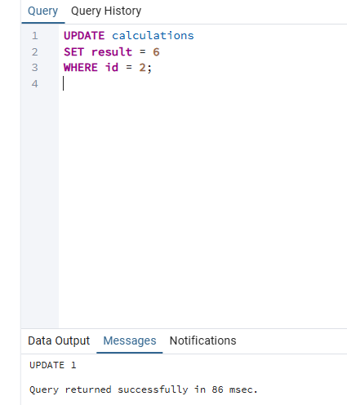
Query returned successfully: Data updated in row 2

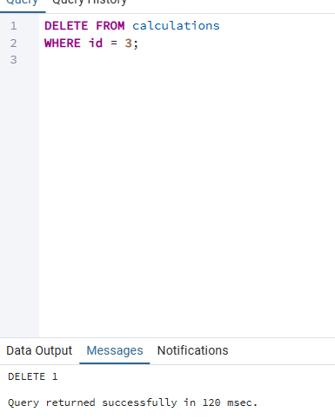
Query returned successfully: row 3 deleted

