Ping a computer
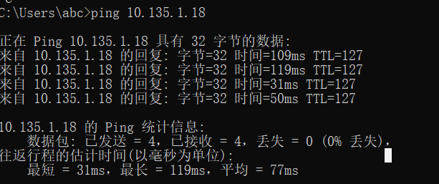
Tracert a server
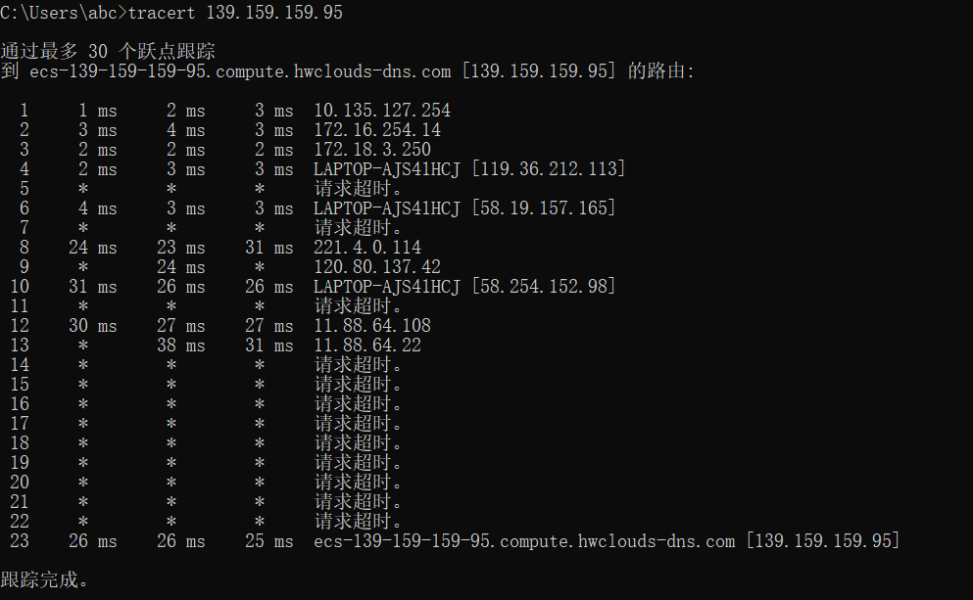
P5 Review the car-caravan analogy in Section 1.4. Assume a propagation speed
of 100 km/hour.
a. Suppose the caravan travels 175 km, beginning in front of one tollbooth,
passing through a second tollbooth, and finishing just after a third tollbooth. What is the end-to-end delay?

It cost 10*12s = 2 min on each toll booth.
And it cost 175 / 100 h= 1.75 h= 105 min on transmission.
So the end-to-end delay is 105 + 2 * 3 = 111 min.

b. Repeat (a), now assuming that there are eight cars in the caravan instead
of ten.

It cost 8*12s = 1.6 min on each toll booth.
And it cost 175 / 100 h= 1.75 h= 105 min on transmission.
So the end-to-end delay is 105 + 1.6 * 3 = 109.8 min.

P14. Consider the queuing delay in a router buffer. Let I denote traffic intensity;
that is, I = La/R. Suppose that the queuing delay takes the form IL/R (1 - I)
for I < 1.
a. Provide a formula for the total delay, that is, the queuing delay plus the
transmission delay.

D(total delay) = d(queueing) + d(transmission) = L/R + IL/R(1-I) = L/R(1-I)

b. Plot the total delay as a function of L/R.

Assume that x = L/R
D(total delay) = x/(1-ax). when x is approaching 0, total delay will approach 0. when x increases, total delay will increase. When x approaches 1/a, total delay will approach infinite.

P15. Let a denote the rate of packets arriving at a link in packets/sec, and let µ
denote the link’s transmission rate in packets/sec. Based on the formula for
the total delay (i.e., the queuing delay plus the transmission delay) derived
in the previous problem, derive a formula for the total delay in terms of a
and µ.

Transmision delay is 1/μ = L/R, so d(total delay) = L/R/(1-I) = 1/(μ-a)

P6. Obtain the HTTP/1.1 specification (RFC 2616). Answer the following
questions:
a. Explain the mechanism used for signaling between the client and server
to indicate that a persistent connection is being closed. Can the client, the
server, or both signal the close of a connection?

An HTTP/1.1 server MAY assume that a HTTP/1.1 client intends to maintain a persistent connection unless a Connection header including the connection-token "close" was sent in the request. If the server chooses to close the connection immediately after sending the response, it SHOULD send a Connection header including the connection-token close.
An HTTP/1.1 client MAY expect a connection to remain open, but would decide to keep it open based on whether the response from a server contains a Connection header with the connection-token close. In case the client does not want to maintain a connection for more than that request, it SHOULD send a Connection header including the connection-token close.
If either the client or the server sends the close token in the Connection header, that request becomes the last one for the connection.
Clients and servers SHOULD NOT assume that a persistent connection is maintained for HTTP versions less than 1.1 unless it is explicitly signaled. See section 19.6.2 for more information on backward compatibility with HTTP/1.0 clients.
In order to remain persistent, all messages on the connection MUST have a self-defined message length (i.e., one not defined by closure of the connection), as described in section.
Both client and server can signal the close of a connection.

b. What encryption services are provided by HTTP?

HTTP can provide no encryption.

c. Can a client open three or more simultaneous connections with a given
server?

No, a clinet can only open two connections at most.
Clients that use persistent connections should limit the number of simultaneous connections that they maintain to a given server. A single-user client SHOULD NOT maintain more than 2 connections with any server or proxy.

d. Either a server or a client may close a transport connection between them
if either one detects the connection has been idle for some time. Is it
possible that one side starts closing a connection while the other side is
transmitting data via this connection? Explain.

It is possible that one side starts closing a connection while the other side is
transmitting data via this connection.
A client might have started to send a new request at the same time that the server has decided to close the "idle" connection. From the server's point of view, the connection is being closed while it was idle, but from the client's point of view, a request is in progress.

P12. Write a simple TCP program for a server that accepts lines of input from a client and prints the lines onto the server’s standard output. (You can do this by modifying the TCPServer.py program in the text.) Compile and execute your program. On any other machine that contains a Web browser, set the proxy server in the browser to the host that is running your server program; also configure the port number appropriately. Your browser should now send its GET request messages to your server, and your server should display the messages on its standard output. Use this platform to determine whether your browser generates conditional GET messages for objects that are locally cached

import java.io.*;
import java.net.*;
class TCPServerDemo {
public static void main(String argv[]) throws Exception {
String clientMessage;
ServerSocket messageSocket = new ServerSocket(6789);
while(true) {
Socket connectionSocket = messageSocket.accept();
BufferedReader bd = new BufferedReader(new InputStreamReader(
connectionSocket.getInputStream( ) ) );
clientMessage = bd.readLine();
System.out.println(“Client message recieved: ” + clientMessage + “\n”);
}
}
}

