Tutorial 2 - Interactive PLV

C:\Users\Owner\Desktop\MMIL\TS Documentation\tutorials\FastWords

Neuroscan EEG epoch data file: NY77_FWIO.eeg

Procedure

1. Load data
2. Load interactive study file
3. Modify parameter values
4. Run analysis
5. Visualize results using **syncview**

Load event-related data.

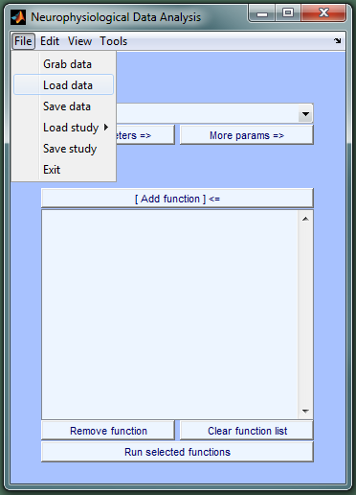

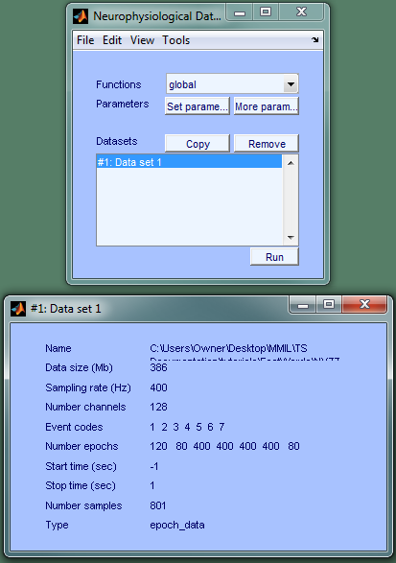

The meta-data figure displays information on the data set currently selected in the Datasets list.

Load the interactive study file.

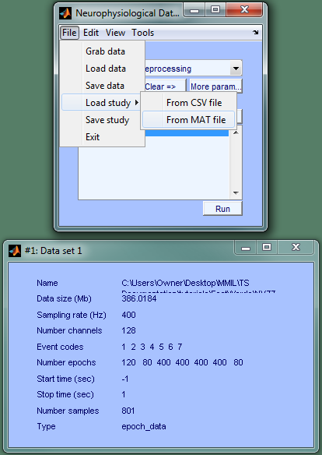

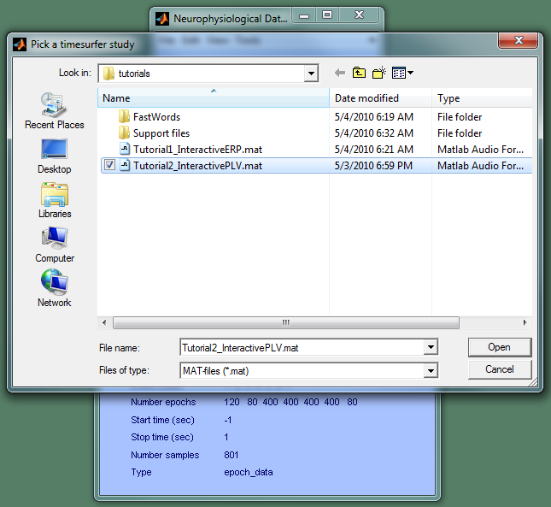

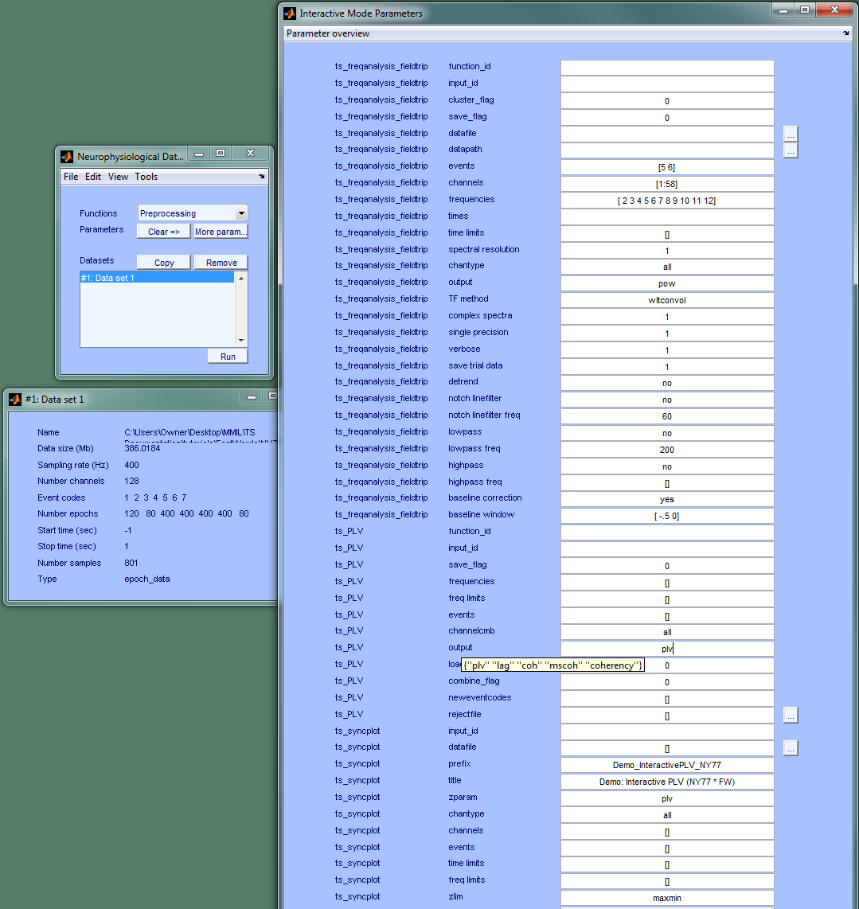

This interactive study file specifies a sequence of three functions. The data set selected in the Datasets list will start at the top of the right parameter figure and "flow" downward through the other functions. Specifically, ts_freqanaalysis_fieldtrrip() inputs epochs or continuous data and returns the TFR calculated using the user-specified TF method (Morlet wavelet analysis by default - "wltconvol"). ts_PLV() uses the TFR to calculate synchrony metrics like phase-locking and coherence (metrics are selected using the "output" parameter).

Tip: hover over parameter names to obtain useful information on individual parameters. (ex. in the above figure, hovering over the "output" parameter for ts_PLV() produced a list of available outputs).

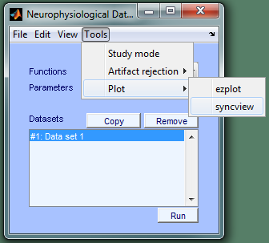

Select layout file generated by ts_syncplot() and the jpeg images with which it is associated. Note: layouts are automatically generated for intracranial data but not for MEG data. In both cases, ts_syncplot() saves layout files and images to the same directory. Syncview takes all layouts & images and presents it in an efficient manner that greatly facilitates high-dimensional data visualization and exploration.

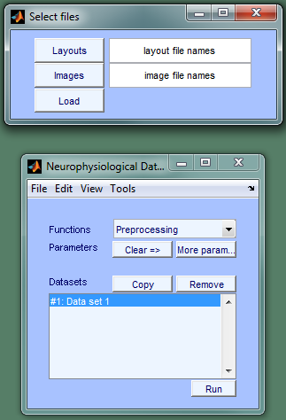

Select all jpeg images. Repeat for layout files.

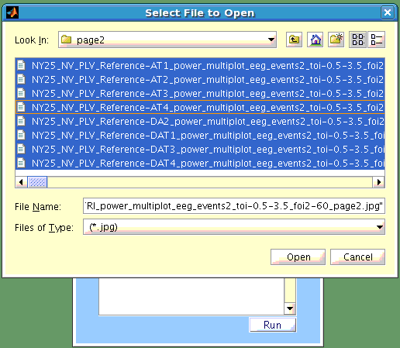

Then, click Load in syncview's file selection window.

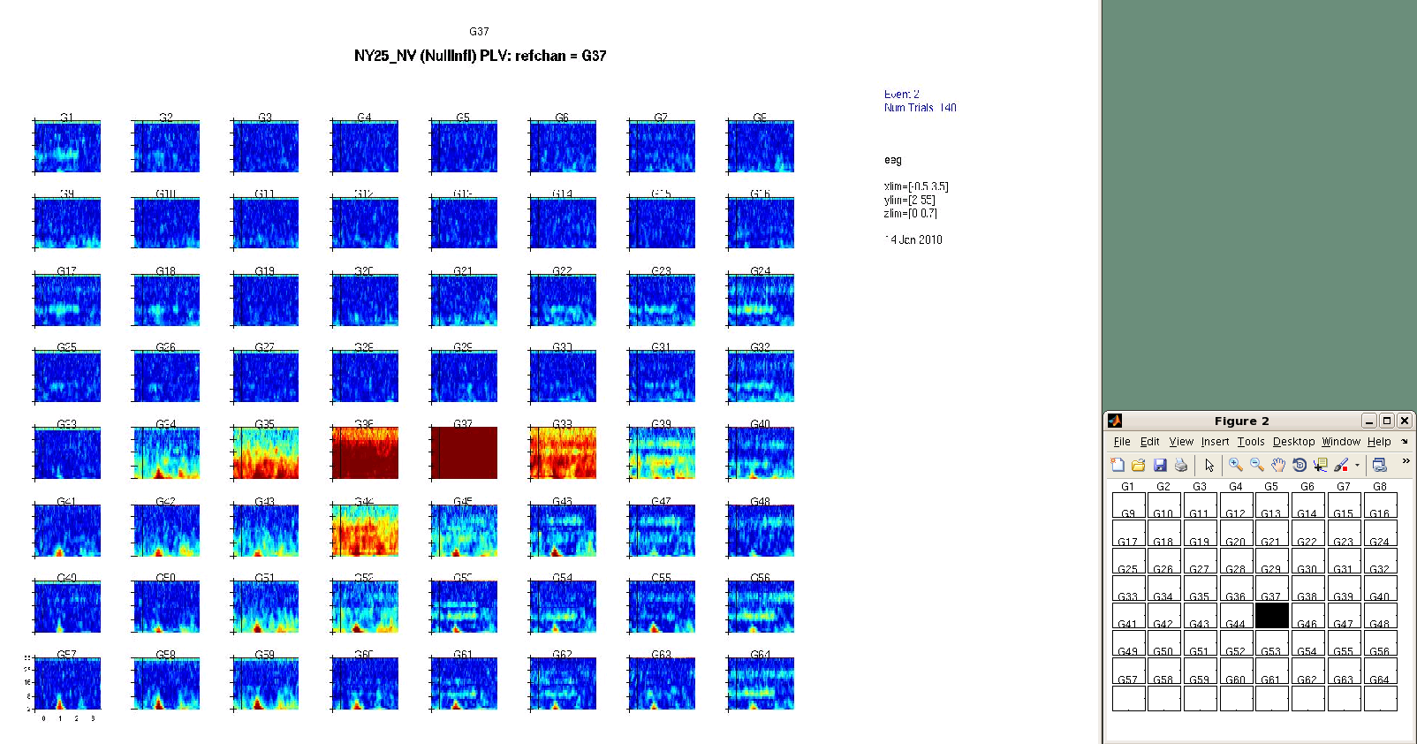

Click on a white square in the smaller "control" figure to specify a reference channel for the 3D data display (chan x time x frequency). The black square marks the reference channel of the image shown.

