Tutorial 3 - Template PLV

Batch template to calculate time-frequency representations and phase-locking values for event-related, intracranial electrophysiology data.

Description

Tutorial 3 will demonstrate how to use a batch template to analyze a single data set. The input data file is iEEG data that was epoched using Neuroscan software. The output files- epoch data, TFR, PLV, images, and logs - will be saved to subdirectories of the current working directory.

Demonstration data

Working directory for demonstration: ~\tutorials\FastWords

Neuroscan EEG epoch data file: NY77_FWIO.eeg

Event code 6 (FF - False Fonts)

Channels 1-8 (G1, G2, G3, G4, G5, G6, G7, G8)

Epochs: 500 ms before to 1000ms after each FF event

Frequencies 2 - 30Hz in 2Hz steps

Analysis protocol: wavelet analysis, phase-locking calculation, pair-wise plotting of 4D phase-locking data (chan x chan x time x frequency), and reference-based plot visualization ("syncview").

GUI procedure

1. Load template
2. Select datafile
3. Specify event codes
4. Select functions to execute & run the analysis
5. View results

Load the template.

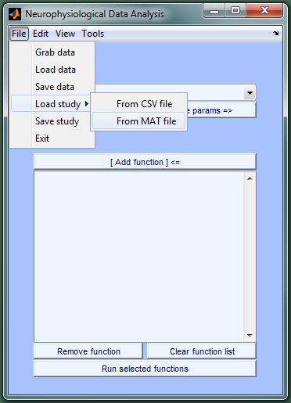

Select the template MAT file and click Open.

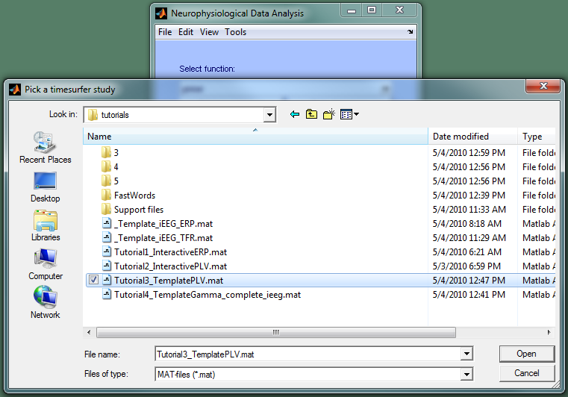

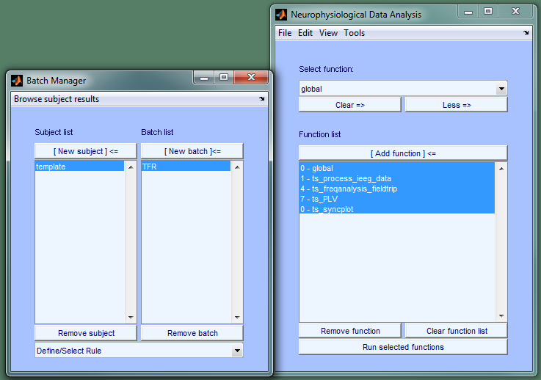

Specify the input data file for **ts_process_ieeg_data**.

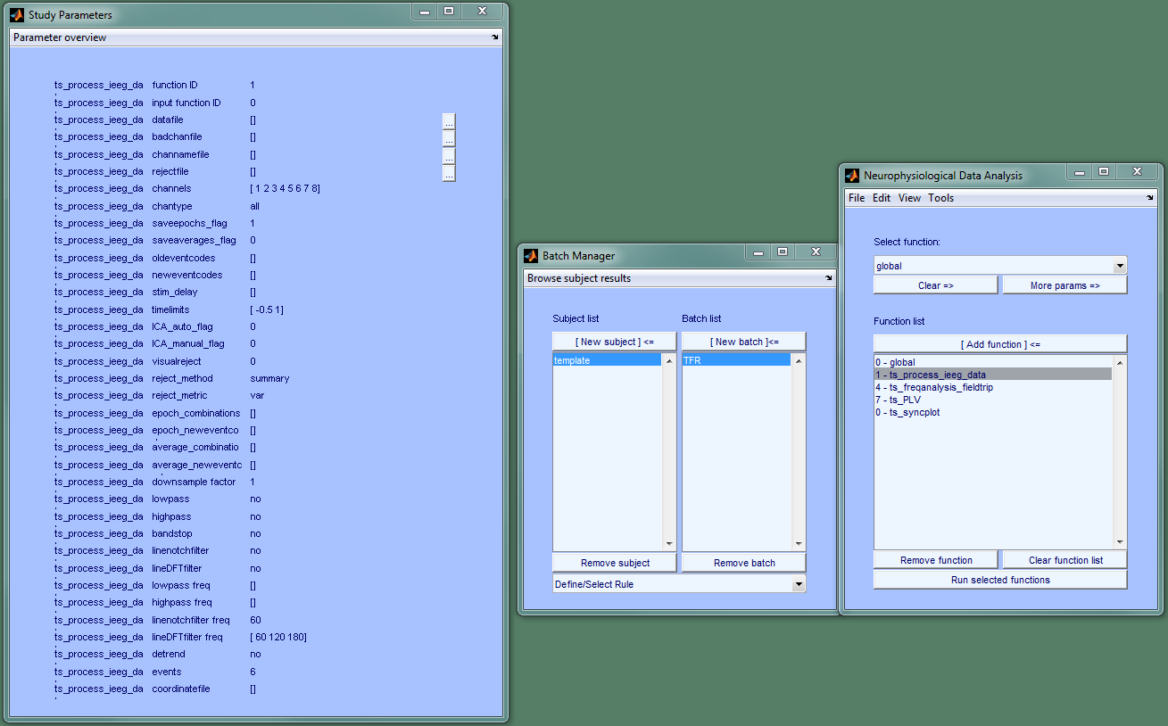

To specify the Neuroscan data file: click on the auxiliary button to the right of **datafile** in the left parameter figure.

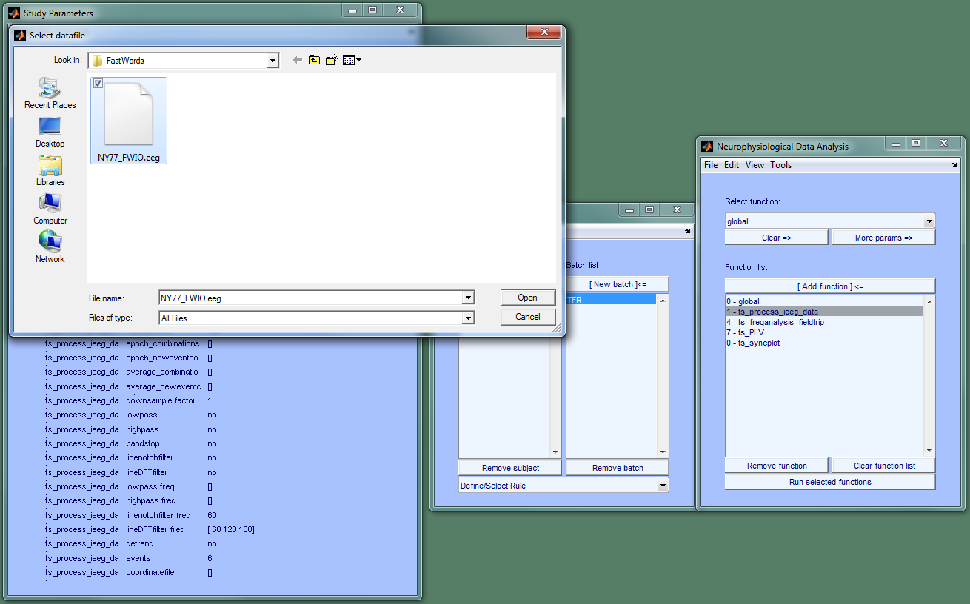

Specify event codes (in four functions). Click "**Parameter overview**" in left parameter figure to open a text box that lists all the parameters for all the functions in the selected batch. You can specify as many parameters as you wish in the text box, then click "Save & Close" and the new values will be assigned.

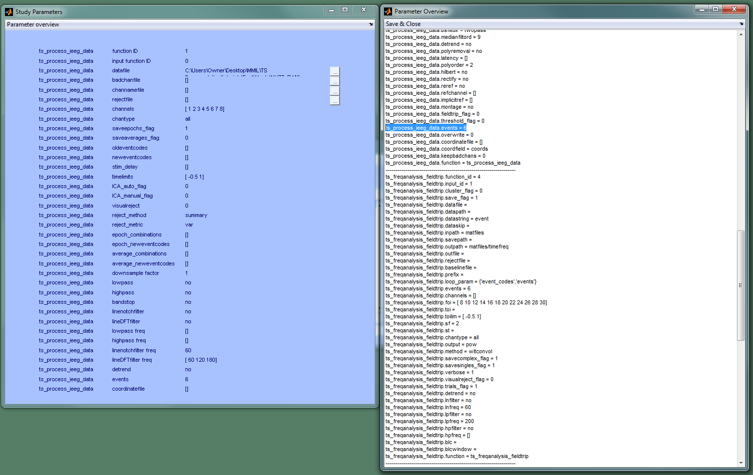

After setting event codes for all four functions in the Parameter Overview figure, click "Save & Close" to save the changes. Any changes will be lost if if you do not close the figure using "Save & Close."

Select the functions you want to execute and click "Run selected functions" to perform the analysis. For instance, if processing stopped after the wavelet analysis and you want to calculate & plot phase-locking values, make the following selection and click Run:

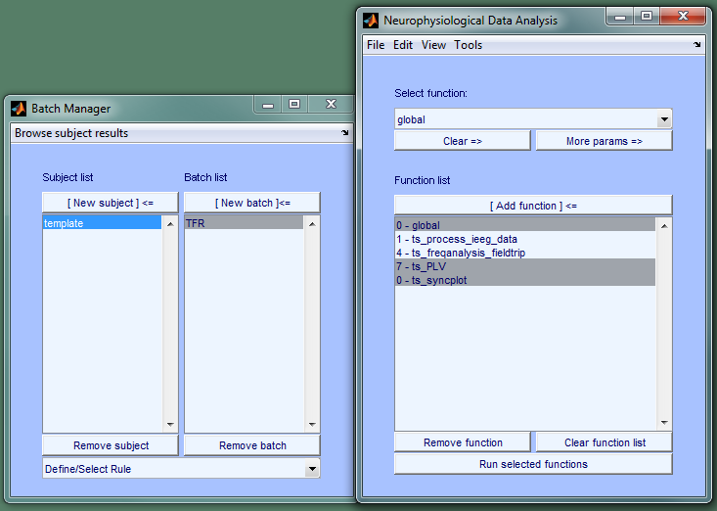

Once the analysis finishes, PLV can be viewed conveniently using syncview: Tools => Plot => **syncview** (as demonstrated in the Interactive PLV tutorial: Tutorial2_InteractivePLV.mat).

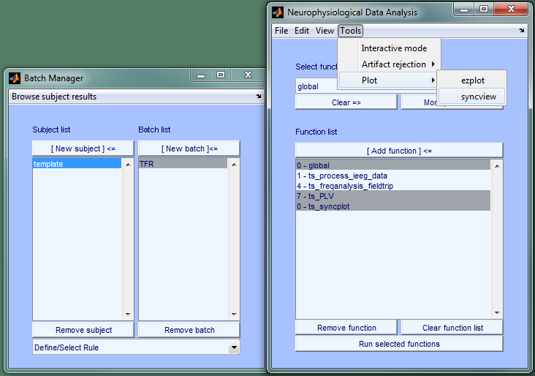

Other outputs can be viewed using the Results Browser by clicking "Browse subject results" in the Batch Manager. (See Tutorial 4 - a large study from templates to browsing results).

Note 1: While the parameter overview can be used to modify several parameters quickly, it only works for one subject at a time. Right-clicking on parameter values in the left parameter figure can be used to change values for several subjects simultaneously.

Note 2: Now would be the right time to change task-specific processing parameters if they were different from those in the template (ex. baseline window, filter cutoff frequencies; frequencies of interest for the wavelet analysis, plottings parameters, etc).