Tutorial 5

A complete event-related task analysis

[Tutorial5_CompleteTask.mat]

This tutorial shows how to use a template setup file to perform a standard analysis for a particular task

(Topics: analysis specification, execution, and viewing results)

Quick instructions to analyze one subject:

1. Create an output directory for results of the analysis.
2. Launch "timesurfer" in Matlab from the output directory and load the template setup file.
3. Specify input data using *datafile* parameter for ts_process_ieeg_data (function_id=1) in the ERP batch.
4. Select all batches and click "Run selected functions."

Tip: use prefix to make output file names more descriptive. Specify pre-processing parameters, plotting parameters and event codes.

Setting up batch processing for multiple subjects at the task-level is more complicated. That will be the focus of this tutorial.

This tutorial will demonstrate how to use a template setup file to set up and execute an event-related task analysis with multiple subjects and multiple batches. While this tutorial demonstrates how to use the template to set up an analysis for a particular task, the same procedure can be used for any event-related task. We will first outline the analysis protocol, in general. The general outline and the template that it describes are independent of the particular task. Next, we will discuss what files are necessary to begin executing the protocol as well as useful directory structure and file naming conventions. Following the general discussion, we will present a particular task and some background information before getting started.

Analysis protocol (see table)

1. ERP (event-related potential) analysis
   1. Remove rejected trials and channels
   2. Save results without rejects
   3. Detrend, filter, baseline correct; average over trials
   4. Detrend, filter, baseline correct; calculate Monte Carlo stats comparing pairs of conditions
   5. Multi-plot condition overlays with statistically significant shading
2. TFR (time-frequency representation) analysis
   1. Complex Morlet wavelet analysis on baseline-corrected epoch data
   2. Multi-plot trial-averaged power spectrograms (z-scores)
   3. Calculate event-related coherence & phase-locking values for each event
   4. Multi-plot MSCOH and PLV for each reference channel
   5. Manually inspect synchrony metrics using the syncview visualization tool
3. Gamma analysis
   1. Correct power spectrum for 1/f^2 scaling, baseline-correct, and calculate averages over high gamma frequencies within each trial
   2. Perform visual artifact rejection on the gamma waves (see Tutorial 4)
   3. Calculate Monte Carlo stats comparing gamma for pairs of conditions
   4. Average the gamma waves over trials
   5. Multi-plot condition overlays with statistically significant shading

GUI Procedure

1. Load template setup file
2. Set task-specific parameter values for each function of the analysis protocol (event codes, epoch parameters, preprocessing options, plotting options)
3. Create a copy of the template subject for each subject in the Batch Manager
4. Define constants in the Rule Manager and apply rules
5. Set the remaining subject-specific parameters (ex. *datafile*)
6. Select subjects and batches to analyze and click Run selected functions

Recommendation: save the STUDY file before executing the analysis

1. Browse results; record & export notes

Tutorial conventions

* Output directory structure: ROOT/SUBJECT/SUBJECT_TASK/<results>
  + When we set up the analysis, we will define **ROOT**, **SUBJECT**, and **TASK**
  + **ROOT** is a user-defined analysis directory containing the results for all subjects
  + **SUBJECT** is a Subject ID and **TASK** is a Task ID.
  + **rootoutdir** is a frequently-used function parameter that we will encounter; it determines where TimeSurfer analysis results will be saved.
* Output file names will begin with a user-specified **prefix** that we will define as **SUBJECT**_**TASK**
* Several parameters in addition to **rootoutdir** and **prefix** can be defined in terms of **ROOT**, **SUBJECT**, and **TASK**. After defining **ROOT** and **TASK** as constants and creating a list of our subjects, we will be able to apply pre-defined rules to automatically set several parameters using the template setup file.

Note: it is not necessary that other analyses adhere to these conventions, and rules can be defined to accommodate any convention.

Prerequisite files

1. **datafile** – input EEG data file containing one subject’s epoch file from Neuroscan. This is the only required file. The other files are optional. The input data could also be one of several alternative formats for intracranial data and MEG/EEG data, epoch data or continuous data.
2. **conditionkey** – a CSV file containing three columns: <condition #><event code><condition name>. It is used to generate plot legends & include condition names in image file names.
   * Save one copy of this for the task (e.g., in the **ROOT** analysis directory)
3. **rejectfile** – the MAT file containing reject_data (lists rejected trials and channels) saved after visual artifact rejection as described in Tutorial 4.

* Naming convention: **rootoutdir**/matfiles/**SUBJECT**_**TASK**_reject_data.mat

1. **badchanfile** – a TXT file listing channel labels of channels to skip
   * Naming convention: **rootoutdir**/**SUBJECT**_badchannels.txt

Summary:

**conditionkey**: **ROOT**/**TASK**_conditionkey.csv

For each subject:

**datafile**: <*user-selected*>

**rootoutdir**: ROOT/SUBJECT/SUBJECT_TASK

**rejectfile**: rootoutdir/matfiles/SUBJECT_TASK_reject_data.mat

**badchanfile**: rootoutdir/SUBJECT_badchannels.txt

Task: Happy/Neutral/Sad Faces (FEM)

We will analyze intracranial electrophysiology data collected from two patients at MGH (MG34, MG36).

Condition Key

|  |  |  |  |  |
| --- | --- | --- | --- | --- |
| Condition | Event Code | Name | Combinations | Number of trials |
| 1 | 1 | male-happy-new |  |  |
| 2 | 2 | male-happy-repeat |  |  |
| 3 | 3 | male-sad-new |  |  |
| 4 | 4 | male-sad-repeat |  |  |
| 5 | 5 | male-neutral-new |  |  |
| 6 | 6 | male-neutral-repeat |  |  |
| 7 | 7 | female-happy-new |  |  |
| 8 | 8 | female-happy-repeat |  |  |
| 9 | 9 | female-sad-new |  |  |
| 10 | 10 | female-sad-repeat |  |  |
| 11 | 11 | female-neutral-new |  |  |
| 12 | 12 | female-neutral-repeat |  |  |
| 13 | 13 | male | 1+2+3+4+5+6 |  |
| 14 | 14 | female | 7+8+9+10+11+12 |  |
| 15 | 15 | happy | 1+2+7+8 |  |
| 16 | 16 | sad | 3+4+9+10 |  |
| 17 | 17 | neutral | 5+6+11+12 |  |

Note: only the first three columns are required in the *conditionkey* file.

In this tutorial, we will focus on comparing Happy, Sad, and Neutral conditions in two subjects. In terms of event codes, we are interested in comparing event codes 15 vs. 16, 15 vs. 17, and 16 vs. 17. We will start with data that has already been epoched using Neuroscan and proceed with the analysis through standard ERP analysis, wavelet analysis, high gamma analysis, and synchrony analysis. It will also be assumed that visual artifact rejection was performed as described in Tutorial 4. Example reject files for these data are saved to the paths given below.

Before beginning, create a directory for the results of this tutorial; we will refer to it as <OutputDirectory>.

**ROOT**: <OutputDirectory>

**TASK**: FEM

**SUBJECT**: MG34, MG36

ROOT and TASK are constants that will be set in the Rule Manager before applying rules that are pre-defined in the template based on the previously-described conventions. SUBJECT will be the names we give to the subjects in the Batch Manager’s Subject list.

Files

*conditionkey*: /home/halgdev/analysis/iEEG_MGH/protocols/gui/FEM/StudyInfo/FEM_conditionkey.csv

*datafile*

* /space/mdeh1/1/halgdev/analysis/iEEG_MGH/MG34/MG34_FEM/eeg/MG34FEM_BC_rejchannels.eeg
* /space/mdeh1/1/halgdev/analysis/iEEG_MGH/MG36/MG36_FEM/eeg/MG36FEM_conditions_BC_rejectchannels.eeg

*rejectfile*

* /home/halgdev/analysis/iEEG_MGH/MG34/MG34_FEM/matfiles/MG34_FEM_reject_data.mat
* /home/halgdev/analysis/iEEG_MGH/MG36/MG36_FEM/matfiles/MG36_FEM_reject_data.mat

In the tutorial, rules will be applied to set *rejectfile* and *conditionkey* according to the previously-described conventions. To follow the tutorial step-by-step, these files (2 reject files and 1 condition key) need to be copied to appropriate directories within your <OutputDirectory>. Otherwise, after applying the rules in the tutorial, you could intervene and copy & paste the full filenames given above for each subject to set the appropriate parameters.

The appropriate locations for the former approach would be:

*conditionkey*: <OutputDirectory>/FEM_conditionkey.csv

*rejectfile*

* <OutputDirectory>/MG34/MG34_FEM/matfiles/MG34_FEM_reject_data.mat
* <OutputDirectory>/MG36/MG36_FEM/matfiles/MG36_FEM_reject_data.mat

You are ready to begin the tutorial once you have created an <OutputDirectory> and decided how to handle the *conditionkey* and *rejectfile*. The table on the following page summarizes the complete analysis protocol along with the following information for each function: protocol step, description, input and output data structures, paths where results are saved, and the function_id and input_id. The tutorial begins on the page after the table.

Good luck!

Analysis Protocol

|  |  |  |  |  |  |
| --- | --- | --- | --- | --- | --- |
| **Step** | **Function** | **Purpose** | **Input** | **Output** | **(rootoutdir) / output path** |
| **ERP (event-related potential analysis)** | | | | | |
| 1.1 | [1] ts_process_ieeg_data | Remove rejected trials and channels; Save results without rejects | *.eeg (*datafile*)  reject_data (*rejectfile*) | [1] epoch_data | matfiles |
| 1.2 | [2] ts_process_ieeg_data | Detrend, filter, baseline correct; average over trials | [1] epoch_data | [2] avg_data | matfiles |
| 1.3 | [3] ts_statistics_wrapper | Detrend, filter, baseline correct; calculate Monte Carlo stats comparing pairs of conditions | [1] epoch_data | [3] stat_data | matfiles/stats |
| 1.4 | ts_ezplot* | Multi-plot condition overlays with statistically significant shading | [2] avg_data  [3] stat_data | *.jpeg | images/erp |
|  |  |  |  |  |  |
| **TFR (time-frequency representation analysis)** | | | | | |
| 2.1 | [4] ts_freqanalysis_fieldtrip | Complex Morlet wavelet analysis on baseline-corrected epoch data | [1] epoch_data | [4] timefreq_data | matfiles/timefreq |
| 2.2 | ts_ezplot* | Multi-plot trial-averaged power spectrograms (z-scores) | [4] timefreq_data  (average) | *.jpeg | images/power |
| 2.3 | [5] ts_PLV | Calculate event-related coherence & phase-locking values for each event | [4] timefreq_data  (trials) | [5] plv_data | matfiles/timefreq |
| 2.4 | [6] ts_syncplot* | Multi-plot MSCOH and PLV for each reference channel | [5] plv_data | *.jpeg | images/sync |
| 2.5 | [syncview] | Manually inspect synchrony metrics using the syncview visualization tool | [6] *.jpeg, layout |  |  |
|  |  |  |  |  |  |
| **TF waves (gamma analysis)** | | | | | |
| 3.1 | [7] ts_freqband_average | Correct power spectrum for 1/f^2 scaling, baseline-correct, and calculate averages over high gamma frequencies within each trial | [4] timefreq_data  (trials) | [7] epoch_data | matfiles/timefreq/bands |
| 3.2 | [8] [Visual Rejection] | Perform visual artifact rejection on the gamma waves (see Tutorial 4) | [7] epoch_data | [8] reject_data | matfiles/timefreq/bands |
| 3.3 | [9] ts_statistics_wrapper | Calculate Monte Carlo stats comparing gamma for pairs of conditions | [7] epoch_data  [8] reject_data | [9] stat_data | matfiles/timefreq/bands/stats |
| 3.4 | ts_ezplot* | Average the gamma waves over trials; multi-plot condition overlays with statistically significant shading | [7] epoch_data  [8] reject_data  [9] stat_data | *.jpeg | images/gamma |

* Plotting functions recognize these parameters: *conditionkey* and *badchanfile*. Images can be saved in many formats (ex. jpeg, eps, tiff).

Note: A flow chart may be added in the future. If you think that’s a good idea or have other suggestions, email Jason Sherfey and let him know.

Launch the TimeSurfer GUI.

Type “timesurfer” in the Matlab command window.

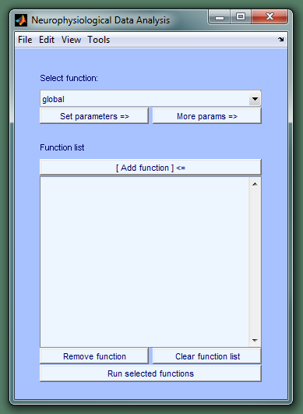

Load the template setup file.

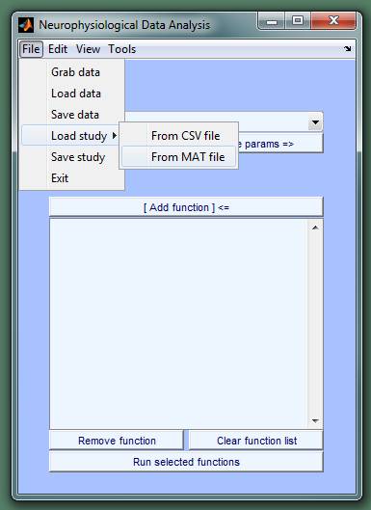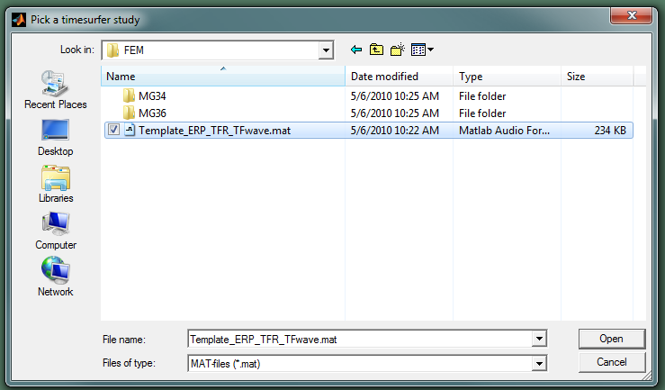

The template setup file has one subject, template, with three batches: ERP, TFR, and TF waves. The functions for a selected batch are displayed in the Function list. The Function list may also contain a “global” specification for parameters that will be passed to all functions with the same values. As shown below, the ERP batch consists of two calls to the **ts_process_ieeg_data** function and one call to each **ts_statistics_wrapper** and **ts_ezplot** as well as a set of **global** parameters. In addition to these batches, the template setup file also contains a list of pre-defined rules that are based on the previously discussed directory and file naming conventions. We will be able to use those rules to help set several parameters that vary across subjects.

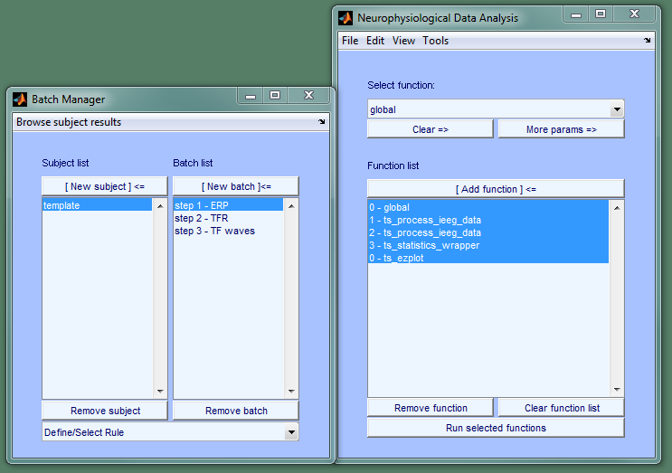

The first thing we need to do is set task-specific parameter values. That may include event codes, epoch parameters, pre-processing parameters, other analysis parameters, and plotting parameters. For this tutorial, we need to set the following parameters:

|  |  |  |  |
| --- | --- | --- | --- |
| **[Protocol step] Function** | **Parameter label (name)** | **Value** | **See help** |
| [ERP batch] |  |  |  |
| global | bpfilter | yes | ts_preproc() |
|  | blfreq | [.1 30] | ts_preproc() |
|  | blc | yes | ts_preproc() |
|  | blcwindow | [-.375 -.125] | ts_preproc() |
| [1.1] ts_process_ieeg_data | channels | [1:5] |  |
|  | time limits (timelimits) | [-.5 2] |  |
|  | epoch_combinations | {'1+2+7+8','3+4+9+10','5+6+11+12'} | ts_combine_conditions() |
|  | epoch_neweventcodes | [15:17] | ts_combine_conditions() |
| [1.2] ts_process_ieeg_data | average_combinations | {'1+2+7+8','3+4+9+10','5+6+11+12'} | ts_combine_conditions() |
|  | average_neweventcodes | [15:17] | ts_combine_conditions() |
| [1.3] ts_statistics_wrapper | events | {[ 15 16],[ 15 17],[ 16 17]} | ts_statistics() |
| [1.4] ts_ezplot | events | {[ 15 16],[ 15 17],[ 16 17]} |  |
|  | xlim | [-.2 1.5] |  |
| [TFR batch] |  |  |  |
| [2.1] ts_freqanalysis_fieldtrip | baseline correction (blc) | yes |  |
|  | baseline window (blcwindow) | [-.375 -.125] |  |
|  | events | {[15],[16],[17]} |  |
| [2.2] ts_ezplot | events | {[15],[16],[17]} |  |
|  | baseline window (blcwindow) | [-.375 -.125] |  |
|  | xlim | [-.2 1.5] |  |
| [2.3] ts_PLV | events | {[15],[16],[17]} |  |
| [2.4] ts_syncplot | events | {[15],[16],[17]} |  |
|  | time limits (toilim) | [-.2 1.5] |  |
| [TF wave batch] |  |  |  |
| global | blc | yes |  |
|  | blcwindow | [-.375 -.125] |  |
| [3.1] ts_freqband_average | events | [15 16 17] |  |
|  | baseline window (blcwindow) | [-.375 -.125] |  |
| [3.3] ts_statistics_wrapper | events | {[ 15 16],[ 15 17],[ 16 17]} |  |
| [3.4] ts_ezplot | events | {[ 15 16],[ 15 17],[ 16 17]} |  |
|  | baseline window (blcwindow) | [-.375 -.125] |  |
|  | xlim | [-.2 1.5] |  |
| [3.5] ts_ezplot | events | {[ 15 16],[ 15 17],[ 16 17]} |  |
|  | baseline window (blcwindow) | [-.375 -.125] |  |
|  | xlim | [-.2 1.5] |  |

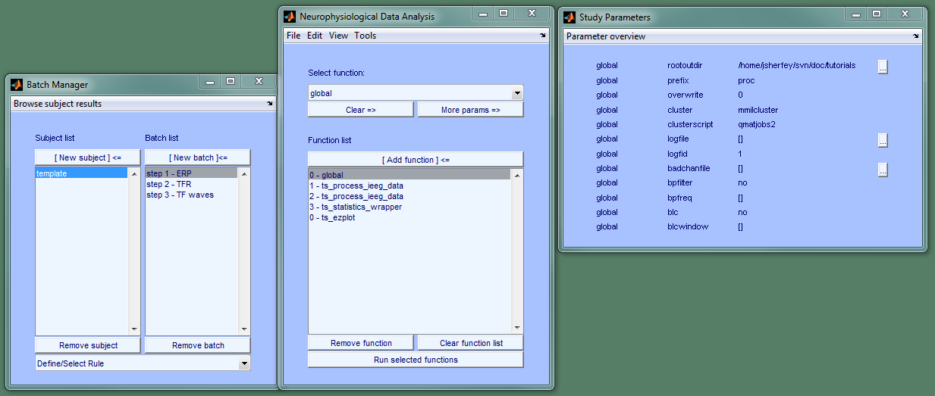

Right-click on bpfilter “no” =>

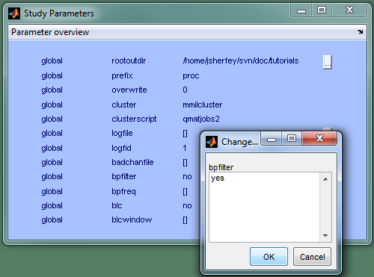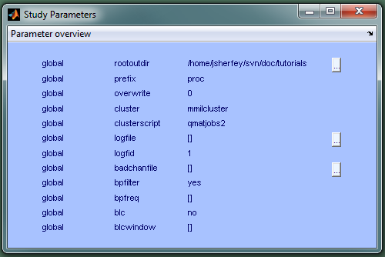

Repeat for bpfreq, blc, and blcwindow.

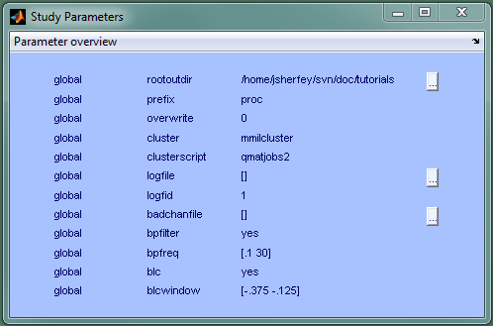

Select the next function: ts_process_ieeg_data.

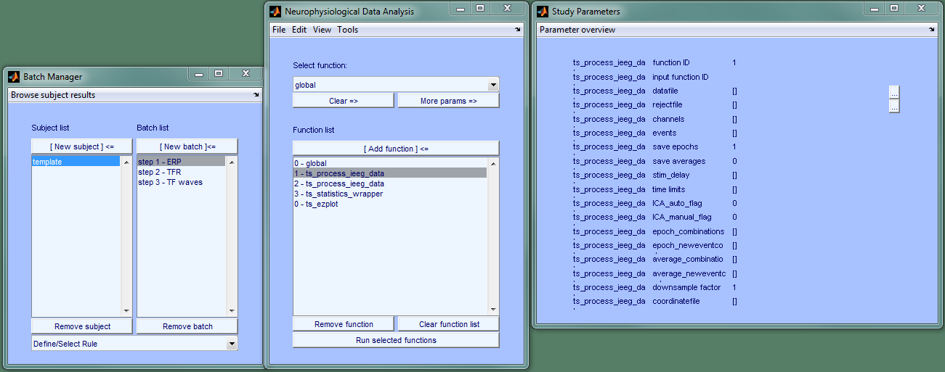

Repeat the process for this function.

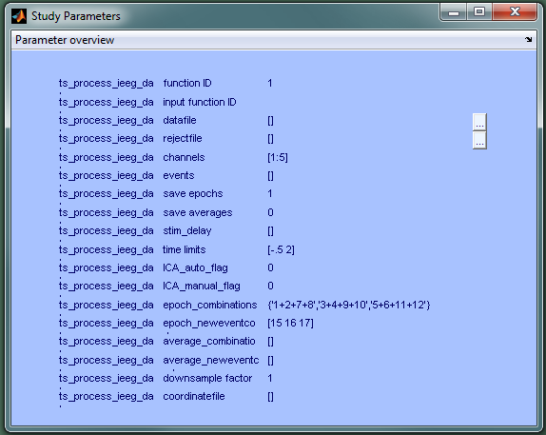

Repeat for the other functions in this batch: ts_process_ieeg_data, ts_statistics_wrapper, and ts_ezplot

Now, move on to the second batch.

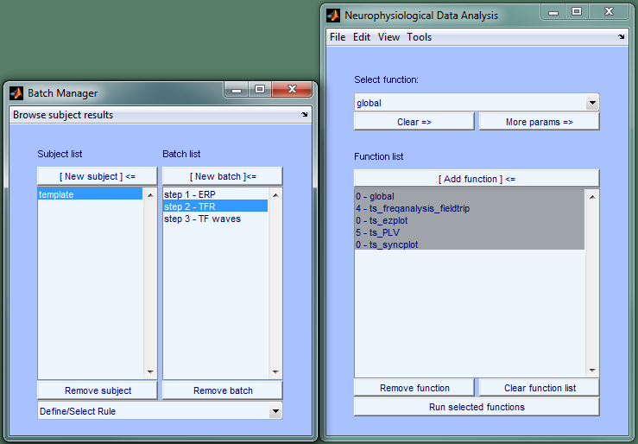

Repeat the process for these functions and then the third batch:

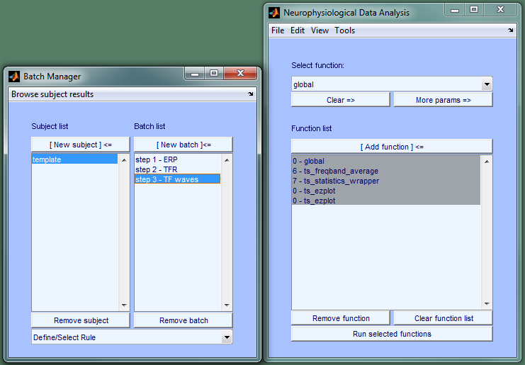

Now that we've set the task-specific parameters, we can set up our subjects. Copy the template and name the new subjects. Select the template and click “New subject” in the Batch Manager.

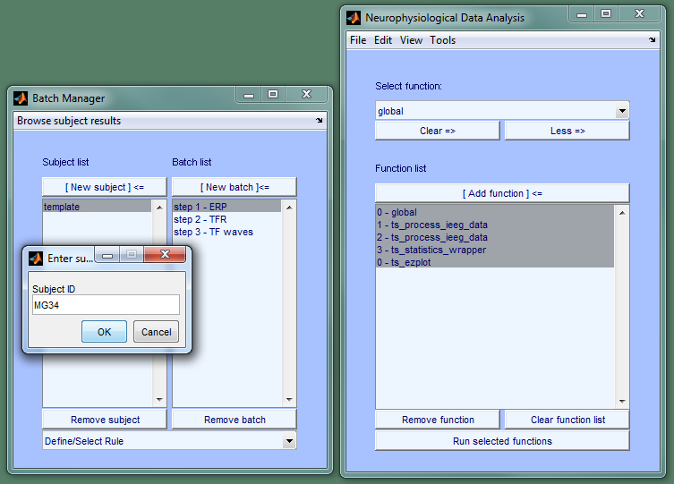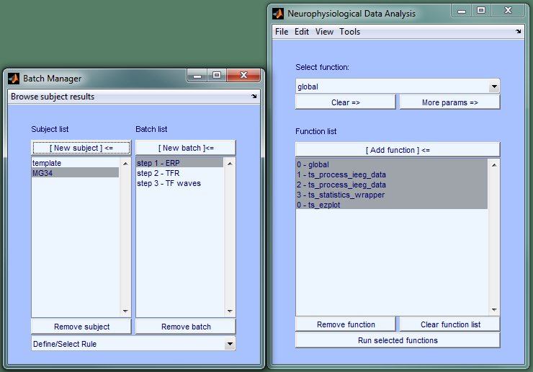

Repeat for MG36.

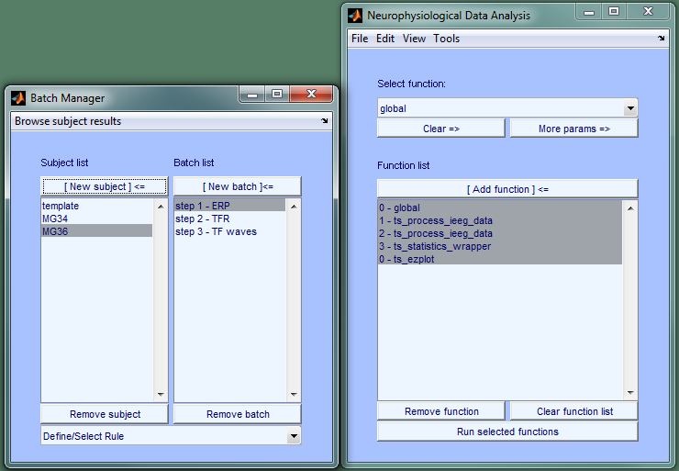

Now we can complete the rule specification and use rules to set parameters that vary systematically across subjects.

Open the Rule Manager =>

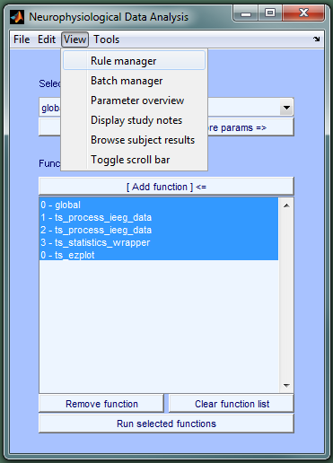

The template setup file has 10 pre-defined rules that we can use to help set global parameters (rootoutdir, prefix, badchanfile, and conditionkey), the rejectfile in ts_process_ieeg_data, and plotting parameters for ts_ezplot (title, statfile). The pre-defined rules adhere to the directory structure and file naming conventions described at the beginning of this tutorial. All we need to do in order to use these rules is create two constants: ROOT and TASK. In the illustration on the next few pages, ROOT is set to “/home/jsherfey/doc/Tutorial5/FEM.” You should set ROOT to your <OutputDirectory>. TASK will be set to “FEM”

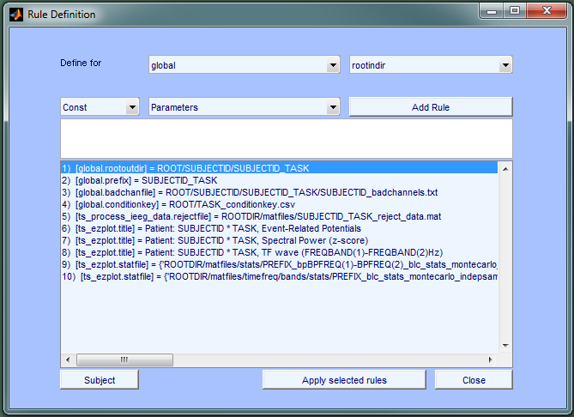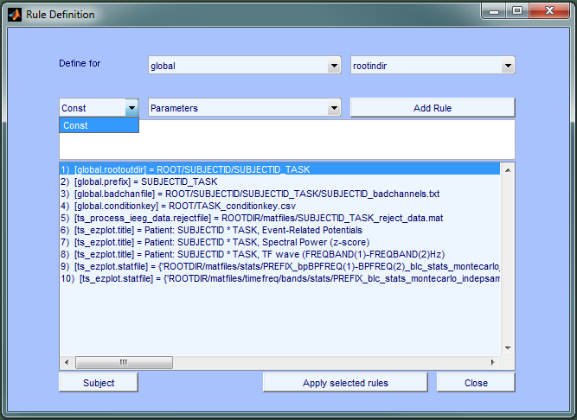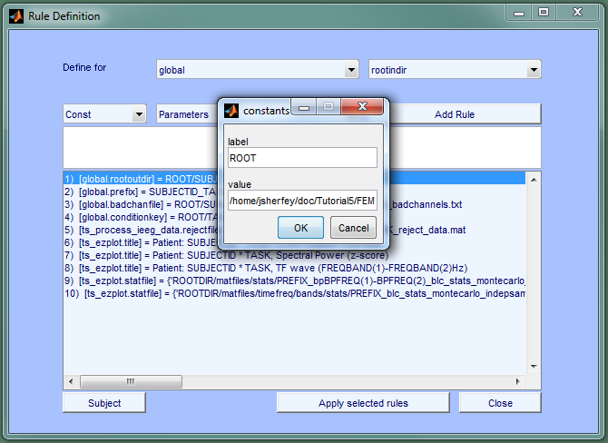

Click ok and repeat for TASK

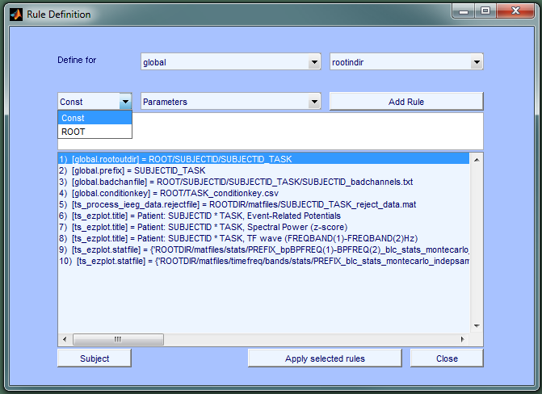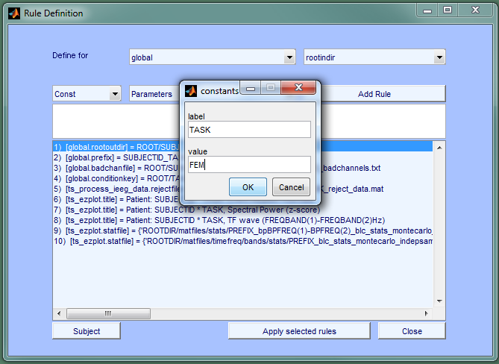

After defining ROOT and TASK, we are ready to apply the rules.

The first four rules apply to all batches for both subjects. Select both subjects, all three batches, the first four rules, and click "Apply selected rules."

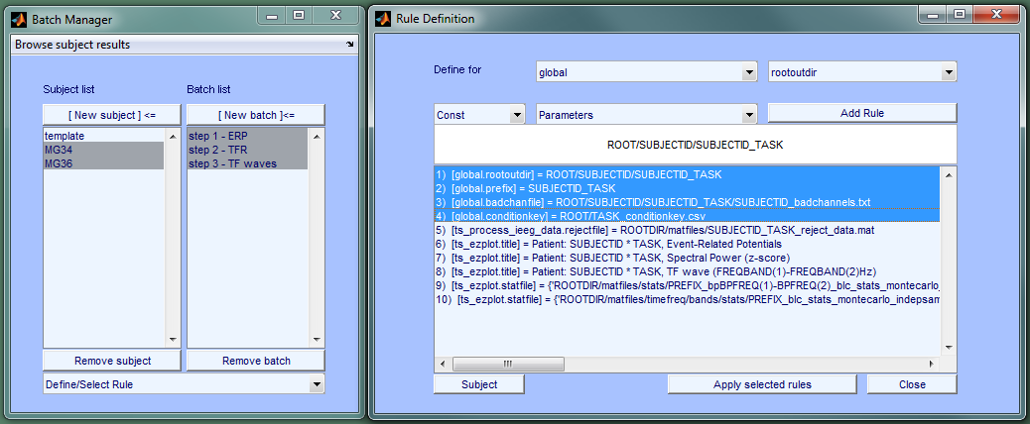

Rules 5, 6, and 9 apply to the first batch.

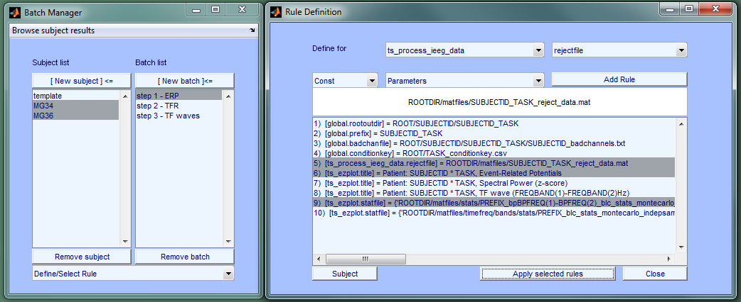

Finally, apply rule 7 to the second batch and rules 8 and 10 to the third batch. Then close the Rule Manager.

The only remaining parameter specifies the input data file; we did not assume a naming convention and cannot define a rule for those. We must specify them manually, individually.

Click on MG34, ERP batch, and the first ts_process_ieeg_data call.

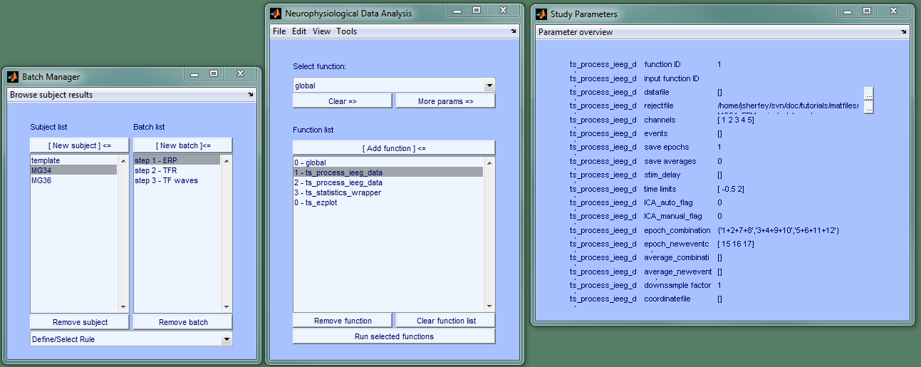

Click on the button to the right of datafile and browse to the input data file. Select it and click ok.

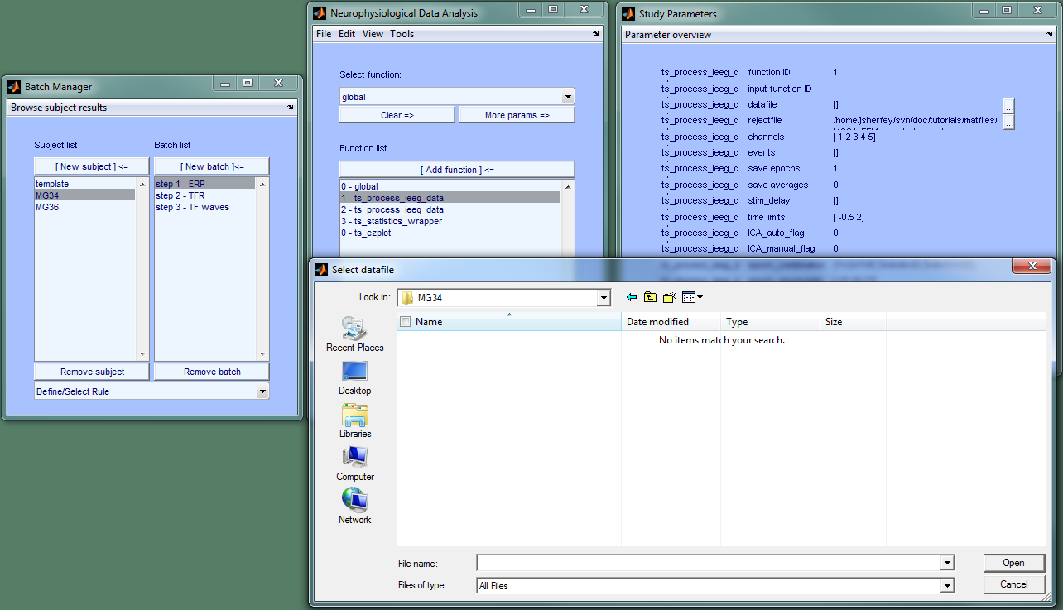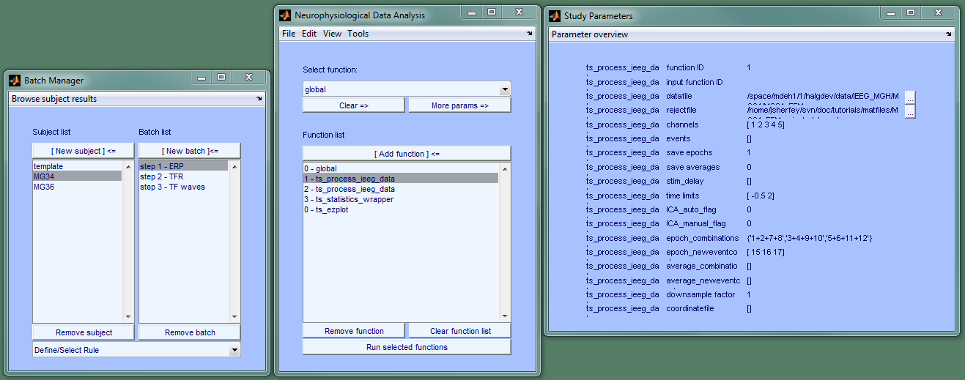

Repeat the process for MG36.

This completes the setup of our analysis protocol for MG34 and MG36. Select both subjects, all three batches, and click "Run selected functions."

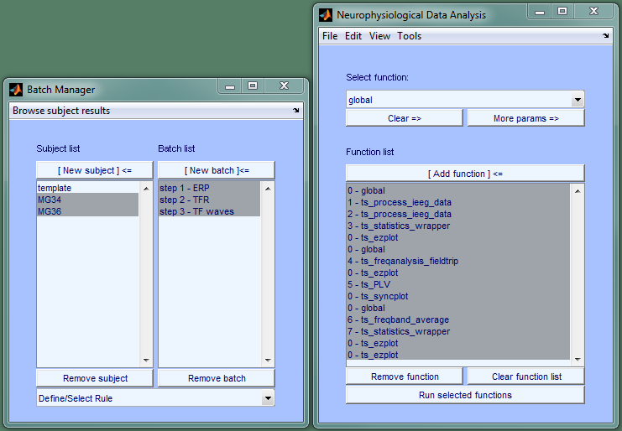

The analysis will take a while to run and generate all the output files listed at the beginning. We can browse results using the results browser.

In the Batch Manager, select a single subject, MG34, and click "Browse subject results."

The left listbox displays all directories where results were saved for MG34.

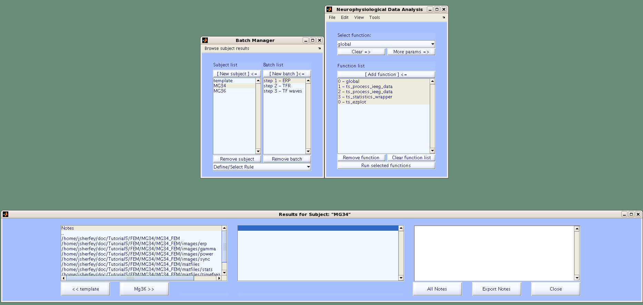

The central listbox displays the contents of the selected directory (rootoutdir below). rootoutdir contains several log files including outfiles.log (list of saved files) and session.log (standard output).

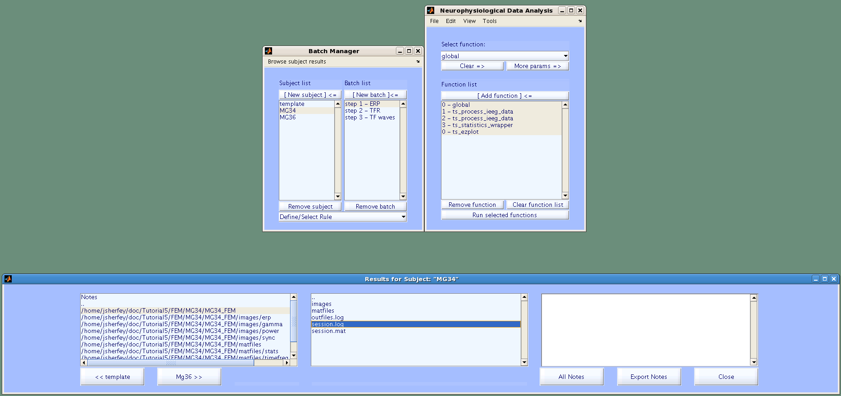

Selecting “outfiles.log” in the central listbox opens the “File Viewer” and displays a list of all saved files.

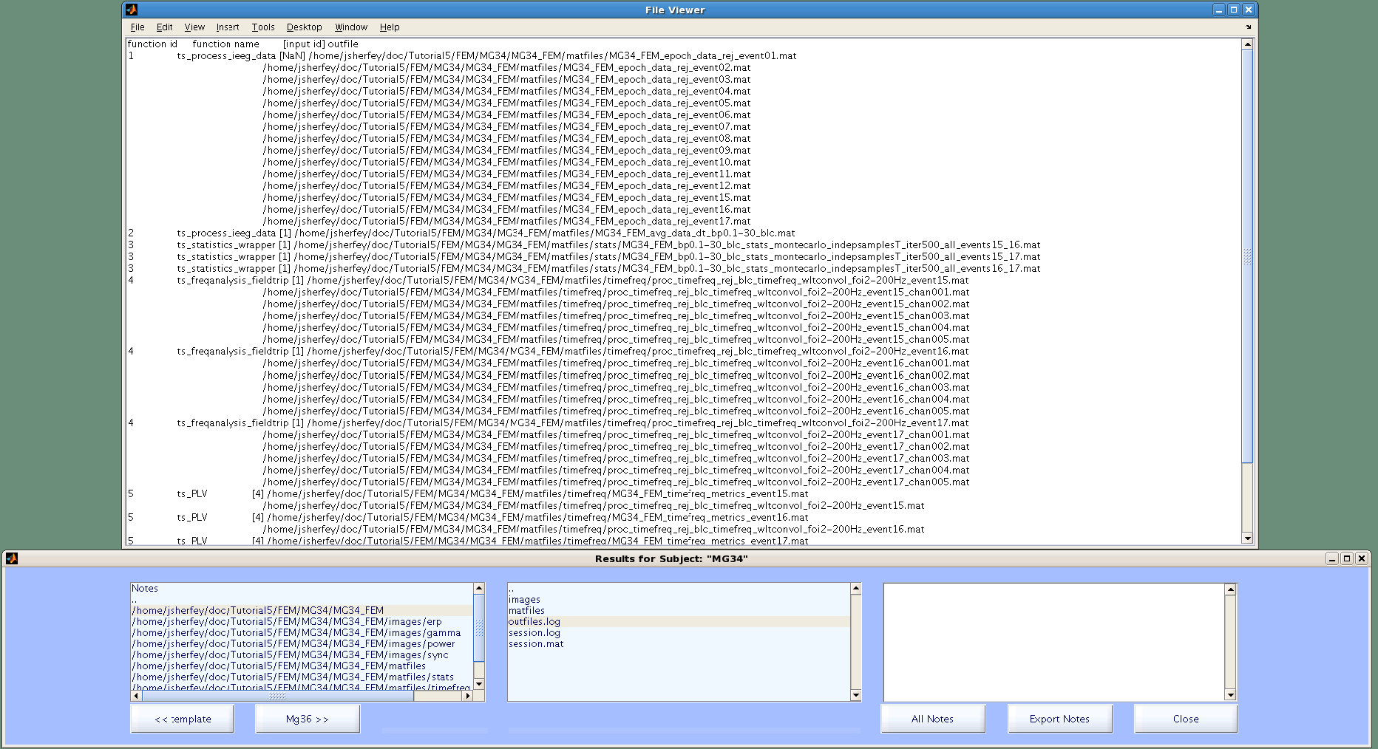

Selecting “session.log” displays the standard output recorded for MG34.

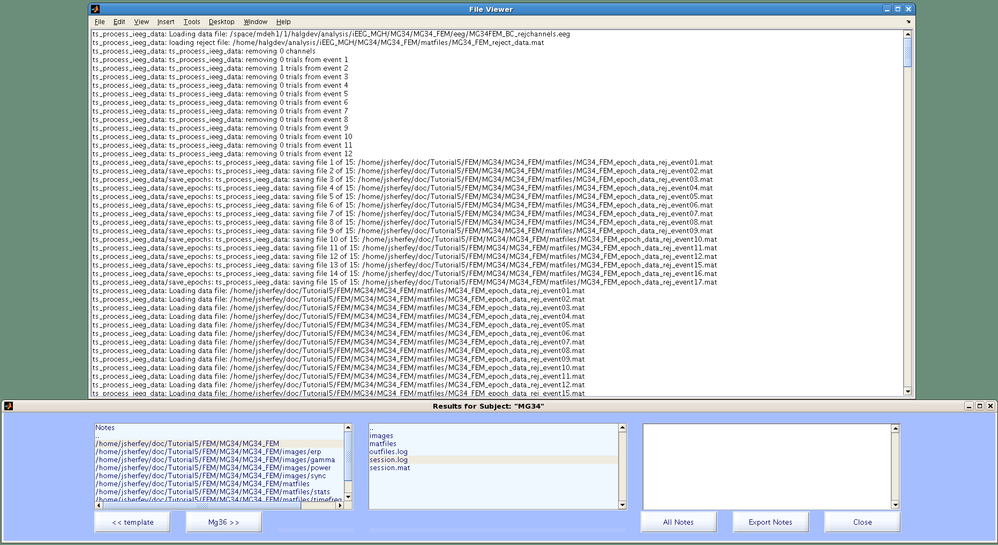

Happy:

Browsing to an images directory in the left box and selecting an image in the central box will open the image. The spectral power image for the five analyzed channels in the Happy condition is shown below.

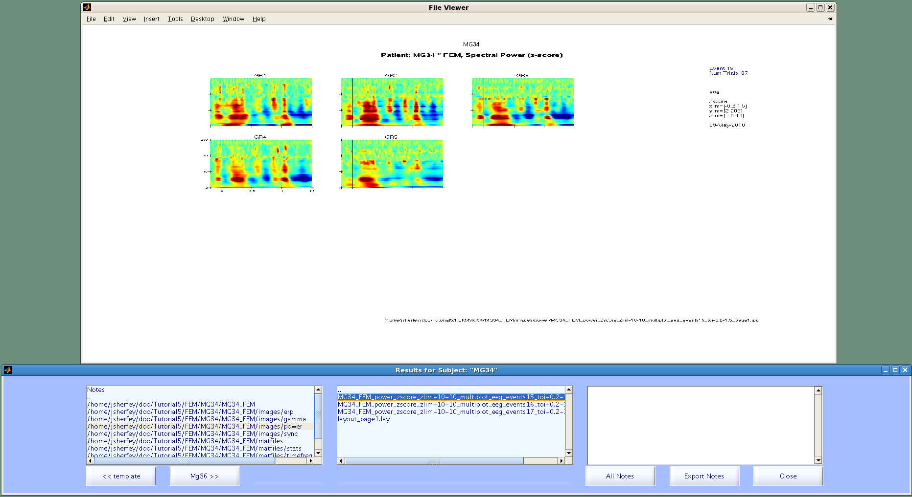

The next image in the same directory is the spectral power in the Sad condition. There are obvious differences that can be noted in the right listbox.

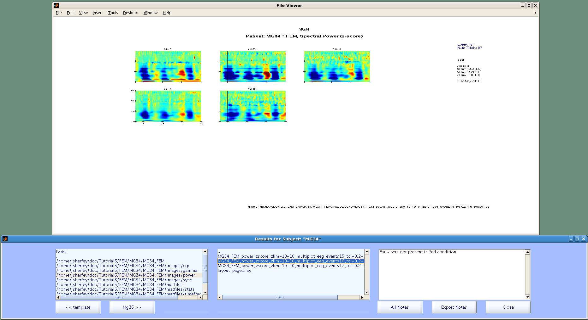

Notes:

The first item in the directory box is the word “Notes.” Clicking on Notes displays a list of files with user notes (that were added using the right comment box) in the central box. Clicking on a file in the central box will open the file for viewing and display any notes in the right box. Notes can be modified or added at any later time.

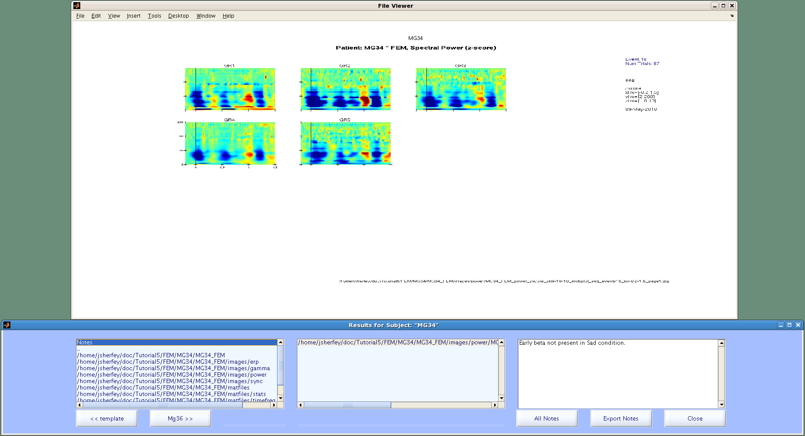

The buttons at the lower-left corner can be used to move to the next or previous subject. This shows the contents of outfiles.log as well as a note that was made about that file:

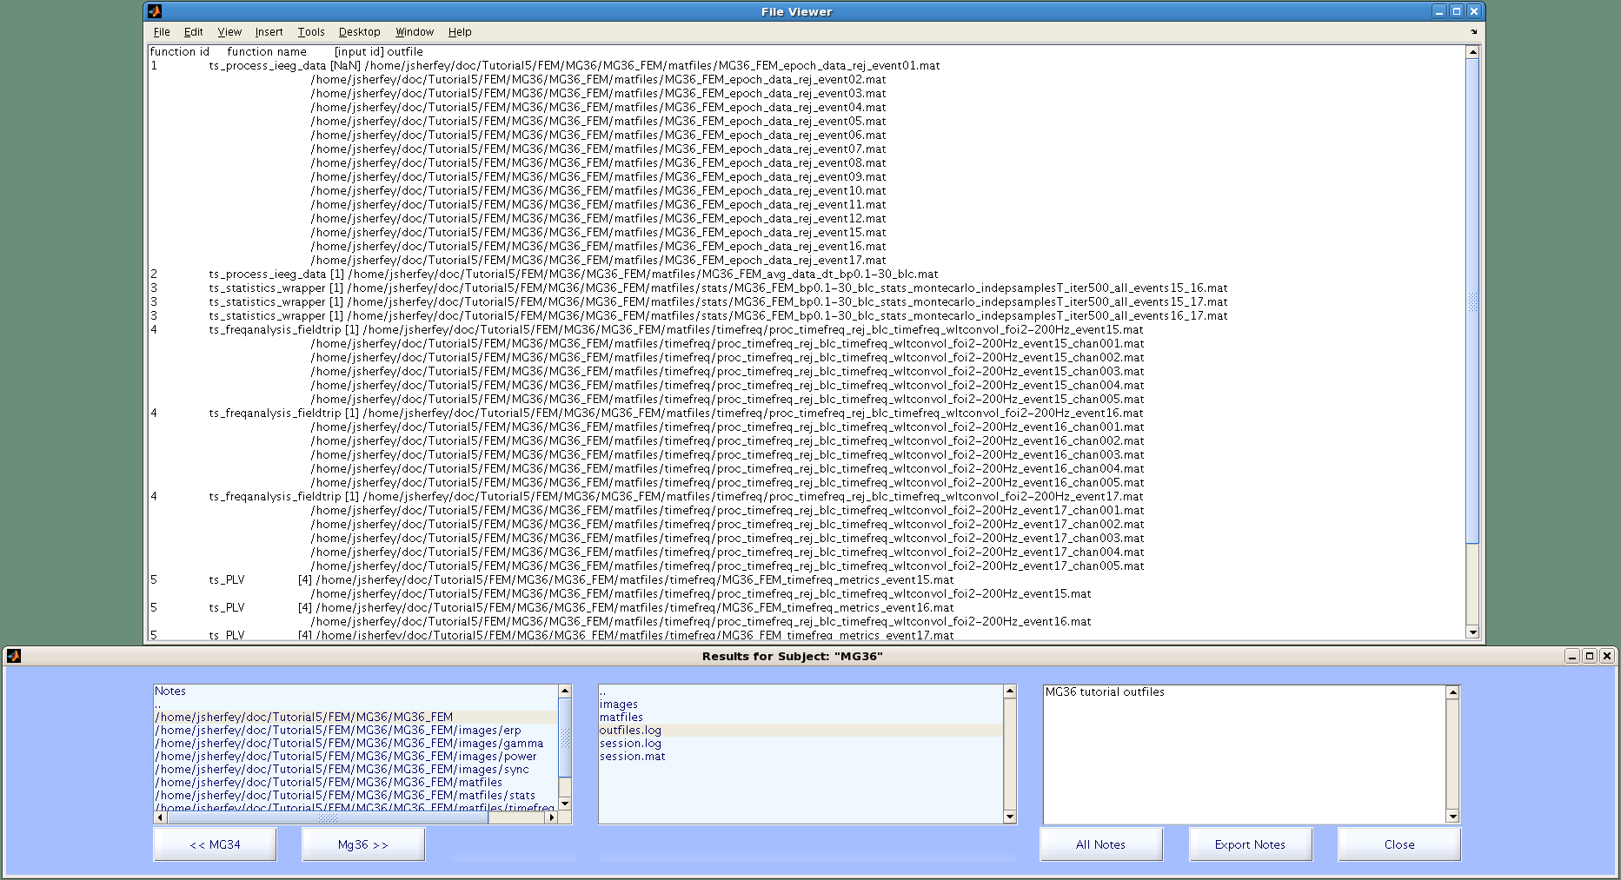

Clicking on the button “All Notes” displays a list of all the notes for all the subjects in the command window:

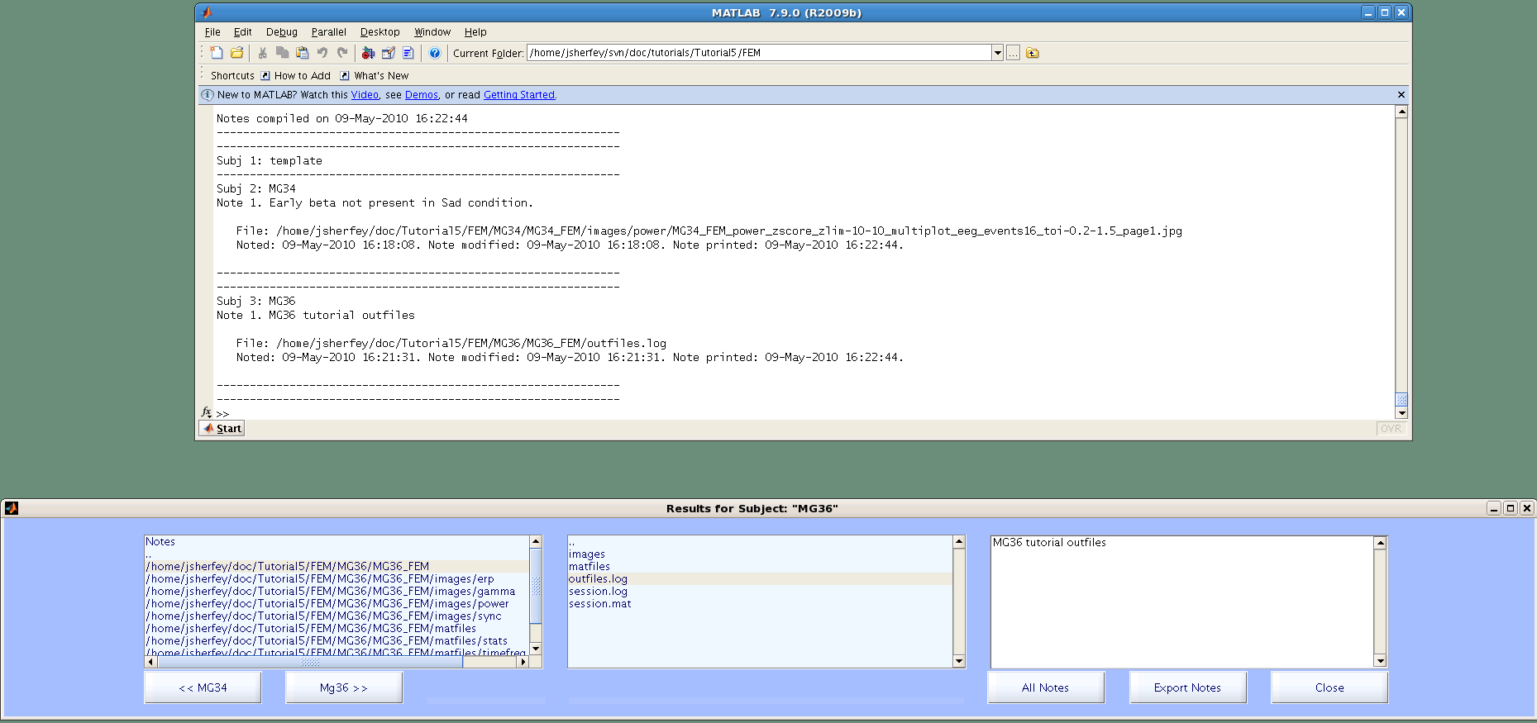

Clicking on “Export Notes” allows the user to save all task notes to a TXT file (the same text displayed by clicking “All Notes”).

The best way to view phase-locking images is to use syncview as described in Tutorials 2 and 3.

To add a new subject:

1. Select the template in the Subject list in the Batch Manager
2. Click “New subject” and name the new subject
3. Select the new subject in the Subject list and apply rules to the same batches as done for MG34 & MG36
4. Manually browse to the new subject’s *datafile* in the first call to ts_process_ieeg_data in the ERP batch
5. Select the new subject and all three batches, then click “Run selected functions”

To set up a different task:

If you adhere to the same directory structure and file naming conventions as followed in this tutorial, the entire procedure is identical except for ROOT, TASK, and *conditionkey*. Remember: *datafile*, *rejectfile*, and *badchanfile* are always different for each subject and must be prepared before starting the analysis.

Always save the STUDY file before closing Matlab or Exiting the TimeSurfer GUI. Notes are saved with the STUDY file; the only time the STUDY file is automatically saved is after executing selected functions.