Tutorial 1 - Interactive ERP

Load event-related data, preprocess (linear detrending, baseline subtraction, and band-pass filtering), average over epochs, and display the result.

C:\Users\Owner\Desktop\MMIL\TS Documentation\tutorials\FastWords

Neuroscan EEG epoch data file: NY77_FWIO.eeg

Procedure

1. Launch the TimeSurfer graphical interface
2. Load data
3. Select Preprocessing from the function drop-down menu
4. Specify the desired pre-processing parameters
5. Select EZ Plot from the function drop-down menu
6. Specify plotting parameters
7. Click run to pre-process and plot the data currently selected in the Datasets list

Note: if multiple data sets are selected in the Datasets list, they will be processed independently, in turn, starting at the top of the list.

Note: the same procedure works for MEG, EEG, and intracranial recordings.

Tip: hover over parameter names to see helpful information on particular parameters.

Launch the TimeSurfer graphical program by typing "timesurfer" at the Matlab command-line.

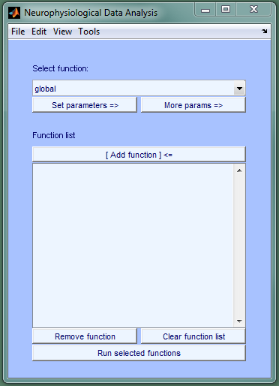

Load event-related data (ex., MEG, EEG, iEEG).

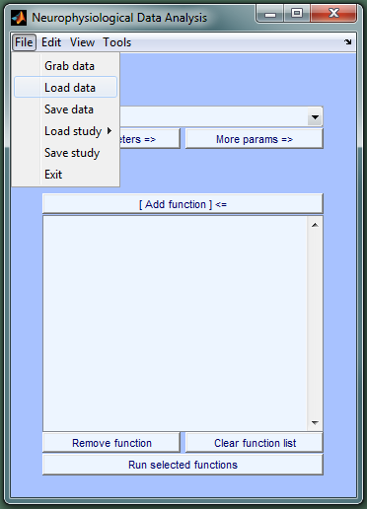

Select the data file and click Open.

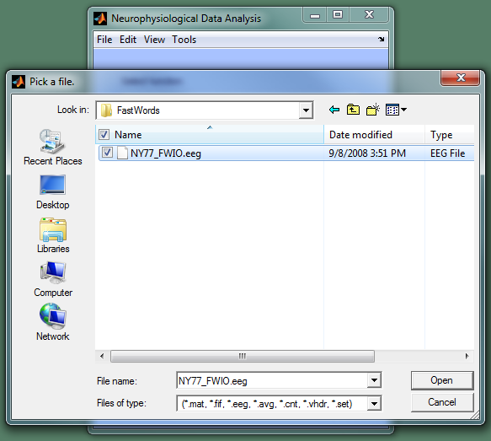

The data is added to the Datasets list and information on it is displayed in a second figure. The name of the data set in the Datasets list can be changed by right-clicking on the item in the list.

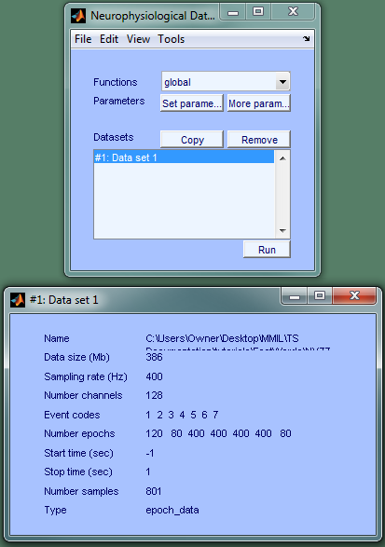

Select the first function that will be used to process the loaded data. The Preprocessing function (ts_preproc) will be used to detrend, baseline subtract, and filter the data.

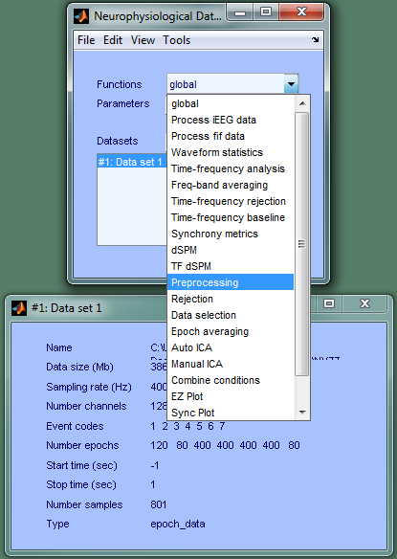 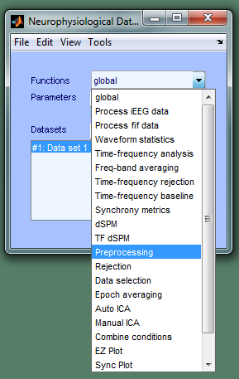

Selecting a function in the function drop-down menu produces another figure that displays the function's parameters and their default values. 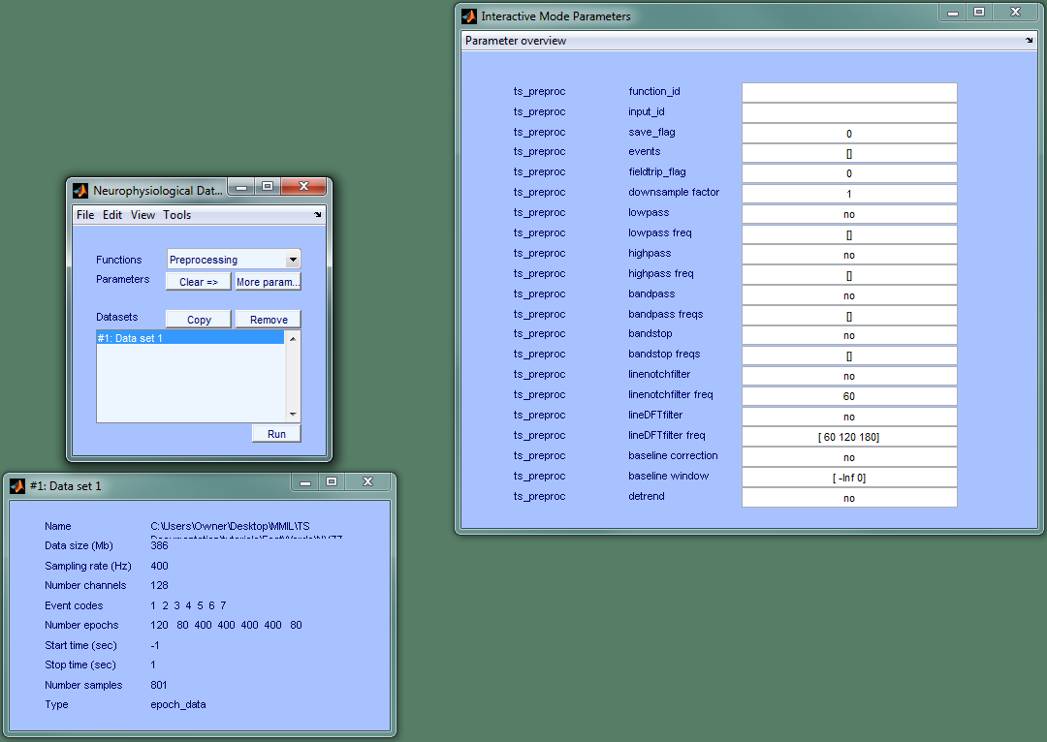

Hovering over a parameter name displays information about it (purpose; defaults; etc). Parameter values can be modified by typing the new value in the edit box next to the parameter name. Specify preprocessing options by editing values in the edit boxes. Parameter values are instantly updated. 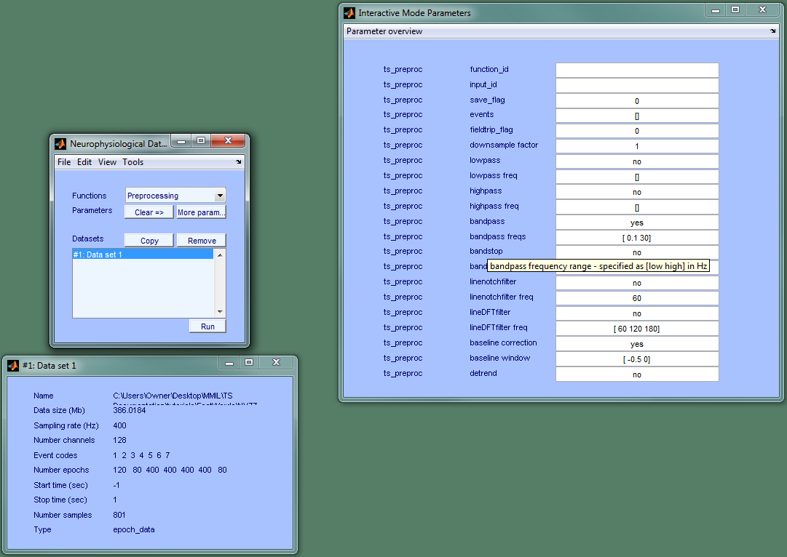

Select the function that will process the output of ts_preproc(). The EZ Plot function (ts_ezplot) averages over epochs by default and displays the resulting averages. It can plot waveforms, power, and synchrony metrics as multi-plots or topo-plots and has a large number of parameters that provide a high-level of control over what is plotted, how it's plotted, and how it looks.

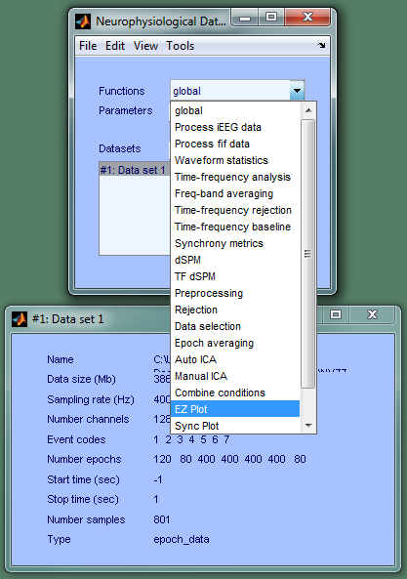. 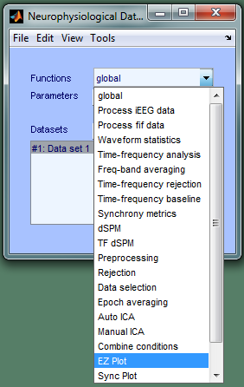

Set plotting parameters. Buttons to the right of parameter edit boxes can be used to graphically select files (ex., conditionkey, layout, statfile) and directories (ex., outpath).

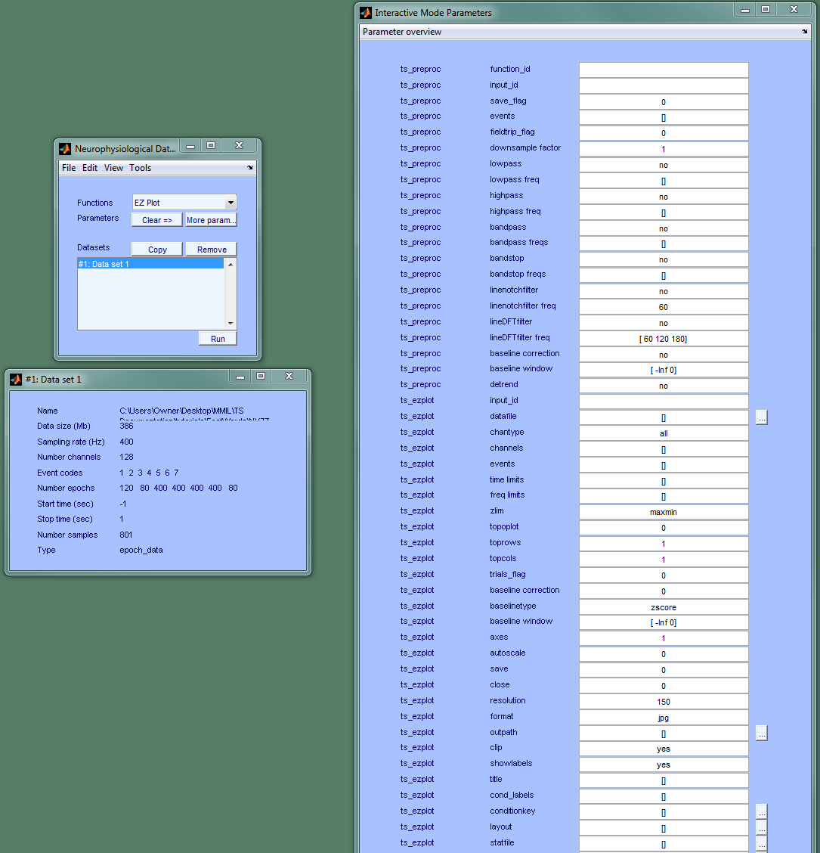

Set trials_flag to 1 to display an overlay of epochs in each channel. Set topoplot to 1 to generate topoplots (multiplots are generated by default).

Click Run to process the data selected in the Datasets list using the functions displayed in the right parameter figure with the parameter values shown.

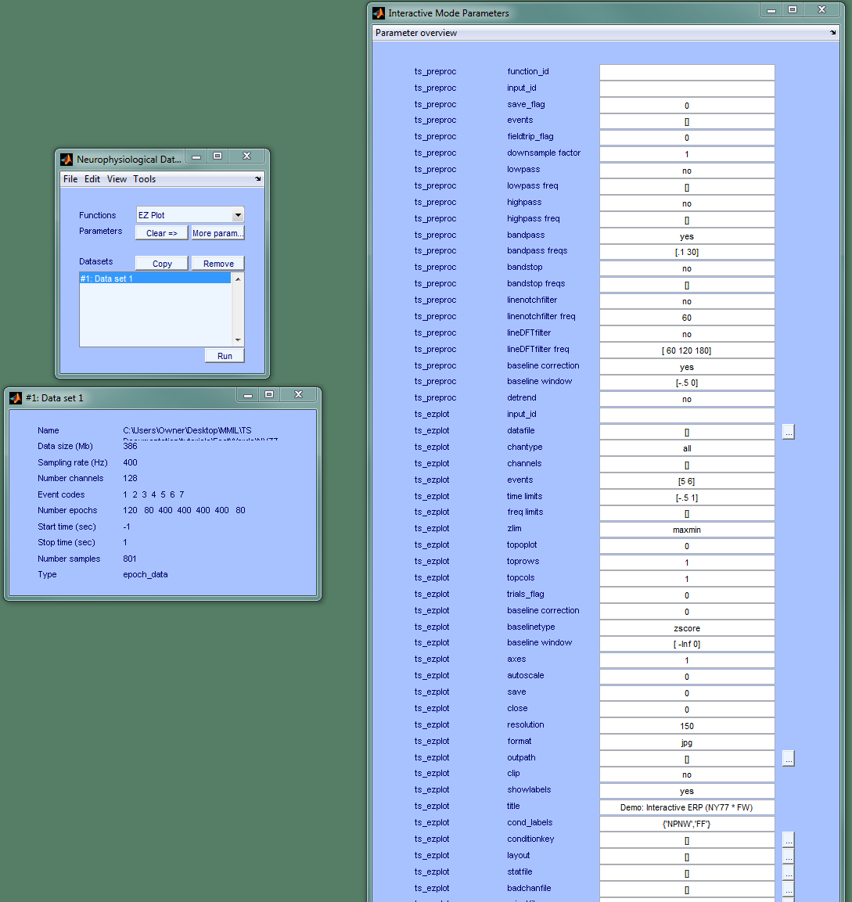

Multi-plot of ECoG grid electrodes G1-G58, averaged over epochs after detrending, baseline subtraction, and band-pass filtering. Each channel shows an overlay of two conditions (False Fonts and Non-Pronounceable Non-Words).

