Tutorial 4 - Visual Artifact Rejection

Artifact rejection using the TimeSurfer graphical interface with FieldTrip-based visual rejection tools.

The TimeSurfer GUI provides a high-level interface to FieldTrip's visual artifact rejection tools. It keeps separate rejection records for each data set and supports iterative rejection procedures. It can save the final record of rejected trials and channels in a format that can be read by subsequent functions in the TimeSurfer (TS) processing stream.

The FieldTrip (FT) documentation includes a tutorial on using the visual rejection tools to identify and remove artifacts. The FT tutorial is located here: <http://fieldtrip.fcdonders.nl/tutorial/rejectvisual>

This tutorial will focus on (1) how to use the visual rejection tools in TS GUI and (2) how to integrate rejection information with automated batch processing. Consult the FT documentation for the theory and practice of identifying artifacts in MEG and EE G data.

Main idea:

Lists of rejected trials and channels identified using the rejection tools are organized in a "reject_data" structure. That structure can be saved to a MAT file which can be passed to subsequent TS functions using the "rejectfile" parameter. A human-readable TXT file is always saved by TS GUI with the MAT file.

Procedure:

1. Load data.
2. Preprocess raw data.
3. Use FT tools to identify artifacts and reject artifactual trials & channels.
4. Go through multiple iterations using a combination of visualization methods ('trial','channel','summary').
5. Save rejection information (lists of rejected trial numbers and channel labels).
6. Pass rejection information to subsequent TS functions using the rejectfile parameter.

Load event-related epoch data.

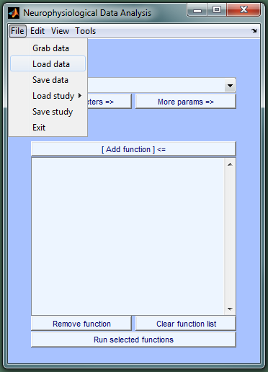

Select the data file and click Open.

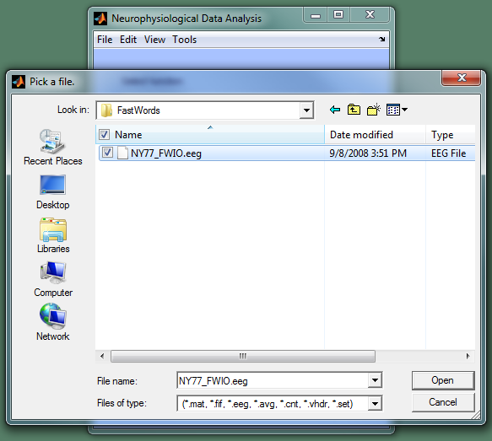

The data is added to the Datasets list and information on it is displayed in a second figure. The name of the data set in the Datasets list can be changed by right-clicking on the item in the list.

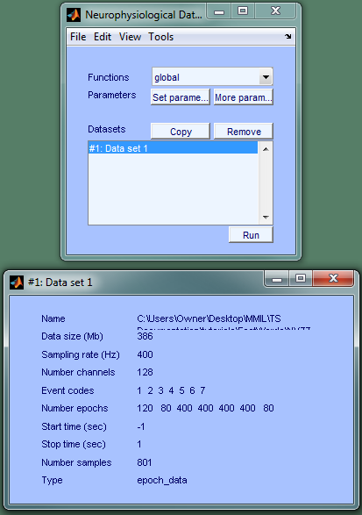

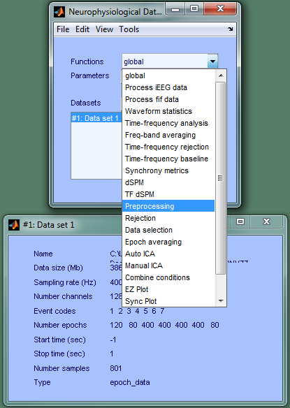 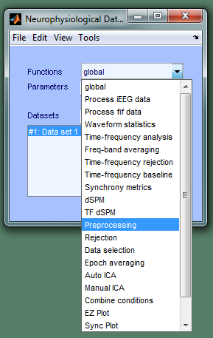

Selecting a function in the function drop-down menu produces another figure that displays the function's parameters and their default values. 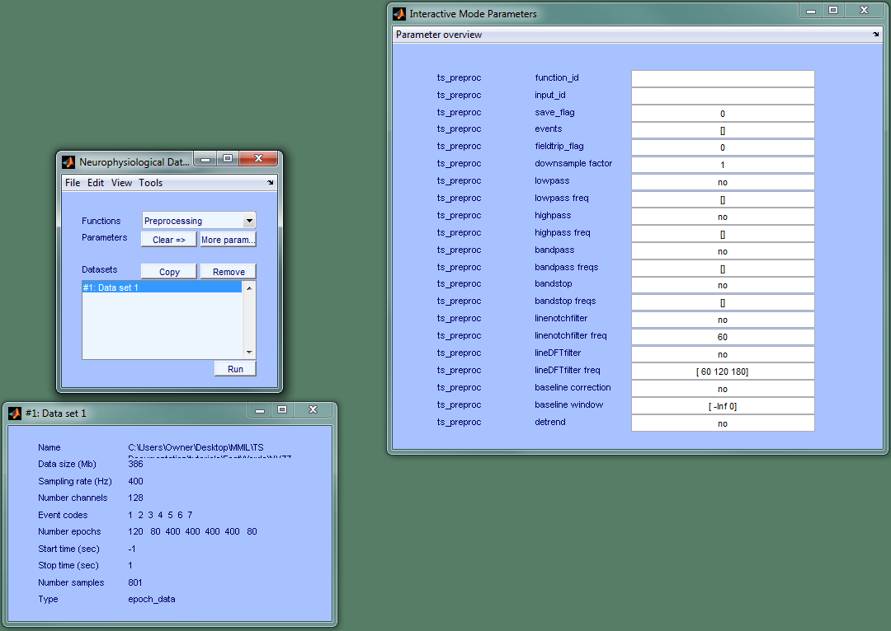

Hovering over a parameter name displays information about it (purpose; defaults; etc). Parameter values can be modified by typing the new value in the edit box next to the parameter name. Specify preprocessing options by editing values in the edit boxes. Parameter values are instantly updated. 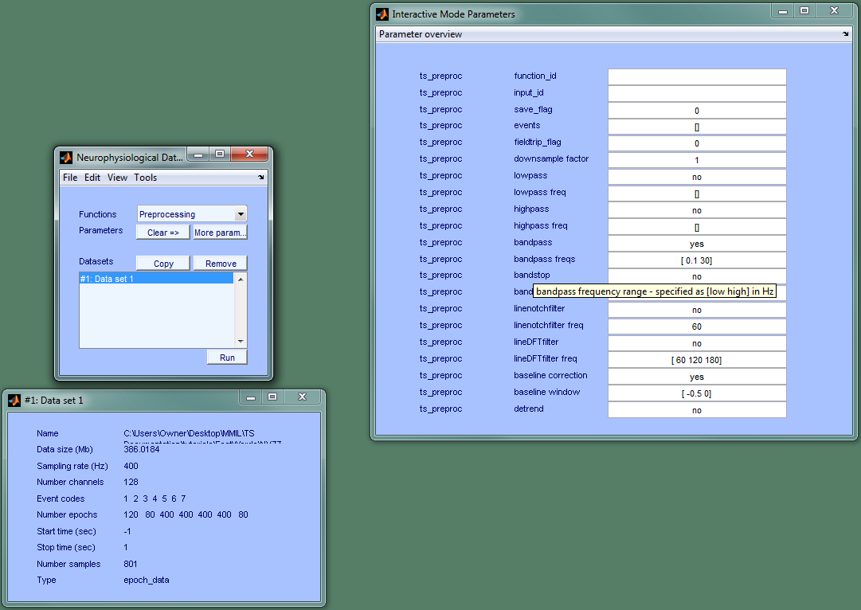

Use Data Selection to remove filter artifacts at the edges of each trial. We will also remove all conditions except NPNW and FF (event codes = [5 6]).

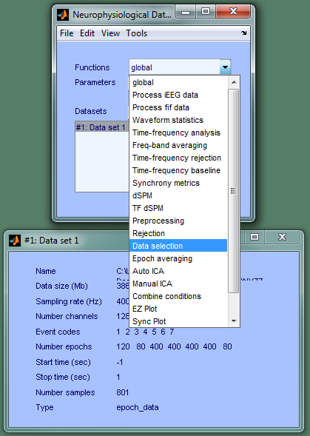 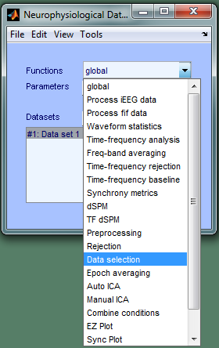

Click Run to process the data selected in the Datasets list using the functions displayed in the right parameter figure with the parameter values shown. The Start and Stop times displayed after the data is processed indicate that the trials have been trimmed.

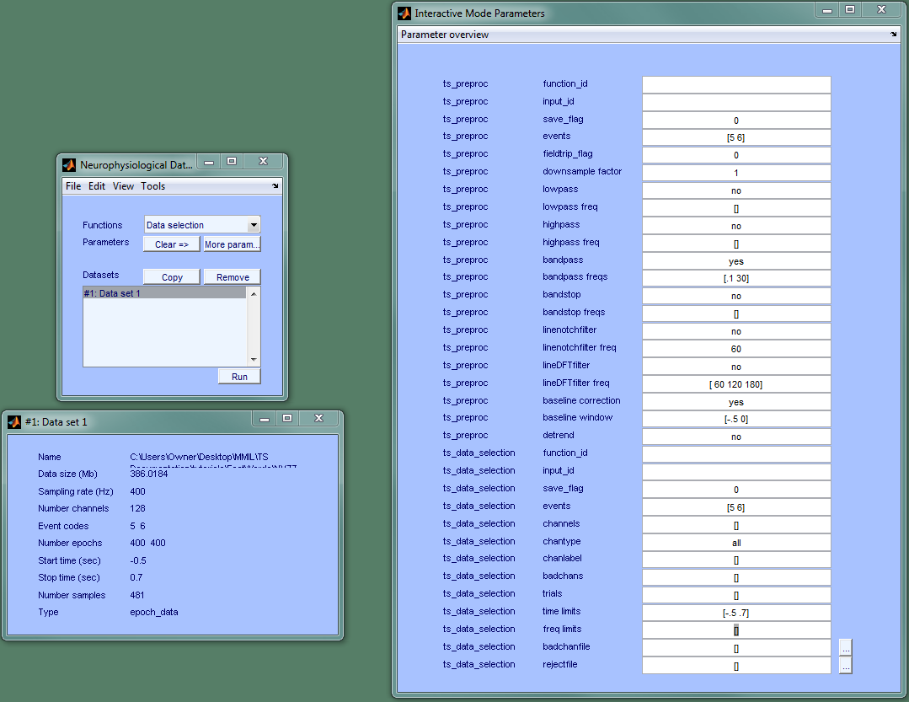

Right-click to rename the data set.

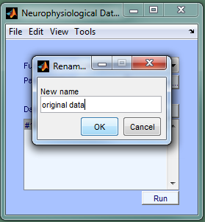 **=>** 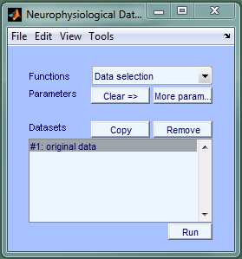

Visual artifact rejection, iteration 1 - trial => identify & remove extraneous channels

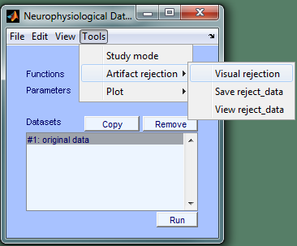 **=>** 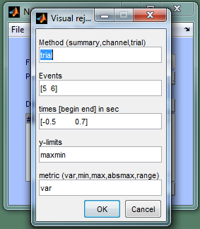

Note "View reject_data" and "Save reject_data"

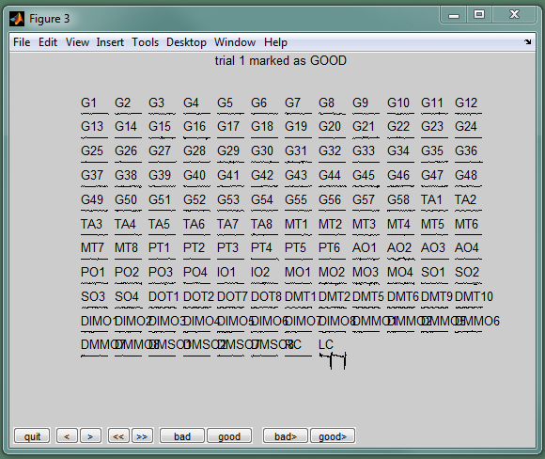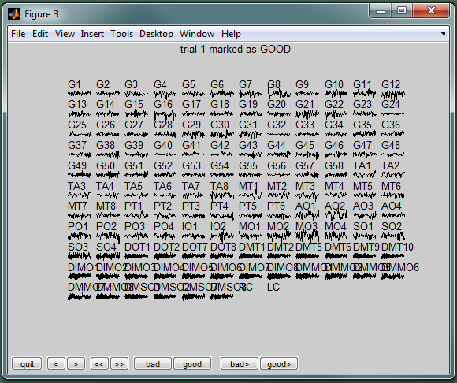

The rejected channels will be recorded after the rejection is completed by clicking Quit. Also, after clicking Quit, TS GUI will treat the structure resulting from removing rejected channels as a new data set. The new data set is added to the Datasets list with a default name. However, it can be renamed in the same way we renamed Data set 1 to "original data."

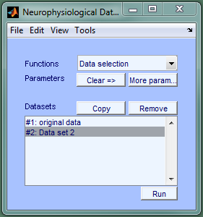 **=>** 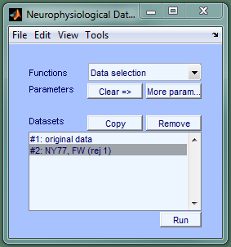

The results of the first iteration of visual rejection can be seen by selecting:

Tools => Artifact Rejection => View reject_data.

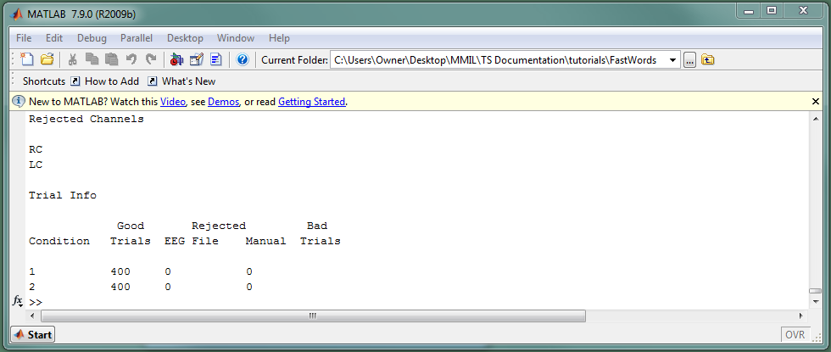

The FT "summary" method is a very quick way to identify artifacts based on cross-channel or cross-trial outliers with respect to a user-specified metric (ex. variance or maximum of the absolute value). The method is documented in the FT tutorial referenced at the beginning of this document.

TS GUI concatenates trials from all conditions before metric calculations are done in order to make it easier to apply the same subjective judgment to all conditions and avoid bias. Command-line instructions serve as a useful guide to the interactive selection of outliers. In the following figure, a box was drawn around five outlier trials with respect to variance calculated across all channels. All trials from both the NPNW and FF conditions are represented in these scatter plots:

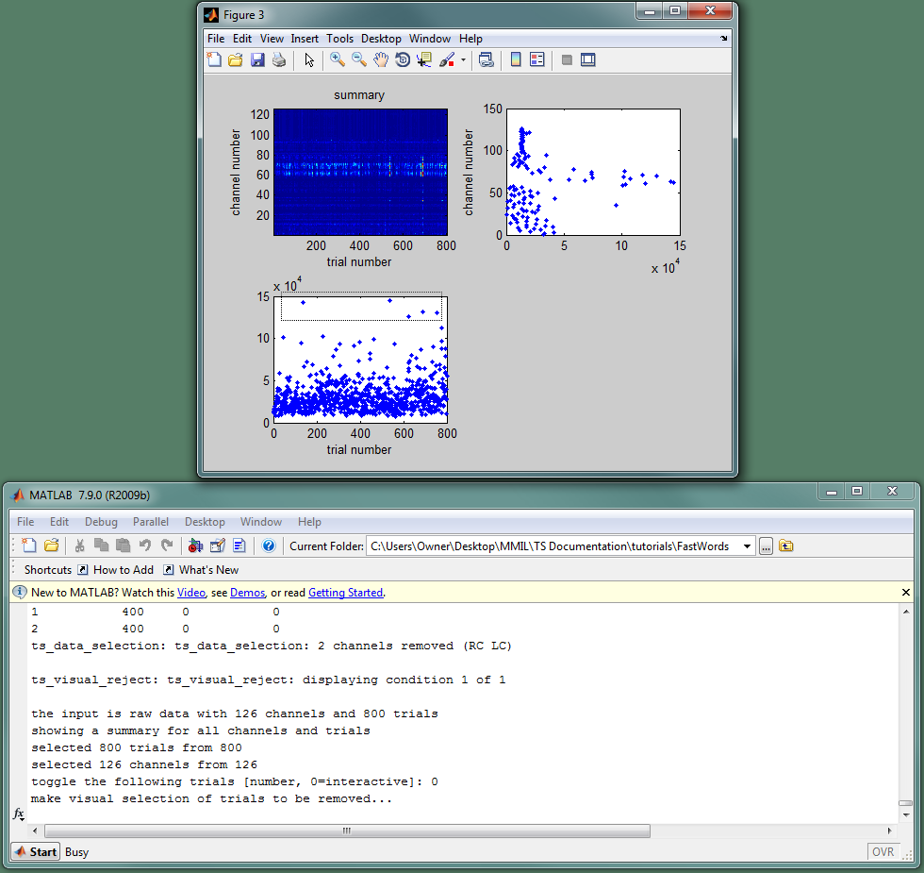

Removal of selected trials triggers the recalculation of the plotted metric and resets the command-line interface.

It is often helpful to temporarily remove channels when using the summary method so that extreme channel-outliers do not mask trials that are clearly artifactual with respect to signals in uncontaminated channels.

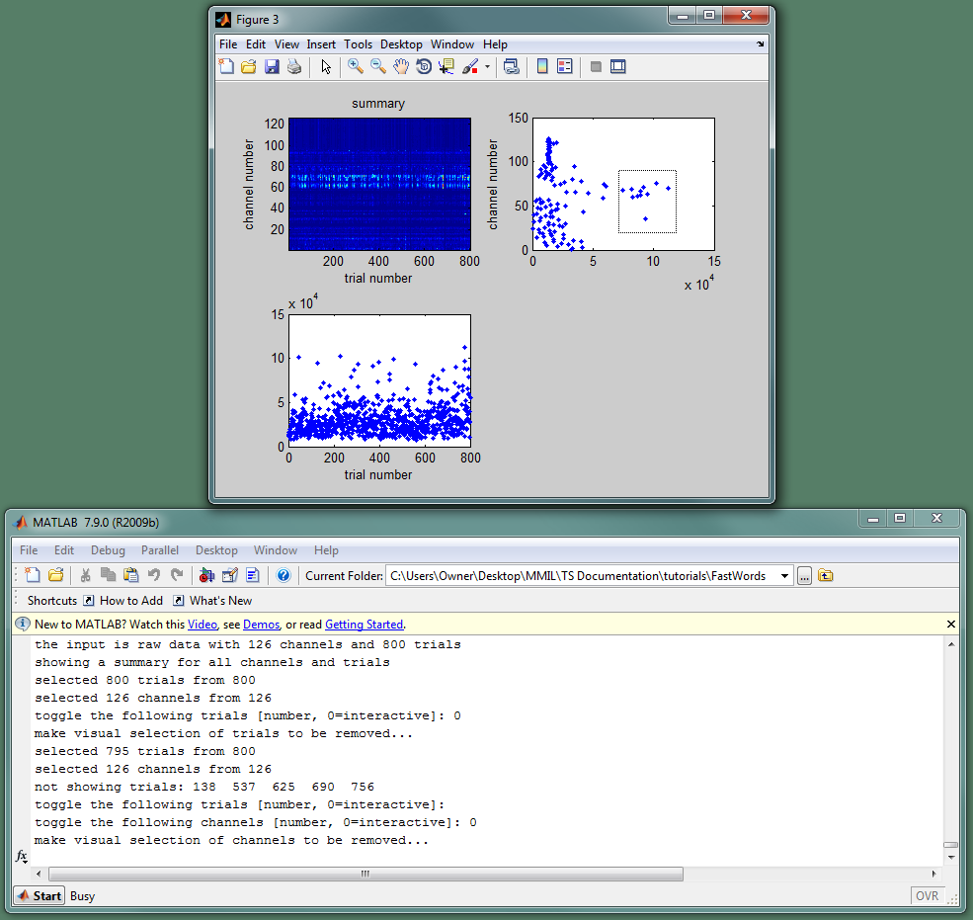

Removing the cluster of channels at the right-side of the upper-right scatter plot reveals three trials with abnormally large variances:

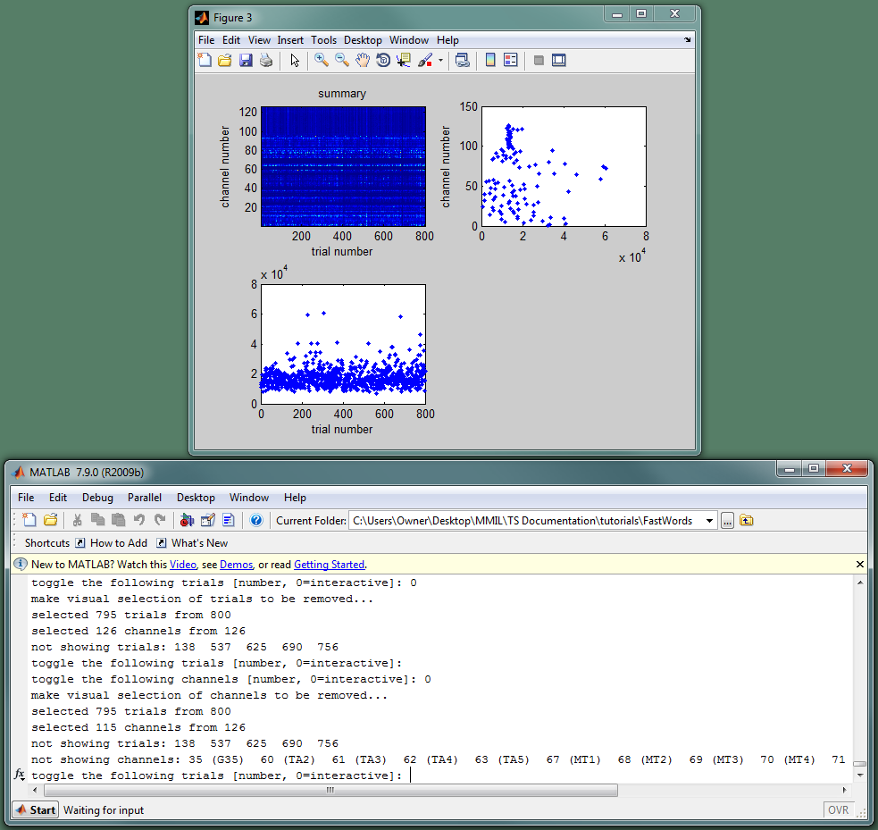

After removing the newly uncovered trial outliers and replacing channels, there are no more trials or channels with large-enough outliers to discard on the basis of scatter plots alone. The visual rejection could be continued using the either the channel or trial method or one of the summary method with a different metric. Each iteration of visual rejection will result in a new data set that is added to the Datasets list. Any set can be renamed at any time, and the rejects associated with a given data set can be seen at any time by selecting

Tools => Artifact rejection => View reject_data.

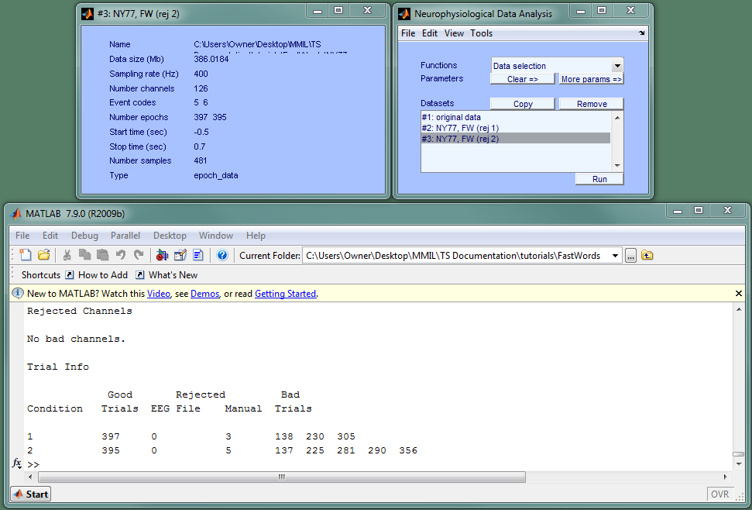

Once you are satisfied with the rejection, the rejected trials and channels can be recorded in a Matlab structure by selecting: Tools => Artifact rejection => Save reject_data.

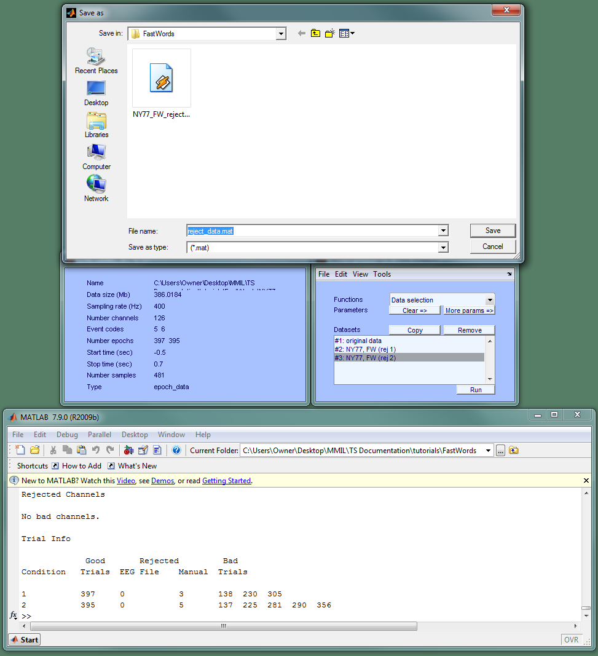

Using the rejection info:

Several functions including ts_data_selection, ts_ezplot, ts_statistics_wrapper, and ts_process_ieeg_data can use reject_data to remove trials and channels BEFORE processing data. To illustrate, select "Data Selection" in the function drop-down menu and set "rejectfile" to the name of the file just saved with reject_data.

Select the original data and click run:

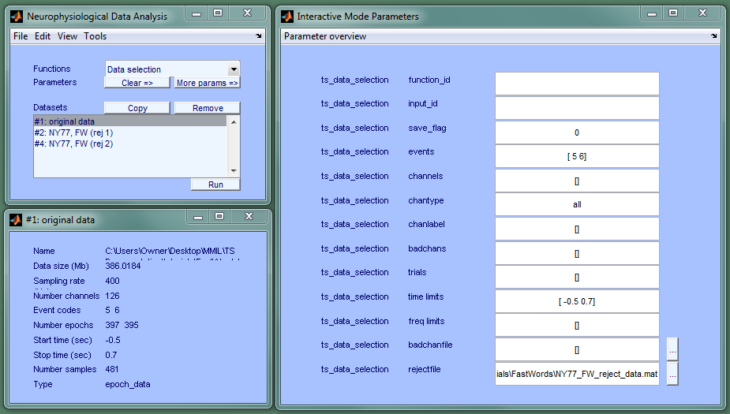

Notice that the trial and channel rejects have been removed (compare Number channels & Number epochs in this figure with numbers after the first call to ts_data_selection before starting visual rejection). In addition to saving reject_data, the original data set minus rejects could be saved directly using File => Save data.

Final note:

When setting up an event-related analysis protocol for iEEG data, the best place to use reject_data based on the original time series is ts_process_ieeg_data. However, reject_data & rejectfile can be used by many TimeSurfer functiuons and ard can be applied to any TimeSurfer data (epoch data, average data, TFRs, PLV, etc).

CAUTION: be careful not to pass the same rejectfile to more than one function for the same data set; otherwise, the second removal will be removing good trials left behind after the first removal.