Fiber tracking and ROI drawing
FA threshold of 0.15 and tract turning-angle threshold of 50 degrees was used for all tracts with the exception of fornix.

A multi-ROI approach was used to obtain the fiber tracts as described in detail by Wakana et al (2007 NeuroImage).
SLF, tSLF, F-Maj and F-Min were modified slightly and CC and fornix were drawn as described below.

SLF / tSLF modification:
All SLF and tSLF fibers within the external capsule were removed but multiple NOT operations.

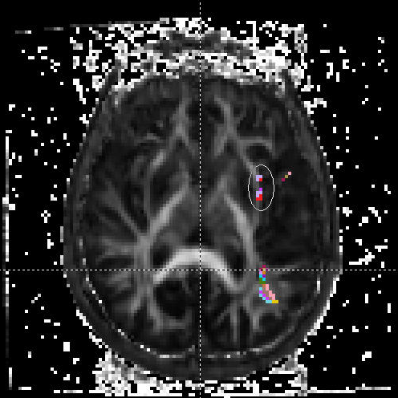

F-MAJ modification:
The 1st ROI is obtained in an identical fashion as described by Wakana et al (2007 NeuroImage. The 2nd ROI was identical to the 1st ROI (using OR operation), but in the opposite hemisphere. The 3rd ROI using an AND operation was drawn to include all fibers in the splenium of CC selected using the mid sagital slice.
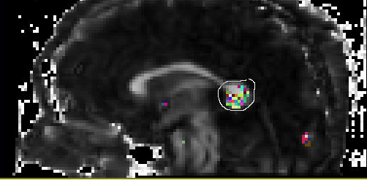
F-MIN modification:
The 1st ROI is obtained in an identical fashion as described by Wakana et al (2007 NeuroImage. The 2nd ROI was identical to the 1st ROI (using OR operation), but in the opposite hemisphere. The 3rd ROI using an AND operation was drawn to include all fibers in the genu of CC selected using the mid sagittal slice.

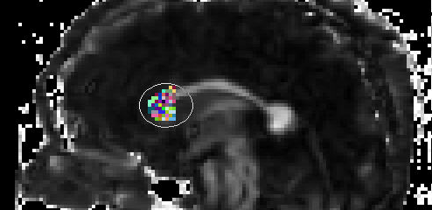
Corpus callosum:
For the first ROI, the mid sagital slice is identified. A freehand OR ROI is drawn to include the entire visualized CC.

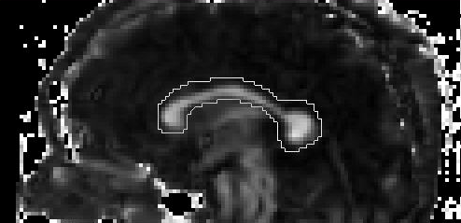
Coronal slice was selected at the level just posterior to the genu of the corpus callosum and large NOT ROI drawn to exclude non CC fibers.

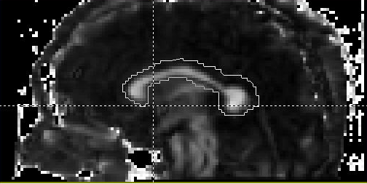
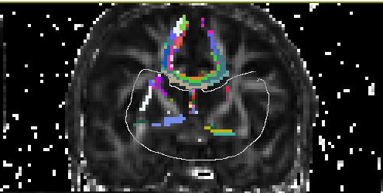
Coronal slice was selected at the level just anterior to the splenum of the corpus callosum and large NOT ROI drawn to exclude non CC fibers.
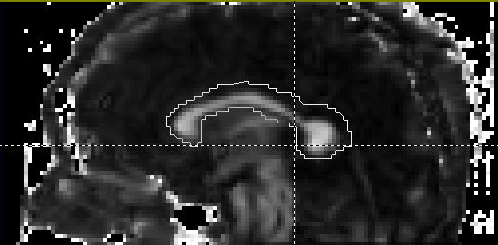
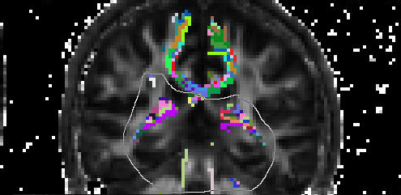
Multiple other NOT operations were performed as needed to exclude fibers which were not part of the CC.
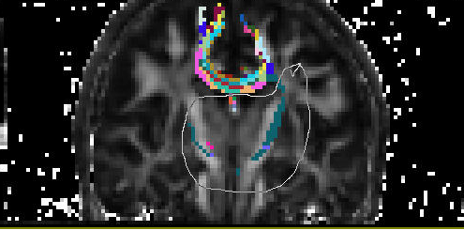
Fornix:
FA threshold of 0.07 and angle threshold of 40 were first used, as higher FA values did not give consistent contiguous fornix fibers. The most posterior coronal slice is identified where CST can been seen continuously from cortex to the brain stem.
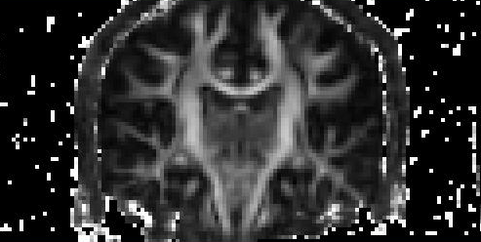

At this point, the coronal slice one posterior to this level is chosen.

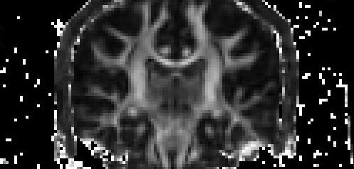

An OR ROI is drawn surrounding a focal high intensity region in the FA map, just lateral to the internal capsule and medial to the temporal stem.
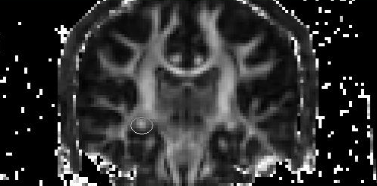

At the same level, an AND ROI is drawn at the level of the body of the fornix.
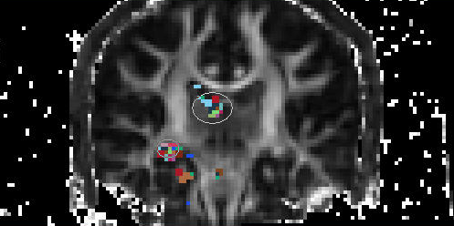

An off sagital slice is selected to remove non-fornix fibers that are extending anterior-superiorly to the frontal lobe.

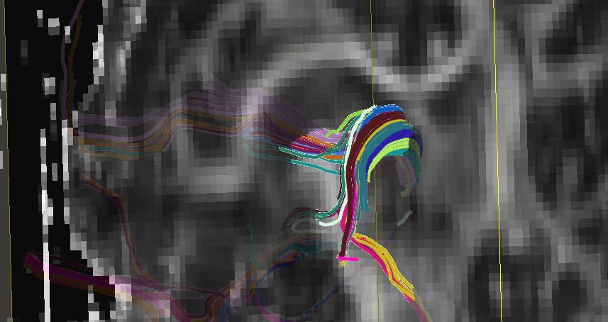

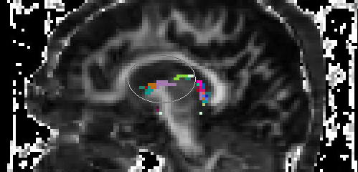

Coronal slice is selected at the level of fibers extending inferiorly from the fornix and NOT ROI is drawn to remove these tracks.

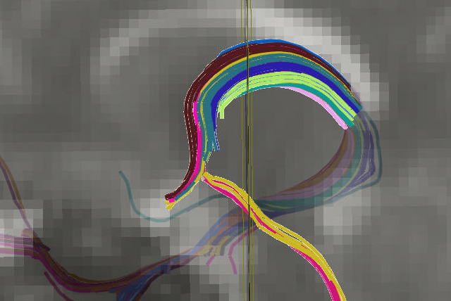

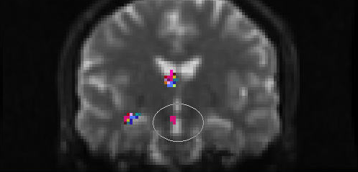

Fibers extending anteriorly in the temporal lobe beyond amygdale are removed via NOT operation.
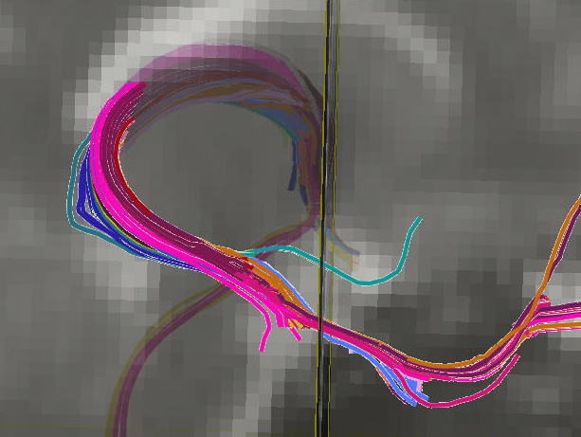
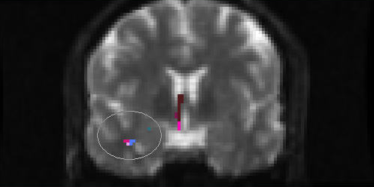

All fibers visualized in cerebral spinal fluid (CSF) are removed.
