Instruction for VR_Plotall_GUI

Start up (paths need to be set correctly before hand)

Open visual_reject_plotall_GUI.mthen using the play button or F5 run the program

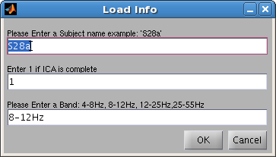
The Load info screen (shown above) will then appear and prompt you to enter the subject name, if ICA has been completed and a band to look at. (Please enter these things in the correct format or the program won't start)

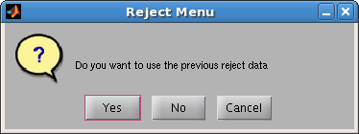
If previous reject data exists, you will be asked if you want to load it before getting started. You should not load it, unless you are reviewing a previous subjects rejections or are continuing from an earlier band. After choosing, the a short wait period will occur until the figures appear
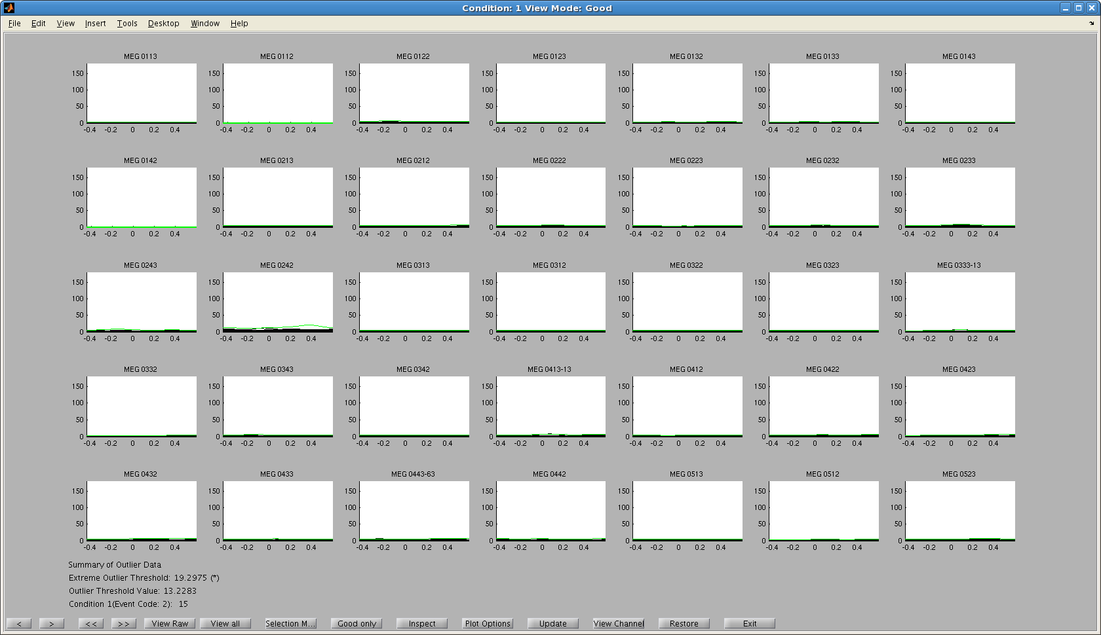
This is the main plot
The > jump pages, >> jumps conditions, View/Hide raw shows and hides the raw data.
View all-Inspect change modes. Plot options allows you to change the number of std's above mean for the threshold and the y-limits of the graph
Update and View channels are discussed in their own sections
Restore will take all your bad data and make it good again
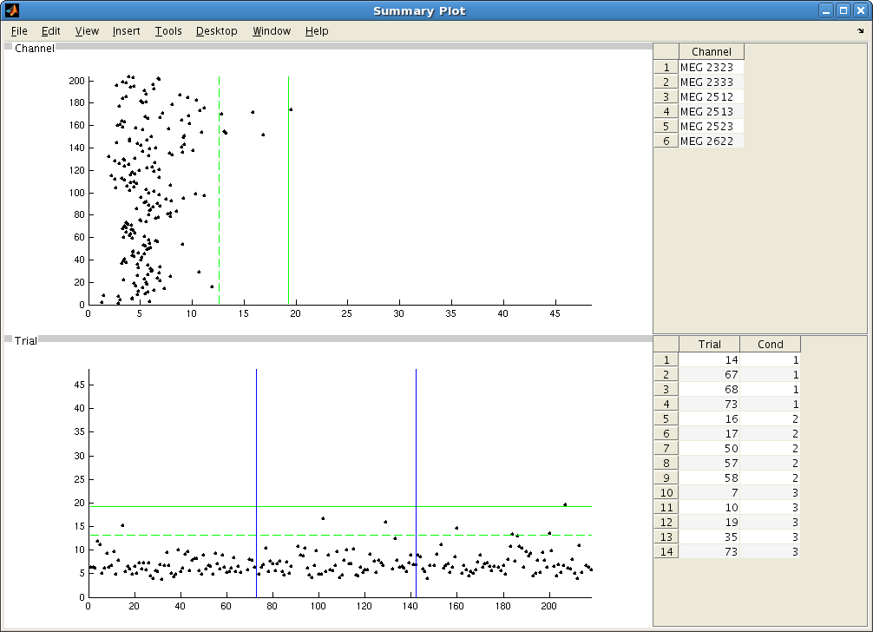
This is the summary plot

The main plot will show you each trial in each channel for that given condition, while the summary plot shows you the maximum value of a given trial on some channel, or of given channel on a trial.

There is also the raw plot
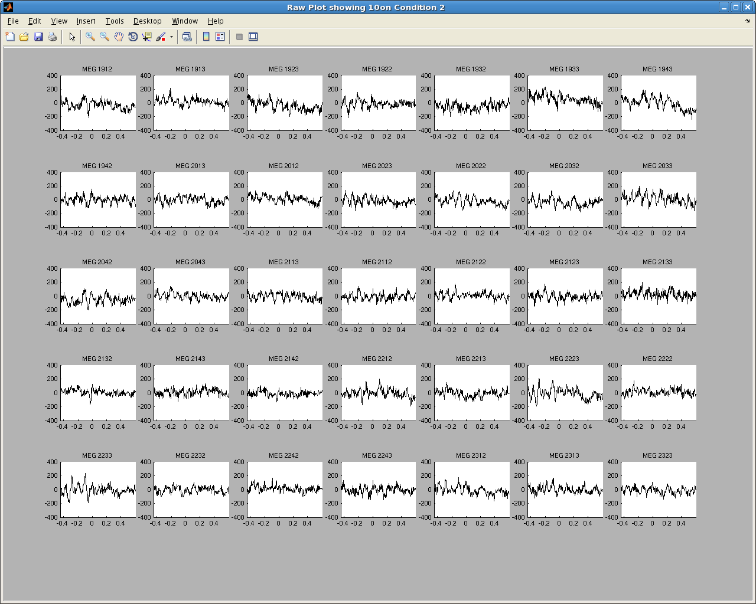
You can zoom in and out on the data using the mouse wheel on the figure you would like to zoom on

Viewing Data
On the main plot, black line are trials and the green line is a threshold for the channel. If any trials cross that threshold, there conditional numbers will be displayed next to the channel name.

In the lower left region there is a print out of the current outliers threshold ( green lines on summary) and the numbers of any trials in that condition which cross those thresholds. There is also a box next to here which prints out selected info.

Modes: Good only
The program will start off in good only mode, which is the primary one for viewing and rejecting data.

Here, clicking on a line in the main plot will select that line and highlight that trial in every channel, highlight it on the summary plot, and highlight the channel with it's max value.
The print out of the trial info appears on the main plot. If you have the raw plot open it will also display the raw_data for that trial

Clicking on a point in the Trial summary plot will also cause all the lines to highlight and it to highlight, and the max channel to highlight. If the raw plot is open it will also cause that trial to appear in the raw plot.

Clicking on a point in the Channel summary, will highlight it and the channel influencing it's max and also jump pages on the main plot to view that channel in the current condition.

Ctrl or Right-Clicking on a line or patch will mark that trial/channel as bad and remove it from view. It can be restored from the list on the summary plot or through selection mode.

Clicking on a channel name on the main plot will also mark it as bad.

Selection Mode
Selection mode will highlight all of the data currently marked as bad. Clicking on highlighted objects will mark them as good, and clicking on unhighlighted objects will mark them as bad.

The last selected trial will appear in a different color(red)
However no update will appear in the info box.

View All
this will display all the data, good or bad as if there are no rejections. Clicking on objects has the same function as good only, however you can not mark anything as good or bad within this mode. Other than restoring from the table on the summary plot

Inspection mode
while similar to selection mode, in that it will highlight the bad data, no rejections can be made from here and selecting additional object will not cause them to be rejected. Right-clicking will reject though.

Here clicking on a line, or trial patch is going to jump you to the condition of that trial and the channel most contributing to it.

Clicking a Channel patch will jump you to that channels page on the condition with the trial contributing to it's max.

The info box will update.

Plot options
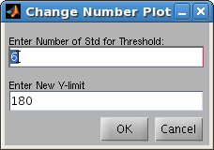
clicking on plot options will allow you to change the std and Y-limits, values that appear are the current settings.

Updating plot
The update method is going to update you 'good only' mode summary plot and also recalculate what crosses thresholds (outlier and channel) and prints that info out.
The update of the summary plot reflects the absmax of each channel/trial based on only the good data. It reflects the changes in the data that have been made through rejections.

Update is the slowest process of the program(why is doesn't happen on the fly) so it should generally not be done after rejecting a single trial. If you do wish to update, either remove several trials or if you have removed a channel it may be worth seeing what happens to the trials.

View Channel
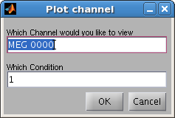
will appear after clicking a Plot Channel the following box will appear after clicking the View channel button.

Enter a channel number to plot, and the condition you wish to plot it on(capital do not matter but spacing does!) Click okay and something like the graph below will appear.

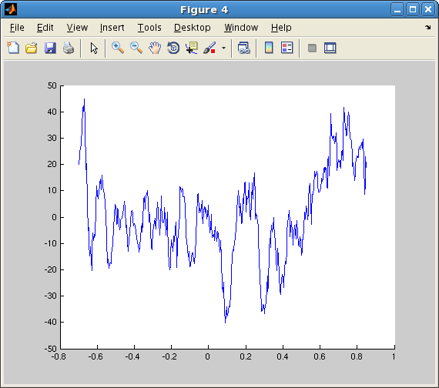
Exiting and Saving
After your done, click exit.

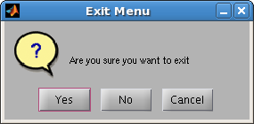
This will appear, anything but yes will return you back

if you say 'yes' this will appear

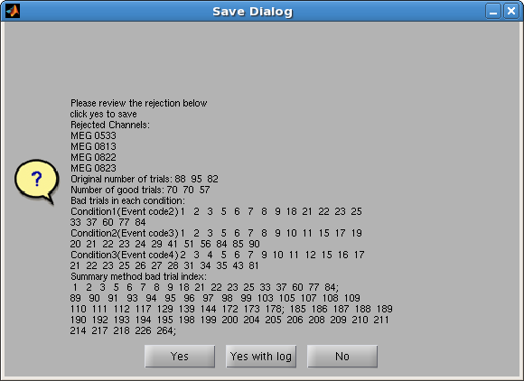
If you want to save the reject data structure click yes, if you want to save it and generate a rejected edited events log. No will not save the data.

