White Matter Fiber Segmentation Using DTI Atlas Probability Maps (in Amira)

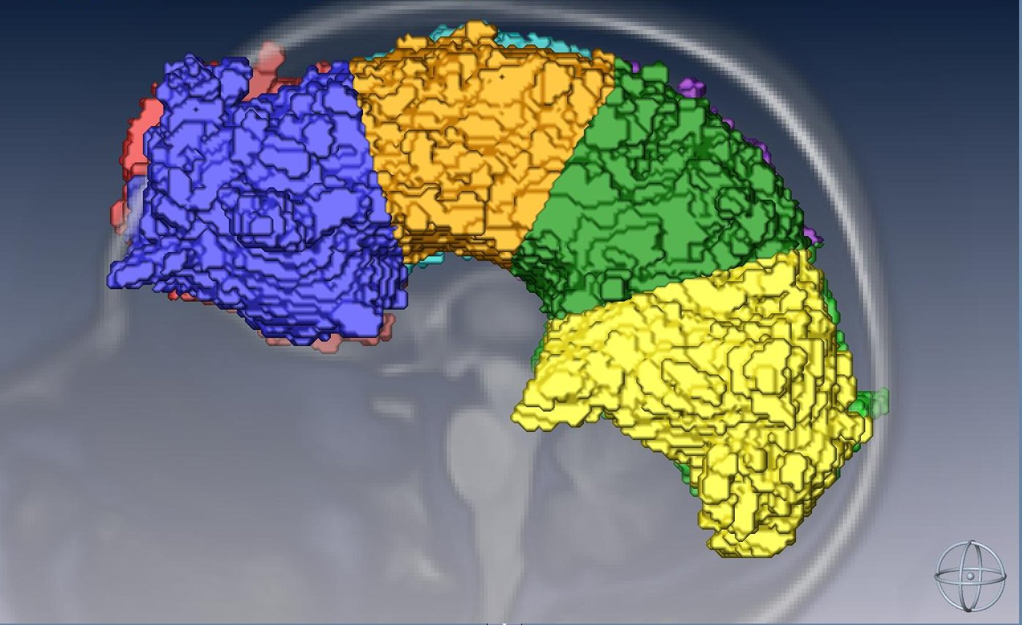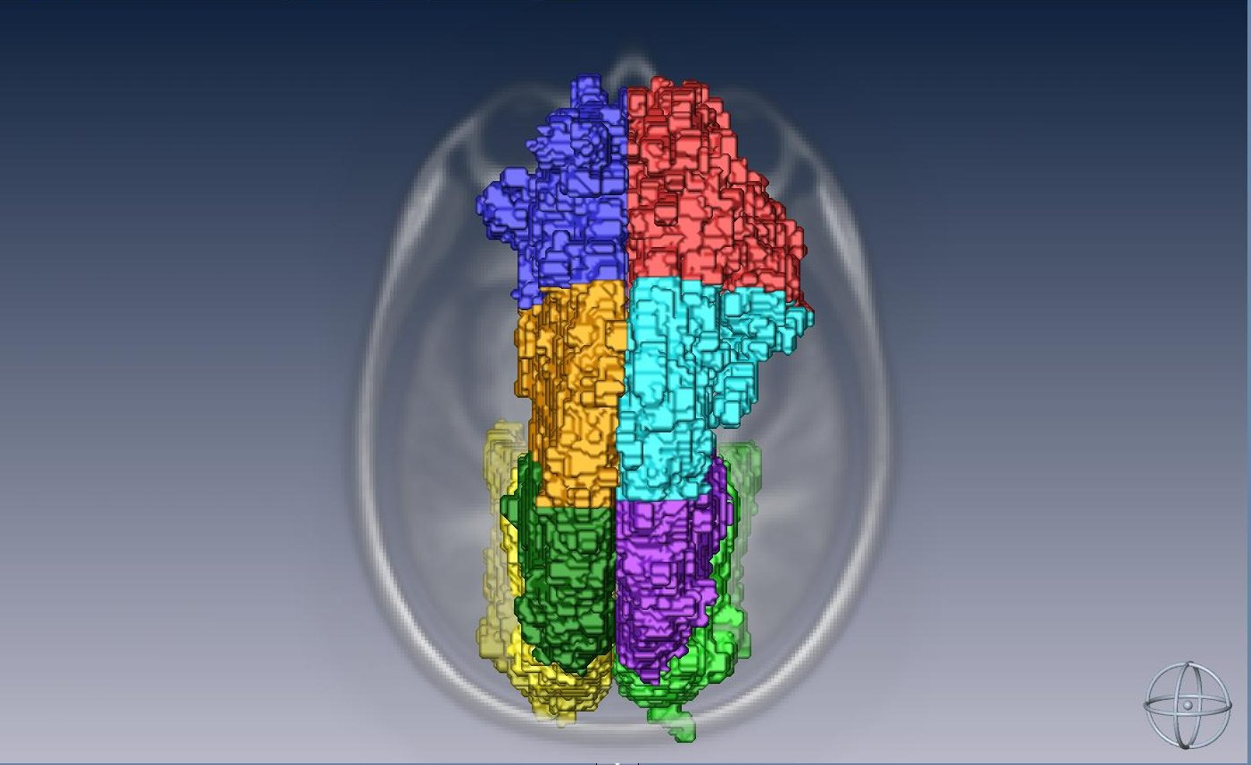

Notes:
- This method assumes that fiber voxels overlapping with areas of CSF, gray matter, and non-brain tissue are masked out after fiber subdivision/segmentation.

Location of directory:
- ~cjpung/fiber_masking

Grab the images:
- Copy average atlas fiber files from ~epiproj/DTIatlas/AllSubjects/fiber_*_mean_countatlas.mgz.
- Copy T1_mean.mgz from ???

Create fiber mask files in matlab:
>> create_fiber_mask (in directory; change script parameters to convert individual fibers)
(Can also change script parameters to adjust probability threshold to better visualize core of fibers)

Then convert 'em:
$ mri_convert --out_orientation LPS fiber_*_mean_countatlas_mask.mgz fiber_*_mean_countatlas_mask.img
$ mri_convert --out_orientation LPS TI_mean.mgz T1_mean.img

Open Amira:
$ ssh -X cjpung@ip76
(enter password)
$ start /bin

GUI setup:
T1 reference images:
- In the upper left corner under Explorer, click Open Data.
- Browse for the T1_mean.hdr file (in /home/cjpung/test_fiber_masking/fiber_###).
- Click on the file in the Pool window, then click on Orthoslice above. In the Properties window below, select Transparency: Alpha. Do this for the other two planes, selecting a different Orientation for each. (xz = coronal, xy = sagittal, yz = axial; renaming the 'OrthoSlice' files is helpful.)
3D fiber image:
- In the upper left corner under Explorer, click Open Data.
- Browse for the fiber_###_mean_countatlas_mask.hdr file (in /home/cjpung/test_fiber_masking/fiber_###).
- Click on the file in the Pool window, then click on Isosurface above. In the Properties window below, click Apply.

Segmentation Editor:
- Click on the Segmentation Editor workspace above the Pool window (the icon is a stack of images).
- Select the fiber_###_mean_countatlas_mask.hdr file under Image Data. Click New. Rename the new material appropriately.
- Choose the Magic Wand from the editor tools below, and check All Slices. Click an area in the image that corresponds to the fiber (white space). All white space in the image should currently be selected (red). Ensure that the newly-created material is highlighted, and click Add Selected Voxels under Selection.
- Select the T1_mean.hdr file under Image Data. Click on the Four Viewers icon above the image window.
- Subdivide each fiber and save files according to the specific instructions below. Oh, and SAVE OFTEN.

Convert 'em back:
- First, copy the *.mat file that was created during file conversion, because this file is necessary to convert them back.
$ cp fiber_*_mean_countatlas_mask.mat fiber_*_mean_countatlas_mask.Labels.*.mat
- Then, convert final segmentation files to *.mgz file format.
$ mri_convert –out_orientation ILA fiber_*_mean_countatlas_mask.Labels.*.img fiber_*_mean_countatlas_mask.Labels.*.mgz

Methods

fiber_101 (R Fx)
Divide the fornix into longitudinally into three parts; one part includes the hippocampal area (mainly to be excluded), then the other part is divided equally.
- Saved fiber as 1010.
- On the most posterior coronal slice in which the hippocampus is visible, divide fornix at a 45-degree angle (superior-lateral to inferior-medial) so that the hippocampal formation is included in the lateral part of the fornix (the fimbra). Saved fiber as 1011.
- Divide the remaining piece (the body and pillar) into two sections of near-equal length, saving each as 1012 and 1013.

fiber_102 (L Fx)
Divide the fornix into longitudinally into three parts; one part includes the hippocampal area (mainly to be excluded), then the other part is divided equally.
- Saved fiber as 1020.
- On the most posterior coronal slice in which the hippocampus is visible, divide fornix at a 45-degree angle (superior-lateral to inferior-medial) so that the hippocampal formation is included in the lateral part of the fornix (the fimbra). Saved fiber as 1021.
- Divide the remaining piece (the body and pillar) into two sections of near-equal length, saving each as 1022 and 1023.

fiber_103 (R CgC)
Divide the cingulum (cingulate) longitudinally (A-P) into three equal parts.
- Saved fiber mask as 1030.
- Divided stalk of CgC into three sections of near-equal length: Anterior, medial, and posterior, saving each as 1031, 1032, and 1033.

fiber_104 (L CgC)
Divide the cingulum (cingulate) longitudinally (A-P) into three equal parts.
- Saved fiber mask as 1040.
- Divided stalk of CgC into three sections of near-equal length: Anterior, medial, and posterior, saving each as 1041, 1042, and 1043.

fiber_105 (R CgH)
Divide the cingulum (hippocampal) longitudinally (A-P) into two equal parts.
- Saved fiber mask as 1050.
- Divided stalk of CgH into two sections of near-equal length: Anterior and posterior, saving each as 1051 and 1052.

fiber_106 (L CgH)
Divide the cingulum (hippocampal) longitudinally (A-P) into three equal parts.
- First, removed any voxels representing fibers in the left hemisphere. Saved fiber mask as 1060.
- Divided stalk of CgH into two sections of near-equal length: Anterior and posterior, saving each as 1061 and 1062.

fiber_107 (R CST)
Divide the CST longitudinally (S-I) into three equal parts.
- First, removed any voxels representing fibers terminating in the left hemisphere. Saved fiber mask as 1070.
- Divided main stalk of CST into three sections of near-equal length: Superior, medial, and inferior, saving each as 1071, 1072, and 1073.

fiber_108 (L CST)
Divide the CST longitudinally (S-I) into three equal parts.
- First, removed any voxels representing fibers terminating in the pre-central cortex. Saved fiber mask as 1080.
- Divided main stalk of CST into three sections of near-equal length: Superior, medial, and inferior, saving each as 1081, 1082, and 1083.

fiber_109 (R ATR)
Divide the ATR longitudinally (A-P) into two parts.
- Saved fiber mask as 1090.
- Divided the ATR into two sections, separating the “frontal lobe expansion” from the main thalamic projection: Anterior and posterior, saving each as 1091 and 1092.

fiber_110 (L ATR)
Divide the ATR longitudinally (A-P) into two parts.
- Saved fiber mask as 1100.
- Divided the ATR into two sections, separating the “frontal lobe expansion” from the main thalamic projection: Anterior and posterior, saving each as 1101 and 1102.

fiber_115 (R Unc)
Divide the uncinate into two parts.
- Saved fiber mask as 1150.
- Divided the uncinate into two sections based on the lobe they occupy, saving the frontal and temporal sections each as 1151 and 1152.

fiber_116 (L Unc)
Divide the uncinate into two parts.
- Saved fiber mask as 1150.
- Divided the uncinate into two sections based on the lobe they occupy, saving the frontal and temporal sections each as 1161 and 1162.

fiber_117 (R ILF)
Divide the ILF longitudinally (A-P) into two parts.
- Saved fiber mask as 1170.
- Divided the ATR into two sections at the thinnest part of the medial “stalk”: Anterior and posterior, saving each as 1171 and 1172.
Divide the ILF longitudinally (A-P) into three parts.
- Divided the ATR into three sections: Anterior, medial (“stalk”), and posterior, saving each as 1173, 1174, and 1175.
fiber_118 (L ILF)
Divide the ILF longitudinally (A-P) into two parts.
- Saved fiber mask as 1180.
- Divided the ATR into two sections at the thinnest part of the medial “stalk”: Anterior and posterior, saving each as 1181 and 1182.
Divide the ILF longitudinally (A-P) into three parts.
- Divided the ATR into three sections: Anterior, medial (“stalk”), and posterior, saving each as 1183, 1184, and 1185.

fiber_119 (R IFO)
Divide the IFO longitudinally (A-P) into two parts.
- First, removed any voxels representing fibers in the left hemisphere. Saved fiber mask as 1190.
- Divided the ATR into two near-equal sections: Anterior and posterior, saving each as 1191 and 1192.
Divide the IFO longitudinally (A-P) into three parts.
- Divided the ATR into three near-equal sections: Anterior, medial, and posterior, saving each as 1193, 1194, and 1195.

fiber_120 (L IFO)
Divide the IFO longitudinally (A-P) into two parts.
- Saved fiber mask as 1200.
- Divided the ATR into two near-equal sections: Anterior and posterior, saving each as 1201 and 1202.
Divide the IFO longitudinally (A-P) into three parts.
- Divided the ATR into three near-equal sections: Anterior, medial, and posterior, saving each as 1203, 1204, and 1205.

fiber_121 (F-maj)
Divide the F-maj laterally (R-L) into two parts.
- First, removed any voxels representing fibers other than the forceps major. Saved fiber mask as 1210.
- Divided the F-maj into two near-equal sections: Right and left, saving each as 1211 and 1212.
Divide the F-maj longitudinally (R-L) into three parts.
- Divided the F-maj into three near-equal sections: Right, medial, and left, saving each as 1213, 1214, and 1215.
Divide the F-maj longitudinally (R-L) into four parts.
Divide the medial secion (fiber# 1214) into half at the sagittal mid-line, saving right and left medial as 1216 and 1217.

fiber_122 (F-min)
Divide the F-min laterally (R-L) into two parts.
- First, removed any voxels representing fibers other than the forceps minor. Saved fiber mask as 1220.
- Divided the F-min into two near-equal sections: Right and left, saving each as 1221 and 1222.
Divide the F-min laterally (R-L) into three parts.
- Divided the F-min into three near-equal sections: Right, medial, and left, saving each as 1223, 1224, and 1225.
Divide the F-min laterally (R-L) into four parts.
- Divide the medial secion (fiber# 1224) into half at the sagittal mid-line, saving right and left medial as 1226 and 1227.
fiber_123 (CC)
Divide the CC laterally (R-L) into two parts.
- Saved fiber mask as 1230.
- Divided the CC into two sections along the mid-sagittal line: Right and left, saving each as 1231 and 1232.
Divide the CC laterally (R-L) into four parts.
- Divided the CC into four sections, starting with the two sections from step 2, then using anterior edge of the CST (thresh=0.1, to help determine the location of the central sulcus. Designated each sections as right anterior, left anterior, right posterior, and left posterior, saving each as 1233, 1234, 1235, and 1236.
fiber_124 (CC): Divide the CC laterally (R-L) into four parts.
- Saved entire CC as 1240.
- Divided the CC into eight sections, starting with the four sections from step 3, then dividing each of the four longitudinally (A-P) in half. Designated each section as right anterior, left anterior, right medial-anterior, left medial-anterior, right medial-posterior, left medial-posterior, right posterior, and left posterior, saving each as 1241, 1242, 1243, 1244, 1245, 1246, 1247, and 1248, respectively.

fiber_133 (R SLF)
Divide the SLF longitudinally along fiber into two parts.
- Saved fiber mask as 1330.
- Loaded fiber 135, saved fiber mask as 1331.
- Loaded fiber 137, saved fiber mask as 1332.
Divide the SLF longitudinally along fiber into three parts.
- Divided the SLF into the three main termination areas (or lobes) that comprise the SLF: the temporal, parietal, and frontal stems. Saved the temporal, parietal, and frontal stem fiber masks as 1333, 1334, 1335, respectively.

fiber_134 (L SLF)
Divide the SLF longitudinally along fiber into two parts.
- Saved fiber mask as 1340.
- Loaded fiber 136, saved fiber mask as 1341.
- Loaded fiber 138, saved fiber mask as 1342.
Divide the SLF longitudinally along fiber into three parts.
- Divided the SLF into the three main termination areas (or lobes) that comprise the SLF: the temporal, parietal, and frontal stems. Saved the temporal, parietal, and frontal stem fiber masks as 1343, 1344, 1345, respectively.

