MMIL MRI Processing Stream
Table of Contents:

1.Create a New Project 4
2.Copy Data to our System 5
3.Process Exams 6
4.Troubleshooting 8
5.Raw QC 9
6.DTI Processing and QC 13
1.Freesurfer Recons Exams 13
7.Surface Review/Edits 14
8.ASEG Review 17
9.Resample to Average 17
10.Analyze MRI Stats/Exams 17
11.Summarize Output 18
12.Concatenate Surfstats 20
13.Longitudinal Analysis 20
14.Provide Data to PI 21
15.Example: Provide Data to PI 22

Key:
- “>” at beginning denotes enter following exactly into command line (command stops at parentheses)
- PROJ_NAME: Replace with name of project you are working on, e.g. ARO_STRUCT
- The projects are seperated into different mmilrec accounts. Replace “mmilrec” throughout this guide with whatever account you are using (i.e. mmilrec14, mmilping, etc)
A Note About.... Aliases

There are aliases referenced throughout this guide to make command lines easier. While the original complete form commands should be included in the instructions, here is the list of all aliases that can be added to the .cshrc script to make processing and editing as easy as possible.

GENERAL USE:
alias qstatall 'qstat -u "*"'

DTI QC:
alias tkregUW 'tkmedit -f \!:1/DTI3_B0uw_f0.mgz -aux \!:1/DTI2_rev_B0uw_f0.mgz'
alias tkregREG 'tkmedit -f \!:1/FLASHhi1.mgh -overlay \!:1/DTI3_corr_f0_resT1.mgh'
alias tkregFA 'tkmedit -f \!:1/T1_resDTI.mgh -aux \!:1/DTcalc/*FA.mgz'

FREESURFER QC:
alias sete 'setenv SUBJECTS_DIR ${PWD}'
alias tke 'tkmedit \!:1 brainmask.mgz lh.white -aux T1.mgz -aux-surface rh.white -tcl /space/md8/6/data/MMILDB/RECHARGE/HAW_METH/FSContainers/bm.tcl'
alias tkwm 'tkmedit \!:1 wm.mgz lh.white -aux brainmask.mgz -aux-surface rh.white -tcl /space/md8/6/data/MMILDB/RECHARGE/HAW_METH/FSContainers/wm.tcl'
alias tka 'tkmedit \!:1 orig.mgz -aux T1.mgz -segmentation aseg.mgz $FREESURFER_HOME/FreeSurferColorLUT.txt -tcl /home/mmilrec/bin/tkmedit_aseg.tcl'

- Create a New Project

- Request a partition with space:
  - Ask system admin (Trevor Cooper) if he knows of a partition that is not being used and can put the project on. This step should be done as far in advanced as possible to allow time for space to be made available if necessary.
  - To determine the amount of space you need here is a basic rule of thumb:
      - Structural MRI Only Projects: 1 GB/visit
      - Projects with DTI: 3.5 GB/visit
      - Per Container (this is unusual, usually use A or B above)
        - FSContainers: 375 MB/visit
        - FSAverage: 130 MB/visit
  - To determine the amount of space on partitions:
    - > df -h (can only see partitions that have been navigated to or linked to – some of these also may be waiting for data from other projects).
  - Choose the partition with the largest amount of space, we will use /space/md#/#/ as an example (replace the #/# with whatever partition you chose, eg md9/9)
- Talk to Cooper Roddey about setting up the project under your account.
  - Information you will need:
    - Where the project will be located (this is the partition space we requested)
    - What type of data the project will have (structural, DTI, fMRI, etc)
    - Who the PI that is in change of the project is
  - Cooper will:
    - Add the project to the ProjInfo file
    - Create links in your home directory that to the data locations on the partitions

- Copy Data to our System

- From OsiriX (locally collected data)
  - Open OsiriX on the Mac (icon in the toolbar at the bottom of the screen)
    - All data locally collected (RIL, Keck, or Hillcrest) and transferred to pacsmmil will automatically show up in this program
  - Open folder "Scans" on the Desktop
    - Delete all files/folders currently in the “Scans” folder
  - Export Scans to Desktop

    - In OsiriX, select all scans that you want to copy onto the network (Hold + Click)
    - Click “Export” in the Icon row at the top
    - Find the Desktop > Scans folder and click “Choose”
  - Do you need to rename the scans for this project? If so, do so in the scans folder
  - Open Terminal in dock at the bottom of the screen
    - cd /Users/pacsmmil/Desktop/scans/
    - scp -rv mmilrec@ip##:/home/mmilrec/data_PROJ_NAME/orig (fill in ## with your IP address)
- From sftp (data transferred to us from off-site)
  - > cd /space/md9/sftp/chroot/home/PROJ_SFTP/incoming
    - PROJ_SFTP will be the project’s folder, probably will have different name then our local PROJ_NAME directory
    - If the folders are archived (end in .zip)
      - > nautilus ${PWD} (this brings up the browser)
      - Select all subjects > Right Click > Unarchive
  - > cp –ruv * /home/mmilrec/data_PROJ_NAME/orig

- Process Exams

- In MATLAB:
  - > REC_MMIL_Process_Exams(‘PROJ_NAME’)
    - This copies files into raw containers, creates mgh/mgz files, unwarps, creates .mat scripts, etc, including for DTI
    - If DTI Project:
      - REC_MMIL_Process_Exams(‘PROJ_NAME’)
      - Run FS Recons (step VII) [this is necessary to get all DTI data output]
      - REC_MMIL_Process_Exams(‘PROJ_NAME’,’DTI_ATLflag’, 1)
        - Note: this takes 6 GB of ram to run, so this is the fastest way to get the data
- Submitting to Cluster:
  - Log onto a cluster
    - >smc# (can use 2, 3 or 4)
  - Check what is on the cluster:
    - >qstat (lists jobs that you are running)
    - OR >qstatall (without aliases >qstat -u “*”) (lists all jobs on cluster)
    - OR >qstat – r (lists more details about the data that is running on the cluster
    - OR >qstat |wc (counts the number of jobs running)
    - OR >qmon (brings up GUI that shows Pending, Running, and Finished Jobs)
  - If too many jobs, switch to another cluster
    - >smc# (can use 2, 3, or 4)
  - Submit to cluster:
    - When MATLAB job has finished running (Step III.1), it will print out a command of what to submit to cluster, copy this command and enter into terminal.
    - Possible Changes:
      - qmatjobs# REC_MMIL_Folder_Name (allocates 2*# gbs of ram for each job, # can be 2-8)
      - qcshjobs#REC_MMIL_Folder_Name (allocates 2*# gbs of ram for each job, # can be 2-8)

Average Job Run Times:

- Process Exams:
    - Structural Only: 1 hour
  - Structural + DTI: 1-2 hours
  - DTI_ATLflag: 2-4 hours
- FSRecon:
  - First run: 24 hours
  - Rerunning after edits: 12 hours
- IcoResamp: 30 minutes
- Analyze Exams:
  - MRI: 1 hour
  - DTI: 1.5 hours
  - Longitudinal: 1 hour
- Summarize (both MRI and Long): 10 secs/visit

- Long_Setup_Exams: 10 minutes
- Long_Register_Exams:: 2 hours

- Troubleshooting

- If not all jobs were processed correctly: (
  - Verify that the subjects passed RawQC
    - If a subject fails RawQC (QC = 3), it will not be FSRecon'ed
  - Check .out and .err files which are created after each job is submitted and updated during processing
    - > cd ~mmilrec/batchdirs/REC_MMIL_Exam_Type_PROJ_NAME/pbsout
      - Refer to the matlab command you entered to run the job to find “REC_MMIL_Exam_Type_PROJ_NAME”
    - *.out – records the output of the entire processing stream – very long!
      - > tail *.out (prints the end of all .out files)
    - *.err – prints errors that interrupt processing
      - > cat *.err (prints all of all .err files)
      - Note: If running Long_Setup_Exams, all of the output prints to the .err file. This is fine and does not denote an error
  - If in Resample subjects are being skipped and Matlab output says "MMIL_IcoResamp_FSRecon_Exams: WARNING: skipping FREESURFERRECON_SUBJ_### (recon incomplete)"
    - This means that not all of the touch files were created for this subject (FS Recon cancelled out). The touch files can be viewed in: FREESURFERRECON_SUBJ_###/touch
    - WORK AROUND (note this may not fix the problem! All it does is allow the data that is there to be analyzed): Compare the touch folders for a subject that did work and the ones that failed. Copy the missing files into the incomplete directory
  - If in either Resample step or Analyze step Matlab produces error: "Empty StudyInfo" this has to do with the FSRecon_QC spreadsheet.
    - Verify that there are columns titled "SurfaceQC" and "ASEG QC"
    - Each subject has a QC in those columns of "Good," "Average," or "Bad."

- Raw QC

- MRI QC:
  - Open MMIL Viewer from MATLAB
    - Open MATLAB
    - >MMIL_Viewer(‘PROJ_NAME’)
      - Troubleshooting: If settings have changed in the ProJInfo spreadsheets, this will fail. Try moving the RawQC.m file in ~mmilrec/ProjInfo/PROJ_NAME to a backup folder
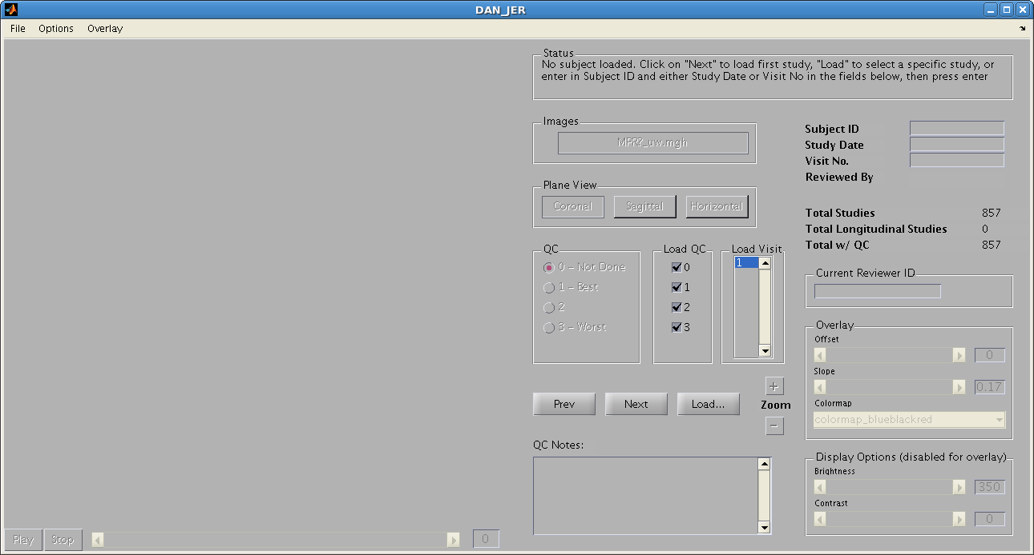
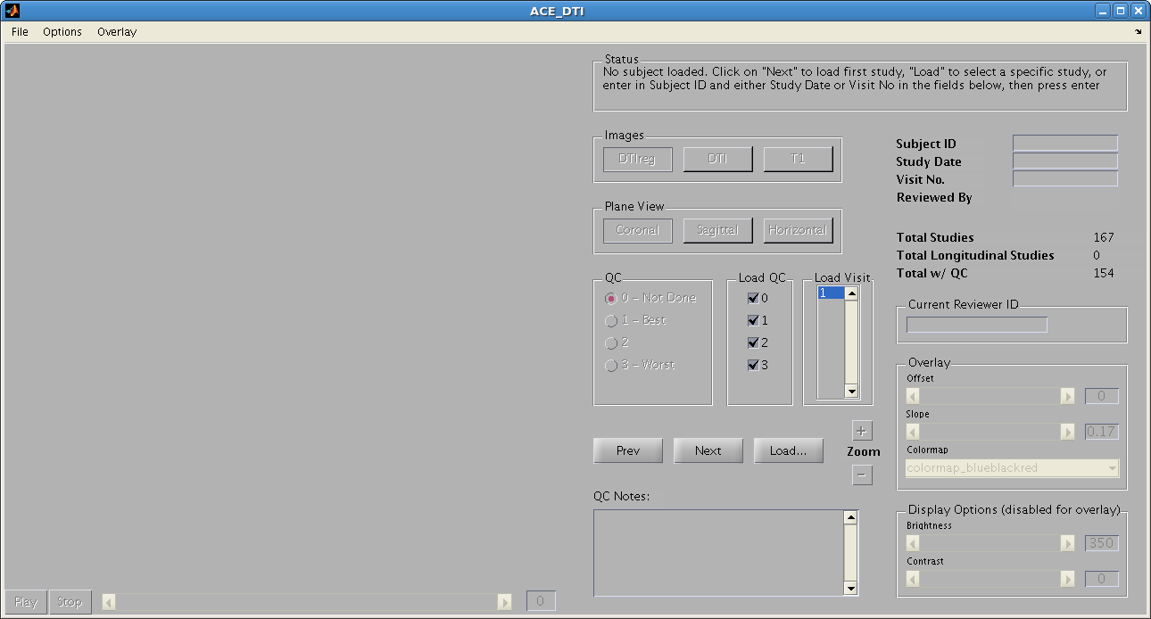
b.i.
b.iii.
b.ii.
c.iii..
c.ii.

c.i.
b.iv.
2.iii .
2.ii.
2.i.

  - Set Criteria in MMIL Viewer
    - Enter reviewer ID (e.g. MC)
    - Choose QC Ratings to load:
0 - Not Done
1 - Best
2 - Average
3 - Worst (Rejected)
    - Click “Next” for first scan to load
    - Adjust brightness/contrast in lower right corner
  - Rate Scans:
    - Can adjust view plane (sagittal, coronal, or axial) above QC options
    - Rate Scan in QC Bubble Column (to the left of check boxes) – see below for help in rating scans
    - Write notes lower left text box:
      - Ghosting: 1-3 (1: will not effect FreeSurfer surfaces, 2: possible effect, 3: definitely will)
      - Motion: 1-3 (can include more information about where specifically motion is, e.g. Motion: 3 Cerebellum)
      - Fuzzy: 1-3 (grainy)
      - Other: unusual brightness distribution, whiteout in the front or side, drop out [metal in the head]
    - Click “Next” until all scans have been rated

2. DTI QC (Matlab > MMIL_Viewer('Proj_Name_DTI')
  - Insert same information as above (Reviwer ID etc).
    - At top: Overlay > Ignore Threshold
    - On right hand side: Overlay: Colormap > Change to colormap_DTI_redyellow
    - Can change between “DTIReg” (DTI overlay on T1); “DTI”; and “T1”
    - Checking:
      - Important: Check registration
        - Want bright spots to be where the CSF is
        - Bad registration: Ventricles will not be bright, will be shifted slightly
      - Cut off: Check to make sure that all lobes are included
        - Cerebellum is commonly cut off - this is fine
      - Flickering (changes in intensity)
      - Dropout (if there is an area that is not red)
Examples: Please see “RawQC Examples” document for more/larger examples
Note: Details in these examples are much easier to view on the computer than when printed
 | 1 | 2 | 3 (Reject)
Motion | 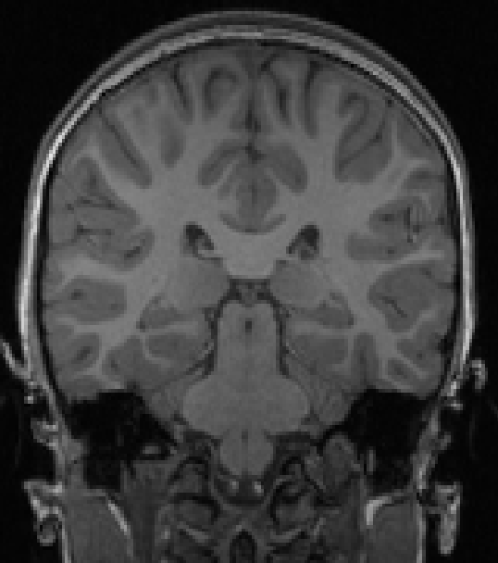 | 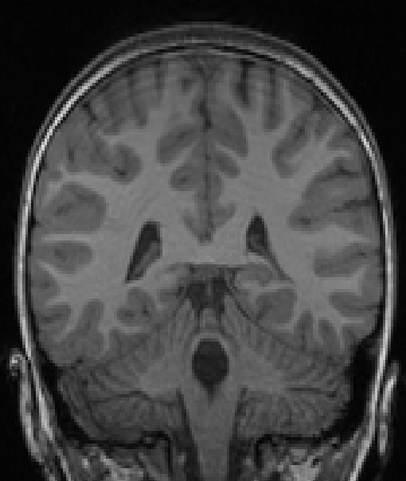 | 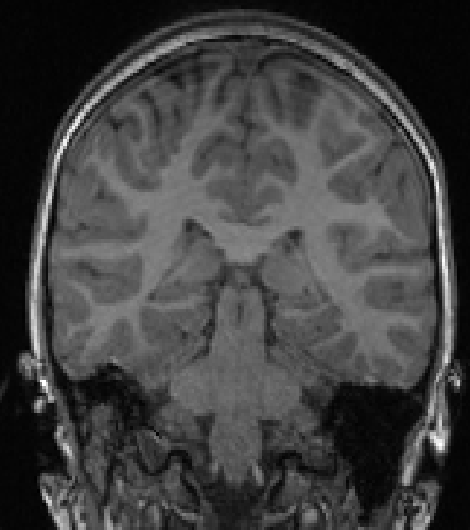
 | 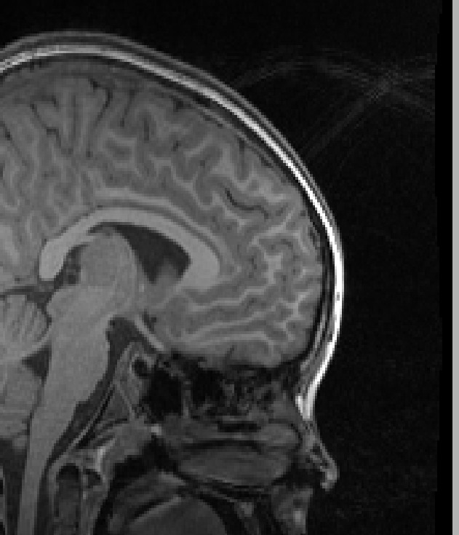 | 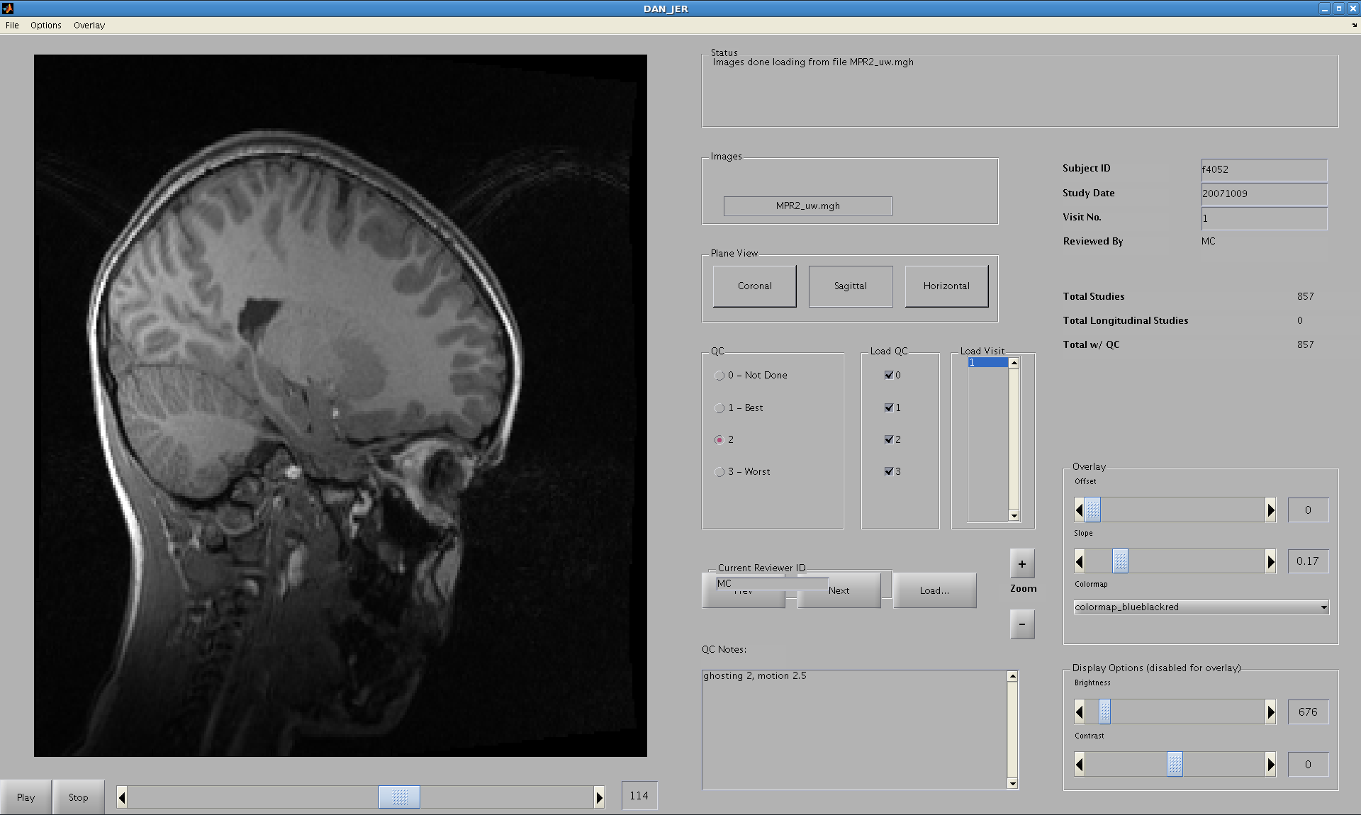 | 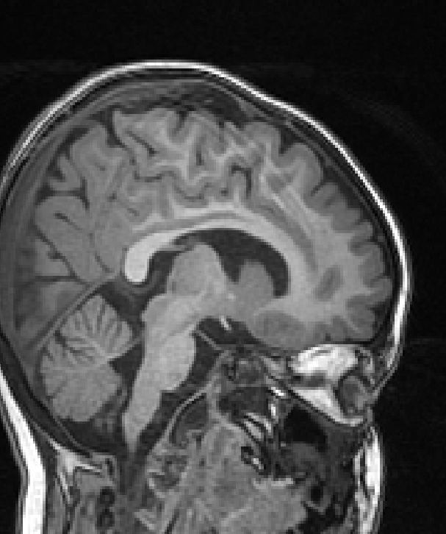  Ghosting
 | DTI - Good Registration  (also: temporal cut off) | DTI - Bad Registration | Mouth and Nose Wrap  (reject if it wraps into brain)
 | 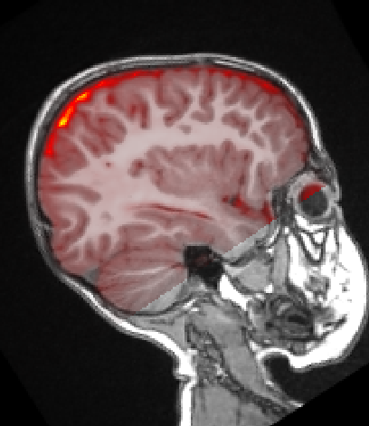 | 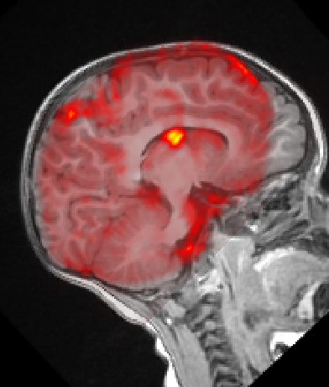 | 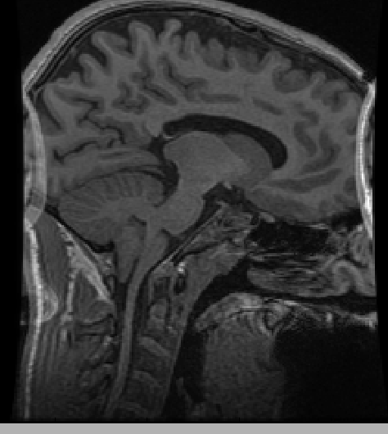

- DTI Processing and QC

- Process DTI (If not completed before):
  - In Matlab: REC_MMIL_Process_Exams('PROJ_NAME', 'DTI_ATLflag', 1)
- Go to PROCContainer for each subject and complete these QC Steps:
  - Look through files in folder and there should be a file named “DTI#VSDTI%_rev_B0dx.mgz” with the # and % both being numbers. Use these numbers in all of the following directions whenenver there is a % or # (e.g. if the file is named DTI3VSDTI2_rev_B0dx.mgz whenever there is a # replace with a 3, and whenever there is a % replace with a 2)
  - Unwarp QC
    - > tkmedit -f DT1#_B0uw_f0.mgz -aux DTI%_rev_B0uw_f0.mgz
    - Switch back and forth between volumes (Ctrl+1 or +2) and make sure that they align correctly (can be some small differences in eyes, but should be aligned very well with each other). Check in all three planes
  - RegQC
    - Can use MMIL_Viewer (see Part 2 in RawQC step)
    - or: tkmedit -f T1.mgh -overlay DTI#_corr_f0_resT1.mgh
      - View > Configure > Functional Overlay > “Ignore Threshold”
      - Overlay should fit exactly on top of T1 (see Separate Protocol Sheet “Raw Data QC: Examples)
  - AFNI
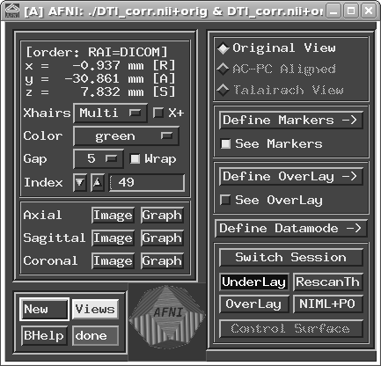
    - > mri_convert DTI#_corr.mgz DTI.nii (converts to NIFTI file)
    - > afni (opens window pictured to right)
    - Select “Image” next to Axial, Sagittal, and Coronal
    - Arrange all four windows so that you can view them simultaneously
    - Scrolls through all of the “Index” Values in the main window. For each index number, make sure there are no large artifacts or drop out in the slices (image will black for large areas or appear fuzzy)
  - FA Map (look for artifacts)
    - > ls Dtcalc
    - Find the file listed that ends in “...FA.mgz”
    - > tkmedit -f T1_resDTI.mgh -aux Dtcalc/DTI_scans.....FA.mgz
    - Change view to sagittal and scroll to the corpus collosum. Switch between the volumes as in b.ii., comparing the location of the corpus collosum. If they are very similar, this is good.
- REC_MMIL_Analyze_DT_Exams('PROJ_NAME', 'xcg_flag', 1)
  - use the “'xcg_flag', 1” if using Freesurfer Recons for DTI analysis

- Freesurfer Recons Exams

- In MATLAB:
  - > REC_MMIL_Freesurfer_Recon_Exams(‘PROJ_NAME’)
- Submit to Cluster (Follow Instructions in III.2)
- Troubleshooting Errors (III.3) Applies

- Surface Review/Edits
NOTE: See "Freesurfer Editing Guide" for more detailed instructions and our current protocols

- Open FSReconQC Spreadsheet:
  - Open FSReconQC (from your own account):
    - > cd ~mmilrec/ProjInfo/PROJ_NAME/
    - > ooffice PROJ_NAME_FSReconQC.csv
      - If this file does not exist, copy it from another projects directory
  - As you edit (Step IX.2, below)
    - Enter your initials and date for each subject
    - Note the date of last edit, what type of edits were made (surface only or control points), as well as if it is complete
    - Once editing has been completed, fill in the following columns for ALL subjects
      - SurfaceQC: good, average, bad
      - Surface Notes: areas that are still underestimated, have “tangles,” etc
      - Anatomical Abnormalities (Free text)
        - Bad WM Integrity (lots of hypointensities (dark spots in WM)
        - Poor Grey/White Contrast (not very distinct difference between GM and WM, inability to see subcortical structures in T1.mgz)
        - Atrophy (large subarachnoid space, very large ventricles)
- View/Edit Surfaces in Freesurfer (see separate Protocol: “Freesurfer Edit Protocols” for more details):
  - > cd data_PROJ_NAME/FSContainers
  - > ls (lists folder names of all available scans)
  - > sete (This is an alias for “>setenv SUBJECTS_DIR $PWD” -- it allows Freesurfer to automatically find all files that you need)
  - To Open Brainmask (Pial Edits:) > tke FREESURFERRECON_SUBJ_FOLDER_#####
  - To Open White Matter Mask (wm edits)> tkwm FREESURFER_SUBJ_FOLDER_####
  - Scroll through each Subject in all three directions making notes or edits where necessary
    - In Brainmask View:
      - Delete meninges and veins where GM is over-estimated (Press “a” to edit data, then press right mouse to delete voxels)
    - In White Matter View:
      - Add white matter in where it is missing (Press right mouse to add voxels), normally around basal ganglia.
      - Rules:
        - Fill basal ganglia in sagittal view as long as area is completely surrounded by white matter
        - Can removew white matter in areas that it extends into grey matter
  - File > Quit and Remember to select “Yes” to save!
    - Do NOT close by clicking the [X] at the top of the window with the image of the brain in it. This will not allow you to save your changes!!
  - For all Recons that you have edited, need to create add touch files:
    - > cd FREESURFER_RECON_SUBJ_FOLDER_####/touch
    - > touch remake_control (added control points) or >touch remake_surf (edited surf)
- Reprocess all edited scans:
  - MATLAB > REC_MMIL_Freesurfer_Recon_Exams
  - Submit to cluster (follow directions in III.2)
- Re-Edit all scans that have reprocessed once they have finished
Original | Edited | After Rerun
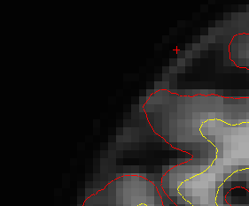 | 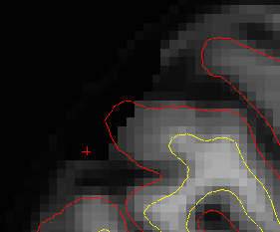 | 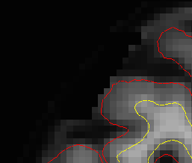
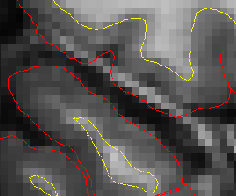 | 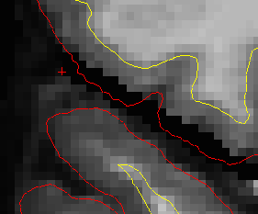 | 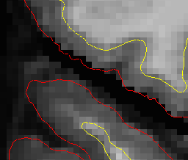
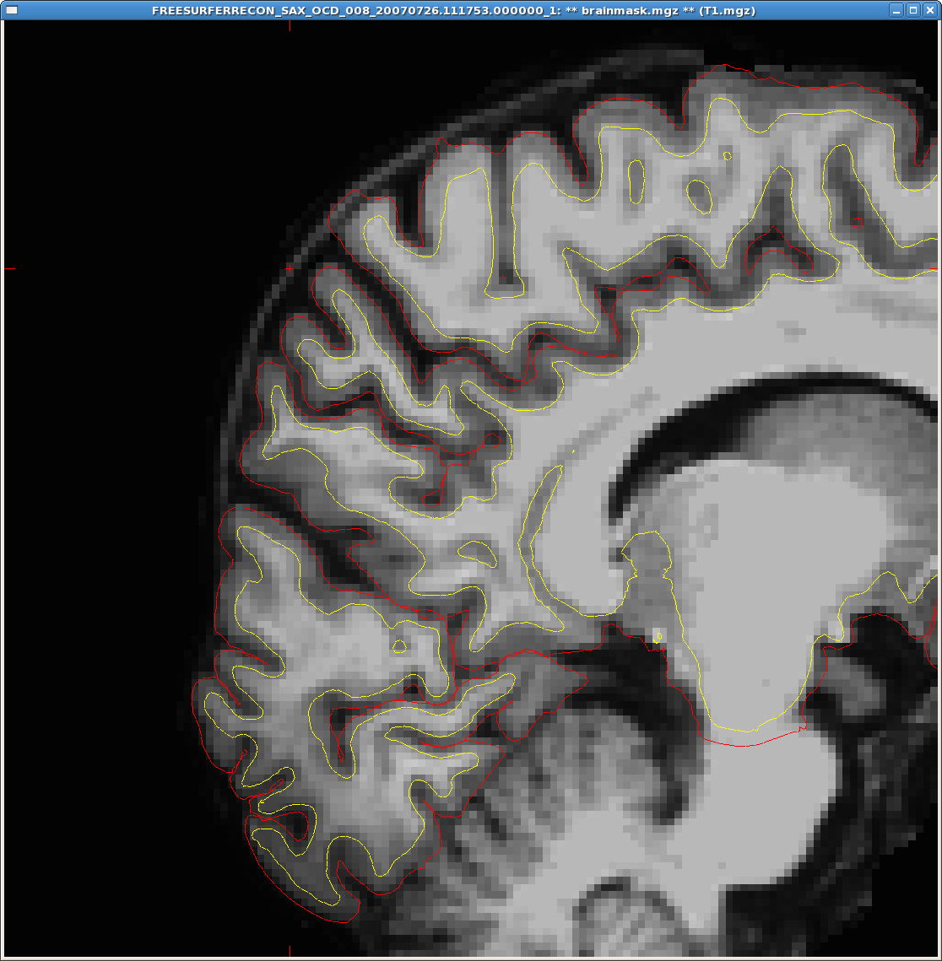 | 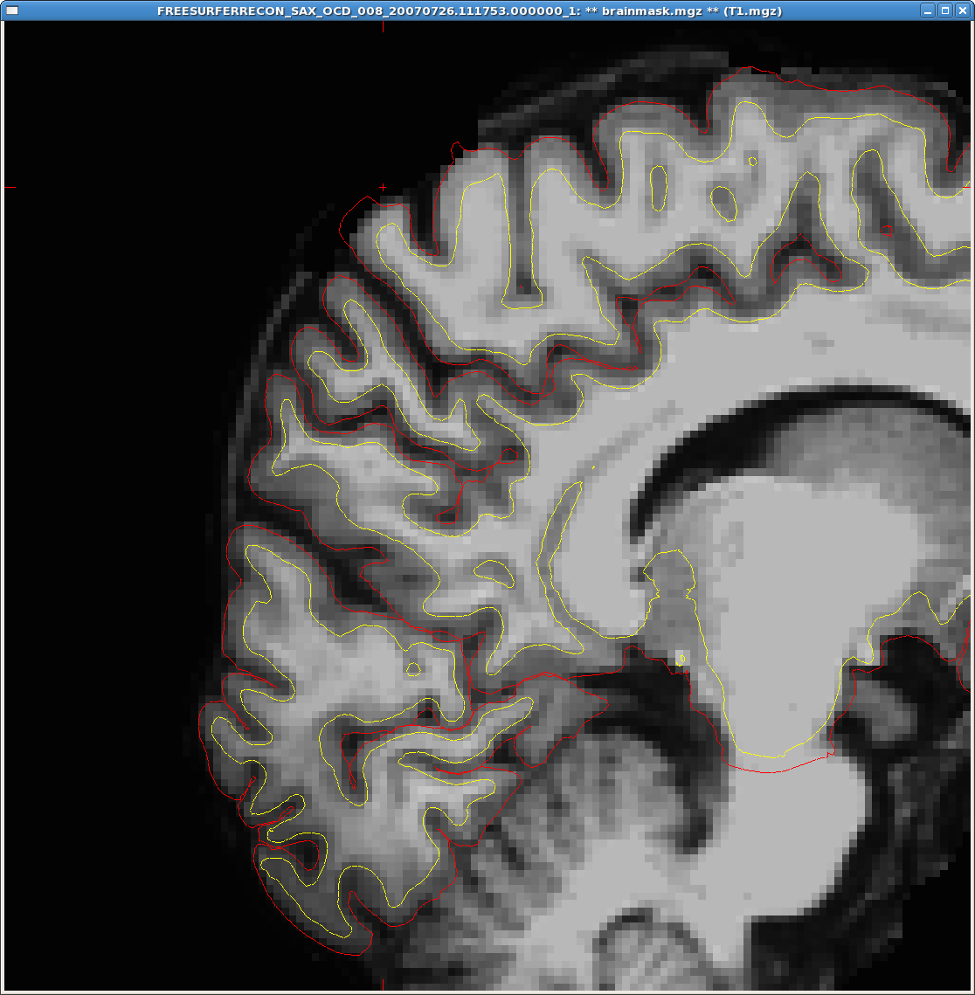 | 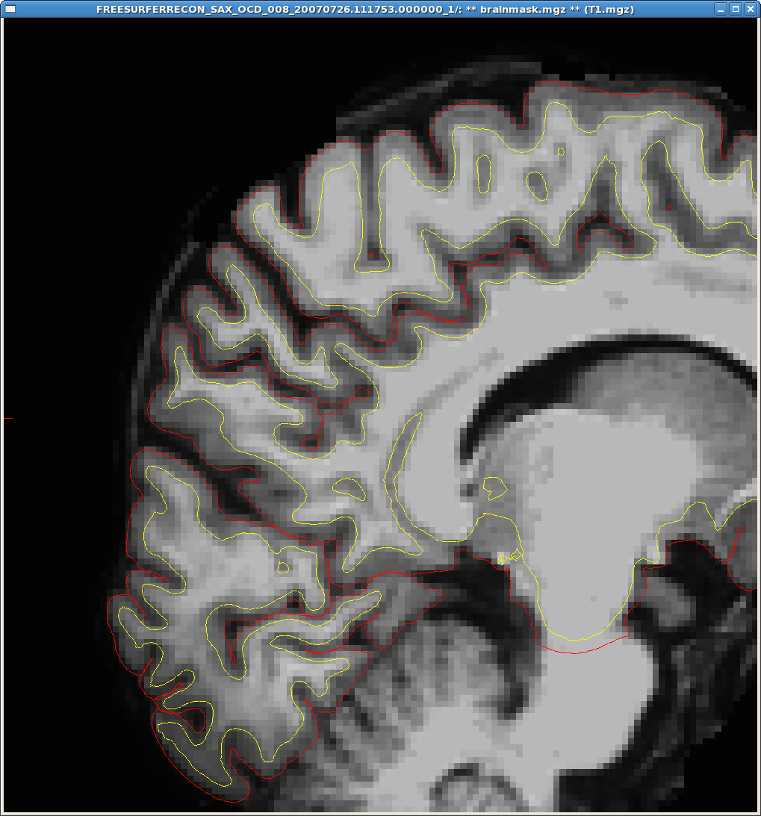

- ASEG Review
NOTE: See Separate Protocol Sheet “ASEG Quality Control: Examples”

- View Segmentation in Freesurfer
  - > cd data_PROJ_NAME/FSContainers
  - > ls (lists folder names of all available scans)
  - > sete (sets environment to be able to open scans)
  - > tka FREESURFER_RECON_SUBJ_FOLDER_####
- Open FSRecon_QC:
  - > cd ProjInfo/PROJ_NAME/
  - > ooffice PROJ_NAME_FSReconQC.csv
- Scroll through all areas in both coronal and sagittal views, if more than 10% of a structure is incorrectly labeled, it should be rejected.
  - Overestimated: Put structure hemisphere and name here (e.g. RH Caudate, or RH/LH Hippocampus)
  - Underestimated: Put structure hemisphere and name here
  - ASEG Notes: Put any other notes pertaining to an ASEG but does not include rejected areas here. For example, if there are a lot of hypointensities throughout the white matter.

- Resample to Average
- MATLAB > REC_MMIL_IcoResamp_FSRecon_Exams(‘PROJ_NAME’)
- Sign onto cluster >qmatjobs PROJ_NAME_MMIL_IcoResamp_FSRecon_Exams
  - Troubleshooting: If in either Resample step or Analyze step Matlab produces error: “Empty StudyInfo” this has to do with the FSRecon_QC spreadsheet. Verify that there are columns titled “Surface QC” and “ASEG QC” and each subject has a QC in those columns of “Good,” “Average,” or “Bad.”
  - Note: This step is not required for Longitudinal only processing. It is used for determine cortical area and contrast stats, Longitudinal determines that on its own.

- Analyze MRI Stats/Exams

- Verify that the “ReconDir” column in PROJ_NAME_FSReconQC.csv contains the same names as the Freesurfer Folders (and that QC columns have been filled as noted above)
- In MATLAB > REC_MMIL_Analyze_MRI_Exams(‘PROJ_NAME’)
- Sign onto cluster > qmatjobs PROJ_NAME_MMIL_Analyze_MRIStats_Exams

- Summarize Output
- Backup Old ROI_Summaries
  - > ll ~mmilrec/MetaData/PROJ_NAME
    - If there is a folder named “ROI_Summaries” note the date and continue to (c)
    - If there is no folder named “ROI_Summaries” continue on to step 2
  - > mv ROI_Summaries ROI_Summaries_20090101(replace 20090101 with the date that the folder was last saved, in format YearMonthDay)
- MATLAB > REC_MMIL_Summarize_MRI_Analysis(‘PROJ_NAME’)
  - For DTI: REC_MMIL_Summarize_DTI_Analysis(‘PROJ_NAME’)
- > cd /home/mmilrec/MetaData/PROJ_NAME/ROI_Summaries -- verify that all files made today
- > ooffice PROJ_NAME_MRIStats_All.csv
- Note all subjects that have “NaN” across the data list. For each subject, resolve errors/QC.
  - If NaN are in...
    - Area measures (thickness output ok): Rerun/troubleshoot IcoResamp
    - Fiber Tracks (aseg ok): Rerun Process_Exams with ATL_flag; rerun Analyze
    - All DTI Measures: Check if FSRecons are complete
    - Just a few "SubCort" measures: This can be from FS errors while creating "aseg.stats." To check, compare the FS_SUBJ_DIR/stats/aseg.stats file with a subject that has all values. The first column in the aseg list should go to 49. If there are rerun freesurfer recon stats from FSContainers folder for each subject.
      - > recon-all -s FREESURFERRECON_0002_####.##.# -segstats -force
      - Need to rerun Analyze and Summarize after all aseg.stats files are complete
  - > cd /home/mmilrec/batchdirs/REC_MMIL_Process_Exams_PROJ_NAME
    - > grep SUBJ_ID *.m (this finds which job contains the subject you are interested in), note this (e.g. job.###.m)
    - > cd pbsout/
    - > cat job_###.err (this will print any error if one is listed in the file. If there is an error, discover what caused it and solve if possible)
    - > cat job_###.out (this will print all of the processing scripts that were run. You want it to say “finished” as the last line.)
      - If there is problem, open data_PROJ_NAME/tmp/
        - > count . (alias to list the number of files within each folder – if one of the NaN subjects has less files this may be why- investigate!)
        - > cd SUBJ_ID and then > tkmedit –f FIRSTFILE.dcm (this will load the MRI – see if you can tell what may cause an error)
  - Open PROJ_NAME_RawQC.csv
    - If the subject has 3 in the QC Column, they failed RawQC, note this and the subject can be deleted from the MRIStats files.
    - If the subject has 0, there is no raw data, note this and the subject can be deleted from the MRIStats files (This is ONLY the case if you know that you did RawQC on all available subjects!)
- Repeat step 5 with all “NaN” subjects, until all errors identified
  - If some errors were fixed (i.e. A column in one of the spreadsheets had incorrect labeling and it has been corrected, rename the old ROI_Summaries folder, and run again).
  - Files that did not pass RawQC can be deleted in all MRIStats files.

- Concatenate Surfstats
This step creates group statistical maps for use in Matlab

- MATLAB > REC_MMIL_Concat_SurfStats(‘PROJ_NAME’)
  - Puts all subjects into one 4D file:
1: Vertices
2/3: Filler
4: Subjects
  - Creates matching csv file that is an index of which row in mgz corresponds to which subject (Subject in 1st row of .csv is 1st subject in .mgz)
  - Information on output files:
    - [...]T1surf-projdist-0.2-lh.mgz : Gives signal intensity/contrast values .2 mm from white matter surface towards cortex
    - [...]T1surf-projdist0.2-lh.mgz : Gives signal intensity/contrast values .2 mm from white matter surface towards white matter

- Longitudinal Analysis
- Verify that a data_PROJ_NAME/LONGContainers folder exists
- Verify that FSRecons of baseline subjects have all been completed
- Run “REC_MMIL_Long_Setup_Exams('PROJ_NAME')” in Matlab then submit to cluster
- Run “REC_MMIL_Long_Register_Exams('PROJ_NAME')” in Matlab then submit to cluster
- Run “REC_MMIL_Analyze_Long_Exams('PROJ_NAME')” in Matlab then submit to cluster
- QC Longitiudinal Data

- Provide Data to PI
See Example on Next Page of Final Info sent to Researcher

- Information to Provide:
  - All QC Info:
    - RawQC
    - ReconQC
      - Create a new file (PROJ_NAME_FSReconQC_Final.csv) from the regular ReconQC and delete all of the intermediate step columns (e.g. Touch Remake, Dates completed, etc) that the researcher would not need.
  - Common problems in most subjects, e.g:
    - Midline
    - Pallidum
    - Cortical Overestimation (meninges)
  - Explanation of shorthand in QC’s
  - Written out explanation of which subjects were rejected at each step and why their data will not be in final information
    - RawQC
    - Bad Surfaces
    - Bad Aseg
  - ROI_Summaries and Concat_Surfstats

- Example: Provide Data to PI
Hi [Insert PI's Name],
The processed data for your project can be found in /home/mmilrec/MetaData/BON_MCI30
The Freesurfer data is in /home/mmilrec/data_BON_MCI30/FSContainers/ if you are interested in looking at any subject in particular.

Some Editing Notes that were common throughout the data:
- Putamen/Basal Ganglia Filled In - This is an edit that has to do with fixing a problem of how Freesurfer draws the white matter
- Nonbrain Deletions - Non brain was included in the pial surface (usually meninges), attempts were made to fix this throughout the data. If the surface could not be fixed, it is noted within the FSReconQC file, and that should be taken into account in your analysis
- Midline: Freesurfer often overlaps the pial surfaces along the interhemispheric fissure. This cannot be corrected and should be considered when evaluating any midline structures.
- Hippocampus/Amygdala: These are both usually incorrectly estimated by the pial surface but the numbers in the ROI summaries are taken from the Aseg, not the pial surface
The files that are going to be important to you are:
- BON_MCI30_RawQC.csv: This includes the Raw Quality Control information.
  - m1 refers to motion in the scan and then the rating (1 will likely not affect the FS Recon, 2 may effect the recon, and 3 will definitely affect and is rejected)
  - GW refers to Gray/White Contrast
  - Subjects Rejected at RawQC (where not processed):
    - 345_Q2Y09
- REC_BON_MCI30_FSReconQC_Final.csv: This goes over the edits that were done in Freesurfer as well as the QC after all processing has been done on the scans. This also includes the ASEG reviews
  - Note the ROIs noted in the surface review, these are incorrect and should not be used for that subject. The same is true for the ROIs in the ASEG review.
  - Subjects Rejected at ReconQC:
    - Rejected for Bad ASEGs:
      - FREESURFERRECON_2008_07_08a_20080708.091056_1
      - FREESURFERRECON_1009_Q4Y08_20081104.121347_1
    - Rejected for Bad Surfaces:
      - FREESURFERRECON_2008_10_16_Bondi_20081016.115448_1
- ROI_Summaries (Folder): Contains .csv files providing different stats on the ROIs
- concat_surfstats (Folder): Contains concatenated .mgz files with statistical measures for the subjects - used for creating group statistical maps.
IMPORTANT: You want to make sure that you do not use any of the rejected subjects in your averages and data, as it will throw off the data. This includes both Raw and Freesurfer rejected data.
Let me know if you can't copy the files out of that folder and into your own, and I can create a DVD with the information on it for you. Also, feel free to let me know if you have any more questions.

