Tractography 3D Viewer Application
Users Manual
&
Development Guide

Author: Sumiko Abe
MMIL Lab, UCSD
Date: Sep, 18, 2007

- Users Manual

This application is specialized for DTI tracto fiber 3D visualization. For running the program, change your location to the program directory and input on comment as “./tractoview”. The program will start with the input parameter option as:

Program Usage: tractoview -options option_parameters

Option Usages:
-help: print out usages of this program.
-iFAmgh: input a mgh format FA image.
-iV0mgh: input a mgh format V0 image.
-iEVamgh: input a mgh format eigenvalue image.
-iFiberFileName: input name of fiber files.
-iColor: multiple fiber color input flag.
example: 0 --> program will create random colors.
1 --> program will open a color definition file.
-iColorFile: multiple fiber input color pallet text file.
-iGlossy: glossy effect on fiber visualization.
0 --> view fiber without glossy effect.
1 --> view fiber with glossy effect, default.
-iOpacity: opacity effect on fiber visualization.
0 --> view fiber without opacity effect.
1 --> view fiber with opadety effect, default.
-iXRotAngle: initial rotation angle on (1, 0, 0) axis in degree unit.
-iYRotAngle: initial rotation angle on (0, 1, 0) axis in degree unit.
-iZRotAngle: initial rotation angle on (0, 0, 1) axis in degree unit.

Check your input arguments, Exit!

Input “./tractoview –help” for the usages option, the following shows an example:

./tractoview -iFAmgh \
./data/DTI_scans_5_6_7_gruw_reg_mc_ecc_B0uw_iso_DT_FA.mgh \
-iV0mgh \
./data/DTI_scans_5_6_7_gruw_reg_mc_ecc_B0uw_iso_DT_V0.mgh \
-iEVamgh \
./data/DTI_scans_5_6_7_gruw_reg_mc_ecc_B0uw_iso_DT_lamdas.mgh \
-iFiberFileName \
./data//fiber_07_path.grp \
./data//fiber_08_path.grp \
./data/fiber_09_path.grp \
./datafiber_paths/fiber_10_path.grp \
-iColorFile ./color_4.dat
-iOpacity 0
-iGlossy 0
-iXRotAngle 30

The Software has 2 parts, one is 3D viewer, other one is file input GUI.

  - 3D viewer

The application starts and 5 windows come up showing as Fig.l. Parameter input panel, axial section, coronal section, sagittal section view and 3D viewer windows.
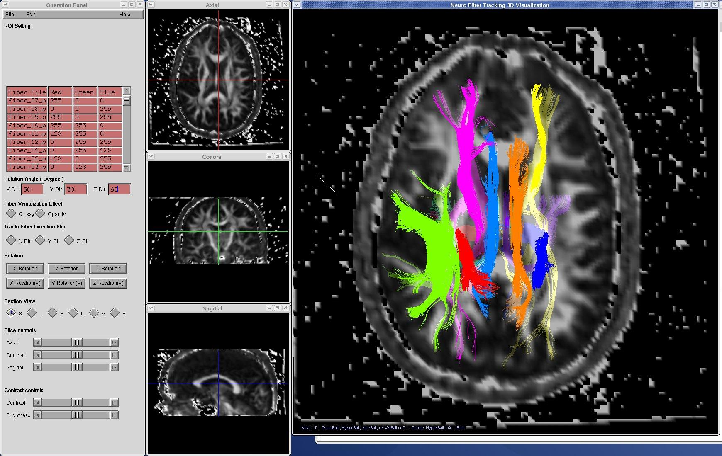
Fig.1 3D Viewer

Parameter input panel window is a GUI for changing the 3D viewer parameters. Axial, coronal and sagittal section window view the current slice on axial, coronal and sagittal direction. The 3D view window views the tracto fibers and currently axial, coronal and sagittal slice.

- Parameter input panel
Parameter input panel window showing as Fig 2. The main menu has “File”, “Edit” and “Help” 3 items. Only “File” item works for new files input and exiting whole application. 2 rows under “File” menu:
Open: the file input GUI start.
Close: exit the application
Fig2 3D Viewer parameter input panel
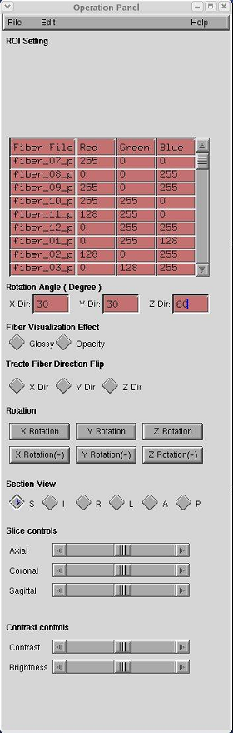
Fiber File Color: A table of viewing fiber colors. The table has 4 columns. “Fiber File” column can not be changed, refer to the “2) File Input GUI” for inputting new files if you want to change the input fiber file. The other 3 columns indicate the viewing current color value in R, G, B. It can be change as following operation:
Click the item in the table which you want to change and input the new value of the color Red, Green and Blue. Press “Enter” Key on key board then the fiber color would be change.
Note: The color would not be changed if users do not press “Enter” key.
Rotation Angle: The rotation angle on X, Y and Z axis. The input value should be degree unit. The program will start viewing at superior direction in axial if users do not define the initial angles with program starting input option. Click the text box and input the angle degree, press “Enter” key. The 3D viewer rotates the viewing direction as user input angle.
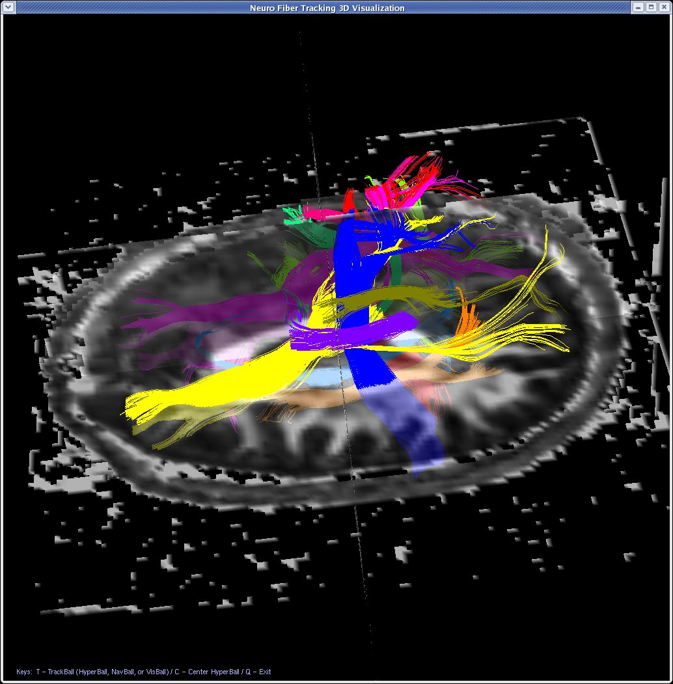
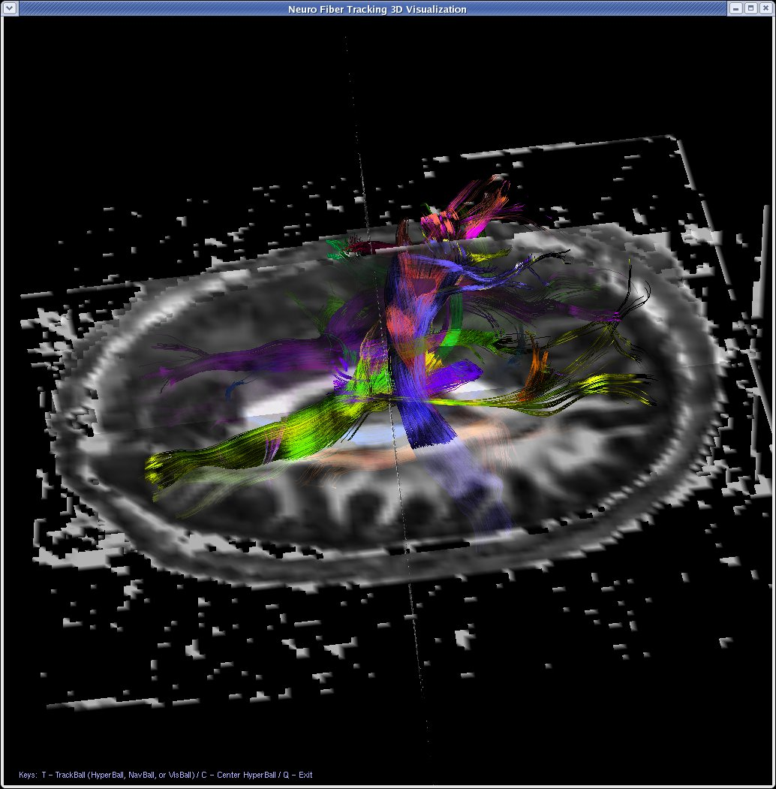
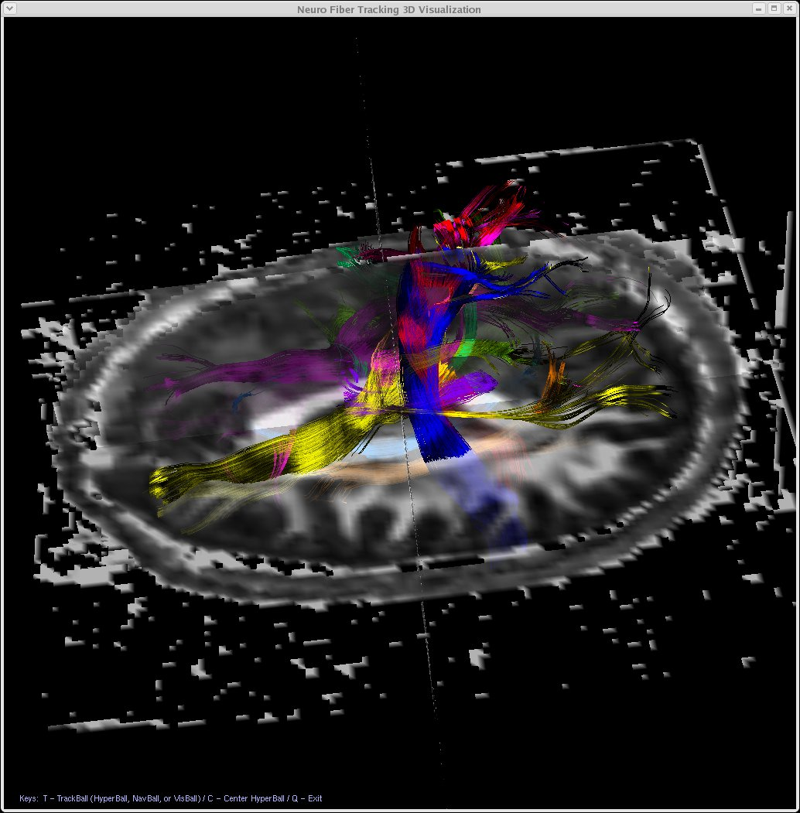
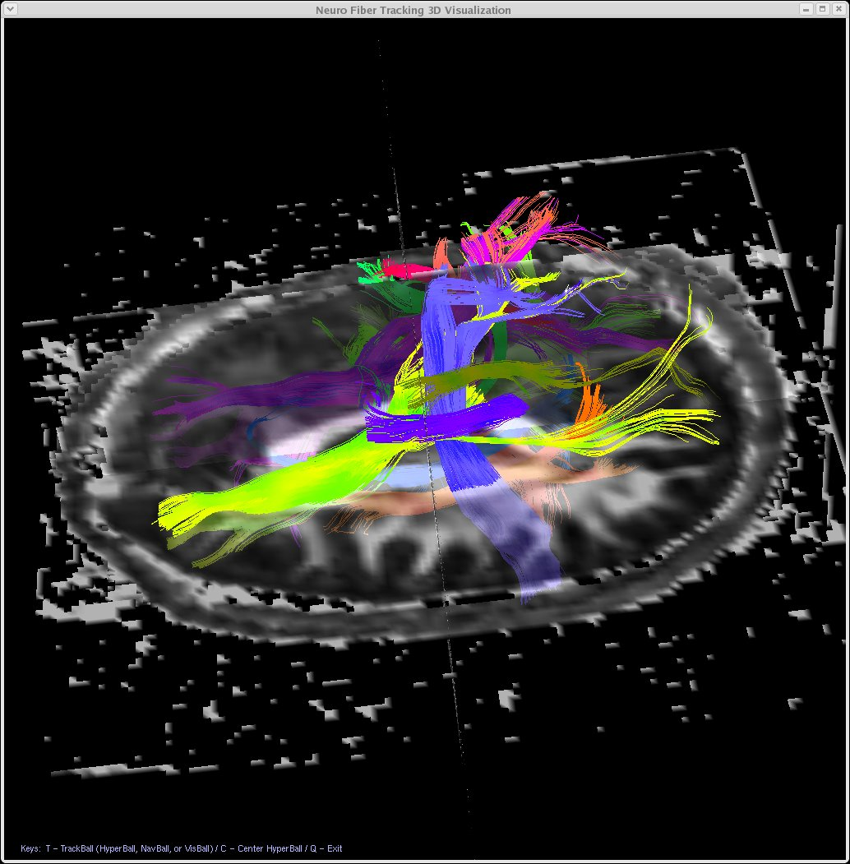
Fiber Visualization Effect: the application views fibers with 2 effects, glossy and opacity. The effects look like the following:
Normal Glossy Opacity
Grossy & Opacity

Fig3. Visualization Effects

Tracto Fiber Dir Flip: The flag of fiber direction flip in X, Y and Z direction.
Rotation: Click the button then the 3D viewer starts to rotate the viewing direction automatically. The rotating direction could be run at X, -X, Y, -Y, Z, -Z directions.

Section View: I, A, R, L, A and P direction viewing.
Slice Controls: Change the current axial, coronal and sagittal image slice location.
Contrast Controls: Change the contrast and brightness of 3D viewer window.

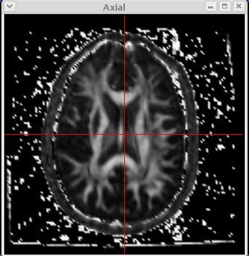
- Axial Section View: View the current Axial slice. Click mouse left button on this section window for changing the current coronal and sagittal slice location.
Fig4. Axial Section View

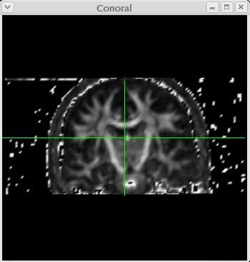
- Coronal Section View: View the current Coronal slice. Click mouse left button on this section window for changing the current coronal and sagittal slice location.
Fig5. Coronal Section View

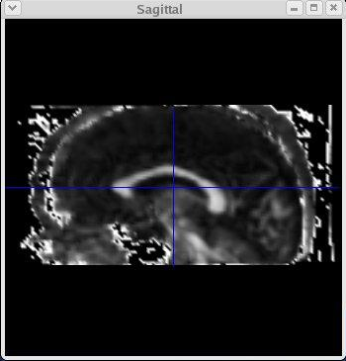
- Sagittal Section View: View the current Sagittal slice. Click the mouse left button on this section window for changing the current coronal and axial slice location.
Fig6 Sagittal Section View

- 3D Viewer Window:
Fig7 3D vewer window

The 3D viewer window is the main part of this application.
The following is viewing operation:

Rotation: → Mouse right drag
Zooming: → Mouse right drag + Control key
Translation: → Mouse right drag + Shift key
RGB Color Map as oriental data: → press “r” key
Gray scale as FA data: → press “g” key

  - File I/O Interface

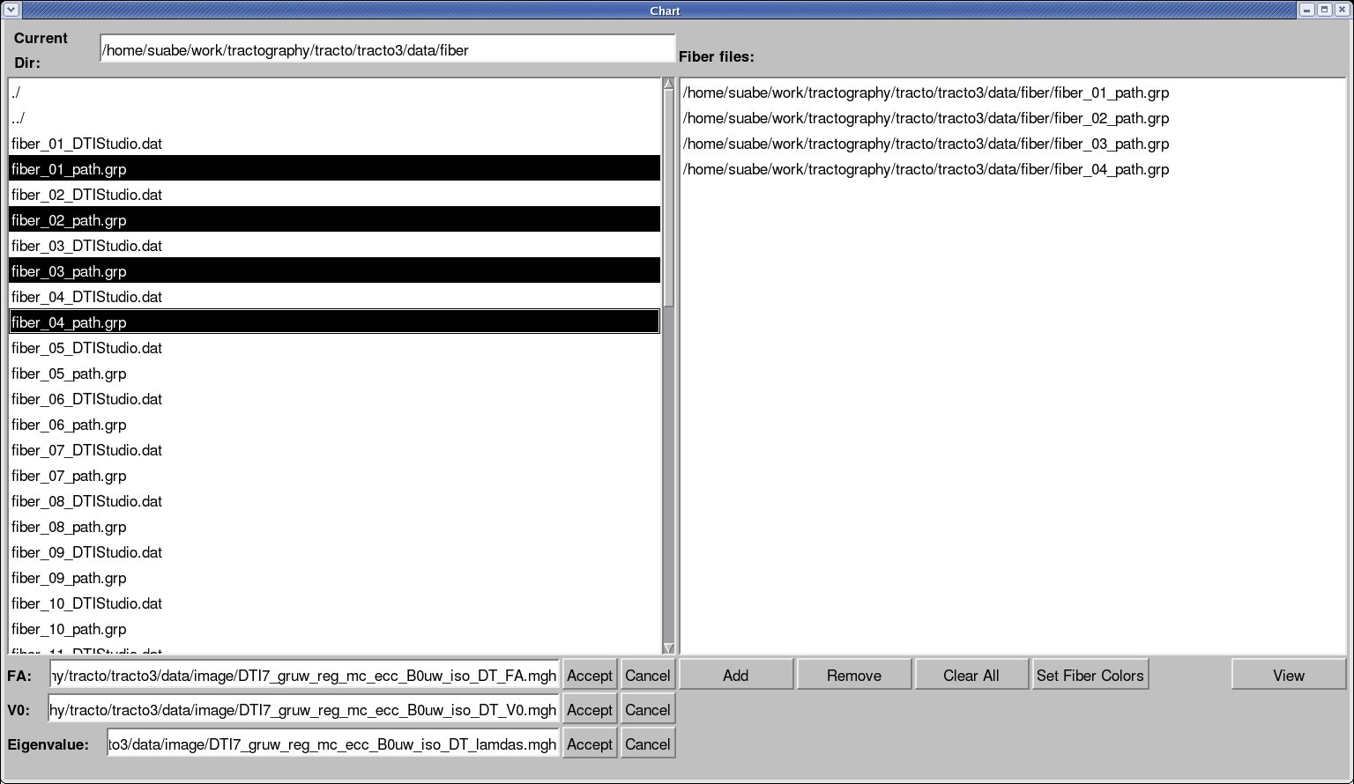
I/O window is showing as the Fig8 and it has 2 frames. The left frame has directory/file list and file selection area. Open this window from main menu→File→Open.
Fig8 File I/O GUI

FA: select a file in directory/file list and press FA “Accept” button, the file would be input to the FA textbox.
V0: select a file in directory/file list and press V0 “Accept” button, the file would be input to the V0 textbox.
Eigenvalue: select a file in directory/file list and press “Accept” button, the file would be input to the Eigenvalue textbox.
Press each “Cancel” button to clear the file respectively which have been input.
Note: FA and V0 are always requested to input. The program does not start to work if the user do not input the FA and V0 files or the file path is incorrect. The Eigen Value file is an option. The program will not working for glossy visualization effect if the user do not input the eigenvalue file.
All of file should be MGH format.

The right frame has a file list and operation area.
Add: select the from the directory/file list in left frame, and click “Add” button. The selected fiber files would be added to the fiber file list.
Remove: select a file in fiber file list and press “Remove” button. The selected fiber file would be deleted from the list.
Clear All: clear all input fiber files from the file list
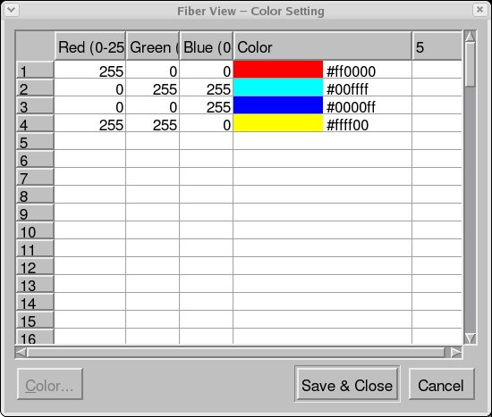
Set Color: Press “Set Fiber Color”, a color selection window comes up showing as Fig9. The

Fig9 Fiber color setting

table is the default color for each selected fiber file. A dialog warning box will come up if no fiber file selected. Click the “color” area in the table then the color pallet dialog window comes up showing as Fig.10. Select a new color and press “OK” then the new color is set or press “Cancel” to avoid the all selection for closing the pallet window. Press “Save & Close” to save the user selected colors and close the color pallet window.
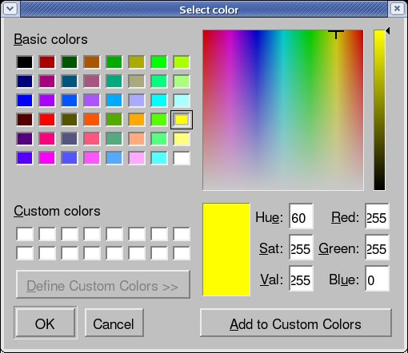

Fig10. Color selection window

View: Click view button for start to view the new fibers.

- Development Guide

  - Program over view

Processing platform: C++
Related Graphic libraries: OpenGL, GLUT, Qt 3, MUI

Program Main Directory:
Ip36:/home/suabe/work/tractography/tracto/tracto3

The structure of programs show as following Fig11.

Ip36:/home/suabe/work/tractography/tracto/tracto3
CVS
Math
Utils
dcmlib
Interaction
OpenGL
fileIO
examples
glutkernel
glutobj

Fig11 The program structure

The following directories are not be used often but they are needed.
CVS: This directory saves the information of version up
dcmlib: dcmtk libraries. The programs need not to change but need to recompile on 32 bit machine. The current *.o files in this directory is 64 bit.
Utils: The programs need not change but need to recompile on 32 bit. The current *.o files in this directory is 64 bit.
Glutobj: GLUT library files. The files is compiled by GLUT makefile and moved to this directory. You could found entire GLUT library in /home/suabe/tool. It needs to recompile on 32 bit machine.
Math: The matrix calculation function routine of 3D coordinate transformation. It is not necessary to modified the programs in this directory duo to the functions is fully enough. That would be possible if you add more function of mathematic calculation in 3D viewer translation such as rotation, zooming and translation.
Interaction: The calculation routine of 3D coordinate transformation. It based on functions in Math directory.

The following directories and files are related directly for the 3D viewer, the following files should be checked if you add new actions to GUI, A-C-S Section viewer or 3D viewer.

Glutkernel: Main functions of the 3D viewer application.
GlutKernelApplication.cxx
GlutKernelApplication.h
glutMain.cxx
OpenGL: 3D drawing functions
glRenderImage.h
Examples: Event control of entire application.
PlantViewerApplication.cxx
PlantViewerApplication.h
FileIO: file I/O input GUI design.
chartform.h

  - Build steps

    - Build file IO library.
Change the current directory to /home/suabe/work/tractography/tracto/tracto3/fileIO and inupt “make” as a comment, the programs under this directory will be compiled. Just make sure about if the object file is updated in .moc/release_static and don’t care about the link errors.

    - Build file in dcmlib directory
Change the current directory to /home/suabe/work/tractography/tracto/tracto3/dcmlib and input “make” as a comment, the prgarms under this directory will be compiled. Just make sure about if the object file is update in the current directory and move the object files to Change the current directory to /home/suabe/work/tractography/tracto/tracto3 directory.

    - Build entire application programs
Change the current directory to /home/suabe/work/tractography/tracto/tracto3, and input “make” as a comment. The programs under this directory will be complied. The new program tractoview will be updated in the current directory.

